# 3 Satellite types

## Optical Data

* + - Can’t penetrate clouds
    - Clouds are 2/3 screentakings in vietnam
    - Cloud filters example in sample ntbk
  + Landsat
    - 8 day revisits
    - 30m/pxl
  + Sentinel 2
    - 10m/pxl
    - 10 day revisits

## Radar Data

* + - Can penetrate clouds
    - Adjusted for terrain slopes
  + Sentinel 1
    - 10m/pxl
    - 12 day revisits

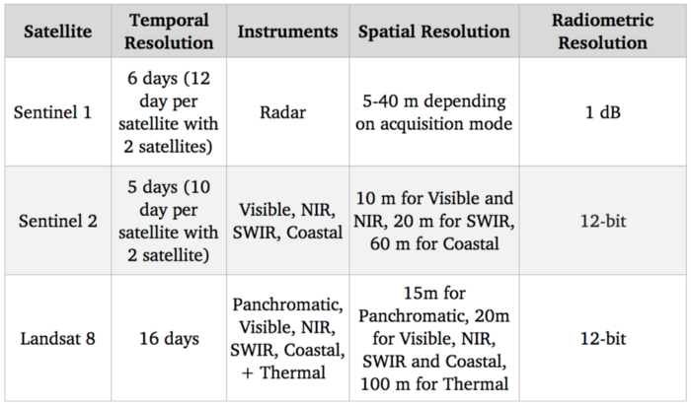

# Region analysis

* An Giang Province
* Late 2021- Mid 2022
* Assumption of triple cropping cycles
  + Nov-April // April-Aug

# Rice Crop Phenology

* Optical data
  + Spectral bands (Red, Green, NIR etc.)
  + Statistical Combinations of band >> indices
  + Indices (NDVI, EVI, SAVI)
* Radar Data
  + C-Band Frequency
    - Horizontal (H) polarization
    - Vertical (V) polarization
    - VV and VH
      * First letter – transmitted polarisation
      * Second letter – Receieved polarisation
      * Statistical combinations
        + RVI – Radar Vegetation Index

sqrt (1- VV / (VV+VH)) * 4 * (VH / (VV + VH))

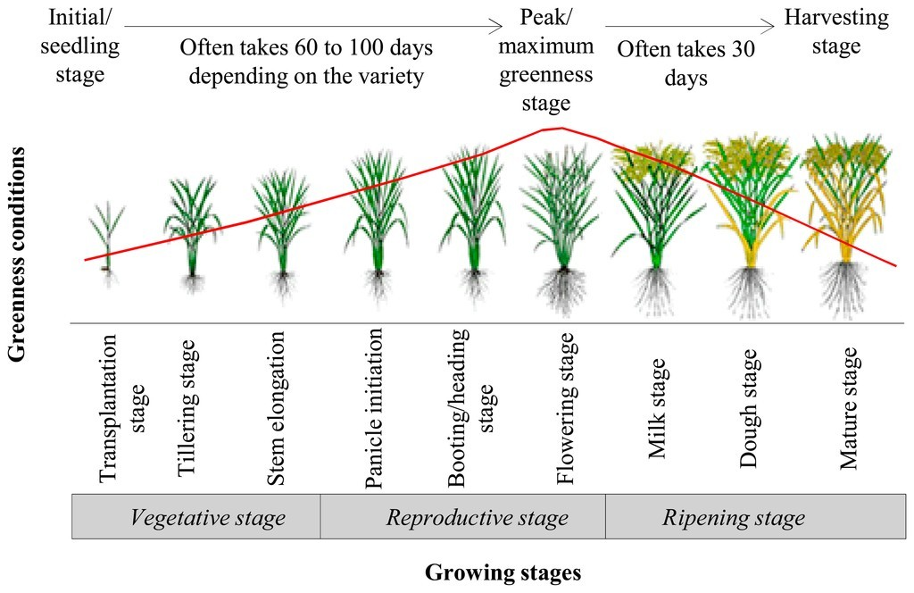

# Climatic Impact

* Main influences in Water and Agriculture
* Temp for Rice 25C-35C
* Rainfall is good during tillering stage bad during flowering stage