**HW1 TASKS.**

**TASK 1.**

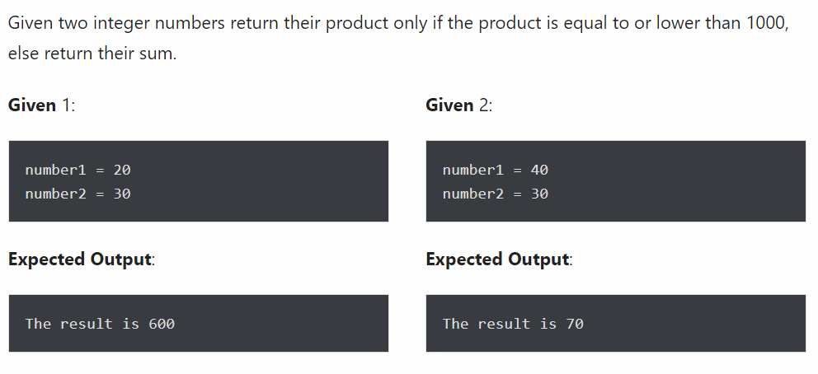

**TASK 2.**



**TASK 3.**

Write a program to print first 10 numbers using for loop.

**TASK 4.**

Write a program to print all numbers from 1 to **N**, which are divisible by 5, where **N** is given.

**TASK 5.**

Write a program to print all numbers from 1 to **N**, which are divisible by **D**, where **N** and **D** is given.

**TASK 6.**

Write a program that prints all numbers from **A** to **B**, where **A** and **B** is given.

**TASK 7.**

Write a program that prints all numbers from **A** to **B** which are divisible by **D**, but not divisible by **K.**

**Hint:** start from accepting values **A**, **B**, **D**, **K.**

**TASK 8.**

Write a program that asks user any number and returns its last digit.

**Hint:** to get last digit of number use “%”.

**TASK 9.**

Write a program that asks user a **number** and **letter** ‘a’, ‘b’ or ‘c’.

If letter is ‘a’, then print number doubled.

If letter is ‘b’, then print 0.

If letter is ‘c’ add to a number 100 and print it.