[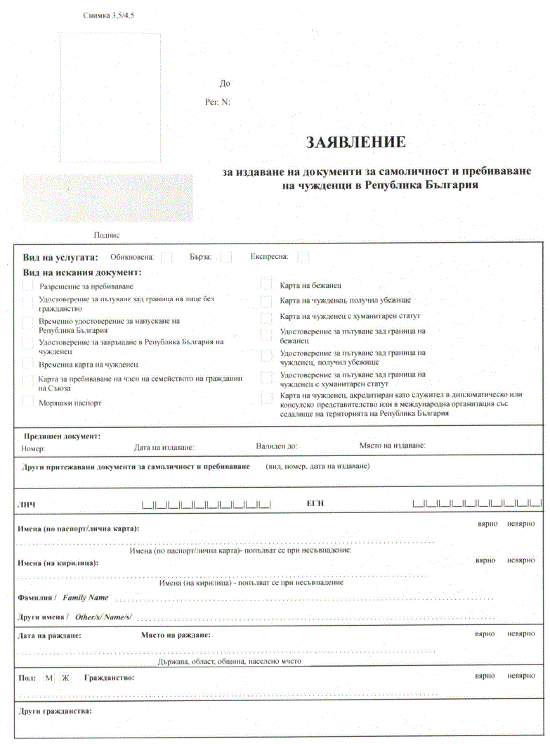](http://ciela.mvr.bg/Content/Images/Document/82_2990023870_dv2021_br066_str15.gif)

[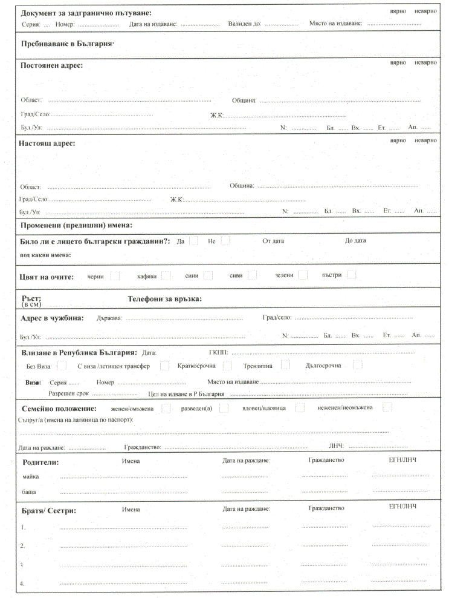](http://ciela.mvr.bg/Content/Images/Document/82_1827273395_dv2021_br066_str16.gif)

[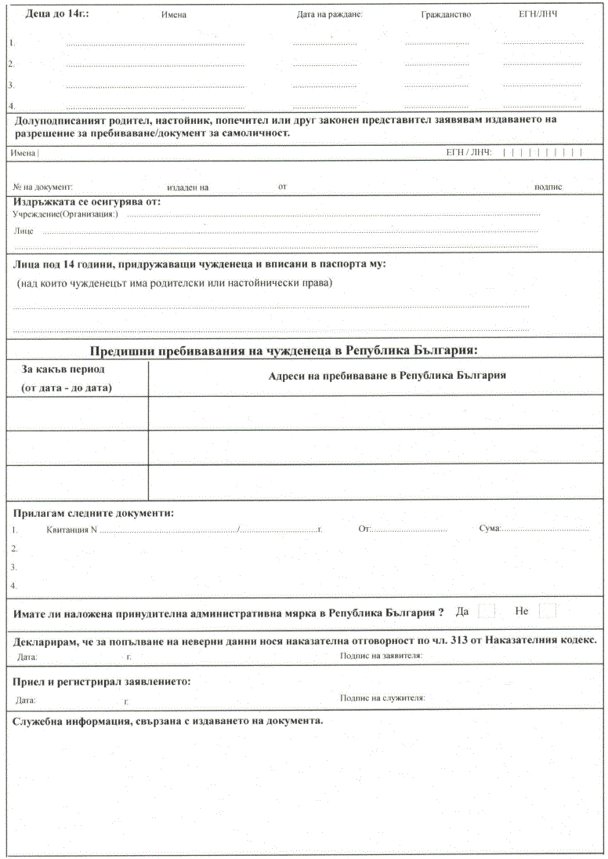](http://ciela.mvr.bg/Content/Images/Document/82_538015019_dv2021_br066_str17.gif)