Description | Part | References | Value | Quantity Per PCB
Unpolarized capacitor | C | C5 C7 C8 C13 C15 C16 C19 C20 C23 C28 C31 C32 | 100n | 12
Unpolarized capacitor | C | C24 | 100u | 1
Unpolarized capacitor | C | C14 C21 C22 C29 C33 | 2.2u | 5
Unpolarized capacitor | C | C9 C10 | 3.3p | 2
Unpolarized capacitor | C | C3 C4 C18 C30 | 4.7u | 4
Unpolarized capacitor | C | C1 C2 | 47p | 2
Unpolarized capacitor | C | C6 C17 | 47u | 2
Unpolarized capacitor | C | C11 C12 | 8.2p | 2
Diode | D | D2 | 1N4148 | 1
LED generic | LED | D1 | CHRG_LED | 1
LED generic | LED | D4 | SYS_LED | 1
Fuse, generic | Fuse | F1 | 1A | 1
Conn_Nokia_BL-5C | Conn_01x03 | J1 | Battery Connector | 1
Generic connector, 01x03 | Conn_01x03 | J13 | CONN_01X03 | 1
External expansion connector | Conn_01x06 | J3 | Conn_Bottom_Expansion | 1
Internal expansion connector | Conn_02x08 | J4 | Conn_Internal_Expansion | 1
Programming connector | Conn_01x06 | J12 | PROG | 1
SD card slot | uSD-timekillerXtreme | J6 | uSD | 1
Inductor | L | L1 | 4.7uH | 1
P-Channel MOSFET, SOT-23-3 | NTR2101P | Q1 | IRLML6302 | 1
Transistor NPN (general) | Q_NPN_BCE | Q2 | PMBT3904.215 | 1
Resistor | R | R19 | 0 | 1
Resistor | R | R1 R12 R13 R24 | 10k | 4
Resistor | R | R9 | 150k | 1
Resistor | R | R2 R14 R15 | 15k | 3
Resistor | R | R16 | 220 | 1
Resistor | R | R3 R4 | 27R | 2
Resistor | R | R5 | 2k | 1
Resistor | R | R6 | 470R | 1
Resistor | R | R7 R20 R21 R22 R23 | 47k | 5
Resistor | R | R8 | 680k | 1
Single Pole Single Throw (SPST) switch | SW_SPST | SW8 | RST | 1
Single Pole Single Throw (SPST) switch | SW_SPST | SW1 - SW7 | A, B, L, R, U, D, PWR | 7
Cmos switch, SOT23-5 | AOZ1310 | U7 | AOZ1310 | 1
FTDI usb to seriál | FT230XS-R | U2 | FT230XS-R | 1
Battery management | MCP73831 | U1 | MCP73831 | 1
Voltage reg. | NCP1529 | U3 | NCP1529 | 1
MCU | STM32F407VGT6 | U5 | STM32F407VGT6 | 1
Voltage refrerence | TLV431 | U4 | TLV431 | 1
ESD protection | USBLC6 | U6 U8 U9 | USBLC6 | 3
Two pin crystal | Crystal | Y2 | 16MHz | 1
Two pin crystal  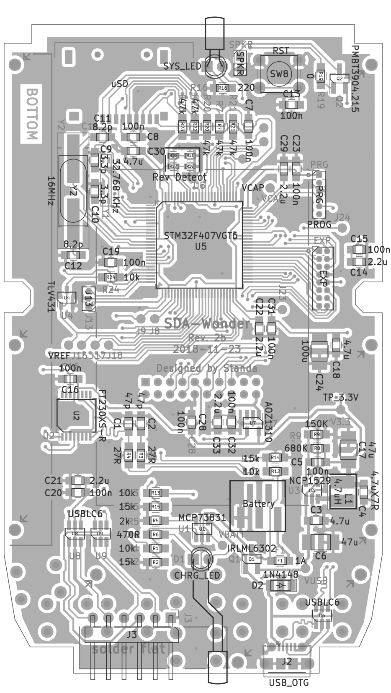SDA-Wonder Rev2b Assembly docs, Standa 2018  hackaday.io/project/35165-sda-the-best-new-pda  github.com/stanislavbrtna/SDA_Wonder_HW | Crystal | Y1 | 32.768 KHz | 1

