CO 323 Computer Communication Networks

Labotary Session 2

E/13/377

# TCP traffic (Client – 10.40.18.73, Server – 10.40.18.74):

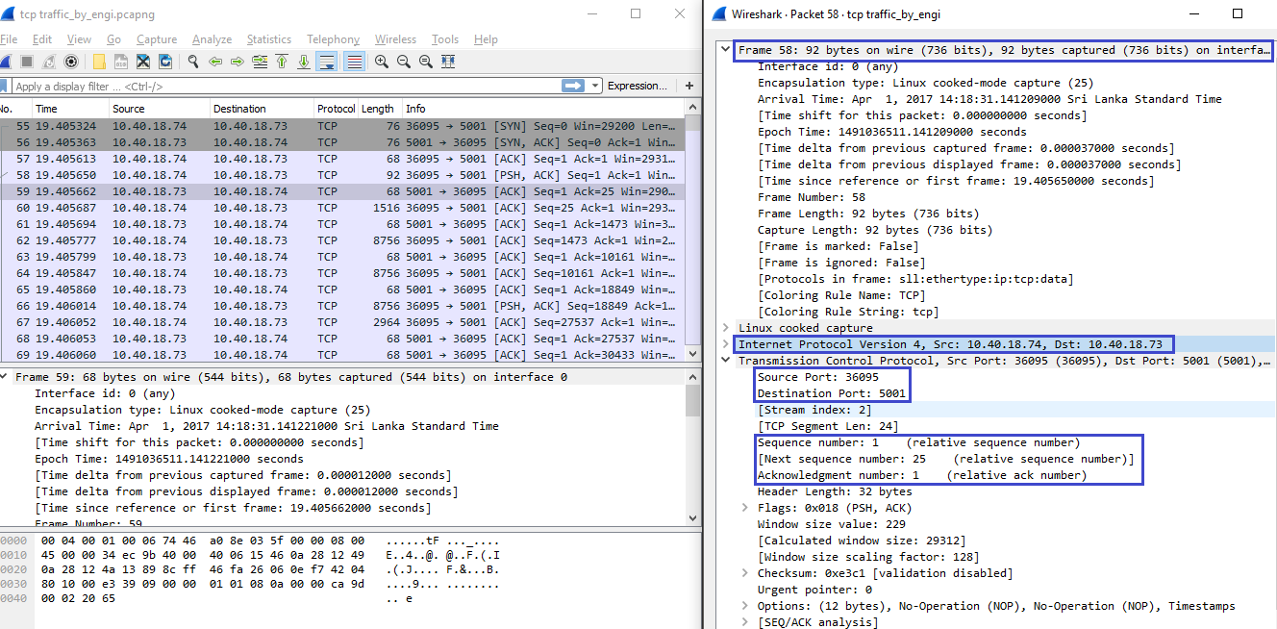

# TCP traffic (Client – 10.40.18.74, Server – 10.40.18.73):



# TCP traffic (Client – 10.40.18.73, Server – 10.40.18.74):

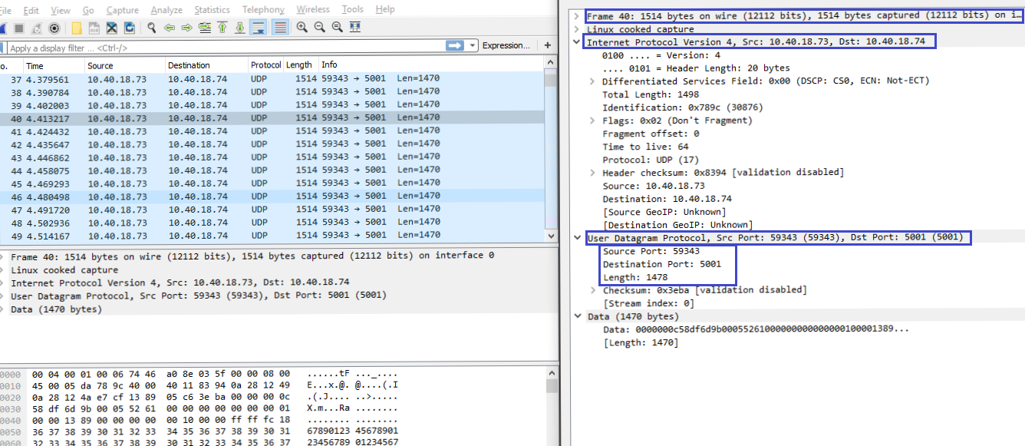

# TCP traffic (Client – 10.40.18.74, Server – 10.40.18.73):

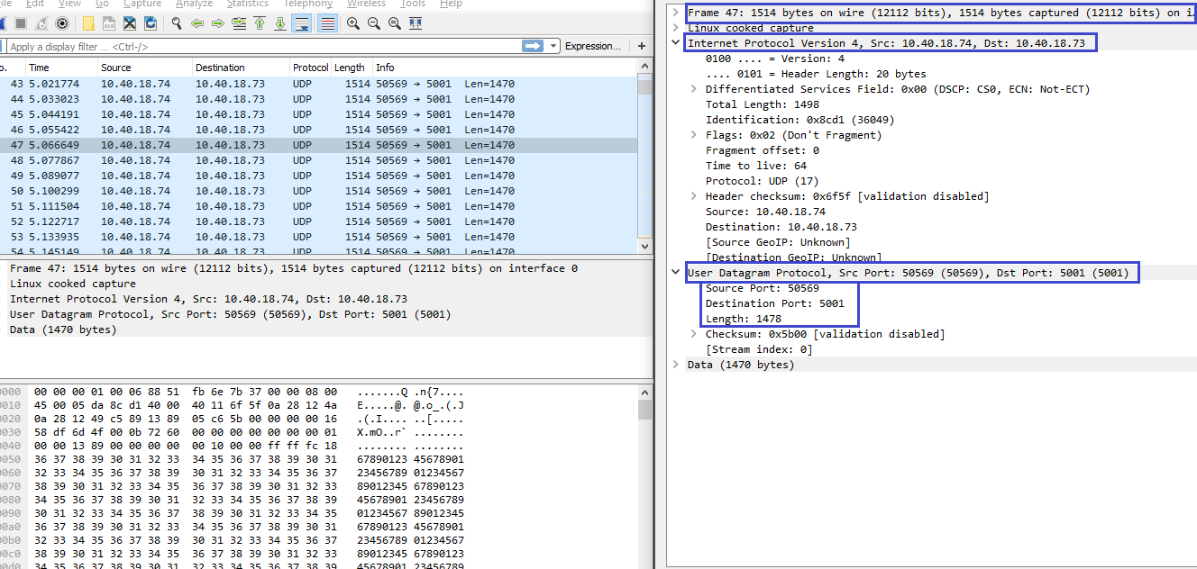

# TCP three way handshaking:

* Client = 10.40.18.73 & Server = 10.40.18.73
* [SYN] Packet
* Sequence number = 0 & Acknowledgement number = 0

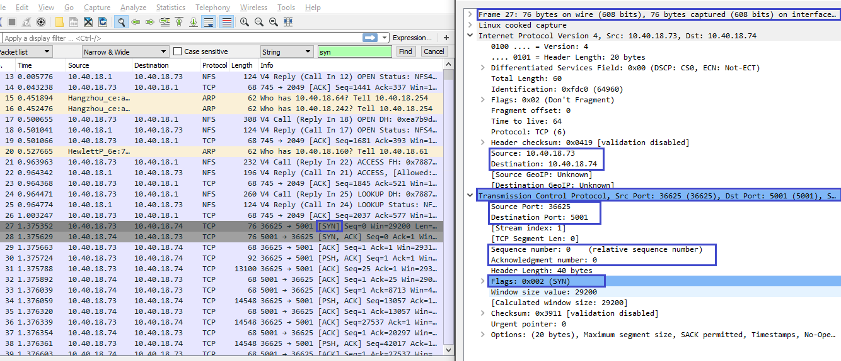

* [SYN ACK] Packet
* Sequence number = 0 & Acknowledgement number = 1

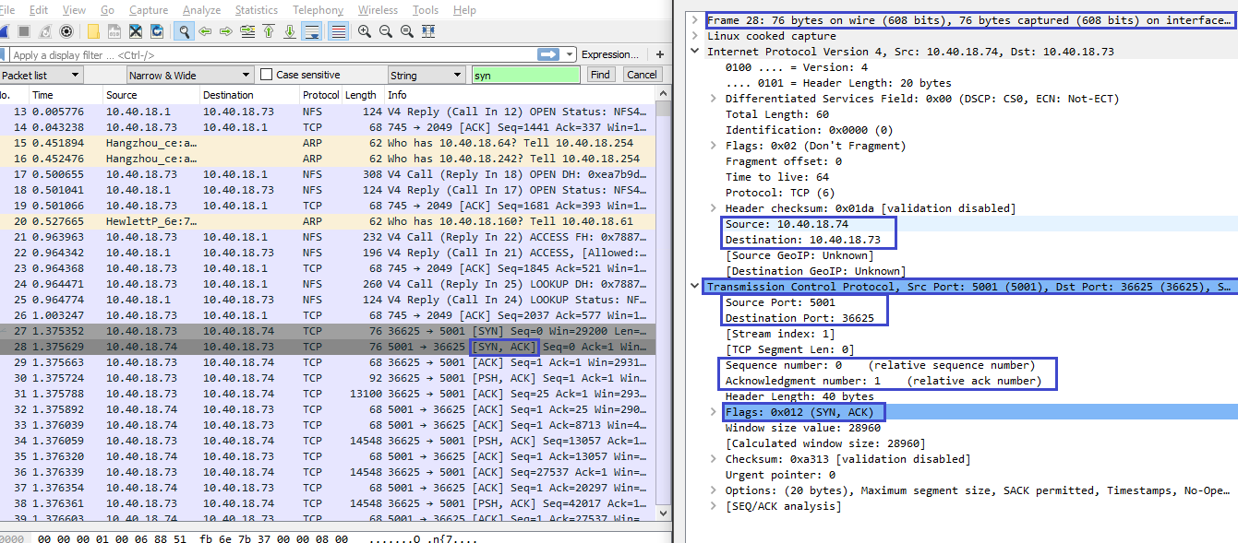

* [ACK] Packet
* Sequence number = 1 & Acknowledgement number = 1

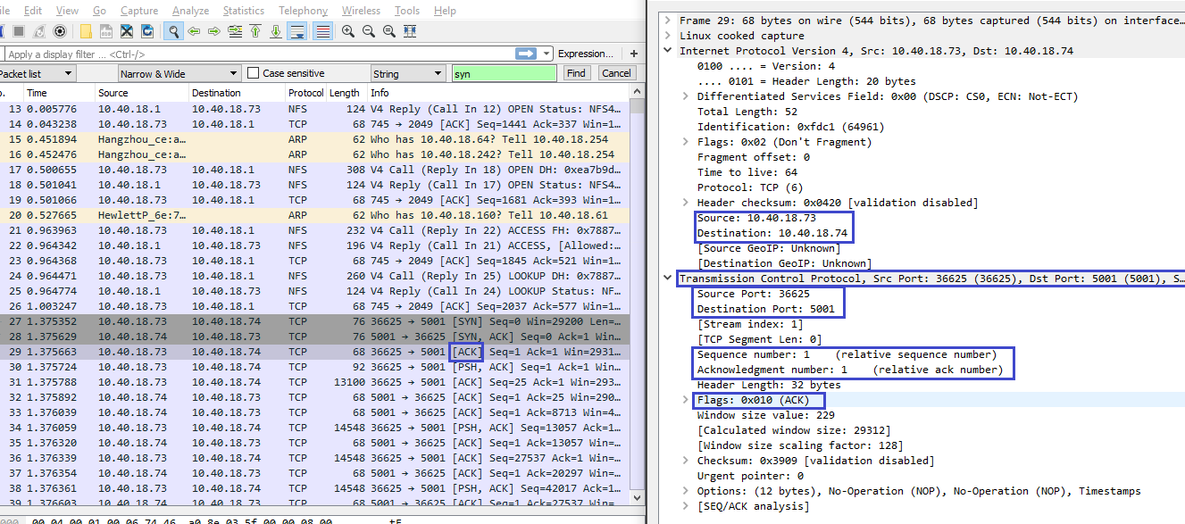

# TCP connection establishment delay:

* Time of first [SYN] packet = 1.375352
* Time of first [SYN ACK] packet = 1.375629
* Time of first [ACK] packet = 1.375663

Therefore TCP connection establishment delay = 1.375663 - 1.375352 = 0.000311

# Initial sequence numbers are shown as zero in each direction. Because normally initial sequence number is a random number. But a software like wireshark, set the first sequence number to 0. This is called relative sequence number.

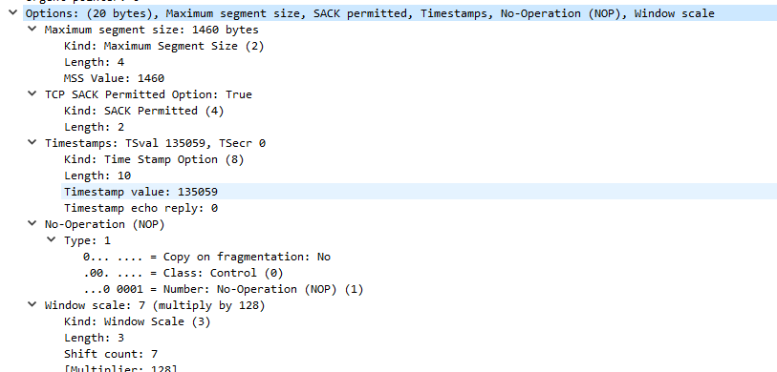

1. Maximum segment size
2. TCP SACK permitted option
3. Timestamps
4. Window scale

# TCP connection teardown message sequence

Server – 10.40.18.73 Client – 10.40.18.74

1. [FIN, PSH, ACK] Packet

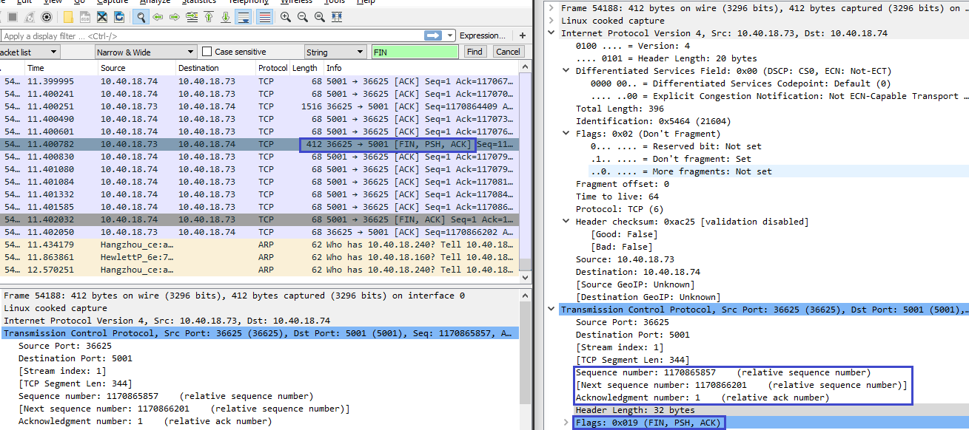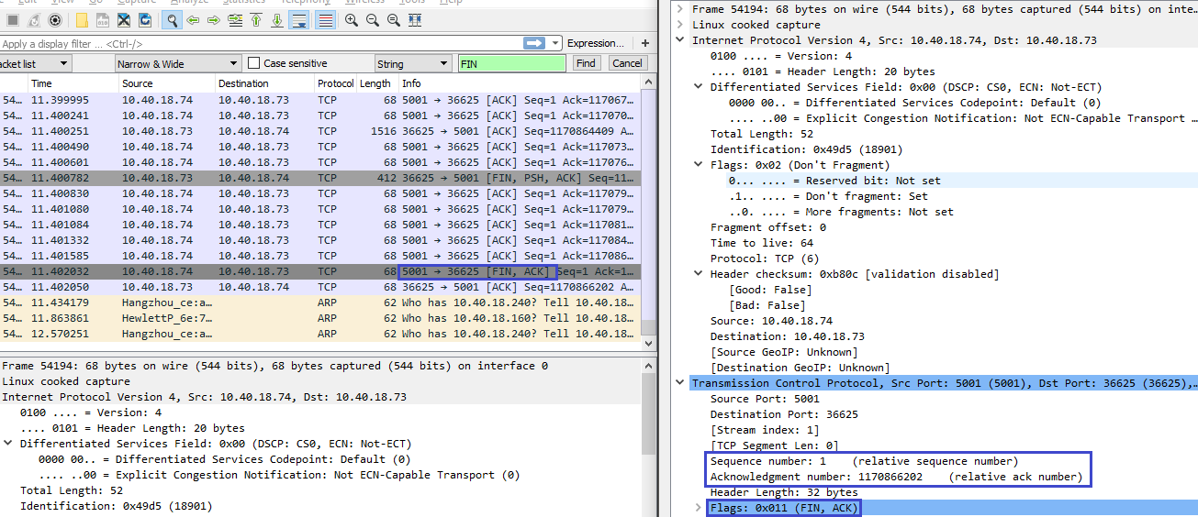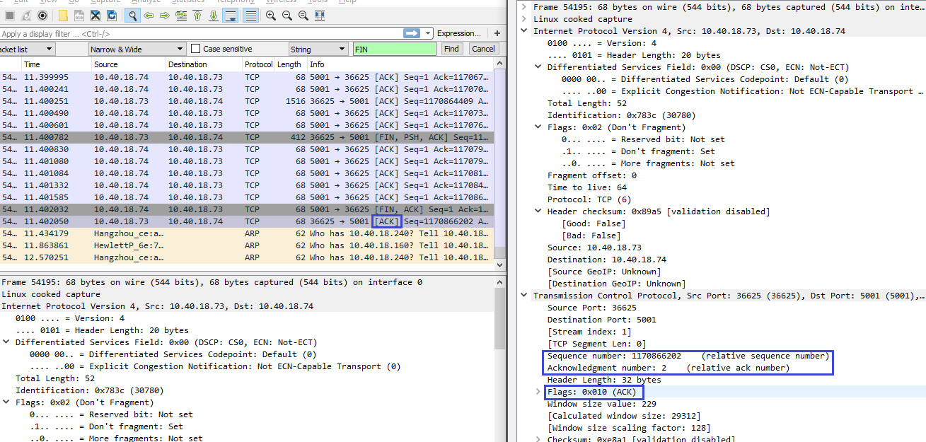

Between two FIN and FIN ACK packets, sent ACK another packets. Because those packets were lost previously.

# Traffic pattern for TCP

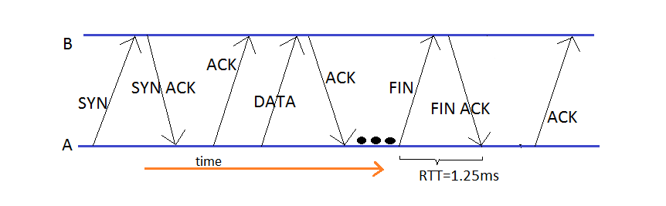

# Traffic pattern for UDP

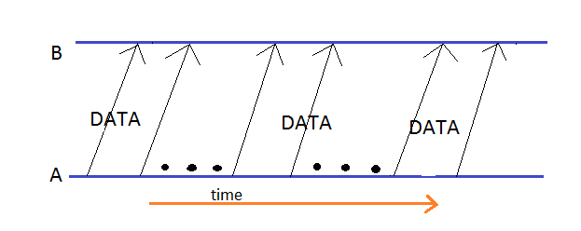

# Throughput is number of frames send per second.

Server = 10.40.18.73 Client – 10.40.18.74

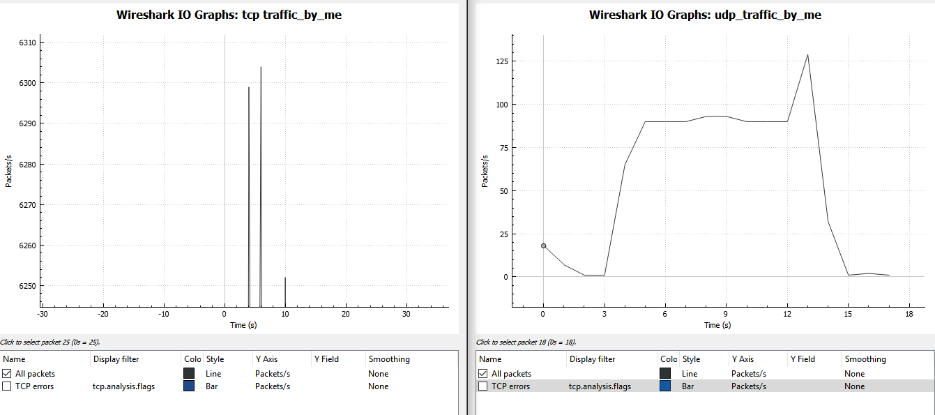

According to these two graphs and the data of iperf, throughput of the TCP connection gets a max value, but for small time. But UDP connection gets a low, but steady value for the throughput. But theoretically UDP is faster than TCP and the reason is ACK packet that permits a continuous packet stream, instead of TCP that acknowledges a set of packets.

# When changing the MTU, number of packets per second are changing.

Below graphs are showing the maximum packets per second when MTU is changing.

1. MTU = 500:

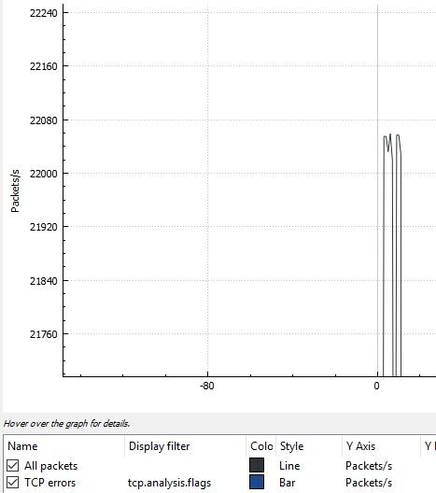

1. MTU = 1000:

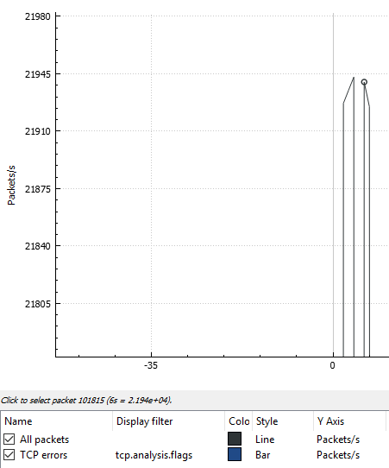

1. MTU = 1500:

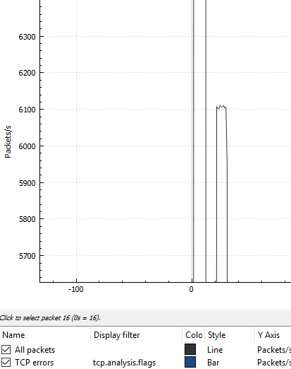

# When MTU size is getting bigger, packets/s is gets lower. When inspecting the traffic patterns in above graphs, the peaks of three graphs are different. For higher MTUs, gets more stable peak and lower MTUs gets unstable peaks. Therefore we can assume that when MTU is getting higher, it comes to a saturation.