E/13/377 | S.S.E vanderputt | April 27, 2017

Lab 03-Assignment 2

CO323



# Configure the static routing in the network shown below

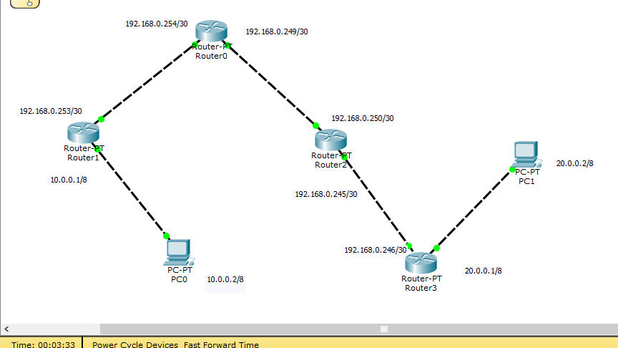

# Router 1

Codes: C - connected, S - static, I - IGRP, R - RIP, M - mobile, B - BGP

D - EIGRP, EX - EIGRP external, O - OSPF, IA - OSPF inter area

N1 - OSPF NSSA external type 1, N2 - OSPF NSSA external type 2

E1 - OSPF external type 1, E2 - OSPF external type 2, E - EGP

i - IS-IS, L1 - IS-IS level-1, L2 - IS-IS level-2, ia - IS-IS inter area

* - candidate default, U - per-user static route, o - ODR

P - periodic downloaded static route

Gateway of last resort is not set

C 10.0.0.0/8 is directly connected, FastEthernet0/0

S 20.0.0.0/8 [1/0] via 192.168.0.254

192.168.0.0/30 is subnetted, 1 subnets

C 192.168.0.252 is directly connected, FastEthernet1/0

# Router 2

S 10.0.0.0/8 [1/0] via 192.168.0.253

S 20.0.0.0/8 [1/0] via 192.168.0.250

192.168.0.0/30 is subnetted, 2 subnets

C 192.168.0.248 is directly connected, FastEthernet0/0

C 192.168.0.252 is directly connected, FastEthernet1/0

# Router 3

S 10.0.0.0/8 [1/0] via 192.168.0.249

S 20.0.0.0/8 [1/0] via 192.168.0.246

192.168.0.0/30 is subnetted, 2 subnets

C 192.168.0.244 is directly connected, FastEthernet1/0

C 192.168.0.248 is directly connected, FastEthernet0/0

# Router 4

S 10.0.0.0/8 [1/0] via 192.168.0.245

C 20.0.0.0/8 is directly connected, FastEthernet0/0

192.168.0.0/30 is subnetted, 1 subnets

C 192.168.0.244 is directly connected, FastEthernet1/0

# Configure the same network with Routing Information Protocol (RIP)

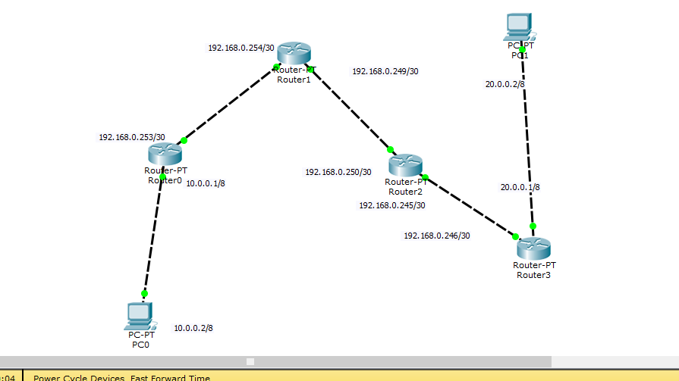

# Router 1

Codes: C - connected, S - static, I - IGRP, R - RIP, M - mobile, B - BGP

D - EIGRP, EX - EIGRP external, O - OSPF, IA - OSPF inter area

N1 - OSPF NSSA external type 1, N2 - OSPF NSSA external type 2

E1 - OSPF external type 1, E2 - OSPF external type 2, E - EGP

i - IS-IS, L1 - IS-IS level-1, L2 - IS-IS level-2, ia - IS-IS inter area

* - candidate default, U - per-user static route, o - ODR

P - periodic downloaded static route

Gateway of last resort is not set

C 10.0.0.0/8 is directly connected, FastEthernet0/0

R 20.0.0.0/8 [120/3] via 192.168.0.254, 00:00:16, FastEthernet1/0

192.168.0.0/30 is subnetted, 3 subnets

R 192.168.0.244 [120/2] via 192.168.0.254, 00:00:16, FastEthernet1/0

R 192.168.0.248 [120/1] via 192.168.0.254, 00:00:16, FastEthernet1/0

C 192.168.0.252 is directly connected, FastEthernet1/0

# Router 2

R 10.0.0.0/8 [120/1] via 192.168.0.253, 00:00:26, FastEthernet1/0

R 20.0.0.0/8 [120/2] via 192.168.0.250, 00:00:27, FastEthernet0/0

192.168.0.0/30 is subnetted, 3 subnets

R 192.168.0.244 [120/1] via 192.168.0.250, 00:00:27, FastEthernet0/0

C 192.168.0.248 is directly connected, FastEthernet0/0

C 192.168.0.252 is directly connected, FastEthernet1/0

# Router 3

R 10.0.0.0/8 [120/2] via 192.168.0.249, 00:00:11, FastEthernet0/0

R 20.0.0.0/8 [120/1] via 192.168.0.246, 00:00:15, FastEthernet1/0

192.168.0.0/30 is subnetted, 3 subnets

C 192.168.0.244 is directly connected, FastEthernet1/0

C 192.168.0.248 is directly connected, FastEthernet0/0

R 192.168.0.252 [120/1] via 192.168.0.249, 00:00:11, FastEthernet0/0

# Router 4

R 10.0.0.0/8 [120/3] via 192.168.0.245, 00:00:09, FastEthernet1/0

C 20.0.0.0/8 is directly connected, FastEthernet0/0

192.168.0.0/30 is subnetted, 3 subnets

C 192.168.0.244 is directly connected, FastEthernet1/0

R 192.168.0.248 [120/1] via 192.168.0.245, 00:00:09, FastEthernet1/0

R 192.168.0.252 [120/2] via 192.168.0.245, 00:00:09, FastEthernet1/0

Router#

# For the following network, submit the outputs of the following commands

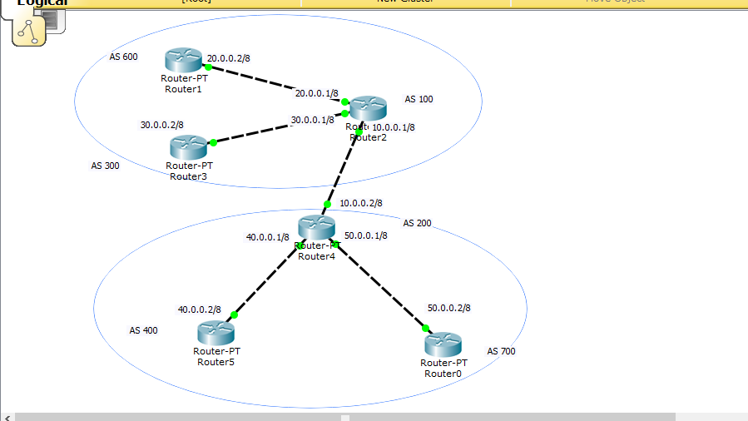

# 1. Router 1 (AS 600)

1. *Router#show ip bgp*

BGP table version is 7, local router ID is 20.0.0.2

Status codes: s suppressed, d damped, h history, * valid, > best, i - internal, r RIB-failure, S Stale

Origin codes: i - IGP, e - EGP, ? - incomplete

Network Next Hop Metric LocPrf Weight Path

*> 10.0.0.0/8 20.0.0.1 0 0 0 100 i

*> 20.0.0.0/8 0.0.0.0 0 0 32768 i

* 20.0.0.1 0 0 0 100 i

*> 30.0.0.0/8 20.0.0.1 0 0 0 100 i

*> 40.0.0.0/8 20.0.0.1 0 0 0 100 200 i

*> 50.0.0.0/8 20.0.0.1 0 0 0 100 200 i

1. *Router# show ip bgp summary*

BGP router identifier 20.0.0.2, local AS number 600

BGP table version is 7, main routing table version 6

6 network entries using 792 bytes of memory

6 path entries using 312 bytes of memory

5/4 BGP path/bestpath attribute entries using 828 bytes of memory

3 BGP AS-PATH entries using 72 bytes of memory

0 BGP route-map cache entries using 0 bytes of memory

0 BGP filter-list cache entries using 0 bytes of memory

Bitfield cache entries: current 1 (at peak 1) using 32 bytes of memory

BGP using 2036 total bytes of memory

BGP activity 5/0 prefixes, 6/0 paths, scan interval 60 secs

Neighbor V AS MsgRcvd MsgSent TblVer InQ OutQ Up/Down State/PfxRcd

20.0.0.1 4 100 21 11 7 0 0 00:09:09 4

1. *Show ip bgp neighbors*

BGP neighbor is 20.0.0.1, remote AS 100, external link

BGP version 4, remote router ID 30.0.0.1

BGP state = Established, up for 00:59:02

Last read 00:59:02, last write 00:59:02, hold time is 180, keepalive interval is 60 seconds

Neighbor capabilities:

Route refresh: advertised and received(new)

Address family IPv4 Unicast: advertised and received

Message statistics:

InQ depth is 0

OutQ depth is 0

Sent Rcvd

Opens: 1 1

Notifications: 0 0

Updates: 2 10

Keepalives: 60 60

Route Refresh: 0 5

Total: 63 76

Default minimum time between advertisements runs is 30 seconds

For address family: IPv4 Unicast

BGP table version 7, neighbor version 6/0

Output queue size : 0

Index 1, Offset 0, Mask 0x2

1 update-group member

Sent Rcvd

Prefix activity: ---- ----

Prefixes Current: 2 5 (Consumes 161 bytes)

Prefixes total: 2 5

Implicit Withdraw: 0 0

Explicit Withdraw: 0 0

Used as bestpath: n/a 1

Used as multipath: n/a 0

Outbound Inbound

Local Policy Denied Prefixes: -------- -------

Total: 0 0

Number of NLRIs in the update sent: max 3, min 1

Address tracking is enabled, the RIB does have a route to 20.0.0.1

Connections established 1; dropped 0

Last reset never

Transport(tcp) path-mtu-discovery is enabled

Connection state is ESTAB, I/O status: 1, unread input bytes: 0

Connection is ECN Disabled, Minimum incoming TTL 0, Outgoing TTL 1

Local host: 20.0.0.2, Local port: 1025

Foreign host: 20.0.0.1, Foreign port: 179

Connection tableid (VRF): 0

Enqueued packets for retransmit: 0, input: 0 mis-ordered: 0 (0 bytes)

Event Timers (current time is 0xC69F4):

Timer Starts Wakeups Next

Retrans 0 0 0x0

TimeWait 0 0 0x0

AckHold 70 0 0x0

SendWnd 0 0 0x0

KeepAlive 60 0 0x0

GiveUp 0 0 0x0

PmtuAger 0 0 0x0

DeadWait 0 0 0x0

Linger 0 0 0x0

ProcessQ 0 0 0x0

iss: 2057115318 snduna: 2057115748 sndnxt: 2057115748 sndwnd: 15955

irs: 3480424370 rcvnxt: 3480424751 rcvwnd: 16004 delrcvwnd: 380

SRTT: 259 ms, RTTO: 579 ms, RTV: 320 ms, KRTT: 0 ms

minRTT: 16 ms, maxRTT: 300 ms, ACK hold: 200 ms

Status Flags: passive open, gen tcbs

Option Flags: nagle, path mtu capable

IP Precedence value : 6

Datagrams (max data segment is 1460 bytes):

Rcvd: 71 (out of order: 0), with data: 5, total data bytes: 120

Sent: 61 (retransmit: 0, fastretransmit: 0, partialack: 0, Second Congestion: 0), with data: 2, total data bytes: 48

Packets received in fast path: 0, fast processed: 0, slow path: 0

fast lock acquisition failures: 0, slow path: 0

# 2. Router 2 (AS 100)

1. *Show ip bgp*

BGP table version is 9, local router ID is 30.0.0.1

Status codes: s suppressed, d damped, h history, * valid, > best, i - internal,r RIB-failure, S Stale

Origin codes: i - IGP, e - EGP, ? - incomplete

Network Next Hop Metric LocPrf Weight Path

*> 10.0.0.0/8 0.0.0.0 0 0 32768 i

* 10.0.0.2 0 0 0 200 i

*> 20.0.0.0/8 0.0.0.0 0 0 32768 i

* 20.0.0.2 0 0 0 600 i

*> 30.0.0.0/8 0.0.0.0 0 0 32768 i

* 30.0.0.2 0 0 0 300 i

*> 40.0.0.0/8 10.0.0.2 0 0 0 200 i

*> 50.0.0.0/8 10.0.0.2 0 0 0 200 i

1. *Show ip bgp summery*

BGP router identifier 30.0.0.1, local AS number 100

BGP table version is 9, main routing table version 6

8 network entries using 1056 bytes of memory

8 path entries using 416 bytes of memory

5/2 BGP path/bestpath attribute entries using 644 bytes of memory

4 BGP AS-PATH entries using 96 bytes of memory

0 BGP route-map cache entries using 0 bytes of memory

0 BGP filter-list cache entries using 0 bytes of memory

Bitfield cache entries: current 1 (at peak 1) using 32 bytes of memory

BGP using 2244 total bytes of memory

BGP activity 5/0 prefixes, 8/0 paths, scan interval 60 secs

Neighbor V AS MsgRcvd MsgSent TblVer InQ OutQ Up/Down State/PfxRcd

20.0.0.2 4 600 15 13 9 0 0 00:11:57 4

30.0.0.2 4 300 15 13 9 0 0 00:11:56 4

10.0.0.2 4 200 20 13 9 0 0 00:11:57 4

1. *Show ip bgp neighbors*

BGP neighbor is 20.0.0.2, remote AS 600, external link

BGP version 4, remote router ID 20.0.0.2

BGP state = Established, up for 01:03:01

Last read 01:03:01, last write 01:03:01, hold time is 180, keepalive interval is 60 seconds

Neighbor capabilities:

Route refresh: advertised and received(new)

Address family IPv4 Unicast: advertised and received

Message statistics:

InQ depth is 0

OutQ depth is 0

Sent Rcvd

Opens: 1 1

Notifications: 0 0

Updates: 12 2

Keepalives: 64 64

Route Refresh: 0 1

Total: 77 68

Default minimum time between advertisements runs is 30 seconds

For address family: IPv4 Unicast

BGP table version 11, neighbor version 6/0

Output queue size : 0

Index 1, Offset 0, Mask 0x2

1 update-group member

Sent Rcvd

Prefix activity: ---- ----

Prefixes Current: 8 1 (Consumes 207 bytes)

Prefixes total: 8 1

Implicit Withdraw: 0 0

Explicit Withdraw: 0 0

Used as bestpath: n/a 1

Used as multipath: n/a 0

Outbound Inbound

Local Policy Denied Prefixes: -------- -------

Total: 0 0

Number of NLRIs in the update sent: max 3, min 1

Address tracking is enabled, the RIB does have a route to 20.0.0.2

Connections established 1; dropped 0

Last reset never

Transport(tcp) path-mtu-discovery is enabled

Connection state is ESTAB, I/O status: 1, unread input bytes: 0

Connection is ECN Disabled, Minimum incoming TTL 0, Outgoing TTL 1

Local host: 20.0.0.1, Local port: 179

Foreign host: 20.0.0.2, Foreign port: 1025

Connection tableid (VRF): 0

Enqueued packets for retransmit: 0, input: 0 mis-ordered: 0 (0 bytes)

Event Timers (current time is 0xC69F4):

Timer Starts Wakeups Next

Retrans 0 0 0x0

TimeWait 0 0 0x0

AckHold 66 0 0x0

SendWnd 0 0 0x0

KeepAlive 64 0 0x0

GiveUp 0 0 0x0

PmtuAger 0 0 0x0

DeadWait 0 0 0x0

Linger 0 0 0x0

ProcessQ 0 0 0x0

iss: 2057115318 snduna: 2057115748 sndnxt: 2057115748 sndwnd: 15955

irs: 3480424370 rcvnxt: 3480424751 rcvwnd: 16004 delrcvwnd: 380

SRTT: 259 ms, RTTO: 579 ms, RTV: 320 ms, KRTT: 0 ms

minRTT: 16 ms, maxRTT: 300 ms, ACK hold: 200 ms

Status Flags: passive open, gen tcbs

Option Flags: nagle, path mtu capable

IP Precedence value : 6

Datagrams (max data segment is 1460 bytes):

Rcvd: 67 (out of order: 0), with data: 1, total data bytes: 24

Sent: 65 (retransmit: 0, fastretransmit: 0, partialack: 0, Second Congestion: 0), with data: 16, total data bytes: 384

Packets received in fast path: 0, fast processed: 0, slow path: 0

fast lock acquisition failures: 0, slow path: 0

BGP neighbor is 30.0.0.2, remote AS 300, external link

BGP version 4, remote router ID 30.0.0.2

BGP state = Established, up for 00:00:00

Last read 00:00:00, last write 00:00:00, hold time is 180, keepalive interval is 60 seconds

Neighbor capabilities:

Route refresh: advertised and received(new)

Address family IPv4 Unicast: advertised and received

Message statistics:

InQ depth is 0

OutQ depth is 0

Sent Rcvd

Opens: 2 2

Notifications: 0 1

Updates: 7 3

Keepalives: 64 63

Route Refresh: 0 1

Total: 73 70

Default minimum time between advertisements runs is 30 seconds

For address family: IPv4 Unicast

BGP table version 11, neighbor version 6/0

Output queue size : 0

Index 1, Offset 0, Mask 0x2

1 update-group member

Sent Rcvd

Prefix activity: ---- ----

Prefixes Current: 0 1 (Consumes 23 bytes)

Prefixes total: 0 1

Implicit Withdraw: 0 0

Explicit Withdraw: 0 0

Used as bestpath: n/a 1

Used as multipath: n/a 0

Outbound Inbound

Local Policy Denied Prefixes: -------- -------

Total: 0 0

Number of NLRIs in the update sent: max 3, min 1

Address tracking is enabled, the RIB does have a route to 30.0.0.2

Connections established 2; dropped 1

Last reset never

Transport(tcp) path-mtu-discovery is enabled

Connection state is ESTAB, I/O status: 1, unread input bytes: 0

Connection is ECN Disabled, Minimum incoming TTL 0, Outgoing TTL 1

Local host: 30.0.0.1, Local port: 1028

Foreign host: 30.0.0.2, Foreign port: 179

Connection tableid (VRF): 0

Enqueued packets for retransmit: 0, input: 0 mis-ordered: 0 (0 bytes)

Event Timers (current time is 0xC69F4):

Timer Starts Wakeups Next

Retrans 0 0 0x0

TimeWait 0 0 0x0

AckHold 66 0 0x0

SendWnd 0 0 0x0

KeepAlive 64 0 0x0

GiveUp 0 0 0x0

PmtuAger 0 0 0x0

DeadWait 0 0 0x0

Linger 0 0 0x0

ProcessQ 0 0 0x0

iss: 2057115318 snduna: 2057115748 sndnxt: 2057115748 sndwnd: 15955

irs: 3480424370 rcvnxt: 3480424751 rcvwnd: 16004 delrcvwnd: 380

SRTT: 259 ms, RTTO: 579 ms, RTV: 320 ms, KRTT: 0 ms

minRTT: 16 ms, maxRTT: 300 ms, ACK hold: 200 ms

Status Flags: passive open, gen tcbs

Option Flags: nagle, path mtu capable

IP Precedence value : 6

Datagrams (max data segment is 1460 bytes):

Rcvd: 69 (out of order: 0), with data: 1, total data bytes: 24

Sent: 66 (retransmit: 0, fastretransmit: 0, partialack: 0, Second Congestion: 0), with data: 8, total data bytes: 192

Packets received in fast path: 0, fast processed: 0, slow path: 0

fast lock acquisition failures: 0, slow path: 0

BGP neighbor is 10.0.0.2, remote AS 200, external link

BGP version 4, remote router ID 50.0.0.1

BGP state = Established, up for 01:03:01

Last read 01:03:01, last write 01:03:01, hold time is 180, keepalive interval is 60 seconds

Neighbor capabilities:

Route refresh: advertised and received(new)

Address family IPv4 Unicast: advertised and received

Message statistics:

InQ depth is 0

OutQ depth is 0

Sent Rcvd

Opens: 1 1

Notifications: 0 0

Updates: 9 11

Keepalives: 64 64

Route Refresh: 0 4

Total: 74 80

Default minimum time between advertisements runs is 30 seconds

For address family: IPv4 Unicast

BGP table version 11, neighbor version 6/0

Output queue size : 0

Index 1, Offset 0, Mask 0x2

1 update-group member

Sent Rcvd

Prefix activity: ---- ----

Prefixes Current: 6 3 (Consumes 207 bytes)

Prefixes total: 6 3

Implicit Withdraw: 0 0

Explicit Withdraw: 0 0

Used as bestpath: n/a 1

Used as multipath: n/a 0

Outbound Inbound

Local Policy Denied Prefixes: -------- -------

Total: 0 0

Number of NLRIs in the update sent: max 3, min 1

Address tracking is enabled, the RIB does have a route to 10.0.0.2

Connections established 1; dropped 0

Last reset never

Transport(tcp) path-mtu-discovery is enabled

Connection state is ESTAB, I/O status: 1, unread input bytes: 0

Connection is ECN Disabled, Minimum incoming TTL 0, Outgoing TTL 1

Local host: 10.0.0.1, Local port: 179

Foreign host: 10.0.0.2, Foreign port: 1026

Connection tableid (VRF): 0

Enqueued packets for retransmit: 0, input: 0 mis-ordered: 0 (0 bytes)

Event Timers (current time is 0xC69F4):

Timer Starts Wakeups Next

Retrans 0 0 0x0

TimeWait 0 0 0x0

AckHold 75 0 0x0

SendWnd 0 0 0x0

KeepAlive 64 0 0x0

GiveUp 0 0 0x0

PmtuAger 0 0 0x0

DeadWait 0 0 0x0

Linger 0 0 0x0

ProcessQ 0 0 0x0

iss: 2057115318 snduna: 2057115748 sndnxt: 2057115748 sndwnd: 15955

irs: 3480424370 rcvnxt: 3480424751 rcvwnd: 16004 delrcvwnd: 380

SRTT: 259 ms, RTTO: 579 ms, RTV: 320 ms, KRTT: 0 ms

minRTT: 16 ms, maxRTT: 300 ms, ACK hold: 200 ms

Status Flags: passive open, gen tcbs

Option Flags: nagle, path mtu capable

IP Precedence value : 6

Datagrams (max data segment is 1460 bytes):

Rcvd: 76 (out of order: 0), with data: 5, total data bytes: 120

Sent: 65 (retransmit: 0, fastretransmit: 0, partialack: 0, Second Congestion: 0), with data: 12, total data bytes: 288

Packets received in fast path: 0, fast processed: 0, slow path: 0

fast lock acquisition failures: 0, slow path: 0

# 3.Router (AS 300)

1. *Show ip bgp*

BGP table version is 7, local router ID is 30.0.0.2

Status codes: s suppressed, d damped, h history, * valid, > best, i - internal, r RIB-failure, S Stale

Origin codes: i - IGP, e - EGP, ? - incomplete

Network Next Hop Metric LocPrf Weight Path

*> 10.0.0.0/8 30.0.0.1 0 0 0 100 i

*> 20.0.0.0/8 30.0.0.1 0 0 0 100 i

*> 30.0.0.0/8 0.0.0.0 0 0 32768 i

* 30.0.0.1 0 0 0 100 i

*> 40.0.0.0/8 30.0.0.1 0 0 0 100 200 i

*> 50.0.0.0/8 30.0.0.1 0 0 0 100 200 i

1. *Show ip bgp summery*

BGP router identifier 30.0.0.2, local AS number 300

BGP table version is 7, main routing table version 6

6 network entries using 792 bytes of memory

6 path entries using 312 bytes of memory

5/4 BGP path/bestpath attribute entries using 828 bytes of memory

3 BGP AS-PATH entries using 72 bytes of memory

0 BGP route-map cache entries using 0 bytes of memory

0 BGP filter-list cache entries using 0 bytes of memory

Bitfield cache entries: current 1 (at peak 1) using 32 bytes of memory

BGP using 2036 total bytes of memory

BGP activity 5/0 prefixes, 6/0 paths, scan interval 60 secs

Neighbor V AS MsgRcvd MsgSent TblVer InQ OutQ Up/Down State/PfxRcd

30.0.0.1 4 100 21 14 7 0 0 00:12:39 4

1. *Show ip bgp neighbors*

BGP neighbor is 30.0.0.1, remote AS 100, external link

BGP version 4, remote router ID 30.0.0.1

BGP state = Established, up for 00:02:31

Last read 00:02:31, last write 00:02:31, hold time is 180, keepalive interval is 60 seconds

Neighbor capabilities:

Route refresh: advertised and received(new)

Address family IPv4 Unicast: advertised and received

Message statistics:

InQ depth is 0

OutQ depth is 0

Sent Rcvd

Opens: 2 2

Notifications: 1 0

Updates: 3 14

Keepalives: 65 63

Route Refresh: 0 4

Total: 71 83

Default minimum time between advertisements runs is 30 seconds

For address family: IPv4 Unicast

BGP table version 12, neighbor version 6/0

Output queue size : 0

Index 1, Offset 0, Mask 0x2

1 update-group member

Sent Rcvd

Prefix activeity: ---- ----

Prefixes Current: 1 5 (Consumes 138 bytes)

Prefixes total: 1 5

Implicit Withdraw: 0 0

Explicit Withdraw: 0 0

Used as bestpath: n/a 1

Used as multipath: n/a 0

Outbound Inbound

Local Policy Denied Prefixes: -------- -------

Total: 0 0

Number of NLRIs in the update sent: max 3, min 1

Address tracking is enabled, the RIB does have a route to 30.0.0.1

Connections established 2; dropped 0

Last reset never

Transport(tcp) path-mtu-discovery is enabled

Connection state is ESTAB, I/O status: 1, unread input bytes: 0

Connection is ECN Disabled, Minimum incoming TTL 0, Outgoing TTL 1

Local host: 30.0.0.2, Local port: 179

Foreign host: 30.0.0.1, Foreign port: 1028

Connection tableid (VRF): 0

Enqueued packets for retransmit: 0, input: 0 mis-ordered: 0 (0 bytes)

Event Timers (current time is 0xC69F4):

Timer Starts Wakeups Next

Retrans 0 0 0x0

TimeWait 0 0 0x0

AckHold 77 0 0x0

SendWnd 0 0 0x0

KeepAlive 65 0 0x0

GiveUp 0 0 0x0

PmtuAger 0 0 0x0

DeadWait 0 0 0x0

Linger 0 0 0x0

ProcessQ 0 0 0x0

iss: 2057115318 snduna: 2057115748 sndnxt: 2057115748 sndwnd: 15955

irs: 3480424370 rcvnxt: 3480424751 rcvwnd: 16004 delrcvwnd: 380

SRTT: 259 ms, RTTO: 579 ms, RTV: 320 ms, KRTT: 0 ms

minRTT: 16 ms, maxRTT: 300 ms, ACK hold: 200 ms

Status Flags: passive open, gen tcbs

Option Flags: nagle, path mtu capable

IP Precedence value : 6

Datagrams (max data segment is 1460 bytes):

Rcvd: 79 (out of order: 0), with data: 4, total data bytes: 96

Sent: 68 (retransmit: 0, fastretransmit: 0, partialack: 0, Second Congestion: 0), with data: 3, total data bytes: 72

Packets received in fast path: 0, fast processed: 0, slow path: 0

fast lock acquisition failures: 0, slow path: 0

# 4.Router (AS 200)

1. *Show ip bgp*

BGP table version is 9, local router ID is 50.0.0.1

Status codes: s suppressed, d damped, h history, * valid, > best, i - internal,r RIB-failure, S Stale

Origin codes: i - IGP, e - EGP, ? - incomplete

Network Next Hop Metric LocPrf Weight Path

*> 10.0.0.0/8 0.0.0.0 0 0 32768 i

* 10.0.0.1 0 0 0 100 i

*> 20.0.0.0/8 10.0.0.1 0 0 0 100 i

*> 30.0.0.0/8 10.0.0.1 0 0 0 100 i

*> 40.0.0.0/8 0.0.0.0 0 0 32768 i

* 40.0.0.2 0 0 0 400 i

*> 50.0.0.0/8 0.0.0.0 0 0 32768 i

* 50.0.0.2 0 0 0 700 i

1. *Show ip bgp summery*

BGP router identifier 50.0.0.1, local AS number 200

BGP table version is 9, main routing table version 6

8 network entries using 1056 bytes of memory

8 path entries using 416 bytes of memory

5/2 BGP path/bestpath attribute entries using 644 bytes of memory

4 BGP AS-PATH entries using 96 bytes of memory

0 BGP route-map cache entries using 0 bytes of memory

0 BGP filter-list cache entries using 0 bytes of memory

Bitfield cache entries: current 1 (at peak 1) using 32 bytes of memory

BGP using 2244 total bytes of memory

BGP activity 5/0 prefixes, 8/0 paths, scan interval 60 secs

Neighbor V AS MsgRcvd MsgSent TblVer InQ OutQ Up/Down State/PfxRcd

40.0.0.2 4 400 17 15 9 0 0 00:13:20 4

10.0.0.1 4 100 23 15 9 0 0 00:13:20 4

* + - 1. 4 700 17 15 9 0 0 00:13:19 4

1. *Show ip bgp neighbors*

BGP neighbor is 40.0.0.2, remote AS 400, external link

BGP version 4, remote router ID 40.0.0.2

BGP state = Established, up for 01:06:05

Last read 01:06:05, last write 01:06:05, hold time is 180, keepalive interval is 60 seconds

Neighbor capabilities:

Route refresh: advertised and received(new)

Address family IPv4 Unicast: advertised and received

Message statistics:

InQ depth is 0

OutQ depth is 0

Sent Rcvd

Opens: 1 1

Notifications: 0 0

Updates: 12 2

Keepalives: 67 67

Route Refresh: 0 1

Total: 80 71

Default minimum time between advertisements runs is 30 seconds

For address family: IPv4 Unicast

BGP table version 12, neighbor version 6/0

Output queue size : 0

Index 1, Offset 0, Mask 0x2

1 update-group member

Sent Rcvd

Prefix activity: ---- ----

Prefixes Current: 8 1 (Consumes 207 bytes)

Prefixes total: 8 1

Implicit Withdraw: 0 0

Explicit Withdraw: 0 0

Used as bestpath: n/a 1

Used as multipath: n/a 0

Outbound Inbound

Local Policy Denied Prefixes: -------- -------

Total: 0 0

Number of NLRIs in the update sent: max 3, min 1

--More—

# 5.Router 5 (AS 400)

1. Show ip bgp

BGP table version is 7, local router ID is 40.0.0.2

Status codes: s suppressed, d damped, h history, * valid, > best, i - internal,

r RIB-failure, S Stale

Origin codes: i - IGP, e - EGP, ? - incomplete

Network Next Hop Metric LocPrf Weight Path

*> 10.0.0.0/8 40.0.0.1 0 0 0 200 i

*> 20.0.0.0/8 40.0.0.1 0 0 0 200 100 i

*> 30.0.0.0/8 40.0.0.1 0 0 0 200 100 i

*> 40.0.0.0/8 0.0.0.0 0 0 32768 i

* 40.0.0.1 0 0 0 200 i

*> 50.0.0.0/8 40.0.0.1 0 0 0 200 i

1. Show ip bgp summery

BGP router identifier 40.0.0.2, local AS number 400

BGP table version is 7, main routing table version 6

6 network entries using 792 bytes of memory

6 path entries using 312 bytes of memory

5/4 BGP path/bestpath attribute entries using 828 bytes of memory

3 BGP AS-PATH entries using 72 bytes of memory

0 BGP route-map cache entries using 0 bytes of memory

0 BGP filter-list cache entries using 0 bytes of memory

Bitfield cache entries: current 1 (at peak 1) using 32 bytes of memory

BGP using 2036 total bytes of memory

BGP activity 5/0 prefixes, 6/0 paths, scan interval 60 secs

Neighbor V AS MsgRcvd MsgSent TblVer InQ OutQ Up/Down State/PfxRcd

40.0.0.1 4 200 25 16 7 0 0 00:14:03 4

1. Show ip bgp neighbors

BGP neighbor is 40.0.0.1, remote AS 200, external link

BGP version 4, remote router ID 50.0.0.1

BGP state = Established, up for 01:08:12

Last read 01:08:12, last write 01:08:12, hold time is 180, keepalive interval is 60 seconds

Neighbor capabilities:

Route refresh: advertised and received(new)

Address family IPv4 Unicast: advertised and received

Message statistics:

InQ depth is 0

OutQ depth is 0

Sent Rcvd

Opens: 1 1

Notifications: 0 0

Updates: 2 16

Keepalives: 69 69

Route Refresh: 0 5

Total: 72 91

Default minimum time between advertisements runs is 30 seconds

For address family: IPv4 Unicast

BGP table version 9, neighbor version 6/0

Output queue size : 0

Index 1, Offset 0, Mask 0x2

1 update-group member

Sent Rcvd

Prefix activity: ---- ----

Prefixes Current: 2 5 (Consumes 161 bytes)

Prefixes total: 2 5

Implicit Withdraw: 0 0

Explicit Withdraw: 0 0

Used as bestpath: n/a 1

Used as multipath: n/a 0

Outbound Inbound

Local Policy Denied Prefixes: -------- -------

Total: 0 0

Number of NLRIs in the update sent: max 3, min 1

Address tracking is enabled, the RIB does have a route to 40.0.0.1

Connections established 1; dropped 0

Last reset never

Transport(tcp) path-mtu-discovery is enabled

Connection state is ESTAB, I/O status: 1, unread input bytes: 0

Connection is ECN Disabled, Minimum incoming TTL 0, Outgoing TTL 1

Local host: 40.0.0.2, Local port: 1025

Foreign host: 40.0.0.1, Foreign port: 179

Connection tableid (VRF): 0

Enqueued packets for retransmit: 0, input: 0 mis-ordered: 0 (0 bytes)

Event Timers (current time is 0xC69F4):

Timer Starts Wakeups Next

Retrans 0 0 0x0

TimeWait 0 0 0x0

AckHold 85 0 0x0

SendWnd 0 0 0x0

KeepAlive 69 0 0x0

GiveUp 0 0 0x0

PmtuAger 0 0 0x0

DeadWait 0 0 0x0

Linger 0 0 0x0

ProcessQ 0 0 0x0

iss: 2057115318 snduna: 2057115748 sndnxt: 2057115748 sndwnd: 15955

irs: 3480424370 rcvnxt: 3480424751 rcvwnd: 16004 delrcvwnd: 380

SRTT: 259 ms, RTTO: 579 ms, RTV: 320 ms, KRTT: 0 ms

minRTT: 16 ms, maxRTT: 300 ms, ACK hold: 200 ms

Status Flags: passive open, gen tcbs

Option Flags: nagle, path mtu capable

IP Precedence value : 6

Datagrams (max data segment is 1460 bytes):

Rcvd: 86 (out of order: 0), with data: 7, total data bytes: 168

Sent: 70 (retransmit: 0, fastretransmit: 0, partialack: 0, Second Congestion: 0), with data: 2, total data bytes: 48

Packets received in fast path: 0, fast processed: 0, slow path: 0

fast lock acquisition failures: 0, slow path: 0

# 6. Router 6 (AS 700)

1. Show ip bgp
2. BGP table version is 7, local router ID is 50.0.0.2

Status codes: s suppressed, d damped, h history, * valid, > best, i - internal,

r RIB-failure, S Stale

Origin codes: i - IGP, e - EGP, ? - incomplete

Network Next Hop Metric LocPrf Weight Path

*> 10.0.0.0/8 50.0.0.1 0 0 0 200 i

*> 20.0.0.0/8 50.0.0.1 0 0 0 200 100 i

*> 30.0.0.0/8 50.0.0.1 0 0 0 200 100 i

*> 40.0.0.0/8 50.0.0.1 0 0 0 200 i

*> 50.0.0.0/8 0.0.0.0 0 0 32768 i

* 50.0.0.1 0 0 0 200 i

1. Show ip bgp summery

BGP router identifier 50.0.0.2, local AS number 700

BGP table version is 7, main routing table version 6

6 network entries using 792 bytes of memory

6 path entries using 312 bytes of memory

5/4 BGP path/bestpath attribute entries using 828 bytes of memory

3 BGP AS-PATH entries using 72 bytes of memory

0 BGP route-map cache entries using 0 bytes of memory

0 BGP filter-list cache entries using 0 bytes of memory

Bitfield cache entries: current 1 (at peak 1) using 32 bytes of memory

BGP using 2036 total bytes of memory

BGP activity 5/0 prefixes, 6/0 paths, scan interval 60 secs

Neighbor V A S MsgRcvd MsgSent TblVer InQ OutQ Up/Down State/PfxRcd

* + - 1. 4 200 23 16 7 0 0 00:14:45 4

1. Show ip bgp neighbors

BGP neighbor is 50.0.0.1, remote AS 200, external link

BGP version 4, remote router ID 50.0.0.1

BGP state = Established, up for 00:04:13

Last read 00:04:13, last write 00:04:13, hold time is 180, keepalive interval is 60 seconds

Neighbor capabilities:

Route refresh: advertised and received(new)

Address family IPv4 Unicast: advertised and received

Message statistics:

InQ depth is 0

OutQ depth is 0

Sent Rcvd

Opens: 2 2

Notifications: 1 0

Updates: 3 14

Keepalives: 67 65

Route Refresh: 0 4

Total: 73 85

Default minimum time between advertisements runs is 30 seconds

For address family: IPv4 Unicast

BGP table version 12, neighbor version 6/0

Output queue size : 0

Index 1, Offset 0, Mask 0x2

1 update-group member

Sent Rcvd

Prefix activity: ---- ----

Prefixes Current: 1 5 (Consumes 138 bytes)

Prefixes total: 1 5

Implicit Withdraw: 0 0

Explicit Withdraw: 0 0

Used as bestpath: n/a 1

Used as multipath: n/a 0

Outbound Inbound

Local Policy Denied Prefixes: -------- -------

Total: 0 0

Number of NLRIs in the update sent: max 3, min 1

Address tracking is enabled, the RIB does have a route to 50.0.0.1

Connections established 2; dropped 0

Last reset never

Transport(tcp) path-mtu-discovery is enabled

Connection state is ESTAB, I/O status: 1, unread input bytes: 0

Connection is ECN Disabled, Minimum incoming TTL 0, Outgoing TTL 1

Local host: 50.0.0.2, Local port: 179

Foreign host: 50.0.0.1, Foreign port: 1028

Connection tableid (VRF): 0

Enqueued packets for retransmit: 0, input: 0 mis-ordered: 0 (0 bytes)

Event Timers (current time is 0xC69F4):

Timer Starts Wakeups Next

Retrans 0 0 0x0

TimeWait 0 0 0x0

AckHold 79 0 0x0

SendWnd 0 0 0x0

KeepAlive 67 0 0x0

GiveUp 0 0 0x0

PmtuAger 0 0 0x0

DeadWait 0 0 0x0

Linger 0 0 0x0

ProcessQ 0 0 0x0

iss: 2057115318 snduna: 2057115748 sndnxt: 2057115748 sndwnd: 15955

irs: 3480424370 rcvnxt: 3480424751 rcvwnd: 16004 delrcvwnd: 380

SRTT: 259 ms, RTTO: 579 ms, RTV: 320 ms, KRTT: 0 ms

minRTT: 16 ms, maxRTT: 300 ms, ACK hold: 200 ms

Status Flags: passive open, gen tcbs

Option Flags: nagle, path mtu capable

IP Precedence value : 6

Datagrams (max data segment is 1460 bytes):

Rcvd: 81 (out of order: 0), with data: 4, total data bytes: 96

Sent: 70 (retransmit: 0, fastretransmit: 0, partialack: 0, Second Congestion: 0), with data: 3, total data bytes: 72

Packets received in fast path: 0, fast processed: 0, slow path: 0

fast lock acquisition failures: 0, slow path: 0

# Commands

# For 1nd Question

1. enable
2. configure terminal
3. ip address 192.168.0.254 255.255.255.252
4. ip route 20.0.0.0 255.0.0.0 192.168.0.254
5. exit

# For 2st question

1. enable
2. configure terminal
3. ip address 192.168.0.254 255.255.255.252
4. router rip
5. network 192.168.0.0
6. exit

# For 3rd question

1. enable
2. configure terminal
3. router bgp 100
4. network 10.0.0.0
5. neighbor 10.0.0.2 remote-as 200 (Router#%BGP-5-ADJCHANGE: neighbor 10.0.0.2 Up)
6. exit