

**EML 4551C Senior Design**

**Marine Keel Cooler Optimization Tool**

**Project Plans and Product Specifications**

**Department of Mechanical Engineering**

**FAMU/FSU College of Engineering**

Project Sponsor: Frank Ruggiero - Cummins Inc.

Faculty Advisor: Steven W. Van Sciver, Ph.D.

Submitted to: Nikhil Gupta, Ph.D.

Submission Date: 9 October 2015

**Team 3**

*Melissa Allende*  [ma10k@my.fsu.edu](mailto:ma10k@my.fsu.edu)

*Grady Beasley* [gob12@my.fsu.edu](mailto:gob12@my.fsu.edu)

*Stanko Gutalj* [hjh11@my.fsu.edu](mailto:hjh11@my.fsu.edu)

*James Haga* [hjh11@my.fsu.edu](mailto:hjh11@my.fsu.edu)

*Jacob Ross* [jmr12@my.fsu.edu](mailto:jmr12@my.fsu.edu)

**Table of Contents**

***Abstract*** 2

***1.*** ***Problem Statement*** 3

***2.*** ***Project Scope and Goal*** 3

***3.*** ***Project Objectives*** 3

***4.*** ***Methodology*** 4

***4.1 Marine Keel Cooler Optimization*** 4

***4.2 Analysis*** 4

***4.3 Schedule*** 4

***5.*** ***Project Constraints*** 5

***6.*** ***Deliverables*** 6

***7.*** ***Assigned Resources*** 7

***8.*** ***Product Specification*** 9

***8.1 Design Specification*** **Error! Bookmark not defined.**

***8.2 Performance Specification*** 11

**Table of Figures**

Figure 1. Gantt Chart. 6

Figure 2. Minimum keel cooler surface area for steel channe or pipe. 10

Figure 3. Number of flow paths required to maintain adequate coolant fllow 10

**Table of Tables**

Table 1. Resource Allocation 10

Table 2. Keel Cooler length formula 11

Table 3. Keel Cooler cross section area formula 12

# ***Abstract***

This report defines the project plans and product specifications for the Marine Keel Cooler Optimization Tool. Cummins Marine is in need of a better tool that would enable the Marine Application Engineers to ensure proper validation of the marine keel cooler. The current tool was developed in the early 1980’s and is limited to only steel keel coolers and only provides a pass/fail output to the user. The team is then faced with the creation of a new tool which will not only test the pass/fail cooling capability of the keel cooler but the tool will also be able to calculate box channel, half round and full pipe sections in steel or aluminum. It will evaluate an existing keel cooler system and be able to recommend other sizes, optimizing the cooling per vessel/engine installation. Such a tool will allow the Marine Application Engineer to validate the keel cooler in extreme conditions as well as different climates since most commercial vessels navigate across international waters.

To ensure tool accuracy, research is currently being conducted to obtain adequate knowledge with regards to keel cooled systems and their required design parameters. The following project plan includes an overview of the steps to be followed to complete the project. The overall plan, methodology and project approach decided upon by the team will ensure deliverables are met on time and timely product delivery to the sponsor.

# ***Problem Statement***

The Senior Design Project for Group 3 for the Marine Keel Cooler Optimization Tool is sponsored by Cummins Marine. The tool currently utilized by the Marine Application Engineers is severely outdated and only returns whether or not the user inputted parameters will result in a passing or failing keel cooler design. The program does not provide any feedback to the designer or operator. This limits the overall design process and does not validate the keel cooler design on the vessel for other nautical water climates.

***“The current Cummins keel cooler design tool provides no feedback on a particular design and is limited in its capability”***

# ***Project Scope and Goal***

The project should cover all marine engines offered by Cummins, both current production and out of production which will/are installed in keel-cooled vessels. The tool is to be used not only to validate the keel cooler system but also suggest the optimal keel cooler design to the boat builder. The tool must be able to calculate and predict how the cooling system will behave under different engine loads and water ambient temperatures. This tool will then be validated through testing on a sea channel constructed by the team and depending on boat builder availability, it will be tested on a current installation.

***“Design a more versatile design tool which generates feedback and provides a more user friendly interface”***

# ***Project Objectives***

**Objectives:**

* Successfully predicts the heat dissipation, efficiency, as well as the optimal operation temperatures for a particular design
* Suggests useful design alterations that would increase the efficiency of the design
* Validate the keel cooler system in scenarios where the vessel is at low idle or relocated to a different body of water (different ambient water temperature)
* Must be user friendly and intuitive

# ***Methodology***

* 1. Marine Keel Cooler Optimization Development

To ensure accuracy and Cummins industry standards are met, extensive research is being conducted in the design and science behind marine keel coolers. It is important to properly define the input design parameters since they will need to be able to be utilized cross engine models and performance ratings and provide the user accurate results.

Once the proper parameters have been defined, the program will be written to utilize the proper equations, constants and provide proper feedback to the user. Ultimately, this program will not only provide a pass/fail result, but also allow the option of the material used as well as a recommendation for the adequate sizing of the keel cooler per engine/vessel installation.

* 1. Analysis

As the optimization tool is being written, part of the team will utilize the resources available to construct a rudimentary sea channel. This sea channel will allow the team to conduct flow analysis testing in order to fine-tune the program. The program will be tested for validation against the sea channel. Once accuracy from the tool has been obtained, the team plans to enter the parameters for a QSK 19 MCRS engine and construct an adequately sized keel cooler based on the programs suggestion or, depending on the availability of the boat builder, test the program against a current engine installation.

* 1. Schedule

To ensure deliverables are achieved on schedule, a Gantt Chart was created through the use of Microsoft Project. This can be seen in section *6. Deliverables.* The team has conducted research on keel cooled installation systems and conducted research on adequate program languages which would be suit the project’s needs. The team is now to move forward by dividing team resources to meet two objectives. The first one is to map the design of the tool, to map out how the logic is going to be processed. The second one, is the creation of a sea channel in which the team would be able to simulate the cooling system and test/validate the tool. The creation of the sea channel would allow the team to collect data from the simulation, such as flow rates, which would greatly assist with the validation of the tool. Once the team has created a tool which can test the system and recommend an optimized keel cooler for the engine/vessel installation, the sponsor has agreed to remain in contact with the boat builder to test the tool on a current keel cooled installation.

# ***Project Constraints***

The most restrictive constraint for the project is the budget. For this project, the sponsor is providing a maximum amount of $5000 for the design of a sea channel testing/validation tool and the building of a keel cooler based on the tools recommendation. A time constraint has also been placed on this project for completion by Spring 2016. The primary program constraint is that it must test keel cooler failure at a temperature of 85°F as determined by Cummins Marine safety standards.

# ***Deliverables***

A list of tasks was made in order to properly employ a Gantt chart for the organization of the project. To ensure deliverables are achieved on schedule, a Gantt chart was created through the use of Microsoft Project. Both the task list and the Gantt chart are shown below.

**Start**

* Initial Set up/Contact
  + Week 3 – 6
  + Meet with involved parties. Establish correspondence methods.
  + Sponsor: Frank Ruggiero
* Gather Information
  + Week 4 – 5
  + Meet with advisor, Dr. Van Sciver: Thursday, September 17, 2015
  + Meet with sponsor, Frank Ruggiero: Tuesday, September 22, 2015
  + Research existing technology and programming languages suitable for application.
* Needs Assessment
  + Week 4 – 5
  + Define constraints
  + Deliverable: Needs Assessment Report
  + Due: Friday, September 25, 2015
* Product Research
  + Week 5 – 7
  + Gather relevant equations/formulae
* Project Plan/Project Specs
  + Week 5 - 7
  + Deliverable: Prepare/complete Project Plan and Specifications Report
  + Due: Friday, October 9, 2015
* Concept Generation
  + Week 6 – 8
  + As necessary research is conducted, ideas can be generated to form new concepts.
* Evaluation of Concepts
  + Week 7 – 9
  + Choose best design using decision matrix and Pugh matrix
  + Prepare pertinent paths per project progression
* Midterm Presentation/Report I
  + Week 8 – 9
  + Milestone: Prepare/complete Midterm I Presentation
  + Due: Tuesday, October 20, 2015
* Product Architecture
  + Week 9 – 11
  + Define framework of project
  + Flow chart depicting product process
* Configuration Design
  + Week 10 – 13
  + Determine appropriate design setup
* Materials Selection
  + Week 11 – 12
  + Model/size parts for design
* Midterm II Presentation
  + Week 12 – 13
  + Milestone: Prepare/complete Midterm II Presentation
  + Due: Tuesday, November 17, 2015
* Robust Design
  + Week 13 – 14
  + Computer analysis will be conducted to ensure design is robust enough for physical implementation.
* Parametric Design
  + One Day: Week 13 – 15
  + Tolerances and Dimensions
  + Week 14
  + Establish appropriate tolerances and dimensions for project testing apparatus
* Final Design Report
  + Week 13 – 15
  + Deliverable: Prepare/complete Final Design Report
  + Due: Tuesday, December 1, 2015

**Finish**

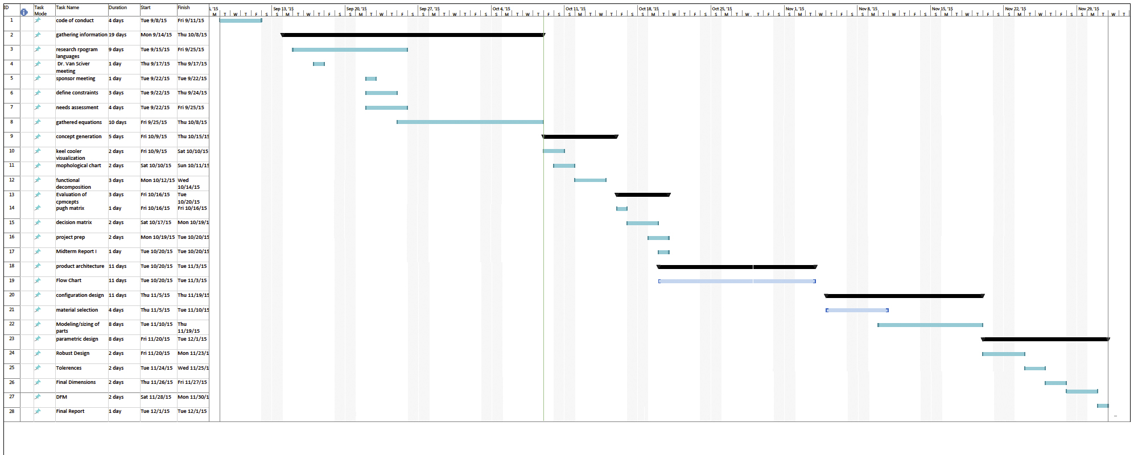

***Figure 1-1 . Gantt Chart***



***Figure 1-2 . Gantt Chart***

# ***Assigned Resources***

Specific roles are charged to each team member based on experience, skill set and preference. Team members are responsible for the role assigned to them throughout the duration of the project. The description of each role is delineated therein.

**Project Leader *Stanko Gutalj***

The project leader advances the project and supports the team. The project leader oversees and ensures that the established plan and timeline is kept. The project leader is also responsible for promoting a positive work environment, maintaining team cohesiveness, and always acting in the best interest of the project. The project leader will delegate tasks to the team members based on experience and skill set. The project leader works alongside team members towards the advancement and ultimate completion of the project.

**Technical Liaison *Melissa Allende***

The technical liaison is the link of communications between the two entities involved in this project, Cummins Marine and FAMU-FSU College of Engineering. Ensures the specific goals of the project are successfully translated to meet end-user tool requirements and is executed upon throughout the development of the project. The technical liaison defines and often will execute appropriate tests to the program to ensure a first-time product acceptance in the marine market. The technical liaison provides real-time feedback and assistance in answering any questions presented by the team members.

**Web Based Technician *Grady Beasley***

The web based technician strives to maintain a cohesive professional design for the team’s website. The web based technician will ensure information on the website is kept up to date and ensure all data is accurate. Will uphold the responsibility to properly represent the team’s sponsor and university with professionalism and dignity.

**Financial Advisor *Jacob Ross***

The financial advisor will be responsible for the administration of the budget for the project. The financial advisor will retain all records of credits and debits charged to the account. Requests for the use of the budget will be submitted to the financial advisor and then the financial advisor will forward the request to the team advisor/sponsor. It is the financial advisors responsibility to maintain proper analysis of the budget and communicate balances and any adjustments to the team.

**Administrative Assistant *James Haga***

The administrative assistant will be responsible for storing, organizing and managing team files. All deliverables will be submitted to the administrative assistant for final review to ensure accuracy and clarity. The administrative assistant is also in charge of planning and scheduling; this includes scheduling team meeting times and dates, staff meetings, tracking deliverable due dates, and key presentation dates. The administrative assistant ensures team members are aware of these dates to ensure the timely progress for the project.

|  |  |  |
| --- | --- | --- |
| ***Table 1 . Resource Allocation*** | | |
| **Team Member** | **Task** | **Time Allotted** |
| Melissa Allende | Research design specification for keel cooled systems | 2 weeks |
| Create flow chart for optimization tool | 1 week |
| Assist with creation/development of tool | 4 weeks |
| Secure test vessel for tool validation | Continuous |
| Grady Beasley | Research thermal fluids/relevant equations | 2 weeks |
| Material acquisition for development of sea channel fabrication | 2 weeks |
| Assist with fabrication of sea channel | 3 weeks |
| Stanko Gutalj | Research thermal fluids/relevant equations | 2 weeks |
| Create flow chart for optimization tool | 1 week |
| Assist with creation/development of tool | 4 weeks |
| James Haga | Research thermal fluids/relevant equations | 2 weeks |
| Developing webpage | Continuous |
| Assist with fabrication of sea channel | 3 weeks |
| Jacob Ross | Research thermal fluids/relevant equations | 2 weeks |
| Assist with creation/development of tool | 4 weeks |

# ***Product Specification***

* 1. Design Specification

Keel cooling utilizes a group of tubes, pipes, or channels attached to the outside of the hull below the waterline. Engine coolant is circulated through the keel cooler to remove excess heat. Fabricated keel coolers are manufactured by the boat builder as a part of the hull construction. Structural steel or aluminum shapes are usually used with 0.187 inch [4.8 mm] to 0.500 inch [12.7 mm] wall thickness. These materials must be compatible with materials used in the vessel’s hull in order to prevent galvanic corrosion. Fabricated keel coolers must be designed oversized to allow for the decrease in effectiveness, which occurs with the formation of rust, scale, pitting, and marine growth on the keel cooler. Keel coolers can be sized given the following data from the Engine Data Sheet: Engine Model and Rating, heat rejection, engine coolant flow to keel coolers, coolant type, as well as the design speed of the vessel (in knots). Typical sizing speeds are 1-2 knots for tugboats/push boats and 0.1-1 knots for generator sets.

Fabricated keel coolers can be made from many different materials and type of construction. Most commonly used are steel channel and pipe, although this tool will also allow calculations for aluminum channel and pips. The shape of the keel cooler is determined by the hull shape and size of the vessel. A fabricated keel cooler is not an efficient heat exchanger and therefore it is much larger in surface area than commercial keel coolers. Keel cooler length formulas for round pipe, half round pipe, and square channel can be found in *Table 2.* The “A” used in the formula is the keel cooler area coefficient. This is dependent on the design speed of the vessel as well as the maximum raw water temperatures as shown in *Figure 2.* Flow path is also a critical part of the design, since the keel cooler can be sized smaller the more flow paths available, *Figure 3.* It is also important to note, the program will ask for the length of the vessel in order not to conduct unnecessary size recommendations.

|  |
| --- |
| ***Table 2. Keel Cooler Length Formula*** |
| ***Round Pipe*** |
|  |
|  |
| **Note:** For half round piping, multiply the calculated length by two. |
| ***Square Channel*** |
|  |
|  |

|  |
| --- |
| ***Table 3. Keel Cooler Cross Section Area Formula*** |
| ***Round Pipe*** |
|  |
| ***Half Round Pipe*** |
|  |
| ***Square Channel*** |
|  |
| **Note:** Using **inch** dimensions gives **square inch** areas. Using **mm** dimensions gives **square mm** areas. |

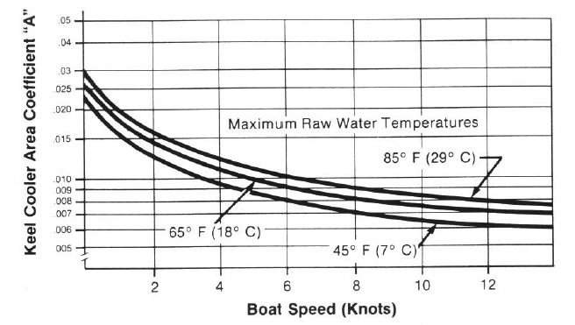

Figure 2. Minimum Keel Cooler Surface Area for Steel Channel or Pipe

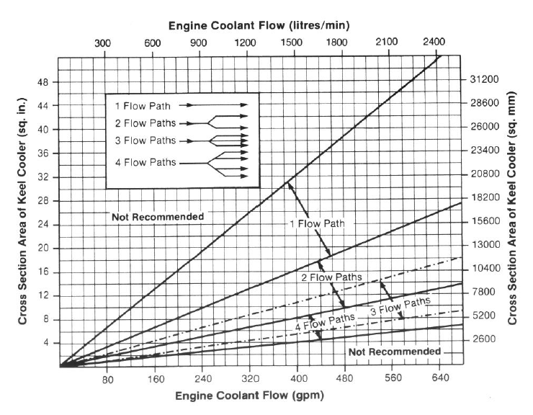

Figure 3. Number of flow paths required to maintain adequate coolant flow

It is important to keep in mind the coolant velocity inside of the cooler. If the coolant flows through the keel cooler faster than 8 ft/sec [2.5 m/sec] the internal components will deteriorate, causing failure near manifold entrances and exits, elbows and other discontinuities in the coolant flow. Likewise, if the coolant flows through the keel coolers’ passages too slowly rust particles or other particulate matter will settle out, choke off the flow and degrade the transfer of heat. In order to determine the proper flow pattern through the keel cooler, one needs to determine the minimum and maximum expected coolant flow through the keel cooler. This can be obtained from the performance data of the engine water pump. Calculating the difference between the maximum and minimum expected coolant flow and multiply the resultant by 2/3 and adding 2/3 will help determine the coolant flow and how to distribute the flow through the keel cooler passages. Then one would divide the coolant flow by the cross-sectional area of one keel-cooler passage to obtain the average velocity. If the average velocity through the keel cooler flow passages is greater than 8 ft/sec [2.5 m/sec], one would arrange the coolant flow in parallel so it would pass through two or more of the keel cooler passages per pass through the keel cooler. If the average velocity though the keel cooler flow passages is less than 2 ft/sec [0.6 m/sec], a keel cooler passage with a smaller cross section would be most adequate.

* 1. Performance Specification

The expectations for this tool are: To fundamentally allow the user, whether that is the boat builder or the Application Engineer conducting the installation review, to know whether the given keel cooler is adequate for the installed engine depending on the type of vessel application; Also, to help design the keel cooler system for an engine prior to the installation. The tool must provide information for the user’s material selection whether that is steel or aluminum, as well as the channel width, channel height, cross-sectional area, and the estimated coolant velocity. This would allow the user to see if the current keel cooler is adequate for the installation since such constraint between 2-8 ft/sec for coolant velocity exists. The tool will also become web-based primarily for distribution, but will be useful when the user is offline since in most instances the shipyards do not have access to the web.

When the user enters the program it will ask them to input some parameters specific to the engine model from the data sheet, as well as the design speed of the vessel. If the keel cooler is already fabricated, the user will be able to validate the design with this tool as well as see how the cooling system should behave under different running conditions, low engine idle, wide open throttle, continuous mode and high rpm engine conditions while the vessel is not moving (bollard push/pull test). This will allow the user to see under which conditions the engine might be at risk for overheating. The tool will also allow the user to validate the keel cooler system in water temperatures in which the vessel was not originally designed to operate (this occurs often since vessels may be contracted to operate in a different body of water).

In cases where the Marine Application Engineer is asked to validate whether a keel cooler system design which has not yet been fabricated, the user will be able to input the material as well as the engine parameters, the vessel design speed and length. The tool will also output a recommendation when optimization is possible by recommending different flow paths, material, length and piping.

***References***

1. Shaw, Courtney. "Cummins Marine Propulsion." *Cummins Marine*. Web. 23 Sept. 2015. <http://marine.cummins.com/>.
2. "Marine Keel Coolers for Heat Dissipation." *Marine Keel Coolers for Heat Dissipation*. Web. 23 Sept. 2015.
3. *Cummins Keel Cooler Sizing Tool*. Computer software. Vers. 2.0. Cummins, n.d. Private Web. 23 Sept. 2015.