FPGA:
In previous lab, we integrates all the previous labs and combines them with the power stage shown in Figure 1. The power stage follows the previously defined design specifications. The ADC used in this system is the AD7822, which is an 8-bit half-flash ADC. The sampling voltage range is 0–2 V, resulting in a quantization range of 7.8125 mV.
Since the target output voltage is 1.5 V, the center code is set to 192. For every 4 bits, one error bit is added, meaning the error ranges from −4 to +4. Because the designed DPWM has a resolution of 10 bits, the counter is designed with 7 bits.
Each component operates with a different clock, so an additional frequency divider is required. Therefore, bits 3–6 of the transaction counter are used for counting. The base clock frequency of the system is 64 MHz. Because the system DPWM exhibits limit cycle oscillation (LCO) when using 9 bits, a 10-bit DPWM is required.
As a result, the compensator output must also be converted to 10 bits. Bits 15–6 of the transaction counter output provide the 10-bit signal. The dithering logic is designed with a 7-bit dither table and a 3-bit counter. The dead-time control is implemented with 7 bits.

In this final report we have to
Bonus:
I used Openlane for tapeout, first of all, I put the original RTL file in the src of the Project project in the OPENLANE file, and use skyout130 to layout Completed an RTL-to-GDS implementation of a digitally controlled PWM core using OpenLane on the Sky130A PDK. The design operates at 64 MHz with a standard-cell area of ~22.9k µm², a core area of ~28.7k µm², and 37.6% utilization, passing all timing and physical signoff checks.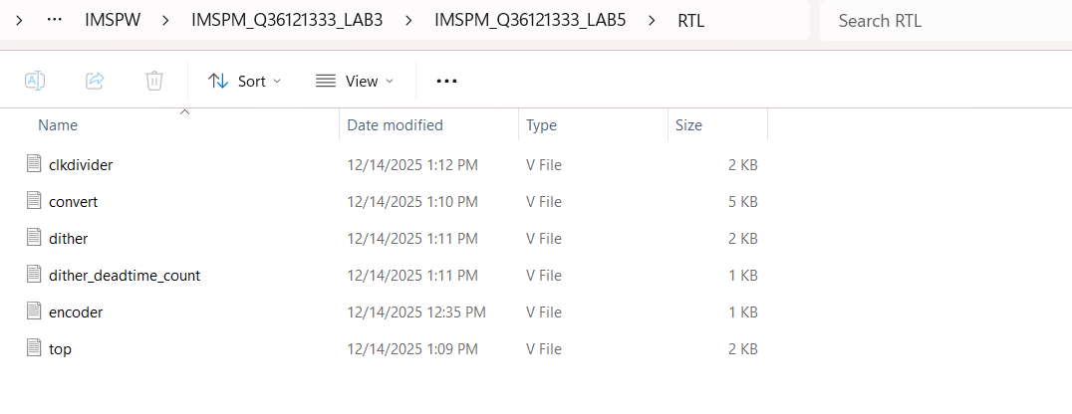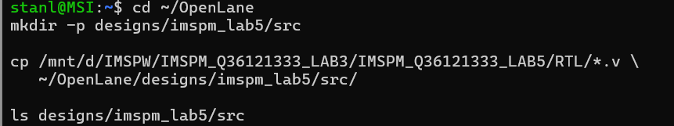
Next, let's start doing constraint, currently using CLK's constraint, since we use 64MHz, the period is designed to be 15.625ns
In addition, we set it to TCL file to perform layout.
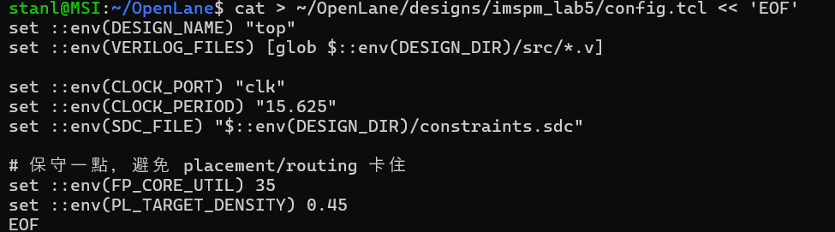

假如還沒有下載sky130，需要先 git pull，make，要更改權限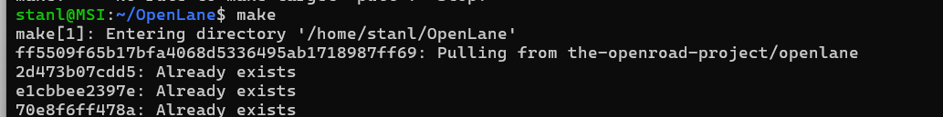
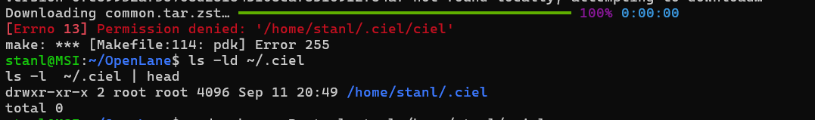
最後只要make pdk就可以進行make mount,並且執行tcl，就可以layout出簡單的ic
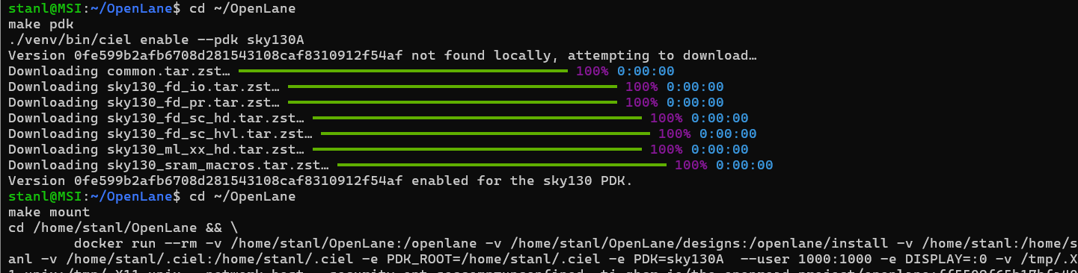
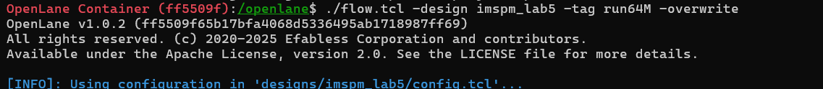
途中或許會有error or warning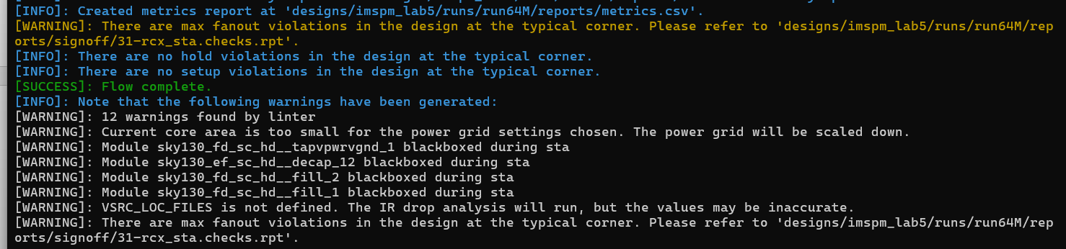
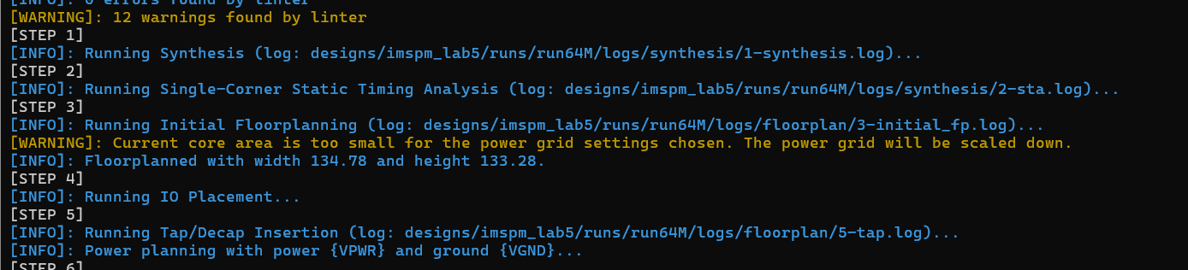

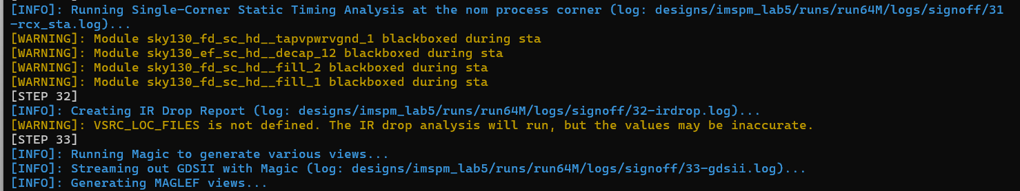
成功就可以用magic的程式打開layout圖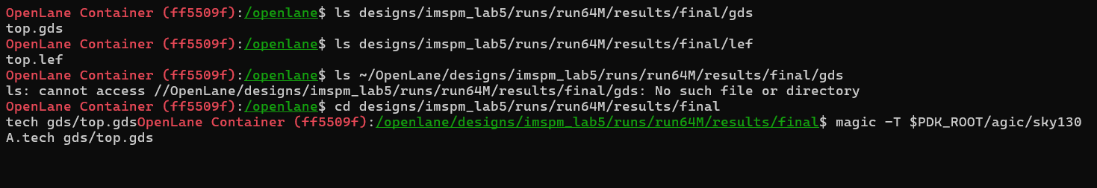
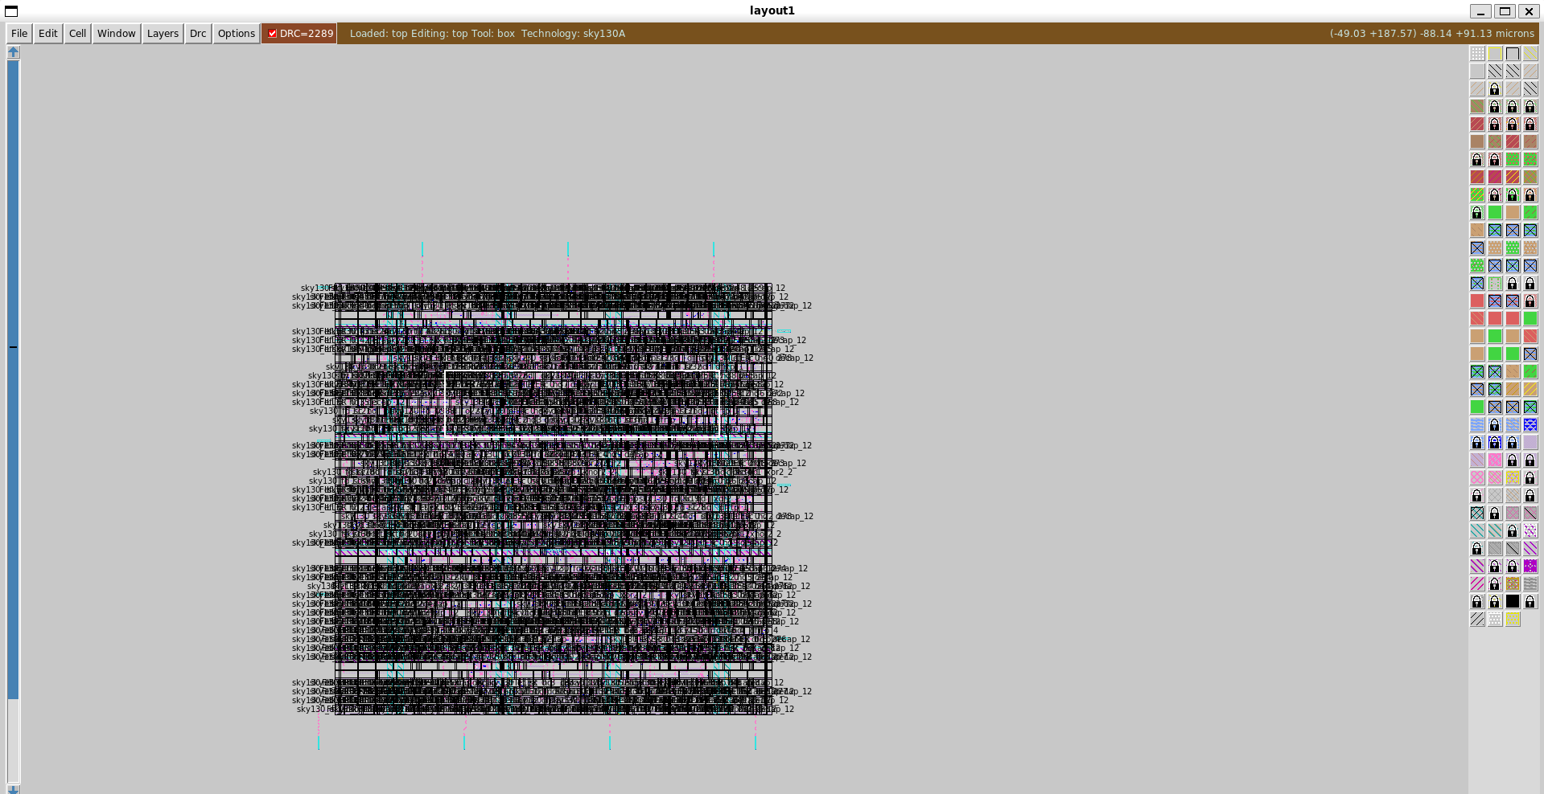
也可以找到設計後的面積參數

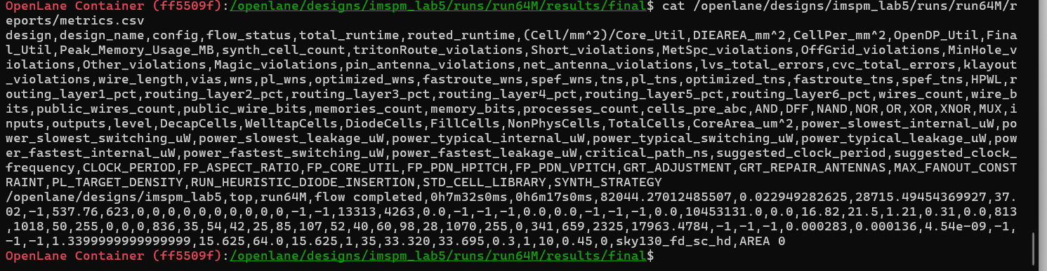

項目 | 數值 | 說明
設計名稱 | top | LAB5 數位控制核心
Flow | OpenLane RTL → GDS | 完整 ASIC backend flow
製程 | Sky130A | 130 nm 開源 PDK
Standard Cell Library | sky130_fd_sc_hd | High-density library
Flow 狀態 | Success | Flow complete
Clock 頻率 | 64 MHz | CLOCK_PERIOD = 15.625 ns
Timing 結果 | Pass | 無 setup / hold violation

項目 | 數值 | 單位 | 意義
Standard Cell Area | 22,949 | µm² | 邏輯實際使用面積（最重要）
Core Area | 28,715 | µm² | Core 實體邊界面積
Core Utilization | 37.6% | – | cell_area / core_area
Die Area | 0.0287 | mm² | 與 core area 相同
Placement Density | 0.45 | – | OpenLane 目標密度

類型 | 功耗 | 單位
Internal Power | 0.000136 | W
Switching Power | 0.000283 | W
Leakage Power | 4.54e-09 | W
Total Power | ~0.000419 | W

