Stanley Wei

CS 163

Zhou - F24

## Contents

**Contents** **1**

**Background** **2**

Machine Learning 2

Neural Networks 6

Backpropagation 7

**Convolutional Neural Networks** **8**

Convolution & Normalization Layers 8

Modern CNN Architectures 12

ResNet 12

Training Neural Networks 15

Initialization 15

Training 18

Choosing Hyperparameters 19

After Training 20

Transfer Learning 20

Visualizing & Understanding Neural Networks 21

**RNNs & Attention** **25**

Attention 26

Transformers 29

**Computer Vision** **33**

Object Detection 33

Semantic Segmentation 37

Instance Segmentation 39

**Generative Models** **41**

Autoregressive Models 43

Variational Autoencoders 44

Generative Adversarial Networks (GANs) 47

Diffusion Models 49

**Trends in CV** **51**

## 

## Background

### Machine Learning

**Linear classifiers**: Given input x/weights W, outputs f(x, W)=Wx+b

* Predict a vector (corresponding to class scores)
  + Bias trick to incorporate biases as last column of weights
* Is a single-layer NN (perceptron); outputs linear predictions
  + Separates space of inputs into different decision regions
  + Cannot predict from nonlinear relationships, XOR
* Intuitively: learns one “template” per class, then measures correlation between template and input image
  + Drawback: Cannot handle multiple modes of data, intra-class variation
* Variations
  + Linear regression: [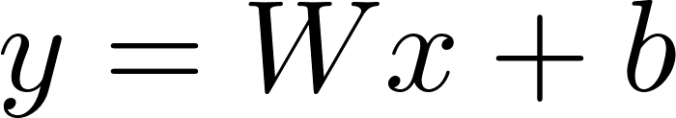](https://www.codecogs.com/eqnedit.php?latex=y%3DWx%2Bb#0)
  + Logistic regression: [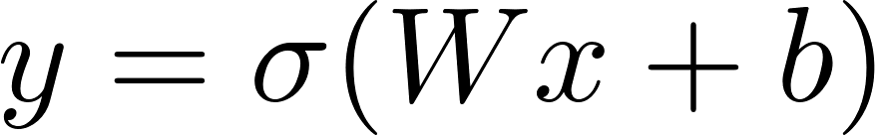](https://www.codecogs.com/eqnedit.php?latex=y%3D%5Csigma(Wx%2Bb)#0)
  + Softmax regression: [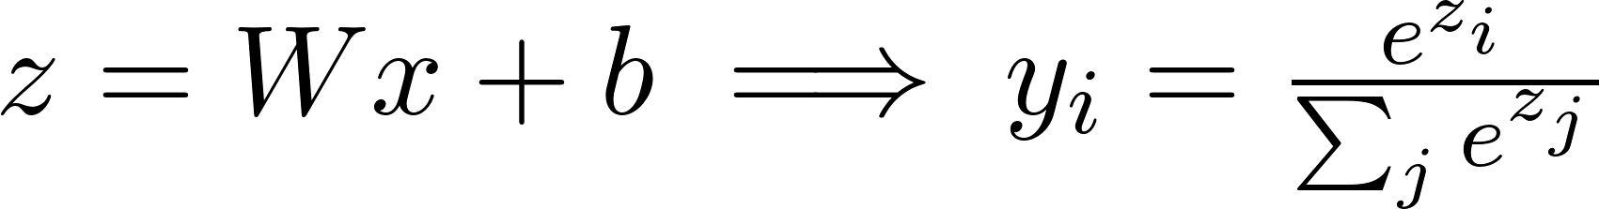](https://www.codecogs.com/eqnedit.php?latex=z%3DWx%2Bb%5Cimplies%20y_i%3D%5Cfrac%7Be%5E%7Bz_i%7D%7D%7B%5Csum_je%5E%7Bz_j%7D%7D#0)

Finding a good W: via a ***loss function*** to quantify performance of W

* Loss function averaged across all samples in dataset
* Example loss functions
  + Linear regression: L2 distance [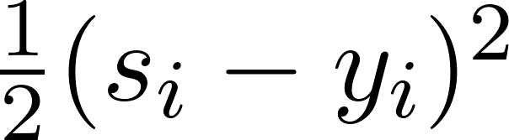](https://www.codecogs.com/eqnedit.php?latex=%20%5Cfrac%7B1%7D%7B2%7D(s_i-y_i)%5E2%20#0)
  + Logistic regression: cross-entropy loss [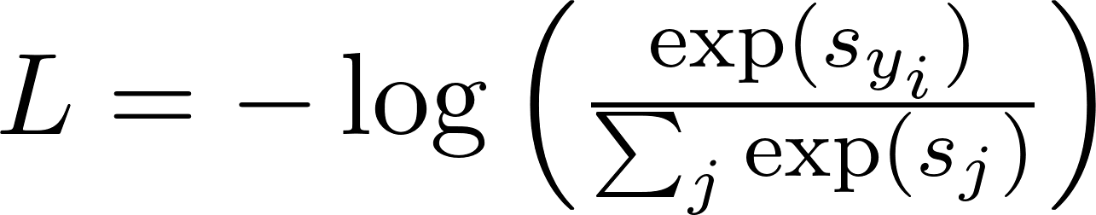](https://www.codecogs.com/eqnedit.php?latex=L%3D-%5Clog%5Cleft(%5Cfrac%7B%5Cexp(s_%7By_i%7D)%7D%7B%5Csum_j%5Cexp(s_j)%7D%5Cright)%20#0)
    - Log of predicted probability (via softmax) of true class
    - Binary cross-entropy/BCE: [](https://www.codecogs.com/eqnedit.php?latex=BCE(p%2Cy)%3D-(y%5Clog(p)%2B(1-y)%5Clog(1-p))#0)
  + Multiclass SVM: hinge loss [](https://www.codecogs.com/eqnedit.php?latex=%20L%3D%5Csum_%7Bj%5Cneq%20y_i%7D%5Cmax(0%2Cs_j-s_%7By_i%7D%2B1)%20#0)
    - Sum of predicted score - true score, max with 0 (wants to make true class’ score higher than all other classes)

**Optimization**: Finding the set of weights minimizing loss

* Via ***gradient descent*** (negative gradient - direction of steepest descent)
* Computing gradients: **numeric gradient** vs **analytic gradient**
  + **Numeric gradient** - approximate & slow convergence, but easier to implement
  + **Analytic gradient** - exact & fast, but more error-prone
    - Used in practice; numeric gradient used as a check (gradient check)
* ***Gradient descent***: at each step, move in the direction of negative gradient
  + Hyperparameters: weight initialization method, # steps, learning rate
  + Challenges: gradient may become zero or vanish, may become stuck in local mins
* *Interpretation*: loss over dataset computes the expected value of loss over real-world distribution of values (x, y)

Issue: *Batch gradient descent* (computing gradient over full batch) is expensive for large batches

* + Can use ***stochastic gradient descent***/**SGD** - GD on minibatches (batch size as hyperparameter)
  + Normal SGD results in noisy gradient; can use ***momentum*** (add a weighted running mean of gradients to SGD update) for less noisy optimization
    - Momentum: [](https://www.codecogs.com/eqnedit.php?latex=%20v_%7Bt%7D%3D%5Cnabla%20f(x_t)%5Cmapsto%20v_t%3D%5Crho%20v_t%2B%5Cnabla%20f(x_t)%20#0)

**AdaGrad**: scale gradient element-wise based on historic sum of squares

* + - [](https://www.codecogs.com/eqnedit.php?latex=%20s_t%3Ds_%7Bt-1%7D%2Bg_t%5E2%5Cimplies%20w_t%3Dw_%7Bt-1%7D-%5Cfrac%7B%5Ceta%7D%7B%5Csqrt%7Bs_t%2B%5Cepsilon%7D%7Dg(t)%20#0)
    - Acts as a form of per-parameter/adaptive learning rate
    - Lowers magnitude of steps along “steep” directions; boosts magnitude of steps along “flat” directions
  + **RMSProp/weighted AdaGrad**: adds a decay rate for historic gradient term
    - [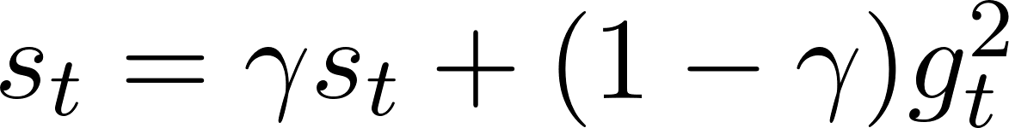](https://www.codecogs.com/eqnedit.php?latex=%20s_t%3D%5Cgamma%20s_t%2B(1-%5Cgamma)g_t%5E2%20#0)
  + **Adam**: “almost” RMSProp + momentum
    - Update step is (almost) momentum SGD update with RMSProp magnitude scaling
    - Bias correction - accounts for first/second moment estimates starting at 0
      * Divides momentum, RMSProp terms by [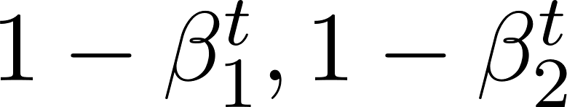](https://www.codecogs.com/eqnedit.php?latex=%201-%5Cbeta_1%5Et%2C1-%5Cbeta_2%5Et%20#0) respectively

Adam:

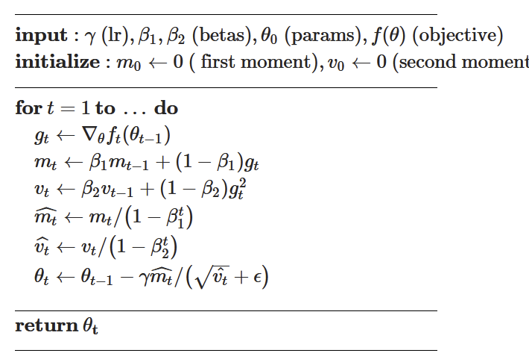

***Overfitting*** occurs when model performs well on training data, but poorly on unseen data

→ ***Regularization*** incorporates an additional term [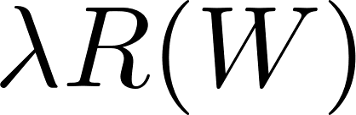](https://www.codecogs.com/eqnedit.php?latex=%20%5Clambda%20R(W)%20#0) in loss function to incentivize less complex learned models; helps to combat overfitting

* Decreases performance on training set in exchange for better performance on validation, test sets
* Simple approach: L1/L2 regularization on magnitude of weights
  + More complex: dropout, batchnorm, cutout, mixup, etc.
  + *Interpretation*: encodes some form of “preference” regarding model weights
    - Ex: L2 prefers more “spread out” weights
* Note: L2 regularization (encodes penalty in loss itself) vs weight decay (adds additional [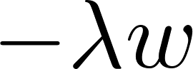](https://www.codecogs.com/eqnedit.php?latex=-%5Clambda%20w#0) term in update step directly)
  + Equivalent for SGD + variants, but different for adaptive methods (e.g. AdaGrad) - weight decay is not included in adaptive sums, but L2 is

***2nd-order optimization***: rather than just the gradient, use gradient + Hessian to make quadratic approximation of loss landscape (look at 2nd-order Taylor expansion, use Newton’s method)

* Issue: Inverting Hessian (Newton’s method) is expensive, O([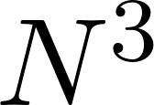](https://www.codecogs.com/eqnedit.php?latex=N%5E3#0))
* Can use Quasi-Newton methods: approximate inverse Hessian via rank-1 updates O([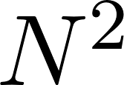](https://www.codecogs.com/eqnedit.php?latex=N%5E2#0))
  + L-BFGS - doesn’t store full inverse Hessian (low memory use), but only works well for full batch setting; does not transfer well to minibatch
* In practice: 1st-order in most cases; L-BFGS when doing full batch updates

*Machine Learning (Misc.)*

* ***Hyperparameters***: choices made before learning regarding parameters (rather than being learned from data)
  + Evaluate via split train/validation/test datasets
  + k-fold cross validation for small datasets
* ***Curse of dimensionality***: Number of points needed for uniform coverage of space increases exponentially with input dimension
* ***Normalization***: can normalize datasets relative to known statistics (mean + stdev, e.g.) for easier learning & better transfer across datasets

## 

### 

### Neural Networks

*Issue*: Linear classifiers can only learn linear decision boundaries

* Can use feature transforms - linear boundaries in transformed space correspond to nonlinear boundaries in original space
  + *Issue*: Requires knowing (fixed) feature transforms beforehand
  + Ex: color histogram/histogram of oriented gradients (HoG) as image features
* Image features via bag of words/BoW approach - extract random patches from image & cluster to form “codebook of visual words”
  + Use codebook as image encoding, a new ML model (e.g. SVM) from classification

***Neural networks*** incorporate a nonlinear ***activation function*** between linear layers

* ***Multi-layer perceptron/MLP*** - use multiple fully-connected layers (rather than regression/single-layer)
  + Later layers use features from previous layer’s activation
  + Weakly inspired by brain structure
  + Universal approximator (similar to k-NN)
* *Ex.* (Activation functions)
  + **ReLU**: [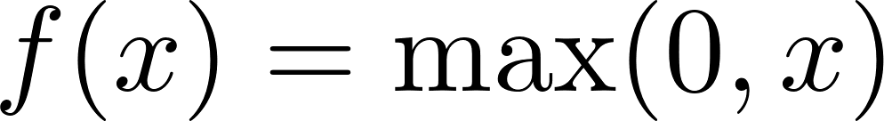](https://www.codecogs.com/eqnedit.php?latex=%20f(x)%3D%5Cmax(0%2Cx)%20#0)/ **Leaky ReLU**: [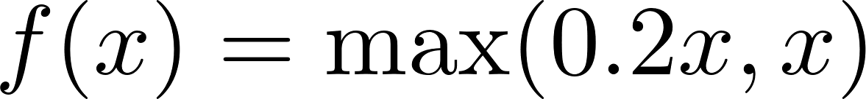](https://www.codecogs.com/eqnedit.php?latex=%20f(x)%3D%5Cmax(0.2x%2Cx)%20#0)
  + **Sigmoid**: [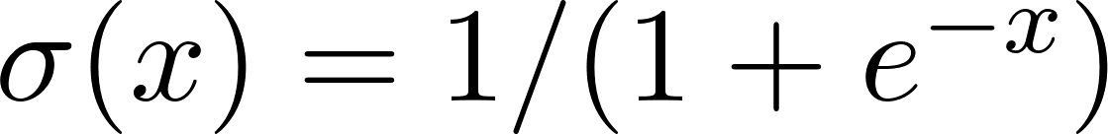](https://www.codecogs.com/eqnedit.php?latex=%20%5Csigma(x)%3D1%2F(1%2Be%5E%7B-x%7D)%20#0)
  + **Tanh**: [](https://www.codecogs.com/eqnedit.php?latex=%20%5Ctanh(x)%3D(e%5E%7B2x%7D-1)%2F(e%5E%7B2x%7D%2B1)%20#0)
  + **Softplus**: [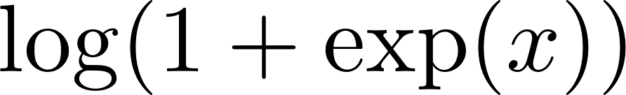](https://www.codecogs.com/eqnedit.php?latex=%20%5Clog(1%2B%5Cexp(x))%20#0)

*Convex functions*: intuitively, look like a “multidimensional bowl”

* Generally easy to optimize, can derive convergence guarantees
  + In optimization, prefer to minimize convex functions if possible
* Linear classifier loss functions are convex; but neural networks are generally non-convex (few/no convergence guarantees, but decent empirical behavior)

### 

### Backpropagation

When training neural networks, need to compute gradients

* Can construct *computational graphs* - indicating operations from inputs to outputs
* ***Backpropagation***: can use the Chain Rule to derive gradients of the loss function with respect to every weight in network
  + From weights at end of network, “backpropagate” derivatives to further-back weights (from last layer to first layer)
  + Chain rule: Downstream gradient [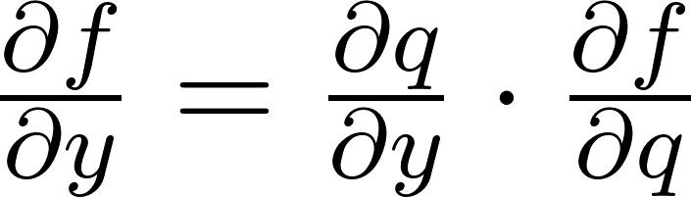](https://www.codecogs.com/eqnedit.php?latex=%20%5Cfrac%7B%5Cpartial%20f%7D%7B%5Cpartial%20y%7D%3D%5Cfrac%7B%5Cpartial%20q%7D%7B%5Cpartial%20y%7D%5Ccdot%5Cfrac%7B%5Cpartial%20f%7D%7B%5Cpartial%20q%7D%20#0) (local * upstream gradients)
  + First perform forward pass (computing [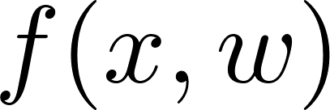](https://www.codecogs.com/eqnedit.php?latex=%20f(x%2Cw)%20#0)), then use backward pass to compute gradients for every weight
* Patterns in gradient flow:
  + Add gates distribute the upstream gradient to both elements of input
  + Copy gate adds upstream gradients to find singular downstream gradient
  + Multiplier gate multiplies upstream gradient with multiplicands
  + Max gate gives downstream gradient equal to upstream (for taken branch), 0 for branches not taken
* Pytorch *autograd* - uses forward, backward methods to compute gradients automatically

*Backpropagation with vectors*: rather than local gradients (i.e. vectors), multiply by local Jacobian matrices (2D) instead

* Jacobians indicate how much each element of inputs influence output
* Jacobians are sparse (all off-diagonal entries 0), large; therefore, can compute matrix product implicitly (via normal multiplication operators, without constructing full matrix)
* For backprop with matrices, use multi-dimensional Jacobian

## Convolutional Neural Networks

**Image classification**: Given an image and a set of K possible classes, output the class that matches that image

* A fundamental CV task
* Challenges: viewpoint & intraclass variations, interclass similarities, occlusion, domain changes, etc.

Image classifiers

* *k-Nearest Neighbors/k-NN*: Find k nearest points to input in the memorized dataset
  + O(1) training, O(N) testing
  + Image classification via pixel distance (questionable metric)
    - Alt: k-NN on ConvNet features (works well)
  + Is a universal approximator (can represent [almost] any function)
* Regular neural networks (MLPs)
* Convolutional neural networks (CNNs)

### Convolution & Normalization Layers

*Issue*: Regular neural networks (i.e. MLPs) don’t explicitly consider the spatial structure of images; act only via local matrix/vector products + activation function

* Within an MLP, have no interaction between adjacent input elements within a layer

*Solution*: can define new spatial operations tailored to image format: ***convolution*** & ***pooling layers***

***Convolution layers*** convolve input image with a filter/kernel

* Filter contains same depth/# channels as input image; “slide” over image spatially (take dot products) to produce *activation map*
  + Kernel dimension corresponds to number of dimensions of input (e.g. 2D input gives 2D kernel; 3D input gives 3D kernel)
  + Can use multiple filters; each produces a single channel in output
  + Also use a bias vector (one scalar per filter, same size as activation map)
  + Shapes: [](https://www.codecogs.com/eqnedit.php?latex=%20(N%2CC_%7Bin%7D%2CH%2CW)%5Cto(N%2CC_%7Bout%7D%2CH'%2CW')%20#0)
* Convolution as cross-correlation: dot product performs a matching between filter, scanned elements (higher -> better match)

Can stack multiple convolutional layers (with activations in between)

* Multiple convolution layers, stacked, correspond to a single larger convolution
  + Each convolution layer is a linear classifier
* Add ***padding*** around input (consisting of zeros) to preserve size of feature map with each convolution layer
  + Can set [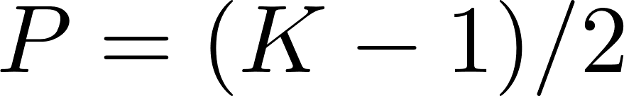](https://www.codecogs.com/eqnedit.php?latex=%20P%20%3D%20(K-1)%20%2F%202%20#0) [[](https://www.codecogs.com/eqnedit.php?latex=%20K%20#0) the kernel size] to preserve input shape
* Further-back convolution layers correspond to convolutions of/depend on larger portions of the region (have larger receptive fields)
  + Each convolution adds [](https://www.codecogs.com/eqnedit.php?latex=K-1#0)to size of ***receptive field***
    - Receptive field size: [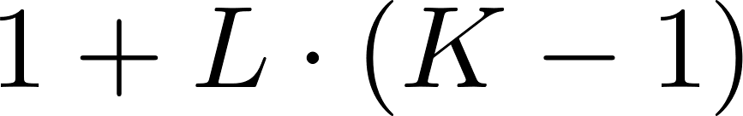](https://www.codecogs.com/eqnedit.php?latex=1%2BL%5Ccdot(K-1)#0)
  + Initial layers learn local features (e.g. local image templates, edges); higher layers learn more complex features
* *Issue*: for large images, need many layers for receptive fields to “see” whole image
  + Can downsample inside network to reduce # layers needed
    - ***Strided convolutions*** - convolutions take larger steps between dot products to produce a smaller activation map
  + For later layers in network: spatial size decreases (via pooling), but number of channels increases (preserving total volume)
* Output size: [](https://www.codecogs.com/eqnedit.php?latex=%20H'%3D(H-K%2B2P)%20%2F%20S%2B1%20#0) (and similar for [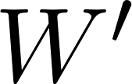](https://www.codecogs.com/eqnedit.php?latex=W'#0))

***Pooling layers***: alternative way to downsample feature map

* ***Max pooling*** - takes maximum of values within receptive field as output value
  + Results in invariance to small spatial shifts
* Hyperparameters: kernel size, stride, pooling function
  + Output size: [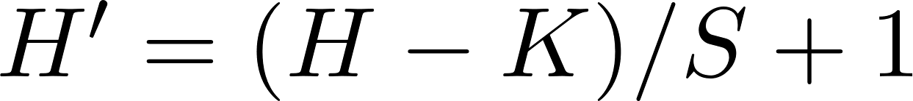](https://www.codecogs.com/eqnedit.php?latex=H'%3D(H-K)%2FS%2B1#0)

**Convolutional Neural Networks** (**CNNs**)

Classic architecture (*LeNet/AlexNet*):

1. [Conv, ReLU, Pool] [](https://www.codecogs.com/eqnedit.php?latex=N#0) times
2. Flatten
3. [FC, ReLU] [](https://www.codecogs.com/eqnedit.php?latex=N#0) times
4. FC to produce output

*Issue*: Deep networks are difficult to train, susceptible to “*internal covariate shift*”

*Solution*: Use ***batch normalization*** - normalize layer outputs to make them have zero mean, unit variance across a batch

* Formula: [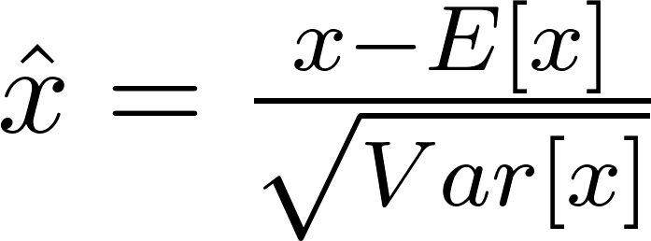](https://www.codecogs.com/eqnedit.php?latex=%20%5Chat%7Bx%7D%3D%5Cfrac%7Bx-E%5Bx%5D%7D%7B%5Csqrt%7BVar%5Bx%5D%7D%7D%20#0) (differentiable, for backprop)
  + Each dimension of input x is normalized separately
    - Use (running) average [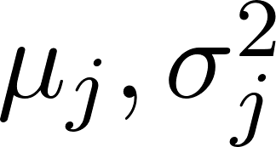](https://www.codecogs.com/eqnedit.php?latex=%20%5Cmu_j%2C%5Csigma_j%5E2%20#0) of mean/variance values observed in training during testing
* Can learn scale, shift parameters [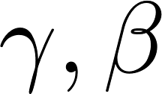](https://www.codecogs.com/eqnedit.php?latex=%20%5Cgamma%2C%5Cbeta%20#0) [dim [](https://www.codecogs.com/eqnedit.php?latex=D#0)] to keep more information than pure zero mean/unit variance
  + Final output: [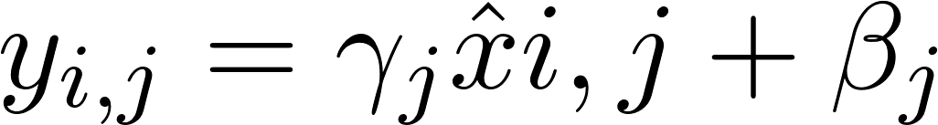](https://www.codecogs.com/eqnedit.php?latex=y_%7Bi%2Cj%7D%3D%5Cgamma_j%5Chat%7Bx%7D%7Bi%2Cj%7D%2B%5Cbeta_j%20#0)
* Batch norm for convolutional networks - *spatial batchnorm*
  + Perform batch-norm across each channel (for [](https://www.codecogs.com/eqnedit.php?latex=(N%2CC%2CH%2CW#0) shape, perform batchnorm across slices [](https://www.codecogs.com/eqnedit.php?latex=(N%2CH%2CW)#0))
* Makes deep networks much easier to train:
  + Allows higher learning rates, faster convergence
  + Makes networks more robust to initialization
  + Acts as a form of regularization during training
  + During testing (parameters fixed), is a linear operator; can incorporate into convolutional layer directly
* *Issues*: not well-understood theoretically, can behave weirdly during training/testing (causes bugs)

Computing parameters

* Number of params - sum of total number of weights in network + number of biases
  + Single convolutional layer: [](https://www.codecogs.com/eqnedit.php?latex=C_%7Bout%7D%5Ccdot%20C_%7Bin%7D%5Ccdot%20K%5Ccdot%20K%2BC_%7Bout%7D#0)
* 4 bytes per element (per float) gives memory
* Floating point operations/FLOPs: number of output elements * ops per output element
  + Single convolutional layer: [](https://www.codecogs.com/eqnedit.php?latex=%20(C_%7Bout%7D%5Ctimes%20H'%5Ctimes%20W')%5Ccdot(C_%7Bin%7D%5Ctimes%20K%5Ctimes%20K)%20#0)

Types of normalization layers

1. Batch normalization (above)
2. *Layer (1D) normalization*: for each input in batch, compute mean/variance across entire dimension of input (channel + height, width, etc.)
3. *Instance (2D) normalization*: for each input in batch, compute mean/variance (for each channel, separately) across entire dimension of input

Inductive bias - encoding some hypothesis about network function into network architecture

### 

### Modern CNN Architectures

***AlexNet*** (2012) - [Conv, ReLU, Pool] into [FC, ReLU]

* First major instance of deep CNNs for classification, achieved 1st place on ImageNet
  + From LeNet: deeper & larger, ReLU instead of sigmoid activationo, larger dataset + more training cycles
  + Architecture (i.e. layer kernel sizes, e.g.) via trial and error
* Notable characteristics:
  + Most memory usage in early convolutional layers; FLOPs in convolutional layers
  + Nearly all parameters in fully-connected layers
* Succeeded by similar, deeper networks (**ZFNet**, **VGG**)
  + *ZFNet*: changed kernel stride sizes
  + ***VGG***: more regular design: all conv are 3x3/pad 1, max pool 2x2 stride 2; double # channels after each pool
    - 2 3x3 convolutions have same receptive field as 5x5, but fewer parameters & faster to compute
    - Significantly larger than AlexNet

**GoogLeNet** - introduced improvements on AlexNet

* Aggressive downsampling at input via *stem network* to decrease computation, memory
* *Inception module* - local unit with parallel branches (multiple parallel convolutional layers with different dimensions, followed by concatenation); repeated throughout network
* ***Global average pooling*** (**GAP**) followed by linear layer (rather than FC layers) at end; requires significantly less parameters
* Hack: auxiliary classifiers (intermediate “classifiers” computing loss) in middle stages of network
  + Since propagating loss across entire network depth is not clean process (before batchnorm)

#### ResNet

*Issue*: With batchnorm, can train deeper and deeper networks; however, CNN (i.e. AlexNet & similar) performance actually decreases with deeper models (rather than shallow models)

* Initial guess was that model was overfitting; however, training error is also worse on deeper models (not just test) -> deeper modes are underfitting
* Hypothesis: deeper models harder to optimize, can’t easily learn identity functions to emulate shallow models
  + Deeper models should be able to learn shallow model + successive layers of identity to match shallower models’ training error

***Residual networks*** add an extra “additive shortcut” between convolutional blocks to make learning identity functions easier

* *Residual blocks*: [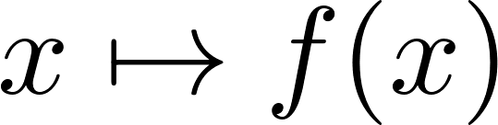](https://www.codecogs.com/eqnedit.php?latex=%20x%5Cmapsto%20f(x)#0) becomes [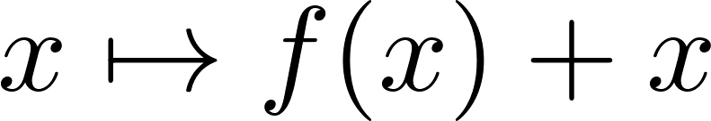](https://www.codecogs.com/eqnedit.php?latex=x%5Cmapsto%20f(x)%2Bx#0)
  + Each residual block - first block halves resolution, doubles # channel

***ResNet*** - stack of residual blocks (similar to VGG)

* Like GoogleNet - stem network at start for downsampling, global average pooling to replace FC layers at end
* *Bottleneck block*: replaces two 3x3 convs (within each residual block) with 1x1 -> 3x3 -> 1x1 convolutions
  + More layers for less computational cost
  + ResNet-50 - replaces ResNet-34 basic blocks with bottleneck blocks
* ResNets are able to train very deep networks, perform better than shallow ones
  + Still widely used today

Complexity of convolutional models

* VGG - highest memory + most operations
* GoogLeNet - very efficient (low # ops)
* AlexNet - low # operations, large # operations
* ResNet - moderately efficient (operations + parameters), higher accuracy
  + Can train very deep networks (to the point of diminishing returns)
  + Good standard choice of architecture
* Later: vision transformer (ViT) matches ResNets, outperform with more data

Improving residual networks

* Block design
  + Pre-activation: ReLU inside residual (rather than after) to ensure block can learn true identity
* *ResNeXt* - rather than single path of convolutions within bottleneck block, compute G-many paths in parallel, add together with residual at end
  + Grouped convolution - rather than all convolutional kernels touching all channels, have parallel convolution layers each working on a subset of channels (e.g. # channels / N)
    - Each parallel layer produces C out / N output channels
    - Allows for parallelization, distributing RAM cost
  + ResNeXt - add groups to improve performance, maintain computational complexity
* *Squeeze-and-Excitation/SENet* - adds “squeeze and excite” branch (global pooling + 2x FC + sigmoid) within each residual block; multiplies with residual output
  + Adds form of global context to each residual block

Other forms of convolutional networks

* *Densely connected neural networks*: introduce dense blocks, where each layer is connected to every other layer (essentially: concatenate outputs from all past layers to current layer’s input at every step)
  + Alleviates vanishing gradient by strengthening propagation + encourages feature reuse across layers
* *MobileNets* - tiny networks (memory-wise)
  + Replaces standard convolution block with “depthwise convolution” (grouped convolution, # groups = # channels) block + pointwise 1x1 conv block
    - Reduces number of parameters dramatically (divides by C)
  + Used in mobile devices; related: ShuffleNet

*Neural architecture search* - automated process for designing NN architectures

* Controller network outputs network architecture, samples & trains child networks from controller; after each batch, perform policy gradient step on controller & repeat
* Outputs good architectures after a long time, but very expensive to perform
  + Can use to find efficient CNN architectures

### Training Neural Networks

#### Initialization

*Notable activation functions*:

1. ***Tanh*** - squashes numbers to [-1, 1]
   1. Zero-centered (good), but kills gradients when saturated (bad)
2. ***ReLU***
   1. Advantages: does not saturate in + region, very efficient, converges fast in practice
   2. Disadvantages: no zero-centered output, gradient 0 for all x<0 (no updates)
3. ***Leaky ReLU***
   1. Advantages of ReLU + no vanishing gradients
4. *Exponential Linear Unit/ELU*: [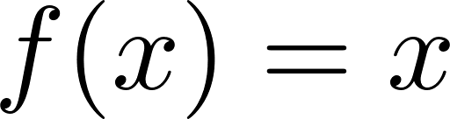](https://www.codecogs.com/eqnedit.php?latex=%20f(x)%3Dx#0) for [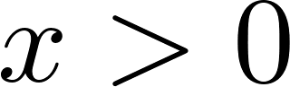](https://www.codecogs.com/eqnedit.php?latex=x%3E0#0), [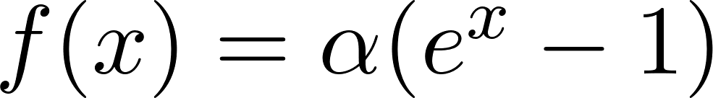](https://www.codecogs.com/eqnedit.php?latex=f(x)%3D%5Calpha(e%5Ex-1)#0) for [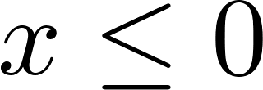](https://www.codecogs.com/eqnedit.php?latex=x%5Cleq0#0)
   1. Benefits of ReLU + closer to zero mean + negative saturation regime compared to leaky ReLU (some robustness to noise)
   2. More expensive to compute (requires exp)
5. *Scaled Exponential Linear Unit/SELU*
   1. [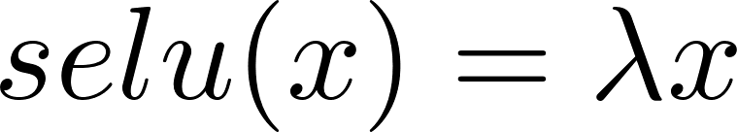](https://www.codecogs.com/eqnedit.php?latex=selu(x)%3D%5Clambda%20x#0) if [](https://www.codecogs.com/eqnedit.php?latex=x%3E0#0), [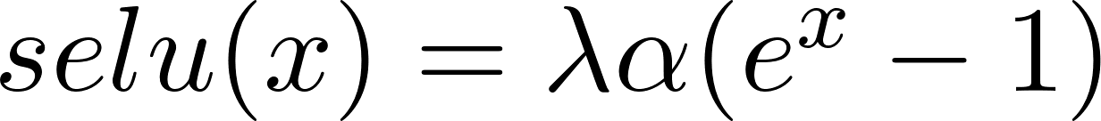](https://www.codecogs.com/eqnedit.php?latex=selu(x)%3D%5Clambda%5Calpha(e%5Ex-1)#0) if [](https://www.codecogs.com/eqnedit.php?latex=x%5Cleq0#0)
   2. Scaled version of ELU, better for deep networks; is “self-normalizing” (can train deep SELU networks without batchnorm)
6. *Gaussian Error Linear Unit/GELU*:
   1. [](https://www.codecogs.com/eqnedit.php?latex=X%5Csim%20N(0%2C1)%5Cimplies%20gelu(x)%3DxP(X%5Cleq%20x)%3D%5Cfrac%7Bx%7D%7B2%7D(1%2Berf(x%2F%5Csqrt%7B2%7D))%5Capprox%20x%5Csigma(1.702x)#0)
   2. Multiplies input by 0 or 1 at random; large values more likely to be multiplied by 1, small values by 0 (data-dependent dropout)
   3. Common in transformers

ReLU used in most cases (Leaky ReLU/ELU/SELU in limited cases)

* Sigmoid, tanh not generally used except to squash the output

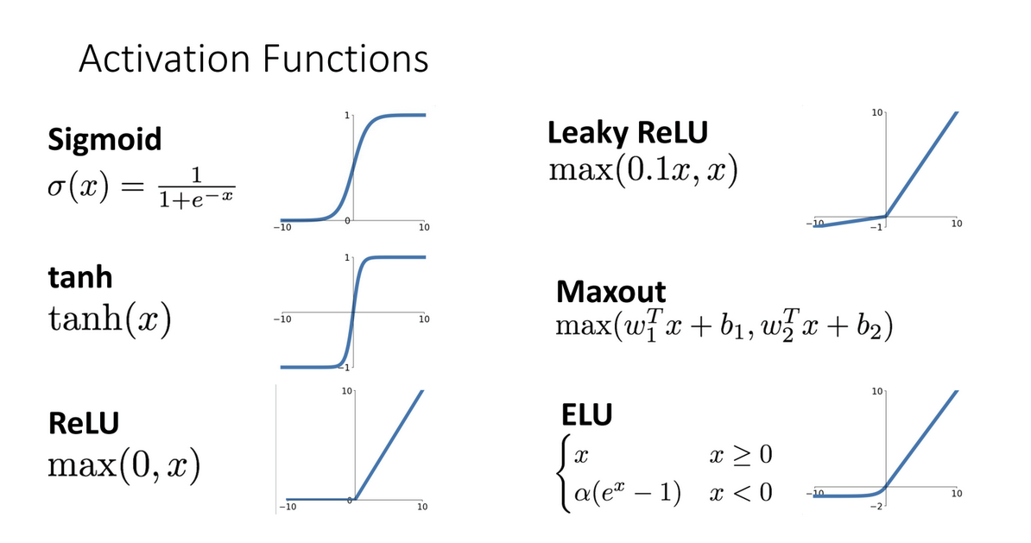

*Weight Initialization*: How to initialize weights?

* Initialize all 0 causes all gradients to be the same; no “symmetry breaking”
* Initialize with small random numbers (Gaussian with zero mean, 0.01 stdev) works okay for small networks, but has problems for deeper networks
  + All activations tend to zero for deeper network layers
* Similar, but with 0.05 stdev -> all gradients saturate (local gradients zero, no learning)
* “*Xavier initialization*” - stdev = 1/sqrt(Din) - scales activations nicely for all layers
  + Conv layers: Din is [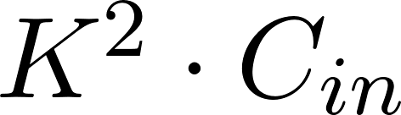](https://www.codecogs.com/eqnedit.php?latex=K%5E2%5Ccdot%20C_%7Bin%7D#0)
  + Derivation: Sets value such that variance of output = variance of input (assuming x, w are i.i.d. zero-mean)
* ReLU initialization: Xavier assumes zero-centered activation function -> doesn’t work, gradients vanish
  + *Kaiming initialization*: stdev = sqrt(2/Din) works well
* For residual networks, intiailizing with Kaiming method causes variance to grow with each block (due to residual connection)
  + *Solution*: first conv with Kaiming, second conv to zero in each residual block

**Regularization**

* Commonly used: L2 regularization, L1 regularization, Elastic net (L1 + L2)
* ***Dropout***: in each forward pass, randomly set some neurons to 0
  + Probability of dropping as hyperparameter; commonly 0.5
  + Forces network to have redundant representation; prevents co-adaptation of features (i.e. each neuron in a layer encoding an entirely separate feature)
    - Alt: dropout trains a large ensemble of models that share parameters
  + Used on FC layers for early networks, e.g. AlexNet/VGG (where most parameters located); GoogLeNet, ResNet, etc. use global average pooling (no dropout needed)
* ***Data augmentation***: when training for image classification, can perform various transformations to image (simulates training on a larger dataset)
  + Ex: horizontal flip, random crops/scales
  + More complex: color jitter, shearing, lens distortions, etc.

Intuitively, augmentation adds some randomness during training

* More approaches:
  + *Stochastic depth*: skip some residual blocks in ResNet during training
    - Use whole network during testing
  + *Cutout*: set random regions of images to 0 during training
    - Works well for small datasets; less common for larger datasets
  + *Mixup* - train on random blends of images
    - Ex: 40% dog, 60% cat (pixel-wise) has target label 0.4 dog, 0.6 cat
    - Scale blend probability from a beta distribution Beta(a,b) to keep blend weights close to 0, 1

General lessons for training NNs:

1. Batch normalization/data augmentation generally good ideas
2. Dropout for large FC layers

#### 

#### Training

***Learning rate schedules***: rather than a fixed learning rate, can instead vary learning rates over time

* *Step* (most common): reduce learning rate at a few fixed points
  + Ex: ResNet multiples LR by 0.1 after epochs 30, 60, 90
* *Cosine*: [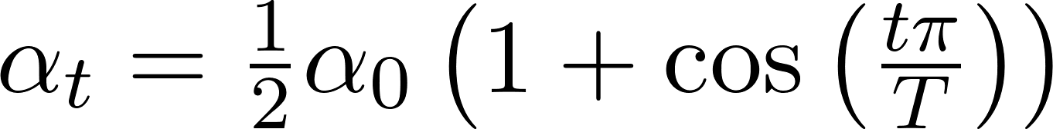](https://www.codecogs.com/eqnedit.php?latex=%5Calpha_t%3D%5Cfrac%7B1%7D%7B2%7D%5Calpha_0%5Cleft(1%2B%5Ccos%5Cleft(%5Cfrac%7Bt%5Cpi%7D%7BT%7D%5Cright)%5Cright)#0)
* *Linear*: [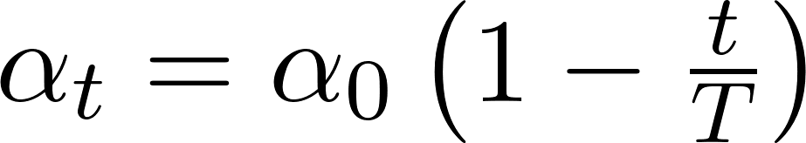](https://www.codecogs.com/eqnedit.php?latex=%5Calpha_t%3D%5Calpha_0%5Cleft(1-%5Cfrac%7Bt%7D%7BT%7D%5Cright)#0)
* *Inverse sqrt*: [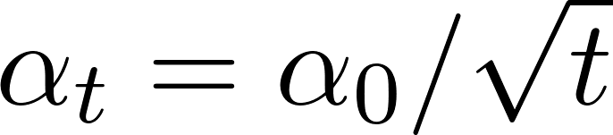](https://www.codecogs.com/eqnedit.php?latex=%5Calpha_t%3D%5Calpha_0%2F%5Csqrt%7Bt%7D#0)

How long to train?: Want to avoid overfitting

* ***Early stopping*** - stop training model when accuracy on validation set decreases
  + Alt: keep training, but store model snapshot that worked best on validation
* Alt approach: first stop training when accuracy on validation set decreases, and record that iteration #; then train train + val dataset together, stopping at previous best iteration

#### 

#### Choosing Hyperparameters

Can model hyperparameter choice as Bayesian optimization problem

***Grid search***: can choose several values for each hyperparameter (e.g. learning rate + weight decay), evaluate all possible choices on the hyperparameter grid

* Often space choices log-linearly
* Alt: via random search (log-uniform on a certain interval, run many different trials)
  + In case where one parameter is known to be more important than th either: ranodm search samples more values of that parameter than grid
* Facebook: one single learning rate & weight decay works well across many different models/architectures (via large-scale empirical random search)

Choosing hyperparameters (in general)

1. First, check initial loss (turn off weight decay, sanity check loss at initialization)
2. Next, overfit a small sample (try to train to 100% accuracy on a small sample of training data, e.g. 5-10 minibatches)
   1. Use to tune architecture, LR, weight initialization (no regularization yet) until loss zeroes out
3. Use architecture from previous step with all training data + small weight decay, use to tune learning rate
   1. Want learning rate that makes loss drop significantly within ~100 iterations
4. Use coarse grid, train for 1-5 epochs to test learning rate, weight decay
5. Refine grid, train longer without learning rate decay
6. Look at learning curves to qualitatively assess training progress/challenges & repeat

#### 

#### After Training

***Model ensembles***: can train multiple independent models and average results at test time for a slight boost in performance

* Take average of predicted probabilities & argmax

#### Transfer Learning

Rather than using a lot of data to train/use CNNs, use a pretrained CNN on a standard dataset (e.g. ImageNet) and use extracted features (before FC layers) on a new dataset

* Remove FC layers at end of CNN & replace with a new set of FCs (using same conv layers + weights as before); then, train CNN for new task
  + Works well for training on new datasets without having to retrain feature extractor
  + Can lower learning rate (e.g. 1/10 of LR used in original training), freeze lower layers during fine-tuning process
* Amount of additional layers + finetuning depends on size of new dataset, similarity to ImageNet
  + For very different datasets + small dataset, may need to add more layers or cut off & retrain some earlier layers
* Allows for transferring improvements in CNN architectures from image classification, e.g., to downstream tasks by replacing CNN feature extractor with a newer one
  + Can use as feature extractor for object detection, e.g.
* Reduces training time needed

Another approach - rather than training the CNN feature extractor on a large labeled dataset (hard to find), can instead train on large unlabeled datasets (unsupervised representation learning)

* Weakly supervised learning

### 

### Visualizing & Understanding Neural Networks

3 perspectives:

* Understanding network as a whole
* Looking at feature spaces
* Looking at individual units

Can visualize convolutional filters in CNN

* Lower layers correspond to local features of image
* Higher layers - not interesting

Looking at features - collect feature vectors from running network on many images, then use k-NN to compare features in feature space

* Can use dimensionality reduction (e.g. PCA) to visualize

***Maximally activating patches*** - pick a layer & channel, then run many images through the network and find the image patches that have the highest value for that channel

* Use guided backprop to visualize

Annotating interpretation of images

* Within classified image, cut out the region (during annotation) corresponding to a label
* Can dissect networks to find “interpretable units” corresponding to each label; use IoU to evaluate (semantic segmentation)

Multimodal neurons in CNNs - some neurons in CNNs become object detectors for specific classes of object

***Saliency*** - want to determine which pixels most affect the output

* **Saliency via occlusion**: Mask part of image before feeding to CNN & determine how probabilities change
* **Saliency via backprop**: Compute probabilities (forward pass) and compute gradient of (unnormalized) class score with respect to each pixel (absolute value)
* Saliency maps act as form of segmentation without supervision
* Not a perfect interpretability metric

***Class activation mapping* (CAM)**

* Rather than summing all entries (across the image) in final FC layer to produce a given class’s score, simply output matrix of final FC values as that class’s CAM
* Can use as a form of weakly-supervised localization/object detection, interpretability
  + Only applies to last conv layer, but recent CNNs use global average pooling anyway

*Gradient-weighted class activation mapping* (Grad-CAM)

* Generalization of CAM:
  + Pick any layer’s activations, compute gradient of class score with respect to activations
  + Use GAP on gradients to get weights, use ReLU to compute activation map
* Can also utilize for other kinds of vision models (e.g. image captioning)

Visualizing CNN features: *gradient ascent*

* Computes the synthetic image that maximally activates a neuron
  + Starting with zero image, keep forward passing & stepping input image in direction of positive gradient (of neuron value w.r.t. image pixels)
    - L2 regularization on generated image pixels; also periodically Gaussian blur + clip pixels with small values t0 0, small gradients to 0
  + Can use to visualize intermediate features at each layer
    - “Multifaceted visualization” (using more careful regularization, enter bias) for even nicer results
  + Can perform gradient ascent by training a deep generator network (prior) for the synthetic image, followed by the CNN
    - Can backpropagate through the CNN and generator network
* Adversarial usage: given an arbitrary image, start with an arbitrary category and modify image (via gradient ascent) to maximize class score until network is fooled

Feature inversion - given a CNN feature vector for an image, find a new image with a similar feature vector that “looks natural” (via some regularization)

DeepDream - try to amplify neuron activations at some layer in the network

* Given an image and layer: perform forward pass, then set gradient of chosen layer equal to its activation & backprop
* Trippy output

*Texture synthesis*: given a sample patch of some texture, try to generate bigger image with same texture

* Via nearest neighbors: generate pixels one at a time in scanline order; form neighborhood of already-generated pixels and copy NN from input
* Via neural networks - reshape features from C x H x W to C x HW and compute Gram matrix [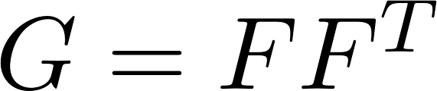](https://www.codecogs.com/eqnedit.php?latex=%20G%3DFF%5ET%20#0)
  + Neural texture synthesis: use a pretrained CNN & run input texture forward through CNN, recording activations on every layer
  + At each layer, compute Gram matrix
  + Initialize generated image from random noise , pass through CNN, compute Gram matrices
  + Compute weighted sum of L2 distance between Gram matrices, backprop to get gradient on image, and make gradient step (& repeat)
* Higher layers recover larger features from input texture
* Can use for style transfer - texture transfer + Gram reconstruction
  + Matches features from content image / Gram matrices from style image
  + Adjust weight-to-style loss coefficients
  + Can mix style from multiple images via weighted average of Gram matrices

Style transfer requires many forward/backward passes through VGG (slow)

* Solution: train another neural network to perform style transfer
  + Fast neural style transfer - train a feedforward network for each style, compute same losses as before -> stylize images via single forward pass (after training)
    - Uses instance normalization
* Can train one network for multiple styles via conditional instance normalization (learning separate scale, shift parameters per style)

## RNNs & Attention

Rather than “one-to-one”/feedforward models (seen previously), look at *sequence models* (one to many/many-to-one/many-to-many)

* Ex: for image captioning (image -> sequence of words), video classification (sequence-to-label), machine translation (sequence-to-sequence)
  + Per-frame video classification

***Recurrent neural networks*** (**RNNs**) - store an “internal state”, update as sequence is processed

* New state is function of old state & input vector at some time step [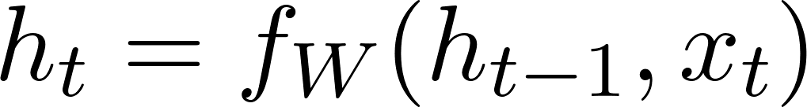](https://www.codecogs.com/eqnedit.php?latex=h_t%3Df_W(h_%7Bt-1%7D%2Cx_t)#0)
  + Same function (i.e. model) [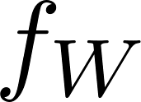](https://www.codecogs.com/eqnedit.php?latex=f_W#0), set of parameters [](https://www.codecogs.com/eqnedit.php?latex=W#0) at every time step

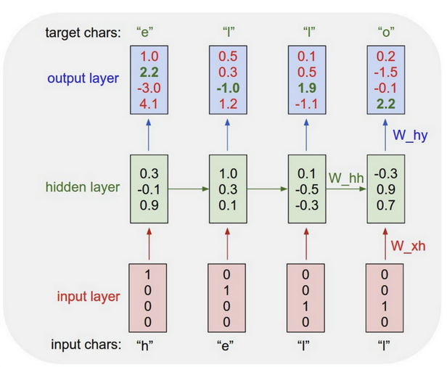

Vanilla RNN - state consists of a single hidden vector [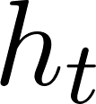](https://www.codecogs.com/eqnedit.php?latex=h_t#0)

* [](https://www.codecogs.com/eqnedit.php?latex=h_t%3D%5Ctanh(W_%7Bhh%7Dh_%7Bt-1%7D%2BW_%7Bxh%7Dx_t%2Bb_h)#0), [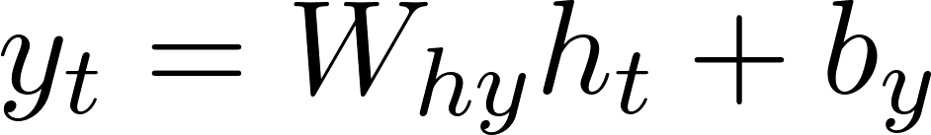](https://www.codecogs.com/eqnedit.php?latex=y_t%3DW_%7Bhy%7Dh_t%2Bb_y#0)
* Ex (language modeling): Given characters [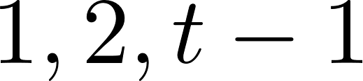](https://www.codecogs.com/eqnedit.php?latex=1%2C2%2Ct-1#0), model predicts character [](https://www.codecogs.com/eqnedit.php?latex=t#0)
  + Character at time t is function of hidden state + preceding character; train model to correctly predict from existing training sequences (strings)
  + At test time: generate new text; sample characters one-by-one and feed back to model
    - At each step: input to model is output from previous sample step
    - Start with an artificial character <START>; cut off sequence when model samples <END> character
* Ex (image captioning): use feature vector from a CNN as initial hidden state for an RNN

### 

### Attention

RNNs for sequence-to-sequence prediction

1. Initially: continuously update hidden state on all characters of input sequence
2. From final hidden state, predict initial decoder state [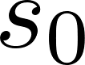](https://www.codecogs.com/eqnedit.php?latex=s_0#0) and context vector [](https://www.codecogs.com/eqnedit.php?latex=c#0) (e.g. [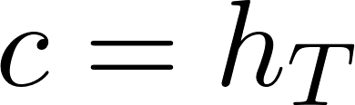](https://www.codecogs.com/eqnedit.php?latex=c%3Dh_T#0))
3. Decoder uses context vector [](https://www.codecogs.com/eqnedit.php?latex=c#0), START character [](https://www.codecogs.com/eqnedit.php?latex=y_0#0) (plus initial state [](https://www.codecogs.com/eqnedit.php?latex=s_0#0)) to determine decoder state [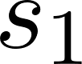](https://www.codecogs.com/eqnedit.php?latex=s_1#0)
4. Afterward: Keep updating decoder state [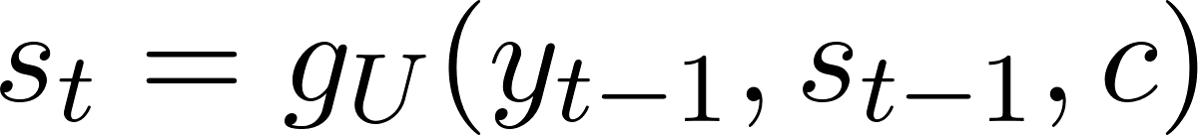](https://www.codecogs.com/eqnedit.php?latex=s_t%3Dg_U(y_%7Bt-1%7D%2Cs_%7Bt-1%7D%2Cc)#0) and sampling another character [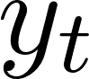](https://www.codecogs.com/eqnedit.php?latex=y_t#0) until STOP character

*Issue*: input sequence bottlenecked through a fixed-size vector; may not be enough for fixed sequences

*Solution*: Use a new context vector at each step of decoder

At each step:

1. Use decoder state [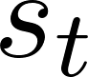](https://www.codecogs.com/eqnedit.php?latex=s_t#0) to compute alignment scores [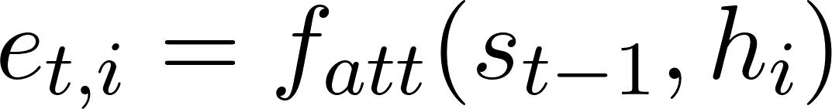](https://www.codecogs.com/eqnedit.php?latex=e_%7Bt%2Ci%7D%3Df_%7Batt%7D(s_%7Bt-1%7D%2Ch_i)#0) (using MLP [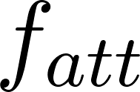](https://www.codecogs.com/eqnedit.php?latex=f_%7Batt%7D#0))
   1. Initial decoder state: predicted from final hidden state [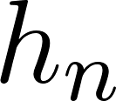](https://www.codecogs.com/eqnedit.php?latex=h_n#0)
2. Use softmax on alignment scores to get attention weights [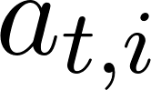](https://www.codecogs.com/eqnedit.php?latex=a_%7Bt%2Ci%7D#0)
3. Compute context vector as linear combination of hidden states [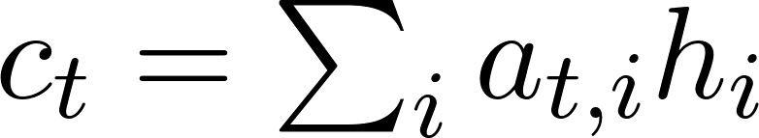](https://www.codecogs.com/eqnedit.php?latex=c_t%3D%5Csum_ia_%7Bt%2Ci%7Dh_i#0)
   1. [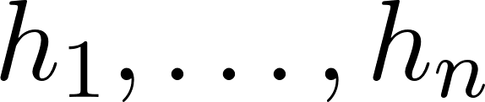](https://www.codecogs.com/eqnedit.php?latex=h_1%2C%5Chdots%2Ch_n#0) one hidden state per input element
4. Use context vector as input to decoder: [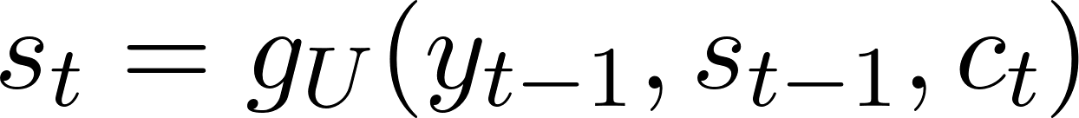](https://www.codecogs.com/eqnedit.php?latex=s_t%3Dg_U(y_%7Bt-1%7D%2Cs_%7Bt-1%7D%2Cc_t)#0)
   1. Sample [](https://www.codecogs.com/eqnedit.php?latex=y_t#0) from decoder

*Intuition*: context vector “attends to” (assigns higher weights [](https://www.codecogs.com/eqnedit.php?latex=a_%7Bt%2Ci%7D#0) to) the relevant part of input sequence [determined by MLP]

* Input sequence no longer bottlenecked through a single context vector; at each decoder timestep, context vector “looks at” different parts of input sequence
* Not limited to language - can use for any set of input hidden vectors [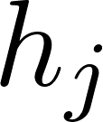](https://www.codecogs.com/eqnedit.php?latex=h_j#0)
  + Decoder doesn’t use ordered nature of [](https://www.codecogs.com/eqnedit.php?latex=h_j#0)’s anywhere; can be unordered

Image captioning with RNNs and attention

* Use CNN to compute grid of features [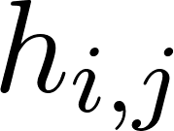](https://www.codecogs.com/eqnedit.php?latex=h_%7Bi%2Cj%7D#0) for image
* At each decoder timestep: compute alignment score for each feature [](https://www.codecogs.com/eqnedit.php?latex=h_%7Bi%2Cj%7D#0) and use to find new context vector

Can use attention for interpretability

* Machine translation - high attention weights correspond to relevant parts of input sentence at the current timestep/stage in translation
* Image captioning - attention weights for each word in caption correspond to the relevant part of image
* *Intuition*: works like human eye attention, picks region of focus

*Types of Attention*

* ***Attention layer***: uses scaled dot product to compute similarities [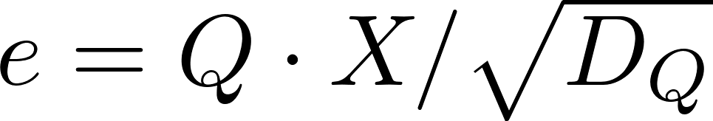](https://www.codecogs.com/eqnedit.php?latex=e%3DQ%5Ccdot%20X%2F%5Csqrt%7BD_Q%7D#0) between query vector(s) [](https://www.codecogs.com/eqnedit.php?latex=Q#0), input vectors [](https://www.codecogs.com/eqnedit.php?latex=X#0)
  + Machine translation: singular query vector is decoder state; input vectors are hidden states
    - Can generalize to multiple query vectors (dot product to matrix product)
  + Scaled dot product - multiplies dot product by sqrt of query vector dimension
* *Attention layer (key-value)*
  + Add new ***key matrix*** [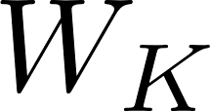](https://www.codecogs.com/eqnedit.php?latex=W_K#0), ***value matrix*** [](https://www.codecogs.com/eqnedit.php?latex=W_V#0)
  + Compute keys by [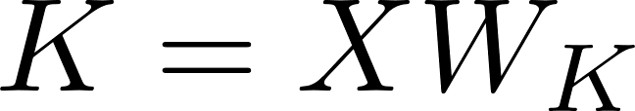](https://www.codecogs.com/eqnedit.php?latex=K%3DXW_K#0), values by [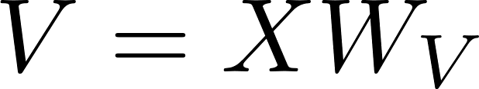](https://www.codecogs.com/eqnedit.php?latex=V%3DXW_V#0)
  + Take similarities by product between query vectors [](https://www.codecogs.com/eqnedit.php?latex=Q#0) and keys [](https://www.codecogs.com/eqnedit.php?latex=K#0); output vectors by [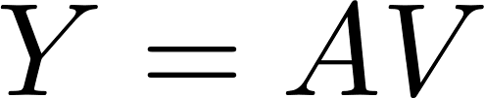](https://www.codecogs.com/eqnedit.php?latex=Y%3DAV#0) ([](https://www.codecogs.com/eqnedit.php?latex=A#0) attention weights)
* ***Self-attention***: uses query matrix [](https://www.codecogs.com/eqnedit.php?latex=W_Q#0) to compute query vectors by [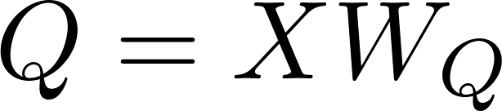](https://www.codecogs.com/eqnedit.php?latex=Q%3DXW_Q#0), in addition to key & value vectors
  + One query per input vector
  + Output is permutation equivariant (permuting input gives permuted version of same output)
  + Self-attention doesn’t consider order of processed vectors
    - Solution: can concatenate input with a positional encoding [vector] [](https://www.codecogs.com/eqnedit.php?latex=E#0) to make processing “position-aware”
      * Encoding may be learned or via fixed function
* Masked self-attention (for language modeling - predicting next word)
  + Zero out all similarities with keys “further ahead” of current query vector
    - Prevents vectors from “looking ahead” in the sequence
* *Multihead self-attention*: use H independent self-attention heads in parallel
  + Copy input for each independent head; concatenate output vectors at end
  + Hyperparameters: query dimension [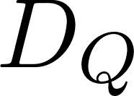](https://www.codecogs.com/eqnedit.php?latex=D_Q#0), number of heads [](https://www.codecogs.com/eqnedit.php?latex=H#0)

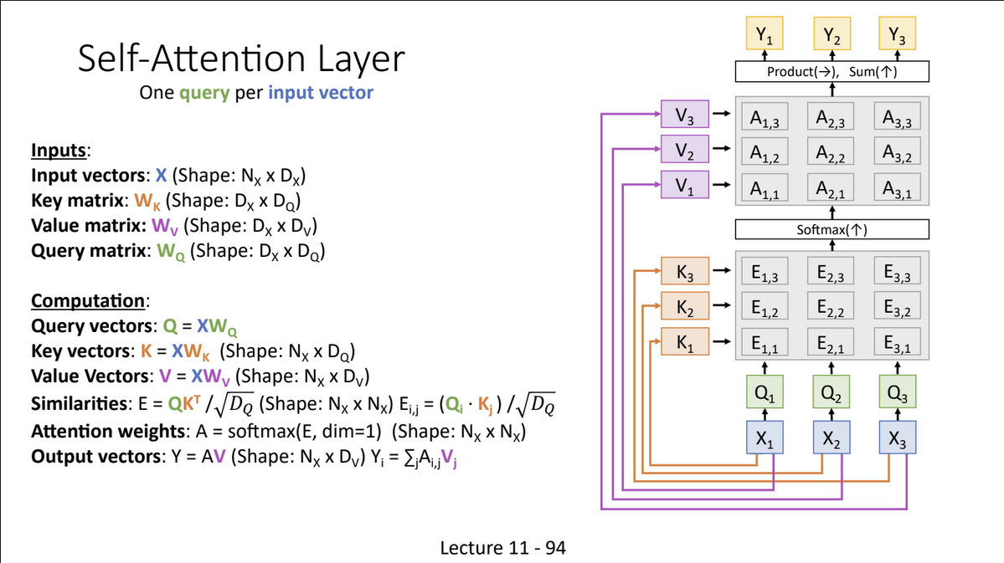

CNN with self-attention

* Query, key, value matrices given by 1x1 conv with dim C’ x H x W
* Use standard self-attention module plus residual connection

Three ways to process sequences

* RNN: works on ordered sequences
  + Good at long sequences ([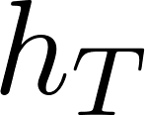](https://www.codecogs.com/eqnedit.php?latex=h_T#0) “sees” whole sequence after one RNN layer), but not parallelizable (requires on sequentially finding hidden states)
* 1D convolution: works on multidimensional grids
  + Bad at long sequences (need to stack many layers for receptive field to include whole sequence), but highly parallel
* Self-attention: works on sets of vectors
  + Good at long sequences and highly parallel, but very memory-intensive

### Transformers

**Transformer block**:

1. Self-attention (with residual connection)
2. Layer normalization
3. MLP independently on each vector (with residual connection)
4. Layer normalization & output

***Transformers*** - sequences of transformer blocks

* Highly scalable & parallelizable
  + Only interaction between vectors happens within self-attention layers
* Multi-head attention: module for attention, runs through attention mechanisms several times in parallel & concatenates (independent) attention outputs
  + Uses a linear layer on final output to transform into expected dimension
* Effect similar to AlexNet for NLP
  + Use pretrained transformers for NLP tasks

Self-attention vs cross-attention

* Cross-attention: rather than computing queries/keys/values all from input, obtain queries from decoder and keys/values from encoder
  + Translation: decoder contains information about target language statistics; encoder contains information about source language

Attention/transformers for vision

1. Add attention to existing CNNs/CNN architectures (add between existing ResNet blocks)
   1. Still a CNN; want to replace convolution entirely
2. Replace convolution with “local attention”
   1. Attention takes center of receptive field as query, surrounding elements to find keys/values; output computed via attention
   2. Issue: hard to implement, only marginally better than ResNets
3. Standard transformer on pixels
   1. Issue: very memory-intensive, R x R image gives [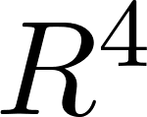](https://www.codecogs.com/eqnedit.php?latex=R%5E4#0) elements per att matrix
4. ***Vision Transformer*** (**ViT**): standard transformer on patches
   1. Divide image into smaller patches (flattened)
      1. Concatenate each patch with a learned position embedding
   2. Pass image patches as input to a standard transformer
   3. Add special extra input (classification token vector, learned, same dim as image patch); take output vector corresponding to classification token as vector of class scores
      1. No convolution layers needed (besides transformer MLPs)

ViT vs ResNet

* ViT performs worse on smaller datasets, but performs/scales better for larger ViTs + larger datasets
  + ViT advantage - better scalability (fairly efficient transformer memory-wise, faster to train)
* Most CNNS (e.g. ResNet): decrease resolution, increase channels for deeper layers; hierarchical structure
  + ViT: all block shave same resolution, # channels; isotropic structure

Improving ViT

* Regularization
  + Weight decay, stochastic depth; dropout in transformer MLP layers
* Data augmentation: MixUp, RandAugment
* Distillation:
  + Train a teacher model to classify images from ground-truth labels
  + Train a student model to match predictions from the teacher (sometimes: also ground truth labels)
    - Easier than training student from scratch
    - Can also train student on unlabeled data for semi-supervised learning
    - Can train teacher CNN -> student ViT

Hierarchical ViT: ***Swin transformer***

* First divide image into very small patches (e.g. 4x4), then merge (halve patch dimension) after every stage between transformer blocks
  + Merging: concatenate groups of 2x2 and linear project to half the channels
  + Results in hierarchical structure (similar to CNNs)
    - Other hierarchical transformers: MViT, Swin-V2, Improved MViT

*Issue*: matrices are big for earlier layers

*Solution*: don’t use full attention, instead use attention over patches

* ***Window attention*** - rather than allowing each token to attend all other tokens, divide attention matrix into smaller M x M windows and only compute attention within each window
  + Linear in size for fixed M
  + Swin transformer - instead of positional embeddings (like ViT), encodes relative position between patches when computing attention
    - Adds bias term to similarity scores (before softmax)

*Issue*: no communication across windows; might lose information

*Solution*: alternate between normal windows and shifted windows (shifting all windows by some amount) in successive blocks

Faster & more accurate than previous models

* Can also use as backbone for downstream CV tasks (beyond classification)

Improving ViT

* ViT uses self-attention to mix across tokens; can try something simpler
  + MLP-Mixer: use MLP to mix across tokens (replacing self-attention)
    - All-MLP architecture
    - First applies an MLP across all N patches, then another MLP across all C channels

Object detection with transformers

* *DETR* (simple object detection pipeline): directly output set of boxes from transformer
  + Train using bipartite matching loss
  + Uses transformer to encode image features, then another transformer to decode & generate output vectors; from output vectors, uses FFNs to generate prediction (no object, or class + box if object)
* *Diffusion Models with Transformers* (DiT): replaces latent diffusion U-Net backbone with transformer operating on latent patches

### 

## 

## Computer Vision

### Object Detection

**CV tasks:**

1. Image classification
2. Semantic segmentation
3. Object detection
4. Instance segmentation

***Object detection***: Given an image, output a set of detected objects (consists of a label + bounding box for each object)

* Bounding box represented via coordinates (x, y, w, h)
* Loss function: Take a weighted sum of label loss (softmax ) & bounding box loss (L2) as final multitask loss
* *Challenges*: Multiple outputs, multiple types of output (label + bounding box), often works on higher resolution images (compared to classification)

Object detection models

* Take feature vector from vision backbone (pretrained ResNet, e.g.) and use separate FC layers for labels, box coordinates
  + Issue: images can have more than one object; need different numbers of outputs per image depending on image contents, # of objects
* Can detect multiple objects via sliding window: apply a CNN to many different crops of image to classify crop as object vs background
  + Bounding box is the window size
* *Issue*: too many possible windows to evaluate for large images
  + ***Region proposals*** - find a small set of boxes likely to cover all objects
    - Often based on heuristics (e.g. look for “blob-like” image regions)
    - Relatively fast (e.g. selective search)

Evaluating object detectors

* Can use ***intersection over union*** (**IoU/Jaccard index**) to compare prediction, ground-truth boxes
  + Formula: (Area of intersection) / (Area of union)
  + Issue: object detectors often output overlapping detections
* Overlapping boxes (solution) - use ***non-max suppression*** (**NMS**)
  + Acts as form of post-processing: at each step, select the next highest-scoring box and eliminate all lower-scoring bounding boxes with a high IoU with current box
  + Issue: may eliminate good boxes if objects are highly overlapping (no easy solution)
* ***Mean Average Precision*** (**mAP**) - run object detector on all test images with NMS
  + For each category, compute average precision (AP) - area under Precision vs Recall curve
    - For each detection (highest to lowest score): if it matches some GT box with IoU >0.5, mark as positive and eliminate GT box; otherwise, mark negative
      * Plot points on PR curve (precision vs recall graph)
    - Aeverage precision: area under PR curve
      * AP = 1.0: hit all GT boxes with IoU >0.5, and have no “false positive” detections ranked above any “true positives”
  + Mean Average Precision: average of AP for each category
    - COCO mAP: compute mAP for multiple IoU thresholds (0.5, 0.55, etc.) and take the average

**Object Detection Models**

***Region-Based CNN*** (**R-CNN**): Takes regions of interest from proposal method, transform to standard CNN input size & forward regions through CNN for classifications

* Bounding box regression: from CNN features, predict a “transform” to correct RoI to produce bounding boxes
  + Can compare with ground-truth boxes
* Running R-CNN
  + For each proposal, resize to standard input size and run independently through CNN to predict class scores & bounding boxes
  + Use scores to select subset of region proposals to output

*Issue*: very slow, need to perform forward pass on many regions

→ *Solution*: Run CNN before warping

***Fast R-CNN***: Run entire image through a CNN, then run region proposal method on CNN-output image features

* Can use any vision backbone (e.g. ResNet)
* From proposed regions; crop & resize, run through a per-region CNN network to obtain category, box transform per region
  + Can have a heavy initial backbone and relatively lightweight per-region network (even just FCs) to save redundant computation
* Significantly faster to train & run than regular R-CNN
* Q: How to crop & resize features?
  + *RoI pool* - find proposal within input image, then project onto features and “snap” to grid cells
    - Can divide into 2x2 grid of roughly equal subregions and maxpool within each subregion - ensures that region features always have same size, even if the proposed regions have different sizes
    - Issue: “snapping” may cause misalignment; method also results in different-sized subregions (in some cases)
  + *RoI align* - find proposal within input image and project
    - Rather than “snapping”, can sample features at regularly-spaced points in each subregion using bilinear interpolation
      * At each point: look at distances to four neighboring grid cells; take feature value as weighted linear combination (no snapping needed)

*Issue*: most of the time running Fast R-CNN is spent finding region proposals (due to needing to run on CPU); want to find a way to learn instead

***Faster R-CNN***: incorporates learnable region proposal network to predict proposals from features

* From feature map, region proposal network predicts proposals
  + At each point in feature map: take a fixed-size “anchor box” arond it and predict whether corresponding center point (anchor) contains an object
  + For positive boxes, also predict a box transform to convert from anchor box to object box
  + Issue: anchor box around a point may have wrong size/shape to include object
    - Solution: Use K different anchor boxes (of different shapes/sizes) at each point
* Jointly train 4 losses: RPN classification & regression + object classification & regression
* Significantly faster to run than Faster R-CNN
* Is a two-stage object detector: (i) Backbone & RPN, run once per image; (ii) Classifier for proposed regions (run once per region)
  + Q: Do we really need the second stage?

***Single-stage object detection*** (e.g. YOLO, SSD): instead of classifying anchors in RPN as object/not object, classify as one of C categories (or background)

* May also use category-specific regression: for each non-background category, also predict a bounding box transform
* Less accurate than two-stage methods, but much faster

Object detection

* Better backbones are slower, but perform better
  + Recent backbones: feature pyramid networks (multiscale backbone), ResNeXt
* Single-stage methods have improved
* Very big models work better
* Test-time augmentation can help boost performance
* ICCV ‘23: object detection as a diffusion process
  + Generate an image overlaid with a random set of boxes; diffusion model will progressively refine into a better box at inference time

### 

### Semantic Segmentation

***Semantic segmentation***: Label each pixel with a category label (without differentiating instances)

Initial idea: sliding window

* Within an image, take a certain crop around a central pixel and classify it
* Assign pixel category to be output class from classifier
* Issue: inefficient, doesn’t reuse shared features between patches

Neural networks for semantic segmentation

First idea: vanilla CNN with constant kernel size

*Issue*: convolution expensive on large images + receptive field is linear in # of convolutional layers

New idea (***encoder-decoder***): structure CNN as two stages: ***downsampling*** -> ***upsampling***

* **Downsampling** - use pooling, strided convolution to decrease resolution of features
* **Upsampling**: use **unpooling**, **transposed convolution** to increase feature resolution
  + ***Unpooling*** (e.g. 2x2 -> 4x4)
    - Naive approaches: simple (only fill in top-left corner), nearest neighbor
    - More complex: bilinear interpolation, bicubic interpolation, etc.
    - “Max unpooling”: in a 2x2 maxpool, remember which position had max; during unpooling, place element into that position
  + Learnable upsampling - “***transposed convolution***”
    - Maps single pixel in input to larger kernel (3x3, e.g.) in output
      * Move one pixel in input -> 2 pixels in output, e.g.
      * Sum where outputs overlap
    - *Intuition*: can express convolution as matrix multiplication -> transposed convolution is multiplication by inverse matrix

Encoder-decoder networks

* Want to improve encoding of spatial information (encoder), maintaining spatial structure of mask (decoder)
* Encoder
  + ***Dilated/astrous convolution*** - rather than multiplying a contiguous region of input image during convolution (3x3 kernel -> 3x3 region, e.g.), place gaps of 1 pixel between each sampled input region (3x3 kernel -> 5x5 region, e.g.)
    - Creates larger receptive field
  + Feature pyramid structures
    - *Pyramid scene parsing network/PSPnet*: use multiple differently-sized convolutions on the same set of features and fuse outputs
      * Hypothesis: different sizes encode different kinds of features
    - *Feature Pyramid Networks/FPN*: predict at each feature size (?)
* ***U-Net*** - popular network for biomedical image segmentation

Semantic segmentation datasets - Cityscapes, MIT ADE20K

* ADE20K - manually labeled over several years by a single expert annotator

### 

### Instance Segmentation

***Instance segmentation***: detect all objects in images + corresponding pixels

One approach - perform object detection, then predict segmentation mask for each object

* ***Mask R-CNN***: Uses Faster R-CNN approach + adds segmentation mask prediction to outputs
  + Outputs: object category, bounding box, segmentation mask

Instance vs semantic segmentation

* Instance segmentation - labels pixels + detects individual instances, but only for pixels corresponding to detected objects (not for background, sky, e.g.)
* Semantic segmentation - labels all pixels, but not instances

More advanced CV tasks

* ***Panoptic segmentation*** - label all pixels in image & separate object instances (for objects)
  + Combination of instance, semantic segmentation
* ***Human keypoints*** - detect human pose via locating a set of keypoints
  + Can extend Mask R-CNN, add keypoint positions as additional output
    - In addition to segmentation mask, output individual masks for each keypoint (K many)
    - Ground truth - one “pixel” enabled per keypoint, use softmax loss

**General approach to advanced CV tasks**: Add additional “heads”/outputs to Mask R-CNN

* Heads incorporated into per-region network
* Ex:
  + LSTM head for dense captioning
  + Mesh R-CNN: mesh predictor head

Segment Anything (SAM): foundation model for image segmentation

## 

## Generative Models

**Supervised vs unsupervised learning**

* ***Supervised learning***: Given a set of data (x, y), want to learn function mapping x to y
  + *Ex*: image classification, object detection, semantic segmentation
  + *Intuition*: Attempts to learn conditional probability distributions p(y | x)
    - Cannot sample raw distribution p(x)
* ***Unsupervised learning***: Given a set of data x (no labels), want to learn some underlying structure of the data
  + *Ex*: clustering, dimensionality reduction, feature learning, density estimation
  + Attempts to learn unconditional probability distribution p(x)
    - Allows for sampling from p(x) directly

**Computer vision**

* Supervised learning via ***discriminative models***
  + For classification, segmentation, etc.
  + Lots of success across many tasks
* ***Generative models*** - unsupervised learning
  + More recent interest nowadays
  + Many advances in recent years

*Recall*: probability mass of a given element in a distribution assigned by density function

* Discriminative models (learn p(y | x)): given an image, different labels compete for probability mass
  + Different images do not compete
  + Correct labels should be assigned more mass
    - Done via feature learning with labels
* Generative models (learn p(x)): different images compete for probability mass
  + “Reasonable” outputs should be assigned more mass
    - Trained via feature learning without labels
    - Sample to generate new data
* Conditional generative models - learn p(x | y)
  + Given a label, different images compete for probability mass

**Classes of Generative Models**

1. *Explicit density*: model can compute p(x) explicitly
   1. Tractable density - can compute p(x) exactly
      1. Ex: autoregressive, NADE/MADE, etc.
   2. Approximate density - can only approximate p(x)
      1. Variational: Variational autoencoder (VAE)
      2. Markov chain: Boltzmann machine, diffusion model
2. *Implicit density*: model does not explicitly compute p(x), only samples from it
   1. Markov chain: GSN
   2. Direct: Generative adversarial networks (GANs)

### 

### Autoregressive Models

**Goal**: Want to write an explicit function [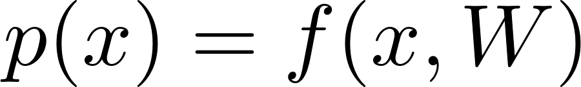](https://www.codecogs.com/eqnedit.php?latex=p(x)%3Df(x%2CW)#0)

* Given dataset [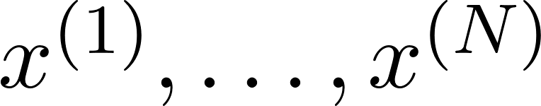](https://www.codecogs.com/eqnedit.php?latex=x%5E%7B(1)%7D%2C%5Chdots%2Cx%5E%7B(N)%7D#0), train the model to solve [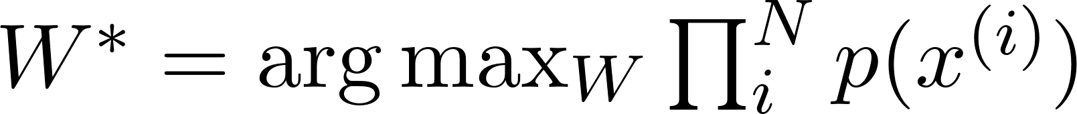](https://www.codecogs.com/eqnedit.php?latex=W%5E%5Cast%3D%5Carg%5Cmax_W%5Cprod_i%5ENp(x%5E%7B(i)%7D)#0)
* Loss function: [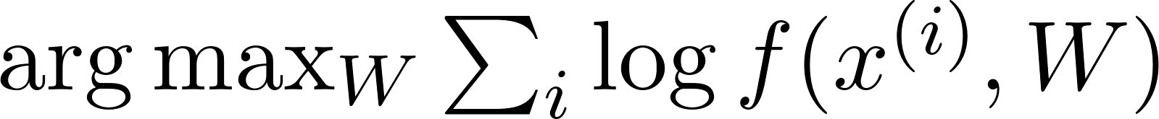](https://www.codecogs.com/eqnedit.php?latex=%5Carg%5Cmax_W%5Csum_i%5Clog%20f(x%5E%7B(i)%7D%2CW)#0)
  + Maximum likelihood estimation
* Idea: for multi-part inputs [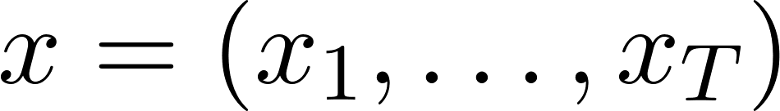](https://www.codecogs.com/eqnedit.php?latex=x%3D(x_1%2C%5Chdots%2Cx_T)#0), model using conditional probabilities [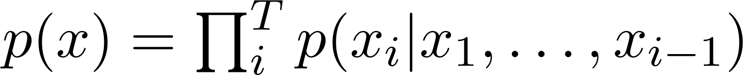](https://www.codecogs.com/eqnedit.php?latex=p(x)%3D%5Cprod_i%5ETp(x_i%7Cx_1%2C%5Chdots%2Cx_%7Bi-1%7D)#0)

***PixelRNN*** - generates pixels one at a time, starting from upper left corner

* Via RNN - computes hidden state for each pixel based on hidden states and RGB values from all preceding pixels (pixels directly to the left and above)
  + At each pixel, predict R, G, B separately and softmax over [0, 1, …, 255]
  + Recurrences via LSTM
* *Issue*: slow to train & test (requires [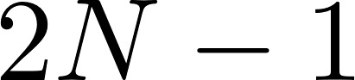](https://www.codecogs.com/eqnedit.php?latex=2N-1#0) sequential steps)

***PixelCNN*** - dependency on previous pixels modeled via CNN over some context region

* Faster to train than PixelRNN (convolution parallelizable), but still slow to generate due to sequential steps

**Autoregressive Models**

Pros:

* Explicitly computes likelihood p(x)
* Explicit likelihood of training data gives a good evaluation metric
* Good samples

Cons:

* Sequential generation is slow

### 

### Variational Autoencoders

***Variational autoencoders*** (**VAE**) - define an intractable density (cannot compute or optimize; only directly optimize a lower bound on density)

***Regular/non-variational autoencoders***: unsupervised method for learning feature vectors from raw data without labels

* Originally linear + nonlinearity; later MLP, ReLU CNN
* Want to learn useful features from data for downstream tasks; Q: how?
  + Idea: Train model as two parts: **encoder** & **decoder**
    - ***Decoder*** attempts to reconstruct original input data from encoded features
      * Loss: L2 between original, reconstructed features
      * Ex: conv layers in encoder -> transpose conv in decoder
    - ***Encoder*** portion is used as autoencoder
      * Throw away decoder after training -> encoder for downstream tasks
* Can use encoder to initialize a supervised model
  + From there, use to train on a final task (with limited data, e.g.)
    - Ex: dimensionality reduction with unsupervised learning
* Regular autoencoders not probabilistic - no way to sample new data from learned model

***Variational autoencoders*** - probabilistic variation on regular autoencoders

* Learn latent features [](https://www.codecogs.com/eqnedit.php?latex=z#0) from raw data -> can sample from model to generate new data
* Assumes training data [](https://www.codecogs.com/eqnedit.php?latex=x%5E%7B(1)%7D%2C%5Chdots%2Cx%5E%7B(N)%7D#0) generated from unobserved/latent representation [](https://www.codecogs.com/eqnedit.php?latex=z#0)
  + Intuition: [](https://www.codecogs.com/eqnedit.php?latex=x#0) an image; [](https://www.codecogs.com/eqnedit.php?latex=z#0) latent features used to represent image (e.g. attributes, orientation, etc.)
* After training: first sample [](https://www.codecogs.com/eqnedit.php?latex=z#0) from prior [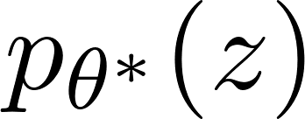](https://www.codecogs.com/eqnedit.php?latex=p_%7B%5Ctheta%5E%5Cast%7D(z)#0), then sample [](https://www.codecogs.com/eqnedit.php?latex=x#0) from conditional distribution [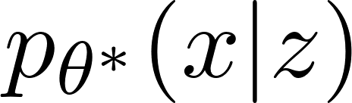](https://www.codecogs.com/eqnedit.php?latex=p_%7B%5Ctheta%5E%5Cast%7D(x%7Cz)#0)
  + Assumes simple prior [](https://www.codecogs.com/eqnedit.php?latex=p_%7B%5Ctheta%5E%5Cast%7D(z)#0) (Gaussian, e.g.)
  + Represent [](https://www.codecogs.com/eqnedit.php?latex=p_%7B%5Ctheta%5E%5Cast%7D(x%7Cz)#0) via NN (similar to autoencoder decoder network)
    - Want to sample [](https://www.codecogs.com/eqnedit.php?latex=x#0) from Gaussian with mean [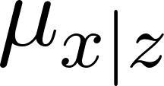](https://www.codecogs.com/eqnedit.php?latex=%5Cmu_%7Bx%7Cz%7D#0), diagonal covariance [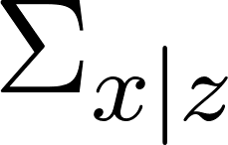](https://www.codecogs.com/eqnedit.php?latex=%5CSigma_%7Bx%7Cz%7D#0)
      * Diagonal prior causes dimensions of [](https://www.codecogs.com/eqnedit.php?latex=z#0) to be independent
* *Idea*: want to learn [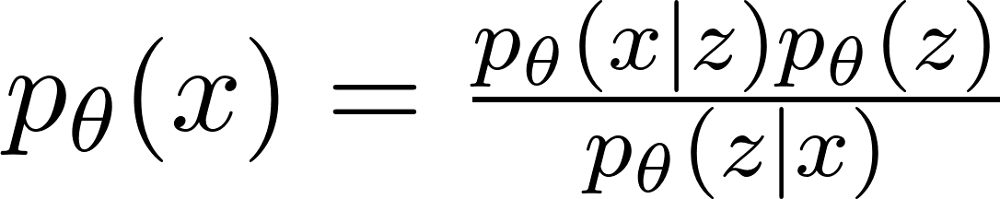](https://www.codecogs.com/eqnedit.php?latex=p_%5Ctheta(x)%3D%5Cfrac%7Bp_%5Ctheta(x%7Cz)p_%5Ctheta(z)%7D%7Bp_%5Ctheta(z%7Cx)%7D#0)
  + [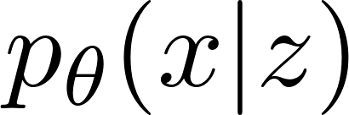](https://www.codecogs.com/eqnedit.php?latex=p_%5Ctheta(x%7Cz)#0) via decoder network; from Gaussian prior
  + [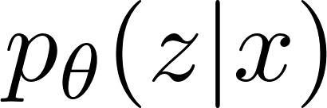](https://www.codecogs.com/eqnedit.php?latex=p_%5Ctheta(z%7Cx)#0): train another network (encoder) [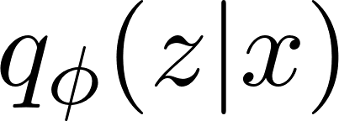](https://www.codecogs.com/eqnedit.php?latex=q_%5Cphi(z%7Cx)#0) to learn this
    - Want [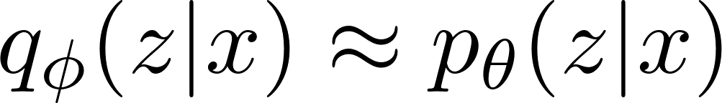](https://www.codecogs.com/eqnedit.php?latex=q_%5Cphi(z%7Cx)%5Capprox%20p_%5Ctheta(z%7Cx)#0)

**Network**:

* Encoder network inputs data [](https://www.codecogs.com/eqnedit.php?latex=x#0), gives distribution over latent codes [](https://www.codecogs.com/eqnedit.php?latex=z#0) (learns [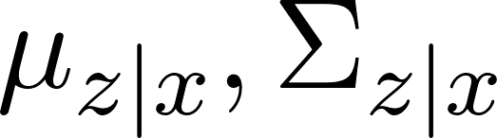](https://www.codecogs.com/eqnedit.php?latex=%5Cmu_%7Bz%7Cx%7D%2C%5CSigma_%7Bz%7Cx%7D#0))
* Decoder network inputs latent code [](https://www.codecogs.com/eqnedit.php?latex=z#0), gives distribution over data [](https://www.codecogs.com/eqnedit.php?latex=x#0) (learns [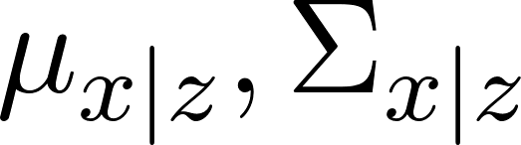](https://www.codecogs.com/eqnedit.php?latex=%5Cmu_%7Bx%7Cz%7D%2C%5CSigma_%7Bx%7Cz%7D#0))
* Want to jointly train both encoder, decoder
  + Train to maximize variational lower bound on data likelihood [](https://www.codecogs.com/eqnedit.php?latex=%5Clog%20p_%5Ctheta(x)%5Cgeq%20E_%7Bz%5Csim%20q_%5Cphi(z%7Cx)%7D%5B%5Clog%20p_%5Ctheta(x%7Cz)%5D-D_%7BKL%7D(q_%5Cphi(z%7Cx)%2Cp(z))#0)

***Fully-connected VAE***:

* Each of encoder, decoder has one initial linear layer + two parallel linear layers for [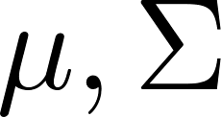](https://www.codecogs.com/eqnedit.php?latex=%5Cmu%2C%5CSigma#0)
  + Encoder: high-dimensional [](https://www.codecogs.com/eqnedit.php?latex=x#0) to low-dimensional [](https://www.codecogs.com/eqnedit.php?latex=%5Cmu%2C%5CSigma#0)
  + Decoder: low-dimensional [](https://www.codecogs.com/eqnedit.php?latex=z#0) to high-dimensional [](https://www.codecogs.com/eqnedit.php?latex=%5Cmu%2C%5CSigma#0) [approx. same dim as original [](https://www.codecogs.com/eqnedit.php?latex=x#0)

Training a VAE (to minimize [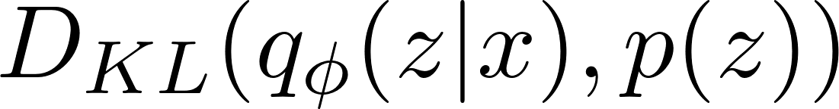](https://www.codecogs.com/eqnedit.php?latex=D_%7BKL%7D(q_%5Cphi(z%7Cx)%2Cp(z))#0))

* Run input data through encoder to get distribution over latent codes
  + Want encoder output to match prior [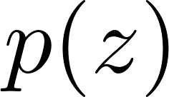](https://www.codecogs.com/eqnedit.php?latex=p(z)#0)
    - Has closed-form solution if [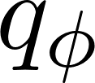](https://www.codecogs.com/eqnedit.php?latex=q_%5Cphi#0) diagonal Gaussian, [](https://www.codecogs.com/eqnedit.php?latex=p#0) unit Gaussian
* Sample latent code [](https://www.codecogs.com/eqnedit.php?latex=z#0) from encoder output
* Run sampled code through decoder to get a distribution over data samples
  + Want original input data to be likely under encoder-output distribution - can sample a reconstruction

Sampling a VAE

* Sample [](https://www.codecogs.com/eqnedit.php?latex=z#0) from prior [](https://www.codecogs.com/eqnedit.php?latex=p(z)#0)
* Run sampled [](https://www.codecogs.com/eqnedit.php?latex=z#0) through decoder to get distribution over data [](https://www.codecogs.com/eqnedit.php?latex=x#0)
* Sample from distribution to generate data

Can edit images after training:

* Run input data through encoder to get distribution over latent codes
* Sample code z from encoder output
  + Modify elements of sampled code as needed
    - Can use to change attributes of image, e.g.
* Run modified z through decoder to get new distribution & sample

**Variational autoencoders**

Pros:

* + Principled approach to generatiev models
  + Allows inference of latent codes q(z|x) -> can be used as feature representation elsewhere

Cons:

* Maximizes lower bound of likelihood rather than computing distribution directly
* Samples are relatively blurry/low-quality compared to SoTA

***Vector-quantized VAE*** (**VQ-VAE**) - combines VAE and autoregressive models

* VAE-like encoder generates latent space
* Converts continuous latent space into discrete distribution (latent code) via vector quantization
  + Trains an autoregressive model on discrete distribution as decoder

Training VQ-VAE

* Train a VAE-like encoder-decoder model to generate multiscale grids of latent codes from input data
  + Decoder - train to reconstruct from latent code
* Use multiscale PixelCNN to sample in/generate from latent code space

VQ-VAE improves on VAE in terms of image quality

* Used as image generation backbone in DALL-E (translating text to images) - uses VQ-VAE to decode text embedding space to generate images

### Generative Adversarial Networks (GANs)

***Generative adversarial networks*** (**GANs**) - train two separate networks: a ***generator network*** G and a ***discriminator network*** D

* Assume have data [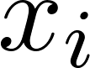](https://www.codecogs.com/eqnedit.php?latex=x_i#0) from [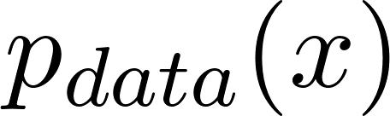](https://www.codecogs.com/eqnedit.php?latex=p_%7Bdata%7D(x)#0), want to sample from [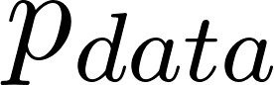](https://www.codecogs.com/eqnedit.php?latex=p_%7Bdata%7D#0)
  + Idea: introduce latent variable [](https://www.codecogs.com/eqnedit.php?latex=z#0) with simple prior [](https://www.codecogs.com/eqnedit.php?latex=p(z)#0)
  + Sample [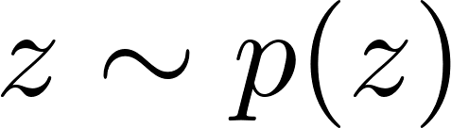](https://www.codecogs.com/eqnedit.php?latex=z%5Csim%20p(z)#0) and pass to generator network [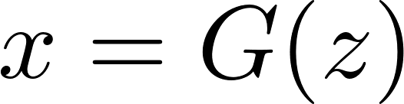](https://www.codecogs.com/eqnedit.php?latex=x%3DG(z)#0)
  + Take samples [](https://www.codecogs.com/eqnedit.php?latex=x#0) from generator distribution [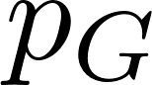](https://www.codecogs.com/eqnedit.php?latex=p_G#0) (want: [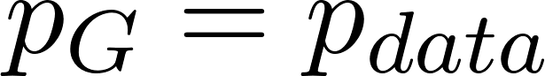](https://www.codecogs.com/eqnedit.php?latex=p_G%3Dp_%7Bdata%7D#0))
    - Train G to “fool” discriminator D
* Discriminator is a classifier network, train to classify data as real/fake
  + Train generator network G to generate an image (taking a sample from generator distribution) and fool the discriminator

**Training GANs**

* Discriminator, generator trained jointly via *minimax* objective
  + Minimax - generator trains to minimize (maximum error across all discriminators)
  + G, D share same loss function, but opposite objectives
    - [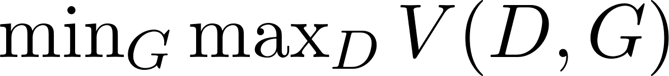](https://www.codecogs.com/eqnedit.php?latex=%5Cmin_G%5Cmax_D%20V(D%2C%20G)#0) [note: no overall loss]
* Doesn’t explicitly model p(x), only samples from it
* Training GANs is difficult, unstable training + loss
  + Plot log(1-D(G(z))
  + Generator initially very bad (very easy for discriminator to distinguish - D(G(z)) near 0), improves over time
    - Issue: vanishing gradients for 0 when D(G(z)) near 0 [log(1-D(G(z)) small]
    - Solution: train G to minimize -log(D(G(z)))
* GANs provably achieve global min when [](https://www.codecogs.com/eqnedit.php?latex=p_G%3Dp_%7Bdata%7D#0)
  + No guarantees on convergence of G, D to optimal

Improving GANs: better loss functions, StyleGAN for higher resolution

* + La begin with fixed constant input vector & add in new layer-wise random latent vectors at each layer

GANs - latent space actually encodes semantic information; can identify patterns in latent space based on semantic attributes (e.g. “man”)

* Latent space is continuous - can perform random walk to traverse
* Can identify subspaces associated with causal relations in latent space using unsupervised learning
  + Can use for manipulation

*Image-to-image translation* (P2P) - can use GANs to translate image types between different domains

* Generator takes input image (rather than random noise) as input; discriminator takes both input image, generator-output image
* *Issue*: for training, need image pairs (one in each domain) for paired translation
  + **CycleGAN** - take two sets of images (one in each domain) with no pairing
    - ***Cycle reconstruction loss*** - minimize reconstruction error from converting from one domain to the other & back again
* Ex: road map to fake satellite image

### 

### Diffusion Models

**Diffusion models**

* Training: rather than one-shot (GAN/VAE), train a model to gradually add Gaussian noise (encoder - forward/diffusion process) and then reverses/denoises the noise (decoder)
  + Decoder uses noise from encoding process to denoise
  + Markov chain process: each step depends only on output of previous step
  + After training: can sample white noise and pass to decoder to generate an image

***Diffusion*** - **Forward/diffusion process**

* At each time step, at some amount of noise [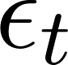](https://www.codecogs.com/eqnedit.php?latex=%5Cepsilon_t#0) from standard normal distribution
  + Hyperparameter [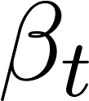](https://www.codecogs.com/eqnedit.php?latex=%5Cbeta_t#0) (noise schedule) determines rate of noise blending
  + Given initial density [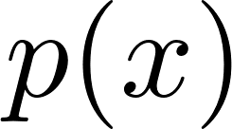](https://www.codecogs.com/eqnedit.php?latex=p(x)#0), diffusion process gradually blurs distribution (moves toward standard normal distribution)
* Take [](https://www.codecogs.com/eqnedit.php?latex=T#0) many steps [](https://www.codecogs.com/eqnedit.php?latex=x%5Cto%20z_1%5Cto%5Chdots%5Cto%20z_T#0)
  + From input image [](https://www.codecogs.com/eqnedit.php?latex=x#0) to [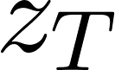](https://www.codecogs.com/eqnedit.php?latex=z_T#0) (approximately pure noise)

***Diffusion*** - ***Reverse/denoising process***

* Want to learn series of probabilistic mappings [](https://www.codecogs.com/eqnedit.php?latex=z_T%5Cto%20z_%7BT-1%7D%5Cto%5Chdots%5Cto%20z_1%5Cto%20x#0)
  + Individual mappings: [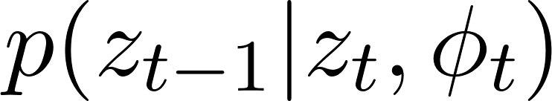](https://www.codecogs.com/eqnedit.php?latex=p(z_%7Bt-1%7D%7Cz_t%2C%5Cphi_t)#0)
  + Maps [](https://www.codecogs.com/eqnedit.php?latex=z_T#0) (pure noise) back to input image [](https://www.codecogs.com/eqnedit.php?latex=x#0) (during training)
  + Via learned neural network
    - Pass in image + time embedding
* Overall, want to learn: [](https://www.codecogs.com/eqnedit.php?latex=%5Chat%5Cphi_%7B1%5Chdots%20T%7D%3D%5Carg%5Cmax_%7B%5Cphi_%7B1%5Chdots%20T%7D%7D%5Cleft%5B%5Csum_%7Bi%3D1%7D%5EI%5Clog%5Cleft%5Bp(x_1%7C%5Cphi_%7B1%5Chdots%20T%7D)%5Cright%5D%5Cright%5D#0)

In practice: use diffusion encoder/decoder as encoder/decoder in U-Net model

* From noise image [](https://www.codecogs.com/eqnedit.php?latex=z_T#0), use U-Net as denoising network for each step [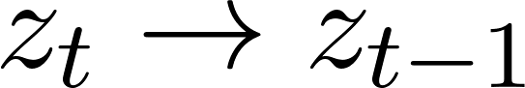](https://www.codecogs.com/eqnedit.php?latex=z_%7Bt%7D%5Cto%20z_%7Bt-1%7D#0)
* After training: pass white noise image + noise concatenations as input to decoder

***Latent diffusion***: use encoder/decoder to move to/from pixel to latent space (similar to VAE)

* Use initial encoder to convert input [](https://www.codecogs.com/eqnedit.php?latex=x#0) into latent space before performing forward diffusion; use final decoder to convert denoising output [](https://www.codecogs.com/eqnedit.php?latex=z#0) back into pixel space output [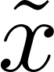](https://www.codecogs.com/eqnedit.php?latex=%5Ctilde%7Bx%7D#0)
  + Performs diffusion within latent space for efficiency + speed
* Ex: unCLIP model
  + Text encoder generates text embedding
  + Use text embedding as input to MLP generating latent code; latent code uses diffusion model as decoder (to generate images)
    - Training - use image encoder (CLIP, e.g.) to convert sampled image to image encoding; CLIP objective - match image encoding with original text encoding

Latent diffusion - extensions

* *Stable diffusion*
* Adding control to text-to-image diffusion (e.g. *ControlNet* - different visual inputs)
  + ControlNet - input condition image & text prompt together; incorporate image encodings of image into diffusion decoder stages via convolution
  + FreeControl: training-free control with any condition

**Generative Models (Summary)**

1. ***Autoregressive models***: directly maximize likelihood of training data [](https://www.codecogs.com/eqnedit.php?latex=p_%5Ctheta(x)%3D%5Cprod_%7Bi%3D1%7D%5ENp_%5Ctheta(x_i%7Cx_1%2C%5Chdots%2Cx_%7Bi-1%7D)#0)
   1. Good quality, but slow & hard to scale
2. ***Variational autoencoders***: introduce latent [](https://www.codecogs.com/eqnedit.php?latex=z#0) for interpolation/editing
   1. Maximizes lower bound
3. ***Generative adversarial networks***: don’t model [](https://www.codecogs.com/eqnedit.php?latex=p(x)#0), but samples [](https://www.codecogs.com/eqnedit.php?latex=p(x)#0)
   1. Good qualitative results
4. ***Diffusion models***: use long Markov chain of diffusion steps to model [](https://www.codecogs.com/eqnedit.php?latex=p(x)#0)
   1. Flexible, but expensive to evaluate/train/sample

## 

## Trends in CV

Current trends:

* Ultra-large vision via foundation models
  + Scaling to large image datasets (OpenAI CLIP)
  + Multimodal image understanding models (LLaVA)
  + Image segmentation (SAMs)
  + Text2Image/Text2Video generation (Stable diffusion, Mochi)
  + Recognition & generation (Chameleon, Janus)
* 3D vision from multiple cameras & neural rendering
  + 3D perception with more cameras/sensors
  + 3D scanning
  + Recognizing 3D shapes (Mesh R-CNN, 3D object detection)
  + Interactive environments for embodied AI
  + Neural rendering: NeRF and Gaussian splatting for surface reconstruction & novel view synthesis from sets of images of objects/environments
    - 3D Gaussian splatting for real-time radiance fields

Challenges

* Interpretability, safety, robustness, etc.
  + Interpretability of AI model
  + AI safety in real-world applications
    - CV models fragile, easily fooled
  + Bias in visual classifiers, datasets
* Need a large amount of training data
  + Low-shot learning - learning from small datasets
  + Self-supervised learning - learning from unlabeled data