OBIARA
Brand Guidelines
The Gathering Identity · Sunset Marigold · Version 1.0

XCreativs Technologies Ltd · Accra, Ghana
July 2026 · Confidential · The Obiara Build Pack

CONTENTS

1. THE IDENTITY AT A GLANCE
Obiara’s identity is The Gathering: eight figures around a shared hearth, bodies rooted to the same center, with the hibiscus figure at the top — the newcomer — completing the circle. It is the compound courtyard, the family meeting and the durbar ground rendered as a single mark, and it is the literal meaning of the name: obiara, everyone, anyone at all, has a place at this fire. This document is the binding rulebook for how that identity appears everywhere: in the app, on a billboard on Liberation Road, on a t-shirt at a campus fire, and on a wedding program. It supersedes the interim system in Build Pack Document 05, which it incorporates.
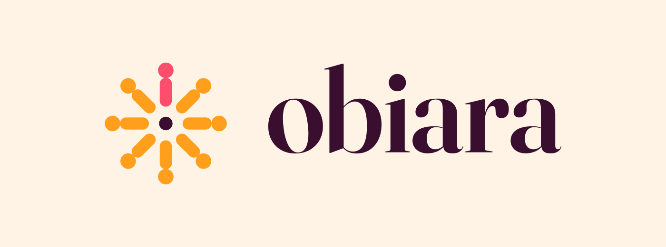
Primary horizontal lockup on Blush Cream — the default expression of the brand.
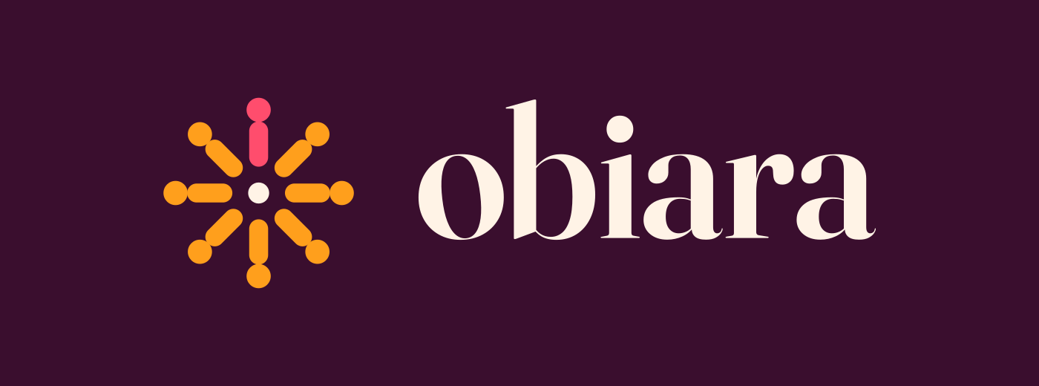
The same lockup reversed on Deep Plum — the brand after sundown.
One sentence to give every printer, agency and intern: marigold figures, one hibiscus newcomer, a shared hearth; Fraunces speaks, Plus Jakarta Sans works; blush cream by day, deep plum by night; and nothing ever shouts.

2. THE MARK: MEANING AND CONSTRUCTION
The story. Eight abstract figures stand in a circle around a hearth. Their heads face outward to the world; their bodies root toward the same center — community that welcomes without closing. Seven figures are Marigold. The eighth, at the top, is Hibiscus: the newcomer, the anyone, the obiara. The hearth at the center is Blush Cream on dark grounds and Deep Plum on light grounds — the fire adapts to the time of day, as fires do.
The construction. The mark is built on a 512-unit grid. Figures sit at 45° intervals; each is a 23-unit-radius head at radius 158 from center and a 36-unit-wide round-capped body stroke from radius 118 to radius 68; the hearth is a 20-unit-radius circle at dead center. This geometry is canonical: never redraw the mark by eye — always place the supplied vector files. The app tile places the mark on the 512 grid inside a rounded square of 115-unit corner radius (the 24% super-ellipse family shared across all product surfaces).
Animation principle (for motion designers). The mark’s signature build is arrival: figures appear one by one around the hearth, the newcomer last, landing with the pod haptic. Never spin, bounce, or explode the mark; people arrive at a fire, they do not orbit it.

3. LOGO VARIANTS AND WHEN TO USE THEM
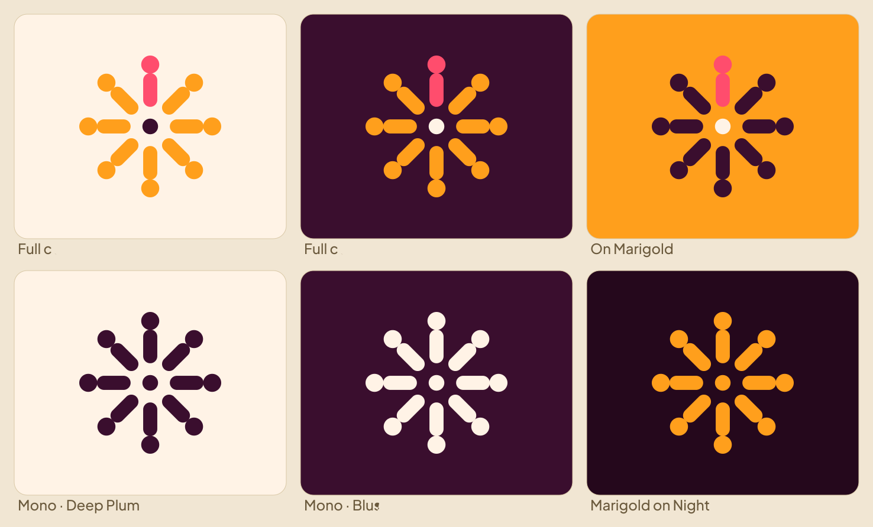
The six sanctioned expressions of the mark. Anything outside this sheet requires brand-lead approval.
Variant | Use when | Files (in the asset pack)
Full colour on light | Default on Blush Cream / Calabash surfaces, documents, light UI | mark-color-onlight, lockup-h/s-color-onlight
Full colour on dark | Deep Plum / Night surfaces, fire-hour UI, social banners | mark-color-ondark, lockup-h/s-color-ondark
On Marigold | Marigold accent blocks, avatar, festival moments | app-tile-gold, profile-avatar-gold
Mono Deep Plum | Single-colour print, fax-grade reproduction, embossing, stamps | mark-mono-ink, lockup-h/s-mono-ink
Mono Blush Cream | Single-colour on dark merch, engraving on dark materials | mark-mono-cream, lockup-h/s-mono-cream
Marigold on Night | Premium contexts: ceremony print, foil, signage at night venues | mark-gold, wordmark-gold
Lockup grammar. The horizontal lockup is the workhorse (headers, banners, cards). The stacked lockup serves square and centered compositions (flyers, merch chest prints, app splash). The mark alone carries the brand wherever the name is already established: app icon, favicons, watermarks, pattern accents. The wordmark alone is permitted only in running text contexts and footers. Never pair the mark with the wordmark in any arrangement other than the two supplied lockups; never let anyone typeset the wordmark in another font — it is supplied as outlined vector art precisely so no one has to.

4. CLEARSPACE AND MINIMUM SIZES
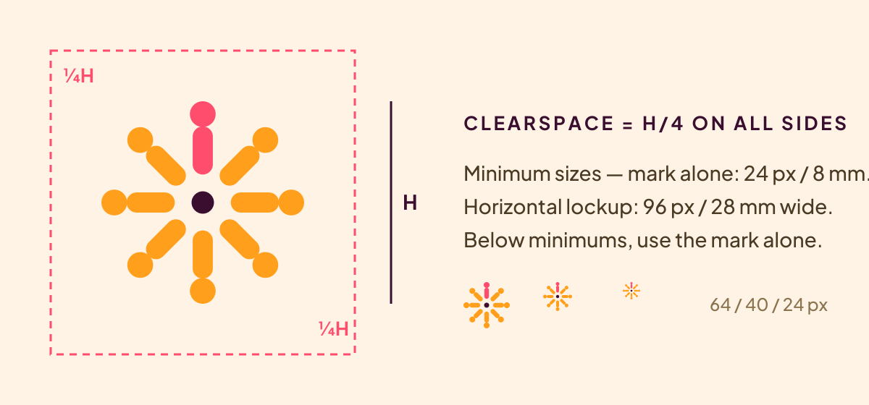
Clearspace equals one quarter of the mark height on all sides; nothing enters it — not text, not photographs, not other logos.
- Minimum sizes: mark alone 24 px digital / 8 mm print; horizontal lockup 96 px / 28 mm wide; stacked lockup 64 px / 20 mm wide. Below these, use the mark alone.
- The mark has been legibility-tested to 24 px; the newcomer figure and hearth must remain distinguishable — if a reproduction process cannot hold them (coarse embroidery, small foil), use the mono variant.

5. MISUSE (THE SHORT LIST OF NEVERS)
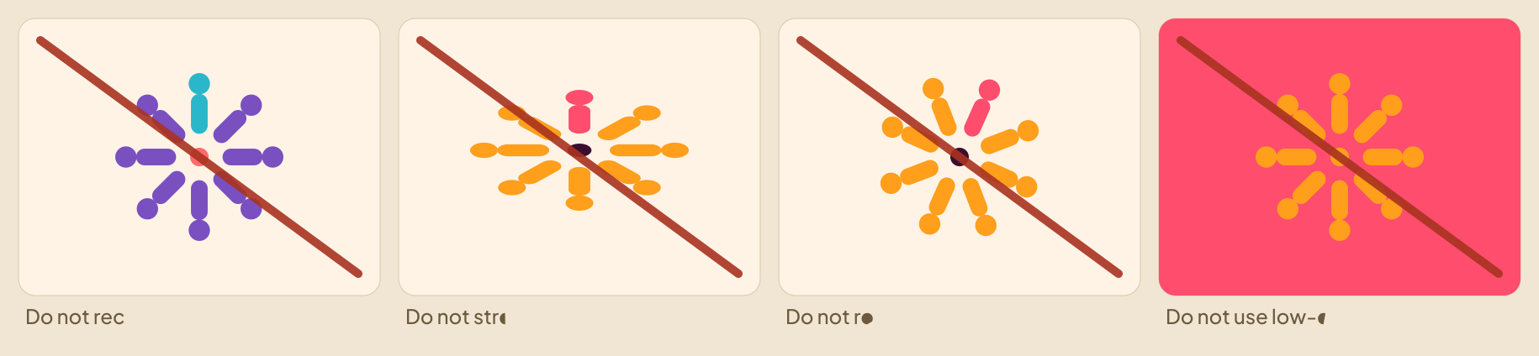
If it is not in Section 3, it is misuse. The four classics, struck through for the avoidance of doubt.
- Never recolour outside the sanctioned variants; never stretch, squash, rotate, outline, shadow, glow or bevel the mark; never place it on low-contrast or visually noisy grounds; never crop it, redraw it, or rearrange the figures; never add taglines into the lockup file; never use the mark as a letter inside other words.

6. COLOUR SYSTEM
The palette is the compound at sunset: the sky gone marigold over a warm courtyard, one flower of hibiscus in the circle. Blush Cream and Deep Plum together carry roughly 80% of every composition; Marigold is the voice of action; Hibiscus is emotional emphasis and the newcomer; Palm Green is growth. Dark mode is not an inversion but a place — Night Fie, the compound after the sun has dropped behind the wall.
Swatch | Token | Role
#3A0E2E | Deep Plum · plum.900 | Primary text on light; Night Fie surface; the mark’s ground
#FFF3E6 | Blush Cream · cream.100 | Light surfaces; text on dark; the hearth on dark grounds
#F3E2CE | Warm Calabash · cream.200 | Cards and elevated surfaces in light mode
#FF9F1C | Marigold · marigold.500 | Primary actions, the drum, the gathered figures
#E8850A | Deep Marigold · marigold.600 | Pressed and active action states
#FF4D6D | Hibiscus · rose.500 | The newcomer; love-context accents; emotional highlights
#12A67C | Palm Green · green.500 | Growth, success, sprout and cloth greens
#2E4270 | Adinkra Indigo · indigo.600 | Informational accents, okyeame presence, links
#FF6B4A | Ember · ember.500 | Fires and live states
#25081C | Night · night.900 | Night Fie base surface
Print conversions (coated stock starting points — always proof): Deep Plum C0 M76 Y21 K77; Marigold C0 M38 Y89 K0; Hibiscus C0 M70 Y57 K0; Palm Green C89 M0 Y25 K35; Blush Cream C0 M5 Y10 K0. For foil and thread: match Marigold to a warm orange-gold, Hibiscus to a coral-fuchsia, Palm Green to jade, Blush Cream to natural unbleached cotton, and Deep Plum to a deep aubergine.
- Contrast law: all text pairings meet WCAG 2.2 AA. Pre-approved pairs ship in the token file; the two most-used are Plum-on-Cream and Cream-on-Plum. Marigold and Hibiscus are never used for body text on light grounds — they carry display headlines and actions only.
- Ratio law: Blush Cream and Deep Plum together carry ~80% of any layout; Marigold ≤12%; Hibiscus ≤5%; everything else is seasoning. When a layout feels loud, it has broken this ratio.

7. TYPOGRAPHY
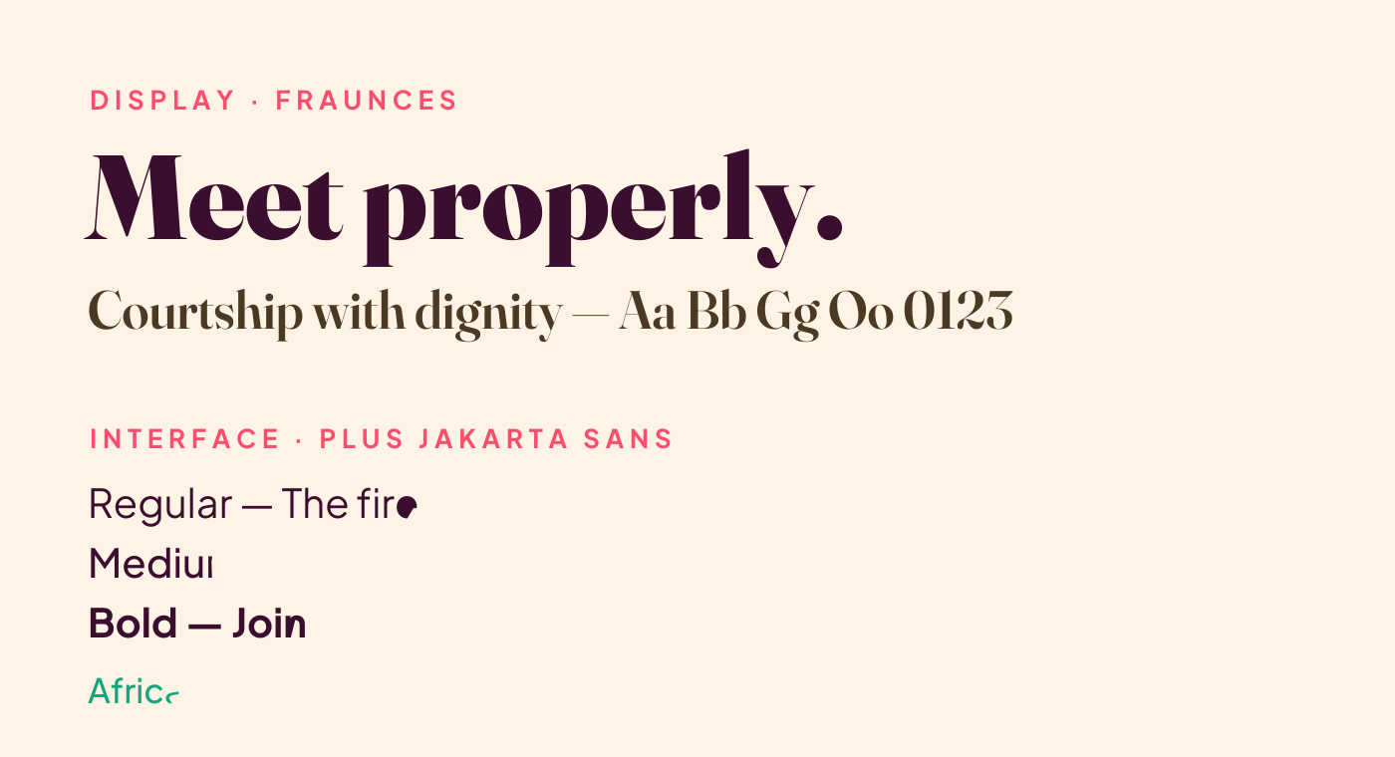
Fraunces speaks; Plus Jakarta Sans works.
Role | Typeface | Rules
Display and brand voice | Fraunces (SemiBold for lockups; Black for headlines) | Never below 21 pt; sentence case; used for rite titles, ceremony moments, campaign headlines
Interface and body | Plus Jakarta Sans (400/500/700/800) | All UI and long text; tabular figures for prices and counts
African-Latin fallback | Noto Sans (mandatory in every font stack) | Verified in testing: PJS lacks ɛ/ɔ glyphs — Twi, Ga and Ewe strings must resolve through Noto Sans; QA includes a glyph-coverage check per language pack
Scale (mobile-first, 1.2 ratio): display 34/40, title 26/32, heading 21/28, body 16/24, secondary 14/20, caption 12/16. Letterspacing +2% on all-caps labels only; the wordmark ships with its spacing baked in. Local-language dignity rule stands: Twi, Ga, Ewe and Pidgin render in the same stack as English — the culture lives in the words and the weave, never in faux-tribal display type.

8. THE KENTE ACCENT BAND AND PATTERN LANGUAGE
The brand’s supporting pattern is the kente accent band — a thin strip-weave sequence of Marigold, Hibiscus, Palm Green and Blush Cream on dark grounds, always horizontal, always anchored to an edge (typically the base of a composition, like the selvedge of a cloth). It appears on social banners, cards, certificates and packaging. Rules: one band per composition; 12–24 px height digital / 3–6 mm print; never as a full background fill; never rotated to vertical except on bookmarks and lanyards where the format demands it. Adinkra symbols follow the product policy: meaning-bearing accents only, named on long-press in product, never wallpaper.

9. SOUND AND MOTION (BRAND LEVEL)
The drum is the brand’s voice: the two-beat atumpan pod phrase is the sonic logo, used at the end of video idents and radio spots. Motion follows the product physics — calm, weighted, cloth-like, 250–350 ms, the custom ease (0.32, 0, 0.16, 1) — and the mark’s only sanctioned build is the arrival animation described in Section 2. Full specifications live in Build Pack Document 05 §6–7; the commissioning brief for the percussion family is launch-critical.

10. APPLICATIONS

10.1 App icon, favicon and avatars
The app icon is the Deep Plum tile with the full-colour mark (primary) or the Marigold tile with deep-plum figures (marketing alternate). Avatars for social profiles use the full-bleed squares supplied — the mark is centred at 62% so every platform’s circular crop is safe. Favicons ship at 512/192/48.

10.2 Social media system
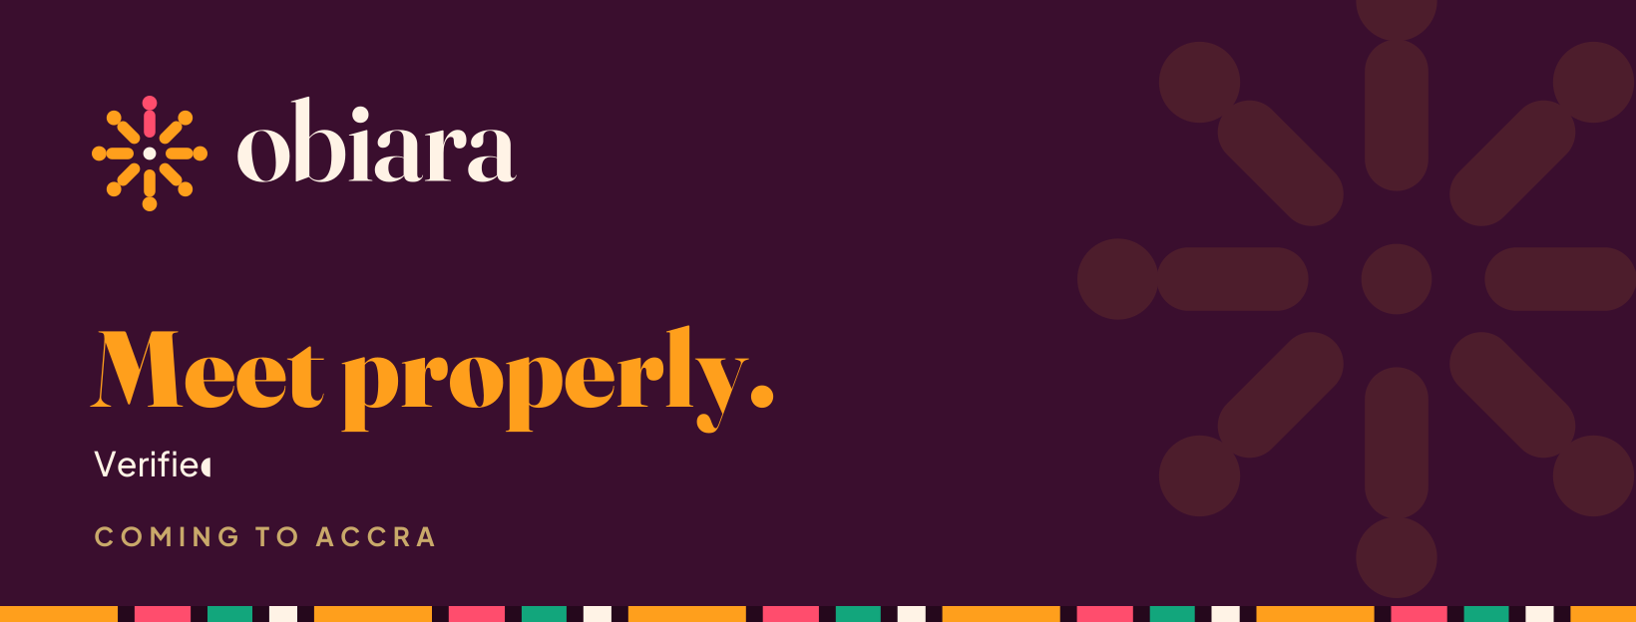
Facebook page cover — supplied print-ready at 1640×624.
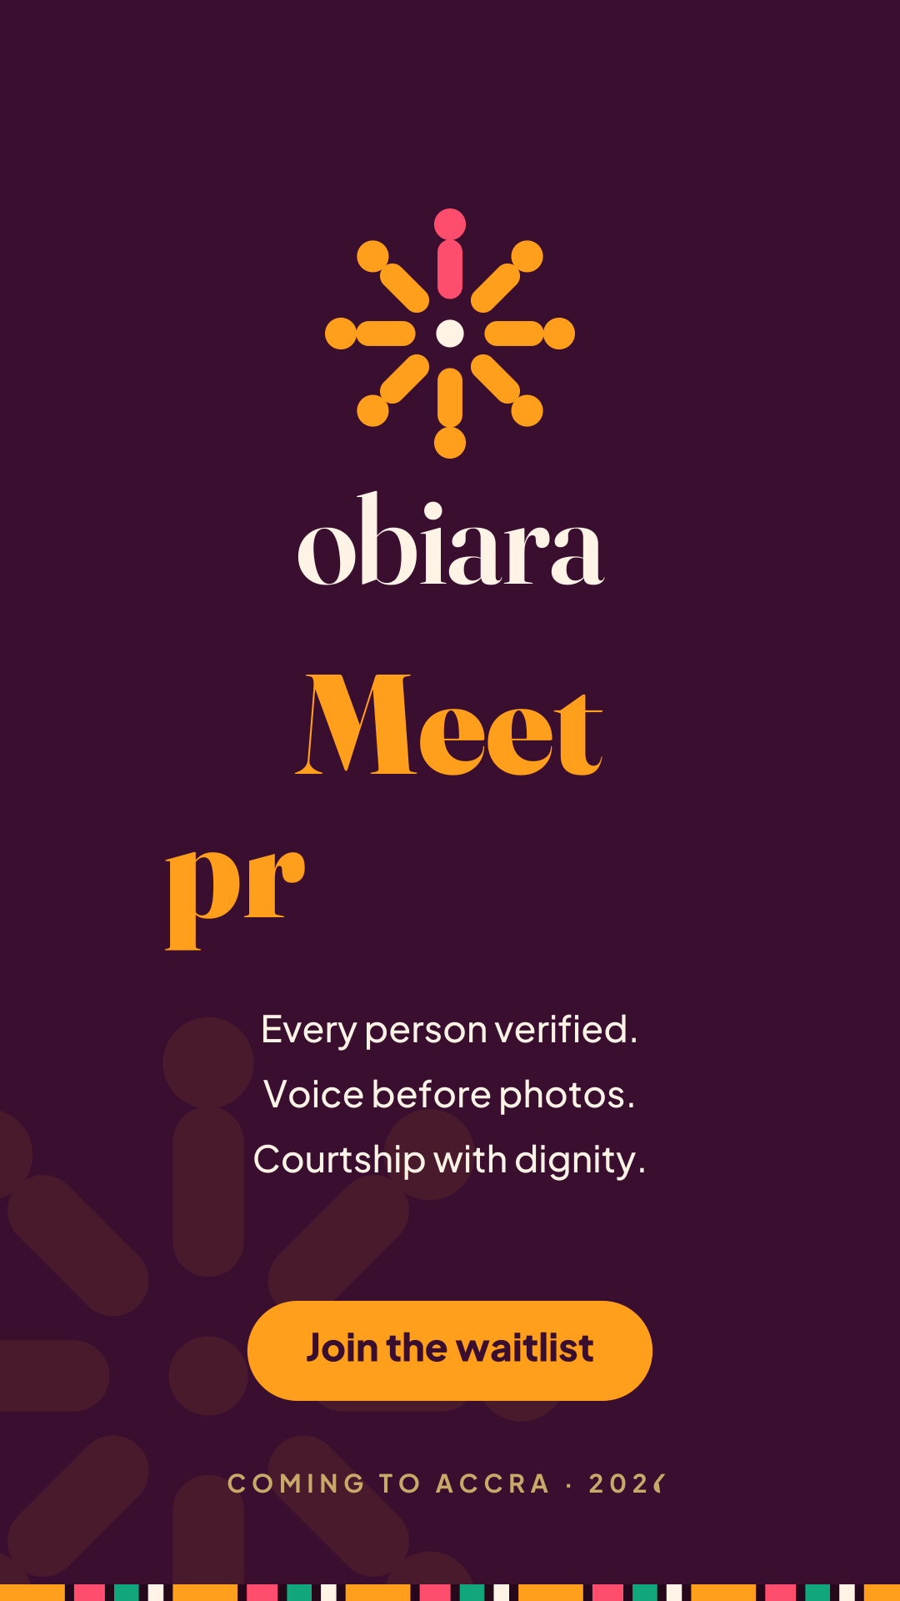
Story and status flyer, 1080×1920 — the vertical launch unit for Instagram, WhatsApp Status and TikTok stills.
Supplied set: Facebook cover 1640×624, LinkedIn company banner 2256×382, X header 1500×500, Instagram launch flyer 1080×1080, Story flyer 1080×1920, plus the three avatars. Composition grammar for any new social unit: a deep-plum ground, a ghosted marigold mark at ≤10% opacity for depth, lockup top-left or centred, a Fraunces Black headline in marigold, a Plus Jakarta support line in cream, kente band at the base, one CTA maximum. Call-to-action copy is "Join the waitlist" until launch — no URLs or handles appear in artwork until the domain and handles are secured and confirmed by leadership (placeholders in supplied files are deliberate).

10.3 Merchandise
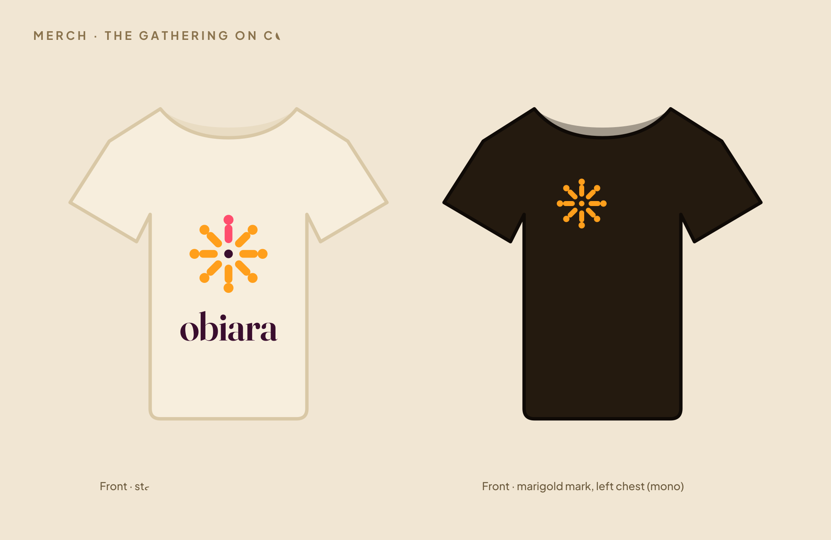
The two sanctioned tee treatments: stacked lockup centred on naturals; marigold mono mark at left chest on darks.
Merch rules: natural cotton (unbleached, close to Blush Cream) and deep-plum garments only; print in the mono or marigold variants (full colour reserved for high-fidelity DTG on naturals); mark at left chest 8–9 cm, or stacked lockup centred at 24–26 cm; the kente band may run on sleeve hems and sock welts; never place the wordmark across shoulder seams; hosts and matchmakers receive badged variants with role wordmarks set in Plus Jakarta Sans 800 — the only sanctioned pairing of the mark with additional type.

10.4 Out-of-home and print
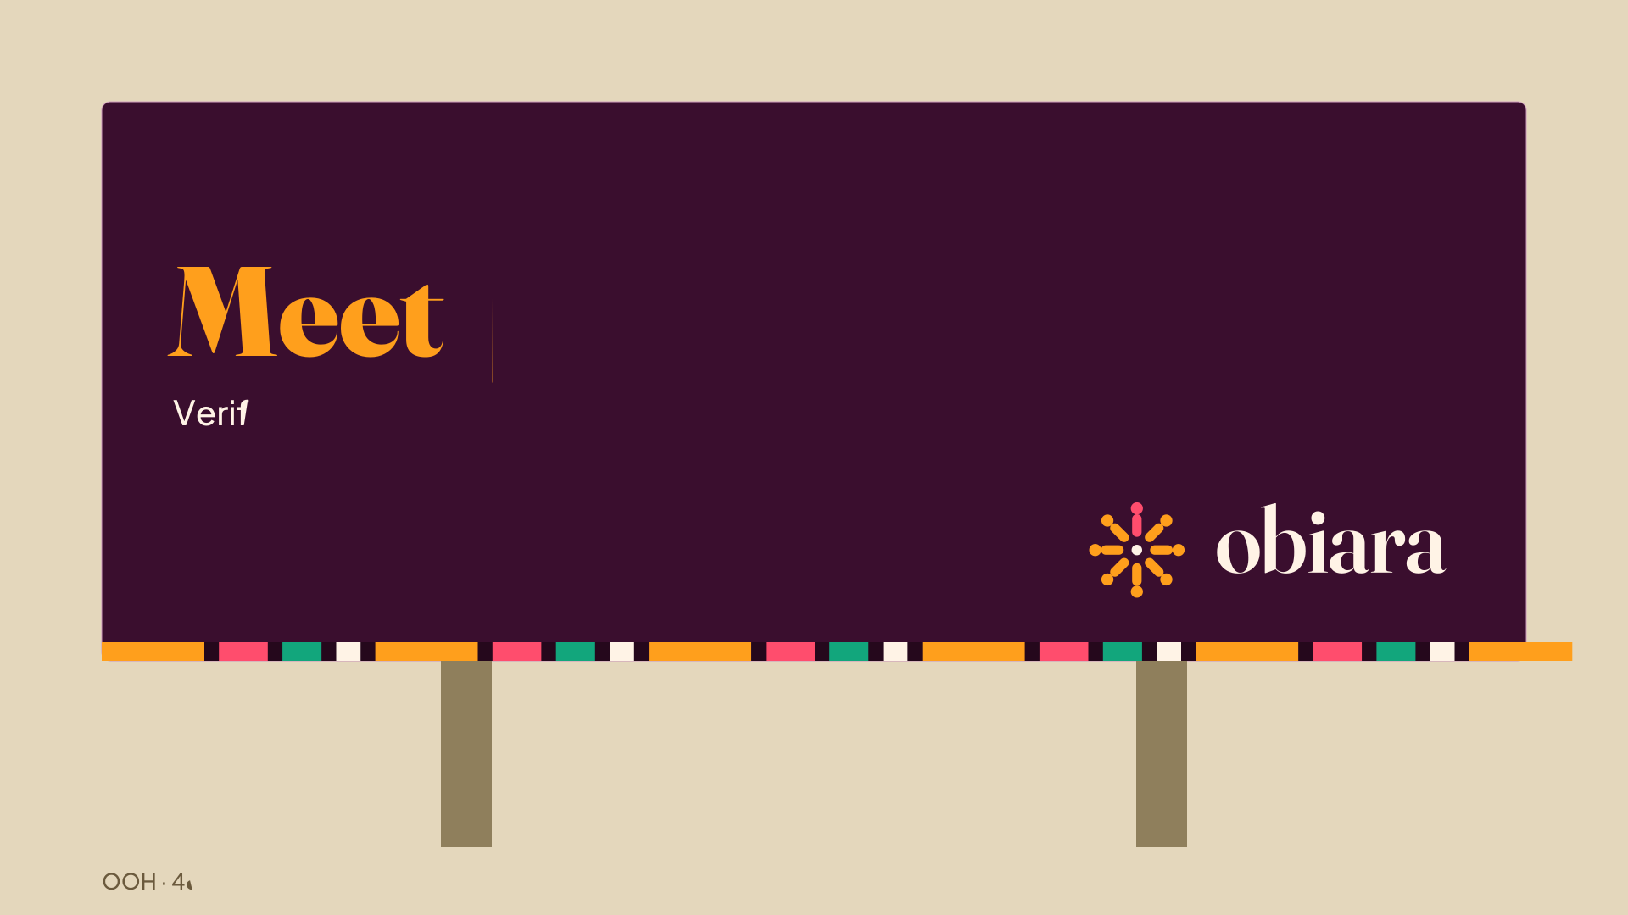
48-sheet grammar: one headline, one support line, the lockup, the band. Nothing else.
OOH grammar: headline ≤3 words where possible (the campaign master is "Meet properly."), support line optional, lockup bottom-right at ~22% of board width, kente band on the base edge, ≥40% empty plum. Trotro and streetpole variants follow the same grammar at their aspect ratios. Print collateral (programmes, certificates, Aseda cards) uses Blush Cream stock, Deep Plum text, gold foil for the mark where budget allows — the ceremony contexts are where the brand spends on finishings.

10.5 Stationery
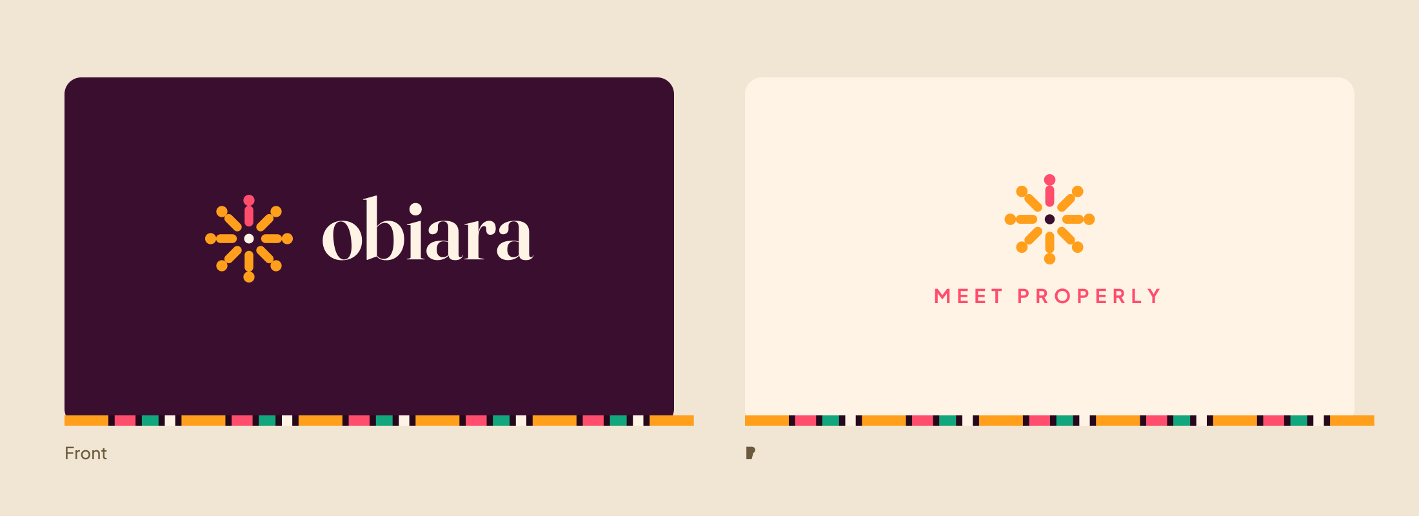
Card system: Deep Plum front with the lockup; Blush Cream back with the mark and campaign line. Contact details set in Plus Jakarta Sans 400/700, cream on plum.

11. THE ASSET PACK INDEX
Everything referenced above ships in Obiara_Brand_Assets.zip, organised as follows. SVGs are the editable masters; PNGs are supplied at production resolution (logos ~2000 px, icons 1024, social at native platform size).
Folder | Contents
logo/svg | 5 mark variants, 8 lockups, 3 wordmarks, 2 app tiles — editable vector masters
logo/png | Every mark and lockup as transparent PNG plus light-ground, dark-ground and marigold-ground background versions
icons | App icons (plum and marigold), favicons 512/192/48, profile avatars (marigold, plum, cream) at 1024
social | Facebook cover, LinkedIn banner, X header, Instagram flyer, Story flyer
mockups | T-shirt treatments, billboard, business cards
fonts | Fraunces and Plus Jakarta Sans (static weights + variable originals) with their SIL Open Font Licenses
File naming grammar: asset-form-variant_background.png (e.g., lockup-h-color-ondark_on-umber.png, where the "_on-umber" suffix denotes the dark plum ground). "ondark/onlight" describes which ground the colourway is designed for; "_on-x" describes the baked background; "_transparent" means alpha.

12. GOVERNANCE
- This document plus the design-token file are the single source of truth; both are versioned together and changes require design-lead and founder sign-off.
- Trademark actions this quarter: register the wordmark and The Gathering device (Ghana Class 9/45, Madrid Protocol for UK/US/NG corridors); commission and trademark-search the atumpan sonic logo.
- The Auntie Review covers brand dignity: any application that would embarrass the aunties at a family gathering fails, whatever the metrics say.
- Requests and exceptions: brand@ (address to be established) routes to the design lead; until then, the founders arbitrate.

