**ABSTRACT**

"Mero Phonebook: A Contact Management System" is a C program based app that aims to provide contact management facility for your countless contact numbers used in everyday life. A user is able to add new contact, modify it, search and delete necessary contacts available by using Mero Phonebook application. In modern era of technology, every person possesses one or two contact number. A contact number is an important aspect for making communication through mobile network and so remembering every contact number of friends, family, etc. can be termed as impossible task. Traditional method of saving contact in small contact book maybe a bad idea as it can be damaged and provide no privacy at all. This project aims to replaces those traditional method to provide application platform for managing contact ensuring swiftness, easier, privacy and cost effectiveness. The core function of this application is contact registration, modifying, searching and deleting contact, etc.

***Keywords: Contact number, mobile network, cost effective, contact registration, modify contact***

**Table of Contents**

1. **Introduction**……………………………………………………………... 1
2. **Problem statement**………………………………………………………. 2
3. **Project objectives**………………………………………………………... 2
4. **Literature Review**……………………………………………………….. 3
5. **Methodology**……………………………………………………………... 4

**5.1. Requirement Identification**………………………………………………... 4

**5.2. Feasibility Study**…………………………………………………………… 5

1. **Testing and Verification**………………………………………………… 6

**6.1. Unit Testing**………………………………………………………….... 6

**6.2. Integration Testing**……………………………………………………. 6

**6.3. Validation Testing**…………………………………………………….. 6

**6.4. System Testing**………………………………………………………… 7

**6.5. Errors and Debugging**………………………………………………… 7

1. **Timeline**…………………………….……………………………………. 8

**Gantt chart**………………………………………………………………... 8

1. **Flowchart**………………………………………………………………… 9
2. **Preview of the program**….…………………………………………….. 10
3. **References**………………………………………………………………. 13

**1. Introduction**

Contact number can be defined as a number that can be used to contact a particular person, company, or organization by using cellular network in phone. A contact management system is a digital method for storing, quick access, editing and tracking contact numbers through computer rather than using a notebook and a pen. Normally this includes opening application on your PC and add up new contacts necessary for future reference.

Many business organization have adopted use of contact management system due to the fact that in today’s fast-paced business world, it can be hard to remember every customer’s information and their individual contact. That’s why it’s essential to store data electronically, share it with team members when needed and continuously gather information to interact with clients and customers.

Mero Phonebook will be an application that aims to register, store and modify contacts with ability to handle basic information, such as names, address, email address, age, sex, etc. of the correspondent in Personal computer. This system provides data quickly with ensured privacy and less error rate compared to traditional methods like saving in notebook.

**2. Problem Statement**

In this technological society where every single person owns personal contact information it seems impossible for any person or organization to remember every contact numbers and their personal information. It bring out major issue including loss of communication, loss of data, etc. while using traditional methods such as use of small notebook can bring problems such as prone to error, time consuming, damaged easily and insecure. This contact management system will be able to address the above issues.

As a general truth we cannot contact each other without either contact number or email address. Storing information in a secure place acts as a better solution to problem which is use of contact management system for convenient data saving by the use of PC for personal use as well as for commercial purpose in various business organization to maintain relationship with customers and clients.

**3. Project Objectives**

The specific objectives of the project includes:

* To store and edit contact and, keep contact information organized in a searchable format.
* To provide quick access to contact data and provide more security and protection to data by use of system.

**4. Literature Review**

Abstract-Memory of human being is usually poor and often fails. On some occasions, it generally causes uneasy situations. As the number of relations among people increases, it is difficult for people to maintain their social contacts with merely memory. To help people for better management their social contacts, a powerful social contact management tool named Social Contact Manager (SCM) is introduced. It supports a simple but efficient contact retrieval interface and auto-collection of rich contact data. On the basic of survey results, the SCM system is developed. To estimate the usability and usefulness of SCM, a user study of contact management is performed which proved SCM is very helpful for contact re-finding. Particular phenomena about social contact management and recall are discovered. Based on the result of this user study, the human contact-memorizing pattern is also concluded. Purposely, the contact name recall is used in the academic community as the target application to showcase our proposed methodology. We further develop an intelligent social contact manager that supports:

1) Auto-collection of rich contact data from a combination of pervasive sensors and Web data sources.

2) When human memory fails, use associative search of contacts.

3) User study on contact memory recall is also conducted, through which several findings about contact memorizing and recall are presented.

**5. Methodology**

**6.1. Requirement Identification**

First step for the completion of project deals with the design of contact management system as per requirement that could store, modify and be easily accessed by user. In this phase, a logical system is built which fulfils the given requirements. Design phase of system development deals with transforming the requirements into a logically working system. In this phase, the system is designed at block level. The blocks are created and the basis of analysis done in the problem identification phase.

The general tasks involved in the design process are the following:

1. Design various blocks for overall system processes.

2. Design smaller, compact and workable modules in each block.

3. Design various database structures.

4. Specify details of programs to achieve desired functionality.

5. Design the form of inputs, and outputs of the system.

6. Perform documentation of the design.

After completion of design process, system should follow the command of user as per requested. It will consist of 6 options i.e. Add contact, list contact, search for contact, edit the contact, delete a contact and exit options. User will gain access to each option available through selecting number from 1 to 5 meaning if a user want to access add contact they shall press 1 and so on. To exit, user shall press 0.

**6.2. Feasibility Study**

The feasibility study was carried out to test whether the proposed system is worth being implemented. It is necessary to evaluate the feasibility of a project at the earliest possible time. The key consideration involved in the feasibility study are:

1. Technical Feasibility
2. Economic Feasibility
3. Operational Feasibility

**Technical Feasibility**

In technical feasibility study, one has to test whether the proposed system can be developed using existing technology or not. The proposed system is planned to implement using C language which is supported by the current hardware and software making it technically feasible.

**Economic Feasibility**

Any project can be termed as economically feasible only when benefits outweigh costs. This system was economically feasible as no costs were needed. The benefits of this system outweighed the cost so this system was further implemented.

**Operational Feasibility**

This test checks if the system works properly when it is developed and installed. Technical staff with knowledge of C programming is required to configure the system. For users, demo can be given to be familiar with the software.

**6. Testing and Verification**

Software testing is s process of executing s program or application with the intent of finding software bugs. Proper testing ensures reliability, security, best performance which result in time saving, effectiveness etc. The testing of the system includes the following testing:

**6.1. Unit Testing**

The Unit testing of the system included the following testing;

* Contact registration validation
* Contact edit validation
* Contact deletion validation
* Contact list validation

**6.2. Integration Testing**

Integration testing aims at constructing the program structure while at the same constructing tests to uncover the errors associated with interfacing the modules. It was done by following ways:

* The test integration plan was prepared.
* The integration testing approach was decided and test cases, test scenarios and test scripts were designed accordingly.
* The chosen modules were deployed together and the integration tests were run.
* The defects were tracked and the test results were recorded.

**6.3. Validation Testing**

Validation testing was performed to ensure that all the functional and performance requirements are met. It was done as following:

* The validation plan was created and the system requirements were defined.
* Validation protocols and test specifications were created.
* The testing was done and the procedures were revised.

**6.4. System Testing**

System testing was done to ensure that the system satisfies all the user requirements. It was performed by following methods:

* The system test plan was prepared.
* A series of test cases were written to use during system evaluation process.
* A testing environment was created by arrangement of predetermined hardware and software.
* Finally, the testing protocols were performed and each evaluations were executed systematically.
* The errors were recorded and then, edited.

**6.5. Errors and Debugging**

System testing is necessary to check whether the intended output is produced or not. So, we tested out our system and following were the results:

|  |  |  |  |
| --- | --- | --- | --- |
| Description | Expected Result | Actual Result | Status |
| Closing program directly from close button | File saved automatically | File not saved | Failed |
| While saving or modifying contact | User can go backs to main menu session anytime in between saving or modifying process | User cannot go back until contact is saved or complete | Failed |

**7. Timeline**

An elementary Gantt chart or Timeline chart for the development plan is given below. The plan explains the tasks versus the time (in weeks) that was taken to be completed.

|  |  |  |  |  |
| --- | --- | --- | --- | --- |
| SDLC | Project Activity | Start Date | Duration(Days) | End Date |
| Phase 1 | Requirement Analysis | 2079-10-1 | 7 | 10-7 |
| Phase 2 | Analysis | 10-8 | 7 | 10-14 |
| Phase 3 | Design | 10-15 | 7 | 10-21 |
| Phase 4 | Coding | 10-22 | 20 | 11-13 |
| Phase 5 | Testing | 11-14 | 7 | 11-20 |
| Phase 6 | Implementation | 11-21 | 7 | 11-27 |

**Gantt chart**

|  |  |  |  |
| --- | --- | --- | --- |
|  | Magh | Falgun |  |
| Requirement Gathering |  |  |
| Analysis |  |  |
| Design |  |  |
| Coding |  |  |
| Testing |  |  |
| Implement |  |  |
|  | W1 W2 W3 W4 | W1 W2 W3 W4 |

**8. Flowchart**

Display Main menu

Prompt user for choice

Add new contact

Display success message

List all contacts

Search for contact

Edit contacts

Delete contact

Exit program

Display error message

Go back to main menu

Choice = 0

Choice = 5

Choice = 4

Choice = 3

Choice = 2

Choice = 1

Yes

Yes

Yes

Yes

No

No

No

No

No

Yes

No

Yes

**9. Preview of the program**

1. 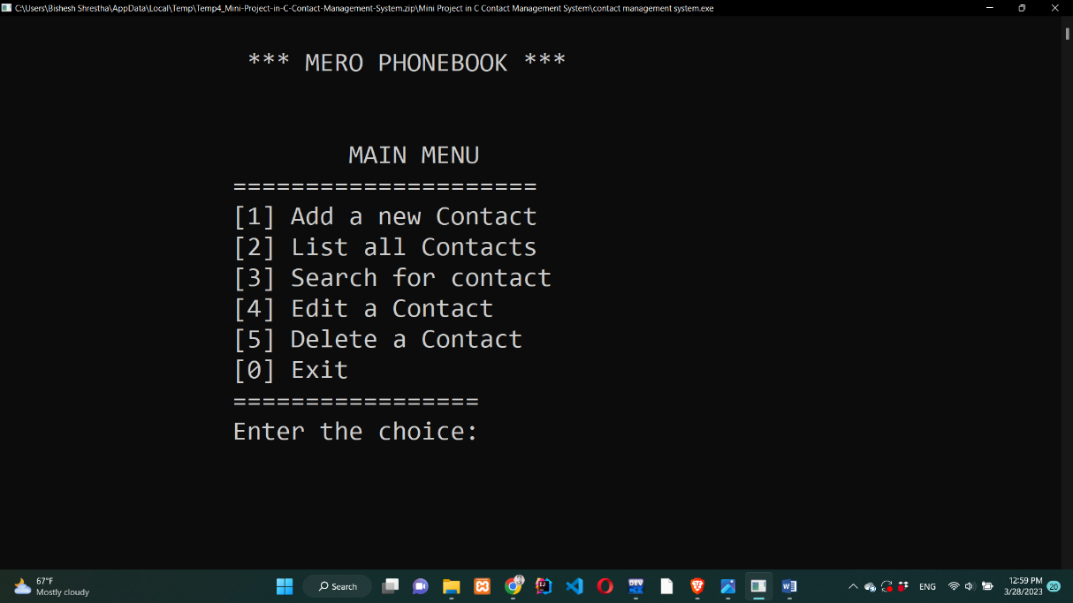Welcome to the main menu of Contact management system.
2. 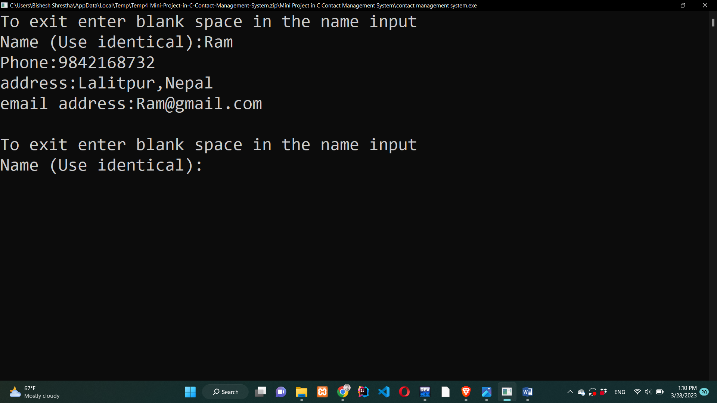New contact: To create a new contact press 1 and enter. Then, add necessary information as required.
3. List out Contact: To List out all saved contact press 2 and enter. Then, all contact that have been saved will be displayed in alphabetical order. Press enter to display next contact.

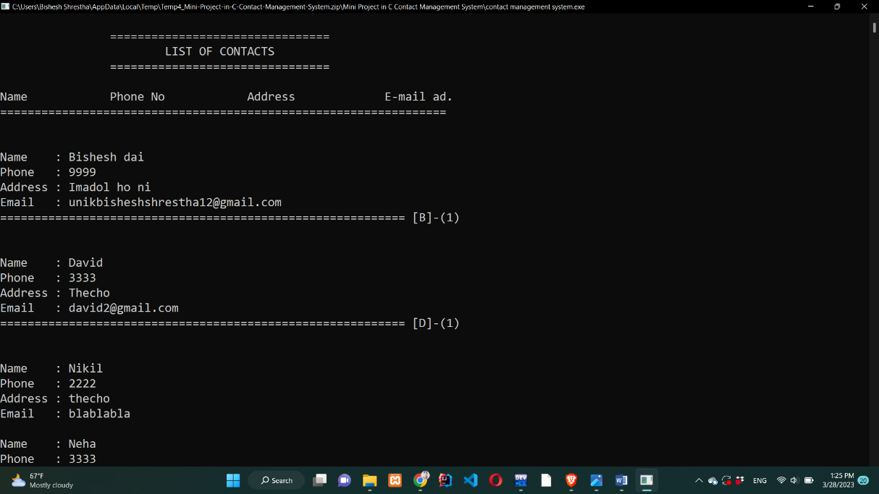

1. 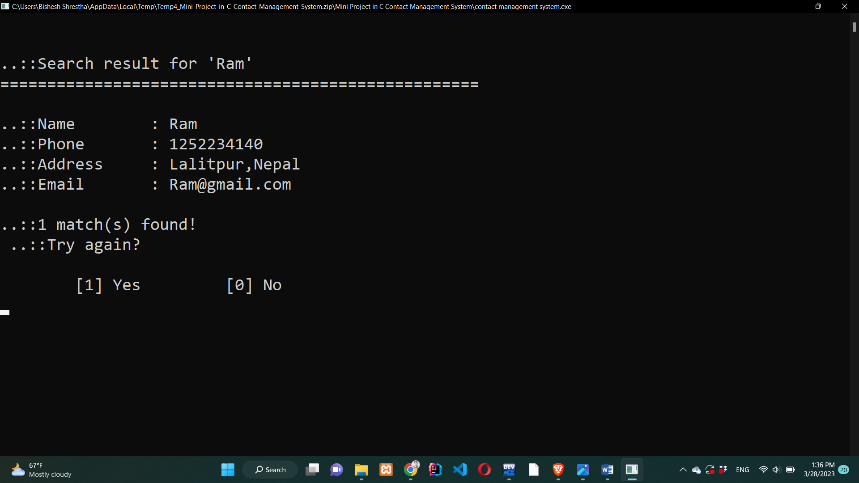Search Contact: To search any contact press 3 and enter. Then, enter the name of contact you want to search. If you want to try again press 1 and enter.
2. Edit Contact: To edit any contact press 4 and enter. Then, enter the name of contact you want to edit. User is able to change name, contact number, mail and location as required.

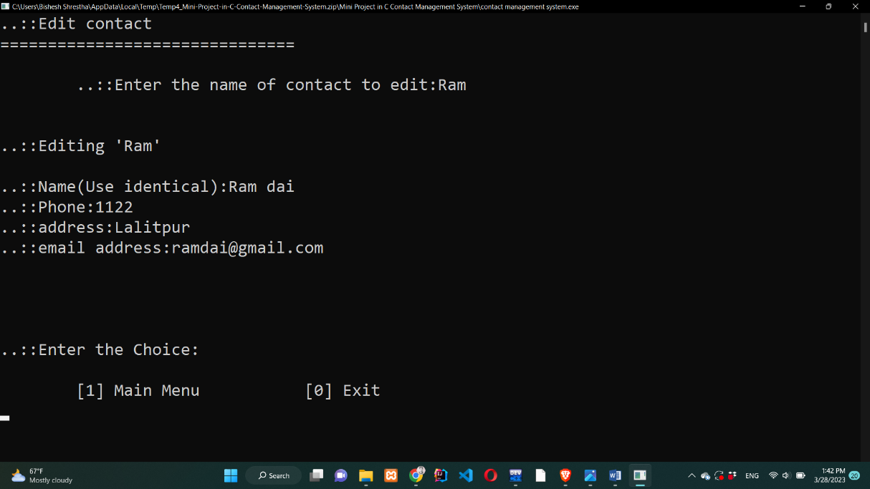

1. 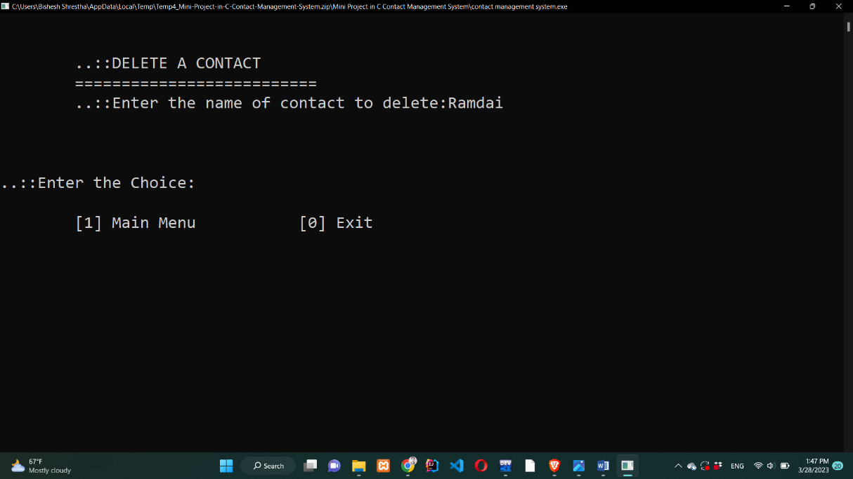Delete contact: To delete any contact press 5 and enter. Then, enter the name of contact you want to delete and press enter. It will be removed.
2. Exit system: Press 0 and user will exit from the contact management system.

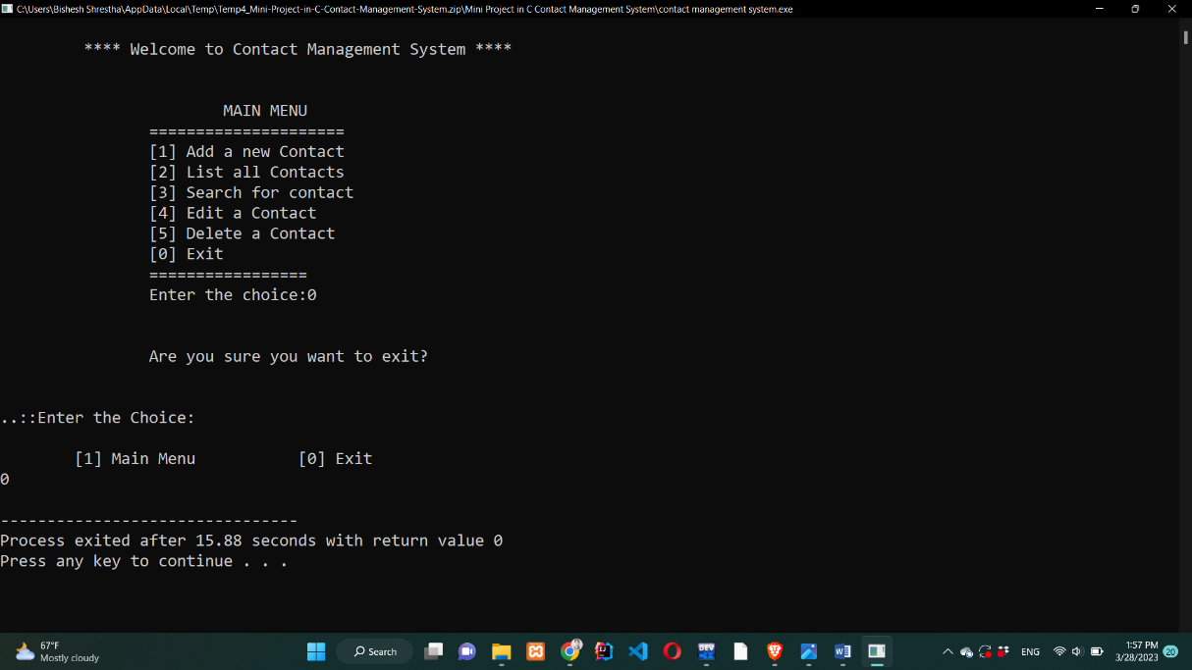

**10. References**

* [https://www.ijeit.com/Vol%203/Issue%209/IJEIT1412201403_42.pdf](https://www.ijeit.com/Vol%203/Issue%209/IJEIT1412201403_42.pdf?fbclid=IwAR3rzh0seJMFwlFzyFwkJPxge__yc0cdDI3pbz5PHH2LDRxonqRFdBib_-w)
* [https://www.scribd.com/document/379538942/Contact-Management-System#](https://www.scribd.com/document/379538942/Contact-Management-System?fbclid=IwAR3JqVBzIMKD_JGirNmzDoOPLRpprU2RpjRLoNn8ismZzeWlpLnP2dVpUwI)
* [https://www.businessnewsdaily.com/16186-what-is-contact-management.html](https://www.businessnewsdaily.com/16186-what-is-contact-management.html?fbclid=IwAR2en4eSn4MW4IgNXMEOpFhGI-PqmJtiIZZF6fknTL80RrIy6xsbNzA4kmg)
* [https://aceproject.org/ace-en/topics/et/etb/etb02/etb02b/etb02b03](https://aceproject.org/ace-en/topics/et/etb/etb02/etb02b/etb02b03?fbclid=IwAR1QTiQDO8dpeFUSD3O4hDhhFtRpvJcB5SDfn7Pnyl9aY-5483YvyKP2O1k)
* [https://www.indeed.com/](https://www.indeed.com/career-advice/career-development/system-testing)
* <https://www.edureka.co/>