**KATHFORD INTERNATIONAL COLLEGE OF ENGINEERING AND MANAGEMENT**

**Balkumari, Lalitpur, Nepal**



**A**

**Project Report**

**On**

**"Hamro Tour (Travel Planner)”**

**Submitted To:**

Department of Information Technology (DoIT)

Kathford International College of Engineering and Management

**Submitted By:**

Nikil Maharjan

Bishesh Ganesh Shrestha

Date: 2080-4-17

**ABSTRACT**

"Mero Tour: Tour Planner " is an online innovative website that aims to provide user friendly interface that allows users to personalize their travel plans based on their preferences, interests, and unique travel needs. A user will be able to plan their tour easily and conveniently by using ‘Mero Tour’ platform. In modern era of social media, discovering popular destination for ourselves, group or family has been easier than ever before. An organized tour is an important aspect for visiting new destination and creating unforgettable experiences once in life. Visitors can be unaware of present condition of destination such as weather, hotel availability, road condition or flights which can create problem during visit including budget. This project aims to replaces those uncertain problems and provide online platform for organizing tour ensuring swiftness, cost effectiveness, pre-arrangement, time saving and enhanced experience. The core function of this website is registration, booking hotel and transport, searching destination etc.

***Keywords: User Friendly, Travel plans, popular destination, booking, cost effective, time saving, transport***

**TABLE OF CONTENTS**

1. INTRODUCTION1

2. PROBLEM STATEMENT2

3. PROJECT OBJECTIVES3

4. SCOPE AND LIMITATIONS3

4.1. Scope3

4.2. Limitations3

5. METHODOLOGY4

5.1. Requirement Identification4

i) Study of existing system4

ii) Requirement Collection6

5.2. Feasibility Study7

A) Economic Feasibility7

B) Technical Feasibility7

C) Operational Feasibility7

6. TIMELINE8

7. EXPECTED OUTCOME9

8. REFERENCES10

9. BIBLIOGRAPHY10

**1. INTRODUCTION**

**Hamro Tour** website is an innovative online platform designed to assist travelers in organizing and optimizing their travel journeys in Nepal. This website aims to provide users with a comprehensive and user-friendly toolset to plan their trips with ease. Whether one seeks a solo adventure, a family vacation, or a group tour, the ‘Hamro Tour’ website caters to diverse travel preferences and interests. The primary objective of this platform is to empower travelers to create personalized schedules that align perfectly with their individual tastes, time constraints, and budgets. It curates a vast repository of travel information, including destination details, points of interest, local attractions, weather forecasts, and cultural insights, thereby serving as a one-stop resource for travel enthusiasts.

Furthermore, the ‘Hamro Tour’ website integrates with reputable third-party travel service providers, enabling users to book flights, hotels, tours, and other essential travel arrangements directly through the platform. This seamless integration simplifies the travel booking process, saving time and effort for travelers and enhancing their overall experience. As the world becomes increasingly interconnected, the ‘Hamro Tour’ website endeavors to be a dynamic and adaptive solution, continually updating its database with the latest travel trends, destinations, and services. It remains committed to delivering a user-centric experience that instills confidence and excitement in travelers, as they embark on journeys that broaden horizons and foster a deep appreciation for the diversity of our homeland landscape.

**2. PROBLEM STATEMENT**

The current travel planning process is often time-consuming, overwhelming, and lacks personalization, leading to difficulties for travelers in efficiently organizing their trips. Travelers face the following challenges:

1. **Information Overload:** With an abundance of travel resources available online, travelers struggle to find reliable and up-to-date information about destinations, attractions, accommodations, and activities.
2. **Lack of Personalization:** Many travel platforms provide generic recommendations that do not consider individual preferences, interests, and budgets, resulting in an unsatisfying and generic travel experience.
3. **Booking Hassles:** Travelers must navigate through multiple websites to book flights, hotels, tours, and other travel essentials, leading to a fragmented and time-consuming booking process.
4. **Safety and Weather Concerns:** Travelers often face uncertainties related to safety, weather conditions, and potential disruptions at their chosen destinations.

To address these issues and improve the overall travel planning experience, we’ve developed the ‘Hamro Tour’ website which will serve as a comprehensive and user-friendly platform that offers personalized travel schedules, a vast repository of travel information, seamless booking integration, collaboration features, and authentic user reviews. By addressing above pain points, the ‘Hamro Tour’ website aims to revolutionize the way travelers plan and experience their journeys, making travel planning efficient, enjoyable, and hassle-free.

**3. PROJECT OBJECTIVES**

The specific objectives of the project includes:

* To make travel planning easy and convenient for users, providing them with a user-friendly interface.
* To allow users personalize their travel plans based on their preferences, interests, and unique travel needs.

**4. SCOPE AND LIMITATIONS**

**4.1 Scope:**

‘Hamro Tour’ is a user-friendly travel planning website designed to assist enables users to efficiently organize their plans, discover popular destinations, and find the best routes and attractions to visit creating unforgettable experiences. With a simple and intuitive interface, ‘Hamro Tour’ scopes to ensure users plan their budget according to cost of expenditure that occurs during travel.

**4.2 Limitations:**

* Requirement of basic computer knowledge
* Limited to area within Network connection
* Vulnerability to hacking

**5. METHODOLOGY**

**5.1. Requirement Identification**

**i) Study of existing system:** (Tizani, 1992)Trip Planning Systems, TPSs are integrated systems which can provide information and guidance to assist travelers with all aspects of travel. This can include assisting in pre-trip planning using all modes, such as private vehicles, buses, trains and airborne travel. It can incorporate a route guidance system for private cars, a Parking Guidance Systems, a Public-transport information system for buses and trains, and a general transport and tourist information. A TPS should coordinate the use of all modes and give guidance on multi-modal travel. It should advice users on making optimal journeys which satisfy their preferences and constraints, e.g. specific departure times or a specific arrival times.

Current information provision is considered deficient in many respects. Travelers are often unaware of alternatives routes or services and many are unable to acquire adequate information from one source especially for multi-modal journeys. In addition, there is a lack of providing real time information where it is required (bus stops and train stations) and of effective interaction of static and real time information. Most of the projects, which integrate static and dynamic data, are single mode systems. Therefore there is a need for an integrated trip planning system which can inform and guide on all aspects of transport. Trip planning systems can provide assistance in trip planning (before and during the journey) using one or a number of modes of travel, taking into account traveler’s preferences and constraints, and effectively integrating static and dynamic data. 16 TPSs could adversely affect traffic demand as people who become aware of new opportunities might be encouraged to make more journeys. It could also affect traveler’s choice as a result of over-saturation of information, over-reaction to predictive information, and concentration on the same 'best' routes. However, it can be argued, based on existing evidence, that such a system can benefit traveler’s, and transport operators as well as the public sector responsible for executing transport policies. Travelers can benefit by obtaining adequate information to help them in making optimal decisions and reducing uncertainty and stress associated with travel. Public transport operators can benefit by making their services known to customers, leading to increased patronage. Public transport authorities can use the supply of information to execute their transport policies and exercise more control over traffic management.

A trip planning system should provide assistance in the following areas. - Pre-trip planning for travelers. Trip planning in any mode of travel, including multi-modal journeys. The modes of travel include: roads, public transport, freight transport, air transport, and local and international transport. - Route selection and route guidance in public and private transport Recommending optimal routes taking into account real time and predictive data about travel conditions, for example: incidents, changing traffic situations, and anticipated journey duration. Optimal route must be based on a trip efficiency criteria which should be defined taking into account user’s bias and network efficiency. - Time of travel. This includes satisfying constraints such as arrival time, route or mode preference, and selecting the optimal time to start the journey taking into account travel conditions. It also includes selecting the day of travel in order to take into account situations at destinations, e.g. events, booking accommodation, and weather. - Selection of suitable destination. The recommendation of destination given the purpose of the journey. - General travel information. This can include: location of service facilities, filling stations, hotels, interesting sites, etc.

**ii) Requirement Collection:** Collecting requirements for ‘Hamro Tour’ website involved understanding the needs and expectations of various stakeholders, such as users, administrators, and business owners. So, some of the requirements that we considered in our project are:

1. Tour Packages and Listings:
   * Display tour package details, including itinerary, pricing, duration, and availability.
   * Categorize tours based on destinations, themes, and activities.
2. Booking and Reservation:
   * Enable users to search and filter tour packages based on their preferences.
   * Allow users to book and pay for tours securely online.

**5.2. Feasibility study**

All projects are feasible – given unlimited resources and infinite time.

Feasibility study includes consideration of all the possible ways to provide a solution to the given problem. The proposed solution should satisfy all the user requirements and should be flexible enough so the future changes can be easily done based on future requirements.

**A. Economic Feasibility**

The availability of computer hardware and software resources has made the project economically feasible. The software resources and the detailed information were easily available on the Internet due to which no costs were required. Therefore, the project was economically feasible.

**B. Technical Feasibility**

This included the study of function, performance and constraints that may affect the ability to achieve an acceptable system. The proposed system was implemented using Windows 11, web server. It is evident that necessary hardware and software were available for the development and implementation of the proposed system. Hence, the solution was technically feasible.

**C. Operational Feasibility**

No doubt the proposed system is fully GUI based that is very user friendly and all inputs to be taken all self-explanatory even to a layman. Besides, a proper training has been conducted to let know the essence of the system to the users. This project aims to provide a comfortable and happy system that can cut down their loads and doing.

**6. TESTING AND VERIFICATION**

Web Testing is checking your web application or website for potential bugs before it’s made live and is accessible to general public. Web Testing checks for functionality, usability, security, compatibility, performance of the web application or website.

**6.1. Functionality Testing**

Functionality Testing of a Website is a process that includes several testing parameters like database testing, client and server testing and basic website functionalities. Functional testing is very convenient and it allows users to perform both manual and automated testing. Testing included:

**a) Link Testing:** All links in our webpages are working correctly and made sure that there are no broken links. Following links were checked :–

* Outgoing links
* Internal links
* Anchor Links
* MailTo Links

**b) Code Testing:** Test HTML and CSS to ensure that search engines can crawl your site easily. This will include:

* Checking for Syntax Errors
* Readable Color Schemas
* Standard Compliance

**6.2. Usability testing:**

Usability Testing can be carried out by a small focus group similar to the target audience of the web application. It includes:

**a) Test the site Navigation:** Menus, buttons or Links to different pages on our site are easily visible and consistent on all webpages.

**b) Test the Content:** Contents are legible with no spelling or grammatical errors.

**6.3. Database Testing:**

Database is one critical component of a web application and stress must be laid to test it thoroughly. Testing activities included-

• No errors were shown while executing queries.

• Data Integrity was maintained while creating, updating or deleting data in database.

• Response time of queries were checked and finely tuned.

• Data retrieved from our database is shown accurately in our web application.

**6.4. Errors and Debugging**

**7. TIMELINE**

An elementary Gantt chart or Timeline chart for the development plan is given below. The plan explains the tasks versus the time (in weeks) that was taken to be completed.

|  |  |  |  |  |
| --- | --- | --- | --- | --- |
| SDLC | Project Activity | Start Date | Duration(Days) | End Date |
| Phase 1 | Requirement Analysis | 2080-06-14 | 2 | 06-16 |
| Phase 2 | Analysis | 06-16 | 3 | 06-19 |
| Phase 3 | Design | 06-19 | 4 | 06-22 |
| Phase 4 | Coding | 06-23 | 14 | 07-06 |
| Phase 5 | Testing | 07-07 | 5 | 07-11 |
| Phase 6 | Implementation | 07-12 | 3 | 07-15 |

**Gantt chart**

|  |  |  |  |  |
| --- | --- | --- | --- | --- |
|  | ASHWIN | | KARTIK | |
| Requirement Gathering |  | |  | |
| Analysis |  | |  | |
| Design |  | |  | |
| Coding |  | |  | |
| Testing |  | |  | |
| Implement |  | |  | |
|  | WEEK 3 | WEEK 4 | WEEK 1 | WEEK 2 |

**8. PREVIEW OF OUR WEBSITE**

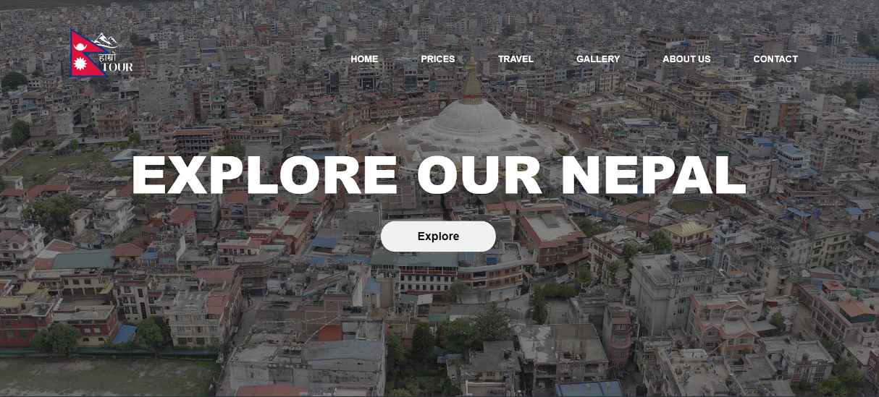1. Welcome to the home page of our website ‘Hamro Tour’.

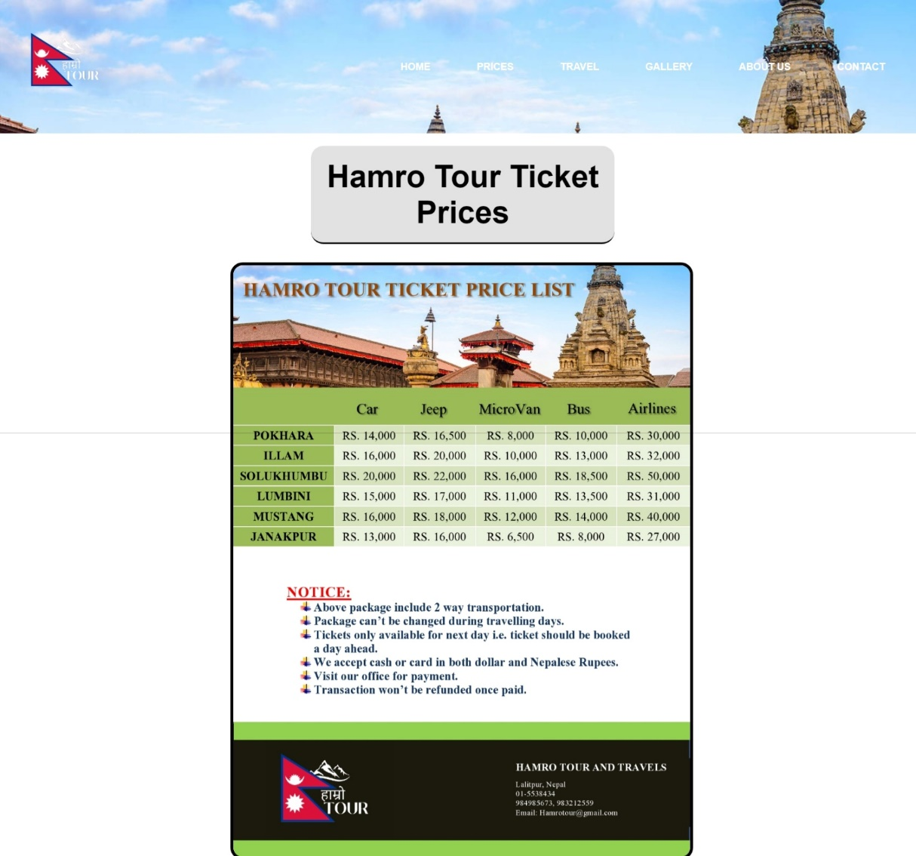2. Prices: This webpage includes different prices of tour package as per the necessity of our customer depending on the vehicle and the place that they want to visit.

3. Travel: This webpage includes the destinations that they want to visit.

* Read More: Clicking on ‘Read More’ button will lead the user to the Wikipedia including the details about the place.
* 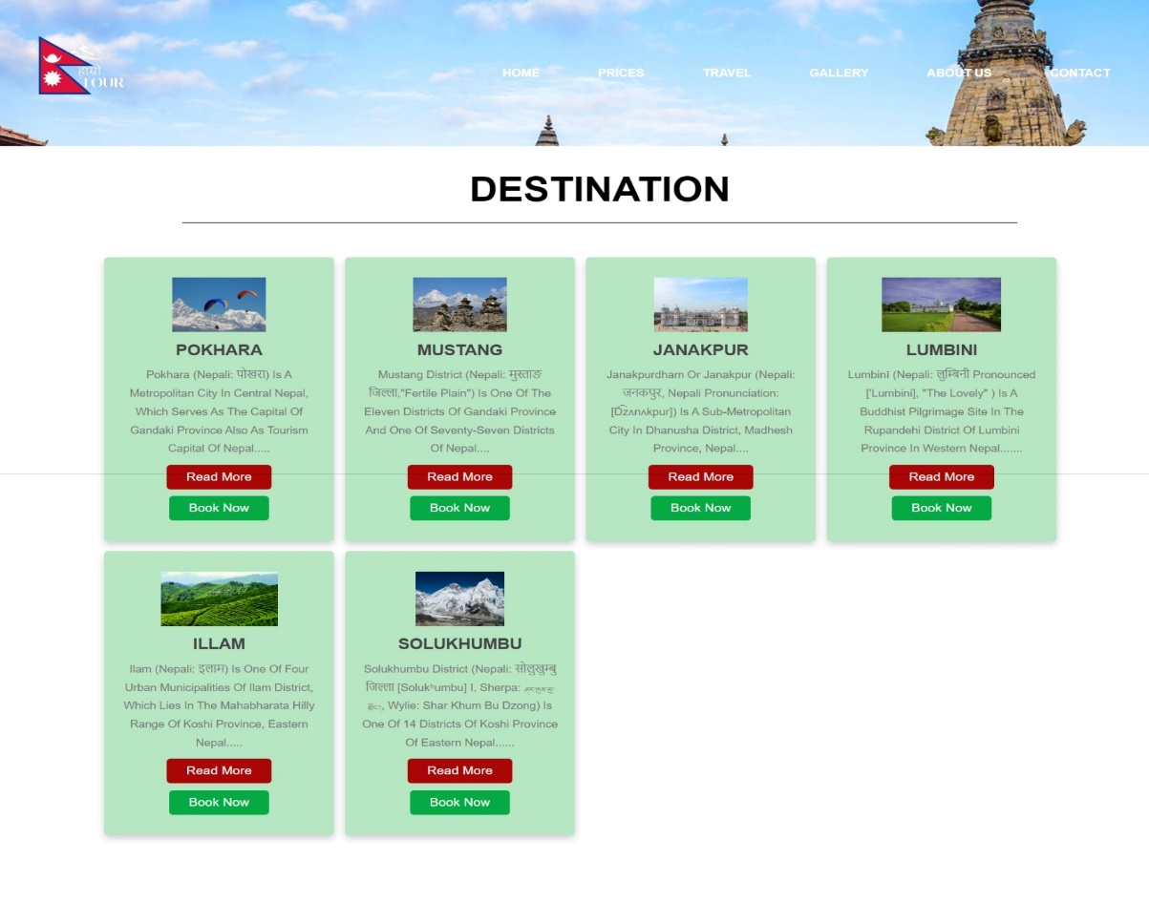Book Now: Clicking on ‘Book Now’ button will lead the user to registration page where they have to enter their personal details and the destination they want to visit.

4. Reservation form: User enters this webpage after clicking on ‘Book Now’ button. Here, the user has to fill up the personal details, transportation and the destination place that they want to visit, etc. Clicking on ‘Submit’ button will lead the user to the thankyou page.

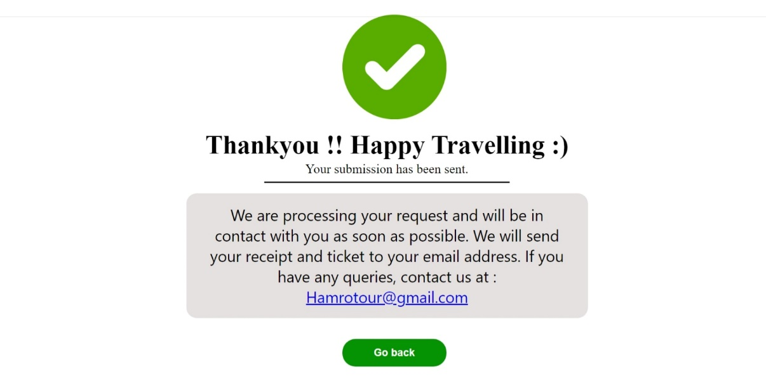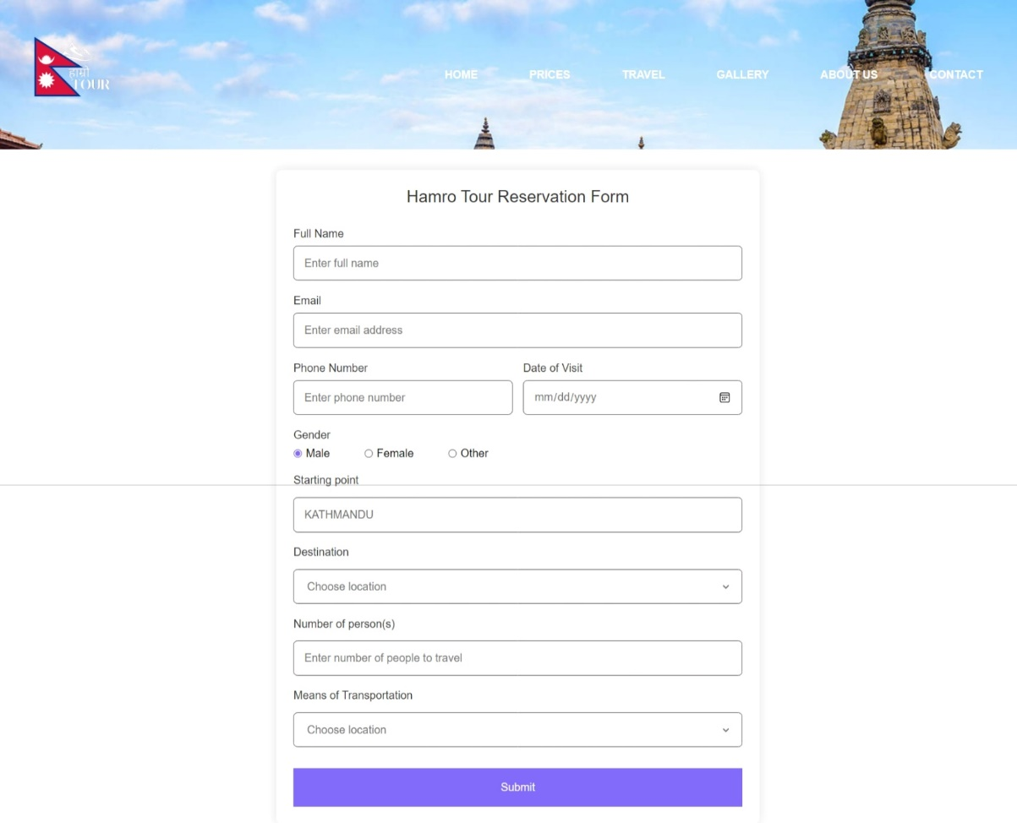

5. Gallery: This webpage includes the photos of places and the people that travelled all around with the help of ‘Hamro Tour’ website. It includes the moments that our customers cherished through our tour packages.

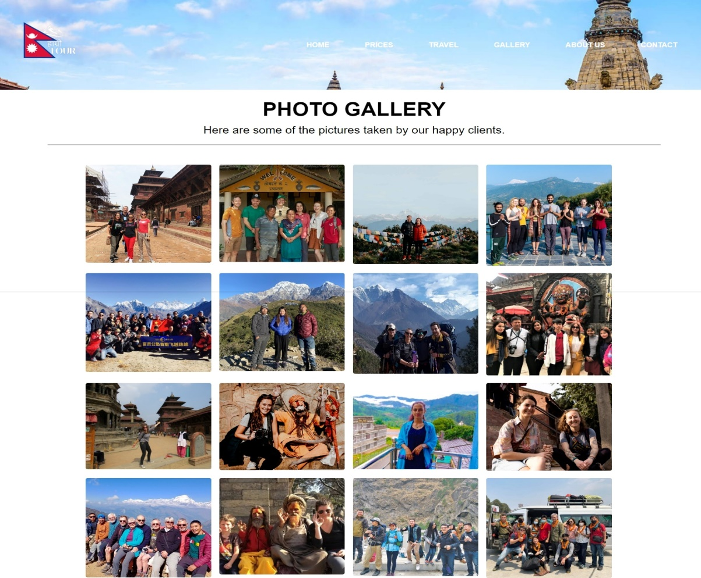

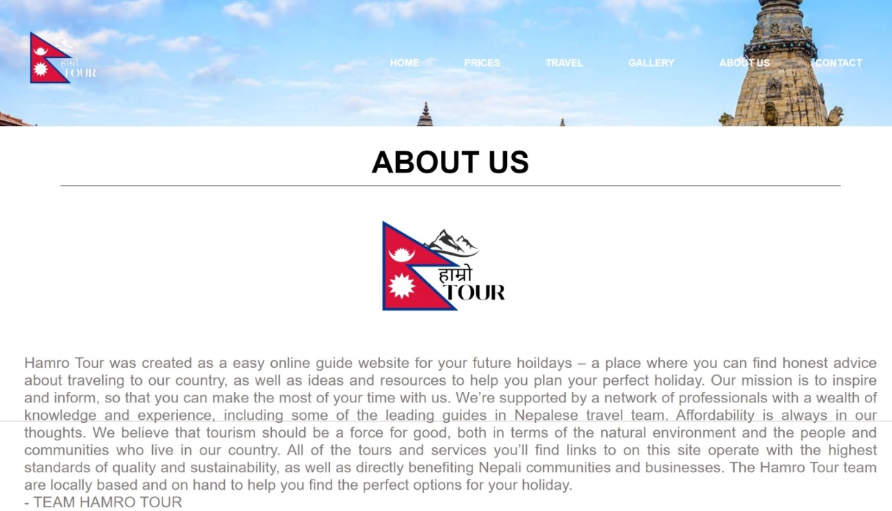6. About Us: This webpage includes a brief description of ‘Hamro Tour’ website.

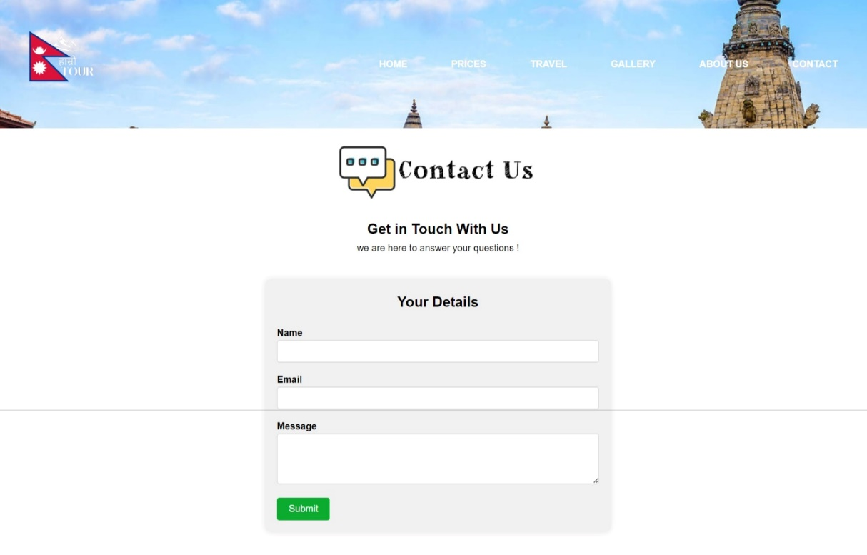7. Contact Us: Finally, this is the last page of our website. Users can contact to our team by filling up the form given in the page.

**9. REFERENCES**

<https://eprints.whiterose.ac.uk/>

<https://travaa.com/>

# **10. Bibliography**

Tizani, W. (1992). Review of Trip Planning Systems. *Institute of Transport Studies*.