Testing_Assignment09

Nonfunctional Testing Assignment

Jmeter is an open source testing software. Jmeter is design to cover various categories of test such as load testing, functional testing, performance testing, regression testing, etc. Jmeter is open source and freely available.

1. Thread group elements are the beginning points of test plan. We can also control via thread group:

* Setting the number of threads - 10/100/250
* Setting the ramp-up time - 10
* Setting the number of test iterations - 1

1. For testing purpose I have use [www.agiletrailblazers.com](http://www.agiletrailblazers.com).
2. Test Response Text/Response Code/Response Message/Response Headers/JSON.
3. Execute test plan for 10 user and get the right result – All pass.
4. Execute test plan again for 10 user and get the wrong result – some pass, some not (fx. response code = 301 the all test fail) So change the value to let the test fail.
5. Graph Result is showed under Graph Result Listener.
6. Parameterize test input data from CSV file:

In parameterization testing the input values for the test are fetched from data files. Input data files name test.csv. A test containing several sets of hard hard coded values will be rather difficult manage. Since I don't have a server site that can return me valid data, so the test is always fail, but the setup is right.

1. Import test plan BlazeMeter and run with the test with 50 users and for 20 minutes from the location Asia Northeast (Japan, Google).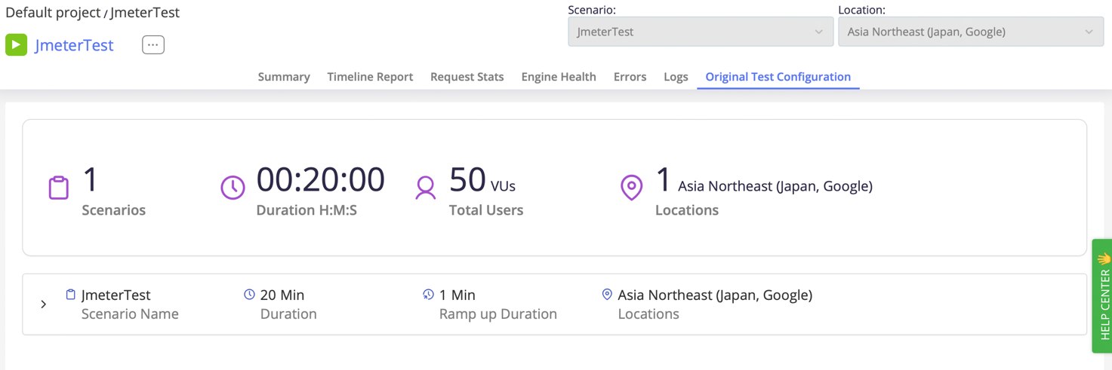
2. The final task combining Jmeter with Junit/maven and selenium is done, but is not entirely satisfying. As the test/unit test could not be showed in the Jmeter panel. The assignment (attempt) in intellij is uploaded.

Setup Blazemeter

1. Go to blazemeter.com and sign up
2. Skip wizard to go to the blazemeter default workspace and create a test
3. Upload a JMeter jmx file
4. Set user to 50
5. Enter a name for the test and save the test
6. Switch to test history and start the test