Forecasting Household Appliance Energy Use
A comparison of benchmark, statistical, machine-learning and foundation models at a 24-hour horizon

1. Introduction
Short-term forecasts of household electricity use underpin a range of practical applications: scheduling flexible appliances against time-of-use tariffs, sizing home battery systems, and giving demand-response aggregators something to plan against. The question this report addresses is a narrow but useful one. If we want to forecast a single household’s appliance energy use 24 hours ahead, how much do increasingly sophisticated models actually buy us over a simple average?
The analysis uses the Appliances Energy Prediction dataset, which records appliance consumption alongside indoor sensors and outdoor weather for one house in Belgium over four and a half months in 2016. Four model classes are compared: simple benchmarks, SARIMAX, gradient boosting on an engineered feature table, and Chronos-2 used zero-shot.
The short answer is that the gains are small and mostly not statistically significant. Only the foundation model beats the strongest benchmark by a margin that survives a significance test, and even it loses to the benchmark on RMSE. The more interesting findings are about why: the series is dominated by a stable seasonal profile plus a large irreducible component driven by occupant behaviour, and the covariates that seem like they should help do not.

2. Data and preprocessing
The raw file contains 19,735 observations at 10-minute resolution, from 11 January to 27 May 2016. It is unusually clean: every gap between consecutive observations is exactly ten minutes, there are no duplicate timestamps and no missing values. No imputation was needed.
Following the brief’s allowance, the data were resampled to hourly means, giving 3,290 observations across 137 days. Averaging rather than summing keeps the target on its original Wh scale. This does discard information — the maximum falls from 1,080 Wh to 608 Wh and the standard deviation from 103 to 81 — but the mean is essentially unchanged at 98 Wh and the strong right skew survives. The hourly resolution is also arguably the more relevant one for the applications above, since tariff periods and appliance scheduling decisions operate at that granularity rather than at ten-minute resolution.
Two columns, rv1 and rv2, were dropped: they are random variables the original authors included as noise controls and carry no information.
The final 14 days (336 hourly observations, 13–27 May) are held out as the test period, as recommended, leaving 2,954 training observations. Four months is enough to estimate daily and weekly seasonality but not annual seasonality — a limitation carried through everything that follows.

3. Exploratory analysis
The series is spiky rather than smooth. Long quiet stretches sit around 50 Wh — effectively the standby load of the house — punctuated by short bursts reaching several hundred watt-hours. Nearly half of all hours fall below 60 Wh, while a small minority carry most of the variation. Skewness is 2.4.
The dominant structure is hour of day: a flat overnight trough from about 01:00 to 05:00, a morning rise, and a broad evening peak between 17:00 and 20:00. Critically, the interquartile band around this profile is narrow at night and very wide during the day, which foreshadows where all the forecast error will end up.
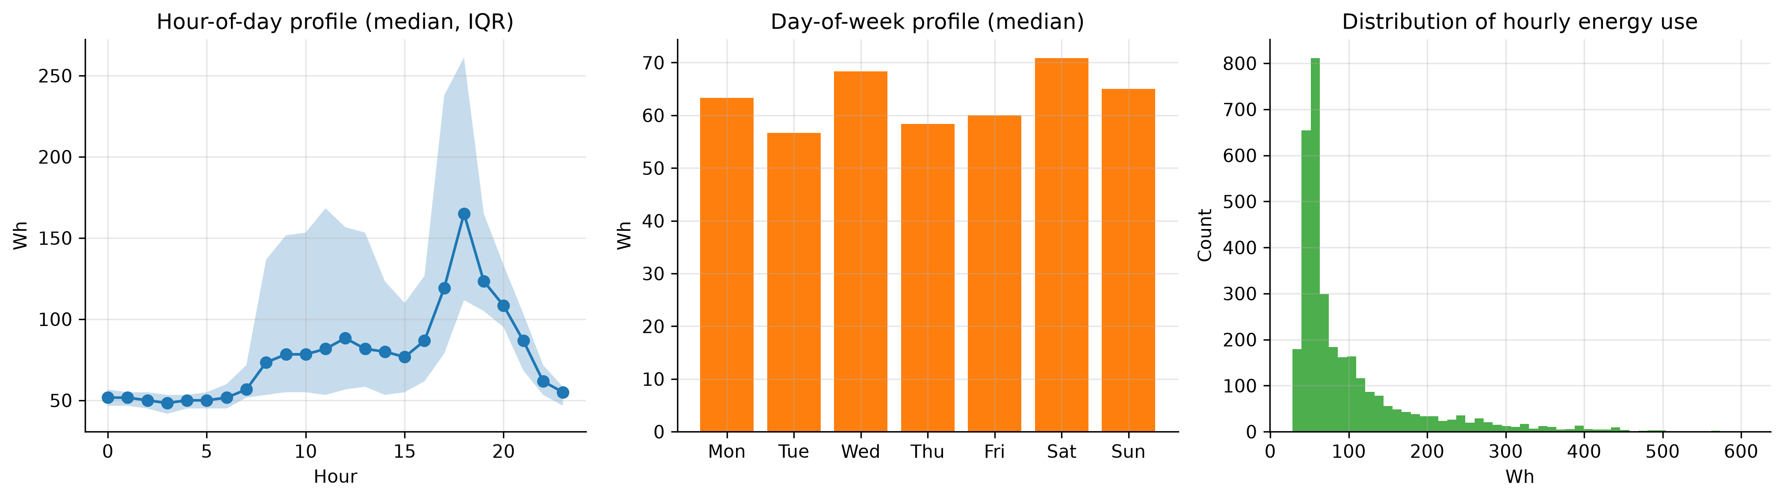
Seasonal profiles
Weekend days average slightly higher than weekdays, but the difference is small relative to within-day variation. This is one household, so the weekly pattern reflects one family’s habits rather than any aggregate regularity.
The autocorrelation function shows clear local peaks at lags 24 and 168, confirming daily and weekly seasonality, but the lag-24 autocorrelation is only about 0.4 and lag-168 is lower still. The seasonality is real but weak — an early warning that MASE values will sit close to 1. An augmented Dickey-Fuller test rejects a unit root and KPSS does not reject stationarity around a constant, so ordinary differencing is unnecessary; seasonal differencing at lag 24 is still warranted.
Importantly for later, no covariate is strongly related to the target. The lights channel is the best of them, which makes sense since lights being on proxies for someone being home, but even that is moderate. The weather variables are weak.

4. Forecasting design
The brief specifies a 24-hour horizon and recommends the final 14 days as the test period. These are not the same requirement, and reconciling them matters more than it first appears.
The design adopted here is a rolling-origin evaluation: the 336 test observations are forecast as fourteen consecutive blocks of 24 hours. At each origin, every model sees all data observed up to that point and forecasts the next day. Every number reported below therefore describes accuracy at the 24-hour horizon that the brief actually asks about.
The alternative — forecasting all 336 points from a single origin two weeks out, as the demo pipeline does — was also run, as a sensitivity check (Section 9).
All models are scored with MAE, RMSE, MASE and bias on identical test points. The MASE scaling factor is the in-sample mean absolute error of a 24-hour seasonal naive forecast on the training data (53.42 Wh), computed once and held fixed so that the denominator never changes between models.
Three leakage distinctions are enforced throughout, and they are the methodological core of this report.
Future values of the target. Standard, and handled by shifting all lag and rolling features. Verified by automated tests.
Information unavailable at the forecast origin. Much subtler. A feature shifted by one hour relative to the target is not necessarily known at an origin 24 hours earlier. This is discussed at length in Section 7.
Covariates that would not themselves be forecastable. Calendar variables are known arbitrarily far ahead; indoor sensor readings and outdoor weather at the target time are not. Models using realised test-period weather are labelled conditional forecasts.

5. Benchmark models
Five benchmarks are required by the brief. A sixth — an hour-of-week mean profile, which averages every past observation falling in the same slot of the week — was added because it is the natural low-variance competitor to the seasonal naive forecasts.
Benchmark | MAE | RMSE | MASE | Bias
Hour-of-week mean profile | 38.06 | 63.74 | 0.712 | -3.39
Weekly seasonal naive | 43.46 | 81.41 | 0.813 | -13.16
Daily seasonal naive | 48.31 | 85.57 | 0.904 | 1.75
Mean | 50.26 | 74.94 | 0.941 | -3.29
Naive | 85.55 | 110.39 | 1.601 | 50.98
Drift | 85.80 | 110.68 | 1.606 | 51.37
The ordering is informative in three ways.
First, naive and drift are hopeless, with MASE above 1.6 and a large positive bias of about 51 Wh. Both hold the 18:00 value constant across the following day, and since 18:00 sits near the daily peak they carry that elevated level straight through the night. The mean forecast beats both simply by refusing to commit to a level.
Second, and more interestingly, the three seasonal methods rank in the opposite order to naive intuition: daily seasonal naive (0.904) is worse than weekly (0.813), which is worse than the mean profile (0.712). Averaging beats copying, and copying last week beats copying yesterday.
Third, the reason for that ordering explains most of what follows. The weekly seasonal naive forecast is about as variable as the series itself, since it copies a real week complete with its idiosyncratic spikes; the mean profile is far smoother. Where the timing of peaks is close to unpredictable, smoothness pays, because a misplaced peak is penalised twice — once for the peak that did not occur and once for the one that did.
This tells us something concrete about the household. Day-to-day behaviour is noisy enough that yesterday is a poor guide to today, but a stable average weekly rhythm exists underneath. The strongest benchmark is the mean profile at MASE 0.712, and that is the number every subsequent model must beat.

6. SARIMAX model
Three specifications were compared, chosen to isolate the effect of covariate availability rather than to search exhaustively over orders.
Notebook 02 established d = 0 (no unit root) with a strong lag-24 cycle, pointing to D = 1 at s = 24. After seasonal differencing, residual autocorrelation is much reduced with a large negative spike at lag 24, the signature of a seasonal MA term. The specification SARIMA(1,0,1)(1,1,1)[24] follows, which is also the brief’s suggested starting point.
Model | Exogenous | AIC | MASE
Target only | none | 32,229.7 | 0.682
+ calendar | hour/day Fourier terms, weekend flag | 32,235.7 | 0.702
+ calendar and weather | plus T_out, RH_out, wind, visibility, dew point | 32,242.8 | 0.713
Adding covariates makes the model worse, and the out-of-sample ordering matches the in-sample ordering exactly. AIC rises monotonically, so the extra parameters do not pay for themselves even in sample. Since the seasonal difference already removes the daily cycle, the calendar regressors are largely redundant; and as Section 3 showed, the weather variables carry little information about this household.
Only the target-only model beats the benchmark, by about 4%.
The residual diagnostics are mixed. The residual ACF sits largely inside the confidence bands, so most linear dependence has been absorbed, but Ljung-Box still rejects at lags 24 and 48. The residuals are also strongly right-skewed — the spikiness of the series showing through — and that skew has a direct consequence. All three specifications produce nominal 80% intervals containing 91% of observations, at an average width of about 181 Wh against a test-period interquartile range of roughly 62 Wh. The Gaussian assumption forces the model to accommodate occasional 400 Wh spikes by inflating variance everywhere, including quiet overnight hours when consumption is reliably near 50 Wh. An interval that wide at 03:00 is useless for any practical decision: over-coverage is a calibration failure, not a safety margin.

7. Feature-based model
Gradient boosting (XGBoost, 600 trees, learning rate 0.03, depth 6) was fitted to an engineered feature table. Most of the work here went into the design of that table rather than the model, because the design determines whether the result means anything.

The problem with the obvious design
The natural supervised table shifts every feature by at least one period:
data["lag_1"] = data["Appliances"].shift(1)
data["roll_mean_24"] = data["Appliances"].shift(1).rolling(24).mean()
No feature uses a future value of the target, so this passes the usual leakage check. It is a correct one-step-ahead design.
It is not a valid 24-hour-ahead design. Forecasting at 18:00 on Monday for 17:00 on Tuesday, lag_1 would be the value at 16:00 on Tuesday — which has not happened yet. The shift protects against using the future relative to the target; it does not protect against using information unavailable at the forecast origin, and those differ by up to 24 hours.

The operational design
Each row is a (forecast origin, horizon) pair, with three feature groups: quantities measured at the origin (lagged target values, rolling statistics, latest sensor and weather readings); calendar features of the target timestamp, which are known arbitrarily far ahead; and the horizon itself. This yields 74,628 rows and 54 features.
Design | MASE | Valid at 24h?
One-step (uses lag_1) | 0.602 | No
Operational (origin-only information) | 0.687 | Yes
Operational + realised future weather | 0.765 | Conditional only
The one-step design appears 12% better. That entire gap is lag_1. It would be easy to report 0.602 in good faith as the model’s 24-hour accuracy — it passes every standard leakage test — but it is the accuracy of a model told the previous hour’s consumption, which at a 24-hour horizon it cannot be. It is reported here as a diagnostic and excluded from every ranking.
Adding realised future weather makes things worse again, from 0.687 to 0.765. This does not mean weather is harmful information. It means the extra columns let the model fit noise in a training sample where weather barely relates to appliance use, and that overfitting costs more than the covariates are worth. Conveniently, the model we could actually deploy outperforms the one requiring information we could not have.

What the model learned
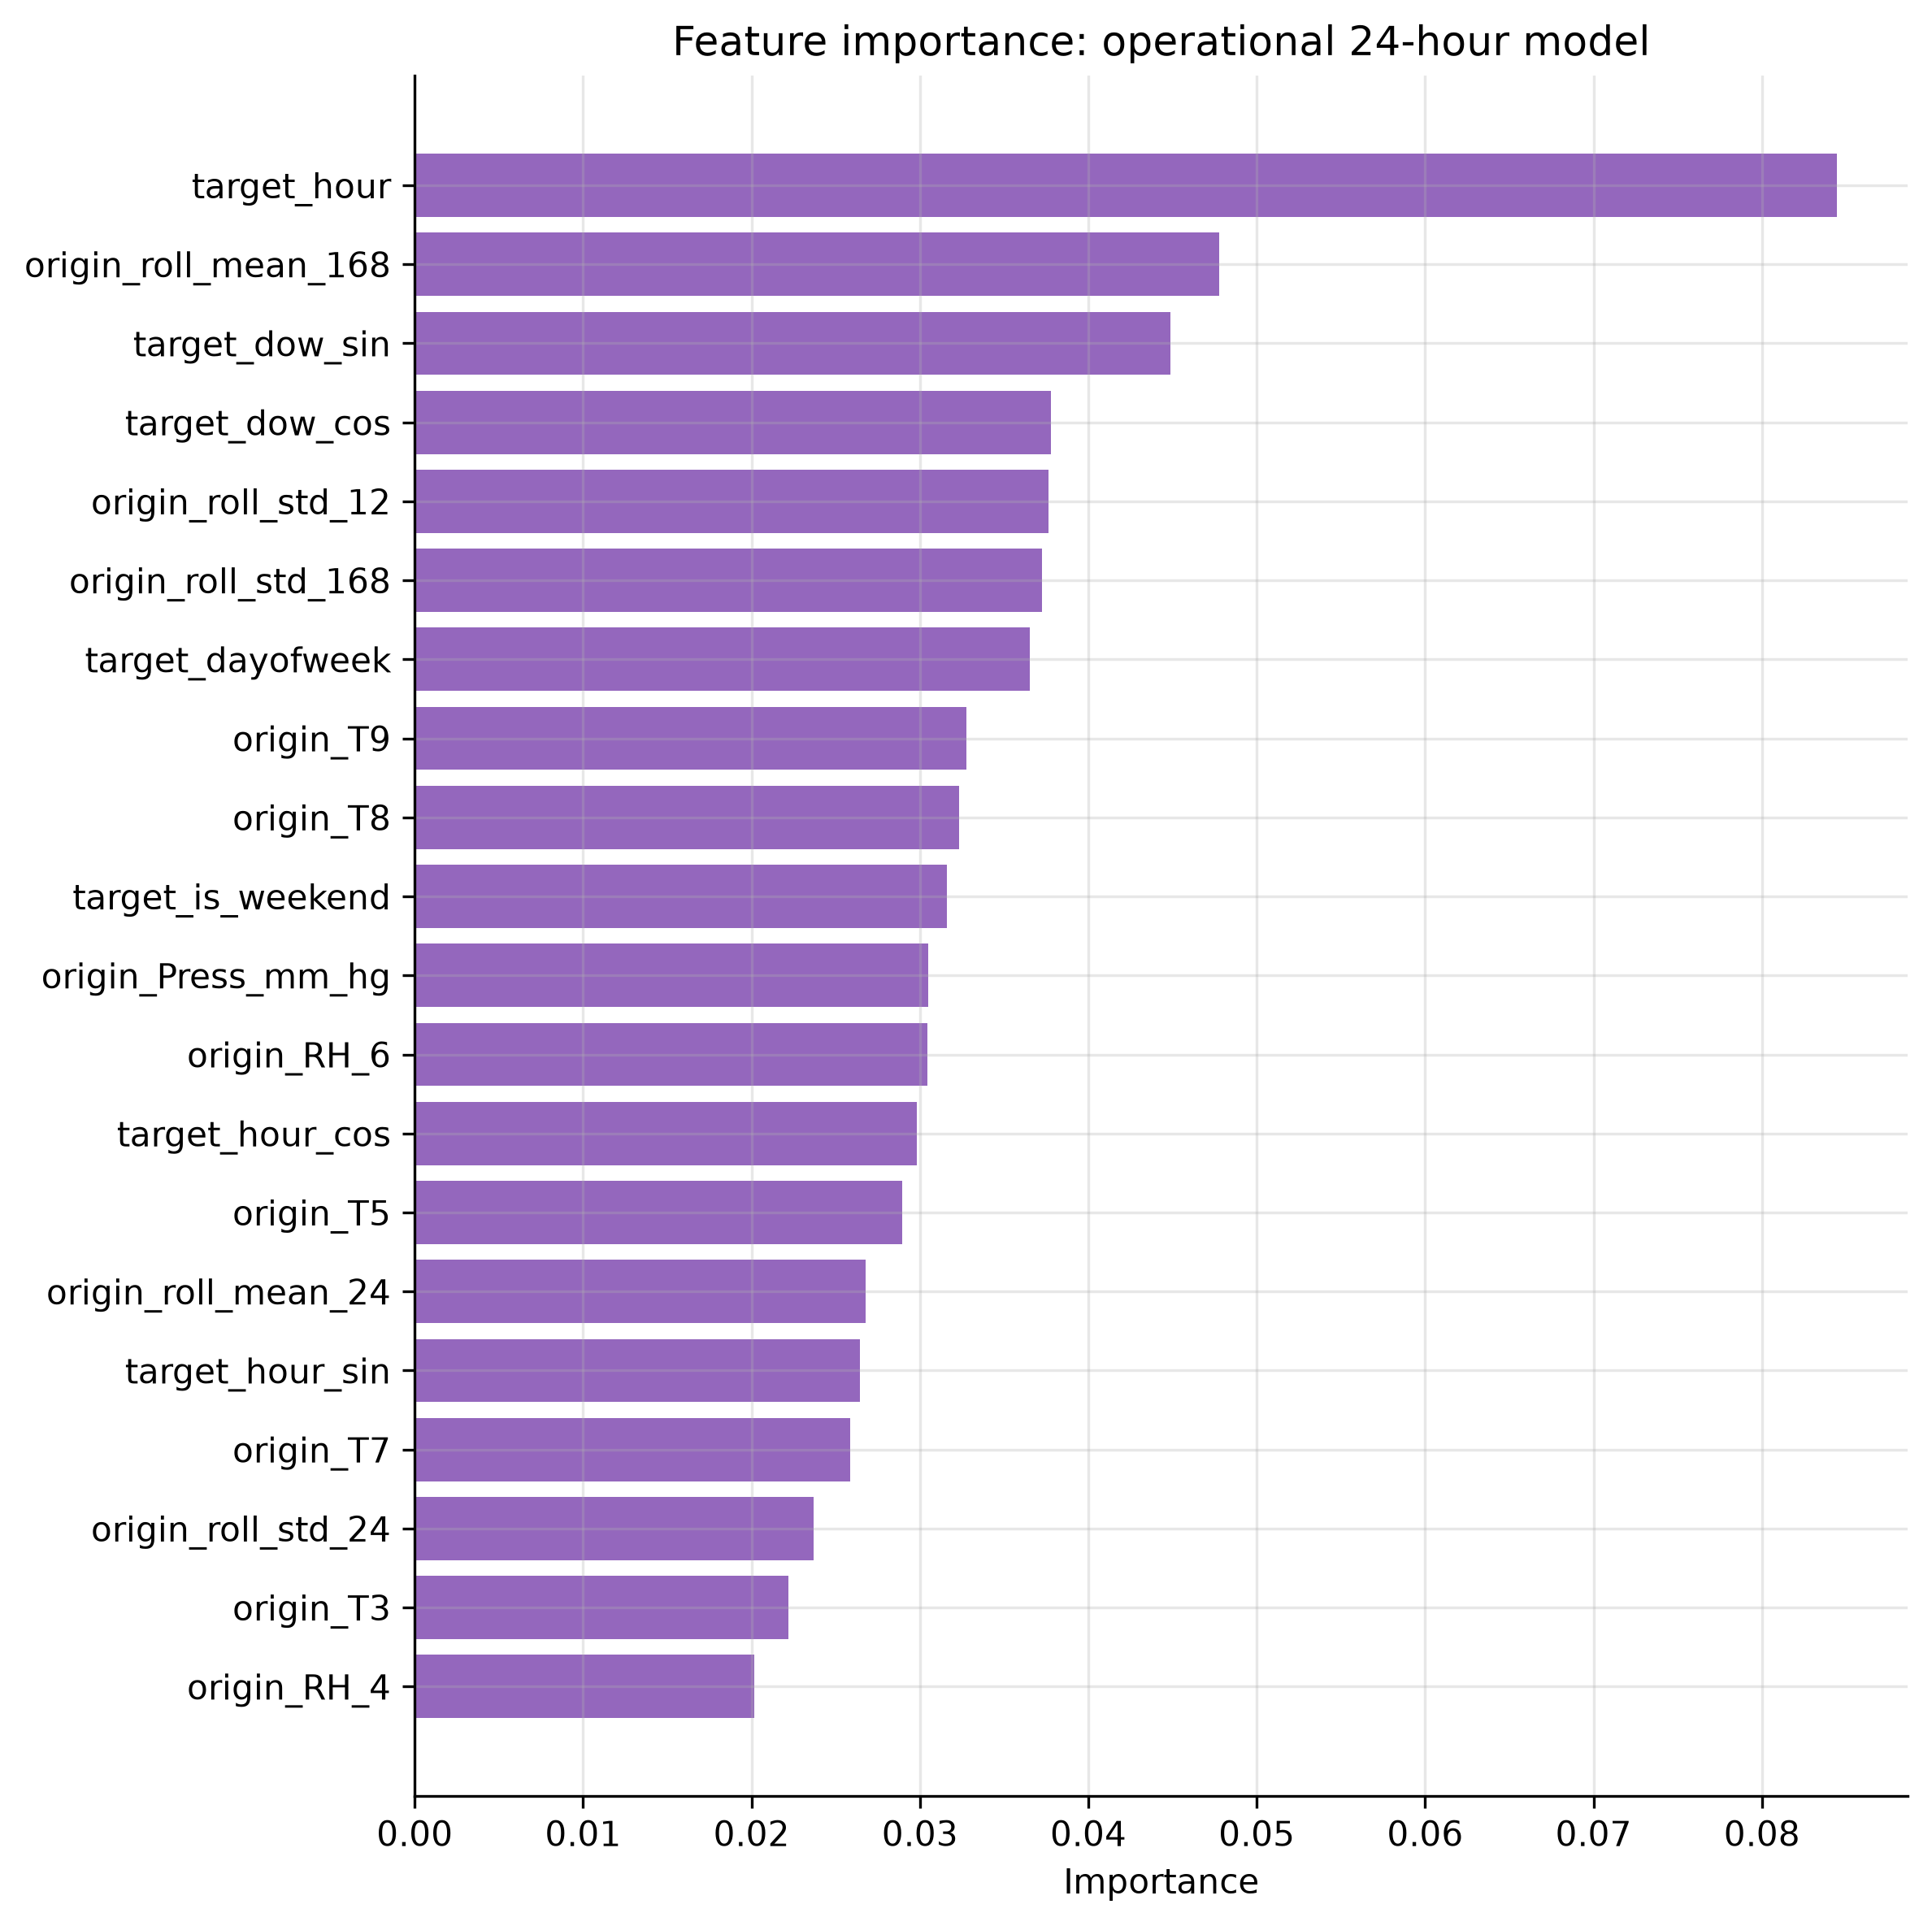
Feature importance
target_hour is the most important feature by a wide margin, followed by the 168-hour rolling mean and the day-of-week terms. Grouped by type, calendar features carry more weight than any other group. The indoor sensors contribute something — plausibly because room temperature is a lagged indicator of occupancy — but no individual sensor is decisive.
In other words, the gradient boosting model rediscovered the hour-of-week profile and added a modest level correction from recent history. That is why it only edges past the benchmark.

8. Foundation model
Chronos-2 (amazon/chronos-2) was used zero-shot: no parameter of the network was updated using appliance data. At each of the fourteen origins the model received the observed history as context and returned quantiles for the next 24 hours.
Some precision about “zero-shot” is warranted. In our procedure no fitting occurred, and the model did see the series history at inference time as context — that is the intended use. However, Chronos was pre-trained by Amazon on a large corpus of time series, and we cannot verify that this dataset was excluded. Appliances Energy Prediction is a well-known public UCI dataset. If it were present in pre-training, the zero-shot claim would be weaker than it appears. This caveat applies to any evaluation of a foundation model on a public benchmark and cannot be resolved from the outside.
Model | MAE | RMSE | MASE | Bias
Chronos-2 | 32.82 | 67.09 | 0.614 | -18.65
Best benchmark | 38.06 | 63.74 | 0.712 | -3.39
At MASE 0.614, Chronos-2 is the best valid 24-hour-ahead model in the study — a 14% improvement over the strongest benchmark, with no fitting, no feature engineering and no tuning.
But it has the best MAE and the worst RMSE of the serious models, and a bias about three times larger than anything else. These three facts describe a single behaviour: it forecasts the typical hour very accurately and systematically undershoots peaks. MAE rewards that, because most hours are typical. RMSE punishes it, because squared error is dominated by the few hours where consumption spikes to 400 Wh and the forecast says 150. On RMSE the simple mean profile wins outright.
Where Chronos is unambiguously ahead is the predictive distribution.
Model | Nominal | Empirical coverage | Average width
Chronos-2 | 80% | 77.7% | 92 Wh
SARIMAX (all variants) | 80% | 91.1% | 181 Wh
Chronos is marginally under-covering where SARIMAX substantially over-covers, and it achieves this with intervals half as wide. The reason is structural: Chronos produces quantiles directly and is not constrained to a symmetric Gaussian error distribution, so it can represent a series with a hard floor near 50 Wh and a long right tail. For probabilistic forecasting this is a decisive advantage.
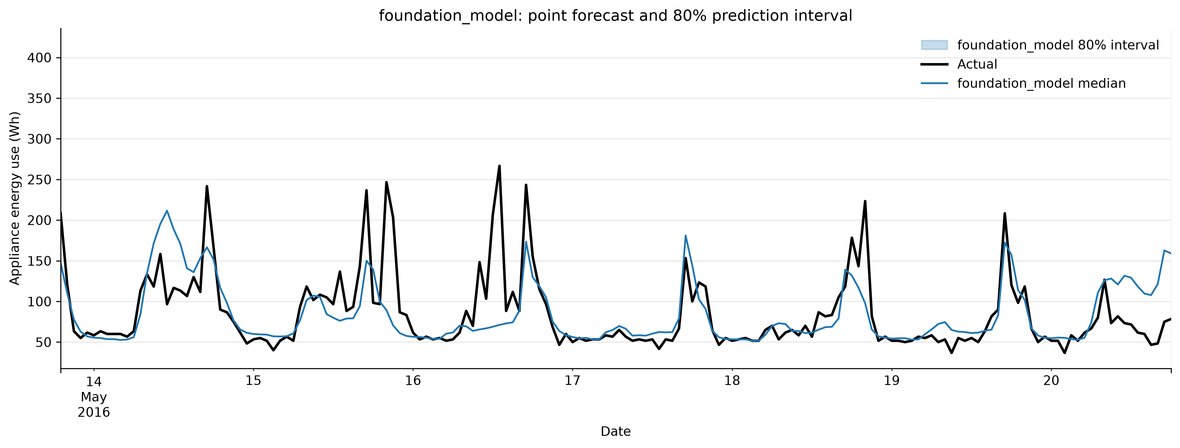
Chronos intervals

9. Results and error analysis

Are the differences real?
A ranking on 336 observations means little without a significance test. Diebold-Mariano tests against the strongest benchmark, using absolute error and a Newey-West variance estimate:
Model | DM statistic | p-value | Significantly better?
Chronos-2 | 2.36 | 0.018 | Yes
SARIMAX + calendar | 0.32 | 0.748 | No
Feature model | 0.62 | 0.534 | No
SARIMAX + weather | -0.02 | 0.988 | No
Feature model, conditional | -1.34 | 0.181 | No
Weekly seasonal naive | -1.47 | 0.141 | No
Daily seasonal naive | -2.35 | 0.019 | Significantly worse
Of three increasingly sophisticated model classes, exactly one produces an improvement that survives a significance test. The feature model’s 3.5% edge and SARIMAX’s 4% edge are indistinguishable from noise.

The universal failure: peaks
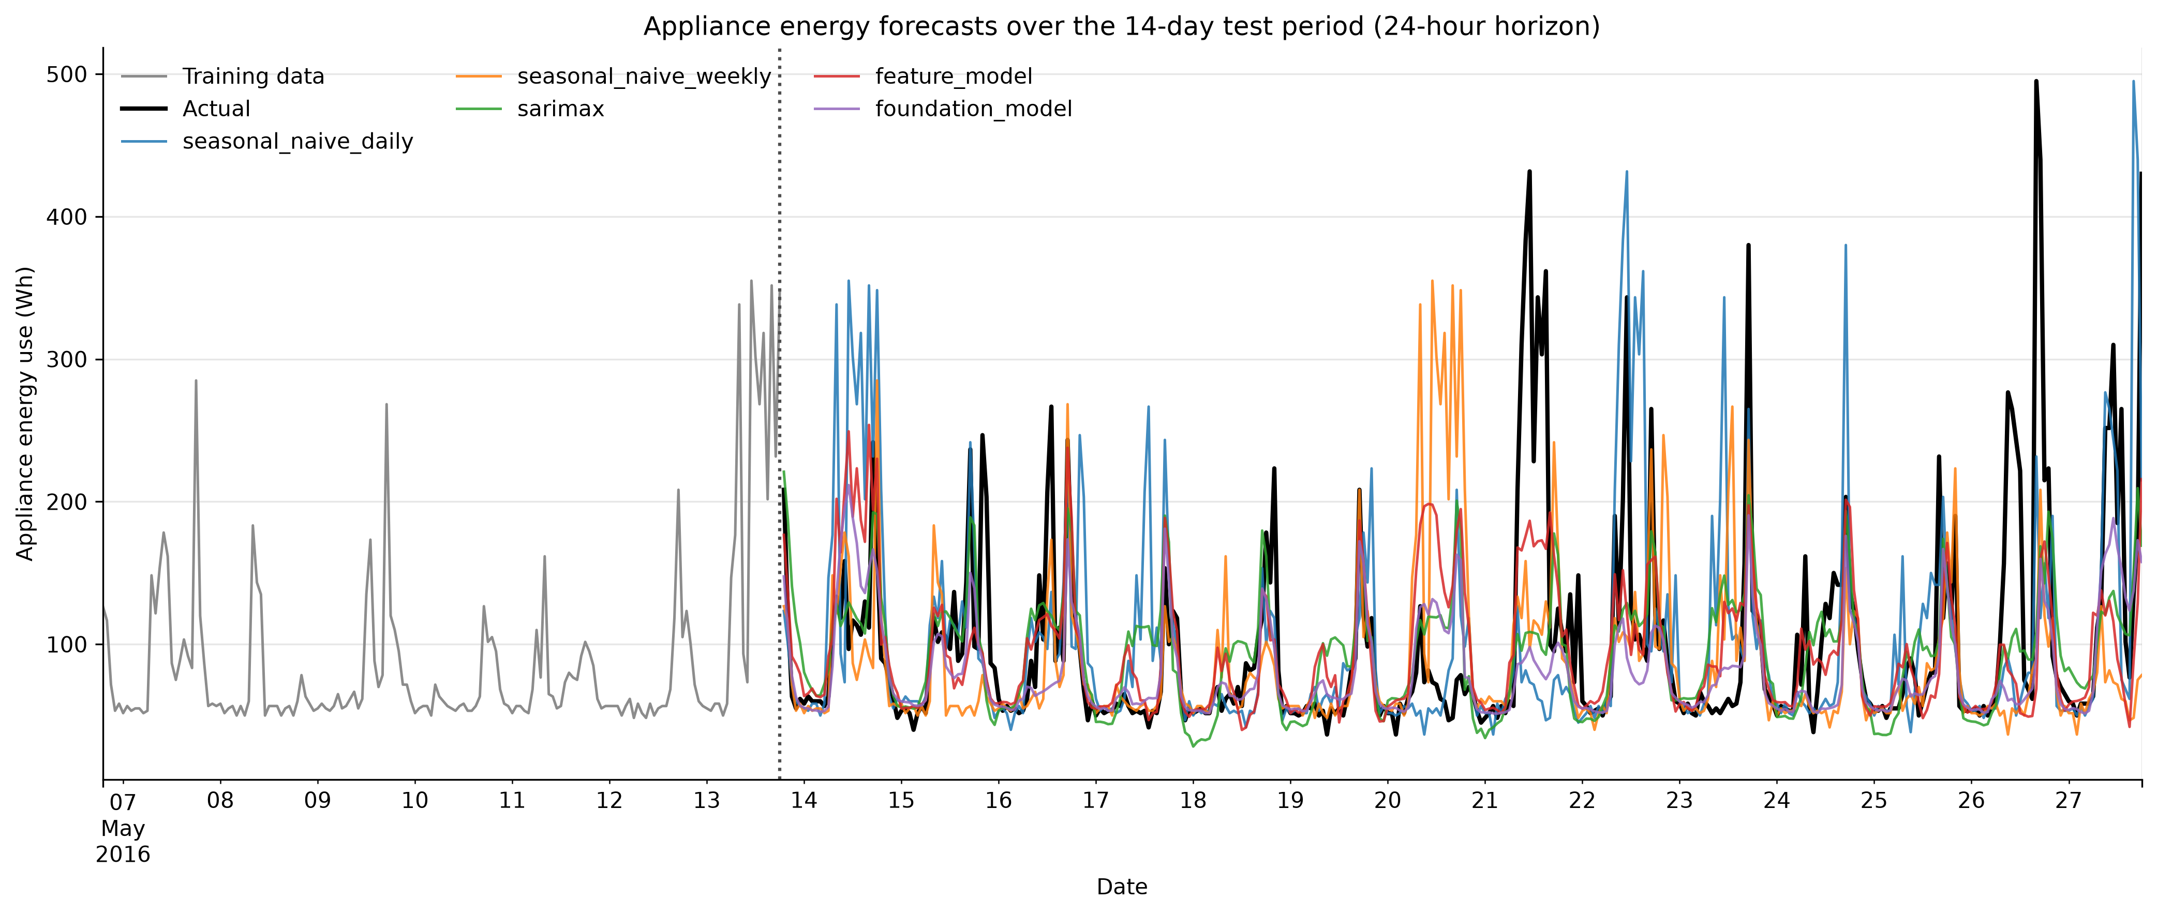
Forecast comparison
The actual series reaches 495 Wh during the test period. No model forecasts above 254 Wh. In the top decile of hours, every model carries a bias between -130 and -190 Wh.
This is not a tuning failure. All these models estimate a conditional mean or median, and the conditional distribution of appliance use in a peak hour is genuinely wide — the household sometimes cooks at 18:00 and sometimes does not. Under squared or absolute loss the optimal point forecast sits in the middle, so peaks are underestimated by construction. The remedy is not a better point forecast but a probabilistic one, which is where Chronos’s sharp, well-calibrated intervals earn their place.

When errors occur
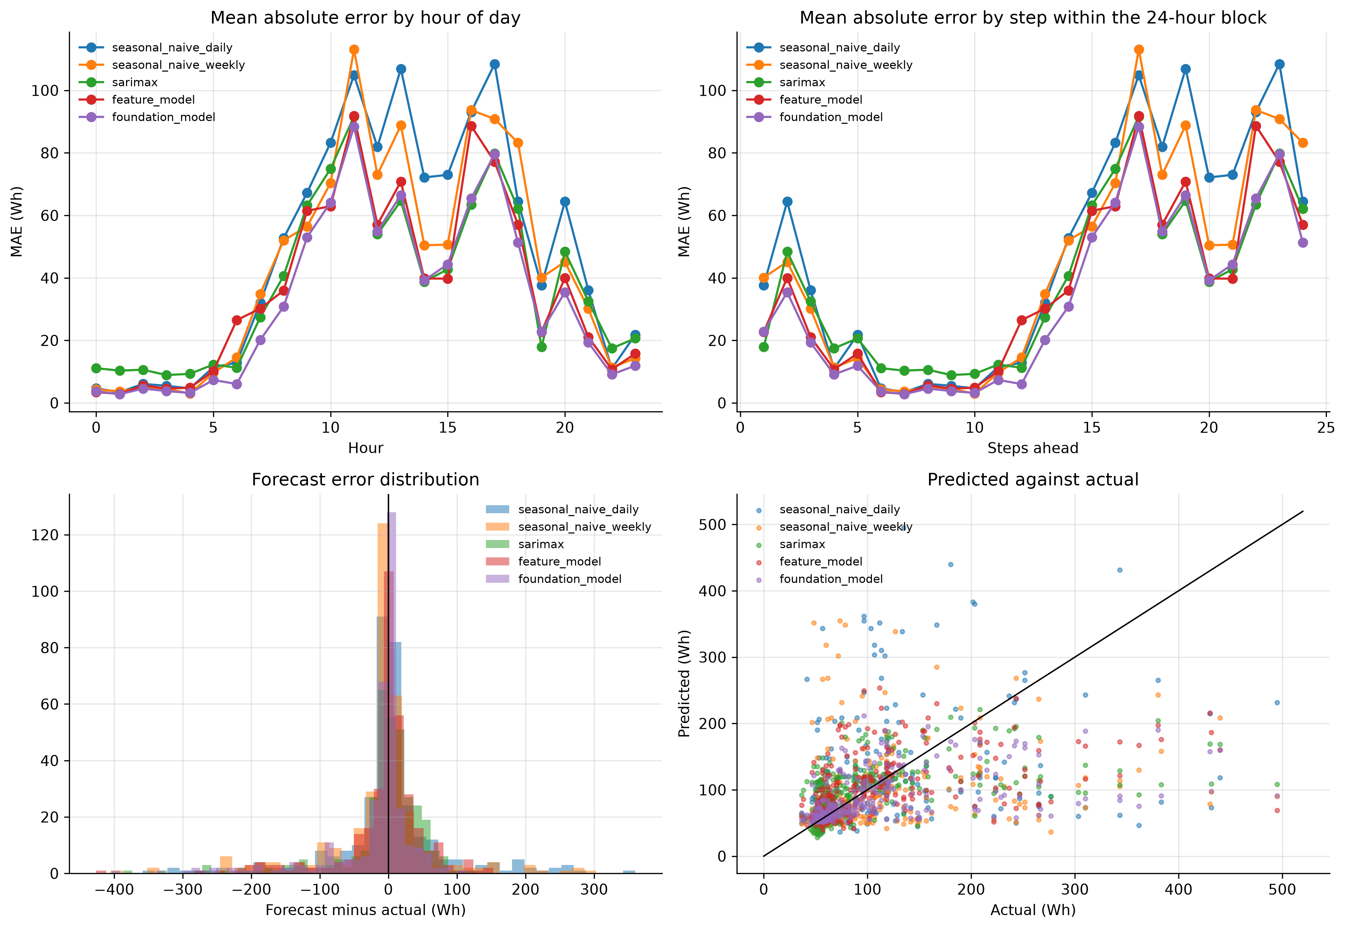
Error diagnostics
Errors are tiny overnight — 3 to 5 Wh between 01:00 and 05:00 — and an order of magnitude larger between 10:00 and 20:00. The forecasting problem is close to trivial for two thirds of the day and hard for the other third. All the difficulty lies in hours when consumption is driven by discretionary human decisions.

A correction on error by horizon
The pipeline’s mae_by_horizon.csv appears to show error growing steeply with lead time. It does not, and the reason is worth stating because it is an easy mistake to make.
Because the design issues one forecast per day at a fixed time (18:00), step h always lands on hour (18 + h) mod 24. Horizon and time of day are perfectly confounded: the horizon table is an exact rotation of the hour-of-day table. Any apparent horizon effect is a time-of-day effect wearing a disguise.
scripts/horizon_analysis.py breaks the confound by re-issuing the feature model from every hour in the test period rather than once a day, so each horizon step averages across all 24 clock times. Each step is then evaluated on 336 forecasts issued from 359 distinct origins.
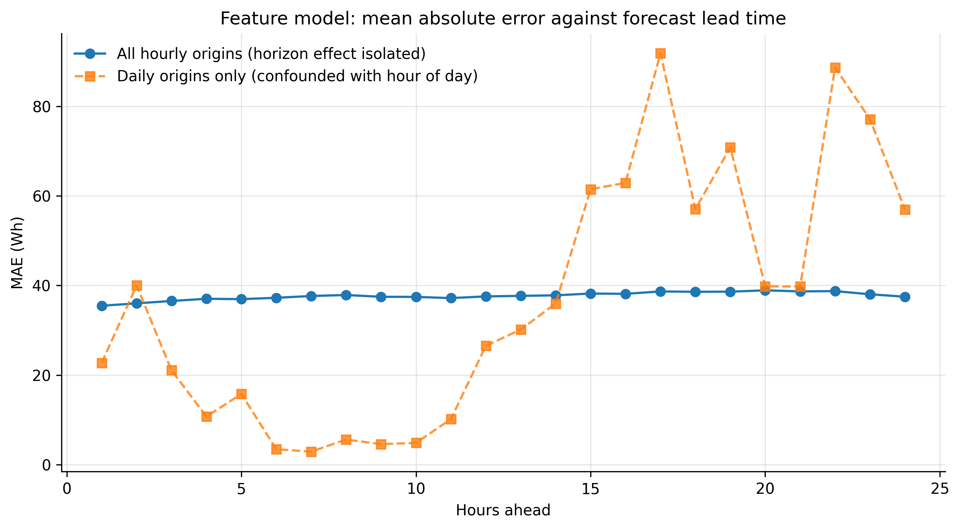
Horizon analysis
Corrected, MAE rises from 35.5 Wh at one hour ahead to a maximum of 38.9 Wh at twenty hours ahead — a linear trend of just +0.10 Wh per hour of lead time, or under 10% degradation across an entire day. Set that against the 24-fold swing, from 2.9 Wh to 91.8 Wh, that the confounded version appeared to show.
The corrected curve also has a feature the confounded one hides: accuracy improves again at the longest horizons, falling back to 37.5 Wh at h = 24. The explanation is the structure of the feature set. At h = 24 the most recent observation available at the origin is exactly the same hour on the previous day, so the model’s origin_lag_0 feature coincides with the daily seasonal lag and becomes informative again. Predictability is highest when the origin is either very recent or exactly one seasonal period away, and worst in between.
Both observations point the same way: almost all the predictable signal is the seasonal profile, equally available at any lead time, and almost none is short-run momentum that decays as the horizon extends. It also explains why the one-step design looked so much better — lag_1 is close to the only genuinely horizon-sensitive information in the dataset.

Sensitivity to evaluation design
Repeating everything as a single 336-step-ahead forecast leaves the seasonal benchmarks and all three model classes essentially unchanged. Only naive and drift differ, collapsing from MASE 1.60 to 4.69 and 4.99.
The substantive findings do not depend on the choice of design. What the design does change is how bad the worst benchmarks look — which is a reason to treat sceptically any study reporting large improvements over a naive benchmark evaluated over a long single block.

10. Discussion and limitations
Which covariates would genuinely be known at the forecast origin? Calendar variables — hour, day of week, weekend, holidays — are known arbitrarily far ahead and are the only covariates used by the operational models. Weather at the target time would in practice come from a numerical weather forecast, which carries its own error; using realised values, as done here for the conditional variants, is optimistic. Indoor sensor readings at the target time are the least defensible: forecasting indoor temperature 24 hours ahead is roughly as hard as the original problem. All indoor sensors therefore enter the operational models only at their origin-time values.
Since every covariate set made forecasts worse, nothing in the conclusions depends on this distinction. But the discipline was maintained throughout, and had covariates helped, the distinction would have been essential.
Limitations.
The sample covers four and a half months of one household, so nothing here generalises to annual seasonality, to other households, or to aggregated demand — where behavioural noise averages out and covariates like temperature typically matter far more. The test period is a single fortnight in May; a different fortnight might rank the models differently, and the Diebold-Mariano results should be read with that in mind.
No systematic search over SARIMAX orders was performed. Each fit takes 20 to 150 seconds and the specifications differ by less than 0.05 MASE, so a different order would not change any conclusion, but a better specification cannot be excluded. Chronos was used target-only; it supports covariates, and although Sections 6 and 7 give good reason to expect little benefit, this was not tested. Finally, XGBoost results are not bit-identical across platforms, so figures may vary by a few percent between machines.

11. Conclusion
Which benchmark is strongest, and what does that reveal? The hour-of-week mean profile, at MASE 0.712, beating both seasonal naive variants. Averaging beats copying because the timing of peaks is close to unpredictable, and a misplaced peak is penalised twice. The household has a stable average weekly rhythm overlaid with substantial day-to-day noise.
Does SARIMAX improve on it? Marginally and not significantly — 0.682, about 4%, with p = 0.99 on a Diebold-Mariano test against the benchmark.
Do covariates help? No. Every covariate set tried made things worse, in AIC and out of sample, for both SARIMAX and gradient boosting. Adding perfect future weather to the feature model degraded it from 0.687 to 0.765.
Does the feature-based model improve? By 3.5% (0.687), not statistically significant. Feature importances show it largely rediscovered the hour-of-week profile.
Does the foundation model outperform? On MAE and MASE, yes — 0.614, a 14% improvement and the only statistically significant one (p = 0.018). On RMSE, no: it is the worst of the serious models, because it undershoots peaks harder than anything else. On interval quality it is the clear winner, achieving near-nominal coverage with intervals half the width of SARIMAX’s.
Which model would I recommend for a practical smart-home system? It depends on which error matters, and the honest recommendation is split.
For a system scheduling flexible loads against a tariff, where being wrong by 30 Wh in either direction is roughly equally costly, Chronos-2 zero-shot is the recommendation: lowest MAE, the only significant improvement over the benchmark, by far the best-calibrated intervals, and no fitting, feature engineering or retraining as the household’s habits drift. The cost is a PyTorch dependency and roughly half a second of inference per forecast.
Where peak errors dominate — battery sizing, avoiding peak-demand charges — the recommendation would differ, since Chronos has the worst RMSE and the largest bias on test. There the hour-of-week mean profile is competitive on RMSE and costs nothing to run.
The broader conclusion is worth stating plainly. On this series, four months of engineering effort across three model classes bought a 14% MAE improvement over an average that can be computed in three lines of pandas, and two of those three classes bought nothing measurable at all. Most of the variation in a single household’s appliance use is not a function of time, weather, or its own past. It is a function of what the occupants decided to do, and that is not in the data.

