Growth of Phalaenopsis aphrodite
- Introduction
Taiwan White Phalaenopsis is a branch of the Phalaenopsis genus, and is a monocotyledonous herbaceous plant. Because of its alias - Phalaenopsis amabilis var. formosana, which sounds like "grandmother" in Taiwanese, it is commonly known as "Taiwanese Grandma."
Phalaenopsis is very popular in Taiwan. In every year's flower expo, Phalaenopsis can often be seen, and Taiwan Phalaenopsis has also won awards in international flower exhibitions. After promotion by the government and continuous improvement by orchid industry practitioners, Taiwan has gradually become one of the main producers and exporters of Phalaenopsis. According to statistics from the Ministry of Finance, in 2021, the total export volume of flowers was 21,514 tons, with a production value of 6.3 billion yuan. Among them, Phalaenopsis accounted for 4.5 billion yuan, which highlights its importance to Taiwan.
There are two species of native Phalaenopsis in Taiwan. One is the white Phalaenopsis (the one discussed here), which mainly grows in the subtropical and tropical jungles of the Hengchun Peninsula, Central Mountain Range, and other areas. The other is the peach-colored Phalaenopsis, which mainly grows on Xiao Lanyu Island.
Phalaenopsis breeding has been going on for a long time domestically and abroad, and many excellent hybrid varieties have been created, such as Perfume Beauty and Perfume Lemon. Currently, Phalaenopsis mainly uses hybrid breeding. Orchid industry practitioners select gene sources that meet breeding goals through the analysis of genetic traits, then select suitable hybrid combinations through offspring testing, and finally select excellent single plants that meet market demand after multiple tests. These plants are then mass-produced through micropropagation technology for export and domestic potted flower production. In recent years, Phalaenopsis breeding and release have continued to innovate, including the continuous research and breeding of its close relative, Doritaenopsis, resulting in hybrid strains with both flower abundance, large flower diameter, superior inflorescence, and easy cultivation.
The stem of the white Phalaenopsis is slender and cannot support the entire plant. The leaves are oval-shaped, somewhat fleshy, usually wider, and slightly narrower at the base. The roots are thick and flat, and emerge from the nodes at the base of the stem, with multiple layers of sponge-like tissue called "root sheaths." The function of the root sheaths is mainly to store water and nutrients, and the surface is slightly waxy. The inflorescence stem is about 20-60 cm long and often branched. The flowers are white, about 5-7 cm in diameter, and alternate from the base to the top of the inflorescence axis. The upper sepal is oval-shaped. At the junction of the three lobes, there is a shield-shaped fleshy protrusion with a yellow-orange spot (this is one of the main differences between the white Phalaenopsis in Taiwan and the Philippine subspecies).
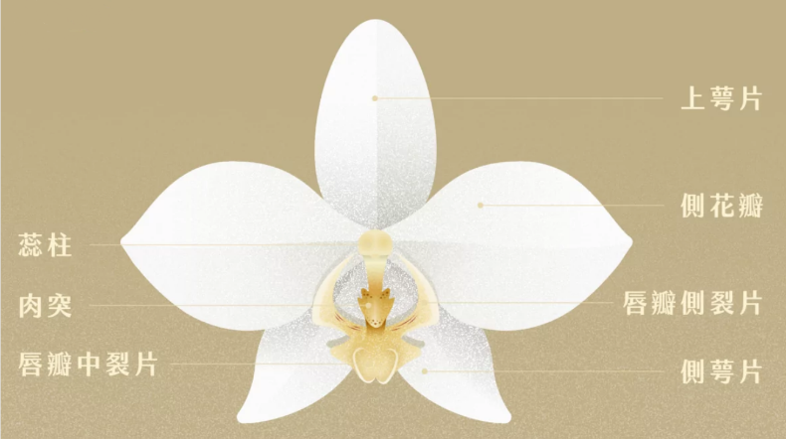
- Growing Guidelines
There are several crucial guidelines for cultivating Phalaenopsis aphrodite, and they can be summarized into the following 5 points.
temperature:
The phalaenopsis orchid prefers temperatures between 15-28℃. When we are growing the plant, the temperature is usually in the range, so we did not do anything to help the plant to regulate the temperature. However, the temperature in summer can be between 32-34℃. We found several ways that can help the plant to survive in the high temperature in summer.
To lower the temperature during summer, it is recommended to use shading and watering methods, or the orchid may experience heat dormancy. Keeping the orchid in an air-conditioned room during summer or indoors during winter is suitable, but you should make sure it is not kept in a poorly ventilated area.
watering:
The "roots" of the Phalaenopsis orchid have a greater function of fixing than absorbing water, so we think maybe there is no need to water it often. The information I found is that watering every 4-5 days is sufficient if indoors. When watering, we avoid watering the flowers and do not let the water remain on the leaves. It is suggested to water in the morning and avoid leaving water on the leaves at night to prevent diseases in winter (Water left on the leaves of plants during the night can create a humid environment, which can lead to the growth of harmful microorganisms such as fungi and bacteria) , so we took the advice and water it in the morning.
fertilizer:
No fertilizer is needed during the flowering period, so we did not do anything on fertilization, but we should give fertilizer after the flower stages. The following is what the internet suggests we do in terms of fertilization after the flowering stage.
Mature plants should be supplemented with balanced fertilizers containing nitrogen, phosphorus, and potassium. Different nutrients affect the plant in different stages. Nitrogen fertilizer is most needed during the period of new shoots and leaves, while phosphorus and potassium fertilizers are needed during the maturity period. When fertilizing, it is best to apply a small amount of fertilizer multiple times.
humidity:
Phalaenopsis orchids prefer well-ventilated and humid air, with a relative humidity of around 70%. We place our plant on the seventh floor of the 12th dormitory, and the room is well-ventilated. The humidity varies between days, and we did our best to evaluate how much water it needs everyday.
suggestion for the plant after fading (in the future)
- don’t discard the whole flower stem. Instead, simply remove the faded
flowers, leaving the stem intact to allow for the growth of new flower buds.
- move the plant outdoors after the blooming period to promote new growth.

- Plant Records
2/26:
In the begining, only 5 flowers on the plant bloomed (Fig. 3.1). And there is one flower that is going to bloom (Fig. 3.2).

3/1:
The flower which was almost in bloom we mentioned on 2/26 is in full bloom now (Fig. 3.3). We also see the leaves are deep green (Fig. 3.4). To understand what happened to our orchid, we searched the information on the internet and recognized that the reason that the leaves go deep green might be related to the time it bathes in sunlight. According to the information from the internet, if the sunshine hours aren’t enough, the leaves’ color will become deeper, which means the plant generates more Chlorophyll to promote photosynthesis. In contrast, when the sunlight hours are too much, the leaves color will become lighter.

3/12:
During 3/1 to 3/12, we tried to increase the sunlight hours and observed whether doing so can improve the situation of leaves. Let’s take a look at the Fig. 3.5. We can see that the color of leaves is obviously lighter than before. And there are more and more flowers that keep flowering during these days (Fig. 3.6).

3/17:
This week was a very hot week. Seeing the 3.7, we can find that the color of leaves is much lighter than the color in 3/12. In this period of time, more flowers bloomed (Fig. 3.8).

3/19:
Due to intense sun exposure, the leaves seem to be a little yellow (Fig. 3.9). We decided to lower the time the plant is exposed to the sunlight. At the same time, we chose to increase the watering frequency and amount attempting to help the leaves to recover to their original color.

3/26:
We tried to water the plant in a new way. At the beginning, we pour water directly into the sphagnum moss, which is found to be an inefficient way. Therefore, we adapted a new way suggested on the internet. We think this way is better because the sphagnum moss seems to be unable to store water. The way we did before is not an efficient way because the sphagnum moss can not hold water well, and therefore, when we were watering using the previous way, the water is leaking out of the pot.

4/1:
The method mentioned in the record of 3/26 is as follows (Fig. 3.10) : (1) put the pot into a container, (2) dump the water between the container and the pot until all the sphagnum moss is bathed in the water, (3) wait for about 30 minutes to let the water be fully absorbed by the sphagnum moss, (4) take the pot out of the container and clean the container. This is our first time adapting the method (shown in Fig. 3.11), and this way works well, so we decided to use the new method from then on.

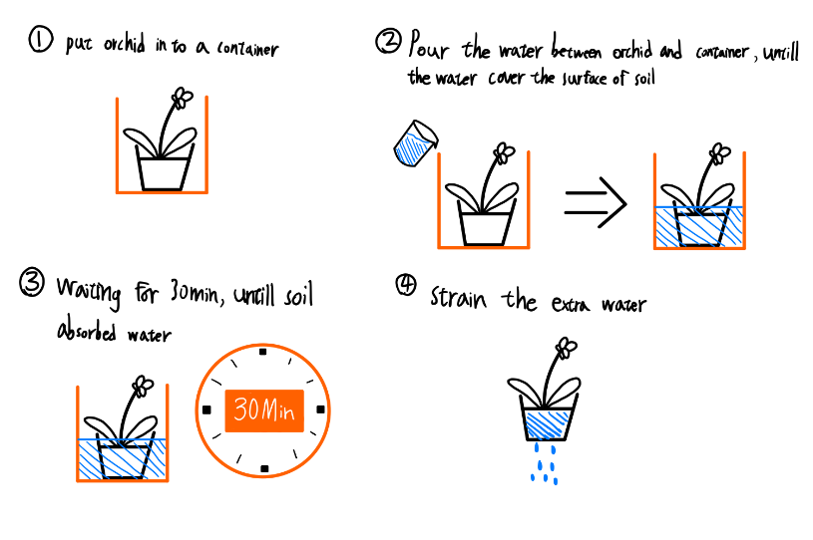
Fig. 3.9

4/16:
Weather has been getting more humid since 4/1, so the color of the leaves darkened which were quite similar to the ones when we started to grow the plant(Fig. 3.12).

4/20:
One of the branches became a little pink and orange (Fig. 3.13). We tried to find out what happened to the plant, but there is no related information on the internet. The weather is a little cloudy, so the leaves appear to be getting darker and darker (Fig. 3.14).

4/23:
The leaves were blackkkkk……, which is not a good sign (Fig. 3.15). The cause of the phenomenon might be insufficient sunlight, so we tried to make it exposed to more light by giving the plant artificial sunshine (the lamp on our desk).

4/28:
The flowers faded and started to fall (Fig. 3.16). We think the reason is sudden changes of weather and the fact that we are approaching the end of the flowering stage.

- reference:
- https://www.toga.org.tw/info/認識蘭花/蝴蝶蘭屬
- https://www.toga.org.tw/info/蘭花栽植/蝴蝶蘭
- 蝴蝶蘭 (biodiv.tw)
- 台灣蝴蝶蘭突破疫情，2021年外銷量成長8.5％ | 簡惠茹 | 遠見雜誌 (gvm.com.tw)
- 香水美人、龍魅力獲青睞 高雄新奇蘭花國際蘭展獲6獎 - 生活 - 自由時報電子報 (ltn.com.tw)
- 台東地區農會全球資訊網 (eastfa.org.tw)
- 台灣蝴蝶蘭 - 維基百科，自由的百科全書 (wikipedia.org)
- https://www.toga.org.tw/info/蘭花栽植/蘭花栽培管理要點
- 好種好開的 花市台灣白蝴蝶蘭！ 圓圓滾滾的花就是他的特色之一 - YouTube

