Berkeley algorithm

Scenario A:
With the three clocks initially offset by 0, 750, and 1500 ms and zero drift, I ran one Sync on node-1. The coordinator computed a group mean of about 750 ms and scheduled corrections of roughly +733 ms, +0.35 ms, and −750 ms. Immediately after the round the corrections were still pending; a later read showed all three nodes at approximately 750 ms with pendingMS=0. This confirms that Berkeley converges to the average of the participating clocks, not to real time.

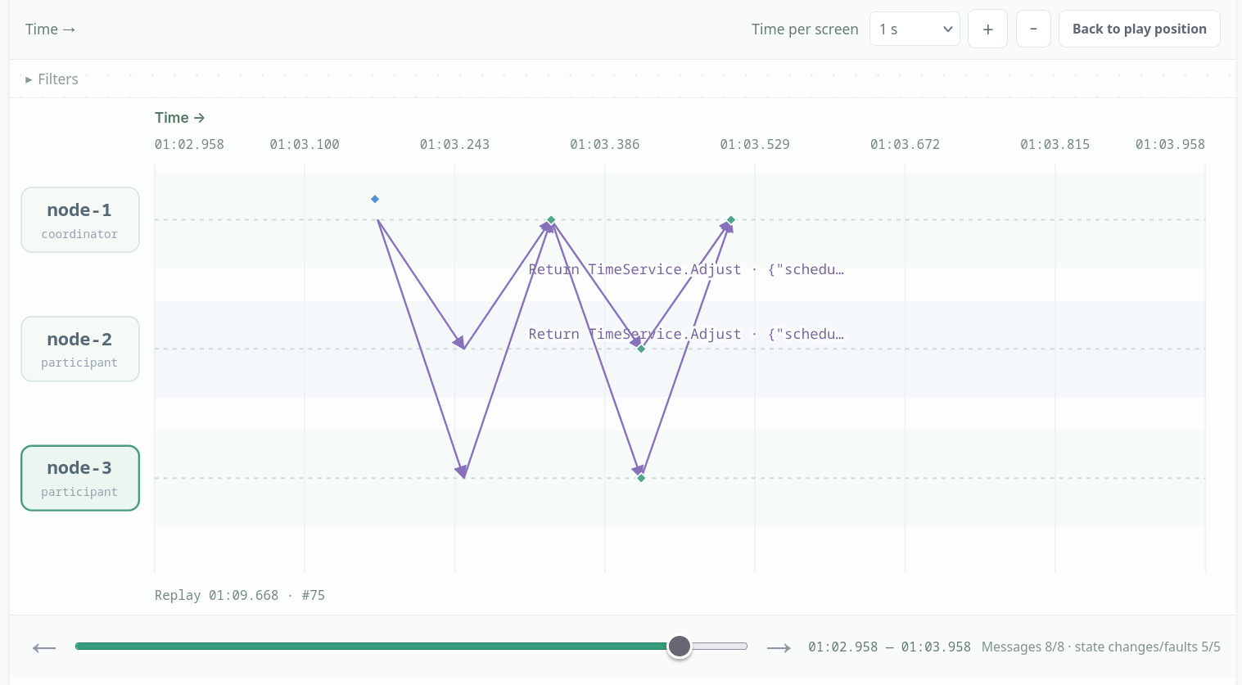
Initially:
node1: {"timeMS":1793014376659.0457,"hostOffsetMS":0.045654296875,"driftPPM":0,"pendingMS":0}
node2:
{"timeMS":1793014377408.0657,"hostOffsetMS":750.065673828125,"driftPPM":0,"pendingMS":0}
node3:
{"timeMS":1793014378161.0532,"hostOffsetMS":1500.05322265625,"driftPPM":0,"pendingMS":0}

After running sync on node 1:
node1:
{"timeMS":1793014471776.6123,"hostOffsetMS":17.6123046875,"driftPPM":0,"pendingMS":732.8520899239584}

node2:
{"timeMS":1793014472423.2632,"hostOffsetMS":750.26318359375,"driftPPM":0,"pendingMS":0.3508372583333712}

node3:
{"timeMS":1793014473173.123,"hostOffsetMS":1500.123046875,"driftPPM":0,"pendingMS":-750.3444698822916}

After running application.read:
node1:
{"timeMS":1793015093258.315,"hostOffsetMS":749.31494140625,"driftPPM":0,"pendingMS":0}
node2:
{"timeMS":1793015049411.0955,"hostOffsetMS":750.095458984375,"driftPPM":0,"pendingMS":0}
node3:
{"timeMS":1793015059547.1812,"hostOffsetMS":750.18115234375,"driftPPM":0,"pendingMS":0}

Scenario B:
I then set node-3 to 10000 ms and ran Sync again. Its offset was more than the 2000 ms threshold from the median (750 ms), so it was excluded from the mean; the mean of the remaining clocks was about 375 ms. The coordinator scheduled roughly +358 ms, −375 ms, and −9624 ms, and after read all three nodes had settled to about 375 ms. The outlier lost its vote in the average but still received the correction, so one bad clock did not drag the group toward 3583 ms.

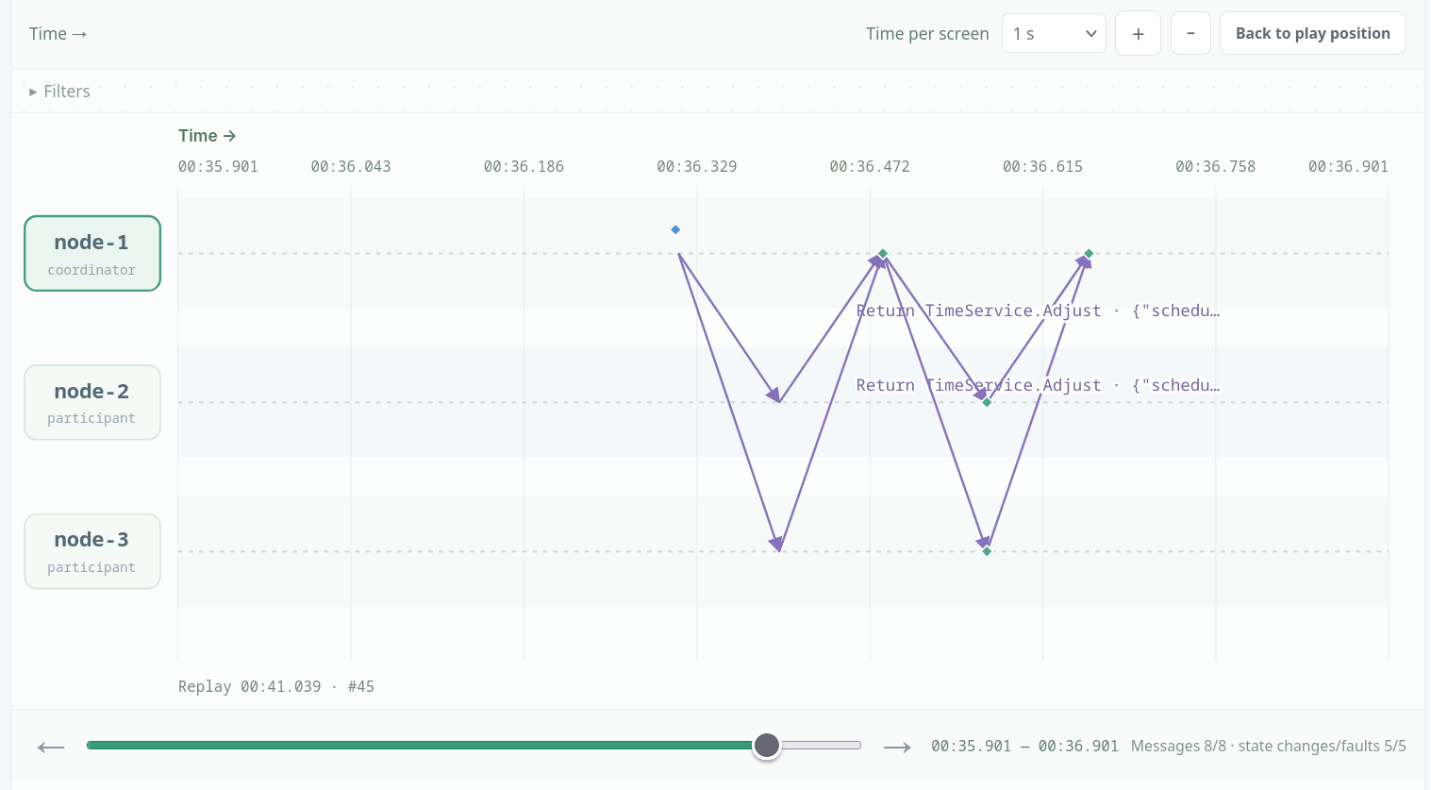

initially:
node1: {"timeMS":1793014376659.0457,"hostOffsetMS":0.045654296875,"driftPPM":0,"pendingMS":0}
node2:
{"timeMS":1793014377408.0657,"hostOffsetMS":750.065673828125,"driftPPM":0,"pendingMS":0}
node3:
{"timeMS":1793014378161.0532,"hostOffsetMS":1500.05322265625,"driftPPM":0,"pendingMS":0}

then, after setting node3 to 10000 and running sync:
node1:
{"timeMS":1793015221889.563,"hostOffsetMS":16.56298828125,"driftPPM":0,"pendingMS":357.7802150125}

node2:
{"timeMS":1793015222538.1323,"hostOffsetMS":750.13232421875,"driftPPM":0,"pendingMS":-374.9109324125}
node3:
{"timeMS":1793015231787.8088,"hostOffsetMS":9999.808837890625,"driftPPM":0,"pendingMS":-9624.27097009375}

after running application.read:
node1:
{"timeMS":1793015355495.9573,"hostOffsetMS":374.957275390625,"driftPPM":0,"pendingMS":0}

node2:
{"timeMS":1793015359747.7346,"hostOffsetMS":374.734619140625,"driftPPM":0,"pendingMS":0}

node3:
{"timeMS":1793015363202.801,"hostOffsetMS":375.801025390625,"driftPPM":0,"pendingMS":0}

Scenario C:
I reset the clocks to 0/750/1500 ms and ran Sync in slew mode. The group mean was about 749.5 ms, and the corrections (+749.5/+0.1/−749.7 ms) were applied gradually: at 3s node-1 was at 325.7 ms and node-3 at 1184.0 ms, and at 10s all clocks had settled at about 750 ms with slewMsLeft=0. In jump mode the same mean and deltas were applied instantly, so node-3 jumped from 1500 to 750 ms in one step and slewMsLeft was immediately 0. The final state is identical, but the jump moves time backward and violates monotonicity, while slewing keeps the clock strictly increasing. Results can be seen in json files.

Design variant:
Berkeley synchronization here has a fixed coordinator: only node-1 can run Sync. After I crashed node-1, attempts to run Sync from another node were rejected because that node is not the coordinator, and no election or failover exists. The remaining nodes cannot compute a new round, so recovery requires starting a fresh experiment. This shows that the protocol depends on an active, agreed-upon coordinator and deliberately does not solve coordinator failure. See Json file for results.

Bully election:

Scenario A:
I started a five-node run and held an election. Node-5 became coordinator because it has the highest ID, and nodes 1–4 became followers after receiving its Coordinator announcement. No lower node won, because every higher live node answered OK and took over. So, the highest live node leads.
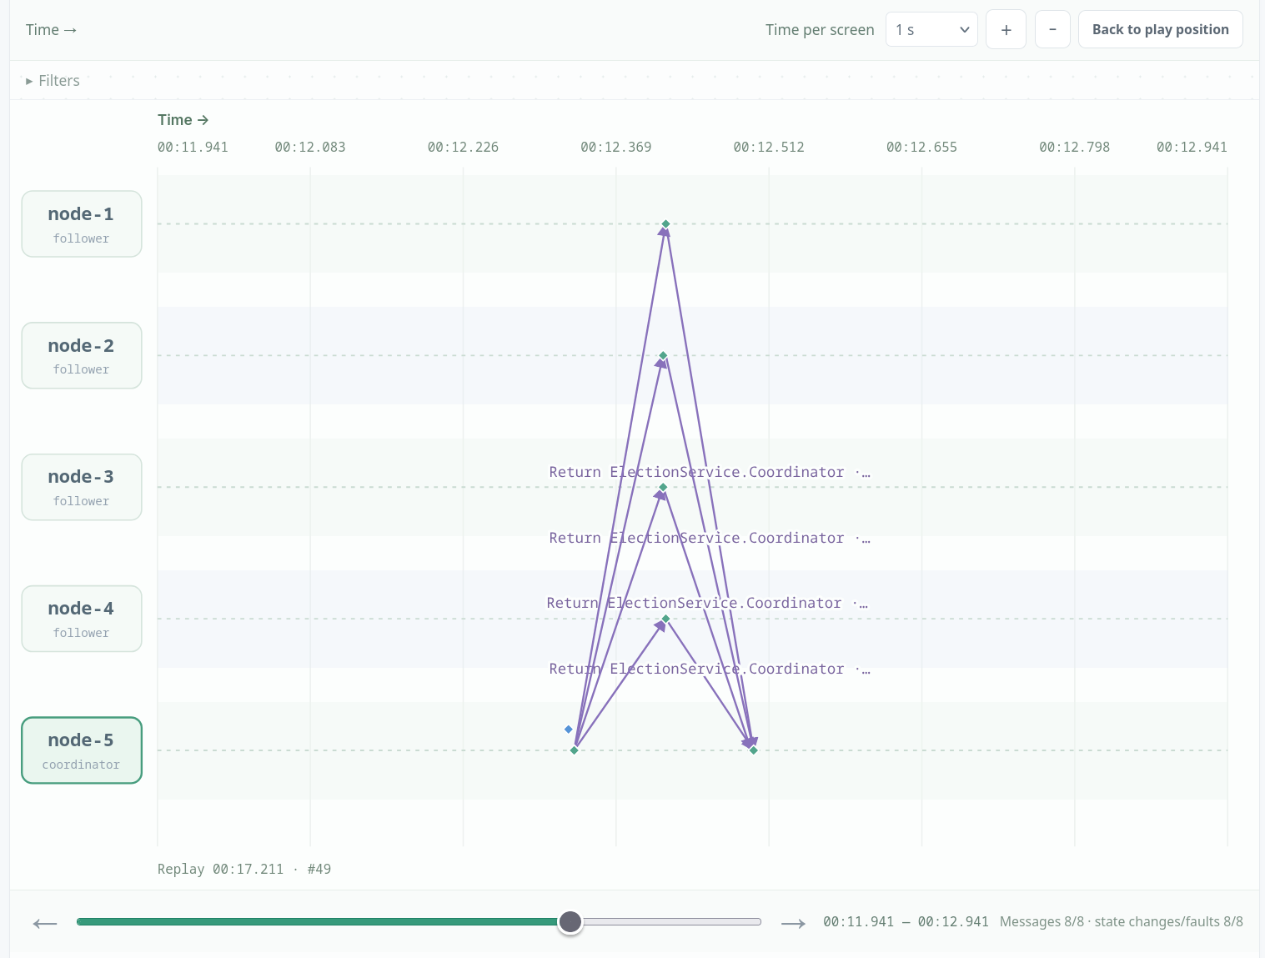

Scenario B:
Node-5 was coordinator, and I then crashed it. I triggered a new election from node-1, which sent election to nodes 2–5. Node-5 was dead, nodes 2–4 answered OK, and node-4, the highest live node, waited for node-5 to time out and then declared itself coordinator. All live nodes switched to node-4, while node-5 remained offline.

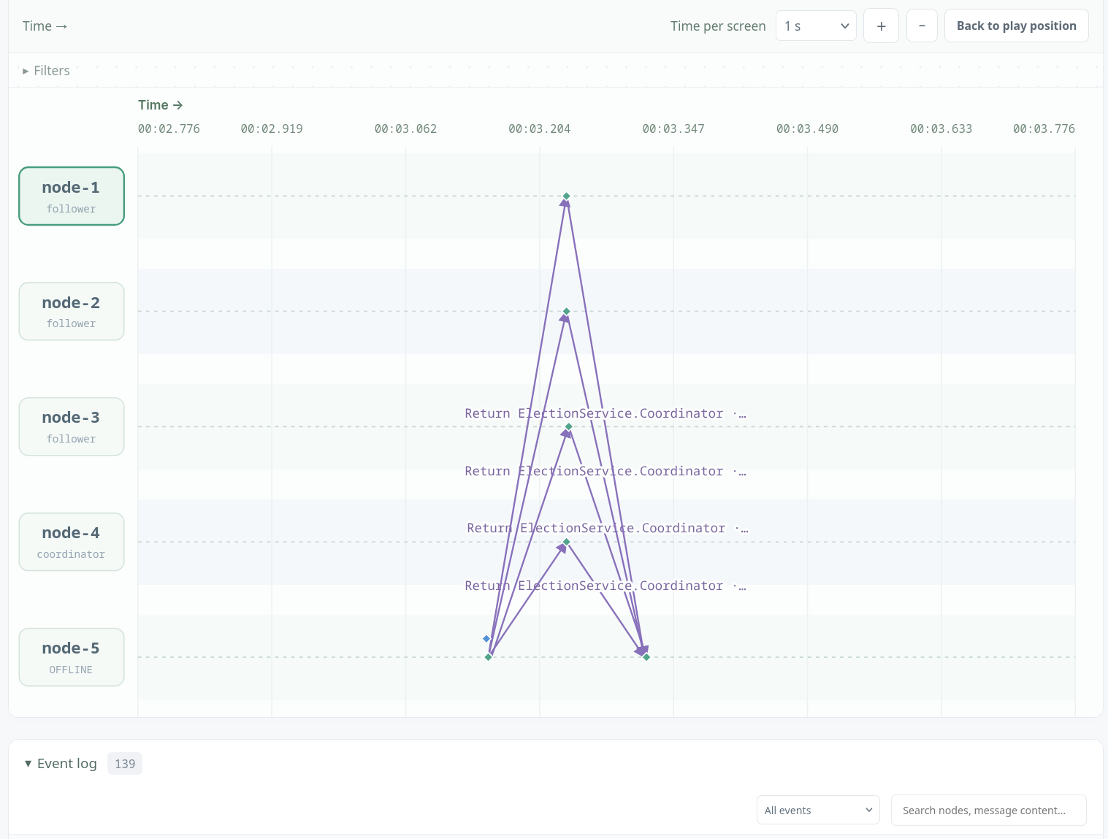

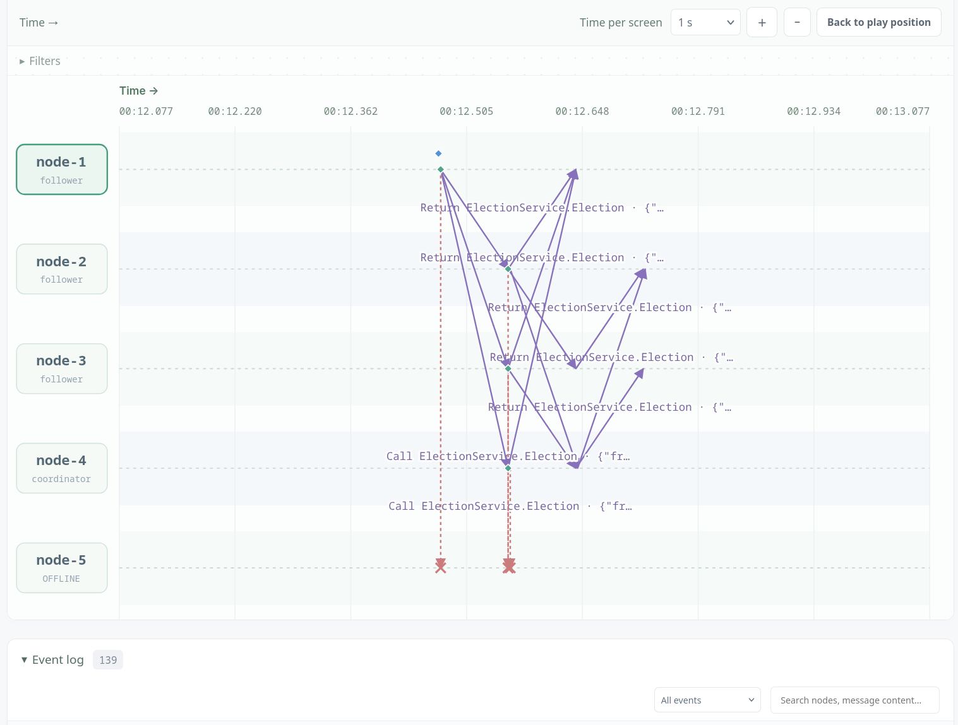
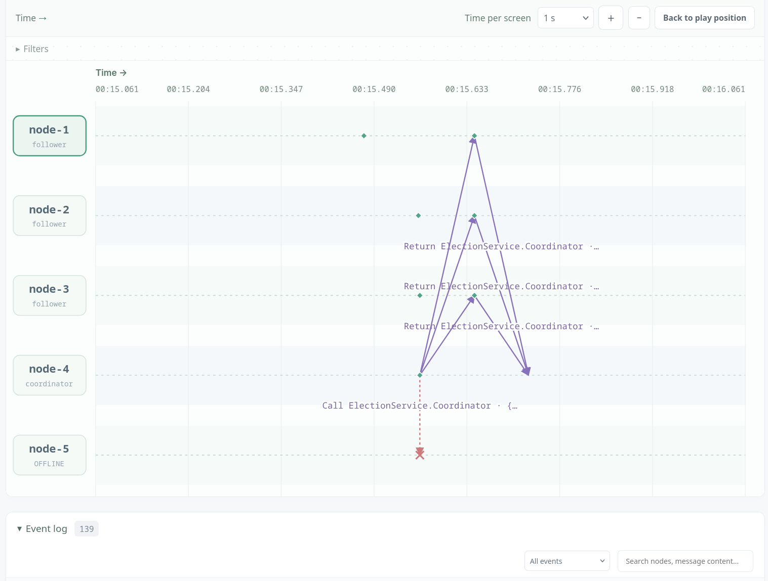

Scenario C:
Using eight-node mapping, node-8 was first made coordinator by an election started from node-4. I crashed node-8 and started another election from node-4, nodes 5–7 were still alive and node-7 was the highest live node. Node-7 won after timing out the dead node-8 and broadcast coordinator to the group. This reproduces the lecture: the initiator wakes the higher nodes, and the highest survivor becomes coordinator.
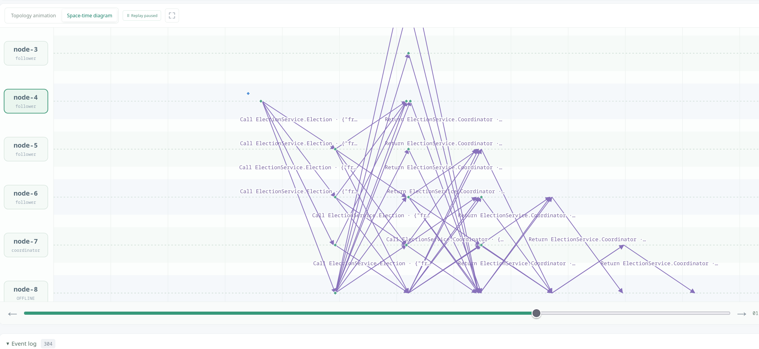
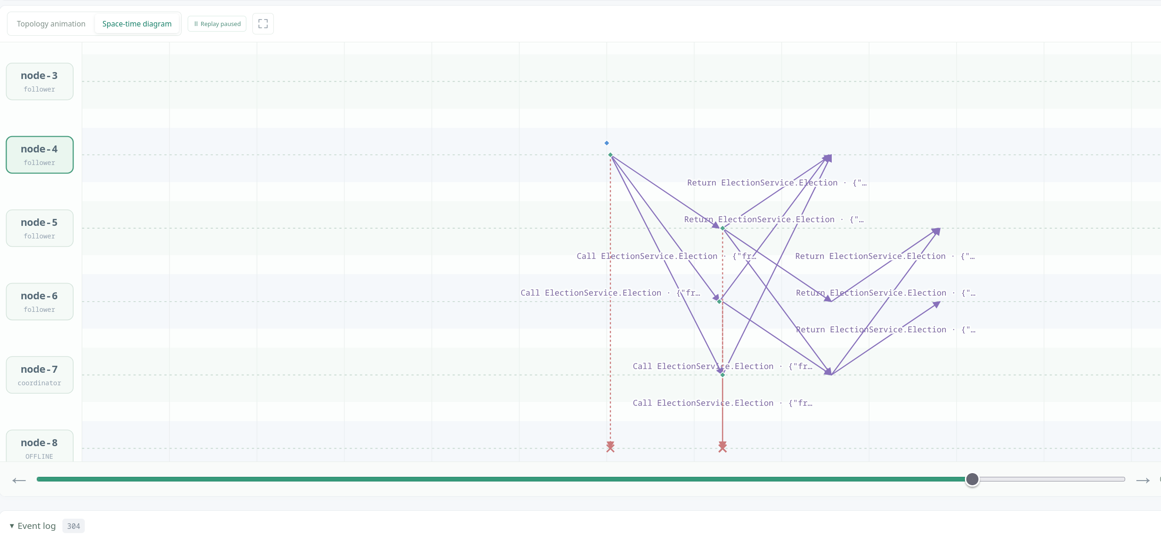

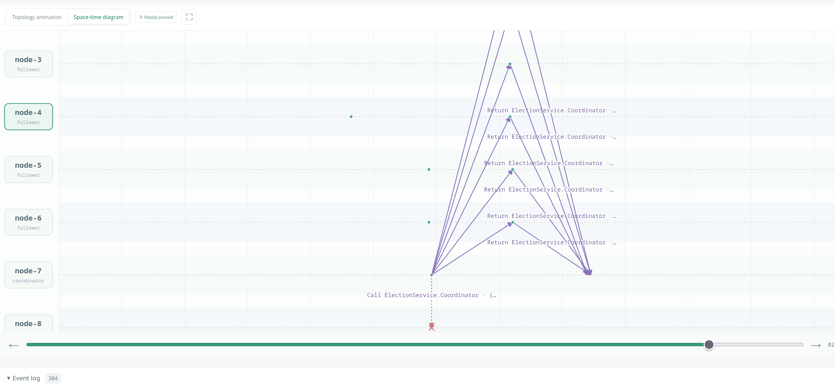

Scenario D:
With node-8 already down, I also crashed nodes 6 and 7. The remaining nodes were 1–5, so node-5 was now the highest live node. An election triggered from a lower node caused node-5 to campaign, time out the dead higher nodes, and win. All live nodes accepted node-5, so the two extra failures added timeout delay but still produced exactly one coordinator.
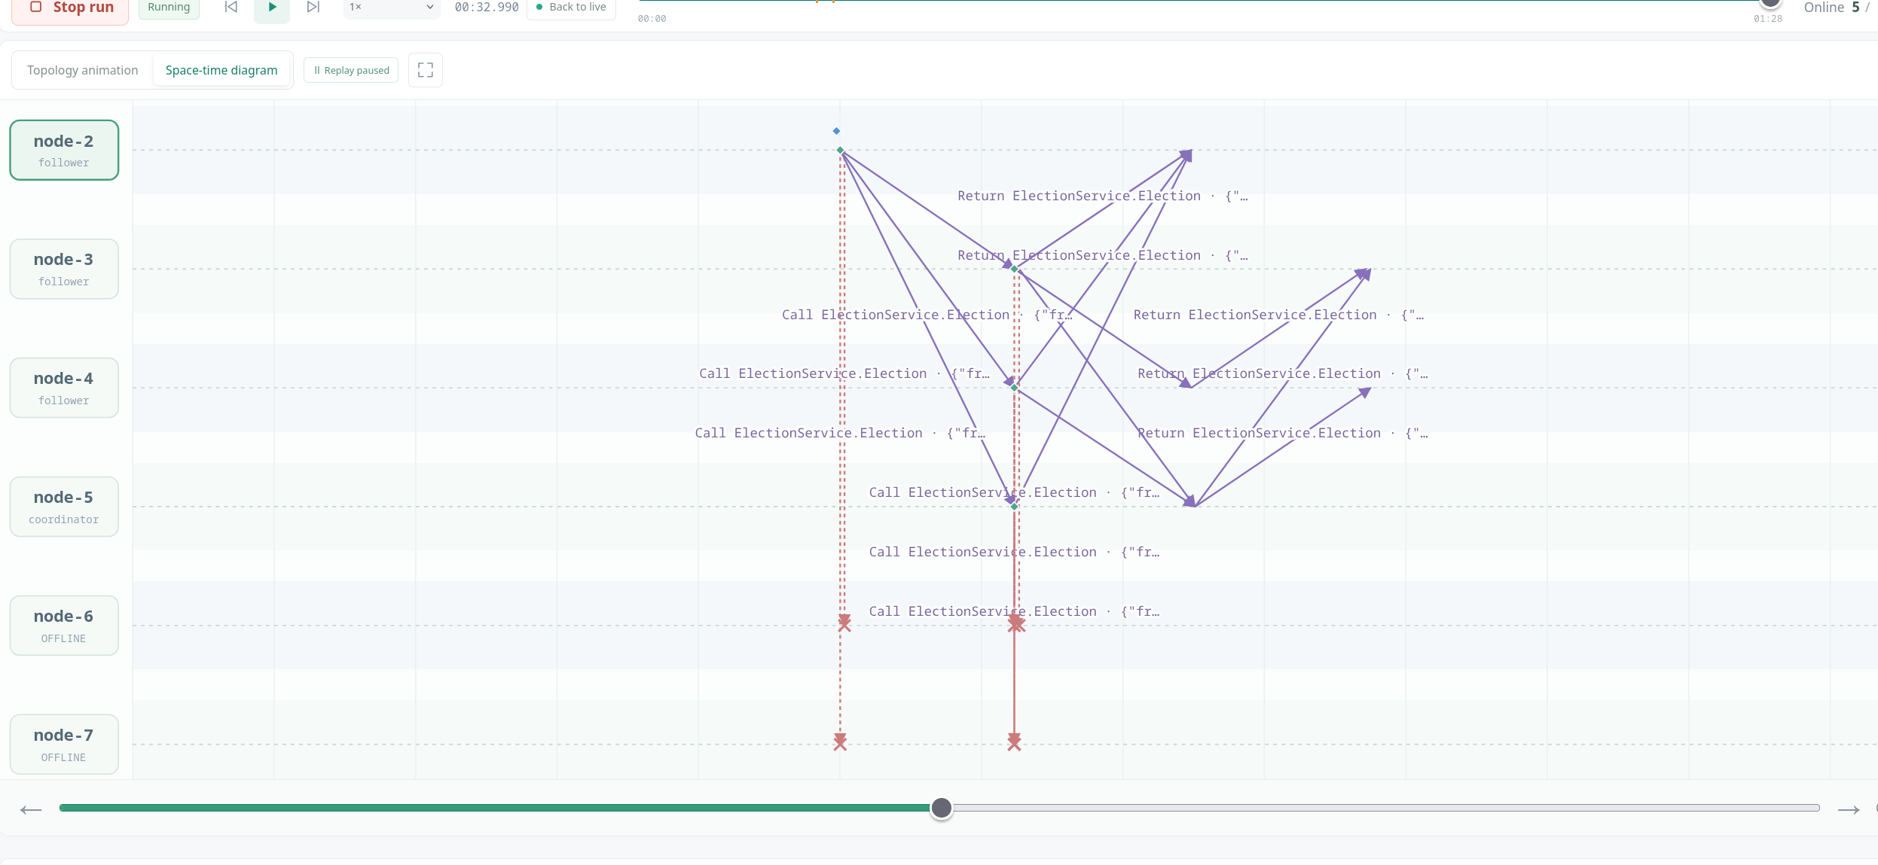

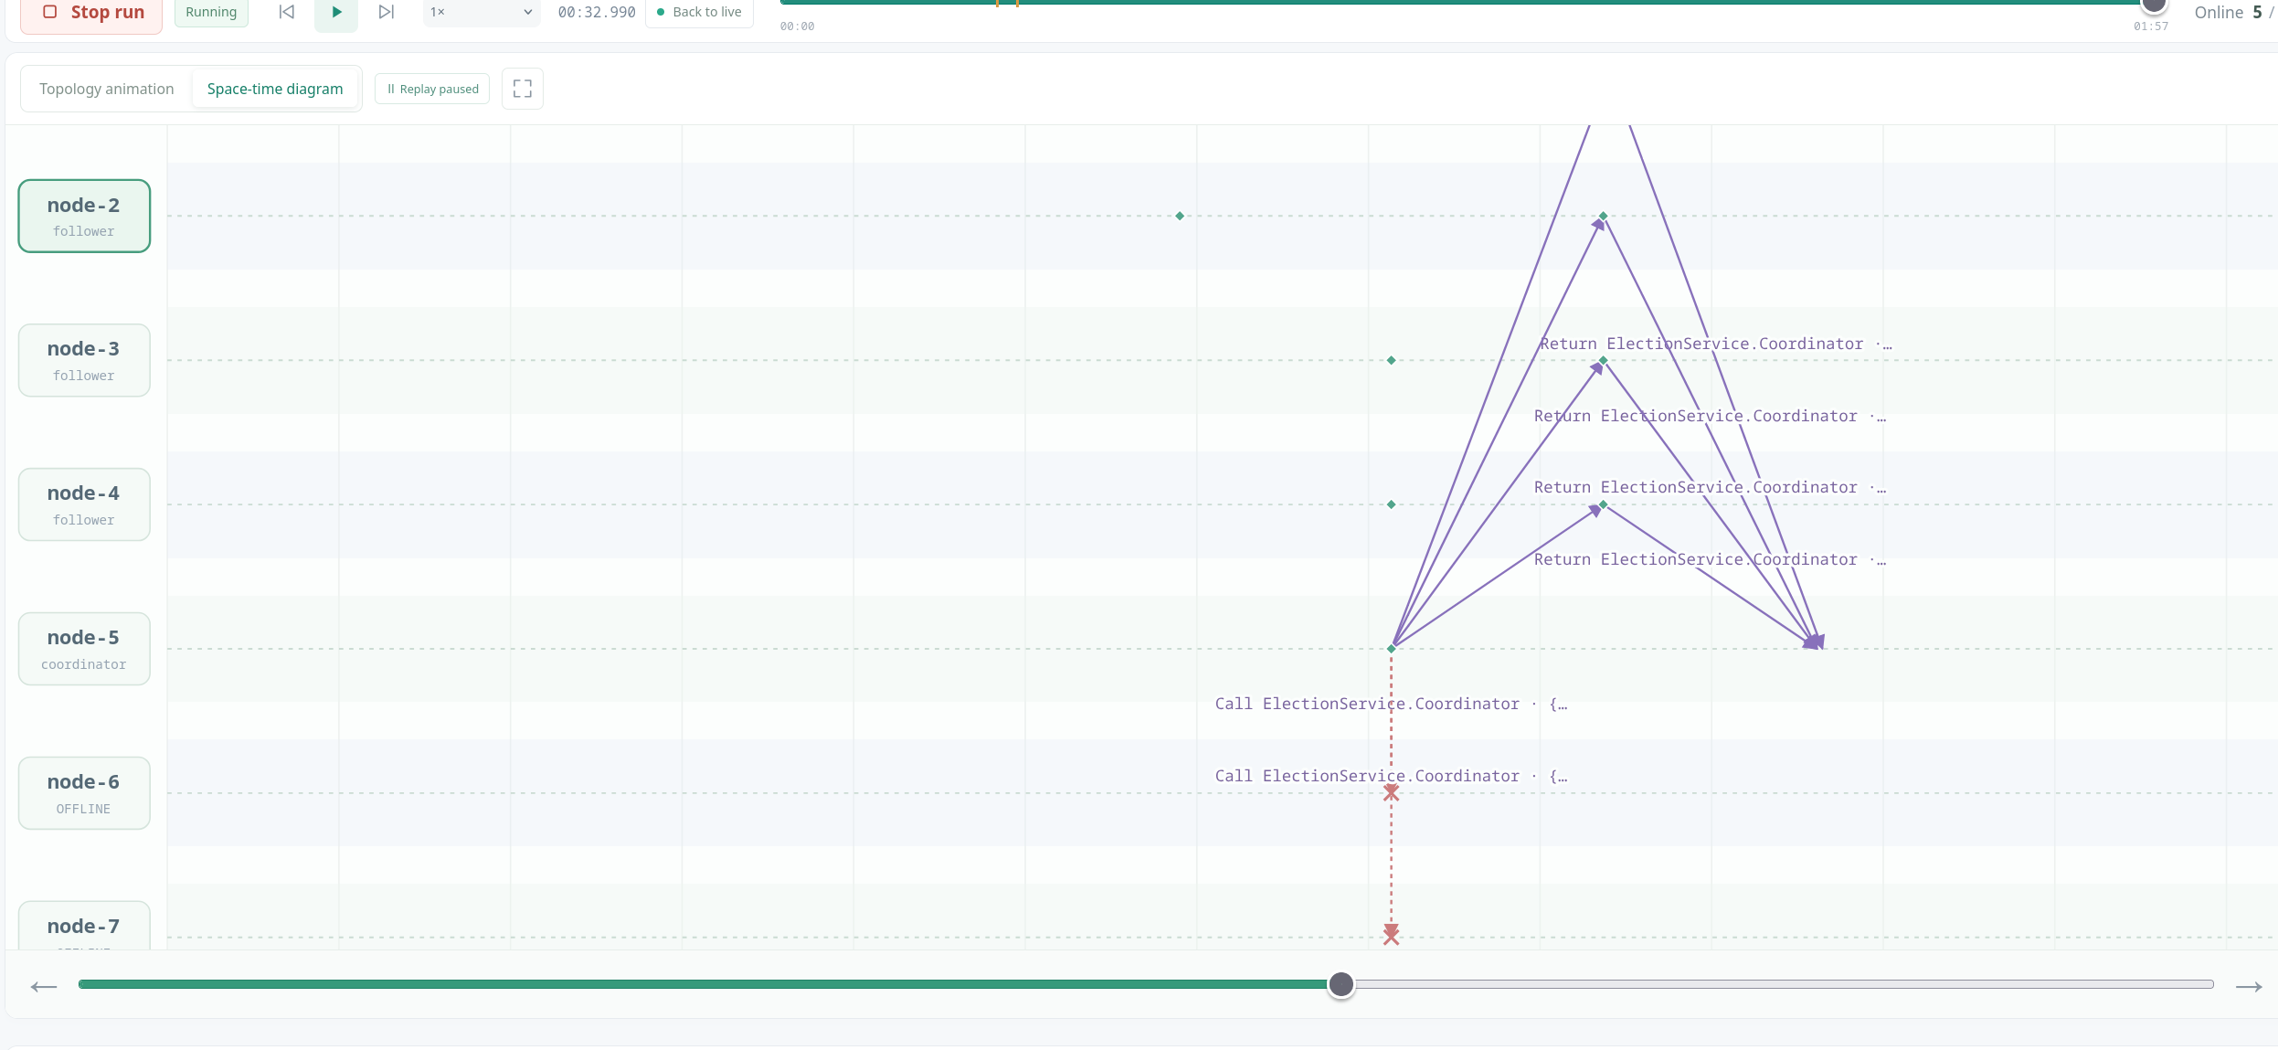
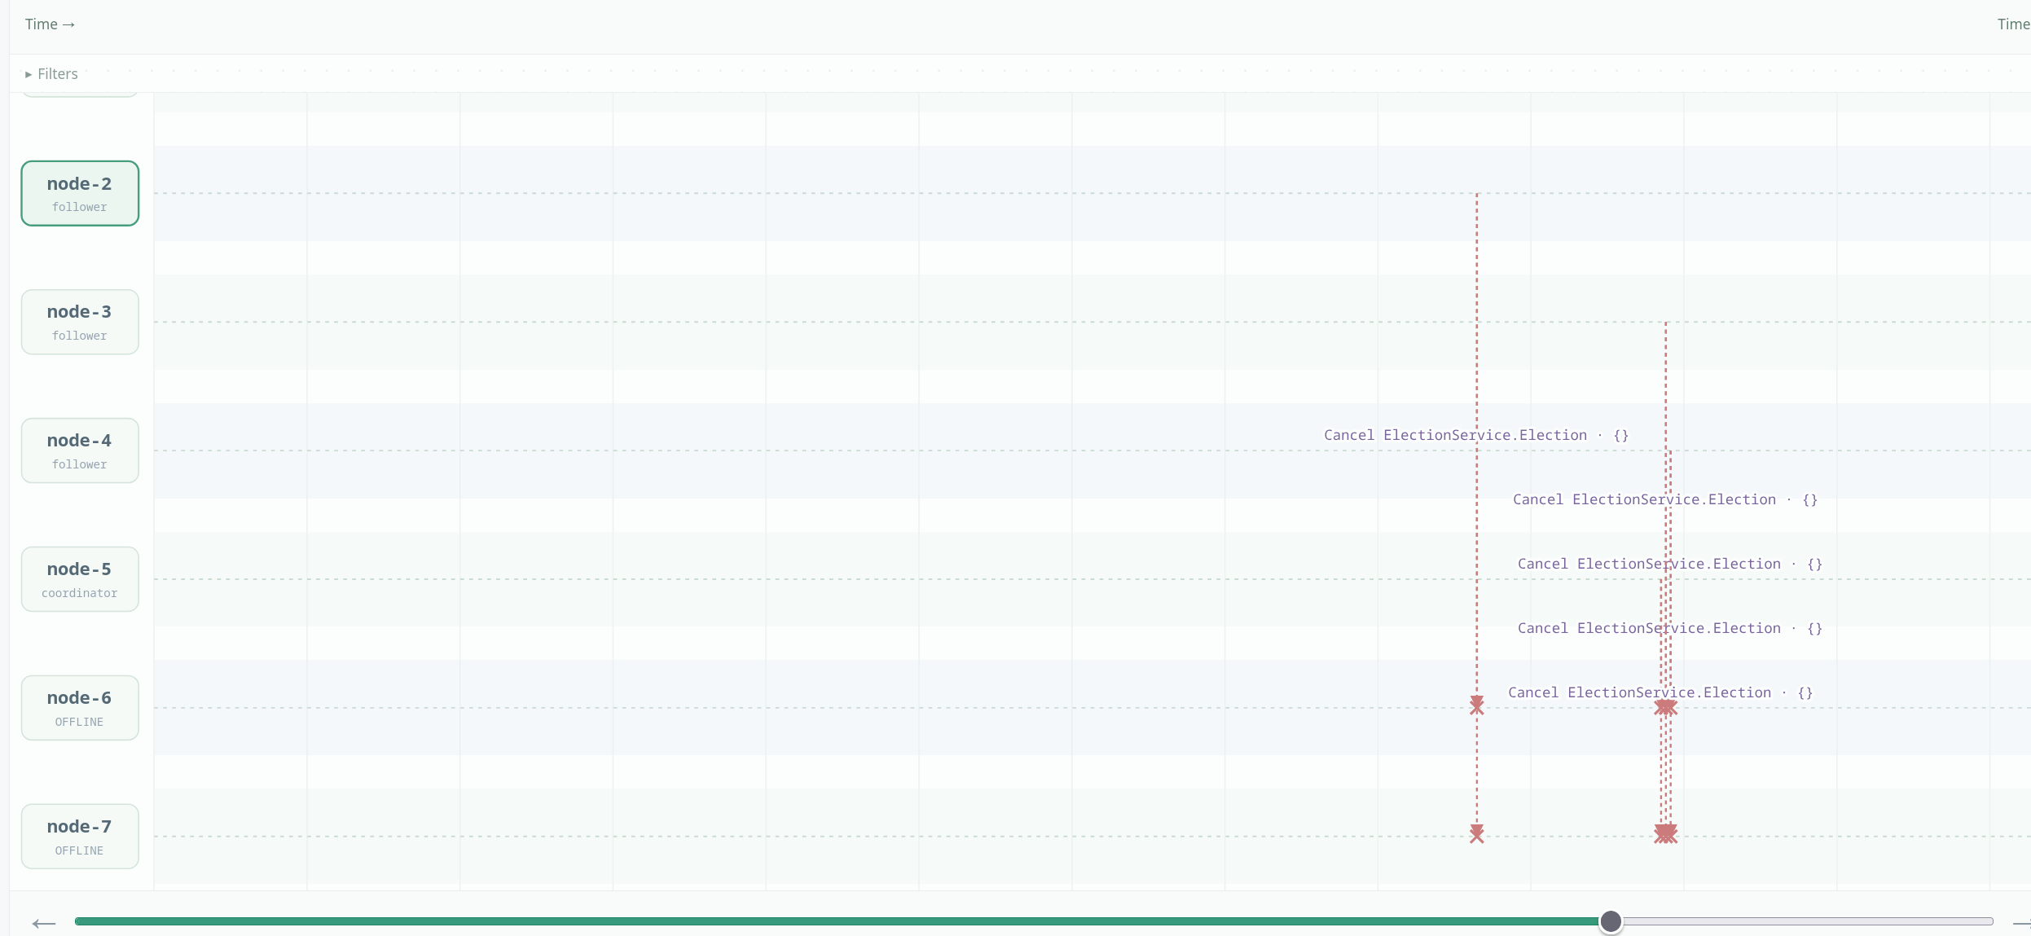

Design variant:
Node-7 was coordinator, then crashed; node-6 took over as the highest live node. I recovered node-7 and triggered a new election from node-4, and node-7, now the highest live node again, won. Node-6 stepped down and all live nodes switched back to node-7. This is reasonable for a preferred primary but can cause issues with frequent switching when the failure is only temporary slowdowns.

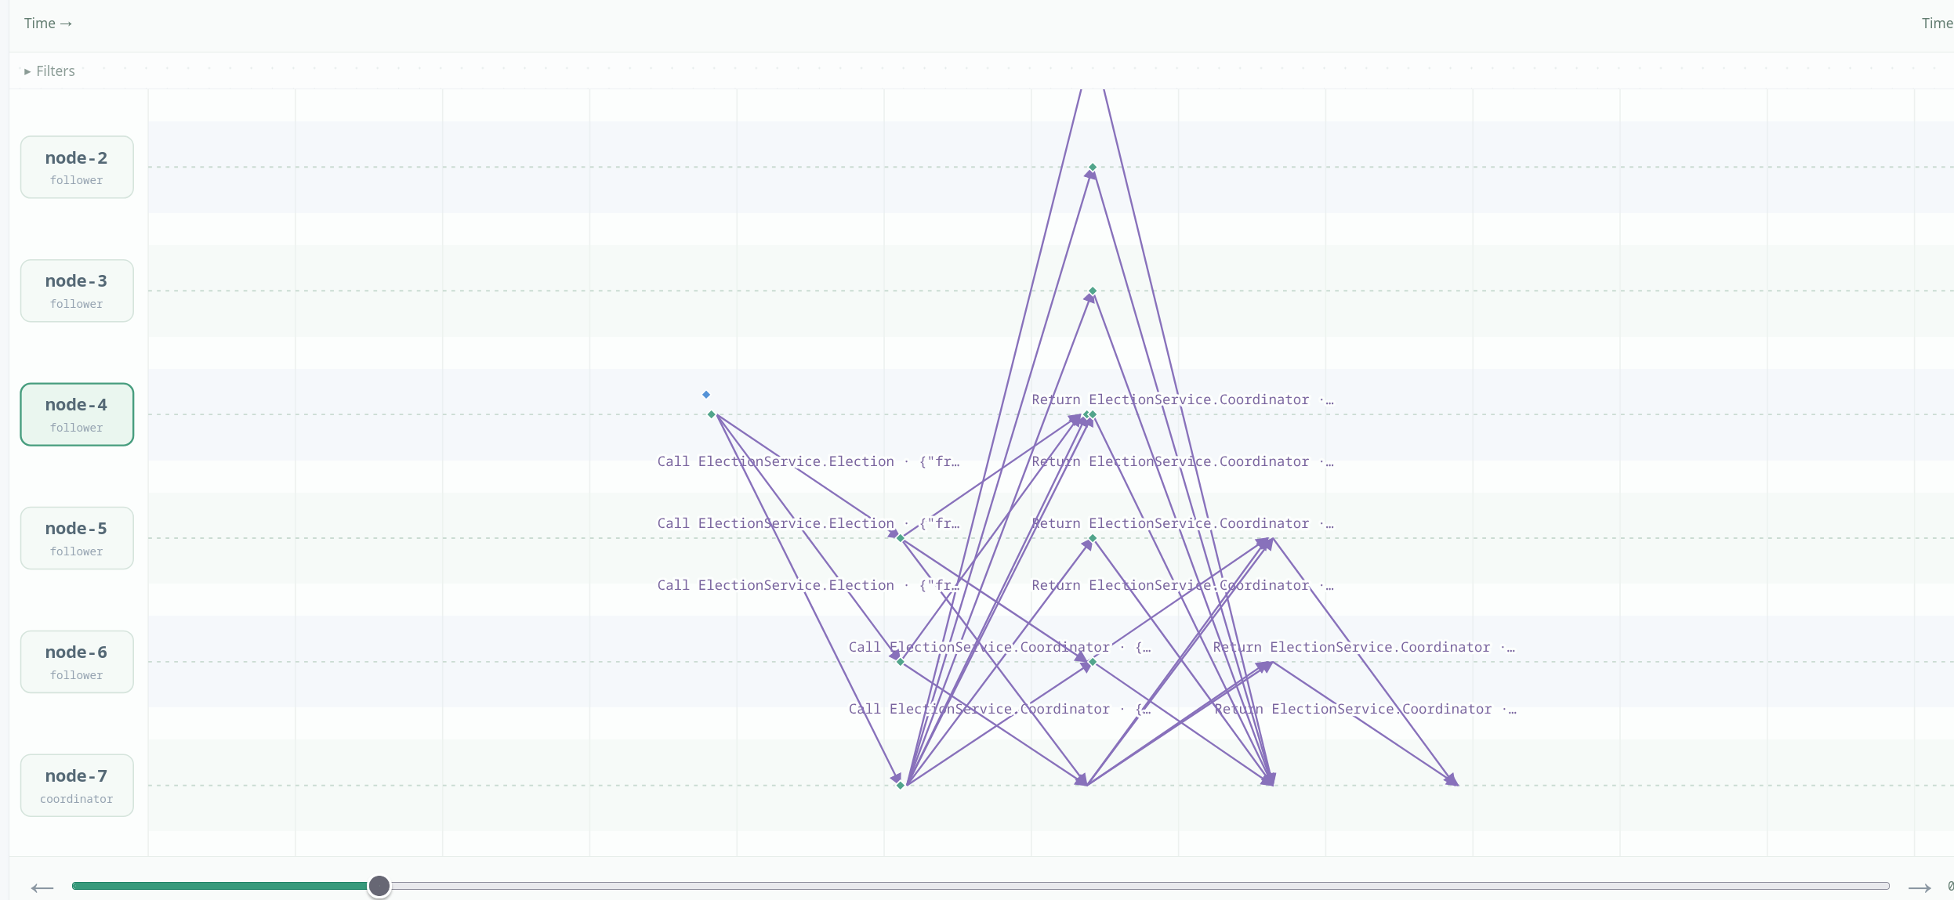
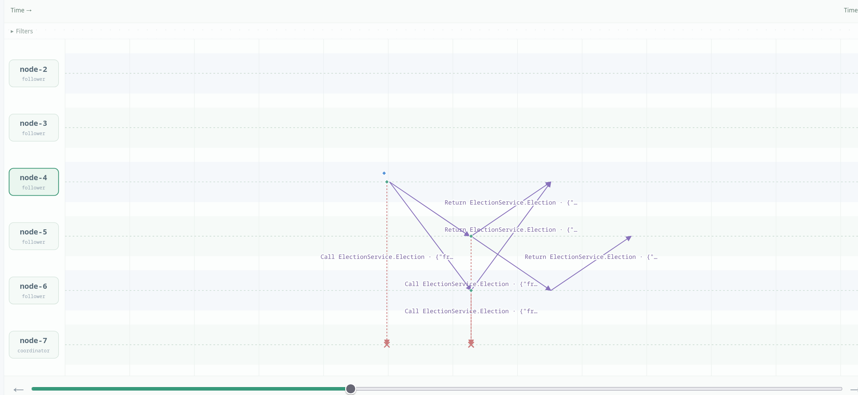
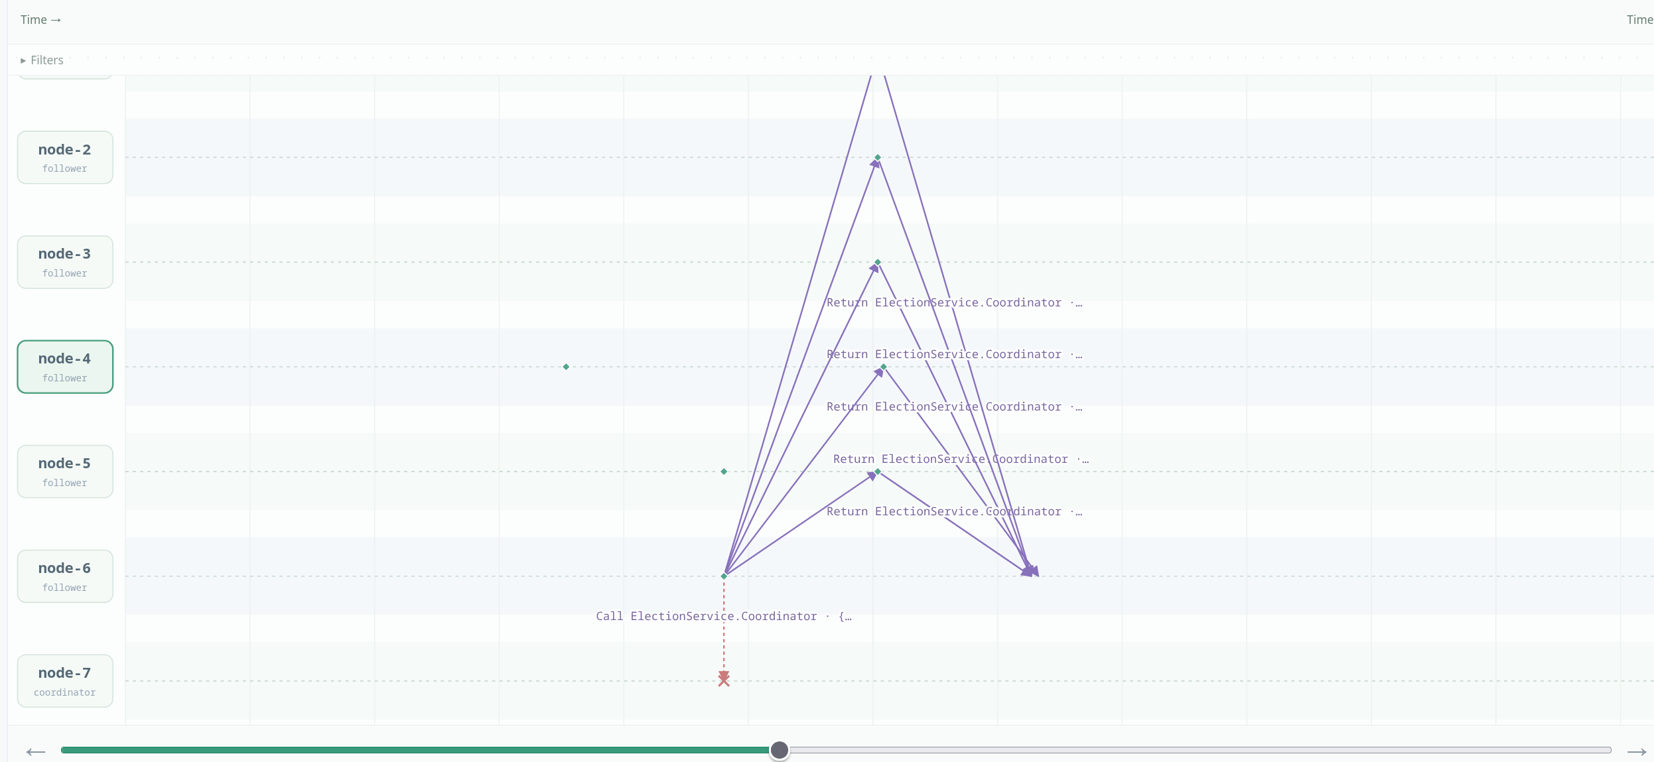
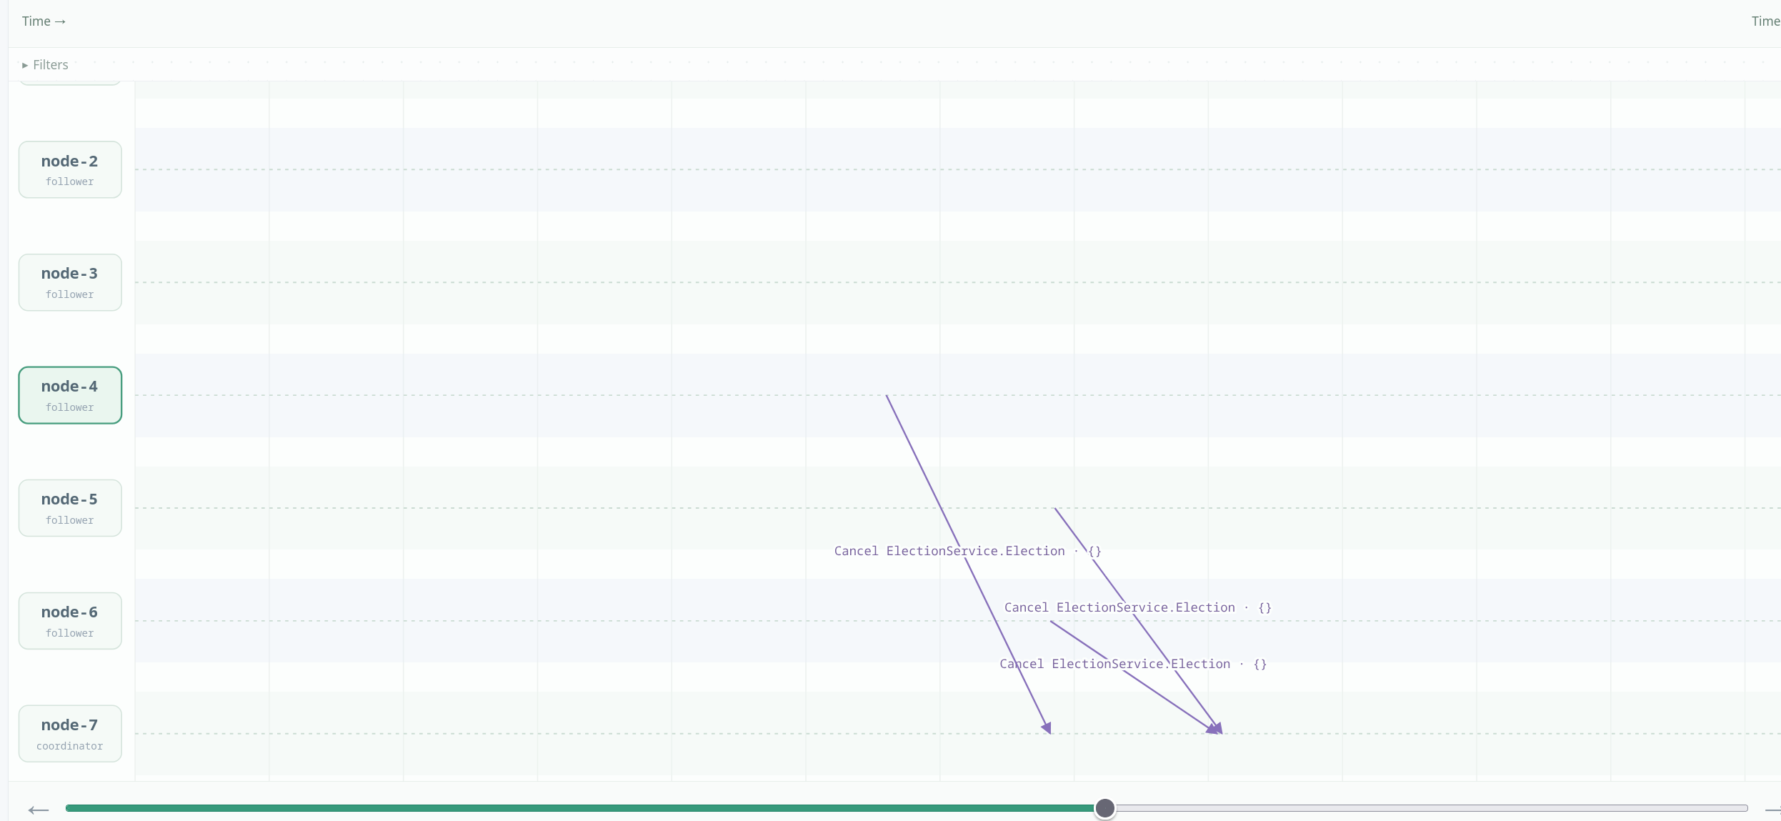
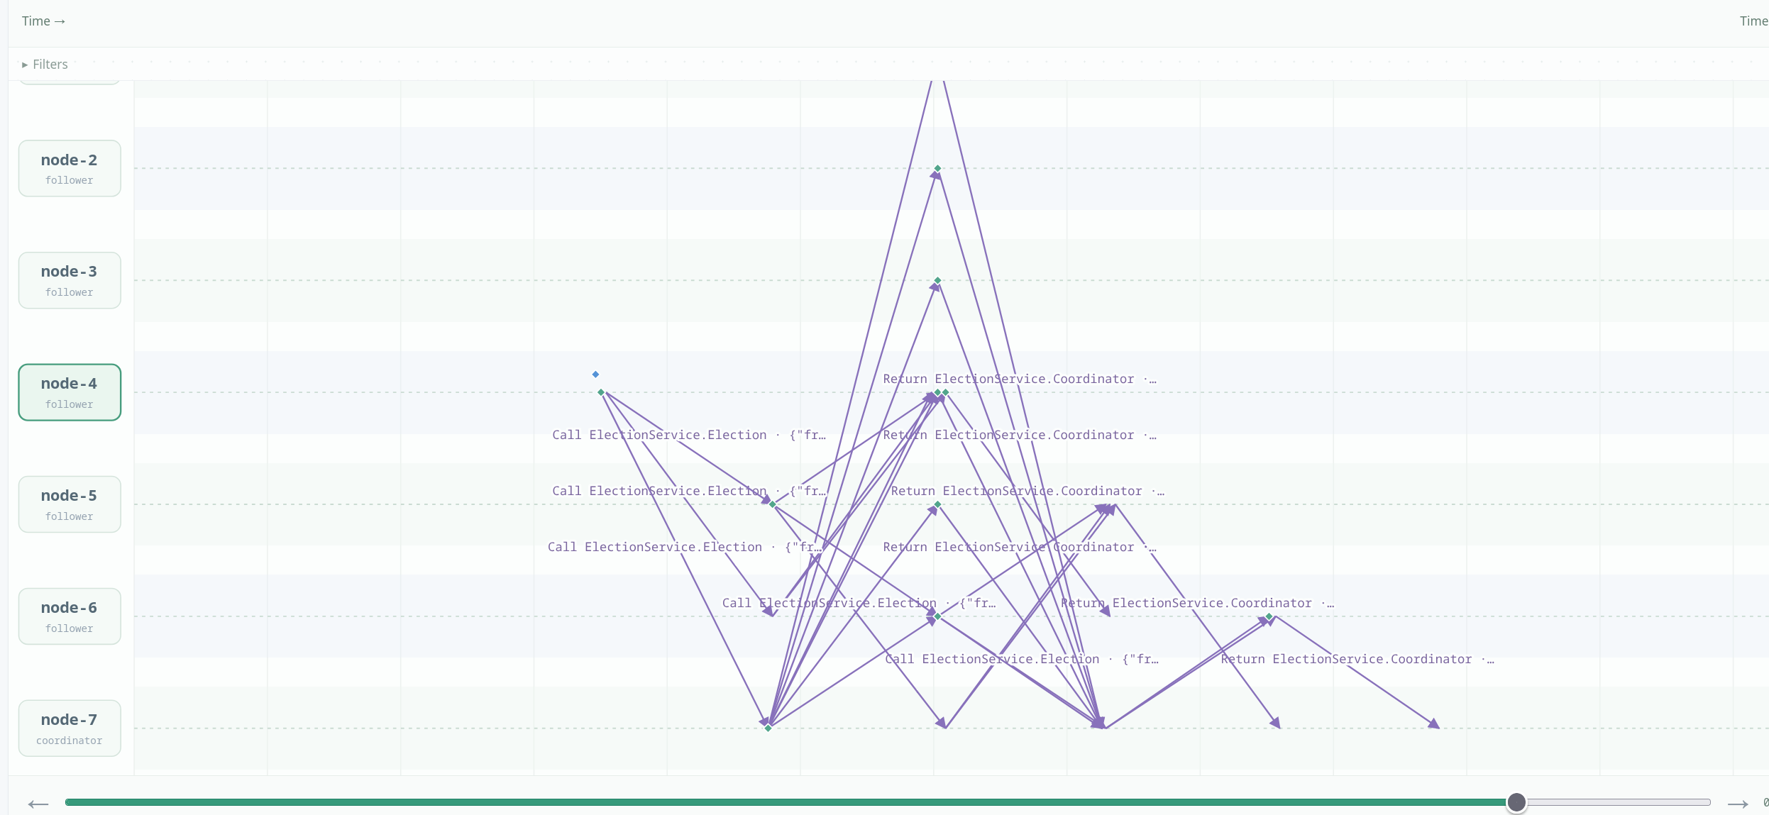

Lamport mutual exclusion

Scenario A:
I triggered acquire simultaneously on node-2 and node-3 with holdMs=2000. Both requests received Lamport timestamp 1, so the tie was broken by node ID: node-2 entered first. Node-2 deferred its Ack to node-3 while it was in the critical section, so node-3 waited about 2255 ms while node-2 waited only 168 ms. The critical sections did not overlap, both nodes completed one entry, and all nodes returned to idle.
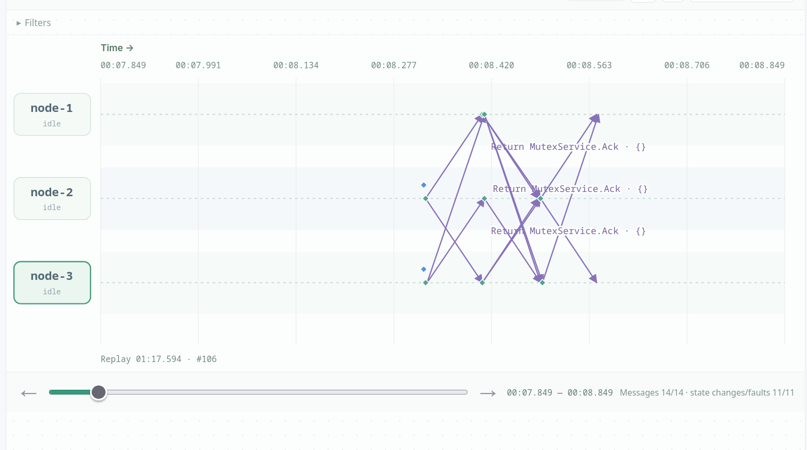
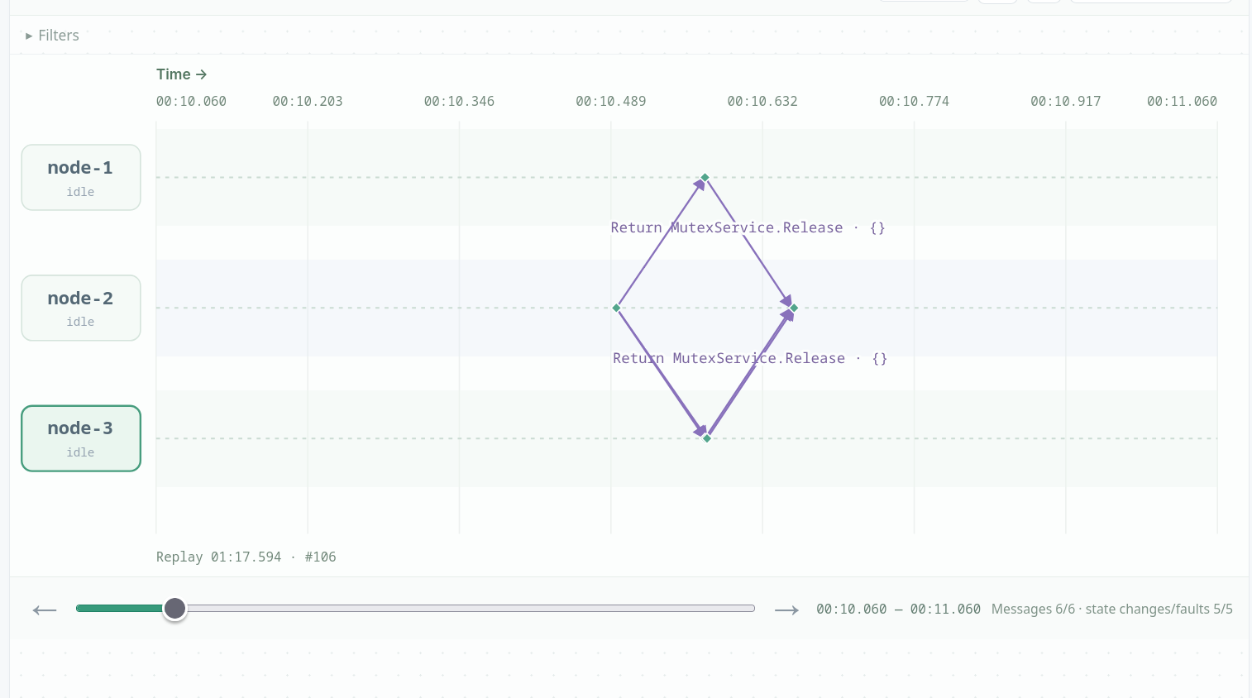
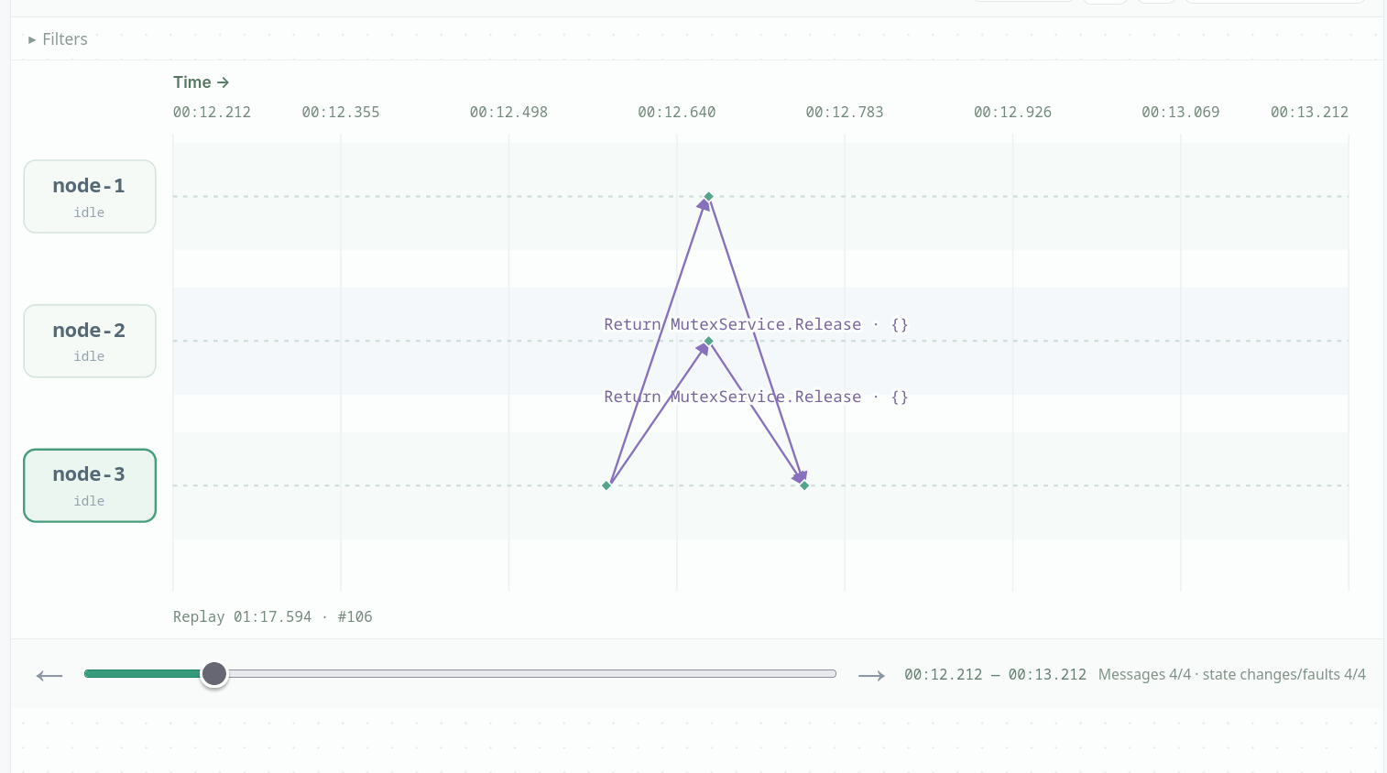

Scenario B:
I crashed node-2 and then called Acquire on node-1. Node-1 sent Request to nodes 2 and 3 and received node-3’s Ack, but node-2’s Ack never arrived. Node-1 stayed waiting with acksHave=1 of 2 and never entered the critical section. This shows that Lamport mutual exclusion has no failure detector or coordinator: one unrelated crashed node can block everyone forever.
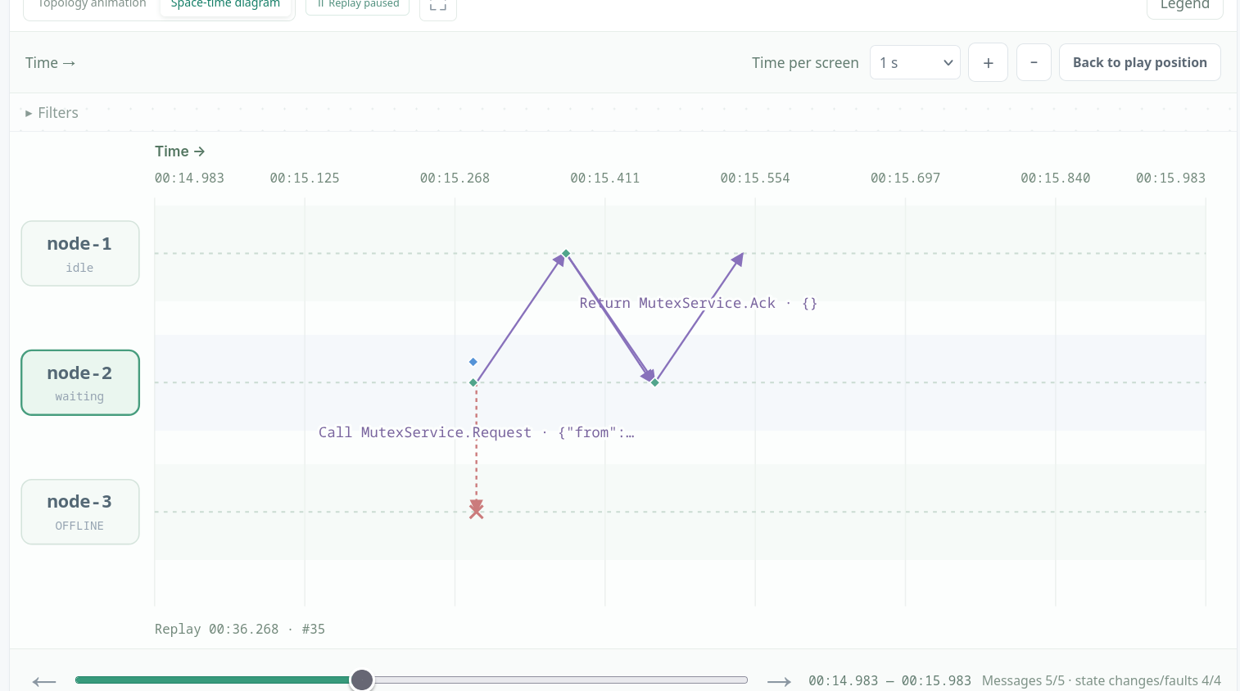
Design variant

Two-phase-commit

Scenario A:
I transfer 30 from node-2 to node-3. The TM sends RM.Prepare to all three RMs; node-2 (-30), node-3 (+30) and node-4 (0) all answer vote:"yes" and enter prepared, so the TM writes commit to its log and sends RM.Commit. node-2 drops to 70, node-3 rises to 130, and node-4 stays at 100, keeping the total at 300, and all four nodes record the same outcome.
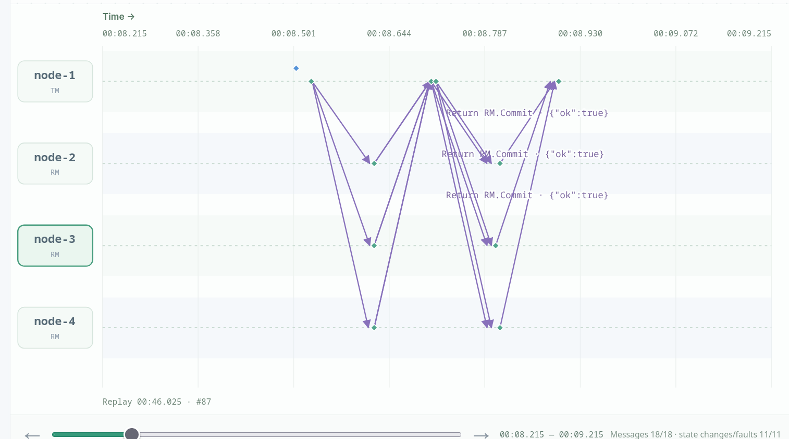
see JSON

Scenario B:
I transfer 150, which exceeds node-2's balance of 100. node-2 answers vote:"no" with reason "insufficient funds", while node-3 has already answered vote:"yes" and locked a +150 delta. The TM sees the No and writes abort, then sends RM.Abort, which releases node-3's lock and leaves
both balances at 100. This demonstrates that 2PC follows the: one resource that cannot pay forces the whole transaction to fail, unlike Paxos/Raft where a majority is renough.
see JSON

Scenario C:
I start a transfer with pauseBeforeDecisionMs=30000; both RMs vote YES and lock, and the TM pauses with decision:"" before writing anything. I crash node-1, and the RMs' TM.Status polls are dropped, so they enter uncertain and stay locked in a blocking state. When I recover node-1, it finds no decision in its log and so it writes abort and releases both RMs, with balances unchanged. The contrast with D shows that the logical commit instant is the log write, not the moment a participant sees Commit.
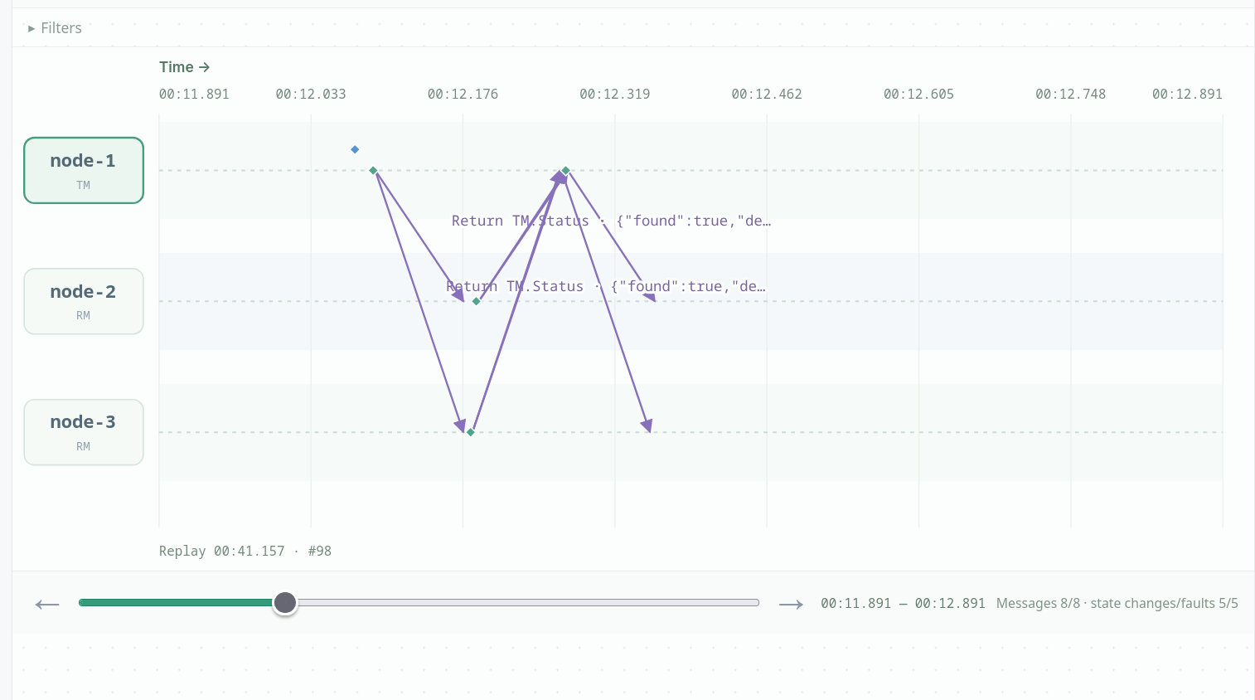

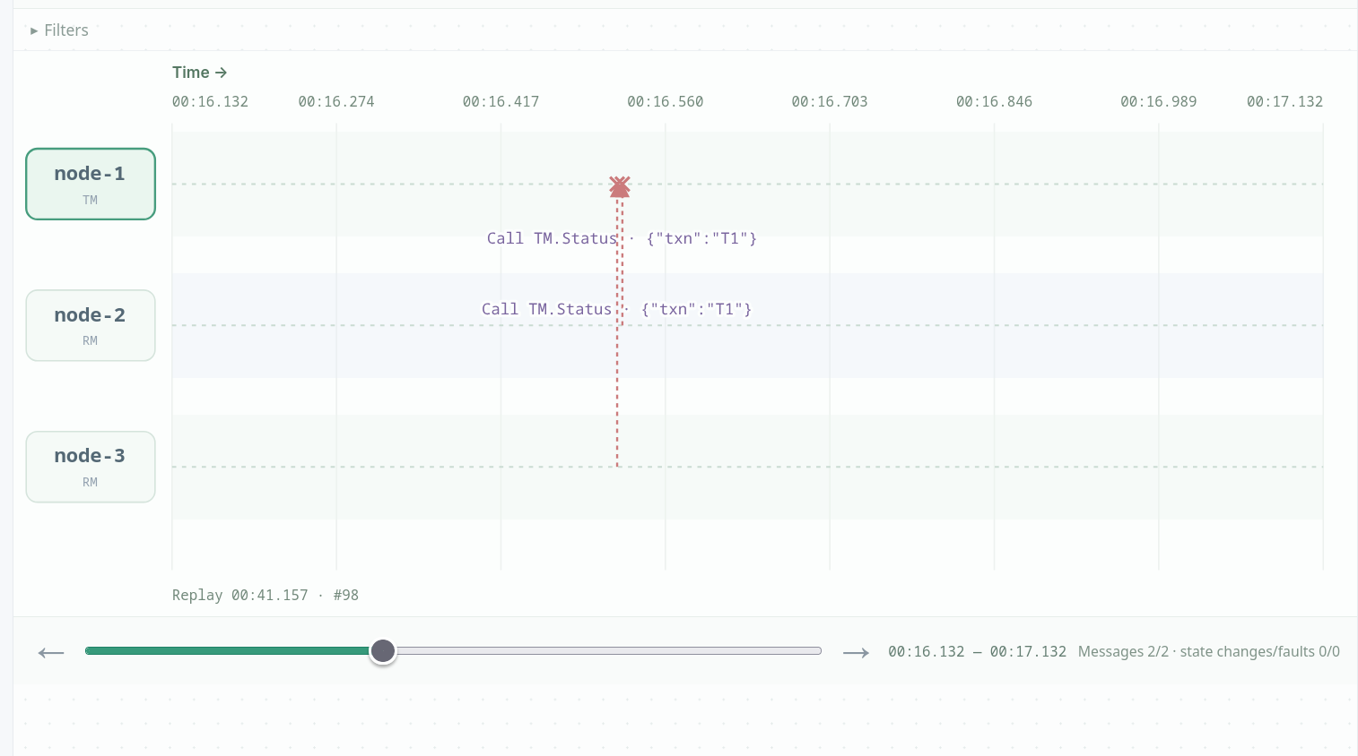
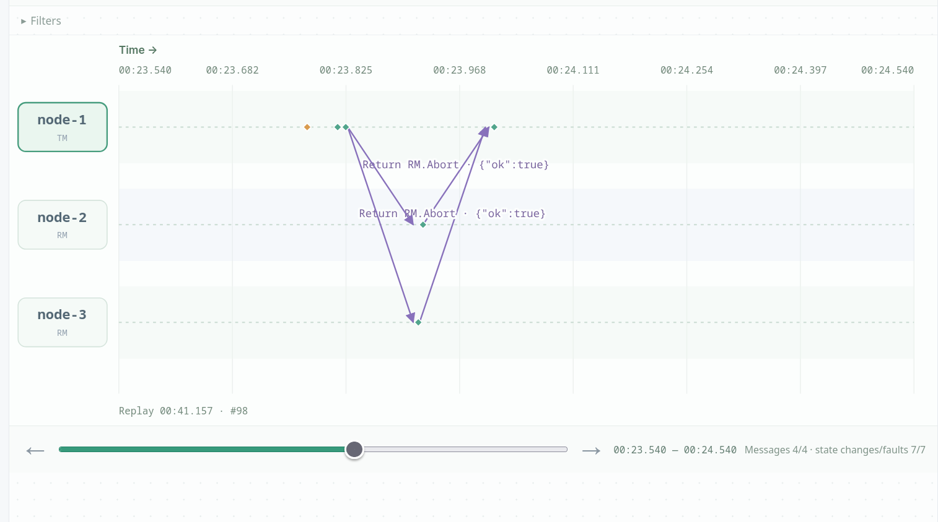
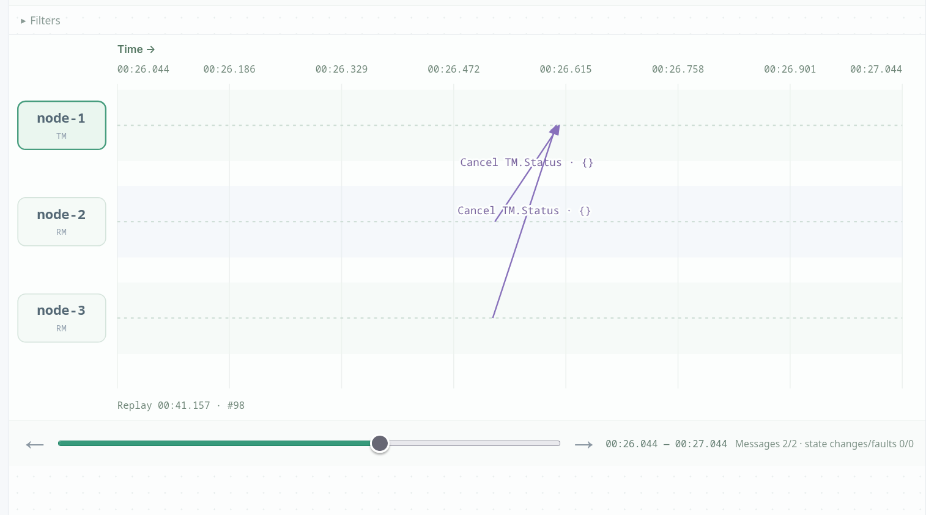

Scenario D:
I start a transfer with pauseAfterDecisionMs=30000. The TM writes commit to its log but crashes before notifying anyone. The RMs are prepared (locked) during the pause, and once the crash makes their TM.Status polls fail they become uncertain, with balances unchanged. On recovery the TM re-reads its log, sees commit, and resends RM.Commit until both RMs acknowledge, moving each balance exactly once. This shows that durability at the commit point is what turns a crash from an abort into a completed transfer.
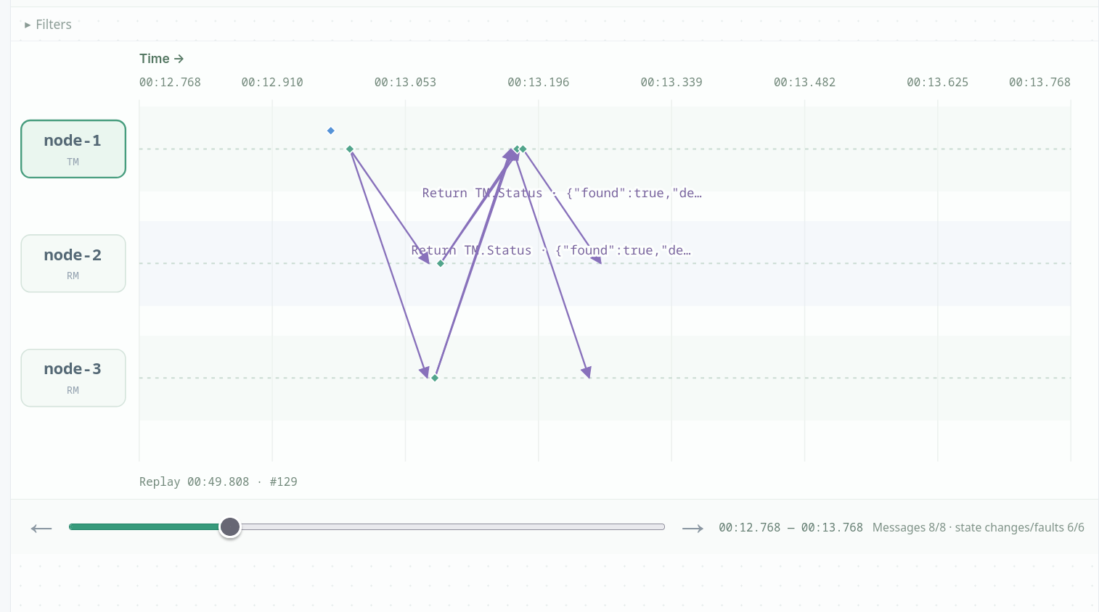
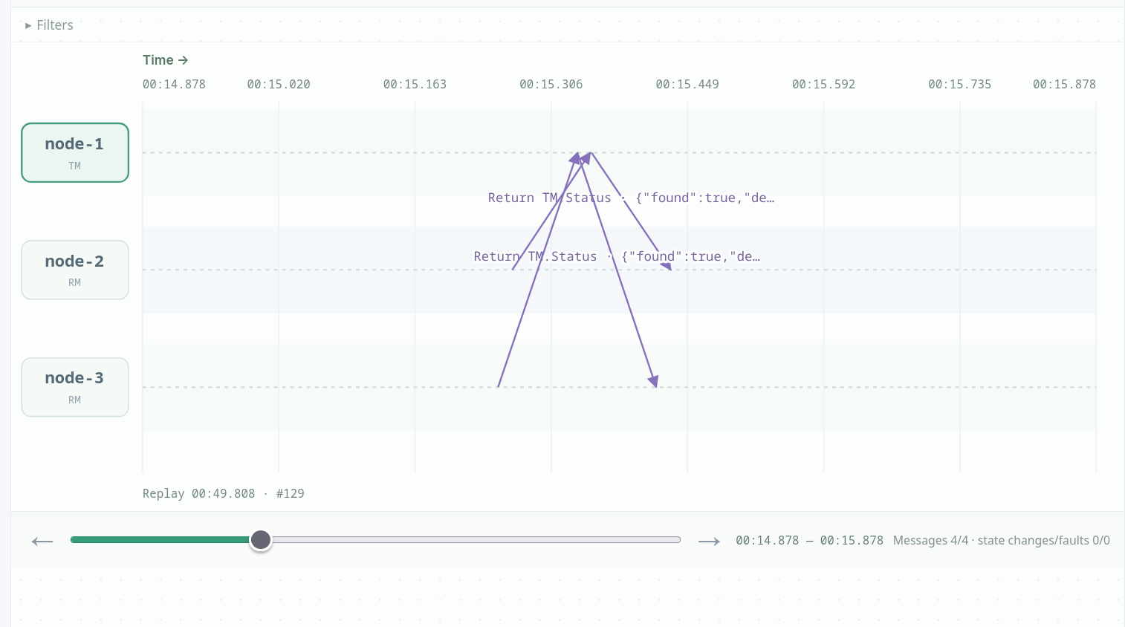
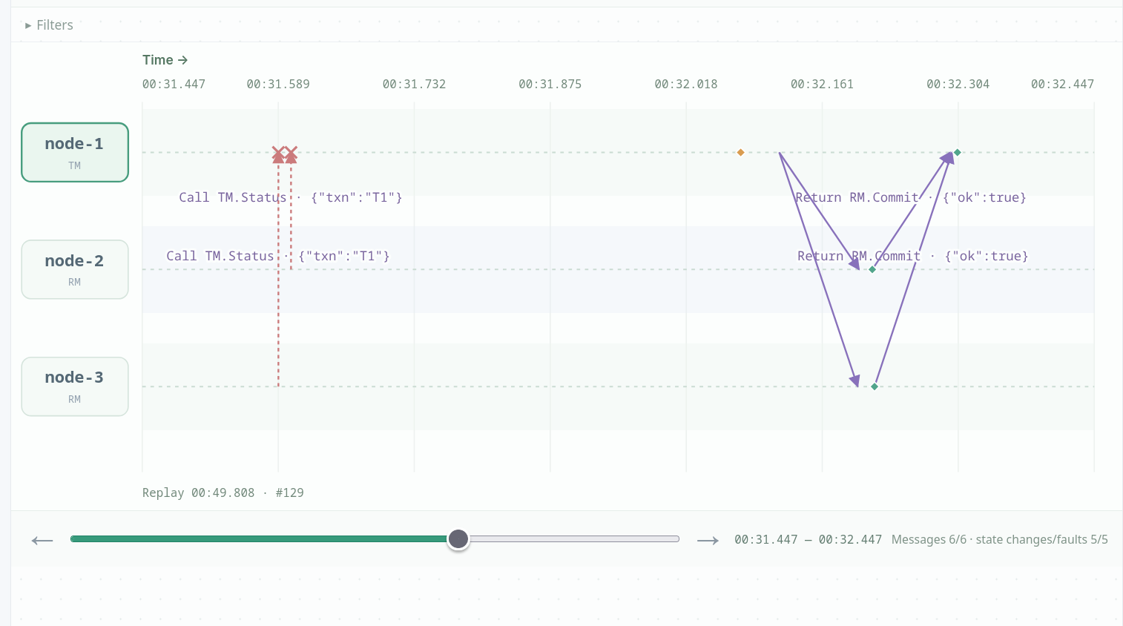
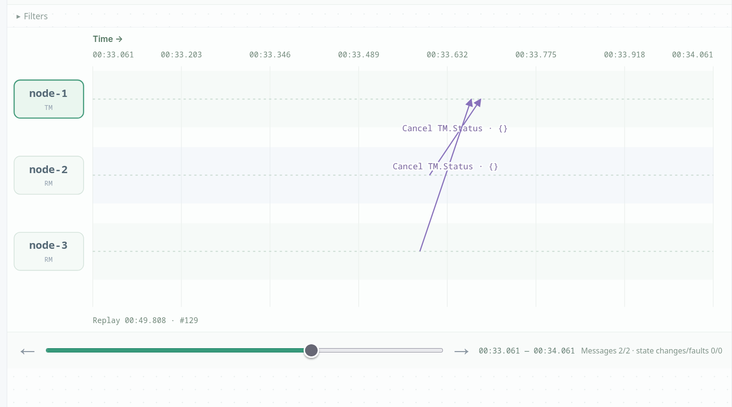

Design variant:
Removing the sdk.Save in RM.Prepare means an RM can send vote:"yes" and then crash before persisting its prepared state. On restart it has no record, so it presumes abort and keeps its old balance, while the TM has already collected all YES votes and commits, and the other RM applies the transfer. The result is two RMs that disagree about the transaction's outcome, a violation of 2PC's all-or-nothing guarantee. The TM remains in decided with acks:{node-3:true} and keeps resending RM.Commit to node-2, which keeps answering no prepared record for T1 and the transaction never finishes. This is the same lesson as Paxos "amnesia": a vote must be durable before it is sent, or recovery can contradict what was already decided.

In protocol.go I removed:
if err := rm.persistLocked(); err != nil {
return err
}

