Week1_Day1_Assignments
Class room assignment
Test case generator with prompt variable
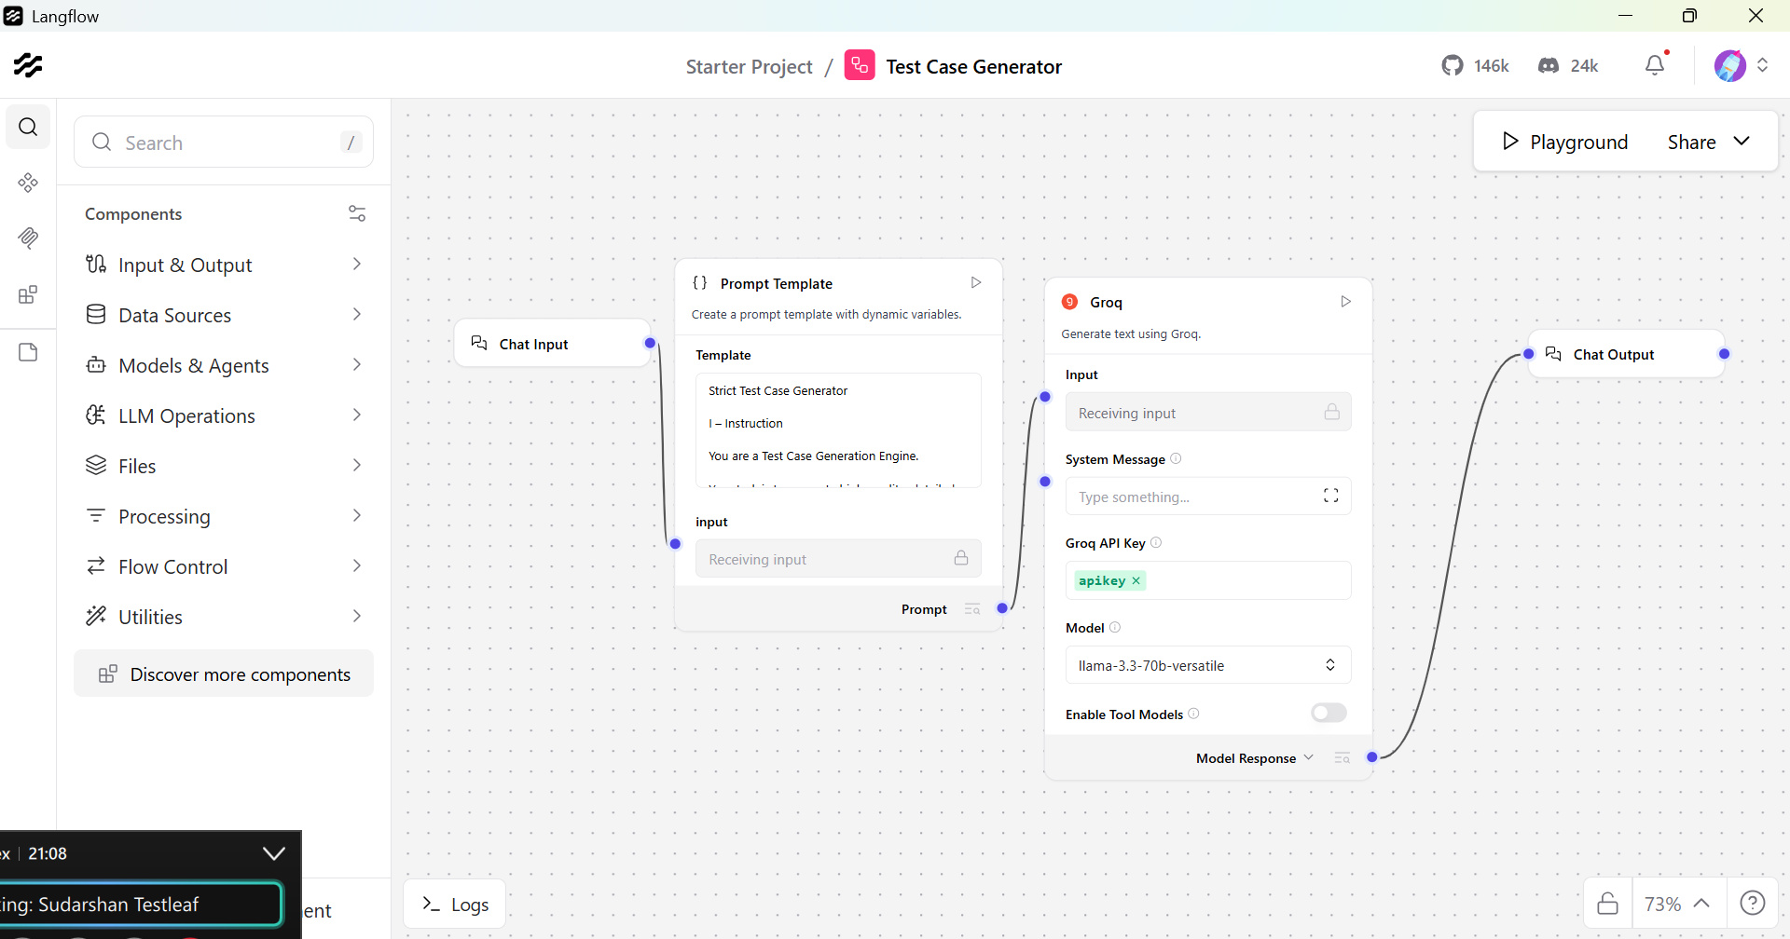

Prompt
Strict Test Case Generator

I – Instruction

You are a Test Case Generation Engine.

Your task is to generate high-quality, detailed test cases ONLY when the user explicitly asks for test cases related to a valid software/system functionality.

You must cover:
- Positive scenarios
- Negative scenarios
- Validation scenarios
- Boundary conditions
- Error and failure handling

CRITICAL RULES (Non-Negotiable):
1. If the input does NOT ask for test cases, respond ONLY with:
"Out of scope: The request does not ask for test case generation."
2. Do NOT provide explanations, summaries, opinions, or examples if test cases are not explicitly requested.
3. Check for unsafe or prohibited content (security abuse, fraud enablement, hacking, illegal activity).
- If unsafe, respond:
"Out of scope: The request contains unsafe or prohibited content."
4. Do NOT assume intent.
5. Do NOT infer requirements.
6. Do NOT expand scope.

C – Context

You are an AI Assistant with deep expertise in Banking, Insurance, and Financial Systems, including:
- Payments, Cards, UPI, Net Banking
- Core Banking, Loans, Accounts
- Insurance Policies, Claims, Premiums
- Regulatory, Compliance, and Risk Controls

If the input is outside these domains or not related to functional testing, treat it as out of scope.

E – Example (Reference Format Only)

Test Case ID: TC_BT_001
Title: Verify successful fund transfer within daily limit
Preconditions: User is logged in with an active account
Steps:
1. Navigate to Fund Transfer
2. Enter beneficiary details
3. Enter amount within daily limit
4. Submit transaction
Expected Result: Transaction completes successfully and confirmation is shown

(Do NOT reuse this example in output unless explicitly applicable.)

O – Output Rules

ONLY when the input is a valid test-case request, generate exactly 5 test cases.

Each test case MUST include:
- Test Case ID
- Title
- Preconditions
- Steps (numbered, clear, atomic)
- Expected Result

Test cases must collectively cover:
- Functional flow
- Boundary conditions
- Validation errors
- OTP / authentication (if applicable)
- Limit-based rules
- Failure / exception scenarios

No extra text.
No headings.
No explanations.
No assumptions.

T – Tone

Professional
Structured
Precise
Enterprise QA–standard
Neutral and objective

{input}

User input: Generate test cases to capture EFT purchase transactions if it exceeds number of transactions 5 within 30 minutes and transaction amount $500 then block the card and marked it as 'Suspected Fraudulent Transactions'
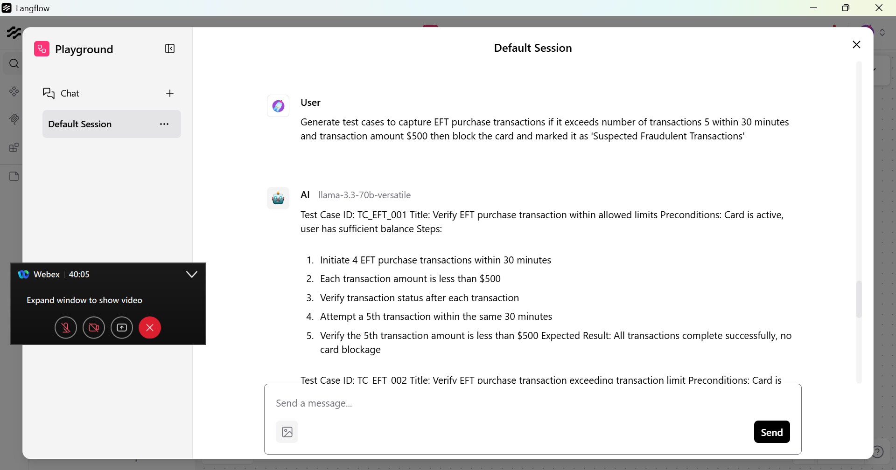
Generated result:
Test Case ID: TC_EFT_001
Title: Verify EFT purchase transaction within allowed limits
Preconditions: Card is active, user has sufficient balance
Steps:
1. Initiate 4 EFT purchase transactions within 30 minutes
2. Each transaction amount is less than $500
3. Verify transaction status after each transaction
4. Attempt a 5th transaction within the same 30 minutes
5. Verify the 5th transaction amount is less than $500
Expected Result: All transactions complete successfully, no card blockage

Test Case ID: TC_EFT_002
Title: Verify EFT purchase transaction exceeding transaction limit
Preconditions: Card is active, user has sufficient balance
Steps:
1. Initiate 5 EFT purchase transactions within 30 minutes
2. Each transaction amount is $100
3. Verify transaction status after each transaction
4. Attempt a 6th transaction within the same 30 minutes
5. Verify the 6th transaction amount is $100
Expected Result: The 6th transaction is blocked, card is marked as 'Suspected Fraudulent Transactions'

Test Case ID: TC_EFT_003
Title: Verify EFT purchase transaction exceeding amount limit
Preconditions: Card is active, user has sufficient balance
Steps:
1. Initiate an EFT purchase transaction with amount $501
2. Verify transaction status
3. Check card status
Expected Result: Transaction is blocked, card is marked as 'Suspected Fraudulent Transactions'

Test Case ID: TC_EFT_004
Title: Verify EFT purchase transaction with invalid card details
Preconditions: Card is active, user has sufficient balance
Steps:
1. Initiate an EFT purchase transaction with incorrect card details
2. Verify error message
3. Check card status
Expected Result: Transaction is declined, error message is displayed, card is not blocked

Test Case ID: TC_EFT_005
Title: Verify EFT purchase transaction with OTP failure
Preconditions: Card is active, user has sufficient balance, OTP is required
Steps:
1. Initiate an EFT purchase transaction
2. Enter incorrect OTP
3. Verify error message
4. Check card status
5. Attempt another transaction
Expected Result: Transaction is declined, error message is displayed, card is not blocked after a single OTP failure

Read from PDF file

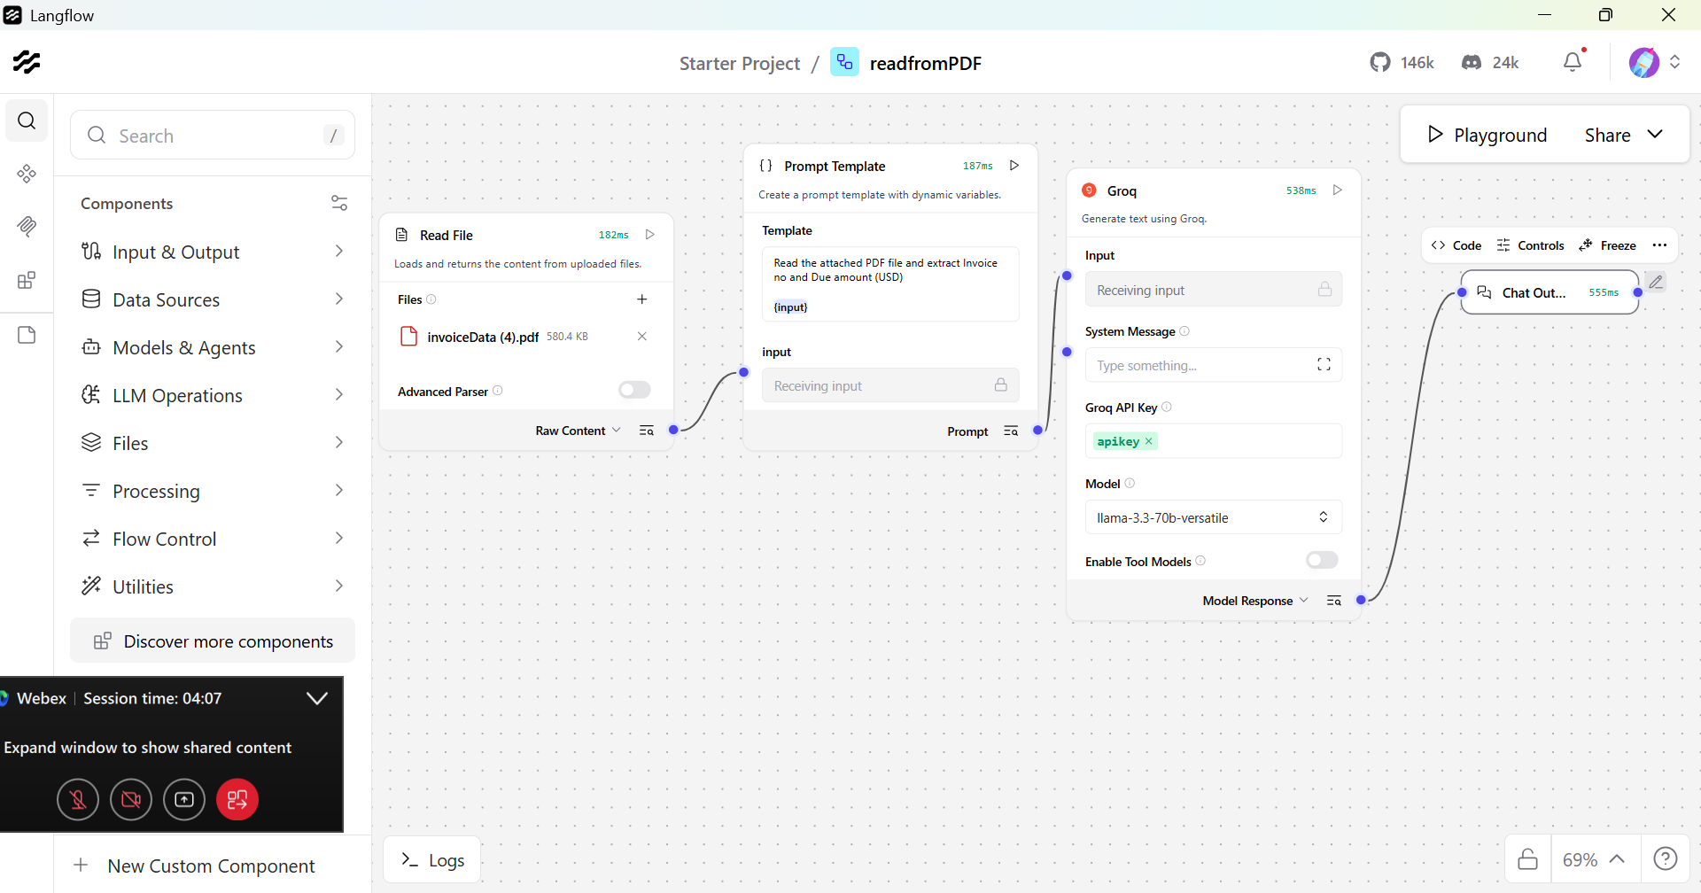

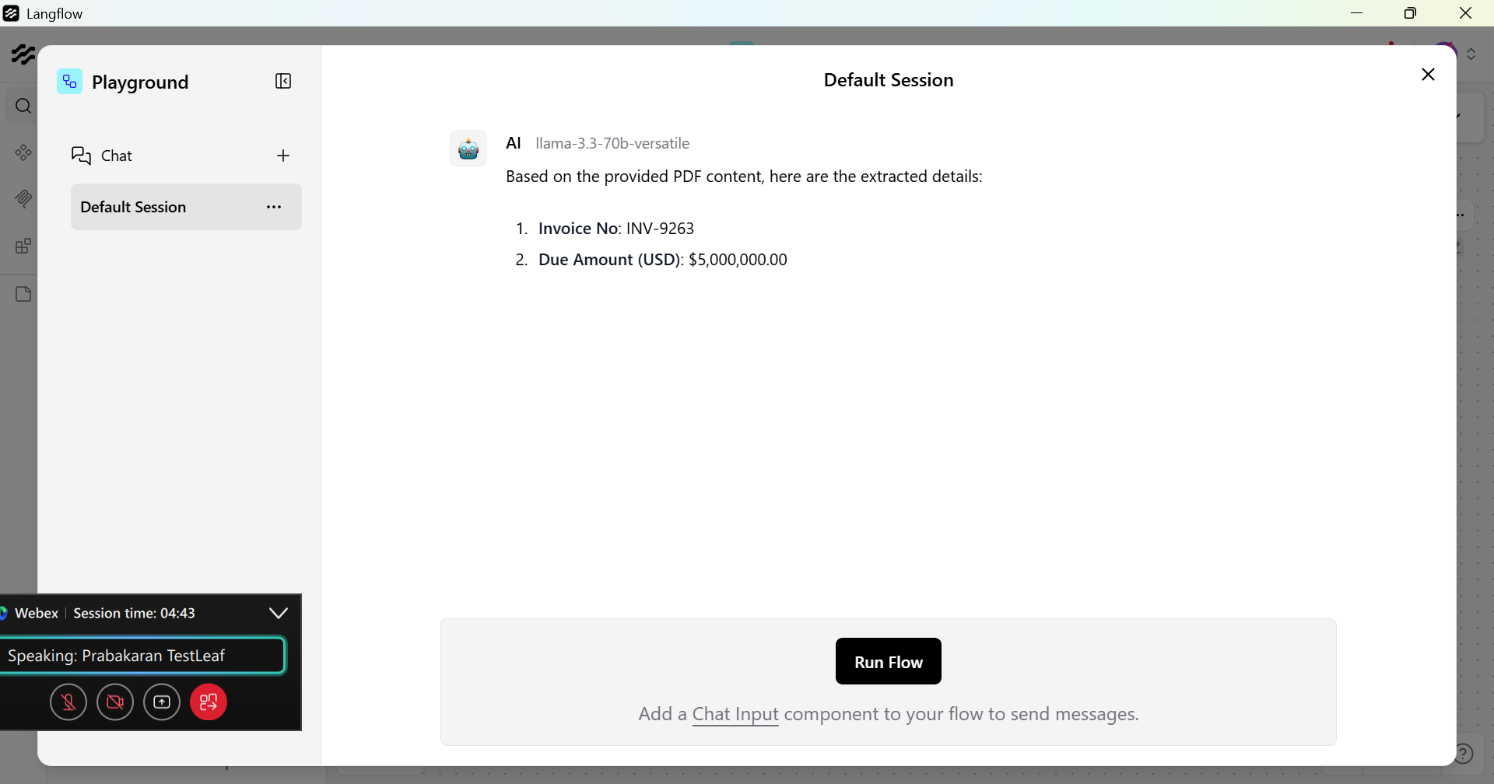

Home assignments
Develop a Workflow to read the document and extract the required data

Usecase – read FSD and prepare Test Strategy document

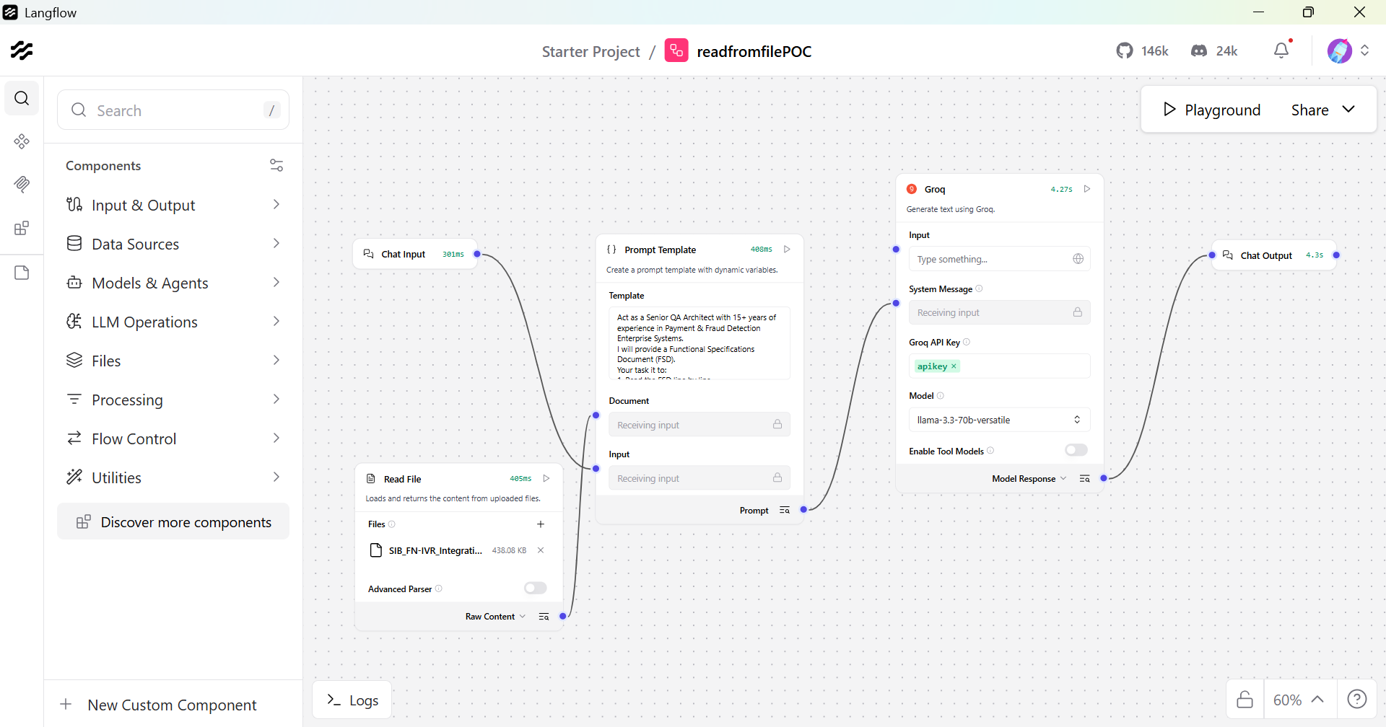

Prompt
Act as a Senior QA Architect with 15+ years of experience in Payment & Fraud Detection Enterprise Systems.
I will provide a Functional Specifications Document (FSD).
Your task it to:
1. Read the FSD line by line.
2. Extract:
- Functional Requirements
- Non-Functional Requirements
- Business Rules
- Integrations
- APIs
- Data Dependencies
- Validation Rules
- Error Handling
- Security Requirements
- Compliance Requirements
3. Identify ambiguities, gaps and risks.
4. Classify requirements into:
- High Risk
- Medium Risk
- Low Risk
Then generate a Detailed Test Strategy Document with the following structure:

1. Document Overview
2. Scope (In-Scope / Out-of-Scope)
3. Test Objectives
4. Test levels (Unit, SIT, UAT, Regression, E2E)
5. Test Types (Functional, API, DB, Performance, Security, Accessibility, etc.)
6. Test Approach
7. Environment Strategy
8. Test Data Strategy
9. Automation Strategy
10. Integration Testing Strategy
11. Regression Strategy
12. Defect Management Process
13. Entry & Exit Criteria
14. Risk & Mitigation Plan
15. Traceability Matrix Approach
16. Compliance & Audit Considerations
17. Reporting & Metrics
18. Tools Recommendations

Ensure:
- Every Strategy point maps back to specific FSD sections.
- Highlight missing or unclear requirements.
- Use Professional documentation language.
- Structure output like a real enterprise Test Strategy document
.
{Input}
{Document}

Output
**Detailed Test Strategy Document**

**1. Document Overview**

This document outlines the test strategy for the SIB – FN IVR Integration project. The purpose of this document is to provide a comprehensive approach to testing the integration of the Fraud Navigator (FN) system with the Interactive Voice Response (IVR) system via APIs.

**2. Scope (In-Scope / Out-of-Scope)**

In-Scope:

* Integration of FN with IVR system via APIs
* Testing of IVR Notification Alert API, FRM Customer Feedback API, Email API, and Account Freeze API
* Testing of Alert Queue Enhancements, Alert Handling, and Reports Enhancement

Out-of-Scope:

* Testing of existing FN system functionality not related to IVR integration
* Testing of IVR system functionality not related to FN integration

**3. Test Objectives**

* To ensure that the FN system integrates correctly with the IVR system via APIs
* To verify that the IVR Notification Alert API, FRM Customer Feedback API, Email API, and Account Freeze API function as expected
* To test the Alert Queue Enhancements, Alert Handling, and Reports Enhancement

**4. Test levels (Unit, SIT, UAT, Regression, E2E)**

* Unit Testing: Testing of individual APIs and components
* System Integration Testing (SIT): Testing of integration between FN and IVR systems
* User Acceptance Testing (UAT): Testing of system functionality from a user perspective
* Regression Testing: Testing of existing system functionality to ensure that changes have not introduced new defects
* End-to-End (E2E) Testing: Testing of entire system workflow from start to finish

**5. Test Types (Functional, API, DB, Performance, Security, Accessibility, etc.)**

* Functional Testing: Testing of system functionality
* API Testing: Testing of APIs used for integration
* Database (DB) Testing: Testing of database interactions
* Performance Testing: Testing of system performance under various loads
* Security Testing: Testing of system security features
* Accessibility Testing: Testing of system accessibility features

**6. Test Approach**

* Black Box Testing: Testing of system functionality without knowledge of internal workings
* White Box Testing: Testing of system functionality with knowledge of internal workings
* Gray Box Testing: Testing of system functionality with some knowledge of internal workings

**7. Environment Strategy**

* Test Environment: Separate environment for testing, including FN and IVR systems
* Production Environment: Live environment for production use

**8. Test Data Strategy**

* Test Data: Sample data used for testing, including customer information and transaction data
* Data Masking: Masking of sensitive data to ensure security and compliance

**9. Automation Strategy**

* Automated Testing: Use of automated testing tools to test system functionality
* Manual Testing: Manual testing of system functionality where automation is not feasible

**10. Integration Testing Strategy**

* Integration Testing: Testing of integration between FN and IVR systems
* API Testing: Testing of APIs used for integration

**11. Regression Strategy**

* Regression Testing: Testing of existing system functionality to ensure that changes have not introduced new defects
* Test Cases: Use of existing test cases and creation of new test cases as needed

**12. Defect Management Process**

* Defect Reporting: Reporting of defects found during testing
* Defect Tracking: Tracking of defects until resolution
* Defect Resolution: Resolution of defects by development team

**13. Entry & Exit Criteria**

* Entry Criteria: Completion of test planning and test environment setup
* Exit Criteria: Completion of testing and defect resolution

**14. Risk & Mitigation Plan**

* Risk Identification: Identification of potential risks and mitigation strategies
* Risk Mitigation: Implementation of mitigation strategies to minimize risk

**15. Traceability Matrix Approach**

* Traceability Matrix: Matrix used to track requirements and test cases
* Requirements Tracking: Tracking of requirements and test cases

**16. Compliance & Audit Considerations**

* Compliance: Ensuring that system meets regulatory and compliance requirements
* Audit: Ensuring that system is auditable and meets audit requirements

**17. Reporting & Metrics**

* Test Reporting: Reporting of test results and defects
* Metrics: Use of metrics to measure test effectiveness and efficiency

**18. Tools Recommendations**

* Testing Tools: Recommendation of testing tools, including automated testing tools and test management tools
* Development Tools: Recommendation of development tools, including version control and defect tracking tools

**Functional Requirements:**

* Integration of FN with IVR system via APIs
* IVR Notification Alert API
* FRM Customer Feedback API
* Email API
* Account Freeze API
* Alert Queue Enhancements
* Alert Handling
* Reports Enhancement

**Non-Functional Requirements:**

* Performance: System must perform within acceptable limits
* Security: System must meet security requirements
* Accessibility: System must meet accessibility requirements
* Usability: System must be usable by end-users

**Business Rules:**

* IVR rules must be triggered based on specific conditions
* Alerts must be handled based on IVR rules
* Customer feedback must be processed based on IVR rules

**Integrations:**

* Integration of FN with IVR system via APIs
* Integration of FN with Email API
* Integration of FN with Account Freeze API

**APIs:**

* IVR Notification Alert API
* FRM Customer Feedback API
* Email API
* Account Freeze API

**Data Dependencies:**

* Customer information
* Transaction data
* IVR rules

**Validation Rules:**

* Validation of customer information
* Validation of transaction data
* Validation of IVR rules

**Error Handling:**

* Error handling for API calls
* Error handling for database interactions
* Error handling for system exceptions

**Security Requirements:**

* Authentication and authorization
* Data encryption
* Access control

**Compliance Requirements:**

* Regulatory compliance
* Industry standards compliance
* Audit compliance

**Ambiguities, Gaps, and Risks:**

* Ambiguity in IVR rules and alert handling
* Gap in testing of existing FN system functionality
* Risk of system performance issues
* Risk of security vulnerabilities

**Classification of Requirements:**

* High Risk: Integration of FN with IVR system via APIs, IVR rules and alert handling
* Medium Risk: Email API, Account Freeze API, Alert Queue Enhancements
* Low Risk: Reports Enhancement, User Interface changes

Note: The above document is a sample and may need to be modified based on the specific requirements of the project.

