Norton
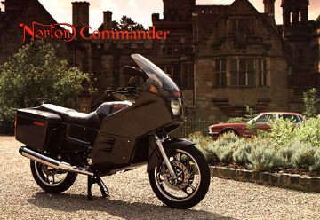
Norton motor Ltd., Lichfield, England. The firm constructed very dependable Wankelmotoren what appears therein that the at that time kernel motor is constructed as an airplane motor yet today. The cir
cumstances of that Broke the firm rather are confused. Therewith the long and successful tradition of the Motorradbau ended in Norton.
The Norton Commander controlled 294 ccm and a condensation ratio of 9:1 a two disks-Wankelmotor with a chamber volume of 2 xs. the achievement amounted to 63,4kW (85PS) in 9000 Upm. We owe the photos Chris Biddulph, a long-time Norton-man.
© Photo Norton
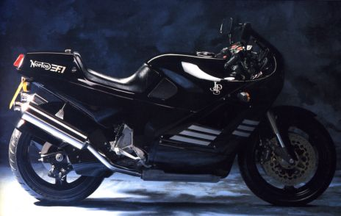
The Norton F1 was practical the streets version of the RCW 588, that in England
In the Superbike-class was successful. Chamber volumes 2 x 294ccm.
The motor had an achievement of 69,9kW (95 HP) in 9500 Upm and a max.
Torque of 77,3 Nm in 7500 Upm.
© Photo Norton
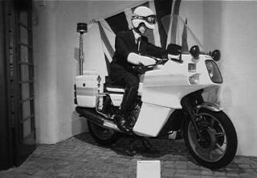
The Norton Interpol 2, it became of 1983 to 1988 constructed. The chambers and the runners were luftgekühlt. Altogether 350 pieces were constructed. The motors had an achievement of 80-85 HP. The chamber volume amounted to 2 xs 294 ccm.

