Norton-triumph
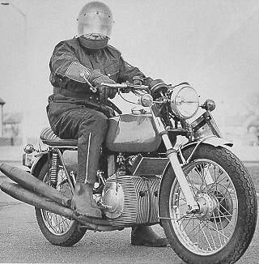
Norton-triumph prototype luftgekühlt
2 xs 294 ccm. Norton-triumph led the work begun by BSA on the Wankelmotor further. That Two disks-Wankelmotor be constructed later by Norton in series. The achievement amounted to 65PS. The chamber is is luftgekühlt, the runner luftgekühlt. In the geometry, the motor is based on the KM914 of Sachs.
1. The runner
2. The chamber
3Rd Exenterwelle
4. Öldosierpumpe
5Th carburetor
6. Air filter
7Th page part
© Photo Norton
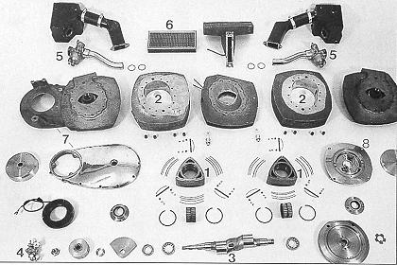
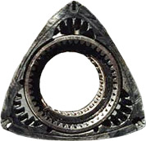
The runner of the Norton Wankelmotors. Around the warmth abzuführen, the piston is interior verrippt.

