It's a lesser known fact that Chevrolet acquired a licence for the Wankel engine in 1970. Two and four rotor engines were built and mounted mid-ships in experimental cars.
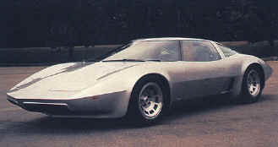
The XP882T used two rotory engines bolted together to produce around 400bhp
They went on to get Pininfarina to style a new Corvette around the engine as they considered production options. Various two and four rotor, steel bodied and glass-fibre bodied Corvettes were worked on until 1974 when retiring GM president Ed Cole suspended rotary engine development due to emissions difficulties. Research was halted completely in 1977.

