EDA_Project

Install the required packages only for the first time.

#install.packages("ProjectTemplate")  
#install.packages("rmarkdown")

library(ProjectTemplate)

## Warning: package 'ProjectTemplate' was built under R version 3.4.4

library(rmarkdown)  
library(ggplot2)  
# create.project("EDA_Project")

setwd("C:/Users/HP/OneDrive - Newcastle University/Data management and exploratory Data Analysis/EDA_Project/")  
load.project()

## Project name: EDA_Project

## Loading project configuration

## Autoloading helper functions

## Running helper script: globals.R

## Running helper script: helpers.R

## Autoloading data

## Loading cached data set: cyber.security.1.enrolments

## Loading cached data set: cyber.security.1.leaving.survey.responses

## Loading cached data set: cyber.security.1.question.response

## Loading cached data set: cyber.security.1.step.activity

## Loading cached data set: cyber.security.1.weekly.sentiment.survey.responses

## Loading cached data set: cyber.security.2.archetype.survey.responses

## Loading cached data set: cyber.security.2.enrolments

## Loading cached data set: cyber.security.2.leaving.survey.responses

## Loading cached data set: cyber.security.2.question.response

## Loading cached data set: cyber.security.2.step.activity

## Loading cached data set: cyber.security.2.team.members

## Loading cached data set: cyber.security.2.weekly.sentiment.survey.responses

## Loading cached data set: cyber.security.3.archetype.survey.responses

## Loading cached data set: cyber.security.3.enrolments

## Loading cached data set: cyber.security.3.leaving.survey.responses

## Loading cached data set: cyber.security.3.question.response

## Loading cached data set: cyber.security.3.step.activity

## Loading cached data set: cyber.security.3.team.members

## Loading cached data set: cyber.security.3.video.stats

## Loading cached data set: cyber.security.3.weekly.sentiment.survey.responses

## Loading cached data set: cyber.security.4.archetype.survey.responses

## Loading cached data set: cyber.security.4.enrolments

## Loading cached data set: cyber.security.4.leaving.survey.responses

## Loading cached data set: cyber.security.4.question.response

## Loading cached data set: cyber.security.4.step.activity

## Loading cached data set: cyber.security.4.team.members

## Loading cached data set: cyber.security.4.video.stats

## Loading cached data set: cyber.security.4.weekly.sentiment.survey.responses

## Loading cached data set: cyber.security.5.archetype.survey.responses

## Loading cached data set: cyber.security.5.enrolments

## Loading cached data set: cyber.security.5.leaving.survey.responses

## Loading cached data set: cyber.security.5.question.response

## Loading cached data set: cyber.security.5.step.activity

## Loading cached data set: cyber.security.5.team.members

## Loading cached data set: cyber.security.5.video.stats

## Loading cached data set: cyber.security.5.weekly.sentiment.survey.responses

## Loading cached data set: cyber.security.6.archetype.survey.responses

## Loading cached data set: cyber.security.6.enrolments

## Loading cached data set: cyber.security.6.leaving.survey.responses

## Loading cached data set: cyber.security.6.question.response

## Loading cached data set: cyber.security.6.step.activity

## Loading cached data set: cyber.security.6.team.members

## Loading cached data set: cyber.security.6.video.stats

## Loading cached data set: cyber.security.6.weekly.sentiment.survey.responses

## Loading cached data set: cyber.security.7.archetype.survey.responses

## Loading cached data set: cyber.security.7.enrolments

## Loading cached data set: cyber.security.7.leaving.survey.responses

## Loading cached data set: cyber.security.7.question.response

## Loading cached data set: cyber.security.7.step.activity

## Loading cached data set: cyber.security.7.team.members

## Loading cached data set: cyber.security.7.video.stats

## Loading cached data set: cyber.security.7.weekly.sentiment.survey.responses

## Munging data

## Running preprocessing script: 01-A.R

archetype7= read.csv("C:/Users/HP/OneDrive - Newcastle University/Data management and exploratory Data Analysis/EDA_Project/data/cyber-security-7_archetype-survey-responses.csv")  
archetype6= read.csv("C:/Users/HP/OneDrive - Newcastle University/Data management and exploratory Data Analysis/EDA_Project/data/cyber-security-6_archetype-survey-responses.csv")  
archetype5= read.csv("C:/Users/HP/OneDrive - Newcastle University/Data management and exploratory Data Analysis/EDA_Project/data/cyber-security-5_archetype-survey-responses.csv")  
archetype4= read.csv("C:/Users/HP/OneDrive - Newcastle University/Data management and exploratory Data Analysis/EDA_Project/data/cyber-security-4_archetype-survey-responses.csv")  
archetype3= read.csv("C:/Users/HP/OneDrive - Newcastle University/Data management and exploratory Data Analysis/EDA_Project/data/cyber-security-3_archetype-survey-responses.csv")

a=table(archetype7$archetype)  
a

##   
## Advancers Explorers Fixers Flourishers Hobbyists Other   
## 25 36 24 7 12 12   
## Preparers Vitalisers   
## 13 45

a7=data.frame("year"= 2017,"id"= archetype7$id,"archetype"= archetype7$archetype)  
a6=data.frame("year"= 2016,"id"= archetype6$id,"archetype"= archetype6$archetype)  
a5=data.frame("year"= 2015,"id"= archetype5$id,"archetype"= archetype5$archetype)  
a4=data.frame("year"= 2014,"id"= archetype4$id,"archetype"= archetype4$archetype)  
a3=data.frame("year"= 2013,"id"= archetype3$id,"archetype"= archetype3$archetype)  
  
t=rbind(a3,a4,a5,a6,a7)  
head(t)

## year id archetype  
## 1 2013 7525 Fixers  
## 2 2013 18270 Fixers  
## 3 2013 29037 Vitalisers  
## 4 2013 35991 Explorers  
## 5 2013 37806 Advancers  
## 6 2013 38681 Vitalisers

(total=table(t$archetype))

##   
## Advancers Explorers Fixers Flourishers Hobbyists Other   
## 172 208 136 43 96 94   
## Vitalisers Preparers   
## 237 88

sum(total)

## [1] 1074

ggplot(data=archetype7,aes(archetype7$archetype)) + geom_bar()

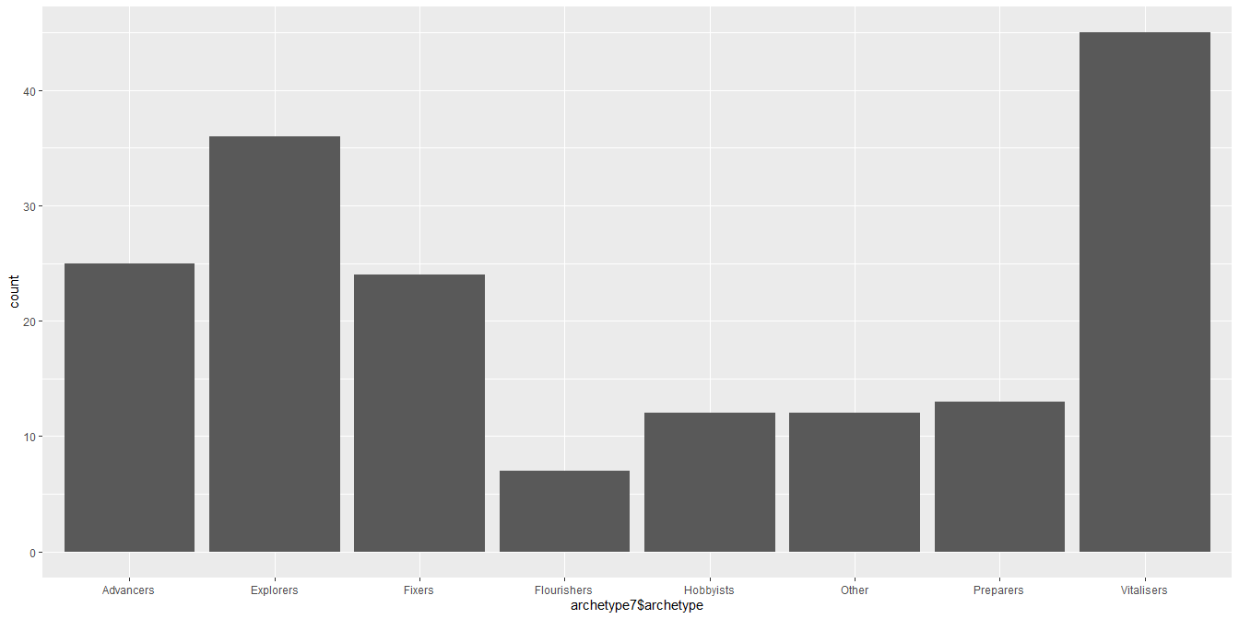

ggplot(data=t) + geom_bar(aes(x=year,fill=factor(archetype)))

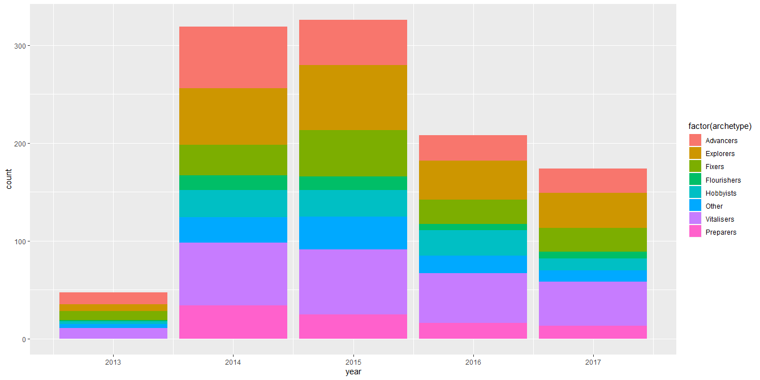

ggplot(data=t) + geom_bar(aes(x=year,fill=factor(archetype)), position = position_dodge(preserve = 'single'))

