

**Remixlive for Mac/PC FAQ**

This is a short list of the most frequently asked questions. For more information about

Remixlive Mac/PC or Mixvibes, or if you need support, please email [support@mixvibes](mailto:support@mixvibes.com)​[.com](mailto:support@mixvibes.com).​



Last updated: April 11th, 2017

General

What is the difference between ‘Loop’, ‘One Shot’ and ‘Gate’?

How do I change the BPM?

How can I move, duplicate or delete a pad?

How can I access the Sample Library?

Can I mix and match samples from different packs?

How do I rename or delete a recording?

How do I share a recording?

Can I connect an external sound card to my device?

Which devices is Remixlive compatible with?

Can I sell songs I make using Remixlive?

Sample packs

How can I create a new sample pack?

Can I rename, duplicate, reset or delete a sample pack?

How to export a sample pack from Remixlive Mac/PC?

Features

What does ‘Transpose’ mean?

How do I change the pitch of a sample?

What is the use of the ‘Quantize’ feature?

How do I modify the quantization of a sample?

How can I change the quantization of an entire sample pack?

What is ‘Advanced Sample Editing’?

How can I change the rule for pad-triggering exclusivity?

What is Auto-Pilot?

Can I select the Auto-Pilot pattern?

How can I select Autopilot Advance speed?

How to use Ableton Link to synchronize apps through the same WiFi network?

Can I browse the files of my Mac/PC from the app?

Record samples

How can I record samples?

What does ‘Rec Length’ mean?

What does ‘Overdub’ mean?

How do I rename, reset or delete a recorded sample?

MIDI

How to setup a MIDI controller in Remixlive?

How does ‘MIDI Learn’ work?

Can I save a MIDI mapping I made ?

Can I create several MIDI mappings just for one MIDI controller?

Can I use my keyboard as a MIDI controller?

VST

How can I enable velocity?

Import/Export

How can I add my own samples to Remixlive?

What kind of file formats can I import in Remixlive?

Can I add songs to Remixlive?

How to export a sample pack from Remixlive Mac/PC?

Can I import a sample pack into Remixlive Mac/PC?

Can I transfer an exported pack from Remixlive Mac/PC to Remixlive iOS/Android? Tips

Can I trigger several samples at once?

How can I change the color of the pads?

Can I record my performance in high quality ?

How can I easily reset the value of a slider or a knob?

How can I make a roll effect?

Can I pause the track while it's playing?

Can I change the master volume of Remixlive without changing the volume of my computer?

How can I retrieve Samples packs Purchases I previously bought?

What should I do if I experience performance issues?

Changes to this FAQ

**General**

**What is the difference between ‘Loop’, ‘One Shot’ and ‘Gate’?**

There are 3 play modes for each pad:

* Loop: click to make the sample play in an endless loop. To stop the sample, click again.
* One Shot: click to play the sample once. You can click on the pad again to stop the sample; alternatively, the sample will stop by itself after being played once.
* Gate: the sample will play for as long as you click and hold the pad.

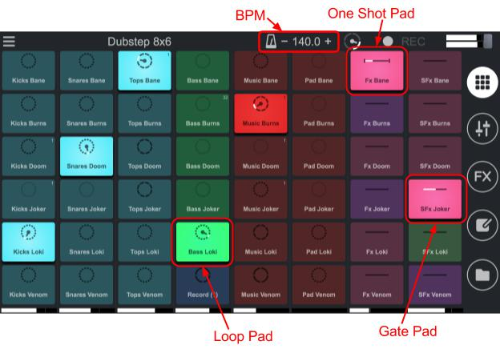

**How do I change the BPM?**

If you want to change the BPM, click on the ‘+‘ or ‘–‘ on either side of the BPM's value to increase or decrease it.

While clicking, keep on holding the ‘+’ or ‘–’ button to make the value change faster.

**How can I move, duplicate or delete a pad?**

To move, duplicate or delete a pad, go to the Sample Editor (notebook​ icon, fourth icon from the top, right side of the main screen)​and select the pad you want to move or delete. Then:



* + If you want to copy-paste the pad, drag the upper part of the pad and drop it onto another pad. The sample of this second pad will be replaced by the sample of the first one.
* If you want to swap pads' samples, drag the lower part of the pad and drop it onto another pad. The two samples will be swapped.
* If you want to delete a sample from the grid, click in the three-dots button at the top

right-hand corner of the grey info area, to open the options panel. Then, click “Unload”.

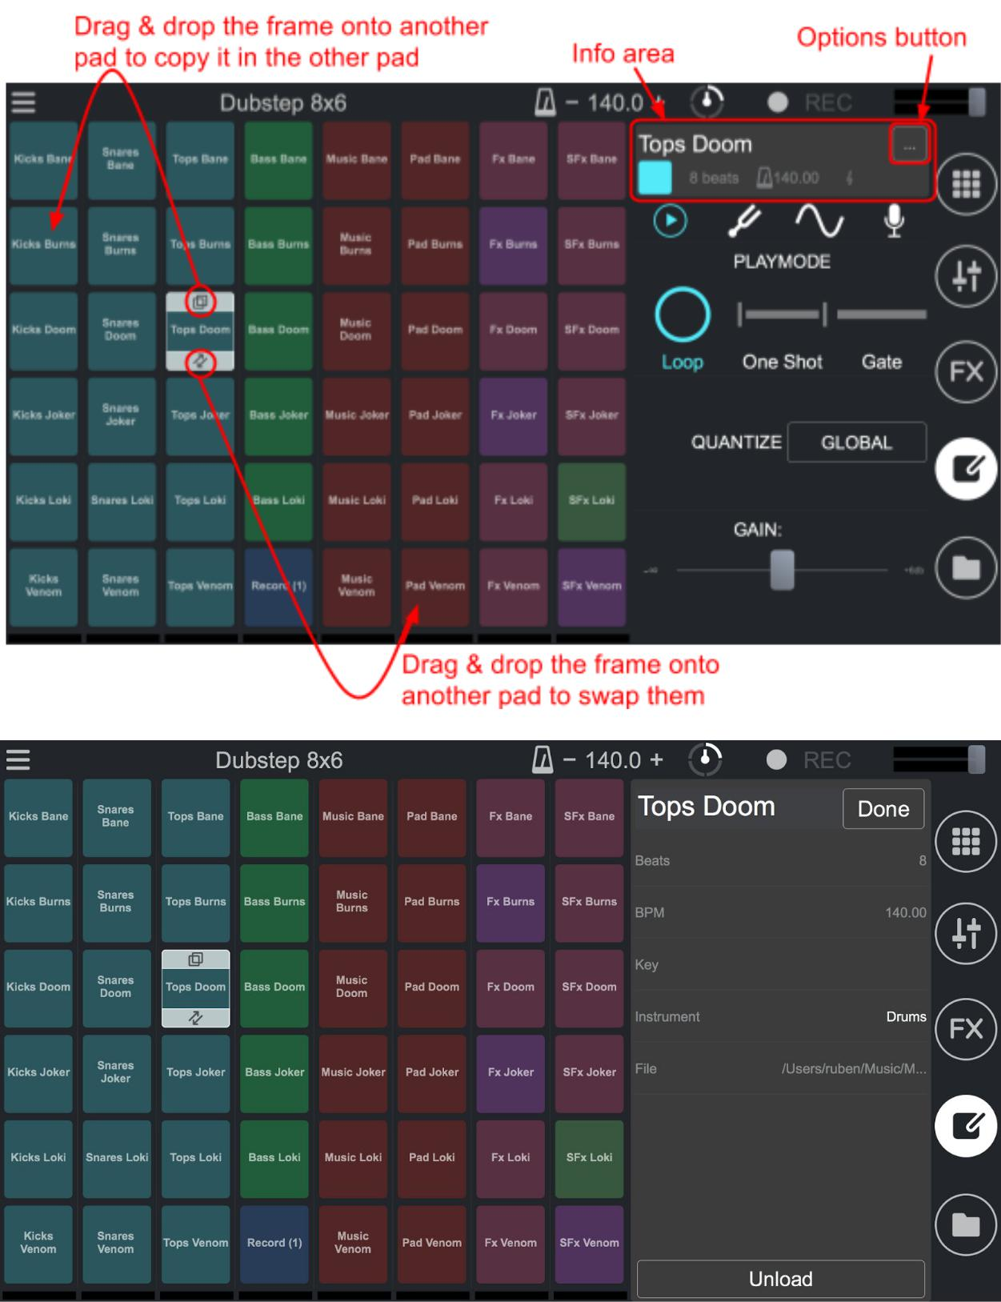

**How can I access the Sample Library?**



To access the Sample Library view, click the folder icon at the bottom right-hand corner of the main screen.

**Can I mix and match samples from different packs?**

To load a pad with a sample from an existing Sample Pack:

1. Go to the Sample Library (folder icon at the bottom right-hand corner of the main screen).
2. In the Library, find the sample you want to load in the pad. You can browse your sample collection by packs (in the 'Packs' tab) or by instruments (in the 'Loops' and



‘Sounds’ tabs). The user tab contains the recorded and imported samples.

3. Then, drag and drop the sample onto the pad.

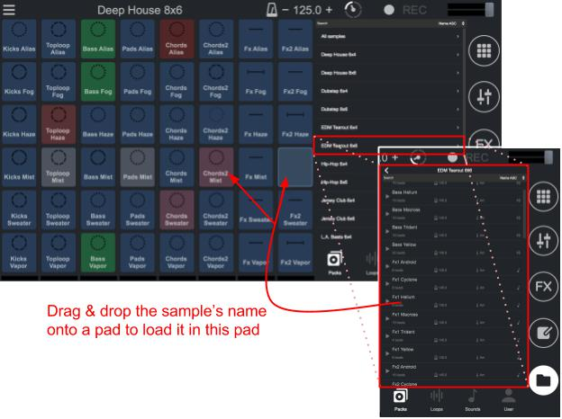

**How do I rename or delete a recording?**

To rename or delete a recording, go to the ‘Recordings’ section.

* To rename a recording, click on the recording to open a window (this is the recording player window). Then, click on the recording’s name to change it.

* If you want to delete a recording, click on the three-dots button (at the right end of the recording’s name), and click on ‘Delete’.

**How do I share a recording?**

You can share your recordings directly via SoundCloud and Youtube. To do so, open the main menu (the hamburger icon in the top left-hand corner of the main screen). Then, go to the ‘Recordings’ section and click on the track you want to share.

If you want to share it on SoundCloud and/or Youtube, click the SoundCloud and/or Youtube button. You will be respectively taken to a login prompt for your SoundCloud and/or Youtube account(s).

**Note**:**​**You also have access to the folder where the recorded file is using the “Open file”button. You can therefore share you recording with any other sharing platform using this file.

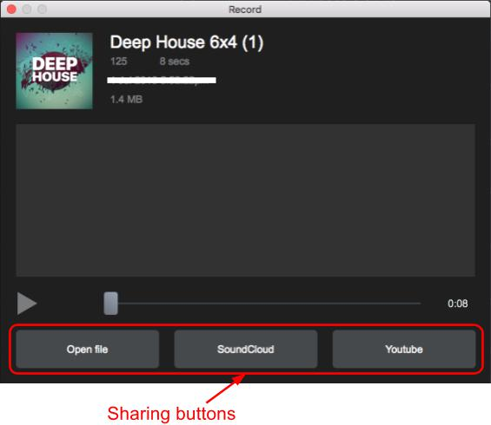

**Can I connect an external sound card to my device?**

Yes, with a compatible external sound card plugged into your computer.

**Which devices is Remixlive compatible with?**

Works on macOS, Windows 7, Windows 8, Windows 8.1, Windows 10 (latest Service Pack, 32/64 Bit), 2.0 GHz Intel Core i5 or equal AMD processor, 4 GB RAM.

Windows: Touch screen compatible: hit the pads to trigger samples, just like on hardware.

Supported Drivers (Windows) : ASIO, CoreAudio, WASAPI.

**Can I sell songs I make using Remixlive?**

The samples contained in Remixlive are royalty-free so you can use them in your tracks without any risk of copyright infringement.

However, selling or distributing samples separately is not permitted. For instance, you can't

upload a track that is just one bass loop on its own. But as long as you add a drum loop or

another sample on top of it, you become the owner of the track. Most of the samples are

provided by Loopmasters, so you can check the Loopmasters license agreement at this

address for reference:

http://support.loopmasters.com/knowledgebase/articles/388556-loopmasters-license

And a guide on how to use Loopmasters' samples:

http://support.loopmasters.com/knowledgebase/articles/242283-how-can-i-use-the-samples

If you are using samples other than the ones natively provided in Remixlive, Mixvibes declines

any responsibility in cases of copyright infringement.

**Sample packs**

**How can I create a new sample pack?**

To create a new sample pack:

1. Open the main menu (hamburger icon in the top left-hand corner of the main screen)
2. Go to the ‘Sample Packs’ page.
3. Click on the ‘Create new pack’ button at the top right-hand corner of the window.
4. In the window that appeared, you can choose the dimensions of the grid and the name of your new pack. You can create grids of up to 10 rows and 10 columns at your convenience, just select the number of columns and the number of rows. Then, click OK.

A new empty pack is created and added to the existing list.

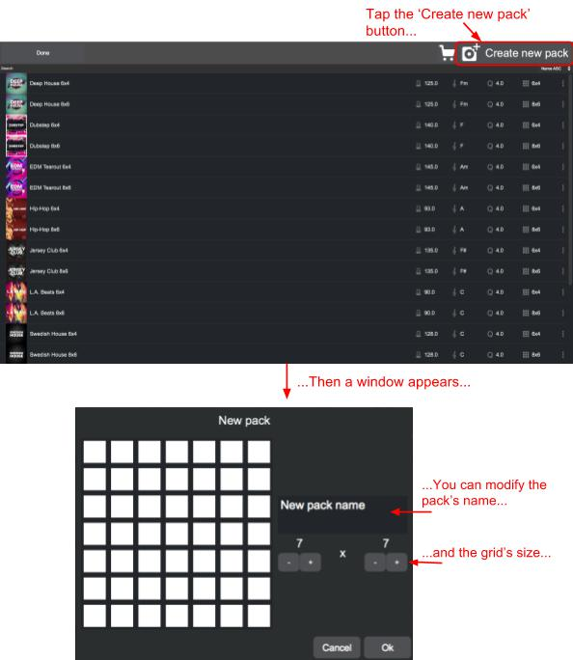

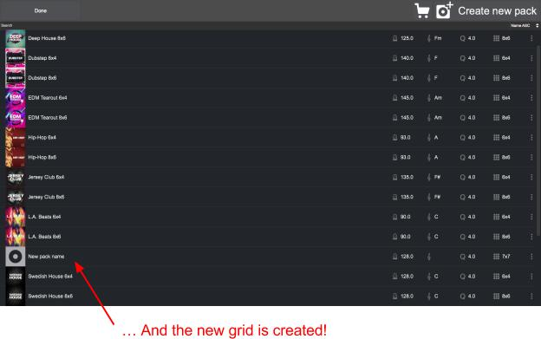

Examples of new empty packs below: from 1x1 to 10x10!

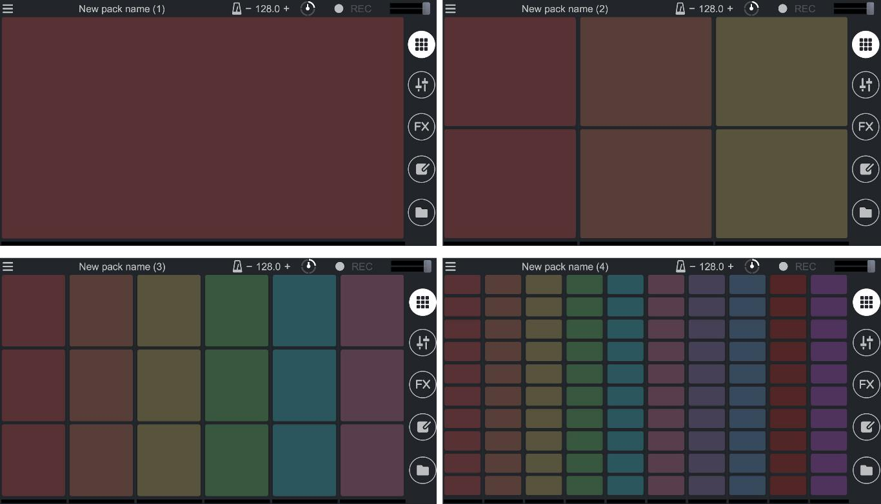

**Can I rename, duplicate, reset or delete a sample pack?**

To rename, duplicate, reset or delete a sample pack, go to the "Sample Packs" page. Click on the three-dots button at the right end of the pack’s line to open the contextual menu.

* The ‘Delete’ and ‘Duplicate’ options allow you, respectively, to delete and duplicate a sample pack.
* The ‘Reset’ option is available only for the default packs of samples, and allow you to reset a sample pack if it is modified (i.e. reverting back to the default values of the samples’ properties, or reverting the grid back to its original sample layout).
* The ‘Edit’ option is available only for the packs you have created. This option opens dialog box where you can rename the pack and

modify its settings.

* The ‘Export’ option is explained in greater detail in the section below

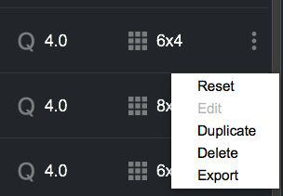

**Note**:**​**You cannot rename a default sample pack.

**How to export a sample pack from Remixlive Mac/PC?**

You can export a sample pack to transfer your own packs to Remixlive for iOS and Android devices. To export a sample pack:

1. Go to the ‘Sample Packs’ page (via the main menu).

2.​In the sample pack list, navigate to the sample pack that you want to export.

1. Click on the three-dots button,​at the right end of the pack’s line​, then click ‘Export’ in the contextual menu (pictured above).
2. Rename the file if you wish, choose a destination folder then confirm. An .rmxl file will appear in the output folder you chose.

**Note**:**​**to know how to import an exported pack from Remixlive Mac/PC into RemixliveiOS/Android, please refer to the Remixlive iOS & Android FAQs.

**Be careful**:**​**You can only import packs that are compatible with your device: mobile phonesonly work with 6x4 grids and tablets only work with 8x6 grids, even though Remixlive Mac/PC allows for up to 10 columns and 10 rows.

**Features**

**What does ‘Transpose’ mean?**

‘Transpose’ raises or lowers the pitch (tone) of the sample without changing its length or its tempo. The higher it is, the more high-pitched it will sound (useful to get that “chipmunk voice” effect on vocals for example). Similarly, the lower it is, the more low-pitched it will sound.

**How do I change the pitch of a sample?**

To change the pitch of a sample, use the ‘Transpose’ feature.

1. Go to the Sample Editor (the notebook icon, the fourth icon on the right side of the main screen).
2. Then, on the mini-grid, select the sample you want to edit.
3. Click on the tab with the tuning fork icon. Here you can increase or decrease the pitch of the selected sample by clicking on ‘+‘ or ‘–’ on either side of the word ‘Transpose’.

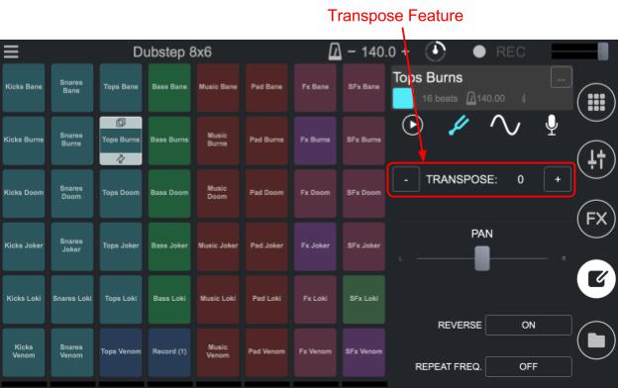

**What is the use of the ‘Quantize’ feature?**

Quantize your samples to be sure they start and end on the beat (in sync).

**How do I modify the quantization of a sample?**

To modify the quantize value of a sample:

1. Go to the Sample Editor (notebook icon, fourth from the top at the right side of the main screen).
2. Then, on the mini-grid, click on the sample you want to edit.
3. Click on the tab with the play icon, then on the circled value next to the ‘Quantize’ option. Then, choose the number of beats corresponding to the quantization you want. ‘Global’ means that the quantize value of the selected sample is the same as the sample pack’s overall quantize value.

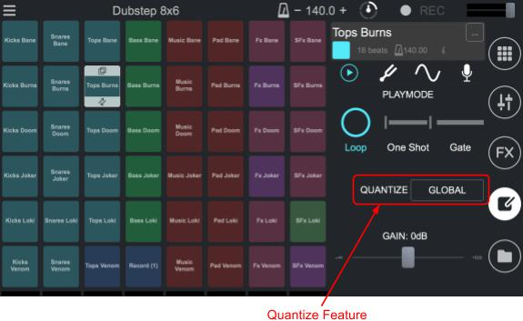

**How can I change the quantization of an entire sample pack?**

It is actually not possible (at the moment) to directly modify the quantize value of an entire sample pack. If you want to do so, first duplicate the pack and then change the quantize value in the ‘Edit’ option of the contextual menu (see the section ‘Can​ I rename, duplicate, reset or delete a sample pack?’​above).

**What is ‘Advanced Sample Editing’?**

‘Advanced Sample Editing’ allows you to change your samples' length and ADSR parameters.

* ‘Start’ and ‘End’ determine the played interval of the sample. Default values are respectively 0 and 1, which corresponds to the original start and end points.
* Attack time (A): duration from zero to maximum amplitude
* Decay time (D): duration from the initial maximum amplitude to a stable state amplitude
* Sustain time (S): duration and level of the steady state amplitude
* Release time (R): duration from the steady state to its final zero amplitude

To modify the ADSR parameters:

* 1. Go to the Sample Editor (notebook icon, fourth from the top at the right side of the main screen)
  2. Go to the Advanced Sample Parameters tab (sine wave icon)
  3. Select the envelope parameter that you want to change.

1. Below the parameters’ buttons, click on ‘+’ or ‘–’ on either side of the value to change it. While clicking, hold the ‘+’ or ‘–’ button to change the value faster.

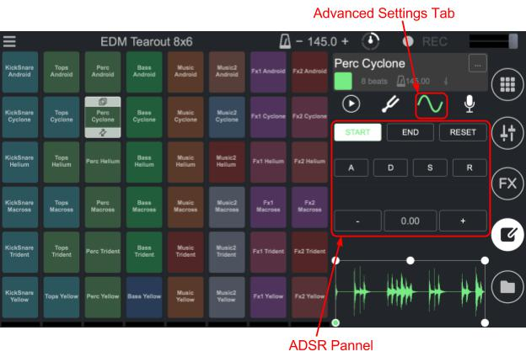

**How****​ can I change the rule for pad-triggering exclusivity?**

Click on the preferences, then select the desired exclusive play option between Full, Column, Line and None.

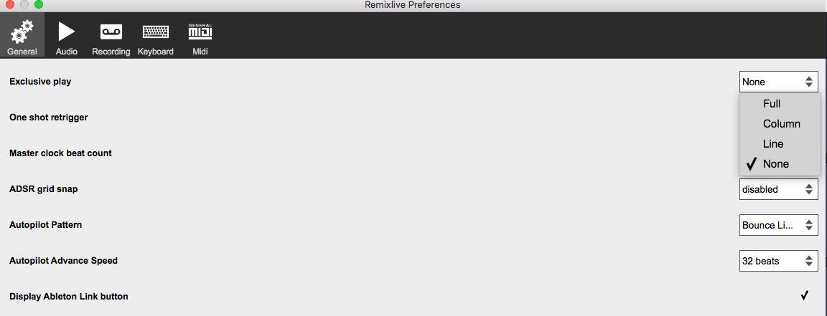

**What is Auto-Pilot?**

Auto-Pilot is a new feature that allows automatic triggering of pads. Click on the hamburger menu and select “Auto-Pilot”. This will lock the Grid view and launch a random sequence of pads. Click on the grid to disable Auto-Pilot at any time.

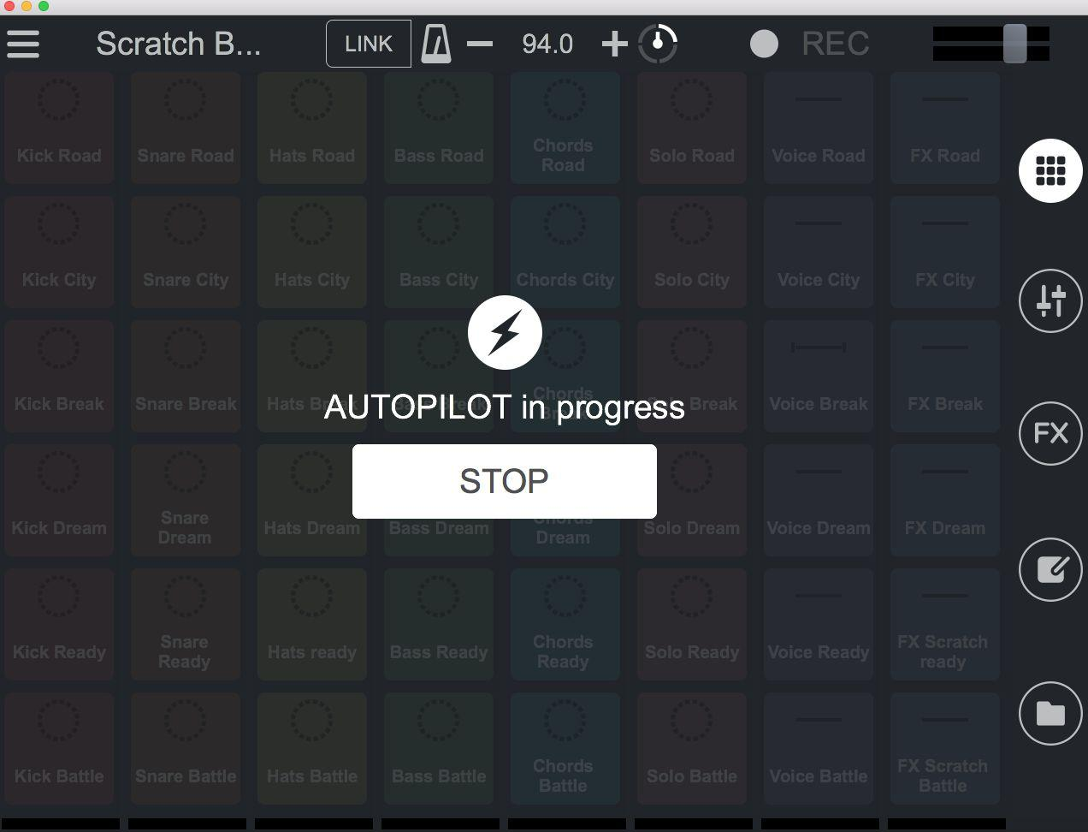

**Can I select the Auto-Pilot pattern?**

Click on the hamburger menu->Preferences->general. Click on the dialog box to select desired pattern i.e lines, Bounce lines and Random.

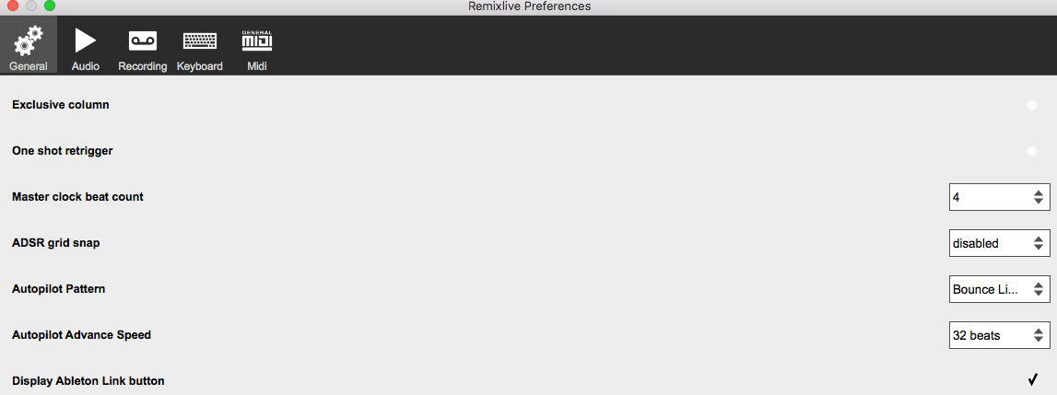

**How can I select Autopilot Advance speed?**

Click on the hamburger menu ->Preferences->General -> Autopilot Advance Speed, then select your desired range from 4 beats, 8 beats,16 beats or 32 beats.

**How to use Ableton Link to synchronize apps through the same WiFi network?**

Ableton Link syncs apps from different devices via a local network, so that everyone plays on the same beat. Make sure your computer and the other device(s) to pair are connected to the same network and click on the “Link” button on the top bar of the Grid view.



**Can I browse my files from the app?**

You can browse the folders of your Mac/PC directly within Remixlive by clicking on the Sample Library view (folder icon) and selecting “Files”.

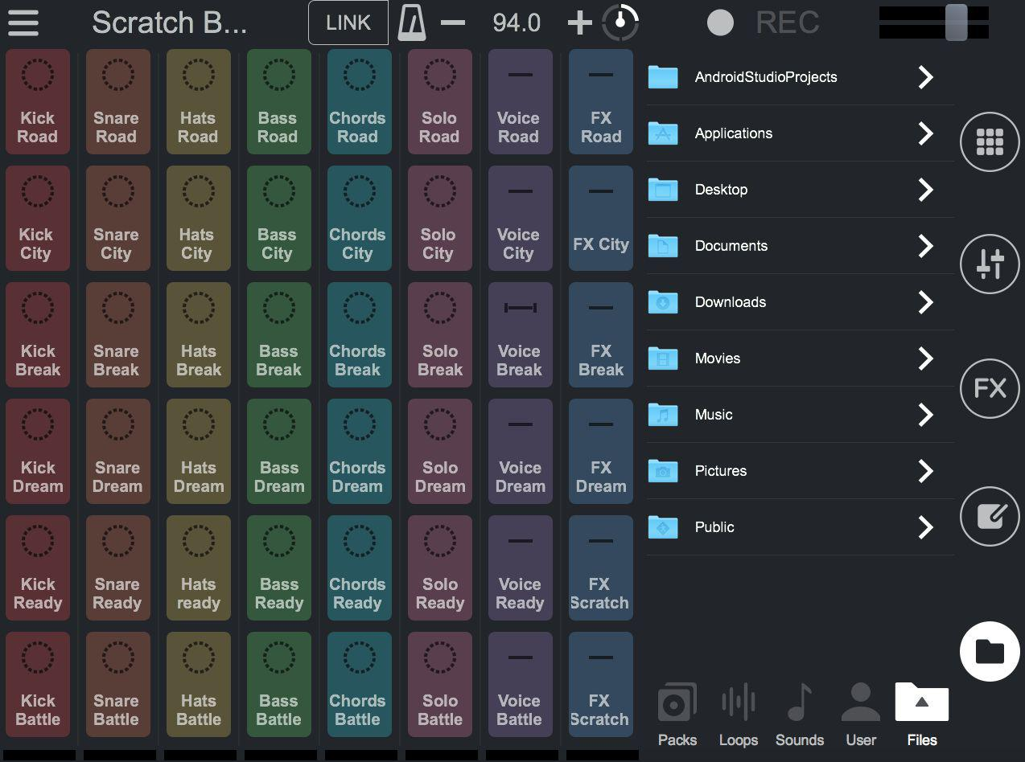

**Record samples**

**How can I record samples?**

To record samples:

1. Go to the Sample Editor (notebook​ icon, fourth from the top, at the right of the main screen)​ and select the pad you want to record over.
2. Go to the tab with the microphone icon. If necessary, choose the recording length and turn the ‘Overdub’ mode on/off.
3. Click on the big microphone icon to start recording your sample. If that doesn’t work, check in Remixlive’s settings that a working microphone is selected. To do so, go to Main menu -> Preferences -> Audio -> Input.

Please keep in mind that the previous sample will be removed from the pad and replaced by the recorded sample.

**What does ‘Rec Length’ mean?**

‘Rec Length’ allows you to choose the number of beats your recording will last. You can also stop the recording of your sample manually during the recording (with a maximum of 16 seconds).

**What does ‘Overdub’ mean?**

‘Overdub’ mode allows you to overlap several recordings on one pad. When ‘Overdub’ is turned on, your new recording will overlap over the existing one.

**Warning:​**This also means that the original recording’s file will be overwritten! (To reset thesample, you can reset the entire pack).

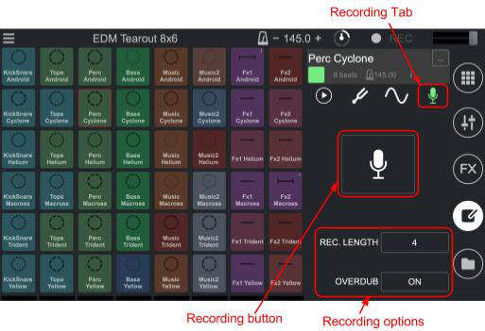

**How do I rename, reset or delete a recorded sample?**

To rename, reset or delete a recorded sample:

1. Go to the Sample Editor (notebook​ icon, fourth from the top, right of the main screen)​.
2. On the mini-grid, select the pad that you want to edit and click on the three-dots button in the top right-hand corner of the sample info zone (grey zone at the top



right-hand corner of the screen).

3. You can now rename your recorded sample by clicking on its name.

**MIDI**

**How to setup a MIDI controller in Remixlive?**

Follow these step to setup a MIDI controller in Remixlive Mac/PC:

1. Connect a MIDI Controller to your computer.
2. Open Remixlive Mac/PC. In the main menu (hamburger icon in the top left-hand corner of the main screen), go to the Preferences window by clicking ‘Preferences’.
3. In the MIDI tab, check that your MIDI controller is detected by Remixlive. Click on the controller’s name, and just above its name, you should see this:
4. You can then map each button of your MIDI controller. Select one of Remixlive’s controls in the list and write down the corresponding MIDI channel of your controller.
5. You can also map your MIDI device using the ‘MIDI Learn’ option. To do that, please refer to the section below.



**How does ‘MIDI Learn’ work?**

The ‘MIDI Learn’ feature is an easier way to map a MIDI controller in Remixlive Mac/PC. Once your MIDI controller is connected to your computer:

1. Open the main menu (hamburger icon in the top left-hand corner of the main screen)
2. Click the ‘MIDI Learn’ option. This will open the MIDI learn view, recognizable by its blue background and white grid pattern.
3. Hover your mouse over a pad, button, slider or knob in the app. This will cause the app to appear shadowed except for the control currently under your mouse cursor.
4. Activate the pad/button/slider/knob of your controller that you want to map the app’s pad/button/slider/knob to.
5. Do it again for every pad you want to map.
6. To exit the MIDI Learn view, click on the ‘Exit’ button at the top-left-hand corner of the view.

**Can I save a MIDI mapping I made?**

You can save a MIDI mapping and use it with another computer or in any situation instead of mapping your MIDI controller again. To save your MIDI mapping:

1. Open the main menu (hamburger icon in the top left-hand corner of the main screen)
2. Go to the Preferences.
3. In the ‘Midi’ tab, select the mapping that you want to save by clicking on it (which will highlight it in orange) and then click on the ‘Save button’ (the rightmost button at the bottom of the window’s left area).
4. A dialog box will open, allowing you to name the mapping (saved as a file with a “.mappings” extension) and choose where you want to save it on your computer.

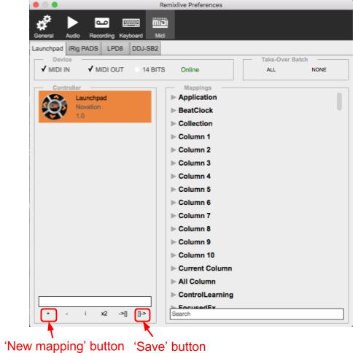

**Can I create several MIDI mappings just for one MIDI controller?**

To create several MIDI mappings just for one MIDI controller, in the ‘Midi’ tab of the ‘Preferences’ window, click on the the ‘New mapping’ button. (See the section before, and the picture above).

**Can I use my keyboard as a MIDI controller?**

Yes, there are two default keyboard mappings in Remixlive Mac/PC: one QWERTY mapping and one AZERTY mapping (for French keyboards). You can then use your keyboard as you would a MIDI controller. You can also create a new mapping for your keyboard.

**VST : How can I set up Remixlive Mac/PC as a VST/AU?**

Here are the steps to setup Remixlive Mac/PC as a VST/AU:

1. Open Remixlive’s application menu (the Apple’s Top bar)
2. Click on the ‘Install as plugin (AU & VST)’ option.
3. The plugin will be installed in the system’s VST/AU folders, and can now be opened in any compatible host (Reaper, Cubase, Ableton Live, Garageband…)

The ‘Sync.’ button synchronizes Remixlive’s clock with the host’s transport.

**How can I Enable Velocity?**

Click on the hamburger menu -> Preferences -> MIDI -> Check the enable velocity option.

When the supported controller is connected, the Enable Velocity option will be displayed.

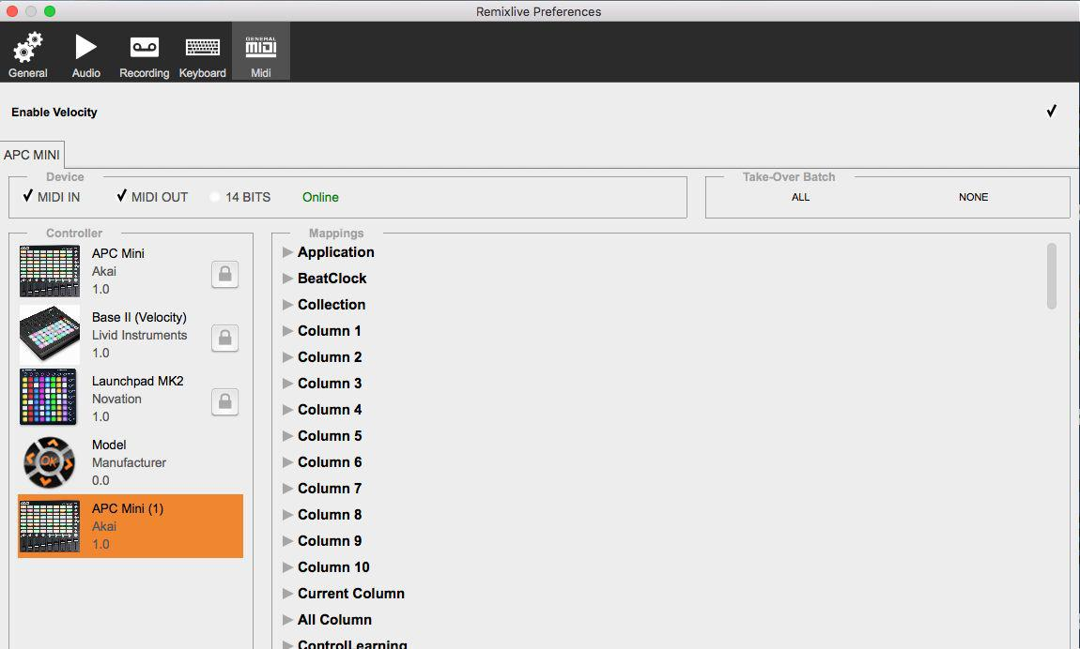

**Import/Export**

**How can I add my own samples to Remixlive?**

It is very easy to import your own samples into Remixlive Mac/PC. To do so:

1. Open the folder in your computer where your samples are located.
2. Drag & drop the sample you want to import from the folder, to the pad you want to fill. You can import several samples at once: just select the samples you want to import, and drag and drop them to Remixlive’s pads.

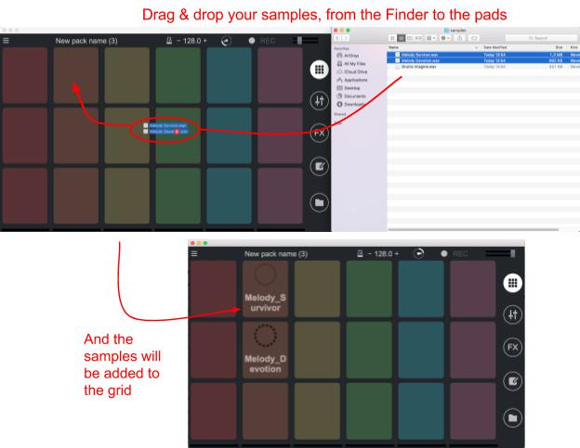

**What kind of file formats can I import in Remixlive?**

Remixlive Mac/PC supports samples encoded in a large variety of audio formats, including WAV, AIFF, MP3, M4a, AAC, FLAC, Ogg, MP4 and WMA.

**Can I add songs to Remixlive?**

The length is limited to a maximum of 200 seconds. However, you can create a sample from a song and then import it into Remixlive Mac/PC. Please keep in mind that using songs in Remixlive requires you to comply with the copyright regulations related to this song. Mixvibes declines all responsibility in cases of copyright infringement.

**How to export a sample pack from Remixlive Mac/PC?**

This has been covered in a section above in this FAQ, so please refer to the item ‘How​ to export a sample pack from Remixlive Mac/PC?’​in the ‘Sample packs’ section.



**Can I import a sample pack into Remixlive Mac/PC?**

To import a sample pack into Remixlive Mac/PC:

1. Open the folder in your computer where the sample’s file is located (.zip or .rmxl files)
2. Drag & drop the sample pack you want to import from the folder in Finder, to Remixlive’s window, it will be added to your collection automatically

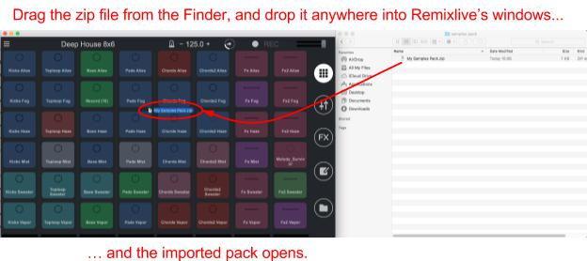

**Can I transfer an exported pack from Remixlive Mac/PC to Remixlive iOS/Android?** You can import the packs you create with Remixlive Mac/PC in Remixlive iOS/PC. For more information, please refer to Remixlive iOS and Android respective FAQs.

**Be careful**:**​**You can only import a compatible pack for your device. Mobile phones only workwith 6x4 grids, and tablets only work with 8x6 grids, even though Remixlive Mac/PC allows for up to 10 columns and 10 rows.

**Tips**

**Can I trigger several samples at once?**

To trigger several samples at once, slide the mouse in any direction while clicking on a pad and all pads over which you drag the mouse will start playing.

**How can I change the color of the pads?**

To change the color of one pad:

1. Go to Sample Editor (notebook icon, fourth icon from the top, right side of the main screen).
2. Select the pad you want to change the color of.
3. In the sample info zone (grey area in the top-right section of the screen), click the colored square.
4. Choose a new color from the 16 available.

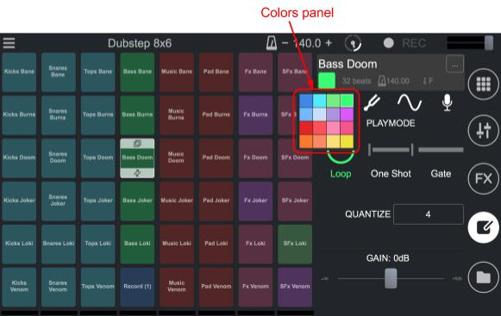

**Can I record my performance in high quality ?**

Every Performance recording is made in high quality. You can even chose the sound format in which you record your performance:

1. Open the main menu (hamburger icon in the top left-hand corner of the main screen).
2. Click on ‘Preferences’ then in the preferences dialog box click on the ‘Recording’ tab.
3. Select your favorite audio format. You can also select a default destination folder for your recording.
4. You can now record in high quality, have fun!

(Note: To record your track, click the REC button in the Top Bar)

**How can I easily reset the value of a slider or a knob?**

To reset the value of a slider or a knob, just double-click on it.

**How can I make a roll effect?**

To make a roll effect:

1. Go to the ‘FX’ tab and press one of the "Beat repeat" pads.
2. Slide to the others "Beat repeat" pads while clicking, to decrease or increase the number of beats to be repeated.

**Can I pause the track while it's playing?**

Click on the Master Clock to play or pause the track. While recording, it will also pause the recording. This feature allows you to take your time to set up more complex or smoother transitions.

**Can I change the master volume of Remixlive without changing the volume of my computer?**

Yes, at the top-right corner of the screen, there is a volume level gauge. This volume level gauge also doubles as a slider that you can use to change Remixlive’s master volume.

**How can I retrieve Samples packs Purchases I previously bought?**

If you lost a Samples pack you purchased or if you are asked to pay for In-App Purchases that you already paid for:

1. Make sure you are connected to the Internet, and that you are logged-in with the same Apple ID/Google account that you used to buy the Sample packs IAPs.
2. Open the main menu (hamburger icon in the top left-hand corner of the main screen)
3. In the ‘Store’, click on the ‘Restore Purchases’ button (at the bottom right-hand corner of the store pop-up window).
4. If this doesn't work, you would likely need to click on “Buy” on these IAPs again, but as long as you are connected with the same account, you won't be charged again for them.

**What should I do when I experience performance issues?**

If you are experiencing performance issues, try to:

* Close any other app or apps that may be running in the background.
* Turn the Wi-Fi / Bluetooth off in order to save battery.
* Turn off the geo tagging or GPS
* Turn off the multiple mode switch
* Make sure your phone is not running too low on battery
* Close and reopen the app
* Restart your phone
* Download the latest update

If none of these solutions work, feel free to contact our support team via e-mail at the following address : support@mixvibes.com

**Changes to this FAQ**

We will occasionally update this FAQ. When we post changes to this FAQ, we will revise the "last updated" date at the top. We recommend that you check from time to time to inform yourself of any changes in this FAQ or any of our other policies.