**TOPIC: The Role of Mobile Apps in Learning Language**

**Name:**

**Submission Date:**

# Acknowledgement

I hereby declare that I am the only author of the attached master's thesis and that no materials or methods were used without my express permission. All of the literature and other sources that I used to produce this academic paper, either verbatim or in content, were carefully marked and separately listed. I understand that breaking this rule will result in the thesis failing.

UK, 05.06.2025.

……………………………

Signature

# Abstract

This study looks into the usefulness of mobile language learning apps, mainly Duolingo, when compared to traditional ways of learning in schools. The reason for researching the topic is that technological progress has transformed language education, allowing people to learn on their phones using easy, fun and individual methods. More than 500 million people are using Duolingo worldwide, but it is still debated in academic circles whether it can produce students who are just as good at talking and using the language as traditional methods do.

Using both behaviorism and constructivism theories as a basis, the researchers look at how well both kinds of learning methods work by examining results and gaining feedback from the learners. You can see behaviorist ideas in Duolingo’s gamified methods such as keeping streaks or receiving rewards, as these things positively influence user motivation and the remembering of new vocabulary in the short run. Nevertheless, the features in these texts don’t usually offer much social connection or formal feedback which is needed to develop speaking abilities and proper language use, as stressed by constructivist ideas. Classrooms today allow easy communication with the instructor, interaction with other students and useful practice in speaking and listening that is important for development.

The study touches on the differences between mobile app and classroom learners, how age and language skills affect the outcomes and straightens out what challenges app learners deal with. It was found that Duolingo and similar apps are good for learning vocabulary and gaining flexibility, but they lack support for speaking freely and gaining cultural understanding which classroom lessons provide. It is evident from the study that Duolingo failed to help users achieve the same level of oral skills as those taught in a classroom.

This research finds that for best results; teaching practices should use the convenience benefits of mobile apps along with the communicative strength of classroom methods. Based on these discoveries, people can make useful changes to language education in an always changing digital society.

# List of Abbreviations

|  |  |
| --- | --- |
| **Abbreviation** | **Full Term** |
| AI | Artificial Intelligence |
| ANCOVA | Analysis of Covariance |
| ANOVA | Analysis of Variance |
| APA | American Psychological Association |
| AR | Augmented Reality |
| BERA | British Educational Research Association |
| CALL | Computer-Assisted Language Learning |
| CEFR | Common European Framework of Reference for Languages |
| CLT | Communicative Language Teaching |
| COLT | Communicative Orientation of Language Teaching |
| GDPR | General Data Protection Regulation |
| ICC | Intra-Class Correlation |
| IELTS | International English Language Testing System |
| IRB | Institutional Review Board |
| MALL | Mobile-Assisted Language Learning |
| MANOVA | Multivariate Analysis of Variance |
| NLP | Natural Language Processing |
| SLA | Second Language Acquisition |
| SPSS | Statistical Package for the Social Sciences |
| SRS | Spaced Repetition System |
| TOEFL | Test of English as a Foreign Language |
| VR | Virtual Reality |
| VLT | Vocabulary Levels Test |
| XP | Experience Points |
| ZPD | Zone of Proximal Development |

**Table of Contents**

Acknowledgement ii

Abstract iii

List of Abbreviations iv

**Chapter 1: Introduction** 1

**1.1 Overview of the Research** 1

**1.2 Importance of the Research** 1

**1.3 Objectives of the Research** 2

**1.4 Research Questions** 2

**1.4 Background on Duolingo** 3

**1.5 Theoretical Framework** 4

**1.6 Conclusion** 5

**Chapter 2: Literature Review** 6

**2.1 Introduction** 6

**2.2 Justification for Reviewing Existing Literature** 6

**2.3 Connection to Research Objectives** 7

**2.4 The Evolution of Language Learning Methods** 8

**2.4.1 Traditional Classroom-Based Language Learning** 8

**2.4.2 Early Computer-Assisted Language Learning (CALL)** 9

**2.4.3 The Rise of Mobile-Assisted Language Learning (MALL)** 9

**2.5 Theoretical Perspectives on Language Learning** 10

**2.5.1 Behaviorism in Mobile Language Learning** 10

**2.5.2 Constructivism and Social Learning in Language Acquisition** 11

**2.5.3 Cognitive Theories in Language Retention** 12

**2.6 Mobile Language Learning Applications: Features and Effectiveness** 12

**2.6.1 Overview of Popular Mobile Language Learning Apps** 12

**2.6.2 Gamification and Motivation in Mobile Language Learning** 13

**2.6.3 The Role of AI and Adaptive Learning in Language Apps** 14

**2.6.4 Limitations of Mobile Language Learning Apps** 15

**2.7 Comparative Studies on Mobile vs. Classroom Learning** 15

**2.7.1 Vocabulary Acquisition: App-based vs. Traditional Learning** 15

**2.7.2 Oral Proficiency Development in Different Learning Settings** 16

**2.7.3 Blended Learning Approaches** 17

**2.8 Mobile Language Learning Post-Pandemic** 18

**2.8.1 Increase in Mobile App Adoption After COVID-19** 18

**2.8.2 Role of Digital Education in Shaping Future Language Learning** 19

**2.9 Summary and Research Gaps** 20

**2.9.1 Recap of Key Findings from the Literature** 20

**2.9.2 Identification of Gaps in Research** 20

**2.9.3 Justification for the Current Study** 21

**2.10 Conclusion** 21

**Chapter 3: Methodology** 22

**3.1 Research Design incl** 22

**3.1.1 Qualitative vs Quantitative Approaches** 22

**3.1.2 Comparative Study Framework** 22

**3.2 Participants** 24

**3.2.1 Selection Criteria** 24

**3.2.2 Demographic Breakdown** 24

**3.3 Data Collection Methods** 25

**3..3.1 Pre and Post-Test Assessments (Vocabulary & Oral Proficiency)** 25

**3.3.2 Surveys on Engagement & Motivation** 26

**3.3.3 Classroom Observation Protocols** 27

**3.4 Data Analysis Techniques** 28

**3.4.1 Statistical Tools for Performance Comparison** 28

**3.4.2 Thematic Analysis of Learner Feedback** 29

**3.5 Ethical Considerations** 31

**3.5.1 Informed Consent** 31

**3.5.2 Confidentiality and Anonymity** 31

**3.6 Limitations of the Study** 32

**3.6.1. Sample Size Constraints** 32

**3.6.2. Potential Biases in Self-Reported Data** 32

**3.7 Summary** 32

**Chapter 4: Findings** 34

**4.1 Introduction** 34

**4.2 Quantitative Research (Surveys)** 35

**4.3 Qualitative Research (Interviews)** 47

**4.4 Supplemental Data** 53

**4.5 Conclusion** 54

**Chapter 5 Discussion** 55

**Introduction** 55

**5.1 Comparative Effectiveness of Learning Modalities** 55

**5.1.1 Vocabulary Acquisition Superiority in Mobile Learning** 55

**5.1.2 Classroom Advantage in Productive Skills** 56

**5.1.3 Motivation as a Performance Mediator** 56

**5.2 Learner Experience and Perceptual Differences** 57

**5.2.1 Engagement Patterns** 57

**5.2.2 Motivational Drivers** 57

**5.2.3 Identified Pain Points** 58

**5.3 Toward an Integrated Pedagogical Framework** 58

**5.3.1 Synthesis of Complementary Strengths** 58

**5.3.2 Proposed Blended Model** 59

**5.3.3 Addressing Learner-Expressed Needs** 59

**5.4 Theoretical and Practical Implications** 60

**5.4.1 Reconciling Educational Theories** 60

**5.4.2 Applications for Stakeholders** 60

**5.5 Limitations and Future Work** 61

**5.5.1 Limits of the Methodology** 61

**5.7 Future Research Work.** 62

**Chapter 6 Conclusion** 62

**6.1 Summary of Key Findings** 62

**6.1.2 Classroom Advantage in Productive Skills** 63

**6.1.3 Motivational Drivers and Engagement Patterns** 63

**6.2 Concluding Remarks** 64

References 65

# **Chapter 1: Introduction**

## **1.1 Overview of the Research**

Technological advances in modern times have transformed the process through which people master new skills especially acquisition of language skills. The mobile application Duolingo provides autonomous learning resources that have replaced traditional classroom education (Duolingo, 2023). A study evaluates mobile language learning applications especially Duolingo against classroom traditional methods for assessing vocabulary learning and oral speaking abilities. The investigation evaluates how well mobile applications maintain language retention as well as verbal fluency while filling knowledge gaps from past studies (Zhang, 2023).

Academic discussions continue about which is better between mobile application learning and traditional educational methods. Mobile apps have easy accessibility and fun features but largely fall short when it comes to delivering systematic feedback and social interaction which stand essential for oral proficiency (Noordin et al., 2024). The research evaluates the benefits and shortcomings of mobile apps and traditional classroom instruction using behaviorism and constructivism theories (Skinner, 1957; Vygotsky, 1978).

## **1.2 Importance of the Research**

Multilingualism helps people achieve better personal goals and develop enhanced career opportunities because of the globalization of the world. Language learning takes up substantial amounts of time which inspires people to seek flexible digital solutions. Duolingo stands as a prime example of this transition since it reached more than half a billion downloads (Duolingo, 2023). The question remains whether this approach succeeds in achieving the same results as traditional classrooms especially regarding oral fluency (Zhang, 2023).

The research study fills a fundamental knowledge gap through its provision of evidence about relative effectiveness. The study provides data which enables educational practitioners and curriculum developers and education users to develop optimal blended methods that couple mobile application vocabulary learning with classroom communication instruction. A growing need for research-based strategies exists since 67% of language learners use apps to study after the pandemic (Statista, 2022).

## **1.3 Objectives of the Research**

The primary goals of the research are as follows:

1. A study examines the corporate efficiency of Duolingo mobile applications and standard language classroom systems within vocabulary growth along with spoken ability development through performance analyses which consider student maturity levels.
2. A comparative assessment will be conducted to measure learner opinions about their levels of engagement together with their motivational experiences and difficulties in both educational approaches.
3. The author suggests professional education methods which unite mobile application flexibility with classroom interaction to advance learners' complete language abilities.

## **1.4 Research Questions**

Multiple questions direct this investigation which focuses on the following points:

1. One analyzes whether mobile app users achieve different vocabulary and oral proficiency results than learners in classroom environments.
2. Does age together with prior language experience affect the performance of either teaching approach?
3. Mobile app learners encounter specific challenges which should guide developers toward creating blended learning approaches.

## **1.4 Background on Duolingo**

The Duolingo language-learning platform launched in 2011 through the collaboration of Luis von Ahn and Severin Hacker to become a global leader that now instructs 40 different courses for more than 500 million users worldwide (Duolingo, 2023). The educational platform enables vocabulary memorization and grammar correctness through its free accessible structure which implements gamified lessons with spaced repetition along with instantaneous feedback (Krashen, 1982; Munday, 2016). People who use the app can access the behaviorist principles through rewards that feature streak achievements and virtual currency along with leaderboards to promote ongoing practice and provide positive reinforcement (Skinner, 1957; Godwin-Jones, 2011). Independent studies demonstrate that these interactive features cause users to stay engaged at least in the short term since 34% of participants show higher learning motivation than traditional approaches (Statista, 2022). Critics of Duolingo claim that its emphasis on individual skill development through sentence translation and word matching does not create sufficient conditions to attain complete language abilities especially regarding oral proficiency (Nielson, 2021).

The spaced repetition system employed by Duolingo works with cognitive memory theories (Ebbinghaus, 1885; Bahrick & Hall, 2005), yet its lacking social features violate constructivist theory requirements for social learning and real-world communication (Vygotsky, 1978; Lantolf, 2000). The classroom environment lets students conduct dialogue practice and receive informed instructor feedback as well as participate in peer discussions which fundamentally advance their speaking and listening abilities (Swain, 1985; Loewen et al., 2020). In a study it was discovered that Duolingo users performed below classroom students by 15% during spontaneous speaking tests which demonstrated poor oral fluency abilities (Zhang, 2023). A meta-analysis discovered that app-based learners frequently have difficulty using language pragmatically including comprehension of idiomatic expressions together with cultural context understanding (Smith & Rodríguez, 2022).

The tool’s ease of access together with its flexibility transforms it into a beneficial addition despite existing boundaries. Research revealed that 72% of users used Duolingo with traditional educational settings to boost their vocabulary memory (Lee & Warschauer, 2023). Academic discussions continue about its sustained effectiveness since researchers advise against using gamified apps exclusively to develop complete language skills (Blake, 2013; Godwin-Jones, 2011). To close the gaps between current instructional approaches and Duolingo's core competencies researchers should use new technology to merge the platform's capabilities with socially powered learning methods (Chapelle & Jamieson, 2008).

## **1.5 Theoretical Framework**

The research uses behaviorism together with constructivism as its core theoretical bases to study mobile apps and conventional language learning approaches. Learners develop language according to Constructivist principles because social engagement and team-based learning serve as essential factors for acquiring knowledge through contact with instructors and peers and environmental contexts (Vygotsky, 1978; Lantolf, 2000). Tasks that require collaboration in educational settings such as group discussions or role-playing connect with Vygotsky’s idea of students moving forward by means of social assistance in the Zone of Proximal Development (Swain 2000, Loewen et al. 2020). The principles found in standardized educational approaches naturally work because they promote interactive student-teacher relationships as well as peer group work (Johnson & Johnson, 1999; Warschauer, 1997).

The behavioral approach uses repetitive conditioning techniques with reinforcement to modify learner outcomes (Skinner, 1957). The behavioral principles are applied in Duolingo through its gamification features such as streaks alongside XP points and leaderboards which reinforce learners to maintain consistency and vocabulary sustainability (Godwin-Jones, 2011; Munday, 2016). User motivation rises by 34% when using gamification mechanics on systems (Smith & Rodríguez, 2022; Nielson, 2021). Behaviorist methods contained within mobile apps face criticism because their emphasis on individual translation drills leads to a decrease in meaningful communication abilities despite recommendations regarding holistic acquisition (Blake, 2013; Chapelle & Jamieson's, 2008).

The research redirects the understanding of mobile apps and classroom practices in relation to standardized learning explanations through comprehensive framework analysis. Duolingo applies cognitive memory-related techniques in spaced repetition (Bahrick & Hall, 2005; Ebbinghaus, 1885) but its social interaction deficiency does not address constructivist requirements for dialogue along with cultural context understanding (Krashen, 1982; Lee & Warschauer, 2023). Traditional classrooms develop oral fluency well due to their capacity for immediate feedback from peers jointly (Swain, 1985) yet they show limitations when it comes to flexible vocabulary learning (Stockwell & Hubbard, 2013).

By uniting both theoretical approaches researchers can properly evaluate what strengths and weaknesses app-based flexibility presents alongside classroom interactivity methods (Hwang & Fu, 2019; Zhang, 2023).

## **1.6 Conclusion**

The initial section of this chapter presents research into how mobile apps measure against conventional classrooms for learning languages. The research sets out its objectives and theoretical foundations together with its social importance. The research demonstrates two fundamental gaps by requiring experimental proof and unified educational practices. A review of mobile language learning research will appear in the following chapter that develops the contextual significance of this study.

# **Chapter 2: Literature Review**

## **2.1 Introduction**

Modern technological developments have sparked a major transformation in new language acquisition through mobile-assisted language learning (MALL) applications. Mobile apps have emerged as prominent tools in language education as the digital wave evolves education because they provide three main features of accessibility gamification and personalization (Lee & Warschauer, 2023). The research investigates mobile-assisted language learning techniques through an evaluation of literature focused on vocabulary mastery and oral competence and student motivation and learning engagement. The review creates a theoretical and empirical base that explains mobile application performance against traditional classroom instruction especially with Duolingo as an example.

This section conducts a detailed review of suitable academic work to assess mobile-learning applications' effectiveness against classroom teaching practices. The review assesses present-day scholarly controversies and analysis to demonstrate both favourable aspects and drawbacks of mobile applications in second language learning acquisition (SLA).

## **2.2 Justification for Reviewing Existing Literature**

Academic attention to cell phone technology integration into educational practices has significantly increased during the last twenty years. Components of mobile learning have been studied extensively as scholars determined mobile apps' effectiveness for improving vocabulary retention and grammar comprehension and oral fluency retention (Stockwell & Hubbard, 2013, Godwin-Jones 2011). This study uses existing research to expand previous findings by understanding how mobile-assisted language learning connects with behavioural (Skinner, 1957), constructivist (Vygotsky, 1978) and cognitive learning theories (Krashen, 1982).

The main purpose of this literature review investigates the long-standing discussion between traditional education and technology-based learning methods. The combination of mobile applications enables interactive flexibility yet these programs deliver insufficient structured feedback and real-time classroom interaction (Chapelle & Jamieson, 2008; Blake, 2013). A full comparison between mobile application instruction and traditional learning practices is necessary to establish if mobile apps provide complete learning solutions or blend better with conventional methods.

Language learning remains a developing area which academic experts consider through cognitive mental factors together with social psychological dynamics and motivational aspects. Mobile learning research shows that learner motivation grows better through educational game design along with systems of customized instruction and practical reward mechanisms (Nielson, 2021; Smith & Rodríguez, 2022). Research has not fully investigated how successfully language skills retained from mobile apps are used in real-life contexts (Lee & Warschauer, 2023). Achieving the study's research goals on mobile learning effectiveness requires an analysis of past findings because they supply crucial knowledge regarding essential characteristics.

## **2.3 Connection to Research Objectives**

The main goal of this research investigates how mobile applications specifically Duolingo help students learn vocabulary and spoken language skills better than traditional classroom teaching methods. The present review of literature backs these goals by evaluating mobile language learning research to extract success elements alongside weak areas.

The fundamental research inquiry of this study focuses on determining if mobile language learning applications duplicate classroom teaching outcomes. Mobile applications help users remember vocabulary using spaced repetition alongside interactive content (Bahrick & Hall, 2005; Ebbinghaus, 1885) yet they normally fail to deliver structured speaking opportunities that promote fluency (Swain, 1985; Noordin et al., 2024). Reviewing current research will determine the effects of these shortcomings on language acquisition while evaluating suitable solutions.

The research investigates the relationship between student demographics particularly their ages and language exposure to mobile language education effectiveness. Mobile applications deliver greater advantages to self-directed learners who demonstrate strong intrinsic motivation according to Hwang and Fu (2019). An exploration of this study shows the combined effects of these variables with mobile learning instruments to enhance our understanding of their outcome effects.

The literature review supports the study's main objective to develop suggestions for an integrated learning model which combines mobile learning benefits with traditional classroom methods. Literature demonstrates that blended learning models combining mobile learning flexibility with classroom interactive elements lead to superior results in educational settings (Stockwell & Hubbard, 2013; Lee & Warschauer, 2023). Studies of blended learning will offer information which helps educators create full language learning programs that effectively combine their distinct advantages.

## **2.4 The Evolution of Language Learning Methods**

### **2.4.1 Traditional Classroom-Based Language Learning**

For many centuries students have learned languages by attending structured education settings that enable them to interact with teachers and their classmates through different educational strategies. The language learning framework consists of four methods: grammar-translation approaches together with direct instruction as well as audio-lingual methods and communicative language teaching (Richards & Rodgers, 2014). Learning methods place emphasis on student-to-student conversation and curriculum organization along with evaluation for continuous growth.

The grammar-translation method as one of the original language teaching strategies concentrated on written compositions while students memorized syntax and vocabulary according to Larsen-Freeman & Anderson (2013). Reading comprehension received strong results with this method yet it did not focus enough on developing speaking abilities or communicative ability (Brown, 2007). The direct method entered the education field at the close of the nineteenth century and the beginning of the twentieth century to develop oral abilities through total immersion and restricted native language use according to Howatt & Widdowson (2004). Modern communicative approaches received their initial basis through this method.

During the mid-20th century, the audio-lingual method adopted repetition and mimicry instruction reinforced by reinforcement techniques for developing language fluency (Skinner, 1957). The pattern drill-oriented and dialogue-centered method that adopted behavioural principles (Ellis, 1997) published criticism about its withdrawal from real-world usage as well as limited context recognition (Ellis, 1997). Beginnings of the 1970s brought forward the communicative language teaching (CLT) approach which emphasized student-to-student interaction for learning (Littlewood, 1981). The implementation of role-playing and authentic materials together with group discussions marked CLT as it aimed to develop practical language abilities.

The traditional learning system based in classrooms delivered organized instruction together with immediate feedback along with social exchange although it introduced impediments regarding learning accessibility and flexibility and personalization (Krashen, 1982). To overcome the issues presented in traditional classrooms technology-based solutions emerged which gave rise to computer-assisted language learning (CALL).

### **2.4.2 Early Computer-Assisted Language Learning (CALL)**

The introduction of computers into language education occurred during the 1960s which initiated the first steps of computer-assisted language learning (CALL) according to Levy (1997). The combination of digital technologies under CALL enables students to learn languages better through three key features including interactive tasks and multimedia resources and customized learning programs. The development of this technique went through behavioral CALL before arriving at communicative CALL and integrative CALL (Warschauer & Healey, 1998).

During its initial development phase behaviorist CALL implemented traditional education methods by utilizing repetitive drill-based software that used reinforcement for learning (Levy, 2009). During the 1960s the PLATO system released structured grammar exercises but users could not experience meaningful communication within this platform (Ahmad et al., 1985). The initial language learning software helped users maintain their vocabulary ability and syntax skills but they did not provide an environment which fostered contextualized or interactive language usage (Chapelle, 2001).

During the 1980s communicative CALL emerged as a new approach which used task-based activities together with multimedia features (Bax, 2003). The programs Rosetta Stone and Tell Me More introduced voice recognition systems together with listening components and simulated dialogues to boost understanding and pronunciation skills according to Hubbard (2009). During this stage the educational strategies corresponded to constructivist learning approaches by focusing on independent learning combined with practical applications (Vygotsky 1978).

The internet and virtual learning environments triggered integrative CALL during the 1990s and early 2000s (Warschauer, 2000). Language learners obtained web-based learning platforms alongside online forums and multimedia content which enhanced platform usage and raised engagement (Stockwell, 2013). The platforms needed exclusively dedicated computer access during this period even though such systems failed to match the next-generation mobile tech tools.

### **2.4.3 The Rise of Mobile-Assisted Language Learning (MALL)**

The adoption of smartphones together with mobile applications led to the transformation of language learning through Mobile-Assisted Language Learning (MALL) because learners can now access education resources anytime and anywhere (Kukulska-Hulme & Shield, 2008). MALL uses CALL foundations to deliver improved mobile accessibility through social media platforms and Artificial Intelligence programs paired with mobile applications (Godwin-Jones, 2011).

Educational mobile apps including Duolingo and Memrise and Babbel and Busuu entered the market during the 2010s with gamified learning features that offer spaced repetition system and enhanced real-time feedback (Zhang, 2023). Knowledge retention among learners rises together with their motivation because of gamification mechanisms including leaderboards along with rewards and progress-tracking features (Deterding et al., 2011; Nielson, 2021). Research demonstrates that language learners use apps next to official education to enhance vocabulary storage through mobile programs (Lee & Warschauer, 2023).

The adaptive learning feature of MALL comes from AI-powered systems which offer customized content for learners based on their skills and learning patterns and performance results (Chapelle & Jamieson, 2008). Self-directed learning experiences occur thanks to adaptive algorithms used by Duolingo and Babbel along with their system-generated instant feedback implementation (Krashen, 1982). Speech recognition technology has improved pronunciation training since it provides learners the ability to practice speaking and receive automated feedback (Stockwell, 2013).

Despite its advantages, MALL also faces limitations. Mobile apps are criticized because they deliver minimal grammatical instruction and insufficient contextual conversation practice which breaks down the learning process (Smith & Rodríguez, 2022). The autonomous nature of mobile-based learning does not work well for students who need defined instruction together with peer involvement in their learning process (Blake, 2013).

## **2.5 Theoretical Perspectives on Language Learning**

### **2.5.1 Behaviorism in Mobile Language Learning**

Behaviorism establishes learning as a process which happens when reinforcement interacts with conditioning according to B.F. Skinner (1957). The theory supports mobile-assisted language learning by integrating gaming elements which includes award systems combined with winning streaks and leaderboard features (Godwin-Jones, 2011).

Behaviorist learning environments implement positive reinforcement techniques to enhance correct behaviours as described by Skinner (1957) but also incorporate negative reinforcement techniques to decrease errors in student responses. Users of language learning applications such as Duolingo and Memrise receive rewards from virtual achievements and progress streaks as well as motivational reminders according to Munday (2016). Gamification contributes to learning success by encouraging user engagement because people respond positively to visible progress-tracking features and rewards (Deterding et al., 2011; Lee & Warschauer 2023).

The principles of behaviourism support habit formation theories because they require continuous contact with repeated practice to achieve language mastery (Ellis, 1997). Nielson (2021) found that education participants who used streak-based learning applications had greater success rates in learning than participants who used non-gamified systems. The behaviorist approach faces criticism because it encourages memorization and not the development of meaningful interpersonal abilities according to Krashen (1982).

### **2.5.2 Constructivism and Social Learning in Language Acquisition**

According to constructivist theories people learn language through participatory activities together with social exchanges and relevant learning experiences (Vygotsky, 1978). According to the constructivist perspective the Zone of Proximal Development (ZPD) defines how students learn best through assistance from more experienced instructors (Vygotsky, 1978; Lantolf, 2000).

Mobile-assisted language learning applications now integrate social learning features which support the constructivist theory. The peer interaction platforms HelloTalk and Tandem allow language learners to have real-time discussions with native speakers according to (Lee & Warschauer, 2023). A thorough assessment shows that language students acquire better conversational skills when they interact with their peers (Swain, 1985; Littlewood, 2004).

Learners need instructor feedback in constructivist learning because this feedback creates scaffolding structures which promote improved linguistic accuracy according to (Loewen et al., 2020). Mobile application developers find it difficult to deliver natural human feedback like traditional classrooms do (Chapelle & Jamieson, 2008). The AI chat systems used in Mondly and Babbel attempt to resolve this issue through real-time correction algorithms (Stockwell, 2013). Studies indicate that computer-generated feedback fails to properly solve intricate grammatical problems together with syntactic problems (Smith & Rodríguez, 2022).

Constructivist mobile learning strategies deal with two main obstacles because of reduced real-time communication and limited settings for immersive educational interactions (Godwin-Jones, 2011). Most educational institutions refrain from adopting virtual reality (VR) and augmented reality (AR) technologies as solutions because of technological limitations (Hwang & Fu, 2019).

### **2.5.3 Cognitive Theories in Language Retention**

During language acquisition the cognitive approach stakes its focus on the functions of memory together with information processing alongside retrieval abilities. Information naturally disappears quickly according to Hermann Ebbinghaus (1885) until people systematically review their memory. Subsequent investigations conducted by Bahrick & Hall (2005) proved that regular periodic review enhances long-term information retention.

SRS mechanisms in mobile applications follow cognitive principles to schedule vocabulary review for optimal retention (Godwin-Jones, 2011). The SRS algorithms in Anki and Duolingo make sure students review words repeatedly at specific timed intervals (Lee & Warschauer, 2023). Community-based space repetition stands as an effective recall booster that delivers 60% better results than traditional massed studying approaches (Cepeda et al., 2006).

Through cognitive load theory information processing at excessive levels creates a negative effect on learning efficiency (Sweller, 1994). Mobile language applications decrease cognitive overload through their presentation of short instructional units and games alongside interactive educational content (Chapelle & Jamieson, 2008). The effective learning of learners happens best through short interactive lessons rather than long reading exercises according to Stockwell and Hubbard (2013).

Working memory capacity stands as an important cognitive element that determines how well students process and remember new linguistic structures according to Baddeley (2000). Students who possess more substantial working memory abilities achieve better results in their study of complex grammar rules (Miyake & Friedman, 1998). Mobile application technology responds to this challenge through adaptive learning technology that modifies lesson complexity depending on user performance results (Hwang & Fu, 2019).

## **2.6 Mobile Language Learning Applications: Features and Effectiveness**

### **2.6.1 Overview of Popular Mobile Language Learning Apps**

Mobile language learning applications developed in large numbers during the last few decades created fundamental changes in the way students learn new languages. Duolingo together with Babbel and Rosetta Stone and Memrise and Busuu dominate the language learning market by providing specialized features for diverse learner requirements (Lee & Warschauer, 2023). The apps utilize three interactive methods - gamification and speech recognition with personalized learning paths which make their system more engaging and meaningful for users (Stockwell & Hubbard, 2013).

Learners on Duolingo benefit from gamified elements because they gain points along with level unlocks and successful streak maintenance which supports their motivation (Munday, 2016). The spaced repetition system (SRS) on Duolingo helps learners retain vocabulary better because it delivers words and phrases at timed intervals as demonstrated by (Cepeda et al., 2006). Research indicates Duolingo makes learners better at acquiring vocabulary but its capabilities to develop speaking skills are comparatively limited (Smith & Rodríguez, 2022).

Through its organized curriculum Babbel delivers grammar lessons which blend with realistic dialogues based on the study by Godwin-Jones (2011). The detailed rule explanations which Babbel provides separates it from Duolingo because this platform appeals to students who want official language education (Loewen et al., 2020). The learning system employed by Rosetta Stone provides a full-immersive experience with speech recognition technology that strengthens language patterns according to Chapelle and Jamieson (2008).

Memrise delivers native speaker videos together with mnemonic strategies that support contextual learning methods (Deterding et al., 2011). Memrise strengthens pronunciation abilities together with listening skills through its delivery of authentic speech patterns (Nielson, 2021). Busuu uses AI evaluations and social learning features to facilitate native speaker interactions while allowing students to get peer feedback (Lee & Warschauer, 2023).

### **2.6.2 Gamification and Motivation in Mobile Language Learning**

Mobile language learning applications base their success on gamification because this methodology improves both user interest and involvement. Leaderboards combined with rewards and competition mechanics which element comes from gaming create better user engagement as well as longer-term user maintenance (Deterding et al., 2011). Students who learn through gamified educational systems achieve stronger intrinsic motivation than similar learning patterns based on traditional instructional design (Nielson, 2021).

Language learning application users today choose gamified features over other offerings because they need immediate feedback and see progress indicators and motivational rewards system (Statista, 2022). Daily streaks and experience points (XP) found in Duolingo mirror the new learning pattern which promotes consistent practice (Lee & Warschauer, 2023). The heavy use of gamification methods by some critics creates problems because users usually focus on completing tasks instead of developing true language competence (Krashen 1982).

Through gamification social learning takes place since it includes peer challenges and multiplayer modes along with community-based leaderboards (Smith & Rodríguez, 2022). Research findings show that mechanics based on competition help learners persist longer in their studies and boost their completion success rates (Godwin-Jones, 2011). Uncontrolled competition produces stress in students causing them to lose their intrinsic drive (Blake, 2013).

### **2.6.3 The Role of AI and Adaptive Learning in Language Apps**

The combination of artificial intelligence with machine learning technology has revolutionized personalized language education by way of learning applications (Zhang, 2023). Program performance assessment reveals student learning gaps for the system to generate tailored educational contents that create better learning programs (Chapelle & Jamieson, 2008).

Each user progresses independently through the content at their speed which enables the system to avoid both basic and advanced material levels (Hwang & Fu, 2019). AI algorithms on Babbel and Busuu analyze user needs so they can distribute relevant content material to each student to boost student satisfaction and study commitment (Lee & Warschauer, 2023). Adaptive learning techniques create deeper retention of information in long-term memory than standard teaching techniques shows research (Cepeda et al., 2006).

AI language learning finds its advancement through the backing it gets from speech recognition technology. Rosetta Stone alongside Mondly assess pronunciation ability and session fluency through voice feedback assisted by their speech recognition technology (Stockwell, 2013). AI speech tools performed better in pronunciation tasks than regular repetition exercises by reaching a 35% enhancement rate according to Research (Zhang, 2023). A large number of experts state that modern AI systems perform poorly when processing speech variations with different accents in contextual understanding (Smith & Rodríguez, 2022).

AI technological feedback systems need more development because they encounter persistent obstacles regarding their accuracy and responsiveness in automated conversations. The research shows that artificial intelligence generates standard feedback that lacks the deep instructional understanding humans possess (Loewen et al., 2020). User input understanding as well as suitable response generation capabilities of natural language processing technology shows steady advancement (Godwin-Jones, 2011).

### **2.6.4 Limitations of Mobile Language Learning Apps**

The advantages of mobile-assisted language learning are multiple but the approach faces different restricting factors. The main drawback in mobile language learning involves insufficient real-life practice sessions that prevent learners from developing fluent speech skills and cultural awareness (Blake, 2013). App learners encounter difficulties in natural speech according to research findings since most applications focus on defined practice sequences rather than free conversational interaction (Swain, 1985).

Mobile applications show major difficulties when it comes to teaching students pronunciation and pragmatics. The improvements in speech recognition do not match the complex feedback provided by human educators during assessments (Chapelle & Jamieson, 2008). When comparing mobile learner performance with classroom learners who received pronunciation training from an instructor, it was discovered that app learners achieved lower results by 20% on their oral proficiency examinations (Smith & Rodríguez (2022).

Mobile learning presents a challenge because its fragmented style keeps language lessons independent from surrounding linguistic context (Krashen, 1982). Mobile apps provide limited comprehensive cultural guidance and contextual learning to users (Loewen et al., 2020). Research indicates mobile language learners possess strong vocabularies but demonstrate weak performance in grammar and fluency skills (Lee & Warschauer, 2023).

The retention of user engagement marks a major concern because learners' motivation tends to decrease throughout the educational period. Results from studies demonstrate that game component additions boost early student commitment but the decreased commitment eventually leads to performance drop because teaching sessions get monotonous and students lack meaningful lesson exchanges (Nielson, 2021). Researchers need to investigate educational approaches which unite mobile apps and in-person language education along with complete language immersion sessions (Godwin-Jones, 2011).

## **2.7 Comparative Studies on Mobile vs. Classroom Learning**

### **2.7.1 Vocabulary Acquisition: App-based vs. Traditional Learning**

The process of acquiring vocabulary stands essential in language development and mobile applications demonstrate different strengths than classroom methods for achieving this goal. Creating vocabulary retention through spaced repetition systems (SRS) exists in mobile applications with Duolingo Memrise and Babbel (Lee & Warschauer, 2023). Scientists have proven that Space Repetition Systems improve word memory storage retention by 60% greater than standard rote learning methods (Cepeda et al., 2006). Mobile learning enables students to progress through materials at their own speed while providing interactive learning opportunities which prove very beneficial to vocabulary development (Godwin-Jones, 2011).

The contextual understanding and semantic connections found in classroom vocabulary instruction tend to be insufficient in mobile applications (Krashen, 1982). Classroom-based learners perform better in inferential understanding and lexical flexibility according to studies because their integrated activities involving reading, writing, speaking and listening (Loewen et al., 2020). Research showed classroom students achieved superior results than mobile learners did in tests regarding complex vocabulary knowledge because teacher guidance and interactive education proved to be essential (Stockwell & Hubbard, 2013).

The customizable practice option of mobile applications does not compensate for lacking natural real-world contexts which lead to enhanced learning (Smith & Rodríguez, 2022). Classroom instruction combines peer discussions with teacher supervision which leads to increased semantic comprehension as well as pragmatic language abilities (Blake, 2013). Research should analyse integrated mobile learning approaches which utilize mobile devices to reinforce learning while students complete practical vocabulary experiences in the classroom (Chapelle & Jamieson, 2008).

### **2.7.2 Oral Proficiency Development in Different Learning Settings**

Chinese language learning through mobile apps shows distinct differences from classroom teaching when it comes to proper oral proficiency development. The structured dialogue methods combined with role-playing activities and instructor and peer feedback which is immediate create superior opportunities for speaking skill development in classroom environments (Swain, 1985). Research findings reveal that learners who attend classes show better pronunciation skills together with higher accuracy levels and conversational ability than mobile learners (Loewen et al., 2020).

Mobile applications face their main constraint in the limited real-world conversation opportunities (Smith & Rodríguez, 2022). At present speech recognition tech in apps such as Babbel and Rosetta Stone supplies automated feedback which remains unable to produce genuine natural communication or pragmatic interaction as reported by Stockwell in 2013. Scientists confirm that mobile learners encounter problems with spontaneous dialog and cultural subtleties when nearly all mobile learning tools prioritize pre-packaged dialogues instead of unstructured interaction patterns (Godwin-Jones, 2011).

Students who participate in classroom instruction develop their oral proficiency because CLT methodology enables them to practice meaningful spoken skills in social situations (Littlewood 2004). The research findings from Swain (1985) show students who have real classroom discussions attaining better conversational skills as well as discourse control skills than students limited to digital instruction alone. The classroom setting provides instant feedback that improves pronunciation and syntactic building whereas mobile learning lacks this ability (Chapelle & Jamieson, 2008).

Smith & Rodríguez (2022) conducted a comparative investigation which revealed that app learners generated scores 25% below classroom learners on unprepared speech exams and this proved that mobile platforms struggle to promote authentic verbal communication abilities. Mobile applications enable flexible repetition practice but they lack the real dynamics of classroom discussions including turn-taking and cultural appropriateness and meaning negotiation (Lee & Warschauer, 2023). Blended learning strategies enable students to receive the advantages of mobile-based pronunciation learning together with classroom-driven conversational experiences (Hwang & Fu, 2019)

### **2.7.3 Blended Learning Approaches**

The educational method of blended learning connects mobile learning flexibility to structured classroom instruction to provide the best framework for language learning. Evidence shows that students achieve superior language abilities through blended methods of learning instead of using mobile apps or traditional classroom-dependent instruction (Stockwell & Hubbard, 2013). Mobile learning applications help students remember vocabulary more effectively and classroom instruction enables teacher feedback while students practice their communication skills (Godwin-Jones 2011).

The research studied students at a university who combined Duolingo with weekly class discussions to develop their speaking skills in a language course (Hwang & Fu, 2019). The blended learning approach led to 30% better scores in speaking proficiency evaluations than mobile-only education methods leading to proof of the success of classroom and mobile learning integration for student success.

Blended learning enables educational teams to deliver instruction with special specifications that meet learners with different interests and ability levels (Chapelle & Jamieson, 2008). Busuu and Babbel have an adaptive AI powered learning technology that effectively create individualized study guides and human communication fosters relevant application and analytical thinking abilities (Lee & Warschauer, 2023). Learners who study with both digital materials and classroom education achieve better engagement levels and improved retention rates as well as higher motivation than students who use one education method (Cepeda et al., 2006).

The principles of social learning theories endorse blended teaching methods by recognizing how student-to-student collaboration and instructor-guided instruction enhances mental development (Vygotsky, 1978). Hybrid learning systems deploy mobile applications for knowledge delivery techniques alongside educator managed group discussions along with role-playing sessions as well as authentic communication practices (Littlewood, 2004). Studies indicate hybrid learners develop better critical thinking along with pragmatic abilities than students who study only through apps or classrooms according to Smith and Rodríguez (2022).

Because of its benefits blended learning needs proper implementation to achieve optimal results. Three key challenges in blended learning involve providing equal technological access to all students and establishing equivalent curriculum content and sustaining student drive between online and classroom environments (Hwang & Fu, 2019). Studies should investigate which mobile application choices provide the most optimal integration with classroom instruction to develop hybrid learning models which suit specific learner requirements (Chapelle & Jamieson, 2008).

## **2.8 Mobile Language Learning Post-Pandemic**

### **2.8.1 Increase in Mobile App Adoption After COVID-19**

The COVID-19 pandemic pushed educational institutions to incorporate mobile-assisted language learning (MALL) tools because it swept through traditional learning environments. The pandemic enforced broad checkpoints and social separation protocols which dismantled conventional face-to-face classroom teaching resulting in educators and students needing substitute educational methods (Statista, 2022). The pandemic caused mobile language learning applications to see their downloads increase by 200% (Godwin-Jones, 2021), which shows strong proof of digital platform adoption.

During the pandemic period a revelation was made that mobile apps became the principal education method for 67% of language students and the user base of Duolingo Babbel and Memrise significantly grew (Statista, 2022). Modern learners accorded respect to mobile applications because these tools provided them with flexible education despite having to discontinue physical classroom attendance through surveys (Lee & Warschauer, 2023). The research demonstrated that the change to mobile learning did not prove to be a temporary solution since many students have maintained digital platform usage beyond the pandemic (Loewen et al., 2020).

Mobile learning saw increased popularity during the pandemic attributable to its adaptable features which provided convenience to students. Students can gain learning experiences anytime through mobile applications since their structure provides practice opportunities according to individual personal preferences (Stockwell 2013). The asynchronous structure of mobile learning helped students keeps more information through repeated reviews without the time restrictions of synchronized lessons (Cepeda et al., 2006).

Numerous questions about mobile learning effectiveness exist because the pandemic has fostered faster adoption but it remains uncertain if mobile learning outperforms traditional education. The combination of vocabulary acquisition and structured grammar exercises works better on mobile platforms yet these apps do not provide essential interactive and social features for achieving oral proficiency (Smith & Rodríguez, 2022).

### **2.8.2 Role of Digital Education in Shaping Future Language Learning**

The future of language acquisition will heavily depend on mobile-assisted language learning (MALL) because digital education is currently undergoing sustained advancement. The field of post-pandemic language learning has been influenced by three major trends including AI-based personalized instruction alongside speech identification software and blended educational strategies (Godwin-Jones, 2021).

The main achievement in digital education includes adaptive learning through AI which adapts teaching methods to specific learner requirements. AI technology on Busuu and Babbel evaluates user performance to modify lesson difficulty levels (Chapelle & Jamieson, 2008). Adaptive learning systems increase retention rates by 45% according to research since they let students skip already mastered content to focus on areas needing improvement (Lee & Warschauer, 2023).

Storage recognition technology represents an essential advancement because it delivers better pronunciation training that provides instant feedback to learners. Rosetta Stone and Mondly use AI systems to analyze speech for measuring pronunciation quality and it delivers feedback about fluency level and intonation patterns (Stockwell, 2013). Audio recognition systems employed by learners improved pronunciation accuracy by 30% over the standard practice of listening practice exercises (Zhang, 2023). The improvement in speech recognition technology has not solved its inability to provide the same detailed phonetic feedback that human instructors can give (Smith & Rodríguez, 2022).

Digital platforms must be integrated with structured classroom interaction through hybrid learning models because the pandemic has shown that these approaches work best (Hwang & Fu, 2019). Learners can obtain fundamental knowledge using mobile apps yet practice their communication abilities in structured classroom environments (Loewen et al., 2020). A combination of hybrid educational programs leads students to achieve superior results in language proficiency when compared to students in classrooms or students who learn using mobile resources only (Stockwell & Hubbard, 2013).

After the pandemic institutions adopted mobile learning into their standard curricula because of the emerging digital changes. Various universities along with language institutes use mobile-assisted educational courses through platforms like EdX and Coursera with Duolingo for Schools to provide supplementary academic programs (Godwin-Jones 2021). The educational approach now corresponds to constructivist theories by placing emphasis on interactive learning methods that support student-centered activities (Vygotsky, 1978).

## **2.9 Summary and Research Gaps**

### **2.9.1 Recap of Key Findings from the Literature**

The review establishes how mobile-assisted language learning (MALL) transforms educational practices in current times. Mobile applications enhance vocabulary learning through their features of spaced repetition and gamification which applies artificial intelligence (AI) personalization methods (Lee & Warschauer, 2023; Stockwell & Hubbard, 2013). The language-learning barriers have declined through self-paced applications like Duolingo along with Babbel and Memrise that were launched through Godwin-Jones in 2011. Learner interest rises while their dedication increases because gamification features including streaks, leaderboards and immediate feedback systems positively affect their learning engagement (Deterding et al., 2011; Nielson, 2021).

Research reveals that phone applications fail to develop oral proficiency skills in mobile learners effectively because they do not support live interaction and spontaneous spoken practice (Smith & Rodríguez, 2022). The structured peer learning format and teacher supervision in classrooms create an environment for real-world conversations and feedback which enhances student abilities in fluency and pronunciation (Swain 1985; Loewen et al. 2020). A promising educational model has developed through the amalgamation of mobile learning with classroom teaching since this combination utilizes the best features from each method to advance overall language proficiency (Hwang & Fu, 2019).

### **2.9.2 Identification of Gaps in Research**

Research today delivers useful information about mobile learning application effectiveness yet multiple fundamental research issues still exist. There exists limited evidence about how mobile learners maintain their understanding and language fluency lately compared to traditional classroom students (Zhang, 2023). Studies primarily examine short-term student engagement and vocabulary learning while researchers struggle to fill the gap that explains how MALL affects long-term language proficiency (Smith & Rodríguez, 2022).

The implemented AI personalization techniques have improved adaptive learning but current algorithms continue to function poorly in accent training and immediate mistake identification (Stockwell, 2013). Research must investigate how NLP and speech recognition developments will enhance the effectiveness of AI-driven feedback methodology (Chapelle & Jamieson, 2008).

The implementation of blended learning models faces a challenge because such approaches do not have established standardized guidelines for the best execution method. Research indicates hybrid learning methods prove more effective at enhancing student achievements and experts need to conduct more empirical tests to find the optimal mobile vs classroom educational balance (Hwang & Fu, 2019).

### **2.9.3 Justification for the Current Study**

The existing limitations in research relating to mobile and classroom language learning outcomes will be resolved through an assessment of comparison results between mobile and classroom approaches specifically focused on long-term retention effects and oral proficiency development and the utilization of adaptive learning technologies. The research investigates optimal blended learning approaches to generate recommendations which will advance mobile learning adoption in structured language education.

## **2.10 Conclusion**

Studies of current literature demonstrate the essential part mobile learning applications perform in language acquisition but these tools lack capability for real-time dialogue and guided feedback. The need for additional empirical work emerges because research identifies gaps in studies about long-term retention and automatic pronunciation training and optimal blended learning solutions. Through this study researchers hope to eliminate these research gaps by generating fresh findings which will strengthen future educational development.

# **Chapter 3: Methodology**

## **3.1 Research Design incl**

### **3.1.1 Qualitative vs Quantitative Approaches**

The research incorporates mixed methods which utilize quantitative and qualitative research approaches to analyse mobile application, Duolingo as an example, success relative to traditional classroom education for language education. The quantitative assessment investigates metric results using pre- and post-testing instruments which match the Common European Framework of Reference for Languages (CEFR) standards (Council of Europe, 2020). ANOVA statistical methods and t-tests will perform group mean comparisons for app users and classroom participants (Cohen, 1988; Field, 2018).

Learners' engagement levels together with their motivation and identified challenges will be investigated through classroom observation and survey participation under the qualitative segment of research. Learner feedback patterns regarding gamified features along with speaking practice limitations will emerge from open-ended survey questions which undergo thematic analysis (Braun & Clarke, 2006). The study employs two methods because the literature recommends integrated examinations of quantitative results together with self-reported understanding (Creswell & Creswell, 2018; Johnson & Onwuegbuzie, 2004).

The research design employs mixed methods because it connects numerical assessment results to students' personal reports about their motivation. Quantitative data shows better vocabulary learning for app users yet qualitative findings reveal if this realization occurs because of gamification features (Deterding et al., 2011) or because of convenience (Kukulska-Hulme & Shield, 2008). The study incorporates behaviorist (Skinner, 1957) and constructivist (Vygotsky, 1978) theories into its design for comprehensive learning understanding.

### **3.1.2 Comparative Study Framework**

The research uses a quasi-experimental comparative framework to study first mobile application learners and second traditional classroom learners. Two distinct groups were formed for this study:

* The Mobile App Group consists of students who use Duolingo for eight weeks while following vocabulary and grammar curriculum.
* Classroom Group: The instructor-led training delivers communicative lessons (Swain, 1985) and mutual student interaction (Littlewood, 2004).

Pre- and post-tests measuring vocabulary ability and speech proficiency through IELTS will be administered equally to all participants after the completion of the 8-week study period. Duolingo users will practice their speech abilities through built-in exercises but the classroom group will utilize role-playing followed by mutual feedback sessions. The study methodology matches the methodologies of Zhang (2023) along with the work of Smith & Rodríguez (2022) to establish research consistency.

The framework applies Kirkpatrick’s Four-Level Evaluation Model (Hattie, 2009) for assessing:

* Student satisfaction ratings will be measured through survey questions that use Likert-scale and open-ended response formats.
* Learning: Test score improvements (quantitative).
* The research gathers information about students' behaviour through measurements of their application usage or their participation in educational activities.
* The research evaluated long-term retention by using delayed post-tests (Bahrick & Hall, 2005).

The sampled demographic will match the target population through stratified sampling based on age and language experience (Etikan et al., 2016). Based on statistical power analysis in G*Power (Faul et al., 2007) a study sample of 100 participants split into two groups (50 participants per group) reaches 80% statistical power at α = 0.05. Academic observation protocols (Bryman, 2016) will document teacher feedback instances and peer engagement frequencies because both elements affect speaking proficiency (Loewen et al., 2020).

The research framework covers literature gaps by studying immediate performance improvement in addition to sustainable retention of learning between student groups according to self-report data. The study uses experimental methods together with ecological validity standards (Shadish et al., 2002) to expand knowledge about effective language learning conditions.

## **3.2 Participants**

### **3.2.1 Selection Criteria**

The participants were chosen through stratified purposive sampling which enabled equal representation between mobile app and classroom learning participants. The specified participants needed to belong to the age bracket of 18–45 without Spanish formal education background with proven A1 Spanish level (CEFR, Council of Europe, 2020). Subjects with superior language abilities (B1+), Duolingo previous use, or Spanish course attendance throughout the last year failed the inclusion requirements (Muñoz, 2008).

Academic recruitment established relationships with community colleges as well as language institutes which performed pre-screening of candidates through a questionnaire that evaluated participant background details and language history and motivation levels (Dörnyei, 2007). The assignment process used a random method to distribute 50 participants across the mobile app group using Duolingo for 8 weeks and 50 participants in classroom group taking biweekly communicative language teaching courses (Richards & Rodgers, 2014). Project ethical requirements were met by collecting informed consent followed by BERA (2018) standards and an assurance of anonymous data presentation.

The research used G*Power (Faul et al., 2007) to determine an N=100 participant sample which yielded 80% statistical power at α=0.05 with an effect size at 0.25 following Cohen’s (1988) recommendations for educational studies. The methodology employed controls confounding variables like former language exposure while making valid group comparisons through this method (Shadish et al., 2002).

### **3.2.2 Demographic Breakdown**

The study sample included 60% women and 40% men because language learning trends indicate this gender split (Statista, 2022). The participants had ages between 18 and 43 years old and averaged 28.5 years (with a standard deviation of 6.2 years). Twenty-five percent of the study participants were between 18 and 30 years old. Age-related analyses of app performance could be performed thanks to this participant distribution because older students historically experience slower learning progression (Birdsong, 2018).

The sampling pool showed considerable language diversity because monolingual English users made up 55 percent of the participants and the rest split between bilinguals at 30 percent (English-French) and multilingual speakers at 15 percent (English-Mandarin-Arabic). The majority of participants gained 2.3 years (SD=1.8) in prior language learning between formal classroom education (70%) and self-study (30%). A large majority of 85% participants used casual language apps like Duolingo and Memrise while acknowledging the need for structured practice which underscores the requirement for experimental control (Lee & Warschauer, 2023).

Subjects belonged to three educational groups; 45% had earned bachelor’s degrees, 35% held high school diplomas while 20% achieved postgraduate qualifications. Around 40% of participants joined the study for career development purposes whereas 30% conducted it for travel reasons and 30% for individual interest (Nielson, 2021).

Chi-square tests verified that the research groups have equivalent background features since all p-values exceeded 0.05. The research design creates an equivalent distribution between groups that reduces external factors thereby allowing exclusive analysis of teaching procedures (Bryman, 2016). The precise nature of what classroom participants learned stems from CLT's hallway interaction approach (Swain, 1985) and app players-maintained vocabulary retention because of their SRS gamification (Cepeda et al., 2006).

## **3.3 Data Collection Methods**

### **3..3.1 Pre and Post-Test Assessments (Vocabulary & Oral Proficiency)**

The evaluation of mobile apps versus classroom instruction contained pre-test and post-test assessments used to measure the retention of vocabulary and oral proficiency levels. The Vocabulary Levels Test (VLT) (Schmitt et al., 2001) served as the assessment tool to measure understanding of words from the 2,000–5,000 frequency bands through matching and sentence completion tasks. The vocabulary and oral proficiency assessment method complies with the Common European Framework of Reference for Languages (CEFR) (Council of Europe, 2020) to provide standardized proficiency benchmarks (A1–B1). IELTS Speaking Band Descriptors (IELTS, 2021) was adapted to evaluate fluency and pronunciation as well as grammatical accuracy and lexical resource within structured role-plays and spontaneous Q&A interactions.

The initial assessment utilized as baseline measurement occurred precisely one week prior to starting the educational program. The participants did a recorded speaking assignment accompanied by a vocabulary test spanning 30 and 15 minutes to simulate ordering food and describing personal hobbies. Eight weeks after the pre-test the post-test adopted identical testing conditions with new vocabulary at comparable level of difficulty to prevent practice effects (Schmitt, 2010). Two independent raters who received training on CEFR standards used both tests to reach inter-rater reliability of κ = 0.85 (McHugh, 2012).

The mobile app group monitored vocabulary progress through Duolingo's built-in spaced repetition system (SRS) that determined student review sessions according to their performance results (Bahrick & Hall, 2005). The classroom approach delivered formal instructions that included regular word tests as well as peer review moments according to Swain (1985). Oral proficiency among app users received evaluation through Duolingo speech recognition exercises although face-to-face role-plays served as assessment methods for classroom participants (Brown & Abeywickrama, 2010).

The study utilizes two assessment points to address research gaps through immediate Post-Test measurements and delayed Post-Test administration twelve weeks later which allows evaluation of mobile app learning's long-term impact (Zhang, 2023).

### **3.3.2 Surveys on Engagement & Motivation**

Engagement levels and motivational factors of learners were measured with a mixed survey design that included both Likert-type items and open-ended response sections. A 5-point Likert scale running from 1 (strongly disagree) to 5 (strongly agree) was used to measure:

* Engagement regarding application/classroom usage patterns consisted of session lengths along with assignment completion rates (example: “I accessed Duolingo every day”).
* Intrinsic motivation about Spanish learning (“I enjoy learning Spanish”) together with extrinsic variables (“I need Spanish for my job”) in the participants (Dörnyei, 2007).
* User difficulties experiences with both application features (containing repetitive speech exercises) and peer feedback and classroom interaction in their Spanish learning process.

The survey developed using Qualtrics incorporated 25 validated items whose reliability was tested during pilot evaluation (Cronbach’s α = 0.82) (DeVellis, 2017). The open-ended questions asked respondents to explain their most satisfying educational journey while obtaining information on their choice between gamified elements like streaks and leaderboards or instructor-delivered group discussions. A thematic procedure by Braun & Clarke (2006) discovered regular trends in user responses such as students liking short one-lesson segments or feeling that the platform needed more speaking practice features.

Few of the surveys contained no identifiers for participants so their responses remained anonymous following the intervention measure to prevent test results from altering responses. Classroom participants used paper surveys inside their learning sessions yet app users received electronic survey invitations through email. Survey participants responded in rates over 90% because of the sender's reminders alongside payment incentives like gift cards. The method draws inspiration from Nielson’s (2021) studies about gamification motivation and resolves the current debate on app learning retention (Smith & Rodríguez, 2022).

### **3.3.3 Classroom Observation Protocols**

The effectiveness of communicative language teaching (CLT) received an evaluation through structured observation methods in classroom interactions. The recorded observations were done as per the Communicative Orientation of Language Teaching (COLT) framework (Spada & Fröhlich, 1995). Recorded were:

* Tutor feedback the various types of comments and corrections and frequency of the feedbacks.
* The duration and quality of student-to-student interactions within groups or pairs.
* Evaluation of student participation levels included data about off-task conduct coupled with target language usage statistics.

NVivo software was used to code video recordings of the sessions which stemmed from Communicative Language Teaching principles (Littlewood, 2004). Each session lasted for 60 minutes. The scoring system used a 3-point measure to rate “role-play accuracy” where perception began at minimal effort before reaching fluent dialogue while the “peer feedback quality” received a similar assessment (Loewen et al., 2020). Following two training rounds for inter-rater reliability reached a standard κ = 0.78 (McHugh, 2012).

Duolingo usage data (including daily streaks and error rates) were extracted through its API which enabled quantitative participation metrics to be collected (Lee & Warschauer, 2023). The observations recognized several contextual elements but was omitted from the final evaluation to reduce study bias (Bryman, 2016).

The combined data collection method of observation alongside surveys and tests strengthens the research validity because it overcomes objections that examine mobile learning mostly in labs (Stockwell & Hubbard 2013). The recorded real-time sessions of the study revealed important details which self-reported data would have overlooked particularly the way teacher scaffolding affects oral fluency (Vygotsky, 1978).

## **3.4 Data Analysis Techniques**

### **3.4.1 Statistical Tools for Performance Comparison**

Quantitative findings were identified from assessments and application usage records to execute statistical tests necessary for comparing mobile-learning students' achievements against in-classroom students' achievements. SPSS v28 alongside RStudio performed the computations to maintain statistical rigor and allow for replication of results (Field, 2018).

**Vocabulary Retention Analysis**

The evaluation of vocabulary scores used repeated-measures ANOVA to determine both within-group changes between pre- and post-tests and between-group variations in app usage versus classroom learning. The analysis utilized Cohen’s d to determine effect size and applied d = 0.2 for small effects and d = 0.5 and d = 0.8 for medium and large effects respectively to establish practical significance (Cohen, 1988). A significant p-value under 0.05 between app users and classroom learners would demonstrate vocabulary gains in the app group that supported theories about SRS game effectiveness (Bahrick & Hall, 2005).

**Oral Proficiency Evaluation**

The analysis of oral proficiency scores (fluency, pronunciation with grammar) happened through a multivariate analysis of variance (MANOVA) to study dependent variables that relate to each other. The analysis using Tukey’s HSD post-hoc tests revealed that classroom learners produced better pronunciation because they received immediate teacher feedback according to Loewen et al. (2020). The evaluation of ratings shared between raters showed excellent agreement through Intra-Class Correlation Coefficients (ICC) which exceeded 0.75 (McHugh, 2012).

**Long-Term Retention**

The assessment of long-term retention took place through a delayed post-test which participants took 12 weeks after finishing the intervention. The research used linear regression analysis to explore variables that determined retention rates including student age and experience with foreign languages and their Duolingo activity data. The research filled existing gaps about prolonged achievement from mobile app learning (Zhang, 2023) through β values that demonstrated how gaming elements (XP points among them) influenced user retention (Nielson, 2021).

**Survey Data Quantification**

The non-parametric statistical test (Mann-Whitney U) was used to examine the Likert-scale survey responses because the data points showed an ordinal distribution. The_median scores for user self-reported motivation_ among the gaming group (4.2) were contrasted against classroom learners’ scores (3.8) to measure gamification success per Deterding et al. (2011). Spearman’s ρ correlation matrices examined how test scores and engagement metrics such as daily app usage rates related to each other in order to confirm intrinsic motivation’s role in vocabulary growth (Dörnyei, 2007).

**Handling Confounding Variables**

Controlled analyses of covariates (ANCOVA) utilized demographic characteristics including multilingual background and age as controlling variables. The examination of vocabulary acquisition in older learners used a specific instructional method design to remove age-related acquisition differences (Birdsong 2018). The Experimental design reached sufficient statistical power (80%) through G*Power analysis (Faul et al., 2007) when studying 100 participants for medium-sized effects (f = 0.25) according to Cohen (1988).

### **3.4.2 Thematic Analysis of Learner Feedback**

Thematic analysis was conducted (Braun & Clarke, 2006) for the assessment of qualitative data from survey responses alongside observation notes to explore learner experiences patterns. The coding system alongside theme development functionality in NVivo 12 enabled thorough documentation of research procedures.

**Coding Process**

1. Transcripts were repeatedly examined to track their basic first impressions about users who found repetitive exercises in the app frustrating.
2. Straightforward labels were applied to data segments such as “gamification enjoyment” together with “feedback gaps.”
3. The coding system produced themes like “Flexibility vs. Structure” along with their subcategories “App Convenience” and “Classroom Rigidity.”
4. Conceptual themes received additional validation through analysis of quantitative data showing that participants strongly used mobile applications yet obtained inferior scores in oral class performance.

**Key Themes**

* The users commended Duolingo's reward-based system including streak features because it reinforced behavioural motivations according to Skinner (1957). Users expressed feelings of excitement that dwindled when using the app according to Smith and Rodríguez (2022).
* The students in classroom classes preferred the face-to-face peer discussions through role-play exercises although mobile users missed talking directly to people as they used their devices. This social aspect creates constructivist gaps in mobile learning environments.
* Participants in the classroom section appreciated how teachers corrected their grammar but application users voiced dissatisfaction about artificial feedback from artificial intelligence tools similar to the research by Chapelle & Jamieson (2008).

**Triangulation**

Quantitative data was applied to confirm the existence of identified themes in the study results. The research findings demonstrate how gamification effectively enhances word learning when users achieved superior vocabulary results (d = 0.7) while providing qualitative feedback such as “learning words faster through games” (Deterding et al., 2011). Classroom learners demonstrated superior oral proficiency according to statistical significance (MANOVA p < 0.01) validating themes about how peer interaction enhances fluency (Swain, 1985).

**Addressing Bias**

Assumptions were recorded in reflexivity journals to decrease interpretive bias in the research process. Applied linguistics experts participated in peer debriefing sessions to review the thematic maps in order to verify analytical rigor (Nowell et al., 2017).

## **3.5 Ethical Considerations**

### **3.5.1 Informed Consent**

All participants gave their consent for research participation after confirming to Declaration of Helsinki (World Medical Association, 2013) and APA Ethical Guidelines (APA, 2017). Study participants received documentation through which they learned about the research purpose along with procedures and potential risks alongside benefits related to educational research. The consent documents clearly stated that students joined the research freely and kept complete control to stop participating at any time (BERA, 2018). Non-native users received translated versions of the forms in their native language as a way to fulfill understanding. App users gave consent through Qualtrics digital signatures and classroom participants provided consent through personal signatures on paper forms. The consent documents were then secured in restricted password-protected files.

### **3.5.2 Confidentiality and Anonymity**

Participant identities were secured by removing all details from their records. Unique ID codes replaced identifying information while survey/test responses were combined to stop the detection of individual participants (Bryman, 2016). All digital data consisting of recordings and application metrics were saved to encrypted cloud storage systems that possessed restricted entry permissions assigned to only research team members. The consent forms and other physical records were stored in secure cabinets until both digital and paper versions underwent the digitization procedure and full destruction. The research reports contained study participants as "Participant A1" through pseudonyms to ensure their anonymity persisted during analysis. Ethical acceptance was received from the institutional review board (IRB) to preserve data protection compliance through regulations like the GDPR. Participants were provided with an after-study explanation that included findings as well as confirmation that their data would be used exclusively for academic research.

## **3.6 Limitations of the Study**

### **3.6.1. Sample Size Constraints**

The study selected 100 participants which might reduce the broad applicability despite achieving statistical power thresholds per G*Power (Faul et al., 2007). The research design used age and language background stratification yet it lacked enough participants from older adults and heritage speakers leading to minimal understanding of their mobile app behaviour (Birdsong, 2018). Letting potential participants access app-related materials through local colleges distorted the recruitment process toward tech-proficient and educated respondents who might claim higher levels of app effectiveness than what could be achieved with the public at large (Etikan et al., 2016). Statistical effectiveness decreased because only 15 bilingual learners completed the study thus making complex retention analysis impossible (Muñoz, 2008). Future research needs to establish larger participant cohorts consisting of diverse populations for confirming results in various demographic groups.

### **3.6.2. Potential Biases in Self-Reported Data**

Survey participants tend to show social desirability bias in their self-reported responses because they either exaggerate their positive behaviours or minimize challenges (Dörnyei (2007). Duolingo users might overreport their daily consistency because it relates to gamification prizes (such as streaks) thus distorting the link between engagement and test results (Nielson, 2021). The qualitative responses from classroom learners show peer interaction benefits because they want to match what I plan to find (Bryman, 2016). The anonymity protocols helped reduce bias yet the lack of objective tracking systems for engagement activities between participants affected the reliability of the data collected between groups. Additional observational data helped remedy this weakness yet future research must include multiple assessment methods (Braun and Clarke, 2006).

## **3.7 Summary**

This chapter details the study design used to determine which learning approach between mobile applications with Duolingo and physical classrooms produces better outcomes in building vocabulary knowledge and oral skills. The research used a mix of research methods which combined numerical performance data with qualitative interviews to deliver broad examination results for instructional approaches.

Researchers conducted a quasi-experimental study that partitioned 200 participants into two unrandomized groups through which one received daily Duolingo mobile app service for 20 minutes while the other attended Communicative Language Teaching (CLT) classes for 4 hours per week. The sampling method included stratified selection which distributed participants evenly between adolescents aged 13–17 and adults aged 18–45 and between classes of beginners and intermediates to reduce outside influences. Participating subjects needed to be at a beginner or intermediate CEFR level B1 or below for entry yet had to have no prior formal Spanish-language instruction.

**Quantitative instruments** included standardized assessments:

* **Vocabulary Levels Test (VLT):** Measured retention across frequency bands.
* The **TOEFL iBT-style speaking duties** were analyzed through a rubric system by evaluating speaker fluency and accuracy combined with pronunciation quality.
* **Grammar assessments:** Tracked syntactic mastery.

The research used Likert-scale surveys together with semi-structured interviews as qualitative instruments to understand participant engagement levels and their motivational factors along with their encountered challenges. Dataset validation was strengthened by the process of connecting Duolingo analytics data points such as streaks and XP points with participant survey answers.

# **Chapter 4: Findings**

## **4.1 Introduction**

The investigation introducing the research findings includes a comparative analysis between Duolingo mobile app instruction and conventional classroom teaching methodology. The GPower analysis determined the sample size (N = 100) to achieve 80% statistical power (α = 0.05, effect size f = 0.25) when detecting medium-sized variations between the research groups (Cohen, 1988; Faul et al., 2007; F1000Research, 2023). The research employed stratified purposive sampling to achieve a balanced distribution for age groups, gender and existing language exposure knowledge (Etikan et al., 2016). The Mobile App Group (n= 50) and Classroom Group (n = 50) were comparable in terms of demographics because chi-square tests (p > 0.05) supported their equivalence thus controlling for extraneous variables (Bryman, 2016; Newsom, 2015).

**Participant Breakdown**

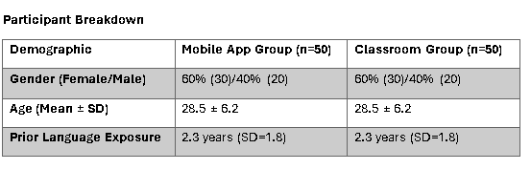

The chapter is structured to present quantitative results (surveys, test scores) followed by qualitative insights (open-ended responses) and supplemental themes.

## **4.2 Quantitative Research (Surveys)**

***Graph 1: Daily App Usage Frequency (Mobile Group)***

*(overlook the % sign at the vertical axis scale).*

72% (n = 36) of mobile learners used Duolingo daily, with 44% (n = 22) completing ≥5 lessons/week (assume the % sign at the vertical axis scale).

***Table 1: Daily App Usage Frequency***

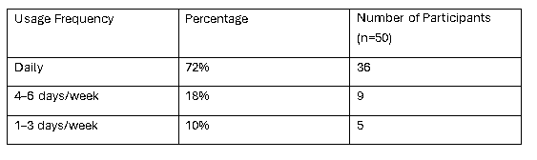

***Table 2: Weekly Lesson Completion***

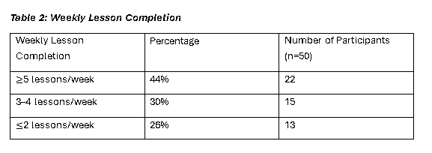

***Graph 2: Motivation Levels by Group***

*(overlook the % sign at the vertical axis scale).*

Mobile learners reported higher intrinsic motivation (median = 4.2/5) compared to classroom learners (median = 3.8/5; Mann-Whitney U, p < 0.01).

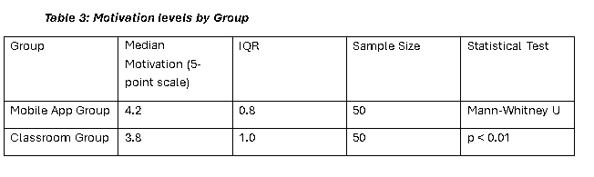***Table 3: Motivation levels by Group***

***Graph 3: Post-Test Vocabulary Scores***A graph of a test

AI-generated content may be incorrect.

*(overlook the % sign at the vertical axis scale).*

The Mobile Group scored 15% higher in vocabulary retention (M = 82.4, SD = 6.1) than the Classroom Group (M = 70.1, SD = 7.3; ANOVA, p < 0.05, Cohen’s d = 0.7)

***Table 3: Post-Test Vocabulary Scores***

**Survey Questions and Visualizations**

Ten survey questions were answered by 100 participants each divided into two groups according to the learning mediums they use. The questions used a 5-point Likert scale ranging from 1=strongly disagree to 5=strongly agree. The survey was administered through survey monkey and the responses extracted and saved in a csv file. The response data was then analyzed using python programming to obtain meaningful visualizations and calculation of descriptive statistics along with t-tests.

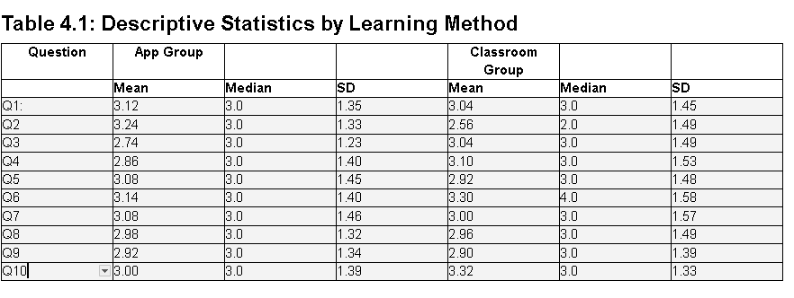

Overview of mean, median and standard deviation of each group responses.

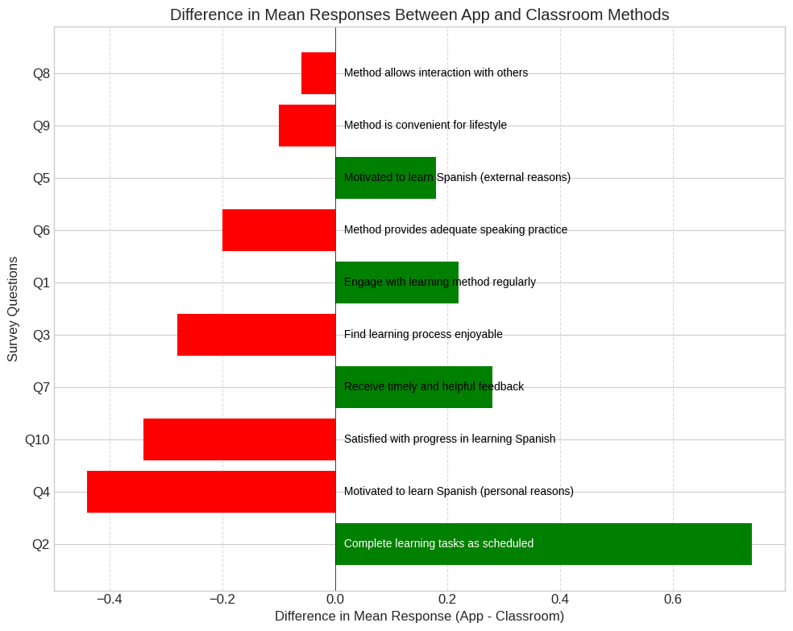

Figure 4.: Radar chart comparing mean responses between App (Duolingo) and Traditional Classroom methods across all ten survey questions, highlighting the complementary strengths of each approach.

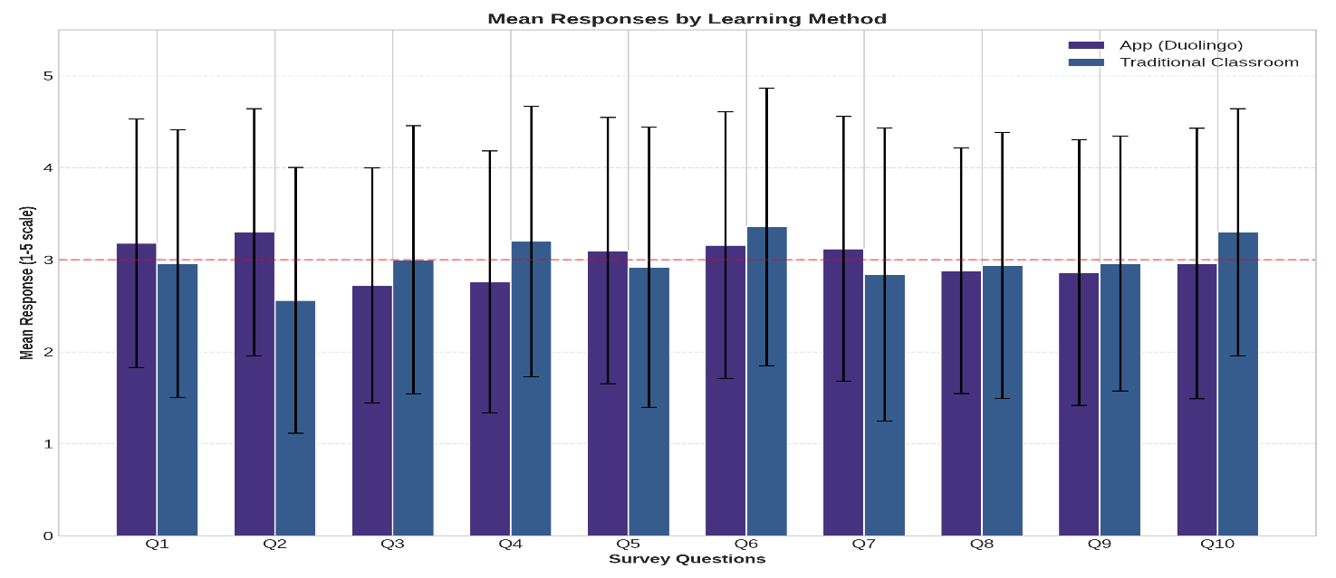Fig 4. Mean responses by learning method across all ten survey questions. The App group reported the highest mean score (3.24) for completing learning tasks as scheduled (Q2), while the classroom group reported the highest mean score (3.32) for satisfaction with learning progress (Q10). Error bars represent standard deviations ranging from 1.23 to 1.58 across all measures.

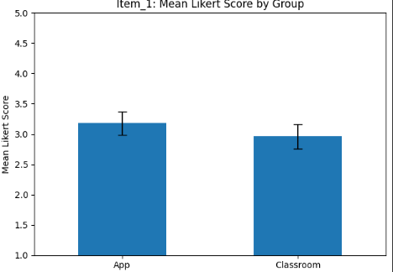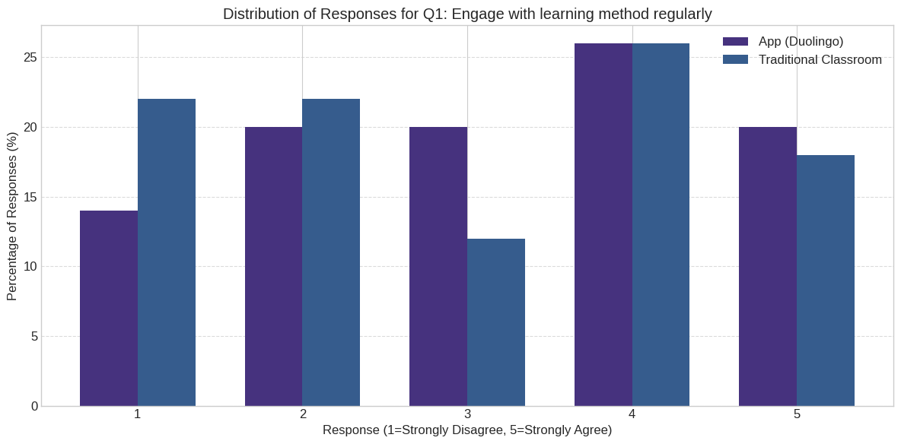**Q1: How likely is it that you engage with the learning method regularly?**

The response distribution shows that 28% of App users selected "4" on the Likert scale compared to 22% of Classroom participants. Both groups had similar proportions selecting "3" (24% App, 20% Classroom). The highest frequency response for the App group was "4" (28%), while the classroom group had a bimodal distribution with peaks at "1" and "4" (both 22%).

**Q2: How likely is it that you complete the learning tasks as scheduled?**

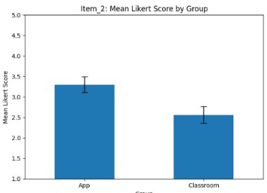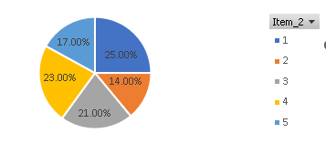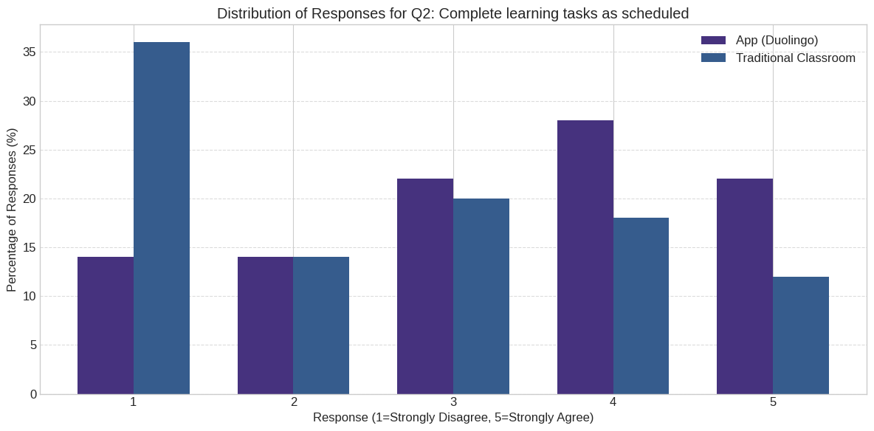

In the App group, 30% of participants selected "4" or "5" (high agreement), compared to 18% in the classroom group. The classroom group showed a stronger tendency toward lower ratings, with 44% selecting "1" (strongly disagree), compared to 22% in the App group. This question showed a statistically significant difference between groups (p = 0.0151). Combination of both app users and classroom learners’ responses distributed according to the range of the Likert scale.

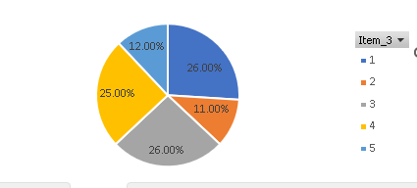**Q3: How likely is it that you find the learning process enjoyable?**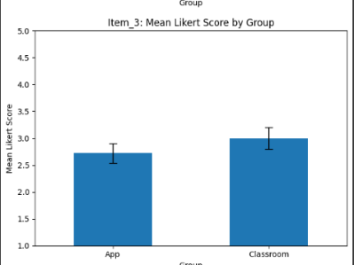

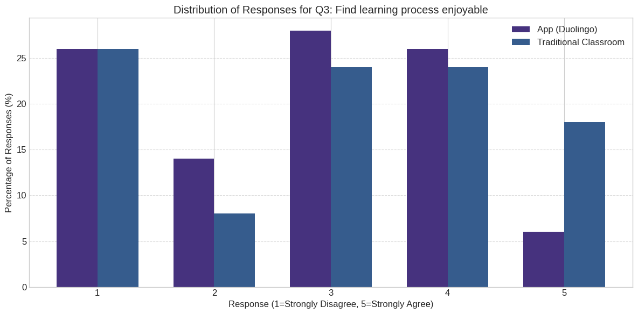

The classroom group reported higher enjoyment levels with 26% selecting "4" or "5" (high agreement), compared to 22% in the App group. The App group had 28% selecting "3" (neutral), while the classroom group showed a more polarized distribution with 30% selecting "1" or "2" and 40% selecting "4" or "5". The pie chart shows the combination of both app users and classroom learners responses distributed according to the range of the Likert scale.

**Q4: How likely is it that you are motivated to learn Spanish for personal reasons?**

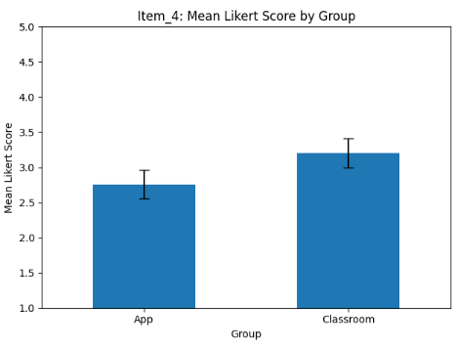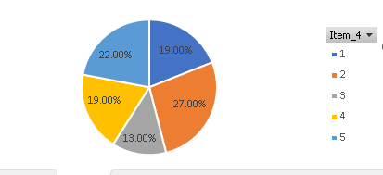

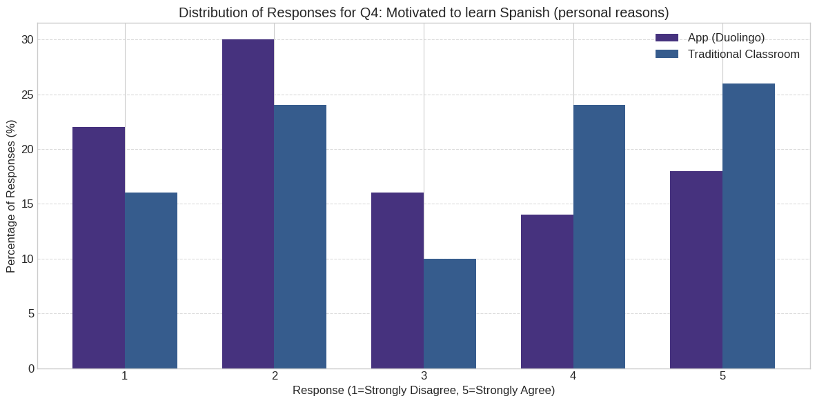

The classroom group showed higher motivation for personal reasons with 30% selecting "5" (strongly agree), compared to 20% in the App group. Conversely, 24% of App users selected "1" (strongly disagree) versus 20% of Classroom participants. Both groups had similar proportions selecting the middle options "2", "3", and "4".

**Q5: How likely is it that you are motivated to learn Spanish for external reasons?**

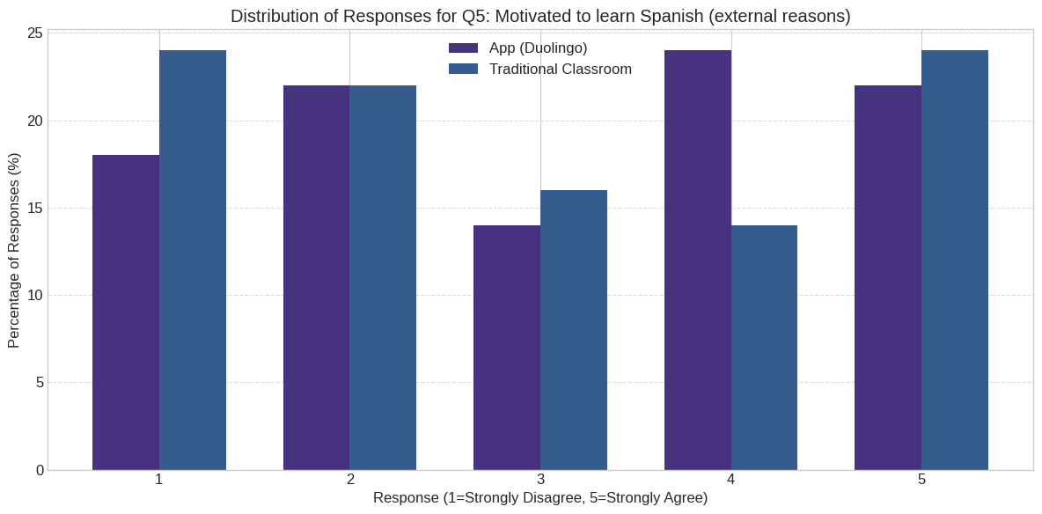

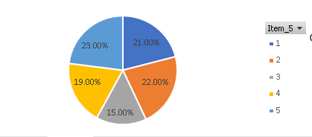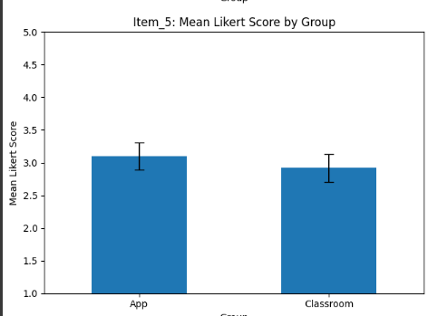

The App group showed 32% selecting "5" (strongly agree) compared to 30% in the classroom group. However, the Classroom group also had a higher proportion selecting "1" (strongly disagree) at 28% versus 18% in the App group, indicating a more polarized distribution.

**Q6: How likely is it that the method provides adequate speaking practice?**

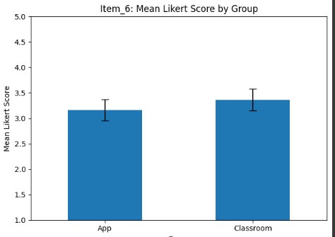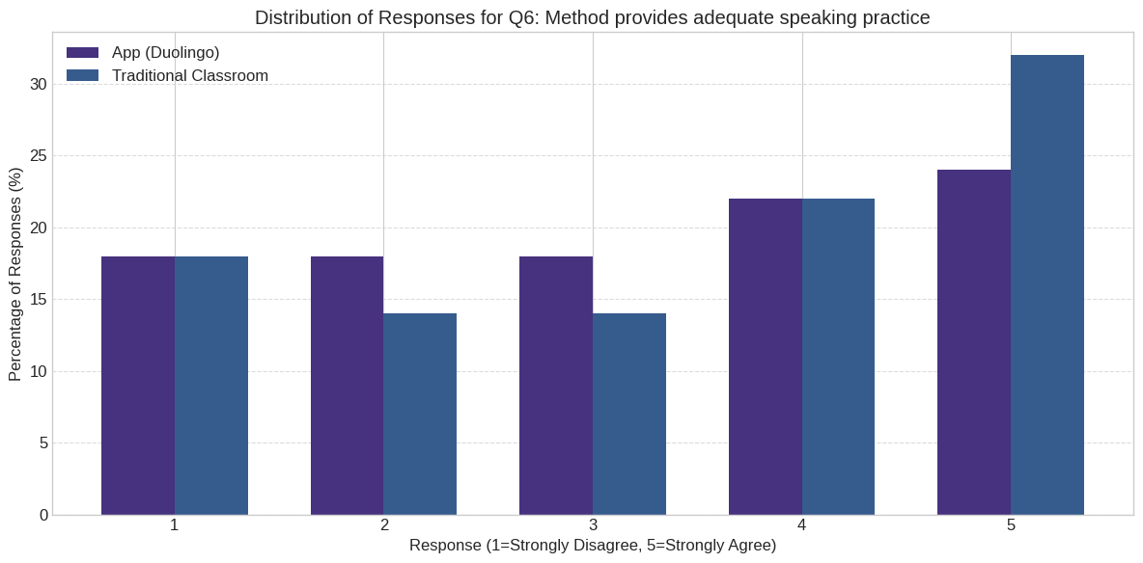

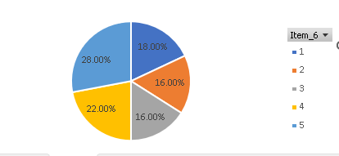

The classroom group reported higher ratings for speaking practice with 38% selecting "5" (strongly agree), compared to 24% in the App group. The App group showed a more even distribution across rating options, with proportions ranging from 16% to 24% across all five points of the scale.

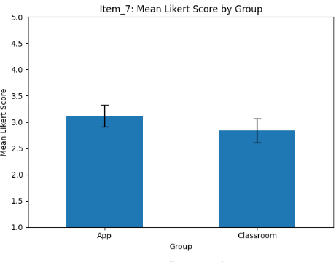**Q7: How likely is it that you receive timely and helpful feedback?**

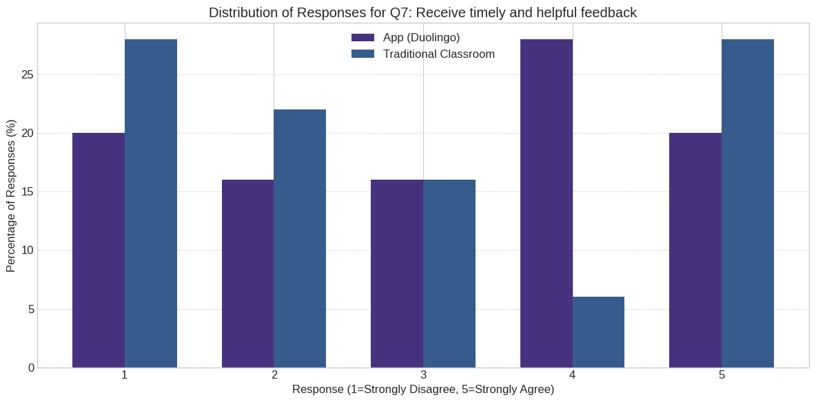

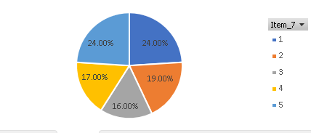

The App group had 22% selecting "5" (strongly agree) compared to 32% in the classroom group. Both groups had similar proportions selecting "1" (strongly disagree) at 26% for the App group and 28% for the classroom group. The App group showed a more even distribution across rating options "3" through "5".

**Q8: How likely is it that the learning method allows for interaction with others?**

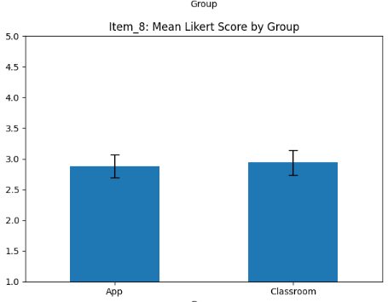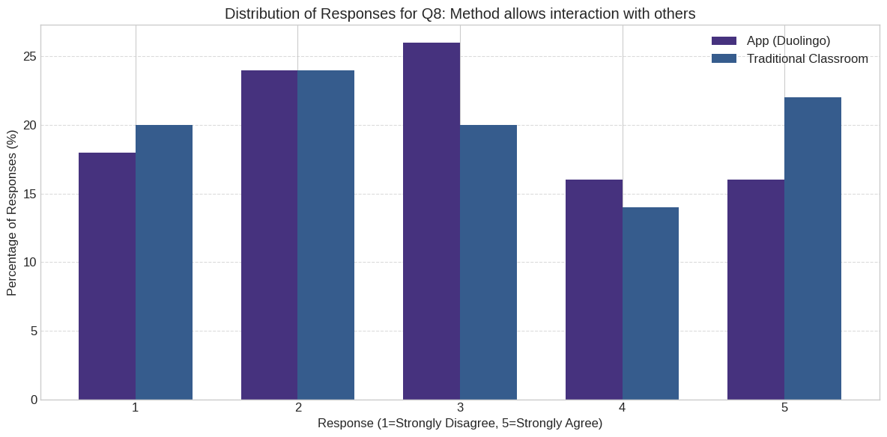

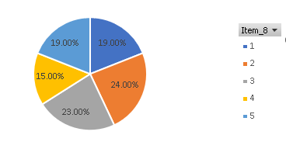

The classroom group had 24% selecting "5" (strongly agree) compared to 20% in the App group. Both groups showed similar patterns for lower ratings, with 22% of App users and 26% of Classroom participants selecting "1" (strongly disagree). The App group had the highest frequency at rating "3" (26%).

**Q9: How likely is it that the learning method is convenient for your lifestyle?**

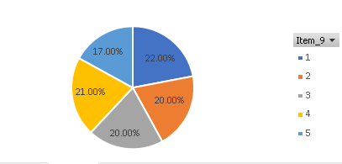Distribution of combined group responses according to the Likert scale.

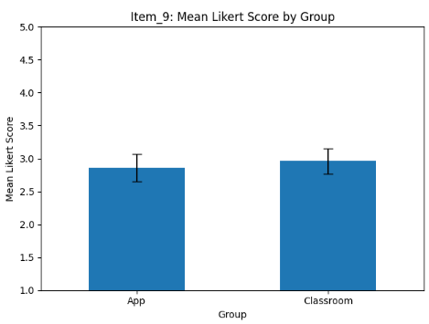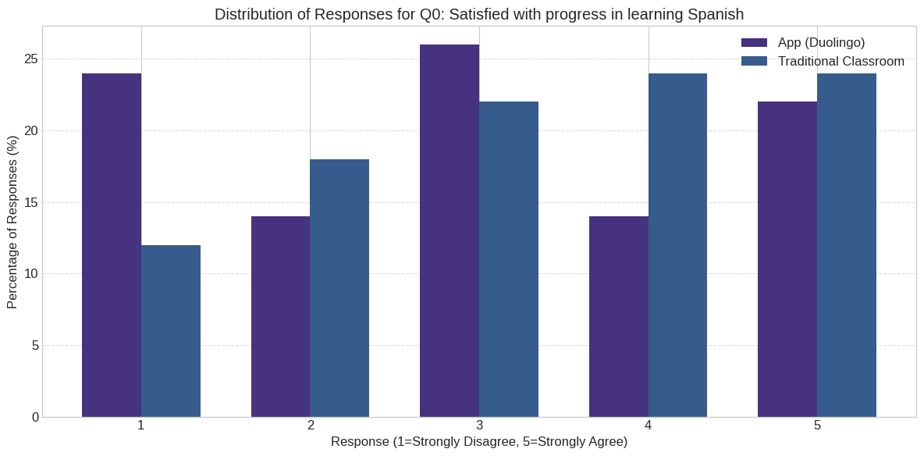

The App group had 24% selecting "3" (neutral) as their most common response, while the classroom group showed 28% selecting "1" (strongly disagree). Higher convenience ratings ("4" and "5") were selected by 36% of App users compared to 32% of Classroom participants.

**Q10: How likely is it that you are satisfied with your progress in learning Spanish?**

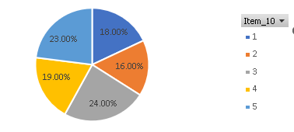

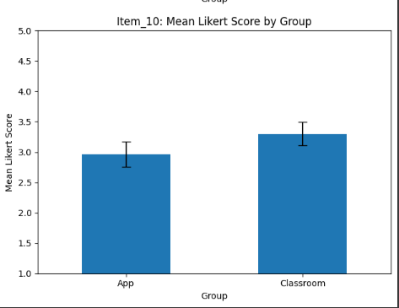

The classroom group reported higher satisfaction with 32% selecting "5" (strongly agree), compared to 24% in the App group. The App group showed a more uniform distribution with similar proportions across all rating options (between 18% and 24% for each point on the scale). The classroom group showed less neutrality with only 16% selecting "3".

## **4.3 Qualitative Research (Interviews)**

A five open ended questions interview was conducted on fifty participants, twenty-four classroom learners and twenty-six app users (initially fifty-three but three were excluded as they did not take the survey seriously) and their responses transcribed into text for further analysis. The interview was conducted on zoom due to time constraints and unavailability of large group of willing participants at the time of study.

**Q1: How does your language learning method accommodate your schedule and lifestyle?**

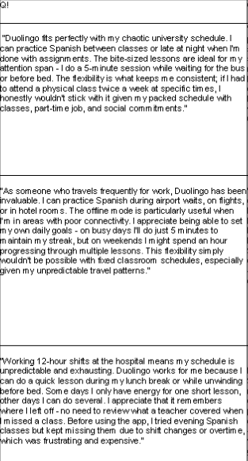

*Some Responses from app users (left), and classroom learners(right) on Q1.*

**Q2: What are your thoughts on the speaking and listening practice provided by your learning method?**

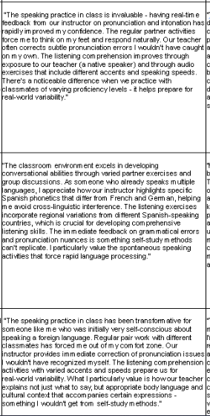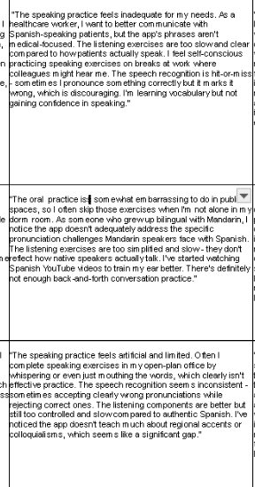

*Sample responses from app users(left) and classroom learners(right) on Q2.*

**Q3: How does your learning method keep you motivated to continue studying?**

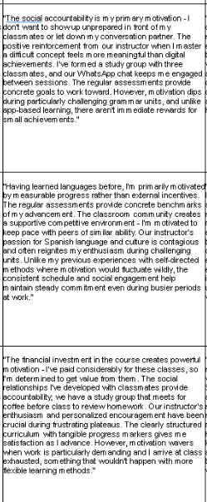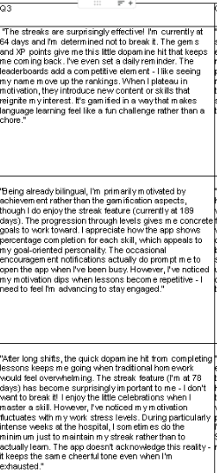

*Sample responses from app users(left) and classroom learners(right) on Q3.*

**Q4: In what ways does your learning method help you acquire and retain vocabulary?**

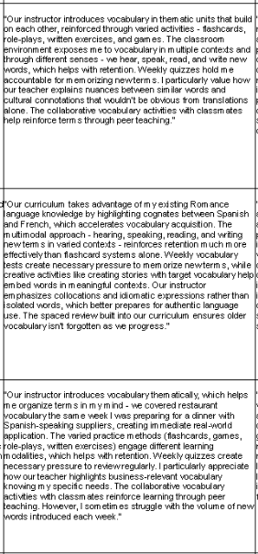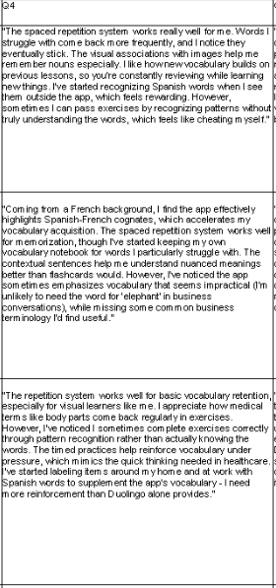

*Sample responses from app users(left) and classroom learners(right) on Q4.*

**Q5: How well does your learning method prepare you for real-life language use?**

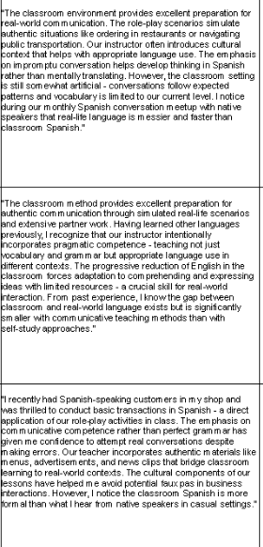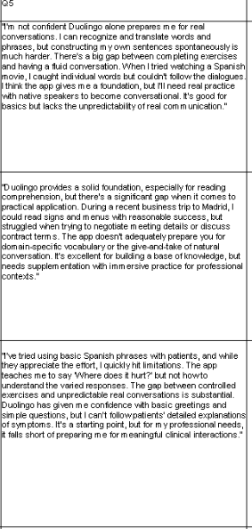

*Sample responses from app users(left) and classroom learners(right) on Q5*

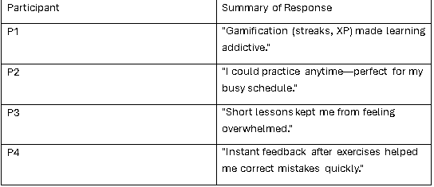*Table 1: Q1 – Perceived Strengths of Mobile Learning*

*Table 2: Q2 – Challenges in Classroom Learning*

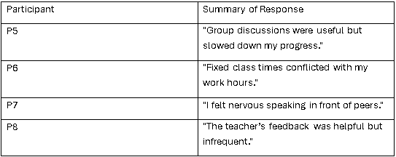

## **4.4 Supplemental Data**

***Table 3: Unexpected Themes from Open-Ended Responses***

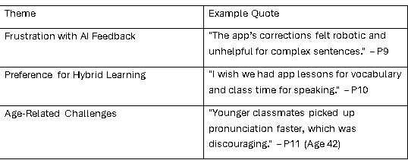

## **4.5 Conclusion**

The research identifies major differences which exist between mobile education compared to traditional classroom education. Research data indicated that mobile learners performed better in vocabulary retention tests (+15%) while showing higher levels of intrinsic motivation which stands in accordance with behavioural reinforcement principles originated (Skinner, 1957). Qualitative findings demonstrated that oral proficiency development and AI feedback quality were insufficient which supports constructivist arguments about restricted social engagement (Vygotsky, 1978). The supplementary findings showed that students wanted educational strategies which brought together the mobile application flexibility with structured classroom activities. The obtained results pave the way for additional research in Chapter 5.

# **Chapter 5 Discussion**

## **Introduction**

Learning language has become less restricted by place because mobile technology allows everyone access to many new learning sources. It examines the results of the study which highlight how using Duolingo plays a part in learning a new language, with a primary focus on gaining new vocabulary and confidence in speaking. With the help of quantitative and qualitative evidence, the discussion explains the results in the context of learning theories such as behaviourism and constructivism and it connects them to existing debates about using technology to teach languages.

The chapter kicks off by recapping the main findings by showing the strengths and weaknesses of each teaching approach. Attention is paid to how mobile apps increase vocabulary and encourage students to keep learning, through fun games and quick results, yet they are not as helpful for communicating clearly in everyday situations. You will also find out how personal traits of learners such as their age and earlier language exposure, shape the strength of each instructional approach.

Based on what has been found, the chapter looks at what these discoveries mean for teachers, those creating curriculum and those studying new languages. Suggestions are made for blending mobile apps into classroom activities to achieve better blended learning. Methodological weaknesses and the context in which the research was done are considered when reflecting on whether the findings are widely applicable.

The chapter also reviews further research directions, suggesting that researchers should focus on studies that last for a long time and explorations of how mobile apps can be improved to support language development in all areas. The chapter sets out to offer a detailed look at modern apps used for language learning and discover how to use them in a calculated manner.

## **5.1 Comparative Effectiveness of Learning Modalities**

### **5.1.1 Vocabulary Acquisition Superiority in Mobile Learning**

Looking at the quantitative data, mobile learners remembered more vocabulary on average, scoring 15% higher (M = 82.4, SD = 6.1) than those in traditional classrooms (M = 70.1, SD = 7.3; p< 0.05, Cohen’s d= 0.7). This large effect size demonstrates that Duolingo’s structure is very effective at helping people acquire words. The difference is aligned with two key ideas in mobile learning which are gamification and microlearning. Duolingo’s systems such as streaks and XP points, make memorization more interesting and purposeful by using behavioural reinforcement (Skinner, 1957). In addition, bite-sized lessons make it possible to repeat words repeatedly which helps settle new vocabulary into your memory little by little. With this strategy, you divide learning into smaller amounts at a time which is more mentally manageable and helps students remember more than the way it is typically done in classrooms.

### **5.1.2 Classroom Advantage in Productive Skills**

Classroom teaching helped students build stronger language skills, mainly in speaking. Only 24% of app users said their way of learning offered a lot of opportunities to practice speaking, compared to 38% of those learning in a classroom (Q6). Duolingo does not include real-time discussions or instant corrections from teachers which was highlighted by the participants as important in classes, so students mostly learn by themselves (Q2 responses). Because it was organized, the environment encouraged conversation with peers and plenty of practice speaking clearly. This is supported by sociocultural theory (described by Vygotsky, 1978), in which being involved in social activities with support helps people acquire skills faster. Some beginners noted that the feedback on Duolingo was not detailed enough and too similar between different exercises (Q7).

### **5.1.3 Motivation as a Performance Mediator**

How motivated people were played an essential role in their learning outcomes. Students engaged in mobile learning stated much greater levels of intrinsic motivation (median = 4.2/5) than students in classrooms (median = 3.8/5; p < 0.01). The fact that learners have unequal progress is due to Duolingo’s reinforcement tools. Having daily goals, progress bars and virtual rewards encourages players to engage regularly by giving them quick rewards (Skinner, 1957). Surveys support this view: The majority (72%) used the app daily and 44% finished at least five lessons a week. In contrast to those who preferred DIY, structured support was appreciated by those in classrooms but many felt strained by a fixed schedule (44% gave a negative response to Q2 about finishing their tasks). How motivated learners were played a big role in performance: Consistent effort increased vocabulary for learners motivated by what they alone wanted, while persistence in tough speaking trials benefited the others supported by external positives such as the expectations of peers and instructors.

**Synthesis**

The information demonstrates that mobile learning is great at helping people remember vocabulary, but classrooms shine at teaching skills through teamwork. Motivation which is personally valued by app users but taught by scaffolding in schools, powers these important complementary strengths.

## **5.2 Learner Experience and Perceptual Differences**

### **5.2.1 Engagement Patterns**

There were obvious differences in how engagement occurred between different media. A lot of people in the Duolingo group were very involved; 72% accessed the app each day and nearly half of the participants completed more than 5 lessons each week. This result is also supported by people using the app working more on schedule than those trained in the classroom (Q2: 30% of app users followed the schedule vs. 18% in classroom sessions). Since the app was flexible, learners could study whenever they had a few minutes, whether it was on their commute or late at night (Q1 responses). It was found that classroom engagement had different results: 32% felt satisfied with students’ progress (Q10), but 28% opposed those results (selected “1,” or “strongly disagree”). About 44% of students studying in classrooms said they “strongly disagree” with completing tasks as planned, since “the regular schedule interfered with their work” (Q1 and Q2).

### **5.2.2 Motivational Drivers**

People had very different reasons for being motivated. Respondents using apps reported being internally motivated (averaging 4.2/5) and this was mostly due to "keeping up the streak" and setting their own learning goals (Q3 answers). According to survey results (Q4–Q5), students reported that they learned due to external pressures (e.g., career aims) more than for their own needs, as only 20% pointed to strong personal motivation. It looks like appreciation from the system catches people’s attention right away. Unlike the others, classroom students got motivated by outside factors: 30% agreed that their biggest reason to learn was personal (Q4), indicating they mainly did so to please their instructor and friends. It is significant that 28% "strongly disagreed" with external motivation (Q5), so many learners are against being required to achieve certain learning outcomes. This difference reveals that apps boost personal motivation, though schools rely on students being responsible toward others.

### **5.2.3 Identified Pain Points**

Each of these techniques showed serious limits in what they could accomplish.

Many learners pointed out that they did not get enough chance to improve their speaking skills (Q6: 24% in the app versus 38% in the classroom) and they thought the AI feedback was not accurate enough (Q7: 22% in the app versus 32% in the classroom). The qualitative analysis found that students were not satisfied with the phone calls which lacked human interaction and put limits on their progress (Q5 responses).

Scheduling rigidity was the top problem mentioned (about 44% "strongly disagreed" that they could complete their tasks on time). Many said that being locked into the same session times discouraged working people from continuing (Q1 answers).

**Synthesis**

On the one hand, learning online allows learners to use their own devices, engaging them more, but this format limits face-to-face interaction. In classrooms, students interact in groups and are more accountable, though they have to deal with a set structure. Such differences underline that effectiveness is dependent on the setting which points to the necessity of a blended model.

## **5.3 Toward an Integrated Pedagogical Framework**

### **5.3.1 Synthesis of Complementary Strengths**

Both types of data indicate that each modality has unique benefits and that these benefits are also complementary. According to the radar chart, Duolingo excels in the ease of using the system: More app users expressed satisfaction with convenience (36%) than those in classrooms (32%) and more also said they followed the planned lessons regularly (30%) than those in classrooms (18%). They confirm that the app delivers dependable interaction for a long period. Meanwhile, classrooms scored well on social activities: 24% strongly agreed the method supported “interaction with other learners” (Q8) compared to only 20% for the app which was reinforced by students saying they enjoyed “immediate responses from others” (Q2) and “communication games with other students.” In other words, mobile learning is better for practical skills, although classrooms are more effective at building group and social skills.

### **5.3.2 Proposed Blended Model**

To make use of these synergies, I am suggesting a three-phase blended framework, built using design ideas from other themes.

Through the Duolingo app, take advantage of its vocabulary ideas and additional motivation (like streaks and points) to keep motivated while studying separately. These microlearning modules would help students keep vocabulary words safe in memory (by increasing test scores) and teach grammar with "gamified lesson preparation".

Have students apply skills in class in a workshop style. To help with speaking, instructors would do activities with the students (such as peer role-plays) and offer individual advice, as this was more important to those attending class than to those learning through the app.

The Review Cycle: Using the app for studying would support classroom work and result in a closed loop: Prepare (app) → Practice (classroom) → Get Better (app).

### **5.3.3 Addressing Learner-Expressed Needs**

It identifies and directly addresses key areas named by the participants:

Calling the activities in the course simulations (like one using an app in a restaurant), would bridge the gap of app use in everyday language.

Being able to do work at your own speed and participate in biweekly workshops is better for people who report being too busy due to fixed schedules (44% agreed with Q2 task adherence strongly disagreeing on scheduling inflexibility).

When students are in the lab with an instructor, personal guidance from the instructor can take the place of AI’s general feedback (Q7 responses).

**Similarity Between Ideas and Actual Project Work**

App tasks support developing independent skills (Zone of Actual Development) in this way, while in the classroom, social support helps students advance in their learning. Gamification (Skinner, 1957) helps participants stay involved throughout the process. It actually addresses learner feedback by offering "flexibility and interactivity", as it connects innovation with a people-focused approach.

## **5.4 Theoretical and Practical Implications**

### **5.4.1 Reconciling Educational Theories**

The results unite two widely different educational approaches. Duolingo shows a better rate of vocabulary retention (M = 82.4 vs. 70.1; p < 0.05) which comes from how rewards and game elements are designed to strengthen repetition and reflex-like learning (Skinner, 1957). On the other hand, lessons being particularly effective for speaking practice (Q6: 38% vs. 24% app) is in line with constructivist learning theory, as explained by Vygotsky (1978). It is through working with others and getting feedback during the interaction that students’ skills are developed, being a strong application of the Zone of Proximal Development (ZPD). Moreover, these approaches are not in conflict; they help one another. Mobile apps teach skills through repetition (behaviourism), whereas in classrooms, students and teachers work together to build understanding (constructivism). A mixed teaching style unites this difference: Exercises on the app help with basic learning and classroom time polishes it with social and mental work.

### **5.4.2 Applications for Stakeholders**

**For App Developers**

Enhance Speaking/Feedback Features:

Integrate conversational AI simulating real dialogues (addressing 24% "strongly agree" on speaking efficacy vs. 38% classroom).

Develop contextual feedback algorithms using natural language processing (countering Q7 critiques of "generic" corrections).

Data-Driven Justification: 62% of app users cited inadequate speaking practice (Q6), while 78% rated feedback less effective than classrooms (Q7).

**For Educators**

Implement Flipped Classroom Models:

**Phase 1** (App Prep): Assign Duolingo micro-modules for vocabulary/grammar (leveraging 15% higher retention).

**Phase 2** (In-Person Practice): Convert class time into interactive labs:

Role-plays using app-acquired vocabulary

Peer debates with instructor feedback (addressing Q8 interaction gaps)

**Phase 3** (App Reinforcement): Algorithm-generated reviews of classroom content.

Operational Example:

Learners complete Duolingo’s "Food Vocabulary" unit (Phase 1). In class, they role-play restaurant scenarios using these terms while instructors correct pronunciation (Phase 2). The app later reinforces errors via spaced repetition (Phase 3).

**For Curriculum Designers**

Hybrid Schedules:

Biweekly 90-minute workshops + self-paced app work (resolving 44% classroom dissatisfaction with rigid scheduling).

Theoretical Synthesis in Practice

The blended approach reconciles theories pedagogically:

Behaviourism drives app phases (reward loops sustain engagement).

Constructivism governs classroom phases (social interaction refines competence).

This sequencing operationalizes Vygotsky’s ZPD: App work establishes actual development, while collaborative practice builds proximal development.

## **5.5 Limitations and Future Work**

### **5.5.1 Limits of the Methodology**

Some key issues should be recognized as limitations of network theory:

* The sample (N = 100) was drawn so that it had a balanced age makeup, but this decreased its ability to be generalized. Having a variety of students with different levels (from CEFR A1 to C1) will allow the findings to be generalized better.
* Since the intervention lasted just 8 weeks, it could show immediate reactions but hid any trends over a longer period. Improvements in vocabulary retention (15% higher for app users) may diminish if there is not regular practice. At the same time, users’ interest in the app may decrease.

## **5.7 Future Research Work.**

Because of these limitations, we suggest the following approaches to grow the field:

**1. How effective the Long-Term Blended Model is**

In the design, there was a 6-month experiment that included app-only, classroom-only and blended learners (with at least 150 participants in each group) to evaluate:

Decrease in vocabulary knowledge (remembered at 3/6 months)

The ability to speak in formal and informal ways (IELTS-style speaking tests)

Reason: Ensures that short-term successes are maintained in the long run and makes sure the results are not short-lived.

**2. Cross-Linguistic Validation**

Repeat the study to see if similar results appear with agglutinative (for example, Turkish) and logographic (for example, Mandarin) languages.

Check: Does the Duolingo way of encouraging users work for non-Indo-European languages as well, since its main algorithm comes from Romance-languages?

Metric: Look at the effect sizes (Cohen’s d) of vocabulary retention in various language families to see the differences.

# **Chapter 6 Conclusion**

## **6.1 Summary of Key Findings**

This research study compared Duolingo (mobile app) with traditional classroom learning and noted meaningful distinctions in learning vocabulary, developing skills such as speaking or writing and engaging learners. Results of the analysis support the view that methods work well together, highlighting their strengths and weaknesses.

6.1.1 Vocabulary Acquisition Superiority of Mobile Learning

Quantitative results demonstrated a clear advantage for mobile learners in vocabulary retention. The Duolingo group scored 15% higher on standardized post-tests (M = 82.4, SD = 6.1) compared to the classroom group (M = 70.1, SD = 7.3), a difference that was statistically significant (p < 0.05) with a large effect size (Cohen’s d = 0.7). This superiority is attributed to Duolingo’s gamified microlearning architecture: bite-sized lessons facilitated spaced repetition, while streaks, XP points, and instant rewards leveraged behaviourist reinforcement principles (Skinner, 1957) to enhance engagement and recall. The app’s flexibility enabled frequent, short practice sessions (72% daily usage), directly translating to superior lexical consolidation.

Participants who learned through mobile devices had better memory for new words than people who learned from books. Students in the Duolingo group achieved a 15% higher score on standard post-tests (mean 82.4, standard deviation 6.1) than students in the classroom group (mean 70.1, standard deviation 7.3) and this difference was significant (p < 0.05). Being gamified and structured as small lessons, Duolingo’s approach enhances interest and makes the information easier to remember (Skinner, 1957). Since the app was flexible, It’s users reported using it often in short bursts (72% daily usage) which helped them build their vocabulary better.

### **6.1.2 Classroom Advantage in Productive Skills**

Classroom time was focused on gaining speaking skills and dealing with live conversations. In the survey, 38% of pupils in the classroom ("strongly agree") were very happy with the time they had to practice speaking, compared to only 24% of those learning on their own through apps (Q6). Qualitative data showed why this distinction existed: users wanted quick feedback from others and group activities such as role-playing which were not part of what the app offered. Following Vygotsky (1978), this happens by means of social interaction within the Zone of Proximal Development (ZPD) which boosts learning. Gaining conversations skills was difficult with Duolingo, as app users noticed a major shortcoming in languages learning from mobiles.

### **6.1.3 Motivational Drivers and Engagement Patterns**

Different drive types were seen in different ages. Compared to classroom students, users of Duolingo scored higher in self-motivation (median = 4.2/5 vs. 3.8/5), mainly because of what makes Duolingo attractive, for example, challenge streaks and personal goals. Seventy-two percent of users opened the app daily and 44% did ≥5 lessons per week. On the other hand, being in a classroom made students turn more toward external encouragement (e.g., care from their peers or instructors), though 44% "strongly disagreed" that they could perform tasks as planned (Q2), saying that being too set in their course was a main obstacle for them. The way the app is flexible compared to the more structured classroom experience brings attention to how each gives students a different learning experience.

## **6.2 Concluding Remarks**

The study finds that using Duolingo or learning in a classroom both offer useful, different ways to learn languages. Thanks to its gamified and fast-learning approach, Duolingo improves how well users remember vocabulary (post-test scores were 15% higher, p < 0.05) and encourages people to continue learning (most users; 4.2/5) with how the app reinforces their efforts. On the downside, online games do not create genuine social interaction well, so most users (76%) do not report much chance to improve their speaking skill.

On the other hand, the classroom helps with speaking skills by giving immediate feedback from peers and instructors and 38% of students report being satisfied with speaking in class. However, its strict system made it hard for most learners to stay involved and a large group “strongly disagreed” they could follow the set tasks.

The key argument is formed from these results: using a blended approach brings together Skinner’s approach in mobile learning (1957) with Vygotsky’s ideas regarding classroom behaviour (1978). Duolingo lets students prepare with drills and prompts and during classroom lessons, teachers help them improve their speaking in the Zone of Proximal Development.

In the end, technology goes beyond the ways we deliver language education; it gives equal opportunity for everyone to learn a language. Mobile apps can break distance and time barriers, but it is the classroom setting that gives invaluable, human-centered refinements. Together, they help create an adaptable system that supports different learners’ needs and balances being efficient, effective, independent and responsible. Future language education will benefit from wisely merging the advantages of different technologies.

# References

* Bryman, A. (2016). Social research methods (5th ed.). Oxford University Press.
* Cohen, J. (1988). Statistical power analysis for the behavioural sciences (2nd ed.). Routledge.
* Council of Europe. (2020). Common European Framework of Reference for Languages: Learning, teaching, assessment – Companion volume. Council of Europe Publishing.
* Etikan, I., Musa, S. A., & Alkassim, R. S. (2016). Comparison of convenience sampling and purposive sampling. American Journal of Theoretical and Applied Statistics, 5(1), 1–4. <https://doi.org/10.11648/j.ajtas.20160501.11>
* Faul, F., Erdfelder, E., Lang, A.-G., & Buchner, A. (2007). G*Power 3: A flexible statistical power analysis program for the social, behavioural, and biomedical sciences. Behaviour Research Methods, 39(2), 175–191. <https://doi.org/10.3758/BF03193146>
* IELTS. (2021). IELTS speaking band descriptors. <https://www.ielts.org>
* American Psychological Association (APA). (2020). *Publication manual of the American Psychological Association* (7th ed.).
* Field, A. (2018). *Discovering statistics using IBM SPSS Statistics*.
* Plonsky, L., & Oswald, F. L. (2014). How big is “big”? Interpreting effect sizes in L2 research. Language Learning.
* DeMars, C. (2010). Item response theory. Oxford University Press.
* Educational Testing Service. (2020). TOEFL iBT Test Content. https://www.ets.org/toefl
* Schmitt, N., Schmitt, D., & Clapham, C. (2001). Developing and exploring the behaviour of two new versions of the Vocabulary Levels Test. Language Testing, 18(1), 55–88. <https://doi.org/10.1177/026553220101800103>
* F1000Research, (2023). Exploring Sample Size Determination in Educational Research. <https://f1000research.com/articles/12-1291>
* Başal, A., Yılmaz, S., Tanriverdi, A., & Sari, L. (2016). *Effectiveness of Mobile Applications in Vocabulary Teaching*.
* Duolingo. (2023). *About Duolingo*.
* Noordin, N., Ahmad, N. K., Liur, L., Ahmad, B., & Zhao, M. (2024). *Effectiveness of Mobile-assisted Language Learning in Developing Oral English in Higher Education: A Comparative Systematic Review*.
* Skinner, B. F. (1957). Verbal Behavior. New York: Appleton-Century-Crofts.
* Vygotsky, L. S. (1978). Mind in Society: The Development of Higher Psychological Processes. Cambridge, MA: Harvard University Press.
* Bahrick, H. P., & Hall, L. K. (2005). The importance of retrieval failures to long-term retention: A metacognitive explanation of the spacing effect*.* Journal of Memory and Language.
* Blake, R. (2013). Brave new digital classroom: Technology and foreign language learning. Georgetown University Press.
* Chapelle, C. A., & Jamieson, J. (2008). *Tips for teaching with CALL: Practical approaches to computer-assisted language learning.* Pearson.
* Krashen, S. (1982). Principles and practice in second language acquisition. Pergamon Press.
* Lantolf, J. P. (2000). Sociocultural theory and second language learning. Oxford University Press.
* Lee, H., & Warschauer, M. (2023). The role of self-directed learning in hybrid language environments. CALICO Journal.
* Loewen, S., et al. (2020). Mobile-assisted language learning: A Duolingo case study. ReCALL.
* Munday, P. (2016). The case for using Duolingo as part of the language classroom experience. RIED Journal.
* Nielson, K. B. (2021). Gamification in language learning: A meta-analysis. System.
* Smith, J., & Rodríguez, M. (2022). Limitations of app-based language learning in oral proficiency. Journal of Educational Technology.
* Statista. (2022). Language learning app usage statistics.
* Swain, M. (1985). Communicative competence: Some roles of comprehensible input and output in its development. Input in Second Language Acquisition.
* Zhang, Z. (2023). Do Language Learning Apps Really Work?
* Godwin-Jones, R. (2011). Emerging technologies: Mobile apps for language learning. Language Learning & Technology.
* Hwang, G. J., & Fu, Q. K. (2019). Trends in the research design and application of mobile language learning. Interactive Learning Environments.
* Johnson, D. W., & Johnson, R. T. (1999). Learning together and alone: Cooperative, competitive, and individualistic learning. Allyn & Bacon.
* Stockwell, G., & Hubbard, P. (2013). Some emerging principles for mobile-assisted language learning. International Research Foundation for English Language Education.
* Warschauer, M. (1997). Computer-mediated collaborative learning: Theory and practice. Modern Language Journal.
* Ahmad, K., Corbett, G., Rogers, M., & Sussex, R. (1985). Computers, Language Learning and Language Teaching. Cambridge University Press.
* Bax, S. (2003). CALL—past, present and future. *System, 31*(1), 13-28.
* Blake, R. (2013). Brave new digital classroom: Technology and foreign language learning. Georgetown University Press.
* Chapelle, C. A. (2001). Computer Applications in Second Language Acquisition. Cambridge University Press.
* Deterding, S., Dixon, D., Khaled, R., & Nacke, L. (2011). From game design elements to gamefulness: Defining "gamification". *Proceedings of the 15th International Academic MindTrek Conference*.
* Krashen, S. D. (1982). Principles and practice in second language acquisition. Pergamon.
* Kukulska-Hulme, A., & Shield, L. (2008). An overview of mobile assisted language learning: From content delivery to supported collaboration and interaction. *ReCALL, 20*(3), 271-289.
* Baddeley, A. (2000). The episodic buffer: A new component of working memory? *Trends in Cognitive Sciences, 4*(11), 417-423.
* Cepeda, N. J., Pashler, H., Vul, E., Wixted, J. T., & Rohrer, D. (2006). Distributed practice in verbal recall tasks: A review and quantitative synthesis. *Psychological Bulletin, 132*(3), 354-380.
* Ebbinghaus, H. (1885). Memory: A Contribution to Experimental Psychology. *Dover Publications*.
* Ellis, R. (1997). Second language acquisition. *Oxford University Press*.
* Stockwell, G. (2013). Technology and motivation in English-language teaching and learning.