**1. How an ERP system can be used to manage the full supply chain process.**

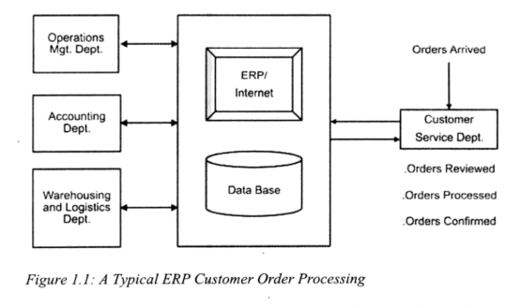In order to meet the deadline of 4 weeks, producing 10,000 units of Product A requires the company to closely manage both its internal output and what is purchased externally. Systems such as SAP S/4HANA, Oracle Fusion and Microsoft Dynamics 365 gather data from procurement, manufacturing and logistics to provide a clear overview of how the organization works. Below are the ways through which ERP systems handle each step of the supply chain process for this order.

**1. Planning & Scheduling**

Historical sales data and the number of current orders can be analysed by ERP systems to determine and manage the needed number of raw materials for plastic granulate, steel blocks and electrical components. For example:

* The MRP (Materials Requirements Planning) part of Design Suite’s software prepares a detailed list of components using the bill of materials (BOM) for Product A, so nothing is missed during injection molding or machining process.
* With capacity planning tools, resources are effectively assigned, to ensure proper deadline management, making sure all work is handled in the 4-week time space, with evenly distributed shifts to balance the workload.
* Up-to-date visual tools and summary dashboards integrated into ERPs let you notice if milestones are not met, facilitating managerial decision making and operational adjustments in response to the dynamic variables.

**2. Procurement Management**

Procurement for plastic granulates, steel blocks and electrical items is much easier for Supplier A, Supplier B and Supplier C respectively, through the use of ERPs.

* Automatic Purchase Orders: They are formed when the stock gets low, so employees don’t have to keep checking stocks thus reducing risks of human err.
* Following up on Supplier Work: Provides updates on supplier progress to ensure that Supplier A, B and C are on time with deliveries and work to the agreed price range to meet quality requirements and expected output.
* Contract Management ensures transparency of both the supplier and the organisation and enforces accountability to so that the customer receives a high-quality product as per the guidelines stated in the contract.

**3. Inventory Control**

Real-time inventory tracking prevents stockouts and overstocking:

* Allows stock tracking in real time stopping the organization from running out of stock or having too much inventory.
* WMS, warehouse management system, modules oversee tracking of both raw materials (plastic granulate), as well as Work-In-Progress items during the machining process.
* Externally procured materials from suppliers can be traced from manufacture to assembly thanks to batch tracking which cuts down on mistakes.
* If the production line, in context, ends up using up a resource (e.g. electrical components) against the predicted forecast, then auto-replenishment from Supplier C starts automatically.

**4. Production Execution**

ERPs bring together different internal tasks in an automatic and cohesive manner. In context,

* When using Injection Molding, plans work depending on the availability of molds and materials being ready.
* Machining: Distributes CNC machines to work on steel blocks, guided by gathered IoT sensor reports of tool wear for maintenance notices.
* The next stage is assembly, where priority is given to meeting daily goals thanks to barcode scanners feeding data to the ERPs on the use statistics of components.

**5. Quality Assurance**

Having QM, quality management, modules in place ensures all the rules are adhered to.:

* Defect Tracking: Detects oddities in parts and right away sends rework orders with no disturbance to other workflow stages.
* Supplier Quality Analytics assesses supplier products (e.g. Plastic granulates from Supplier A to ensure it is consistent and therefore low scrap levels). The process certifies that all the externally procured components Supplier are in top condition and backed by publicly available checks (e.g. Supplier C’s electrical components backed by approval from related regulators.

**6. Method Planning and Delivery Process.**

* Thanks to ERP, shipments are delivered promptly and with surprising precision due to availability of core information shared between the suppliers, the organization and customer through the system
* Organises carriage within approved budget and by necessary standards and organizes transportation priorities to ensure on-time delivery.
* Invoices, packing lists and forms for custom clearance are all automatically generated to keep deliveries on time.
* GPS in the vehicle communication system gives live updates, so managers are alerted if a diversion route is needed.

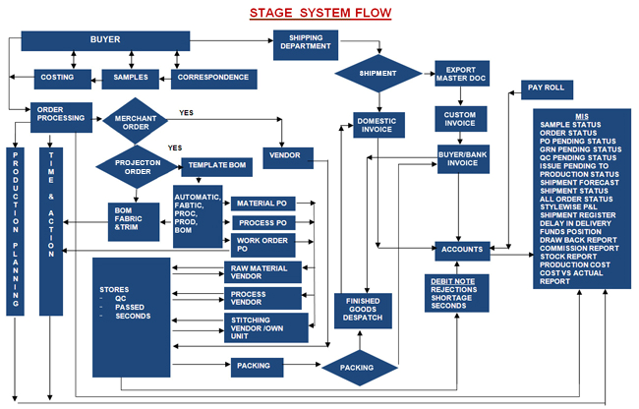**2. ERP modules required at each stage and rationale behind their use.**

Work flow diagram of an Enterprise

**1. Order Initialization: Sales & Distribution.**

**Key Activities:**

* Confirming and getting each customer’s order.
* Checking if the framework agreement is valid.
* Approval of the agreed upon mode and time of delivery.

**Modules of an ERP system needed and rationale:**

* Sales and Distribution (SD) module - Follows the current framework agreement when placing a call-off order.
* Customer Relationship Management Module (CRM): The system uses CRM to keep track of how it has interacted with each customer and what they prefer to buy.
* Master Data Management Module – Has access to basic information about customers and products. Stores the product master catalogue.

**Stage 2, Material Requirements Planning (MRP).**

**Key Activities:**

* A 10,000-unit Bill of Materials (BOM) explosion.
* Checking if items are in stock.
* Finding the net power required.

**Required ERP Modules.**

* By using MRP (Material Requirements Planning) module, the organisation can calculate the net needs for all components from one place.
* Inventory Management - Looks over the current levels of plastic granulate, steel blocks and electrical components kept in stock.
* Production Planning establishes when and how much need to be produced by the company.

**Stage 3: Procurement (purchasing) and Vendor Management**.

**Key Activities:**

* The need for a purchase order is documented by a process called purchase requisition generation.
* Choosing who to buy from and preparing the orders
* Managing when packages will be delivered

**ERP Modules Needed:**

* Materials Management module (MM) - Looks after how external components are purchased
* Vendor Evaluation is used to measure how up to standard a supplier is and their ability to deliver.
* Purchase Order Processing module - Creates and manages the purchase of goods from Suppliers A, B and C.

**Stage 4 Scheduling and Organization of the Production Process.**

**Key Activities:**

* Extensive planning of all parts of production
* Planning how much work a specific work center can handle
* Internally created job orders

**What Modules are Required and Rationale?**

* Production Planning’s (PP) responsibility is to plan the detailed schedules used during production.
* Capacity Requirement Planning (CRP) - ensures there is enough capacity available for making plastic parts through molding, machining and assembly.
* Work tracking and organizing product creation are part of Shop Floor Control module functionalities.

This process covers planning the sequence in which manufacturing will happen. i.e.

* Materials need to be accepted and checked when they are received.
* Work carried out in the injection molding process.
* Machining processes.
* Component assembly.
* Inspection, organization and packaging at the end.

**Stage 5 Inventory and Warehouse Management.**

**Key Activities:**

* Getting materials and then storing them.
* Work-in-process items tracking.
* Steps taken for managing finished goods.

**ERP Modules needed:**

* WMS module helps improve the ways items are both kept and retrieved.
* Inventory Management - Keeps track of what has been shipped, received and the stock available.
* Quality Management - Responsible for overseeing proper quality of incoming materials.

**Stage 6 Production Execution.**

**Key Activities:**

* Carrying out manufacturing production.
* Making sure the product is of high quality.
* Overseeing production as it gets done.

**The ERP Solution includes the following modules as necessities:**

* Controls and tracks the activities occurring in the production area with a Manufacturing Execution System (MES)
* Quality Management (QM) deals with handling quality control work and keeping records from it
* Ensuring equipment is available and does not fail is the main aim of maintenance management.

**Stage 7 Shipping and Logistics (Operations Management)**

**Key Activities:**

* The sending and packaging of orders.
* Transportation planning.
* Delivery coordination.

**Modules required include:**

* SD - Takes care of providing goods and shipping when orders are made.
* Transportation Management module - Ensures the best route plans are used and gets the product to customers by managing carriers.
* Document Management module - Generates both documents needed for shipping and for Customs.

**Stage 8: Financial Integration and Reports Generation**

**Key Activities:**

* Working on reports that track and explain costs.
* Invoice processing.
* Financial reporting.

**ERP Modules Needed:**

* Financial Accounting (FI) - covers all the information about financial transactions.
* Controlling (CO) module - It focuses on studying the costs and income earned in the company.
* Accounts Payable/ Receivable - Deals with offices payments to suppliers and with sending bills to customers.

**3. Key Data Entries Required at Each Process Step.**

|  |  |  |
| --- | --- | --- |
| Step | Data |  |
| Order Initialization | -Customer ID  -Delivery Address | -Sales Portal (Sales Department), CRM system. |
| -Framework Agreement Number | -Framework Agreement Database. |
| -Product ID  -Order Amount  -Delivery Deadline  -Quality Specifications | -Product Master Catalogue  (Master Data Management module) |
| Materials Requirements Planning. | -Bill of Materials (BOM):  -Product: Product A;  -Amount of Component Items required per product. i.e. Plastic Granulate, Steel Block, Electric Component.  . | -Materials Requirement Planning Module  -WMS |
| -Current Stock Levels. | -Inventory Planning |
| -Time to Acquire Materials from suppliers A, B $ C. | -Supplier Master Data and performance based on previous interactions |
| Procurement and Vendor Management | -Requisition Number  -Required Delivery Dates  -Cost | -MRP |
| -Requesting Department | -Production Planning |
| -Supplier Data i.e. ID, Product Supplied, , Contact No, Payment Details | -Vendor Management DB |
| Purchase Order Data i.e. Total Amount, Unit price, Delivery deadline, Quality Requirements. | -Active Contracts and Price Lists.  -Terms & Conditions. |
| Production Planning Process and Scheduling | -Work centre data i.e.  Injection Molding, Machining Centre, Assembly Line. (Production Frequency, Setup time, runtime) | -Manufacturing Engineering Database |
| -Production order data i.e. start date - end date  Resource Assignment details  Quality Check stats | -Production Planning Module.  -Capacity Planning System |
| Production Workflow from one centre to the next, | -Process Engineering and work flow specifications  -Factory shift patterns and calendar. |
| Inventory & Warehouse Management | -Goods Receipt data:  Material ID’s and Quantities received.  -Storage Locations Assigned according to status (RAW, WIP, Finished Goods) -Quality Inspection Feedback  -Assigning Batch Numbers for categorising products into modular manageable groups/batches. | - Supplier delivery notes  -WMS  -Quality and Management inspection results. |
| Production Execution | Start/End times, machine IDs, output quantity, operator ID. Resource consumption | IoT sensors, MES  Operator manual Input |
| Inspection reviews. | Manual Testing and inspection. |
| Shipping and Logistics | Delivery note, packaging list, transporter ID, shipment tracking number, Transport vehicle ID, Freight costs | -Transportation management integration.  -Original Customer requirements. |
| Update inventory stock data | WMS |
| Financial Integration and reports generation | -Predicted Costs vs Actual costs  -Supplier Invoice -Customer Invoice | -Actual consumptions and labour confirmations.  -Supplier systems or Electronic Invoicing |

**4. Data will be needed at each stage to support operational and managerial decisions.**

|  |  |  |
| --- | --- | --- |
| Stage | Operational Requirements | Managerial Requirements |
| Order Processing | - Real-time inventory levels.  - Current production schedule utilization  - Supplier delivery performance.  - Quality history with customer. | - Customer profitability analysis.  - Market demand trends  - Capacity utilization forecasts.  - Competitive positioning data. |
| MRP | - Historical consumption patterns.  - Supplier price breaks.  - Storage capacity constraints.  - Scrap rates by operation. | - Total cost of ownership analysis.  - Supplier risk assessments.  - Long-term demand forecasts.  - Investment requirements for capacity expansion. |
| Procurement | - Supplier scorecards.  - Current inventory turnover.  - Purchase price variance trends.  - Quality inspection results. | - Supplier dependency analysis.  - Total procurement spend analysis.  - Market price intelligence.  - Strategic sourcing opportunities. |
| Production Planning | - Equipment Overall Equipment Effectiveness (OEE):  - Setup time optimization data.  - Worker skill matrix and availability.  - Energy consumption patterns. | - ROI analysis for automation investments  - Productivity benchmarking  - Labor cost trends  - Technology upgrade impact assessments |

**5. Digital technologies that can support real-time data gathering for ERP integration and decision-making.**

* IoT Sensors: Monitor how often machines work, record cycle time and oversee temperature inside the holding mold.
* Using a barcode/RFID scanner, all material movement actions are immediately recorded and used while receiving, processing and shipping products.
* AI Forecast Tools - Predict if delays or a shortage of inventory will impact production; help select the most efficient time to produce goods. Act as pre-warning tools.
* Through Digital Twins, the bottlenecks (potential major issues) can be found in advance by simulating the processes of production lines and pre-empting the errors.
* Mobile access to ERP is possible due to cloud integration, as is working remotely with suppliers and teams thus effectively connecting all parties and providing easily accessible mediums of exchange.

**6. How digital supply chain tools help optimize operations and prevent delivery failure.**

* AI is used to notice patterns showing that a machine isn’t working as well as expected or that a vendor is consistently getting unreliable from analysing historical data stored in the respective databases accessible due to ERP systems distributed nature.
* Supplier Portals that provide real-time asynchronous updates on supply or production delays and Advanced Shipment Notifications to update on shipment status and progress.
* A tool in predictive analytics looks at production data to spot potential areas where a deadline may be missed or batches might be faulty.
* 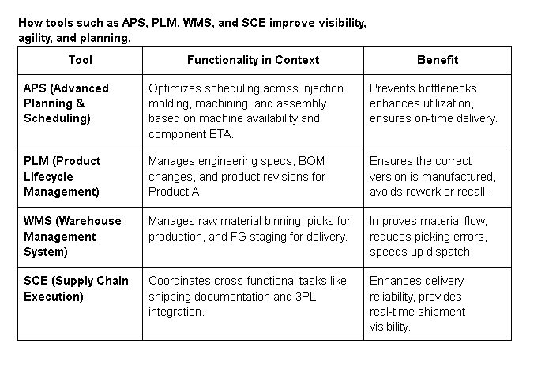ERP systems with real-time information make it possible to move workloads among departments or re-plan shipments when delays appear.

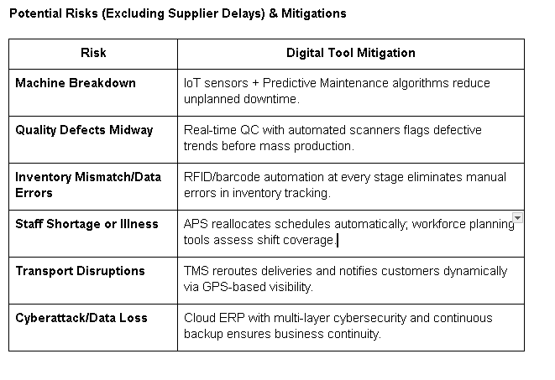Disclaimer.   
I used perplexity ai to summarize the articles on ERP for (SCM) and the role of ERPs in Supply Chain management (“https://www.netsuite.com/portal/resource/articles/erp/supply-chain-management-erp.shtml”)(“https://www.deskera.com/erp-for-supply-chain-management”) and highlight the key points to draw from them. This helped me speed up the whole research process by compressing bulk data into key points and therefore giving me a running start on the report. Grammarly was employed to perform minor editing and grammar checks, but it acted only as a validation tool and a time saver.