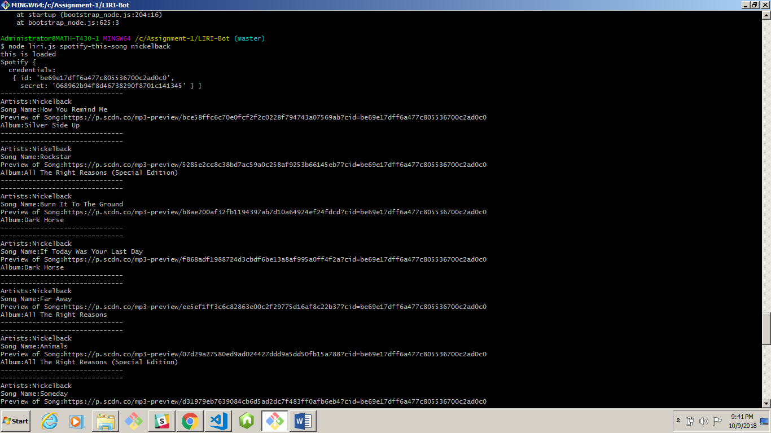

Screenshot for spotifyThis

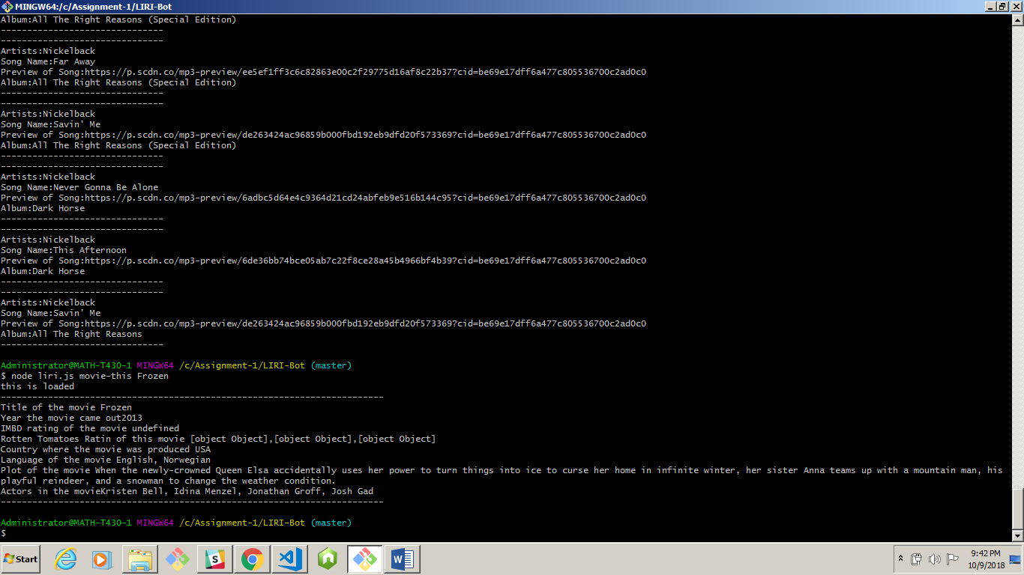

Screesnshot for concert this

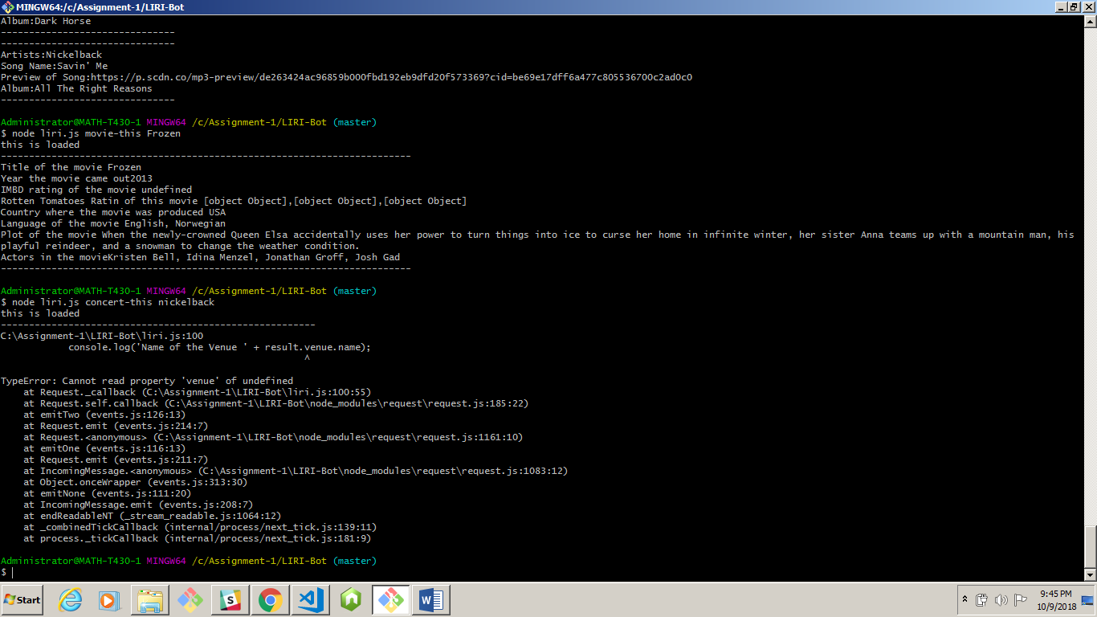

I don’t why its doing this

<http://www.artists.bandsintown.com/events-widget-2#api> documentation

Rest of the details is provided in my readme