Paul Stanton

CS-04605 – Advanced Web Programming

Final Project Part 3

07/20/23

**Backend Implemented with Mongo**

This part will be focusing on implementing the endpoints created in part two and wiring them up to mongo to make them fully functional.

Retro-Templates GET

Here is an example of using the GET endpoints. I have a get by ID and a get all, I can show the usage in swagger as well as the data in mongo.

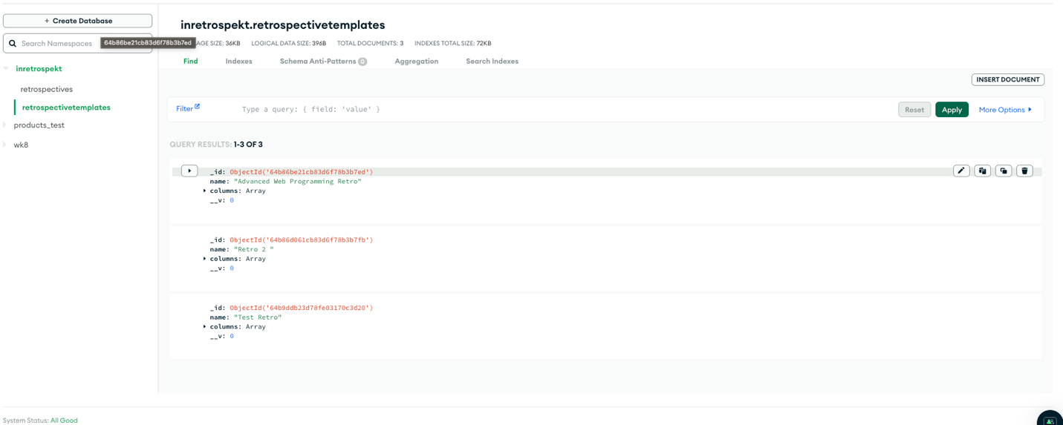

Retro-Templates POST

