Paul Stanton

CS-04605 – Advanced Web Programming

Final Project Screenshots

07/20/23

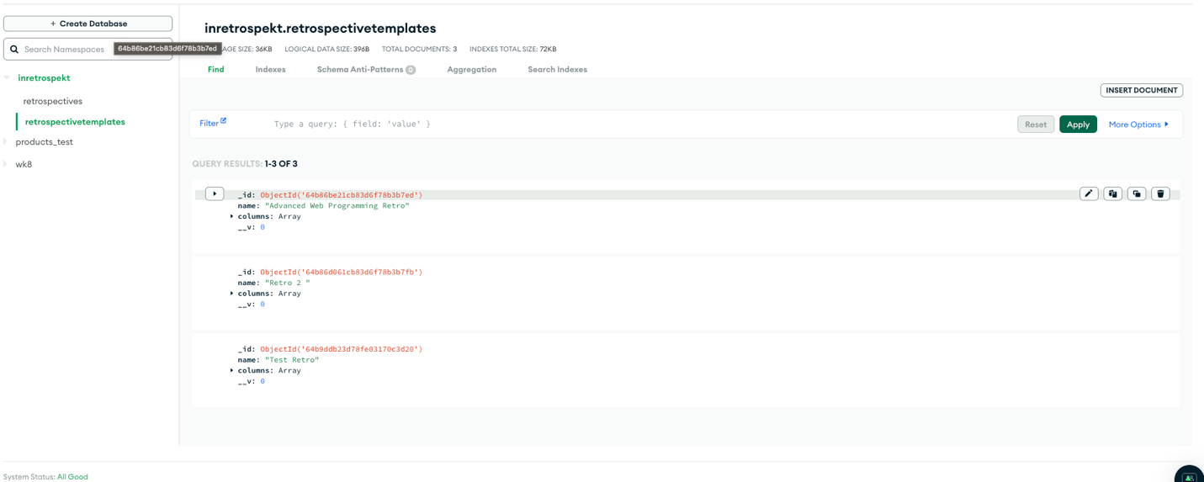

Retro-Templates POST



