HEIMDALL
External Attack Surface Management
for Small and Medium Businesses
──────────────────────────────────────────────────
Angel Investor Business Plan

Prepared by: Federico — Founder
Location: Vejle, Denmark
Date: March 2026
Classification: Confidential — For Intended Recipients Only

Table of Contents
1. Executive Summary
2. The Problem
3. The Solution
4. How It Works
5. Market Opportunity
6. Business Model & Unit Economics
7. Go-to-Market Strategy
8. Competitive Landscape
9. Infrastructure & Scaling Plan
10. Risk Analysis & Mitigations
11. Regulatory & Legal Framework
12. Team & Execution Capability
13. Financial Projections
14. The Ask
15. Why Now?
References

1. Executive Summary
SMB SECURITY GAP  40%  of Danish SMBs lack protection¹ | GOVERNMENT SPENDING  211M kr.  cybersecurity 2026–2029² | STARTING PRICE  199 kr./mo  cheaper than any competitor | BREAK-EVEN  ~10  paying clients

Forty percent of Danish small and medium businesses do not have a security level matching the severity of the threats they face.¹ The Danish government has responded — in January 2026 it allocated 211 million kr. over four years to close this gap.² Meanwhile, every cybersecurity tool on the market delivers findings through technical dashboards designed for security professionals. The restaurant owner with an online booking system running on outdated WordPress does not have a security professional. She has a Telegram account.
Heimdall is an External Attack Surface Management (EASM) service that continuously monitors a business’s public-facing digital surface and delivers findings as plain-language messages through Telegram and WhatsApp. Not a dashboard. A conversation, in Danish, that tells the owner what is wrong, who should fix it, and what to say to that person.
Aggressive Pricing Strategy
Three tiers: Watchman 199 kr./mo, Sentinel 399 kr./mo, Guardian 799 kr./mo (annual: 599 kr./mo). Watchman is cheaper than every competitor’s entry tier — including HostedScan’s paid plan (~215 kr./mo). For a restaurant owner, 199 kr./month is less than a single dinner delivery. Client acquisition starts with a free first scan that produces real findings at near-zero cost.

Current state: The lead generation pipeline is built and operational — 14 Python modules, a 10-agent architecture, a programmatic legal compliance system (Valdí) with two-gate validation and forensic logging, and a complete legal risk assessment. The pipeline has been tested against 353 live Vejle-area domains.
The Ask: 150,000–250,000 kr.
Angel funding to cover legal confirmation, pilot execution, first revenue, and an NCC-DK grant consortium application. The NCC-DK grant pool (5.5M kr., deadline 15 April 2026) fits Heimdall’s profile directly.³

2. The Problem

2.1 The 40% Gap
According to Styrelsen for Samfundssikkerhed, 40% of Danish SMBs lack adequate cybersecurity relative to the threats they face.¹ VikingCloud’s 2026 report found that 60% of SMBs that suffer a major breach close within six months.⁵ The median cost of a data breach for small businesses exceeds $120,000.⁶

2.2 The Compliance Obligation
GDPR Article 32 requires every organisation handling personal data to implement “appropriate technical and organisational measures” to ensure security appropriate to the risk.⁷ A restaurant collecting customer names and phone numbers through an online booking system is a data controller under GDPR. If it runs WordPress 5.8 on shared hosting with an expired SSL certificate and three unpatched plugins, it is not meeting Article 32. It simply does not know this.
NIS2 (effective in Denmark since July 2025) expands mandatory security requirements into the SMB space through supply chain obligations, pulling smaller businesses into compliance scope.

2.3 The Dashboard Gap
Every existing EASM tool delivers findings through web dashboards designed for security teams. The image below shows the difference between what competitors deliver and what Heimdall delivers:
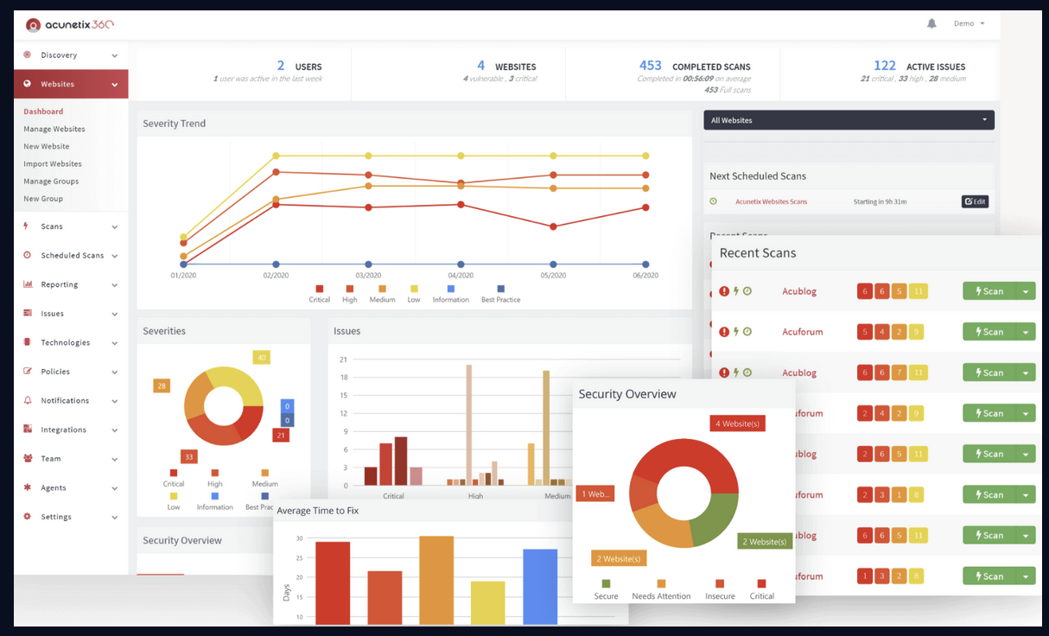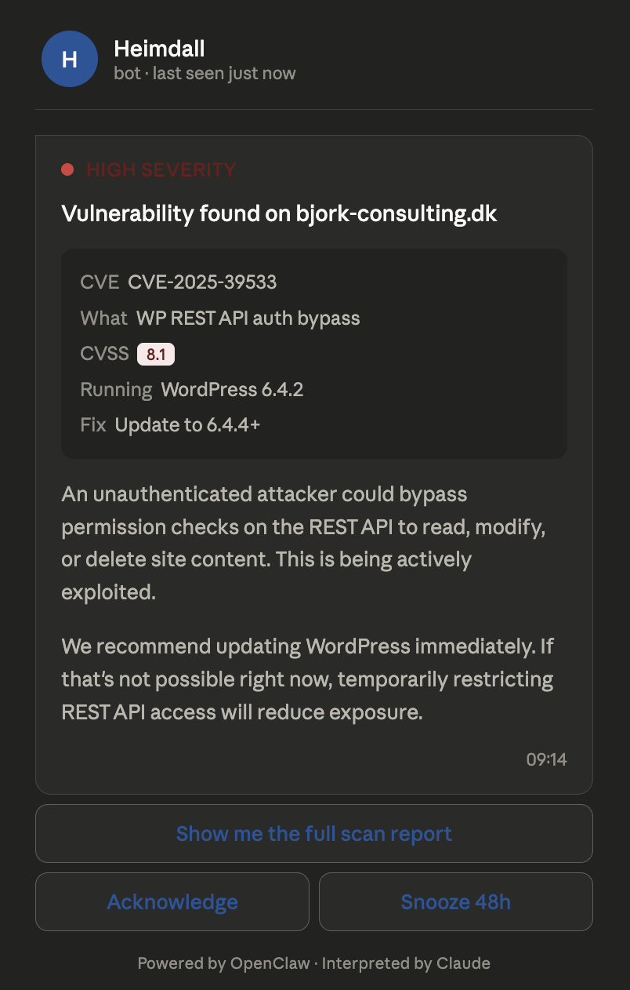
Figure 1. Left: a typical vulnerability scanner dashboard with CVSS scores, QQL queries, and drill-down widgets. Right: Heimdall delivers a plain-language Telegram conversation the owner reads while having their morning coffee.
The market assumes that the buyer of a security product has someone on staff who reads security dashboards. For the 200,000+ Danish SMBs with websites, this assumption fails.

2.4 The “Who Do I Send This To?” Problem
Even when a business owner learns about a vulnerability, the next question is: “What do I do with this information?” Findings without routing are useless — and every existing tool stops at the finding.
Client Scenario | What They Need
Has a web developer | A message they can forward directly to the developer
Self-manages WordPress | Step-by-step wp-admin instructions
Fully hosted (Shopify/Squarespace) | Platform-specific settings guidance
Nobody manages it | A drafted support ticket for the hosting provider

3. The Solution

3.1 Conversational Delivery
Heimdall delivers security findings through Telegram and WhatsApp — the messaging apps the business owner already uses daily. Below is an actual Heimdall message as it appears in Telegram:
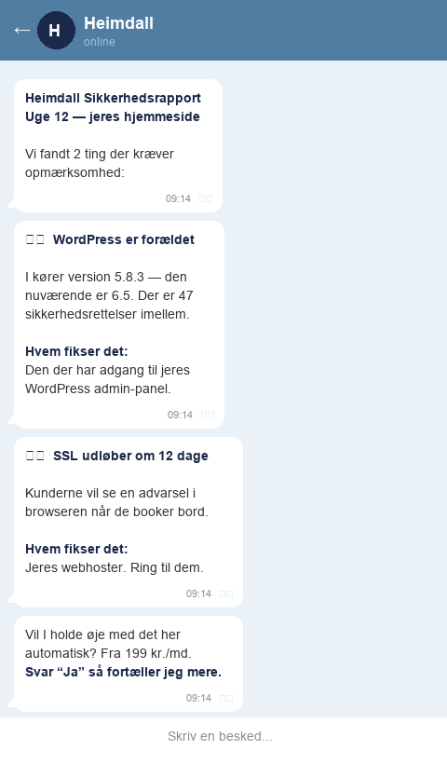
Figure 2. Heimdall security report as it appears in Telegram. Plain Danish, actionable findings, clear routing to the person who should fix each issue. No login portal. No dashboard.

3.2 Persistent Memory and Follow-Up
Heimdall maintains a persistent memory of each client’s technology stack, past findings, and remediation state. Unresolved findings trigger escalating follow-up:
- Week 1: Initial finding delivered with context and routing
- Week 2: Reminder with increased urgency
- Week 3: Escalation with alternative remediation paths
This persistent memory creates a natural switching cost — a new provider rebuilds the client’s security history from scratch.

3.3 Shadow AI and Agent Detection
Over 21,000 OpenClaw instances are publicly exposed, many running agent skills with access to internal tools.¹⁰ Kaspersky identified 512 vulnerabilities in the platform.¹² No SMB-focused security tool scans for exposed AI agent infrastructure. Heimdall does. This is a first-mover position.

3.4 The “First Finding Free” Acquisition Model
Heimdall’s Layer 1 scan reads publicly served information (headers, HTML, DNS, SSL, CMS versions) and produces real findings at near-zero cost. The sales motion is a demonstration, not a pitch:
“We already scanned your website. Your WordPress is three major versions behind, and your SSL certificate expires in two weeks. Heimdall monitors this continuously — starting at 199 kr./month.”

3.5 Service Tiers
Tier | Monthly | Annual | What It Does
Watchman | 199 kr. | — | Finds problems, explains them, tells you who should fix them
Sentinel | 399 kr. | — | Daily monitoring + step-by-step instructions + draft messages to forward
Guardian | 799 kr. | 599 kr./mo | Active testing (with consent) + fix verification + quarterly report

Watchman tells you what is wrong. Sentinel tells you how to fix it. Guardian tests your defences and documents your security posture.

4. How It Works

4.1 The Pipeline
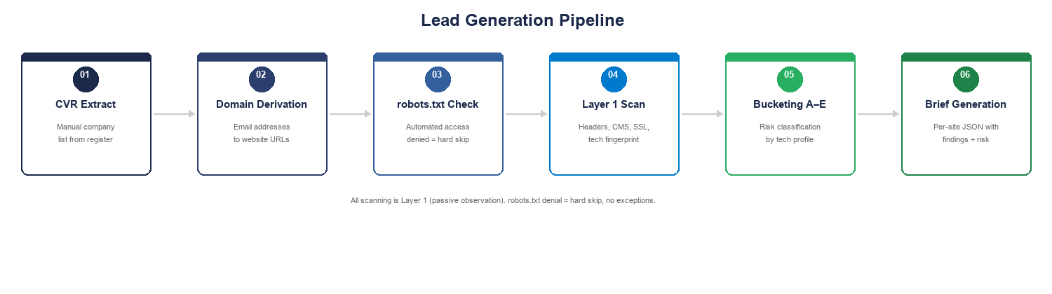
Figure 3. Lead generation pipeline: from public business register data to risk-classified prospect list.

4.2 The Agent Architecture
Heimdall runs on a 10-agent chain, each with a documented specification (SKILL.md) defining responsibilities, boundaries, inputs, and outputs:
Agent | Role
Prospecting | Lead generation pipeline, CVR processing, domain resolution
Scanner | Layer 1/Layer 2 scan execution (tools produce findings)
Interpreter | Claude API — translates raw findings into plain language
Message Composer | Formats findings for Telegram/WhatsApp delivery
Follow-Up | Persistent memory, remediation tracking, escalation
Legal Compliance (Valdí) | Scan validation, forensic logging, approval tokens
Agency Detector | Identifies web agencies from footer credits and meta tags
Brief Generator | Produces per-site technical briefs
Grant & Funding | Grant applications, budget tables, consortium narratives
Reporting | Quarterly security reports (Guardian tier)

Critical Design Principle
Tools produce findings, the LLM interprets them. The scanning tools generate structured technical data. Claude translates that into language the restaurant owner understands. The LLM never decides what is vulnerable — it decides how to explain what the tools found.

4.3 Valdí — The Compliance System
Heimdall operates under Danish criminal law (Straffeloven §263). The legal boundary between permitted passive observation and potentially criminal active probing is enforced programmatically by Valdí:
- Gate 1 — Scan Type Validation: Every scanning function reviewed before execution. Approved functions receive a token; rejected functions are blocked with reasoning.
- Gate 2 — Per-Target Authorisation: Before each batch, Valdí confirms the token is valid and the target’s consent permits the scan’s layer.
No scanning code executes without a valid Valdí approval token. Every review produces a timestamped forensic log.

4.4 Governance Maturity — The Incident
During early development, a function probing admin paths on target domains was identified as crossing the Layer 1 boundary. It had been executed against 353 domains before the violation was caught by the project owner’s manual review.
The response: code removed, all tainted data scrubbed, full code review completed, formal post-incident report documented. Valdí was built as a direct result.
An investor should read this as a strength: the team identifies compliance failures, responds with systemic fixes rather than patches, and documents everything. The forensic log trail demonstrates due diligence.

5. Market Opportunity

5.1 Market Sizing
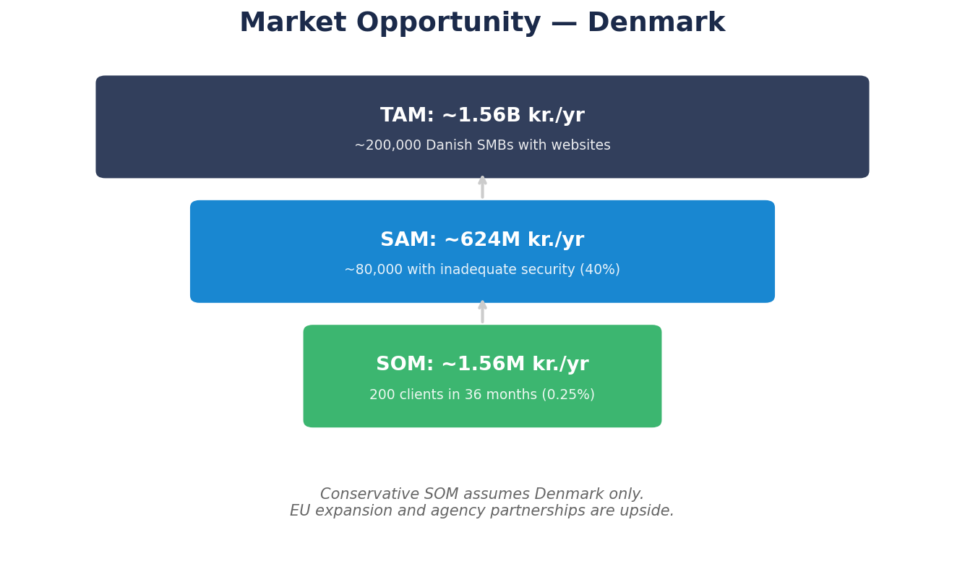
Figure 4. TAM/SAM/SOM for the Danish market. SOM is deliberately conservative at 0.25% of SAM.
The TAM is a theoretical ceiling. The SAM applies the 40% gap statistic. The SOM is deliberately conservative: 200 clients in three years represents 0.25% of the SAM. At the new pricing (blended ~350 kr./mo), SOM = ~840K kr./yr. The upside depends on agency partnerships and grant-funded acceleration.

5.2 Regulatory Tailwinds
Initiative | Amount | Timeline
National Cybersecurity Strategy | 211M kr. | 2026–2029
NIS2 Implementation | 275M kr./year | From 2025
NCC-DK Grant Pool (current) | 5.5M kr. | Deadline: 15 April 2026
NCC-DK Total Budget | 43M kr. | 2026–2029
EU Digital Europe Programme | Up to €60,000/SME | Open calls

5.3 The Expansion Path
- GDPR-first: Built for Danish compliance, translates to all 27 EU member states.
- Small enough to validate: 200 clients in Denmark proves the model.
- Language-agnostic delivery: Telegram/WhatsApp work everywhere. Only the output language changes.
Conservative projections assume Denmark only. EU expansion is upside.

6. Business Model & Unit Economics

6.1 Pricing
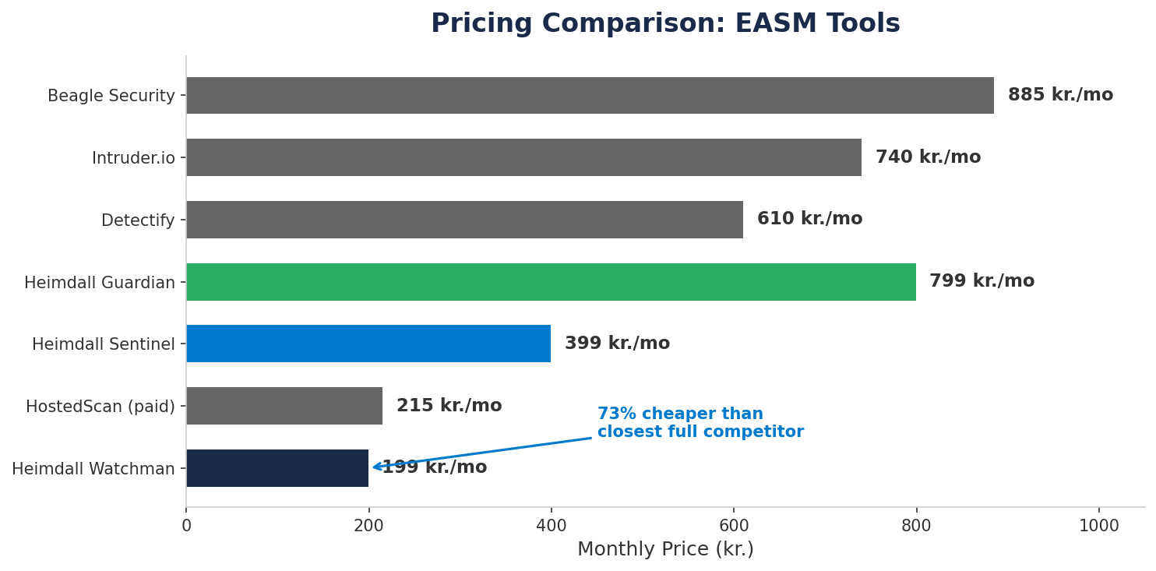
Figure 5. Pricing comparison. Heimdall Watchman at 199 kr./mo is cheaper than every competitor’s entry tier.
Tier | Monthly | Annual Option | Scan Frequency | Key Value
Watchman | 199 kr. | — | Weekly | What is wrong + who should fix it
Sentinel | 399 kr. | — | Daily | How to fix it + drafted messages to forward
Guardian | 799 kr. | 599 kr./mo × 12 | Daily | Active testing + fix verification + quarterly report

Blended average revenue per client: ~350 kr./month (early mix weighted toward Watchman). Increases to ~420 kr./month as tier mix matures.

6.2 Unit Economics Per Client (Monthly, at Scale)
Component | Amount | Notes
Revenue (blended) | ~350 kr. | Weighted average, early mix
Claude API | ~50 kr. | Interpretation + follow-up (lower tiers = less processing)
Infrastructure | ~15–25 kr. | At 50+ clients
Insurance allocation | ~30–40 kr. | Professional indemnity, pro-rated
Total COGS | ~95–115 kr.
Gross margin | ~67–73% | Improves with scale and tier migration

The margin is lower than premium-priced competitors but the pricing creates a fundamentally different market dynamic: 199 kr./mo eliminates price as an objection. The decision barrier is negligible. Volume compensates for margin.

6.3 Acquisition Economics
First Finding Free: The Layer 1 scan costs near-zero. It produces real findings that power a free-sample sales motion. The cost of acquiring a lead is the time spent on the in-person conversation.
Agency partnerships: One relationship with a web agency yields 10–35 client sites. The pitch: “I scanned 35 of your client sites. 22 have issues. Your name is on the footer.”
No paid advertising in Phase 1–3. Danish marketing law prohibits unsolicited electronic marketing without consent. This constraint eliminates the temptation to burn money on outbound.

6.4 Churn
Expected: 30–40% Year 1, declining to 20–25% Year 2+. Realistic for SMB SaaS. At 199 kr./mo, re-acquisition is cheap if a churned client returns. Mitigations: persistent memory as switching cost, agency cohort retention, GDPR compliance value, escalating follow-up.

6.5 Break-Even
Break-Even: ~10 Paying Clients
At ~350 kr. blended revenue and fixed costs of ~2,500 kr./month, break-even occurs at approximately 10 paying clients. At the aggressive pricing, this requires a larger client base than a premium model — but the lower price point makes each conversion significantly easier.

7. Go-to-Market Strategy

7.1 The Marketing Constraint
Danish marketing law (Markedsføringsloven) prohibits unsolicited electronic marketing — email, SMS, automated messages — without prior consent. Additionally, businesses can register as “Reklamebeskyttet” (ad-protected), which prohibits direct marketing contact including phone calls.
This is the single greatest constraint on Heimdall’s growth model. It must be addressed directly, not glossed over.

7.2 The Contactability Constraint — Real Numbers
The Vejle CVR extract contains 995 companies. Here is what happens when we apply the filters:
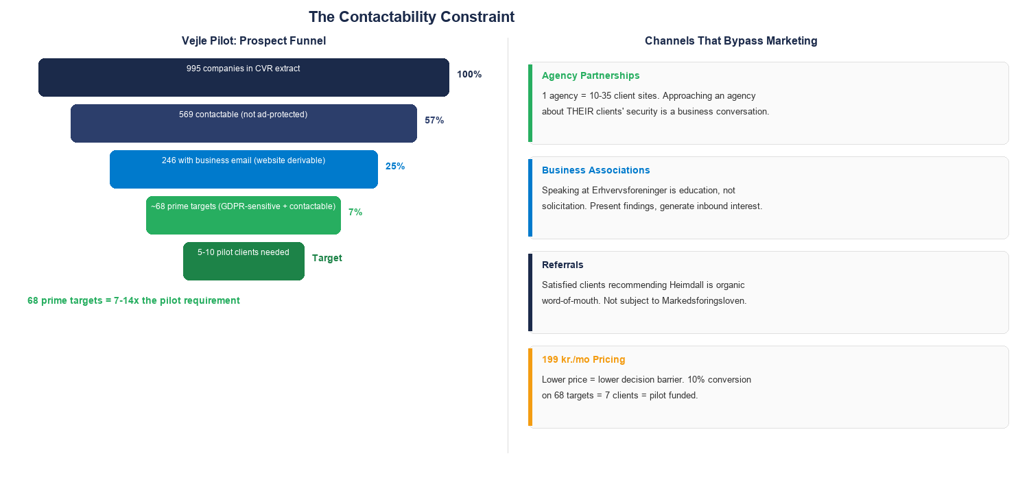
Figure 6. Left: the prospect funnel from 995 CVR companies to pilot targets. Right: four channels that bypass individual marketing restrictions. 68 prime targets is 7–14× the pilot requirement.
The headline number: 68 prime targets (contactable, GDPR-sensitive, with a business domain) in a single small city. The pilot needs 5–10. That is a 7–14× surplus. At 199 kr./mo with a real scan finding in hand, even a conservative 10% conversion rate yields 7 clients — enough for the pilot and approaching break-even.

7.3 Channels That Are Not Marketing
The constraint eliminates cold outreach. It does not eliminate all paths to the client:
- Agency partnerships: Approaching a web agency about the security of sites they built is a business conversation, not marketing. One agency = 10–35 client sites. The pipeline already detects agencies from footer credits and meta tags.
- Business associations (Erhvervsforeninger): Speaking at local business events is education, not solicitation. Present findings, generate inbound interest.
- Referrals: A satisfied client recommending Heimdall is organic word-of-mouth. Not subject to Markedsføringsloven.
- In-person visits to contactable businesses: The 569 non-ad-protected businesses in the Vejle extract can be approached directly with a physical visit and a real scan finding.
The marketing constraint is real. It eliminates the cheapest growth channel (cold email). But it also eliminates that channel for every competitor. The in-person, high-trust model creates a local moat that remote-first competitors cannot replicate.

7.4 Five Phases
Phase | Timeline | Activity | Target
1 — Vejle Pilot | Month 1–3 | 5 clients from 68 prime targets, in-person “first finding free” | Validate delivery model
2 — Agency Partnerships | Month 3–6 | Approach agencies with aggregate scan data from their portfolios | 2 agency partnerships
3 — Local Networks | Month 6–12 | Erhvervsforeninger, speaking events, referral programme | 20 paying clients
4 — Geographic Expansion | Month 12–24 | Aarhus, Odense, Aalborg — same playbook, multiplied pool | 80 paying clients
5 — EU Expansion | Month 24–36+ | GDPR framework translates directly; messaging is language-agnostic | 200 paying clients

8. Competitive Landscape

8.1 Direct Competitors
Competitor | Starting Price | Interface | Shadow AI | SMB Messaging
Heimdall | 199 kr./mo | Telegram / WhatsApp | Yes | Yes
Intruder.io | ~740 kr./mo | Dashboard + Slack/Jira | No | No
Detectify | ~610 kr./mo | Dashboard | No | No
HostedScan | Free / ~215 kr./mo | Dashboard + API | No | No
Beagle Security | ~885 kr./mo | Dashboard | No | No
Sucuri (GoDaddy) | ~1,480 kr./yr | Dashboard + WAF | No | No

Closest competitor: Intruder.io — GCHQ Cyber Accelerator alumni, 1,000+ customers.⁹ Enterprise EASM players (CrowdStrike, Qualys, Censys) are moving upmarket, not down.

8.2 Anticipated Objections
“Why can’t Intruder just add Telegram?”
They could add a notification. But notification is not delivery. Heimdall’s architecture is built around non-technical users — plain-language interpretation, remediation routing, persistent memory, escalating follow-up. Adding a webhook does not replicate rebuilding the product’s communication layer and user model.

“HostedScan is free — why pay 199 kr.?”
If the owner can navigate a dashboard, interpret CVSS scores, and act on findings — HostedScan wins. For the majority who cannot, the dashboard might as well not exist. At 199 kr./mo, Heimdall costs less than HostedScan’s own paid tier while delivering through the channel the owner actually uses.

“This is just a Telegram bot wrapper.”
The scanning tools are commodity. The value is the chain: which findings matter for this specific business, explained in the owner’s language, routed to the right person, tracked over time, with follow-up that escalates until resolved. The bot is the interface; the intelligence is in interpretation and persistence.

8.3 Three Durable Differentiators
- Messaging-first delivery: Not a feature bolted onto a dashboard — the entire product is built around conversational delivery to non-technical users.
- Persistent memory: Longitudinal understanding of each client’s infrastructure creates switching costs that compound over time.
- Shadow AI/agent detection: First-mover position in scanning for exposed AI agent infrastructure that no SMB competitor addresses.

9. Infrastructure & Scaling Plan
Stage | Clients | Infrastructure | Monthly Cost | Cost/Client
Phase 0 (now) | 0 | Laptop (development) | 0 kr. | —
Pilot | 5–10 | Dedicated secure infrastructure + VPN | 175–560 kr. | ~56–112 kr.
Early production | 10–50 | VPS + Docker | 350–700 kr. | ~14–35 kr.
Scale | 50–200 | Multi-container VPS | 700–2,100 kr. | ~10–14 kr.
Growth | 200+ | Multi-node cloud | 2,100–7,000 kr. | ~10–35 kr.

The same agent architecture runs at every tier. Migration from pilot to cloud is an infrastructure change, not an application rewrite. Client-facing language: “dedicated secure infrastructure with encrypted communications.”

10. Risk Analysis & Mitigations

Figure 7. Risk assessment matrix. Seven risks plotted by probability and impact. Colour zones indicate combined severity.
Risk | Prob. | Impact | Key Mitigation
LLM Hallucination | Med | High | Tools produce findings, LLM only interprets. Human-in-the-loop during pilot. Confidence scoring post-pilot.
Legal (§263) | Low | Critical | Valdí two-gate system. Forensic logging. Legal counsel as funded milestone.
Solo Founder | High | High | Network security partner. Claude Code as force multiplier. Knowledge in transferable SKILL.md specs.
Customer Churn | High | Medium | Persistent memory as switching cost. Agency partnerships. GDPR ongoing obligation.
Competitive Response | Med | Medium | Messaging-first requires full rebuild. Local relationships as moat.
Danish Market Size | N/A | Low | Denmark-first = GDPR-first. 200 clients = viable. EU expansion is upside.
Shadow AI Commoditisation | Med | Low | One of three differentiators. 12–18 month first-mover window.

11. Regulatory & Legal Framework

11.1 Straffeloven §263
§263 criminalises unauthorised access to data systems. Heimdall’s position: Layer 1 (reading publicly served information) carries minimal legal risk. Layer 2 (active probing) requires written consent. This maps to the business model: free scan = Layer 1; paid service = Layer 2 with consent.¹⁵ ¹⁶

11.2 GDPR Article 32
Requires “appropriate technical and organisational measures.”⁷ Most Danish SMBs are non-compliant by default. Heimdall makes the gap visible. The subscription is a compliance measure, not a cost.

11.3 Markedsføringsloven
Prohibits unsolicited electronic marketing. Reframed: forces high-trust, in-person acquisition that competitors cannot replicate. See Section 7 for the full contactability analysis.

11.4 Valdí as Due Diligence
Two-gate validation, forensic logging, approval tokens, documented incident response. If questioned by regulators, the log trail provides timestamped evidence of what was scanned, approved, rejected, and why.

11.5 Open Questions for Counsel
- Confirm the Layer 1/Layer 2 boundary under §263
- Draft/review a scanning authorisation template
- Clarify whether a web agency can authorise scanning of their clients’ sites
Recommended firms: Plesner, Kromann Reumert, Bech-Bruun. Engagement is a funded milestone.

12. Team & Execution Capability

12.1 Founder
Federico — Vejle-based. Technical background: AI-assisted development, React/TSX, self-hosted infrastructure. Built in the first weeks:
- 14-module Python pipeline for lead generation
- 10 agent specifications with documented boundaries and handoff protocols
- Valdí legal compliance system with two-gate validation and forensic logging
- Complete legal risk assessment of §263
- Pipeline tested against 353 live Vejle-area domains
This is not a slide deck. The product is being built.

12.2 Network Security Partner
Domain expertise, technical credibility, operational support. Addresses solo founder risk.

12.3 Claude Code as Force Multiplier
A solo developer with Claude Code operates at the output of a small team. Agent specifications encode domain knowledge in transferable format — new developers onboard by reading them.
Role | Purpose | Status
University partner (AAU/SDU/DTU) | Grant consortium, research validation | Target for NCC-DK
Legal counsel | §263 confirmation, authorisation template | Funded milestone
Industriens Fond | Cybersikkerhedsprogram alignment | Research stage
Operations hire | Client communication, pilot support | Post-funding

13. Financial Projections
All scenarios use the new aggressive pricing. Blended ARPC: ~350 kr./month (early, Watchman-heavy mix), growing to ~420 kr./month as tier mix matures. Churn: 30–40% Year 1.
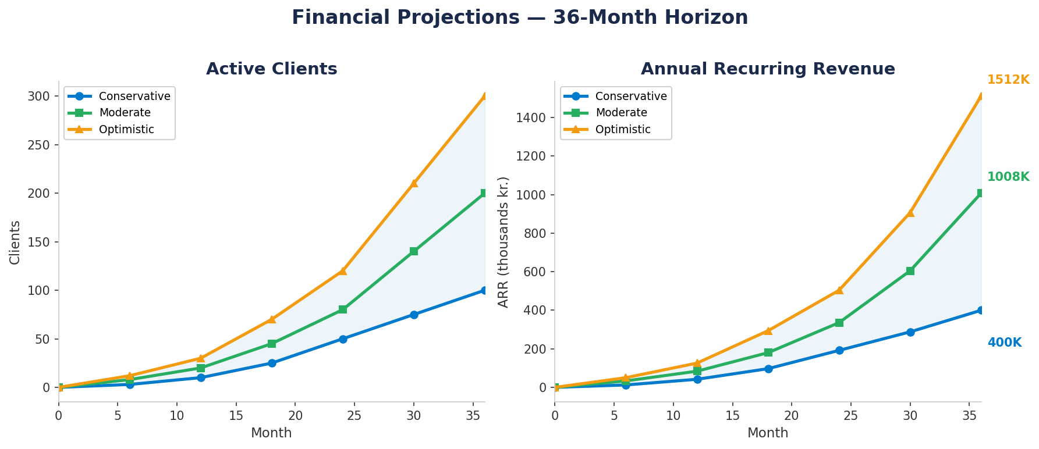
Figure 8. Three-scenario projections: active clients (left) and ARR (right) over 36 months.

13.1 Conservative (Base Case)
 | Month 12 | Month 24 | Month 36
Active clients | 10 | 50 | 100
MRR | 3,500 kr. | 19,000 kr. | 40,000 kr.
ARR | 42,000 kr. | 228,000 kr. | 480,000 kr.
Gross margin | ~63% | ~69% | ~72%
Monthly infra | ~560 kr. | ~700 kr. | ~1,400 kr.
Monthly API | ~500 kr. | ~2,500 kr. | ~5,000 kr.

Assumptions: Organic growth only. No agency partnerships beyond 1. No grant funding.

13.2 Moderate
 | Month 12 | Month 24 | Month 36
Active clients | 20 | 80 | 200
MRR | 7,000 kr. | 30,400 kr. | 84,000 kr.
ARR | 84,000 kr. | 364,800 kr. | 1,008,000 kr.
Gross margin | ~67% | ~72% | ~74%

Assumptions: 2 agency partnerships. Tier mix shifts toward Sentinel. Business association traction.

13.3 Optimistic
 | Month 12 | Month 24 | Month 36
Active clients | 30 | 120 | 300
MRR | 10,800 kr. | 48,000 kr. | 126,000 kr.
ARR | 129,600 kr. | 576,000 kr. | 1,512,000 kr.
Gross margin | ~69% | ~73% | ~75%

Assumptions: NCC-DK grant. 3+ agency partnerships. EU pilot Month 24. Guardian clients.

13.4 Scenario Comparison
CONSERVATIVE  480K kr.  100 clients, organic only | MODERATE  1.01M kr.  200 clients, 2 agencies | OPTIMISTIC  1.51M kr.  300 clients, grant + EU

13.5 Break-Even
Metric | Value
Fixed monthly costs | ~2,500 kr.
Blended ARPC | ~350 kr.
Margin per client | ~235–255 kr.
Break-even | ~10 paying clients
Pilot budget (self-funded) | 12,000 kr.
Pre-revenue runway | 3–4 months

The trade-off is explicit: aggressive pricing requires ~10 clients to break even instead of 5–6 at premium pricing. But at 199 kr./mo, each conversion is significantly easier. The volume play is the strategy.

13.6 What the Numbers Exclude
- Grant funding (NCC-DK, Digital Europe, Industriens Fond) — non-dilutive upside
- Consulting revenue from agency partnerships
- Upsell revenue from tier migration (Watchman → Sentinel → Guardian)
- Annual Guardian discount (599 kr./mo × 12 = 7,188 kr. upfront = cash flow advantage)

14. The Ask
FUNDING REQUESTED  150–250K kr.  deliberately modest | PURPOSE  Pilot → Revenue  legal + launch + grant | BREAK-EVEN  Month 4–6  ~10 paying clients

14.1 Use of Funds
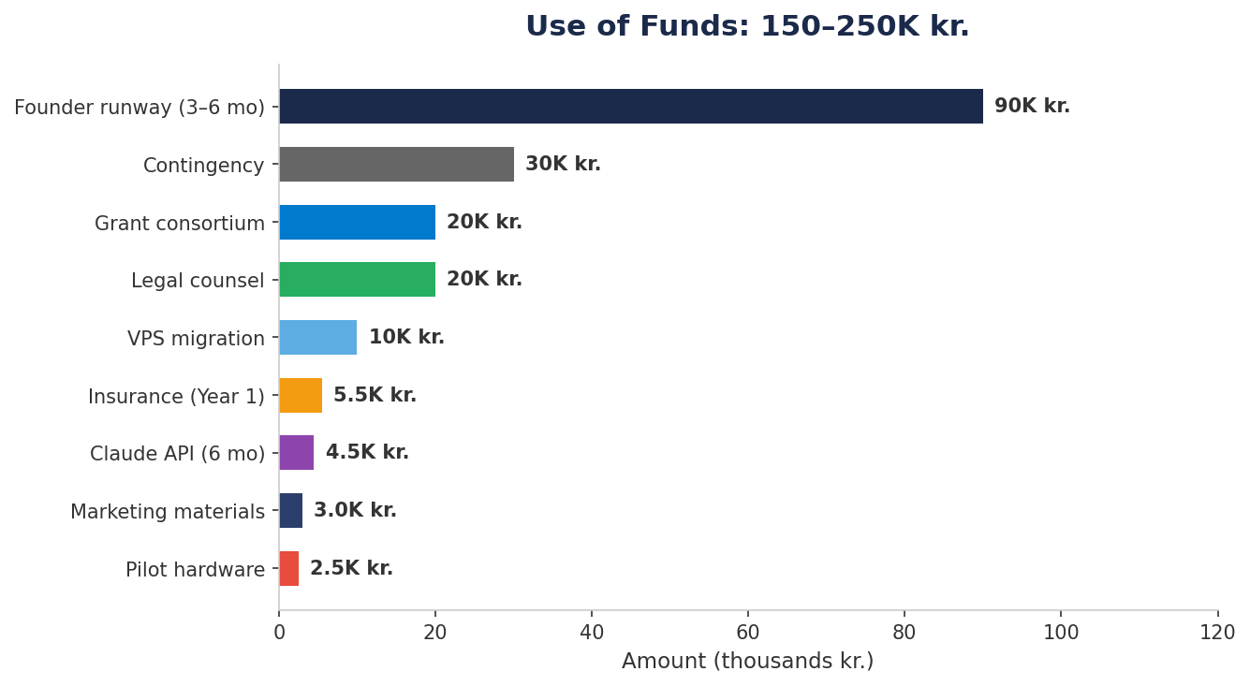
Figure 9. Use of funds. Largest item is founder runway to enable focused execution.
Use | Amount | Why
Legal counsel (§263 + consent template) | 15–25K kr. | Confirm legal framework. Draft authorisation. Clarify agency delegation.
Insurance (Year 1) | 5.5K kr. | Required before commercial scanning.
Pilot hardware | 2.5K kr. | Dedicated always-on infrastructure for 5–10 pilots.
Claude API (6 months) | 4.5K kr. | Finding interpretation and message generation.
Domain + marketing materials | 3K kr. | Landing page, business cards, one-pagers.
Founder runway (3–6 months) | 60–120K kr. | Focused execution alongside existing business.
VPS migration | 10K kr. | Production hosting when pilot capacity exceeded.
Grant consortium costs | 20K kr. | NCC-DK application, university coordination.
Contingency | 20–40K kr. | Unforeseen costs, extended timeline.

14.2 Milestone-Gated Deployment
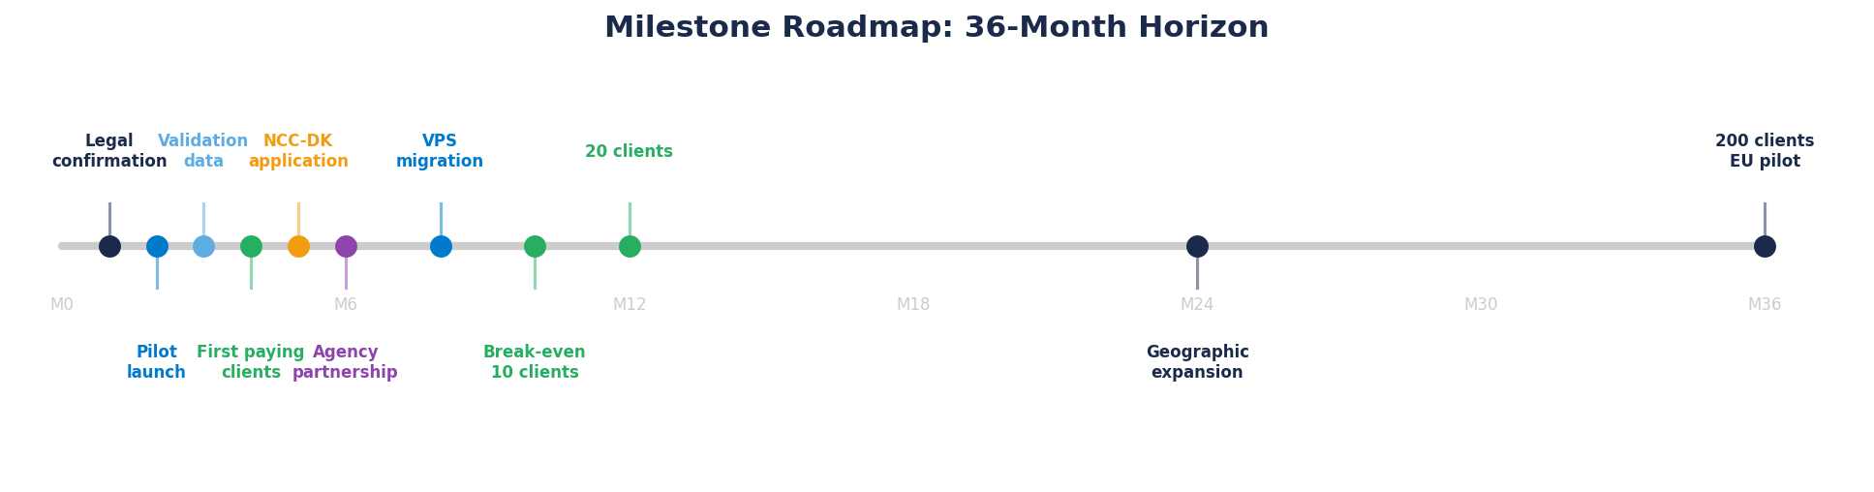
Figure 10. Milestone roadmap. Funding is deployed against specific, verifiable deliverables.
Milestone | Timeline | Funded By
Legal confirmation + template | Month 1–2 | Legal budget
Pilot launch (5 clients) | Month 2 | Hardware + insurance + API
Pilot validation data | Month 3 | Founder runway
First paying clients | Month 3–4 | Runway + marketing
NCC-DK application | Before 15 April | Grant consortium budget
First agency partnership | Month 4–6 | Runway + marketing
Break-even (~10 clients) | Month 4–6 | —
VPS migration | Month 6–8 | VPS budget
20 paying clients | Month 12 | —

14.3 Why This Amount
The ask is small because the cost structure is small. No office, no team of 10, no enterprise sales cycle. The AI runs on a pay-per-use API. The largest item is founder runway — enabling focused execution. Without it, the project progresses at evenings-and-weekends pace. With it, the timeline compresses from 12 months to 6.
If the NCC-DK grant is awarded (5.5M kr. pool), the funding picture changes significantly. The angel investment positions Heimdall to apply from a position of strength: working product, paying clients, legal confirmation.

15. Why Now?
Five forces are converging in 2026 that make this the right moment — not 2024, not 2028.
1. Government Spending Starts Now
211M kr. allocated for cybersecurity 2026–2029, plus 275M kr./year for NIS2. Signed cross-party agreement. SMV-CERT being built as a public-private partnership.²

2. NCC-DK Grant Window Is Open
5.5M kr. pool, deadline 15 April 2026. Stated criteria: “innovative cybersecurity solutions” including “an AI-based tool using pattern recognition.” Describes Heimdall directly.³

3. NIS2 Compliance Pressure Mounting
Supply chain obligations pull SMBs into compliance scope. A restaurant’s payment processor may soon require security attestations from its vendors.

4. Shadow AI Attack Surface Exploding
21,000+ exposed OpenClaw instances. 512 vulnerabilities found by Kaspersky. 48% of security professionals call agentic AI a top attack vector. No SMB tool scans for this.¹⁰ ¹² ¹³

5. The Delivery Gap Is Still Open
As of March 2026, no EASM product delivers through messaging to non-technical owners. Every competitor uses a dashboard. The first mover who builds persistent memory and local trust creates a position expensive to replicate.

These five forces create a convergence: government money, grant opportunity, regulatory pressure, a new attack surface, and an unserved delivery model — all in 2026.
The question for an investor is not whether the cybersecurity market for Danish SMBs will grow. The government has already decided it will. The question is who will serve it.

References
[1] Styrelsen for Samfundssikkerhed — 40% of Danish SMBs lack adequate security. https://samsik.dk
[2] Danish Government — Cybersecurity Strategy 2026–2029. https://mssb.dk/nyheder/nyhedsarkiv/2026/januar/aftale-ny-strategi-for-cyber-og-informationssikkerhed/
[3] NCC-DK — 5.5M kr. grant pool. https://samsik.dk/artikler/2026/02/ny-pulje-55-mio-kr-til-innovative-loesninger-paa-cybertruslen/
[4] DI Digital — SMV-CERT proposal. https://www.danskindustri.dk/brancher/di-digital/nyhedsarkiv/nyheder/2025/12/di-vil-samle-krafterne-mod-cyberangreb-ny-enhed-skal-styrke-beskyttelsen-af-sma-og-mellemstore-virksomheder/
[5] VikingCloud 2026 — 60% breach closure rate. https://digacore.com/blog/managed-cybersecurity-services-smb-2026/
[6] NCSA / Getastra — SMB breach data. https://www.getastra.com/blog/dast/vulnerability-scanning-for-smbs/
[7] GDPR Article 32. https://www.vectra.ai/topics/gdpr-compliance
[8] Qualys — Dashboard documentation. https://blog.qualys.com/product-tech/2020/02/04/actionable-searching-and-data-download-with-vulnerability-management-dashboards
[9] Intruder.io / Bugcrowd. https://www.bugcrowd.com/glossary/intruder-vulnerability-scanner/
[10] SecurityScorecard — 21,000+ exposed OpenClaw. https://pbxscience.com/openclaw-2026s-first-major-ai-agent-security-crisis-explained/
[11] Koi Security — ClawHub malicious skills. https://blog.cyberdesserts.com/openclaw-malicious-skills-security/
[12] Kaspersky — OpenClaw 512 vulnerabilities. https://www.institutionalinvestor.com/article/openclaw-ai-agent-institutional-investors-need-understand-shouldnt-touch
[13] Dark Reading — 48% agentic AI attack vector poll. https://www.kiteworks.com/cybersecurity-risk-management/agentic-ai-attack-surface-enterprise-security-2026/
[14] Danish CVR Register. https://datacvr.virk.dk
[15] Straffeloven §263. https://danskelove.dk/straffeloven/263
[16] ICLG Cybersecurity 2026 — Denmark. https://iclg.com/practice-areas/cybersecurity-laws-and-regulations/denmark

This document was prepared in March 2026. Financial projections are forward-looking estimates based on stated assumptions. All scanning activities comply with Danish law as analysed in the project’s legal risk assessment — confirmation by qualified counsel is a funded milestone.

