HEIMDALL
External Attack Surface Management for SMBs

Business Case v2.0
March 2026
Confidential

1. Executive Summary
Heimdall is a proposed External Attack Surface Management (EASM) service designed for small and medium-sized businesses (SMBs). EASM refers to the continuous discovery, monitoring, and evaluation of an organisation’s internet-facing assets — domain names, SSL certificates, web servers, APIs, CMS platforms, plugins, and cloud services — as seen from the perspective of a potential attacker.
The service addresses a documented market gap: the majority of existing EASM solutions deliver findings through complex web dashboards designed for security professionals. They are priced for mid-market and enterprise buyers, and they assume a dedicated security team will interpret and act on the results. SMBs, which typically lack these resources, are left without practical options for external surface monitoring.
Heimdall reframes the delivery model. Instead of a dashboard, findings are communicated through messaging applications (Telegram, WhatsApp) in plain language, with actionable remediation steps tailored to the client’s technical environment. The service runs on OpenClaw, an open-source AI agent framework, using established vulnerability scanning tools and a large language model interpretation layer to translate technical findings into business-relevant guidance.
This business case is submitted in the context of a significant national policy shift. In January 2026, the Danish government signed a cross-party agreement allocating 211 million kr. to cybersecurity over 2026–2029, with specific provisions for SMB protection. According to Styrelsen for Samfundssikkerhed, 40% of Danish SMBs currently lack security measures commensurate with the threat environment they face.
The initial deployment targets businesses in the Vejle, Denmark area, with a four-week pilot of five clients to validate the service model before scaling.

2. Problem Statement

2.1 The Unmonitored External Surface
Every business with a website exposes an attack surface to the public internet. This surface includes the web server itself, its TLS/SSL configuration, the content management system and its plugins, any connected APIs, subdomains, and DNS records. Unlike internal network security or endpoint protection — which guard devices inside the network — EASM focuses on what an attacker can see and probe from outside.
For a restaurant with an online booking system, this surface might include an outdated WordPress installation, an expired SSL certificate, an exposed administrative panel, and a third-party booking plugin with known vulnerabilities. Each of these represents a potential entry point.

2.2 The SMB Security Gap
The scale of the problem is well documented. Industry data indicates that a substantial majority of cyberattacks now target SMBs, and that a significant proportion of small businesses that suffer a major data breach do not survive. Most SMBs have neither endpoint security nor external surface monitoring.
The root cause is not indifference. SMB owners typically lack the technical expertise to assess their own exposure, the time to learn specialised security tools, and the budget for enterprise-grade solutions. Existing EASM products are not designed for this audience.

2.3 The Dashboard Problem
Current EASM competitors deliver results through web-based dashboards featuring interactive widgets, drill-down analytics, query languages, risk trend charts, and audit-ready report generators. These interfaces are designed for security analysts. They are not usable by the owner of a physiotherapy clinic or a boutique hotel.
The gap is not in the quality of detection. It is in the delivery mechanism. A finding that is never read, understood, or acted upon provides no protection. The following illustration demonstrates the contrast:
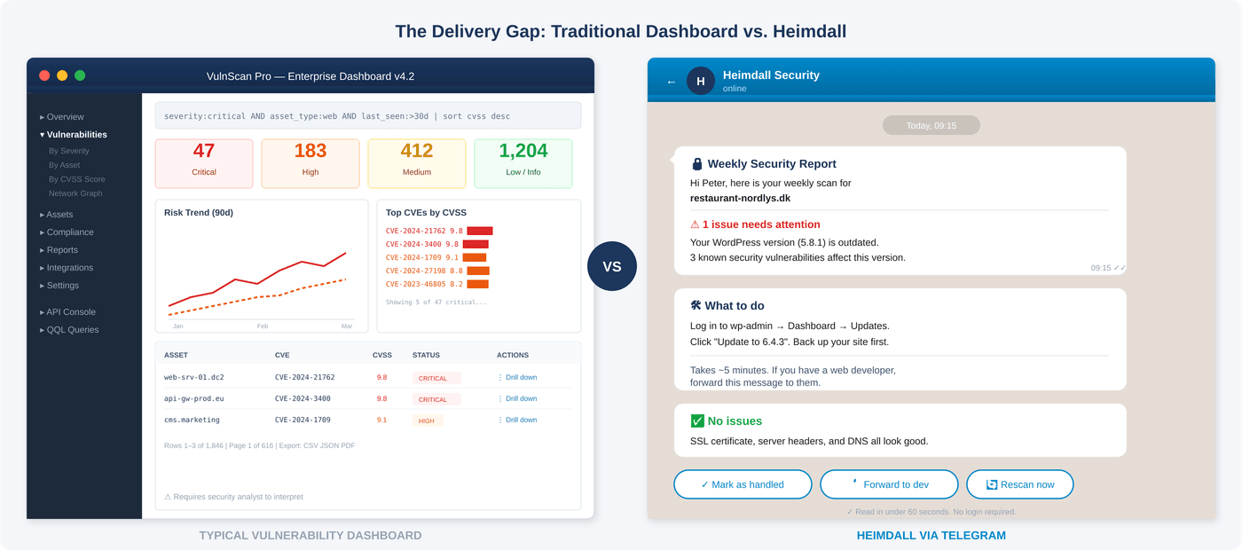
Figure 1. Traditional vulnerability dashboard (left) vs. Heimdall delivery via Telegram (right).

2.4 Regulatory Obligation
Under GDPR Article 32, any organisation processing personal data is required to implement “appropriate technical and organisational measures” to ensure a level of security appropriate to the risk. For businesses collecting customer data through web forms, booking systems, or e-commerce platforms, this creates a regulatory obligation to monitor and secure their public-facing digital infrastructure. Most Danish SMBs are currently not meeting this standard.

3. Danish Cybersecurity Policy Context
In January 2026, the Danish government signed a cross-party agreement titled “Aftale om strategi for cyber- og informationssikkerhed 2026–2029,” backed by nearly every party in the Folketing. This strategy represents the largest dedicated cybersecurity investment in Danish history and directly informs the market opportunity for Heimdall.
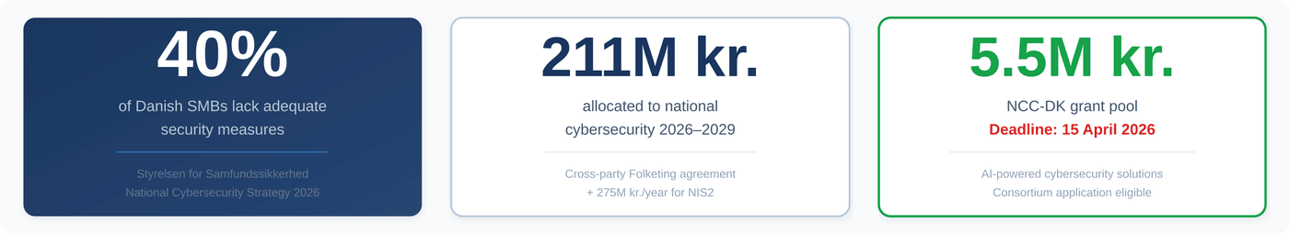
Figure 2. Key figures from the Danish National Cybersecurity Strategy 2026–2029.

3.1 Funding Allocations
Allocation | Amount
Strategy 2026–2029 (total) | 211 million kr.
Annual from 2030 onwards | 33 million kr./year
NIS2 implementation (annual from 2025) | 275 million kr./year
Source: Finansloven 2026 | National reserve for societal security

3.2 Key Initiatives Relevant to Heimdall
SMV-CERT. A new Computer Emergency Response Team specifically for SMBs, structured as a public-private partnership. SMV-CERT will provide early warnings, practical prevention tools, and incident response assistance. Heimdall’s continuous monitoring service is complementary, providing the upstream detection that feeds into incident response workflows.
Industriens Fond Cybersikkerhedsprogram. The Danish Industry Foundation operates a dedicated cybersecurity programme for SMBs, providing tools, case studies, and collaboration with Erhvervsstyrelsen. It also administers D-mærket, Denmark’s certification mark for IT security and responsible data practices.

3.3 Grant Opportunities
NCC-DK Grant Pool (Open). The Nationale Koordinationscenter for Cybersikkerhed opened a 5.5 million kr. grant pool on 26 February 2026, with a deadline of 15 April 2026. The total NCC-DK budget for 2026–2029 is 43 million kr. in grants. Requirements include a minimum of two consortium partners with at least one private company. Example projects cited include an AI-based tool that uses pattern recognition to simulate attacker behaviour.
A consortium application pairing Heimdall with a university or established security firm, developing an AI-powered EASM service for Danish SMBs, aligns directly with the stated grant criteria.
EU-Level: SECURE Project and Digital Europe Programme. The SECURE project, launched 28 January 2026, provides financial support for SMBs achieving cybersecurity compliance through an 18-month mentorship programme. The Digital Europe Programme has active calls for cybersecurity solutions, including grants of up to €60.000 per SME for field-testing cybersecurity technologies.

4. Proposed Solution

4.1 Service Overview
Heimdall provides continuous, automated monitoring of a client’s external attack surface. The service operates through five phases:
Discovery. Automated enumeration of internet-facing assets: domains, subdomains, SSL certificates, web servers, CMS platforms, plugins, open ports, and associated cloud services.
Scanning. Template-based vulnerability scanning using industry-standard open-source tools, calibrated to the client’s technology stack.
Interpretation. An AI interpretation layer (Anthropic Claude API) translates raw scanning output into plain-language findings. Technical severity is mapped to business impact.
Delivery. Findings are delivered through Telegram or WhatsApp as a conversational message. Each finding includes a plain-language description of the issue, its business risk, a recommended action, and a clear indication of who should carry out the remediation.
Follow-Up. The agent maintains persistent memory of each client’s environment, past findings, and remediation state. Unresolved issues generate follow-up messages with escalating urgency.
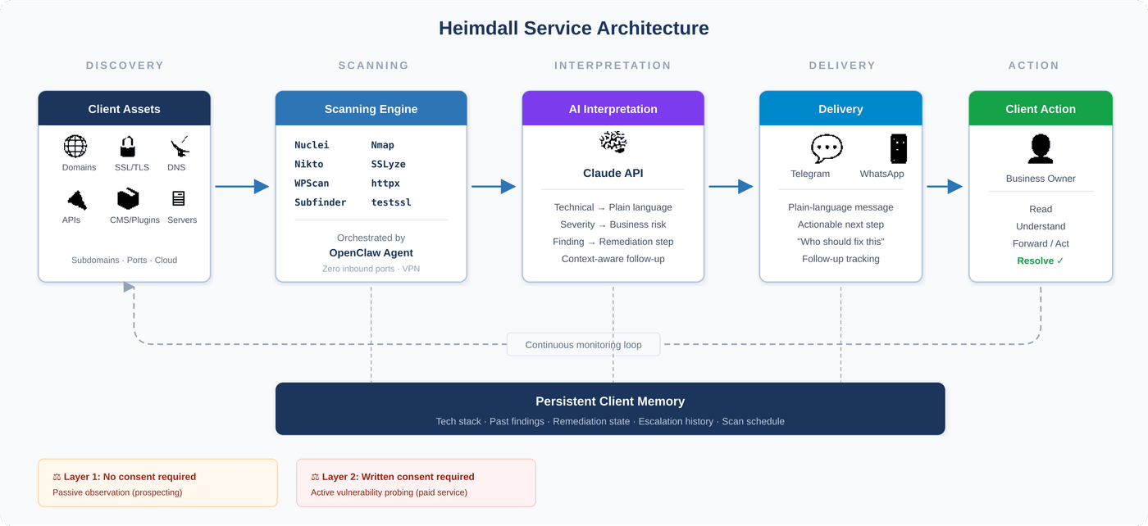
Figure 3. Heimdall end-to-end service architecture with persistent client memory and legal layer indicators.

4.2 Remediation Routing
Heimdall adapts its remediation guidance to the client’s operational context:
Client Scenario | Heimdall’s Response
Has a web developer | Message formatted for direct forwarding to the developer
Self-manages WordPress | Step-by-step wp-admin instructions
Hosted platform (Shopify, Squarespace) | Platform-specific settings guidance or drafted support ticket
No technical resource | Draft hosting provider support ticket and curated freelancer referral

4.3 Scanning Tools
The scanning infrastructure uses established, open-source tools:
Tool | Function | Source Repository
Nuclei | Template-based vulnerability scanner | github.com/projectdiscovery/nuclei
Nikto | Web server vulnerability scanner | github.com/sullo/nikto
Nmap | Port scanning, service detection | github.com/nmap/nmap
SSLyze | TLS/SSL configuration analysis | github.com/nabla-c0d3/sslyze
testssl.sh | SSL/TLS testing | github.com/drwetter/testssl.sh
WPScan | WordPress-specific scanner | github.com/wpscanteam/wpscan
Subfinder | Subdomain enumeration | github.com/projectdiscovery/subfinder
httpx | HTTP probing and tech fingerprinting | github.com/projectdiscovery/httpx
webanalyze | Batch CMS detection | github.com/rverton/webanalyze

4.4 Architecture
The production architecture consists of dedicated secure infrastructure with encrypted communications, always-on monitoring with VPN-secured connectivity and zero inbound ports, and a cloud-based AI interpretation layer (Anthropic Claude API). The scanning infrastructure and client communication channels are logically separated, with Docker containerisation for reproducibility. The system is designed to scale horizontally as client volume grows.

4.5 Known Limitations
Limitation | Mitigation
Internal network scanning | Scope limited to the external surface, which is the attack surface relevant to web properties
Authenticated application testing | Available at premium tier only, with explicit written authorisation
Real-time WAF/IDS | Recommend complementary WAF solutions (e.g. Cloudflare, Sucuri); monitor their configuration status
Compliance certification | Generate evidence for compliance; refer to certified auditors for formal certification
Server patching | Provide step-by-step instructions and vendor escalation email drafts

5. Target Market

5.1 Primary Customer Profile
Heimdall targets businesses meeting the following criteria: (a) they operate a website handling customer data or transactions — online booking, e-commerce, contact forms collecting personal information; (b) they lack the internal resources or expertise to monitor their external attack surface; and (c) they are located in the EU (initially Denmark), where GDPR Article 32 creates a regulatory obligation for appropriate technical and organisational measures.
Representative examples include a restaurant with an online booking system, a physiotherapy clinic with a patient portal, a boutique hotel with a reservation engine, a small e-commerce brand running WooCommerce, and an accounting firm with a client portal.

5.2 Extended Customer Profile
Businesses with existing endpoint security. Endpoint protection (e.g. CrowdStrike Falcon Go) guards devices within the network. It does not monitor the external attack surface. These services are complementary, not overlapping.
Companies with small internal IT teams. An IT generalist managing hardware, passwords, and onboarding rarely has the capacity for continuous external vulnerability monitoring. Heimdall fills this specific gap.

5.3 Exclusions
Heimdall is not positioned for businesses that already have a managed security service provider (MSSP) handling external surface monitoring, nor for organisations requiring formal compliance certification.

6. Competitive Landscape

6.1 Direct Competitors
Competitor | Starting Price | Interface | URL
Intruder.io | ~740 kr./month | Dashboard + Slack/Jira | intruder.io
HostedScan | Free; paid ~215 kr./mo | Dashboard + API | hostedscan.com
Detectify | ~610 kr./month | Dashboard | detectify.com
Beagle Security | ~885 kr./month | Dashboard | beaglesecurity.com
Astra Security | ~740–2.225 kr./mo | Dashboard + pentest | getastra.com
Sucuri (GoDaddy) | ~1.480 kr./year | Dashboard + WAF | sucuri.net

The closest direct competitor is Intruder.io, a GCHQ Cyber Accelerator alumnus with over 1,000 customers. Enterprise-tier EASM players (CrowdStrike Falcon Surface, Trend Micro, Censys, Qualys) are not direct competitors at the SMB price point but provide category context.

6.2 Differentiation
1. Conversational delivery via messaging applications. Findings arrive as a Telegram or WhatsApp message, not a dashboard. The client reads a message; they never log into a portal.
2. Persistent memory and active remediation follow-up. The agent tracks each client’s technology stack, past findings, and remediation state. It follows up on unresolved issues with escalating urgency.
3. Shadow AI and agent infrastructure detection. Scanning for exposed OpenClaw instances, MCP servers, and rogue AI agents. As of March 2026, no SMB-focused competitor offers this capability.

7. Legal Framework

7.1 Applicable Law
Straffeloven §263, stk. 1 criminalises gaining unauthorised access to another person’s data system. The penalty ranges from a fine to 18 months’ imprisonment, and up to 6 years under aggravating circumstances. The ICLG Cybersecurity Report 2026 (Denmark chapter) states that unsolicited penetration of an IT system without the owner’s permission will most likely constitute a violation under this section.

7.2 Scanning Activity Classification
Layer | Activity | Legal Assessment
Layer 1: Passive | Reading HTTP headers, HTML source, meta tags, DNS records, SSL certificates, technology fingerprinting | Minimal risk. Information voluntarily served to any visitor. Search engines operate at this level.
Layer 2: Active probing | Crafted requests testing for specific CVEs (Nuclei, Nikto templates) | Grey zone. No specific Danish court ruling identified. Law is broad enough for prosecutorial argument under §263.
Layer 3: Exploitation | Actively exploiting a discovered vulnerability | Clearly criminal without consent. Outside Heimdall’s scope.

7.3 Operational Implication
The lead generation pipeline (Layer 1 activity) can proceed without consent — it reads publicly served information only. The vulnerability scanning service (Layer 2 activity) requires written consent before activation. This boundary aligns with the business model: the free prospecting scan uses Layer 1 data; the paid service activates Layer 2 scanning only after formal client onboarding and authorisation.

7.4 Outstanding Legal Questions
The following questions should be addressed by qualified legal counsel prior to commercial launch: (a) confirmation of the Layer 1/Layer 2 boundary under §263; (b) drafting and review of a scanning authorisation template; (c) clarification of whether a web agency can authorise scanning of its clients’ sites, or whether each end client must consent independently.

8. Service Tiers and Pricing

8.1 Tier Structure
Tier | Price | Key Features
Watchman | 499 kr./month | We find problems on your website, explain them in plain language, and tell you what needs fixing.  Weekly scan. Findings delivered straight to Telegram. We track what's changed since last time and follow up on anything unresolved.
Sentinel | 699 kr./month | We watch your website every day. If something changes or a new threat hits your setup, you'll know the same day — with step-by-step instructions and a message ready to forward to whoever handles it.  Everything in Watchman, plus: daily scans, uptime monitoring, SSL and DNS change alerts, new vulnerability matching for your specific tech stack, drafted emails to your developer or hosting provider.
Guardian | 999 kr./month | We actively test your defences, confirm that fixes worked, and give you a report you can show your accountant or insurer.  Everything in Sentinel, plus: active vulnerability testing, detection of exposed AI tools and agent infrastructure, remediation verification, quarterly security report.
All tiers require the client’s written consent in compliance with current legislation.

8.2 Unit Economics (Estimates)
Tier | Price | Est. API Cost | Est. Compute
Watchman | 499 kr. | ~22 kr. | ~1,5 kr.
Sentinel | 699 kr. | ~74 kr. | ~3,7 kr.
Guardian | 999 kr. | ~186 kr. | ~7,5 kr.

Note: API cost estimates are based on current Claude API pricing and will vary with usage patterns. Gross margin excludes labour, marketing, and overhead.

9. Lead Generation Pipeline
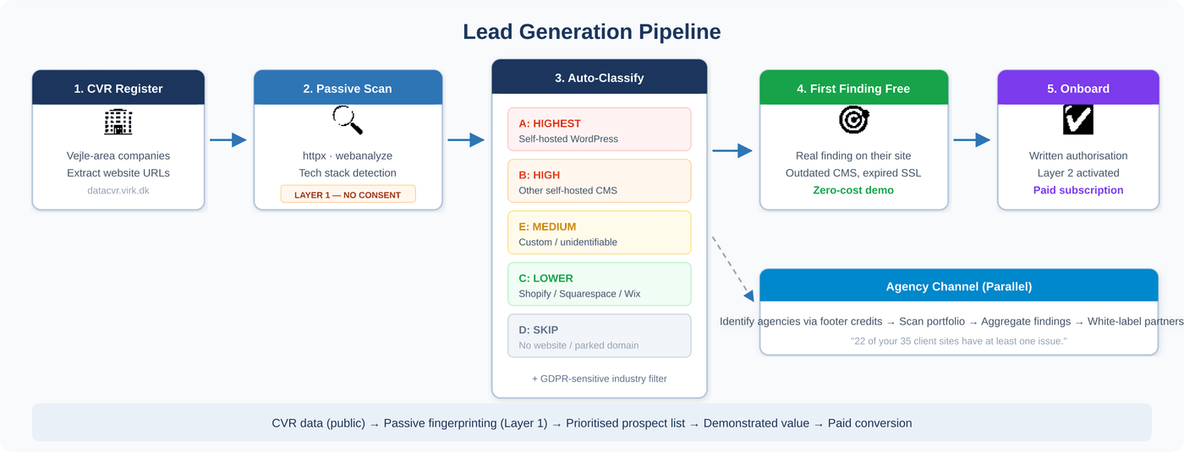
Figure 4. Lead generation pipeline from public CVR data to paid conversion.

9.1 Prospecting Engine
The lead generation process uses publicly available data from the Danish CVR register to identify businesses in the target area, extract their website URLs, and conduct passive technology fingerprinting (Layer 1 activity only). Results are automatically categorised:
Priority | Profile | Rationale
Bucket A (Highest) | Self-hosted WordPress on shared hosting | Largest attack surface, most common SMB platform, frequently unpatched
Bucket B (High) | Other self-hosted CMS | Joomla, Drupal, PrestaShop — similar risk profile, smaller install base
Bucket C (Lower) | Hosted platforms | Shopify, Squarespace, Wix — platform handles most infrastructure security
Bucket D (Skip) | No website / parked domain | No external attack surface to monitor
Bucket E (Medium) | Custom-built / unidentifiable | Requires manual assessment

A second classification dimension filters by CVR industry codes for GDPR-sensitive sectors: healthcare, legal, accounting, real estate, and dental practices.

9.2 Sales Motion: First Finding Free
The prospecting scan (Layer 1) produces real, actionable findings at no cost: outdated CMS versions, expiring SSL certificates, exposed administrative panels, and detectable technology stack details. This data powers a free-sample approach — demonstrating a real finding on the prospect’s actual website before proposing the paid service.

9.3 Agency Channel
Web agencies can be identified by scanning for footer credits, meta author tags, and common templates across client sites. Approaching an agency with aggregated findings across its portfolio creates a white-label partnership opportunity: the agency integrates Heimdall as a value-added service for its existing client base.

10. Pilot Plan

10.1 Budget
Estimated total pilot cost: approximately 12.000 kr.
Item | Estimated Cost
Hardware (Raspberry Pi 5 8gb NVMe HAT + 256 GB SSD) | ~2.000 kr.
Power supply and cooling | ~250 kr.
Claude API usage (3 months) | ~1.500 kr.
Domain and landing page | ~500 kr./year
Professional indemnity insurance | ~3.700–5.500 kr./year
Contingency | ~800–1.500 kr.

10.2 Timeline
Week 1. Build lead generation pipeline. Configure scanning infrastructure with OpenClaw and scanning tools. Develop core scanning skill. Validate against own domains.
Weeks 2–3. Execute prospecting scan across Vejle-area businesses. Recruit five pilot clients from Bucket A (self-hosted WordPress). Offer first month at no charge. Obtain written scanning authorisation from each client.
Weeks 3–4. Run initial scan cycles with human-in-the-loop review (all messages reviewed before delivery). Refine prompt templates. Document accuracy and failure modes.
Week 4. Second scan cycle. Test follow-up and memory model. Conduct end-of-pilot client conversations to assess engagement, comprehension, action rate, and willingness to pay.

10.3 Validation Objectives
The pilot is designed to validate three core hypotheses:
1. Engagement. Will a non-technical business owner read and act on a Telegram security message?
2. Accuracy. Is the LLM interpretation layer accurate enough for production use? A known risk is false specificity — plausible-sounding advice that is incorrect for the specific environment. Mitigation: separate detection from remediation, and bound guidance to generic recommendations with authoritative reference links.
3. Value perception. Does the follow-up model create ongoing value, or does it generate message fatigue?

11. Risk Register
Risk | Severity | Mitigation
LLM false specificity | High | Separate detection from remediation. Bound advice to generic guidance with authoritative links. Human-in-the-loop review during pilot.
Legal exposure (§263) | High | Layer 1 only for prospecting. Written consent before Layer 2. Legal counsel review before commercial launch.
OpenClaw framework security | Medium | Monitor security advisories. Isolate scanning infrastructure. VPN with zero inbound ports. Evaluate alternatives if critical vulnerabilities emerge.
Client disengagement | Medium | Pilot measures read rates and action rates. Iterate on message format and frequency based on feedback.
API cost escalation | Low | Monitor per-client costs. Estimated gross margins of 87–89% provide buffer. Adjust scan frequency or model tier if needed.
Competitive response | Low | Messaging delivery and persistent follow-up are architectural choices. Replication requires rethinking the delivery model, not adding a feature.

12. Recommendation
The convergence of three factors creates a time-bound opportunity: a substantial national policy investment in SMB cybersecurity, an open grant pool with a 15 April 2026 deadline directly aligned with this service concept, and a documented market gap between enterprise EASM solutions and the needs of small businesses.
The recommended course of action is to proceed with the four-week pilot as described in Section 10, with a total budget of approximately 7.000 kr. The pilot will generate the empirical data required to validate the service model, support a grant application to NCC-DK, and inform the decision on whether to proceed to commercial launch.
Parallel to the pilot, legal counsel should be engaged to confirm the scanning consent framework, and consortium partners should be identified for the NCC-DK grant application.

Appendix A: Pilot Infrastructure (Internal Only)
This appendix is for internal reference only and should not be included in client-facing materials.
The pilot infrastructure uses a Raspberry Pi 5 (8 GB RAM) with NVMe SSD via HAT, running Raspberry Pi OS Lite (64-bit). OpenClaw serves as the gateway and orchestrator. Connectivity is secured via Tailscale VPN with zero inbound ports. The Claude API (Sonnet) provides the AI interpretation layer, and a Telegram Bot handles client-facing message delivery.
This hardware was selected for the pilot phase because it is available, inexpensive to operate, and sufficient for the initial five-client scope. The production migration path involves transitioning to VPS or cloud hosting (e.g. Hetzner, DigitalOcean), Docker containerisation, logical separation of scanning and communication infrastructure, and potential multi-node architecture as the client base scales.

CrowdStrike — What Is EASM: https://www.crowdstrike.com/en-us/cybersecurity-101/exposure-management/external-attack-surface-management-easm/
Trend Micro — What Is EASM: https://www.trendmicro.com/en/what-is/attack-surface/external-attack-surface-management.html
Censys — Attack Surface Management: https://censys.com/solutions/attack-surface-management/
Danish Government — Cybersecurity Strategy 2026–2029: https://mssb.dk/nyheder/nyhedsarkiv/2026/januar/aftale-ny-strategi-for-cyber-og-informationssikkerhed/
Styrelsen for Samfundssikkerhed (SAMSIK): https://samsik.dk
NCSC UK — EASM Buyers Guide: https://www.ncsc.gov.uk/guidance/external-attack-surface-management-buyers-guide
VikingCloud 2026 SMB Statistics: https://digacore.com/blog/managed-cybersecurity-services-smb-2026/
NCSA — SMB breach survival: https://www.getastra.com/blog/dast/vulnerability-scanning-for-smbs/
Gurkha Technology — SMB attack trends: https://gurkhatech.com/cybersecurity-solutions-smb-2026/
Qualys — Dashboard documentation: https://blog.qualys.com/product-tech/2020/02/04/actionable-searching-and-data-download-with-vulnerability-management-dashboards
Intruder.io — Vulnerability scanning tools: https://www.intruder.io/blog/the-top-vulnerability-scanning-tools
Vectra — GDPR Compliance Guide: https://www.vectra.ai/topics/gdpr-compliance
Strategy agreement full text (PDF): https://mssb.dk/media/5jdlnv41/aftaletekst.pdf
DI Digital — SMV-CERT proposal: https://www.danskindustri.dk/brancher/di-digital/nyhedsarkiv/nyheder/2025/12/di-vil-samle-krafterne-mod-cyberangreb-ny-enhed-skal-styrke-beskyttelsen-af-sma-og-mellemstore-virksomheder/
Industriens Fond — Cybersikkerhedsprogram: https://industriensfond.dk/vores-fokusomrader/cybersikkerhed/
NCC-DK — 5.5M kr. grant pool: https://samsik.dk/artikler/2026/02/ny-pulje-55-mio-kr-til-innovative-loesninger-paa-cybertruslen/
EU Funding Portal — Cybersecurity grants: https://eufundingportal.eu/cybersecurity/
Bugcrowd — Intruder scanner profile: https://www.bugcrowd.com/glossary/intruder-vulnerability-scanner/
SecurityScorecard STRIKE Team — OpenClaw exposure: https://pbxscience.com/openclaw-2026s-first-major-ai-agent-security-crisis-explained/
Koi Security / Bitdefender — ClawHub malicious skills: https://blog.cyberdesserts.com/openclaw-malicious-skills-security/
Gravitee — State of AI Agent Security 2026: https://beam.ai/agentic-insights/ai-agent-security-in-2026-the-risks-most-enterprises-still-ignore
Straffeloven §263: https://danskelove.dk/straffeloven/263
Aalborg University — Straffelovens §263 analysis: https://vbn.aau.dk/ws/files/305754822/Speciale_Straffelovens_263_stk._1.pdf
ICLG Cybersecurity Report 2026 — Denmark: https://iclg.com/practice-areas/cybersecurity-laws-and-regulations/denmark
Danish CVR Register: https://datacvr.virk.dk
OpenClaw Documentation — Raspberry Pi setup: https://docs.openclaw.ai/platforms/raspberry-pi
Raspberry Pi Foundation — OpenClaw on Pi: https://www.raspberrypi.com/news/turn-your-raspberry-pi-into-an-ai-agent-with-openclaw/

