JavaScript

Variable
Definition
“JavaScript variables are containers for storing data values. Variables are named containers that you can place data in and then refer to the data by naming the container.”
"A variable is a named value in your program. Whenever you use the name in the program, it's replaced with the value."
"You can think of a variable as a box that you can fit one thing in. If you put something else in it, the first thing goes away."

Case Sensitive:
- var myVariableis different than var mYVariable

Invalid Variables:
- Begin with a number
  - Bad:var 1dog;
  - Good:var dog1;

- Contain a JavaScript Keyword - A keyword is a reserved word in JavaScript. JavaScript uses these reserved words for its own purposes, and it would be confusing to you and the browser if you started using them for your variables.
  - eg.var function;
  - eg.var this;
  - full list at https://developer.mozilla.org/en-US/docs/Web/JavaScript/Reference/Lexical_grammar#Reserved_keywords_as_of_ECMAScript?

- Contain a space between words
  - Bad: var my dog;
  - Good: var my_dog;

Safe Variable Beginings:
- Begin with any letter.
- Begin with a dollar sign $.
- Begin with an underscore_.

Best Practice:
- camelCase: First word is lowercase followed by capitalizing the first letter of each additional word.

- Bad practice: var lunchcostperstudent = 5;
All lowercase. Difficult to read.
- Bad practice: var LunchCostPerStudent = 5;
Should not capitalize first word.
- Best practice: var lunchCostPerStudent = 5;

- Human Readable: We code not for ourselves or the computer alone but for the eyes and understanding of others. "Try to give your variables name that describe what they're for or what they do. Other programmers may need to read and update your code in the future, and you'll thank yourself when you return to it at some point down the line. As your programs grow and involve more and more variables, objects, and functions, good variable names can really help you follow the flow of the program and understand its purpose. So keep those variable names simple, direct, and descriptive."

- Acceptable practice: var x = 25;
Though concise, this is not descriptive.
- Better practice: var age = 25;
Not as concise, but makes code clearer.

Summary:

1. Variables let you store data for your program to use while it's running.
2. Declare a variable by following the var keyword with a name.
3. Choose simple, descriptive names for your variables, avoiding JavaScript's keywords and reserved words.
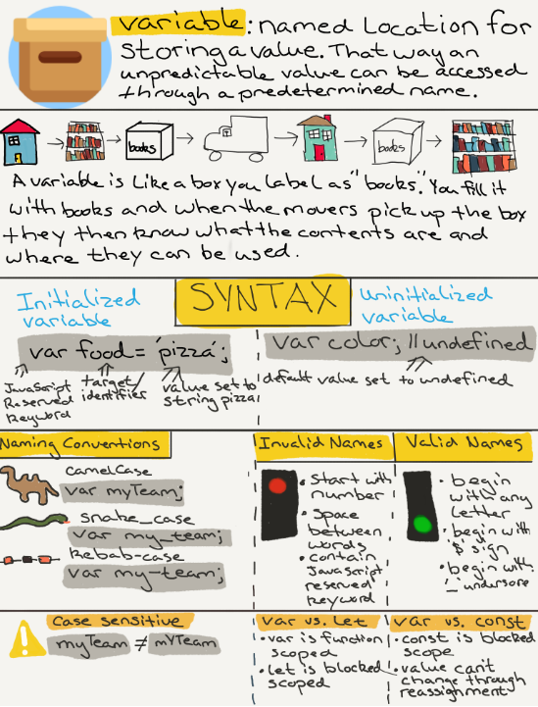
String
Definition

"Strings are a data type used to represent text and are wrapped in either a single or double quotes."

"A list of characters surrounded by quotes, used to represent text in computer programs."

"Strings in JavaScript (as in most programming languages) are just sequences of characters, which can include letters, numbers, punctuation, and spaces. We put strings between quotes so JavaScript knows where they start and end."

Example
- Single quote: var name ='Joe';
- Double quote: var name ="Joe";

Best Practice
- Choose one implementation, either single or double quote, and use consistently.
- Teams will often have agreed upon style guide.

Error
- Single and double quote: var name = 'Joe";
- Double and single quote: var name = "Joe';

Turn Any Data Type Into a String
- typeof 24; // 'number'
- typeof '24'; // 'string'
- typeof true; // 'boolean'
- typeof 'true'; // 'string'

Single or Double Quotes Within Strings
Error
- var greeting = 'It's good to meet you!';
Single quote within text wrapped in single quotes.
- var greeting2 = "Tell Jack that I say "Hi"";
Double quotes within text wrapped in double quotes.
Solution
- var greeting = "It's good to meet you!";
Single quote within double quotes.
- var greeting2 = 'Tell Jack that I say "Hi"';
Doubles quotes within single quotes.

Escape Clause Solution
- var greeting = 'It\'s good to meet you!';
Escape clause used before single quote within text wrapped in single quotes.
- var greeting2 = "Tell Jack that I say \"Hi\"";
Escape clause used before double quotes within text wrapped in double quotes.

Looking Ahead - Future Lessons
Joining Strings
- var greeting = "Hi,";
- var myName = "Rob";
- greeting + " " + myName; // "Hi, Rob"

Finding the Length of a String
- var neighborGreeting = "Hi, Rob";
- neighborGreeting.length; // 7

Getting a Single Character from a String
- var neighborGreeting = "Hi, Rob";
- neighborGreeting[0]; // "H"
- neighborGreeting[1]; // "i"

UpperCase
- var neighborGreeting = "Hi, Rob";
- neighborGreeting.toUpperCase(); // "HI, ROB"

Lower Case
- var neighborGreeting = "Hi, Rob";
- neighborGreeting.toLowerCase(); // "hi, rob"

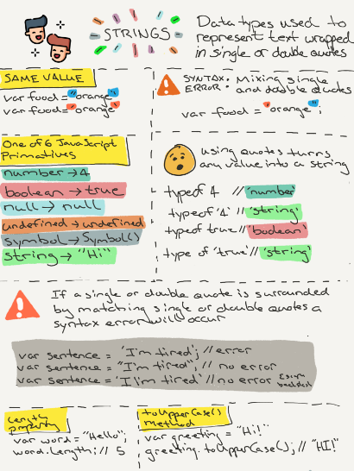

Operators
Definition
“Operators are used to assign values, compare values, perform arithmetic operations and more. Operators allow programmers to create a single value from one or more values.”

Binary Operators:
- Definition: Requires two operands, one before the operator and one after the operator.
- Syntax: operand1 operator operand2
- Example: 2 + 3; or x * z;

Unary Operators:
- Definition: Requires a single operand, either before or after the operator.
- Syntax: operator operand OR operand operator
- Example: y++ OR ++y

Arithmetic Operators: Multiplication, Division, Modulus, Addition and Subtraction
- Definition: Takes numerical values (either literals or variables) as their operands and returns a single numerical value.
- Example: var count = 10 + 5 - 4; // 11
- Example: var mult = 3 * 5; // 15

Modulus Operators
- Definition: This will give us the remainder of two values.
- Example: 21 % 4; // 1

Assignment Operators:
- Definition: Assigns a value to its left operand based on the value of its right operand.
- Example: var count = 5;

Comparison Operators:
- Definition: Compare both sides of equation and returns a logical value based on whether the comparison is true. The operands can be numerical, string, logical, or object values.
- Equality operator (==): Checks for equality in value. Coersion may take place finding equal values between a string and number.
- Strict equality operator (===): Checks for equality in value and type. Does not leave room for coersion.
- Example: 5 == '5'; // true
- example: 5 === '5' // false

String Operator:
- Definition: When the ‘+’ is used on strings the ‘+’ operator is called the concatenation operator.
- Example: 'Hello' + ' ' + 'world'; // 'Hello world'

Object
Definition:
"An object is a value type consisting of key/value pairs inside curly braces. The keys are also known as properties. Everything in JavaScript that isn’t a primitive is an object."

"A set of key-value pairs. Each key is a string that can be paired with any JavaScript value. You can then use the key to retrieve whatever value it's within in the object."

"Objects in JavaScript are very similar to arrays, but objects use strings instead of numbers to access the different elements. The strings are called keys or properties, and the elements they point to are called values. Together these pieces of information are called key-value pairs."

Vocabulary Change:
- Variables become known as properties in objects.
- Functions become known as methods in objects.

Object Literal Notation:
- Syntax: var object = {};
- Key/Properties: Single or double quotes not needed for valid variable names. Invalid variable names will require single or double quotes.
  - age = 24;
  - "user age" = 24;

How to Access Properties on an Object:
- The two primary ways of accessing properties of an object are with dot notation and bracket notation.
- Bracket Notation:
  - Syntax: object[‘property’] = value;
  - Example:
var book = { title: ‘Huck Fin’, pages: 260 };
book[‘title’]; // ‘Huck Fin’
book[’pages’]; // 260
- Dot Notation:
  - Syntax: object.property = value;
  - Example:
var name = { firtName: ‘John’, lastName: ‘Doe’ };
name.firstName; // ‘John’
name.lastName; // ‘Doe’
How to Add Properties and Values on an Object:
- You can add items to an object by using strings.
- Bracket Notation:
  - var person = {};
  - person["name"] = "Rob";

- Dot Notation:
  - var person = {};
  - person.name = "Rob";

Object Constructor Definitivo

A constructor is useful when you want to create multiple similar objects with the same properties and methods. The code creates objects as an instance of it.

This keyword definition:

Refers to an object. Which object depends on how this is being invoked (used or called).
The this keyword refers to different objects depending on how it is used:
In an object method, this refers to the object.
Alone, this refers to the global object.
In a function, this refers to theglobal object.
In a function, in strict mode, this is undefined.
In an event, this refers to the element that received the event.
Methods like call(), apply(), and bind() can refer this to any object.

