Tutorial 6.4 Simulation Results Summary

# Question 2 – Time-varying heatmaps (Excitatory)

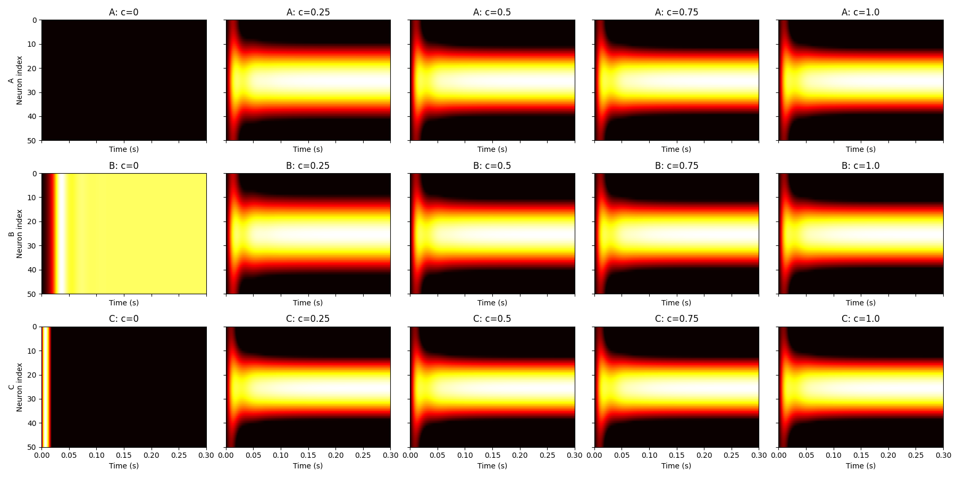

How it was made: Shows excitatory firing rates over time for 50 neurons in each network at 5 contrast levels. Created by plotting rE(t) as heatmaps per network/contrast.

Interpretation: Network A shows no activity at c=0. B has baseline firing due to positive I₀ᴱ. C shows clean contrast-dependent tuning.

# Question 2 – Time-varying heatmaps (Inhibitory)

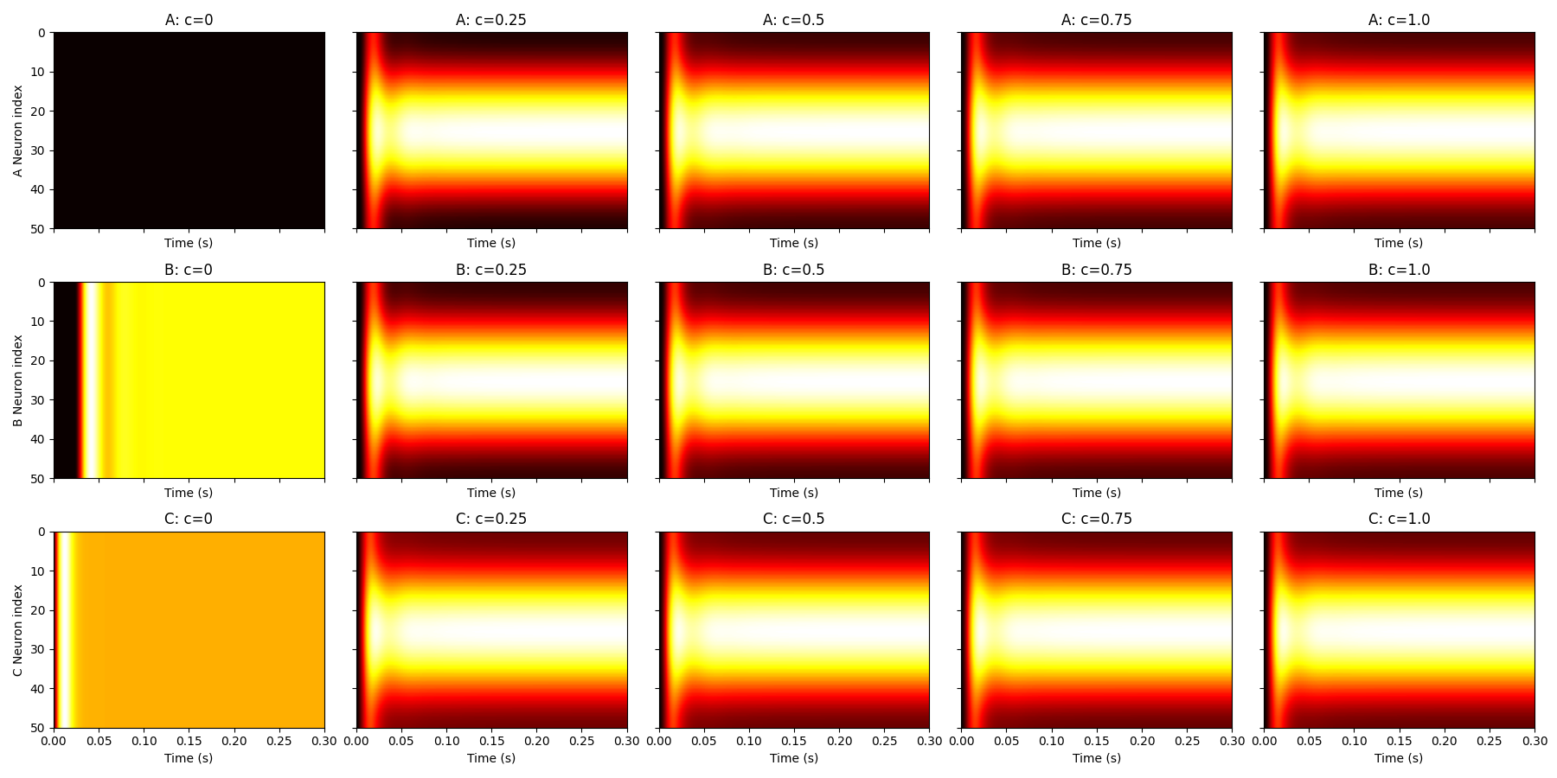

How it was made: Same as above, but for inhibitory neurons (rI).

Interpretation: B and C show spontaneous activity at c=0. C has smoother transitions with contrast.

# Question 3 – Final-timepoint heatmaps (Excitatory)

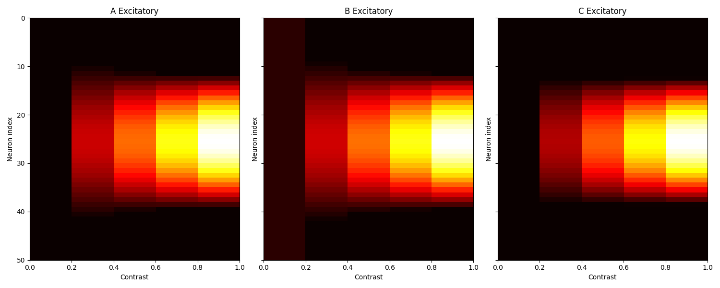

How it was made: Firing rates at final simulation time for excitatory neurons across contrasts.

Interpretation: All networks show stronger responses with increasing contrast. C has sharp, centered tuning.

# Question 3 – Final-timepoint heatmaps (Inhibitory)

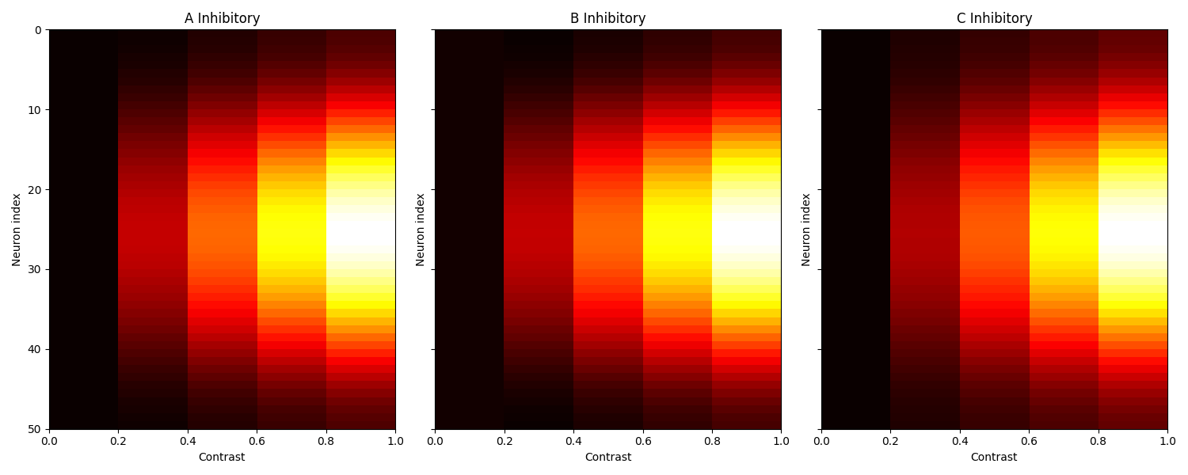

How it was made: Same as above for inhibitory population.

Interpretation: B has broad activity. C’s inhibitory input mirrors its excitatory shape.

# Question 4 – Mean-normalized heatmaps (Excitatory)

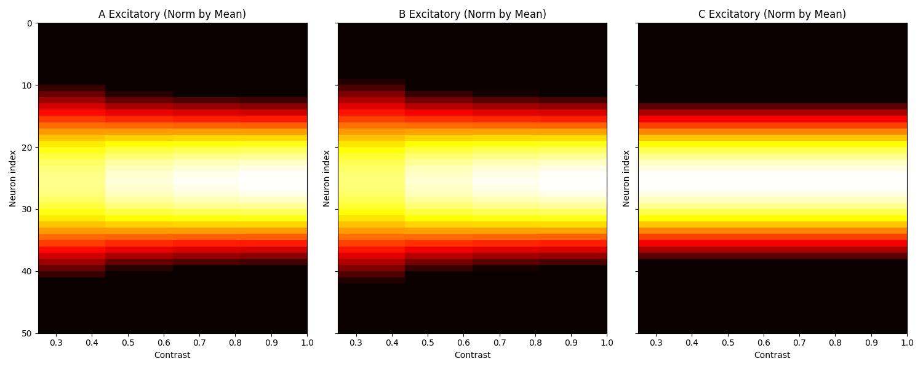

How it was made: Same data as Q3 but normalized by mean firing rate per contrast to assess contrast invariance.

Interpretation: C maintains consistent tuning shape, showing contrast-invariant scaling. A and B less so.

# Question 4 – Mean-normalized heatmaps (Inhibitory)

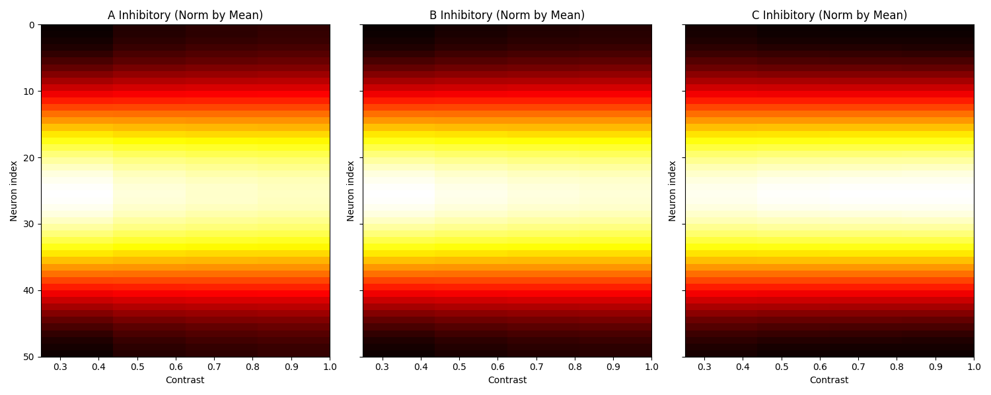

How it was made: Same as Q4 for inhibitory units.

Interpretation: C again shows good contrast invariance; A and B more variable.

# Question 5 – Orientation tuning heatmaps (Excitatory)

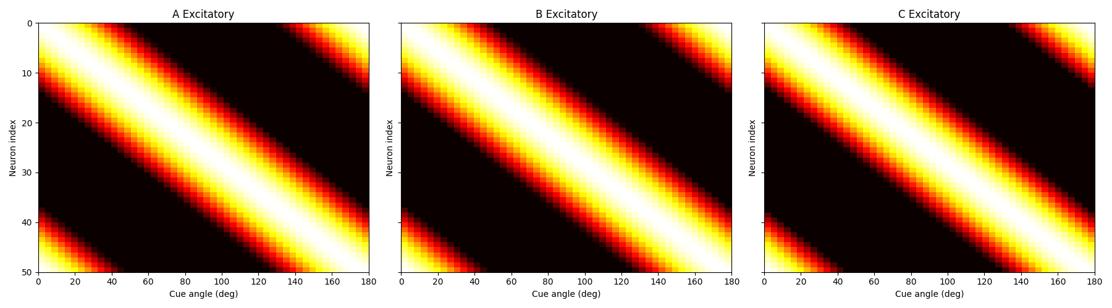

How it was made: Each neuron’s normalized response to 50 cue angles (0 to π). Built by simulating fixed contrast for each angle.

Interpretation: Neurons fire most at their preferred angle. C has narrow tuning.

# Question 5 – Orientation tuning heatmaps (Inhibitory)

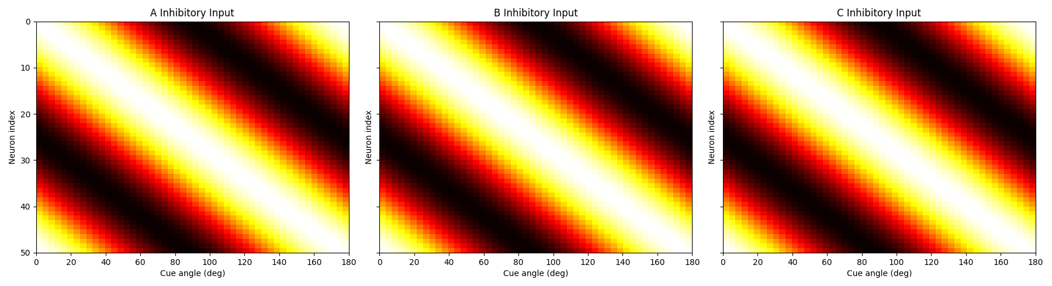

How it was made: Same as above but for total inhibitory input to each neuron.

Interpretation: C shows inhibition peaking at the same preferred angles as excitation, supporting biological findings.

# Question 6 – Tuning curve of a single neuron

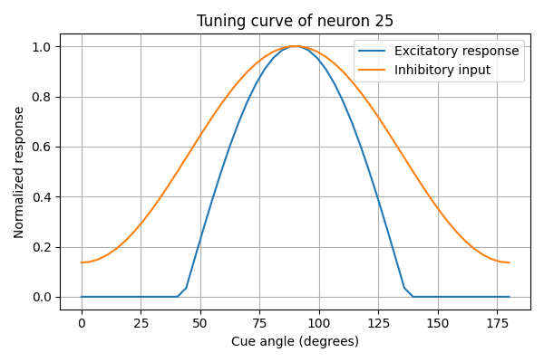

How it was made: Neuron 25's normalized excitatory and inhibitory responses vs. stimulus angle.

Interpretation: Both curves peak at same angle. Inhibition is broader, mimicking biological tuning.