Figure 1 – Student attendance at Academic Skills workshops across trimesters 2024 1

The image should:
- be left-aligned on the page
- have no border
- have no title
- be sized appropriately and consistently where possible
Use Word functionality to insert an automatically numbered caption. (Insert tab, Pictures)
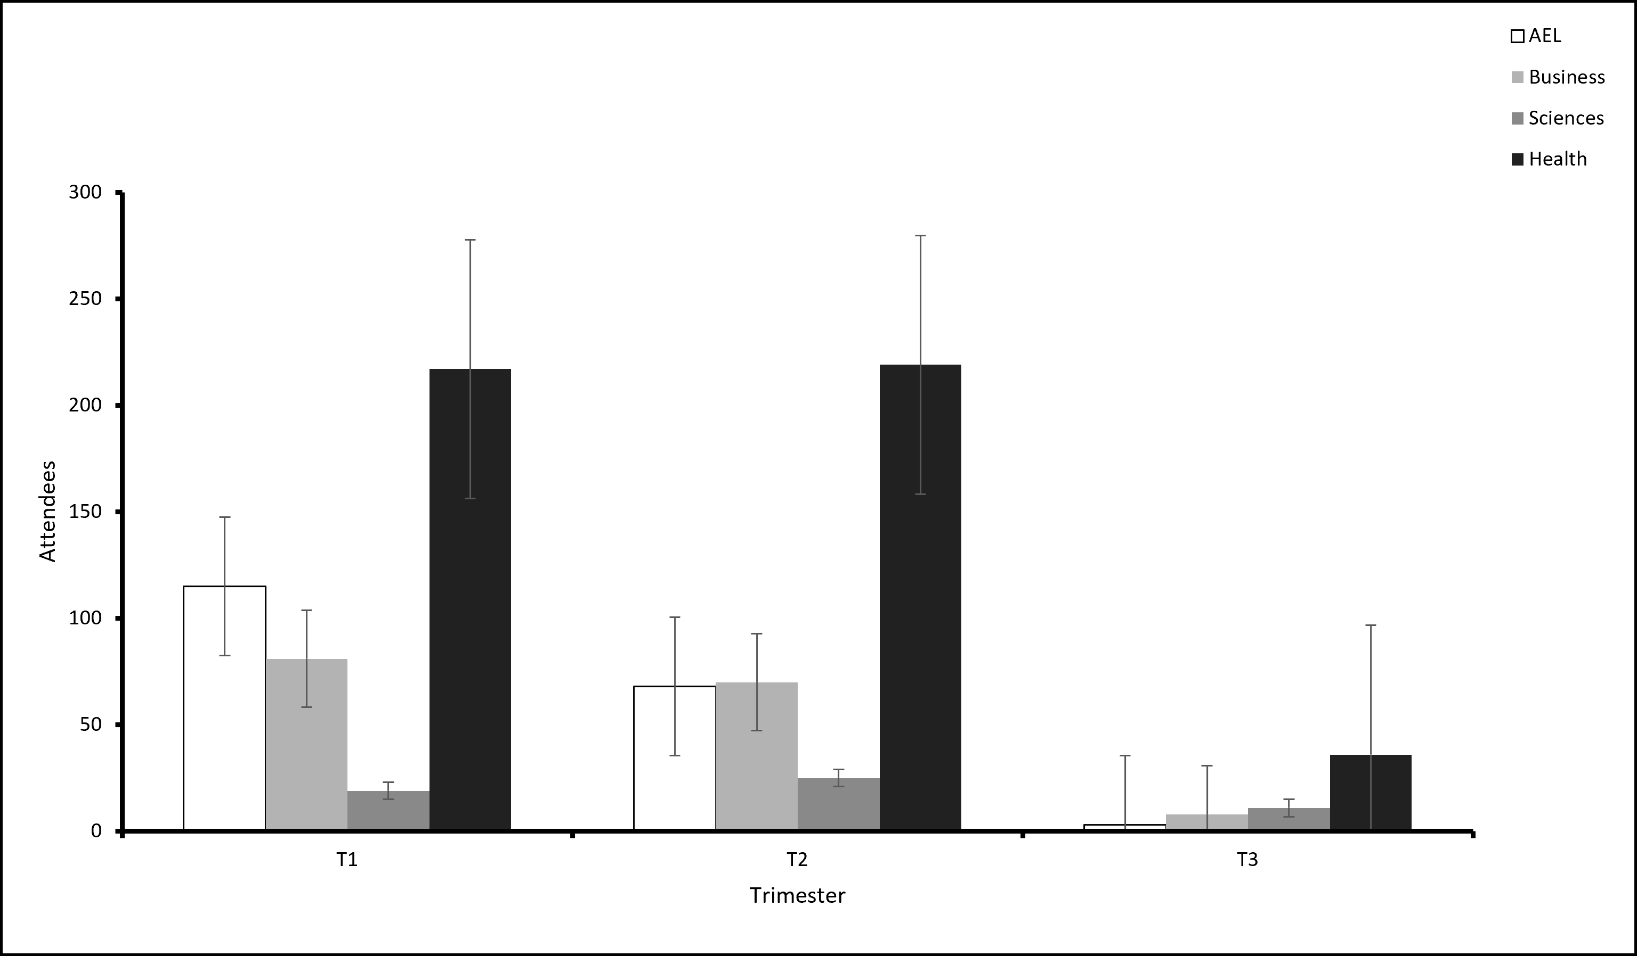
Figure 1 – Student attendance at academic skills workshops across trimesters 2024

The caption should:
- show the figure number in italics
- be a meaningful title
- be written in sentence case
- describe error bars if used
Use Word functionality to insert an automatically numbered caption. (References tab, Insert Caption)

