Project Specification

This project is based on MERN stack technology.  
This project consists of Frontend(cardbuilder) and backend(server).

So you need to install node_module of frontend and backend.

** You must install node installer .

1: Install MongoDB ( https://www.mongodb.com/try/download/community )

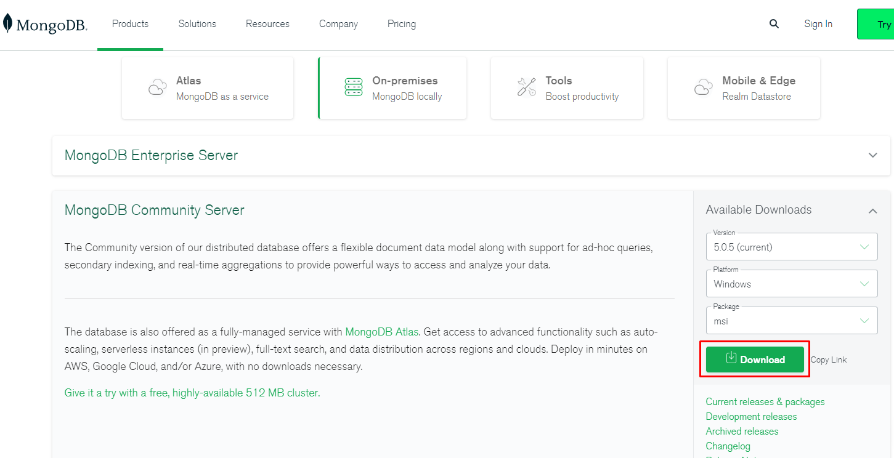

2: Install node_module on frontend.

Go to cardbuilder folder and run following command:

npm install –force

3: Install node_module on backend.

Go to server folder and run following command:

npm install

4: Run frontend and backend.

Once you install node module, you can run following command into frontend and backend folder to run project.

-frontend

npm start

-backend

npm run dev