WEALTHWISE
Smart Savings & Tax Planning Platform for India
Project Documentation — Version 5.0
Field | Value
Financial Year | FY 2026-27
Platform | Web App + PWA (Android-installable)
Tech Stack | React 18, FastAPI, Firebase, Claude AI (Anthropic)
Current Version | 5.2
Theme | Kuber / Laxmi — Saffron Gold & Temple Emerald
Status | Active Development

1. Executive Summary
WealthWise is an India-specific, AI-powered personal finance web application that helps individuals make smarter savings and investment decisions while minimising their income tax liability under FY 2026-27 rules.
Unlike generic financial advisory tools, WealthWise is built from the ground up for the Indian market — incorporating actual IT Act sections, 14 Indian investment instruments, HUF entity support, agricultural income handling, multi-source income aggregation, and the latest Budget 2025 changes including the Section 87A rebate up to ₹12 lakh taxable income.
The platform combines a deterministic multi-income tax engine, a scoring-based risk profiler, a goal-aware portfolio allocator, an IT deductions reference with 20+ sections, a monthly expense tracker with 8 Indian bank PDF parsers, a financial goals SIP planner, and a What-If scenario planner — all integrated with Anthropic Claude AI for plain-English guidance.

2. Problem Statement

2.1 The Gap in Existing Solutions
A significant portion of Indian salaried and self-employed individuals lack access to personalised, affordable financial planning. Seven comparable open-source projects were systematically analysed:

Repository | Core Approach | Critical Gaps
Mugeshwaran-k / Financial-Ai-Advisor-Bot | LLM chatbot (Clerk auth) | No tax logic. API key exposed in frontend.
Annarhysa / BudgetBud | Expense tracker with limits | No investment advice. No tax engine.
Aaditya-5281 / Finance-Advisor | Generic LLM Q&A | No regime comparison. No calculations.
marinaredamekhael / FinancialAdvisor | Rule-based budget calc | USD-centric. No India context.
hadil1999-creator / RAG_Hack_team | RAG over finance PDFs | Over-engineered. No live data. No portfolios.
imRahul05 / Fin_service | India-focused LLM wrapper | No actual tax slab code. Generic prompting only.
EnigmAI / Financely | ML sentiment + KNN | Non-Indian data. API key insecurity.

2.2 Specific Flaws Resolved by WealthWise
- No existing project implements FY 2026-27 Indian income tax slabs, regime comparison, or Section 87A rebate logic in deterministic code — all rely on vague LLM prompting.
- None cover India-specific instruments: PPF, ELSS, NPS, SGB, NSC, SCSS, or HUF entity-specific tax treatment.
- Five of seven projects expose API keys in frontend code. WealthWise uses a backend proxy — the Anthropic key never leaves the Railway server.
- No project handles multi-source income (salary + rental + FD interest + LTCG + agricultural + crypto) in a single tax computation.
- None implement agricultural income via the partial integration method or loan deductions as deduction sources.
- No project provides expenditure-based tax deductions — WealthWise auto-extracts 80D and 80C hints from the expense tracker.
- None provide a comprehensive IT Act deductions reference covering 20+ sections with limits, regime applicability, and pro tips.
- No project provides recurring transaction auto-posting, bank PDF statement import, or per-category budget alerts.
- RAG pipelines add unnecessary complexity. Claude API with a structured FY 2026-27 system prompt achieves superior accuracy with zero infrastructure overhead.

3. Objectives
- Build a fully India-specific multi-income tax engine for FY 2026-27 covering 13 income source types.
- Support HUF (Hindu Undivided Family) as an entity type alongside Individual, with correct tax treatment.
- Provide personalised portfolio allocation across 14 Indian and global asset classes with goal-aware adjustment.
- Show both pre-tax and post-tax CAGR per asset per regime, and dual corpus projections (new vs old regime).
- Create an exhaustive IT Act deductions reference covering 20+ sections with an AI advisor backed by Claude Sonnet.
- Implement a monthly income and expense tracker with expenditure-based tax deduction extraction (80D, 80C hints).
- Build a recurring transaction engine with auto-posting, CSV import from 8 major Indian banks, and per-category budget alerts.
- Deliver a financial goals module with automatic SIP calculation and instrument recommendation, integrated into the planner.
- Build a What-If scenario planner with side-by-side dual projections and milestone snapshots.
- Ensure production-grade API key security: backend proxy, rate limiting, CORS restriction, spend cap.
- Deploy as a PWA installable on Android.

4. System Architecture

4.1 High-Level Architecture
The system follows a three-tier architecture with clear separation between the client, backend, and external services:

Layer | Technology & Role
React Frontend (Vercel CDN) | UI rendering, browser-side tax calculations, PWA
Firebase Auth + Firestore | User authentication (Google/Email), per-user data storage
FastAPI Backend (Railway) | Claude AI proxy, rate limiting, CORS, multi-income API
Anthropic Claude Sonnet | Portfolio explanations, tax Q&A, savings coaching

4.2 Security Architecture
- ANTHROPIC_API_KEY stored exclusively in Railway environment variables. Never in frontend code or GitHub repository.
- All AI calls go through /ai/* FastAPI routes. Browser never contacts Anthropic directly.
- Rate limiting via slowapi: 10/min for portfolio explanations, 15/min for tax advisor, 60/min for /analyze.
- CORS locked to production Vercel domain via ALLOWED_ORIGINS environment variable.
- Firebase Security Rules: users can only read/write their own Firestore documents (matched by Firebase UID).
- Monthly spend cap set at console.anthropic.com to limit maximum financial exposure.

4.3 Firestore Data Architecture (ER Diagram)
WealthWise uses Firestore with a hierarchical sub-collection structure under each user document:
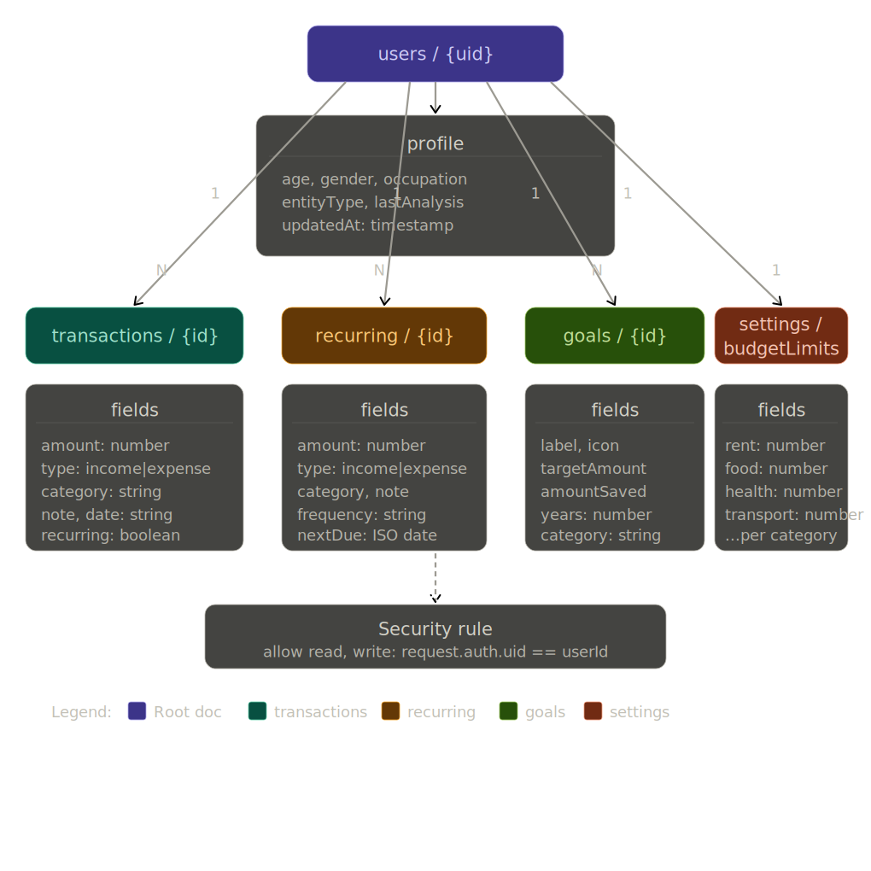
Figure 1: WealthWise Firestore Entity-Relationship Diagram
Each user document (users/{uid}) contains a profile sub-document and four sub-collections:
- transactions/{id} — individual income/expense records with category, amount, date, note, recurring flag
- recurring/{id} — recurring transaction templates with frequency and nextDue date
- goals/{id} — financial goals with target, timeline, saved amount, and SIP calculation
- settings/budgetLimits — per-category monthly budget limits (single document)

5. Application Screenshots

5.1 Income Sources — Multi-Source Input
The income form accepts 13 income source types across four groups: Ordinary Income (slab rate), Capital Gains (special rates), Special Income (exempt or 30% flat), and Loans & Deductions (old regime only).
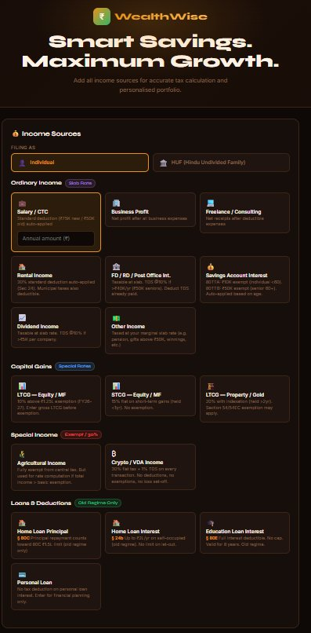
Figure 2: Income Sources Form — HUF selector, 13 income types, live tax preview

5.2 Portfolio Results — Pre/Post-Tax Corpus
Results show risk profile, total tax under best regime, and 10-year corpus under both regimes. Each asset displays pre-tax CAGR → post-tax CAGR (new) / post-tax CAGR (old) with the applicable tax rule. The projection chart shows three lines: pre-tax, new regime, old regime.
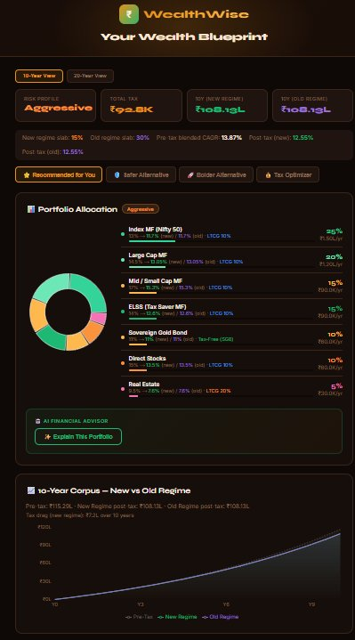
Figure 3: Portfolio Results — Aggressive profile, 10-year corpus with tax drag

5.3 Expense Tracker — Dashboard
The tracker dashboard shows monthly KPIs, spending breakdown pie, 6-month overview bar chart, filter controls, and the AI Savings Coach. Budget alerts appear at the top when any category approaches its limit.
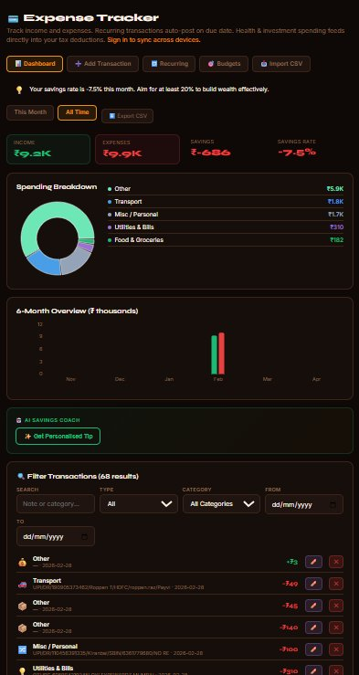
Figure 4: Expense Tracker — Dashboard with KPIs, pie chart, filter, and AI coach

5.4 Import CSV / PDF Statement
The Import tab supports CSV/Excel export from SBI (merged-cell format), HDFC, ICICI, and generic CSVs, plus direct PDF parsing for 8 major Indian banks. Transactions are auto-categorised from merchant names.
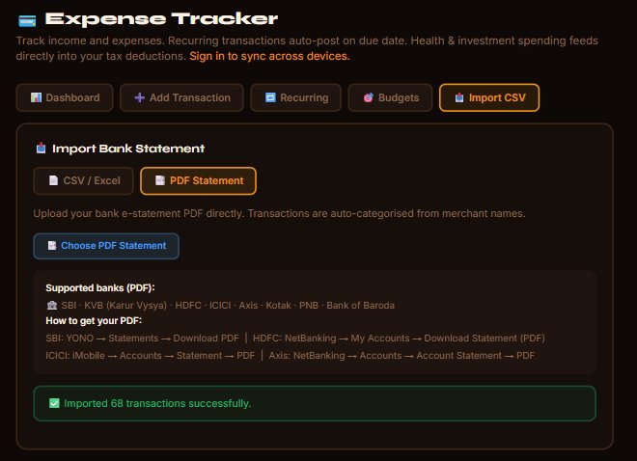
Figure 5: Import — PDF Statement mode showing 68 transactions imported from SBI PDF

6. Feature Specification

6.1 Multi-Income Tax Engine (FY 2026-27)
The tax engine handles 14 distinct income source types, computes tax under both regimes separately, and returns per-regime marginal slab rates for accurate post-tax corpus projections.

Income Source | Tax Treatment | Notes
Salary / CTC | Slab rate | Std deduction ₹75K (new) / ₹50K (old) auto-applied
Business Profit | Slab rate | Net profit after all business expenses
Freelance / Consulting | Slab rate | Net receipts after deductible expenses
Rental Income | Slab rate | 30% std deduction under Sec 24 auto-applied
FD / RD / Post Office Interest | Slab rate | TDS @10% above ₹40K/yr (₹50K seniors)
Savings Account Interest | Slab rate | 80TTA ₹10K exempt (<60); 80TTB ₹50K exempt (60+)
Dividend Income | Slab rate | TDS @10% if >₹5K per company
LTCG - Equity / MF | 10% above ₹1.25L | FY26-27 exemption raised from ₹1L to ₹1.25L
STCG - Equity / MF | 15% flat | No exemption. Holdings <1 year.
LTCG – Property (Pre Jul 23, 2024) | 20% with indexation | Held >2 years. Properties purchased/sold before July 23, 2024. Sec 54/54F/54EC exemption may apply.
LTCG – Property/Gold (Post Jul 23, 2024) | 12.5% without indexation | Budget 2024 removed indexation for properties purchased after July 23, 2024.
Agricultural Income | Exempt + rate computation | Partial integration method: exempt but shifts slab
Crypto / VDA | 30% flat + 1% TDS | No deductions, no loss set-off, no exemption.
Other Income | Slab rate | Pensions, gifts >50K, winnings, etc.

Tax Feature | Detail
New Regime Slabs | 0% ₹0-4L | 5% ₹4-8L | 10% ₹8-12L | 15% ₹12-16L | 20% ₹16-20L | 25% ₹20-24L | 30% above ₹24L
Sec 87A Rebate (New) | Zero tax if net taxable ≤ ₹12L (Budget 2025). Gross CTC ≤ ₹12.75L = zero tax.
Standard Deduction | ₹75K new regime / ₹50K old regime. Auto-applied.
HUF Treatment | Same slabs as individual. No senior citizen benefit. Interest exemption ₹50K.
Per-Regime Slab Rates | NEW: New and old regime each get their own marginal slab rate, producing two different post-tax corpora (fixes identical corpus glitch).

6.2 Asset Classes (14 Total) with Tax Rules
Every asset carries its tax rule. Post-tax CAGR is calculated per regime using that regime's marginal slab rate.

Asset | Pre-Tax CAGR | Tax Rule | Post-Tax @ 30% | Lock-in
PPF | 7.1% | Tax-Free (EEE) | 7.1% | 15yr
Savings Account | 3.5% | Slab Rate | 2.45% | None
Fixed Deposit | 7.2% | Slab Rate | 5.04% | 1-5yr
NPS | 11.0% | Partly Tax-Free | ~9.7% | Till 60
Debt Mutual Fund | 7.5% | Slab Rate | 5.25% | None
Digital Gold / ETF | 11.0% | LTCG 12.5% | 9.625% | None
Sovereign Gold Bond (SGB) | 11.0% | Tax-Free (maturity) | 11.0% | 8yr
ELSS (Tax Saver MF) | 14.0% | LTCG 10% | 12.6% | 3yr
Index MF (Nifty 50) | 13.0% | LTCG 10% | 11.7% | None
Large Cap MF | 14.5% | LTCG 10% | 13.05% | None
Mid / Small Cap MF | 17.0% | LTCG 10% | 15.3% | None
Direct Stocks | 15.0% | LTCG 10% | 13.5% | None
Real Estate | 9.5% | LTCG 20% | 7.6% | 5yr+
Bitcoin / Crypto | 35.0% | 30% Flat | 24.5% | None

6.3 Expense Tracker — v5 Features
- Recurring Transactions: toggle on add, auto-posts overdue recurring templates on app load.
- Pagination + Filtering: search by note, filter by type/category/date range, paginated in batches of 20.
- CSV Export: downloads filtered transactions as .csv with date, type, category, amount, note.
- Budget Alerts: per-category monthly limits with 90% warning and 100% exceeded alert banners.
- CSV Import: auto-detects SBI Excel export (merged-cell fixed-column format), HDFC, ICICI, and generic CSVs.
- PDF Import: 8 Indian bank parsers (SBI, KVB, HDFC, ICICI, Axis, Kotak, PNB, Bank of Baroda). Text extracted via PDF.js, grouped by Y-coordinate to reconstruct rows.
- Edit Transactions: every transaction row has an edit button (✏️) opening an EditModal to change type, amount, category, date, note.
- Empty States: helpful illustrated empty states for no transactions, no filter results, no recurring templates, no budgets.
- Family Category: added for household/dependent expenses alongside 10 other expense categories.
- Auto-Categorisation: autoCategory() function categorises from merchant name. KIIT Hospitality → food; personal UPI transfers → misc/personal.

6.4 Goals + SIP Calculator
- 8 pre-built templates: House, Car, Education, Wedding, Travel, Retirement, Emergency Fund, Business.
- SIP formula: SIP = (Target - Saved) x r / ((1+r)^n - 1) where r = monthly rate, n = months.
- Instrument recommendation: maps goal timeline to optimal asset (FD for <1yr, Index MF for 7yr+).
- Goals loaded into Planner: portfolio automatically adjusted based on goal timelines.

6.5 IT Deductions Reference (20+ Sections)
Each section includes exact limit, regime applicability, eligible instruments, conditions, pro tip, and an "Ask AI about this section" button that calls the backend tax advisor with user context.

7. Technical Implementation

7.1 AI Integration Design

Approach | Build Time | Accuracy | Cost | Chosen?
Train custom model | 3-6 months | Low | GPU servers | No
RAG pipeline (vector DB) | 2-3 weeks | Good | Vector DB + embeddings | No
Claude API + system prompt | 1 day | Excellent — native FY26-27 knowledge | Pay-per-call | YES

7.2 Frontend Architecture

File | Purpose
App.jsx | Main app: 3-step planner, 5-page routing, bottom nav, savings toggle, goal loading
IncomeForm.jsx | Multi-source income entry. SafeInput and SrcGroup hoisted to module scope (cursor/scroll fix).
taxEngine.js | All tax logic, risk profiler, portfolio generator, projection, tracker savings calc. Pure JS.
api.js | All backend HTTP calls. No API key present anywhere in this file.
Tracker.jsx | Expense tracker: recurring, pagination, CSV/PDF import, budget alerts, edit modal, 8 bank parsers.
Goals.jsx | Goal setting with SIP calculator, instrument recommendation, progress tracking.
Scenarios.jsx | What-if planner with 4 presets, dual chart, milestone table.
ITSections.jsx | 20+ IT Act sections guide. Per-section AI advisor calls /ai/tax-advisor.
Login.jsx | Google Sign-in + Email/Password UI with guest skip option.
AuthContext.jsx | Global auth state. Auto-loads Firestore profile on login.
firebase.js | Firebase init + all Firestore CRUD helpers for profiles, transactions, goals, recurring, budgets.
index.css | Kuber/Laxmi theme: saffron gold (#E8921A), midnight maroon (#0e0806), temple emerald (#1DB873).

7.3 Backend API Routes

Route | Method | Rate Limit | Description
GET /health | GET | None | Server health check
POST /analyze | POST | 60/min | Full analysis: multi-income tax + risk + portfolios + projections
POST /ai/explain-portfolio | POST | 10/min | Claude explains portfolio with post-tax CAGR and income mix context
POST /ai/tax-advisor | POST | 15/min | Free-form tax Q&A. Includes user profile context (income, slab, occupation).

8. Bug Register
All significant bugs encountered during development are documented here for transparency and to demonstrate debugging methodology.

Bug | Root Cause | Fix | Version
Cursor disappears after 1 digit in IncomeForm | SafeInput and SrcGroup defined inside IncomeForm. Every keystroke → parent re-render → React sees new component type → unmounts input → focus lost. | Hoist SafeInput and SrcGroup to module scope (outside function). React reuses stable instances. | v4 fix
Page scrolls to top on keypress | Same as above: input remount caused layout recalculation that shifted scroll position. | Module-scope hoist + 400ms debounce on taxResult useMemo. No layout shift while typing. | v4 fix
Vercel build failure: Unterminated regular expression (Tracker.jsx:433) | Multi-line regex literal in autoCategory() function. JavaScript/esbuild requires all regex patterns to be on a single line. | Collapsed all regex patterns in autoCategory() to single lines. Logic unchanged. Example: /zomato|swiggy|...|kiit hospitality|.../ → one line. | v5 fix
Vercel build failure: React hook called at module scope | export default function Tracker() { ... } wrapper declaration was accidentally deleted during editing. All hooks (useAuth, useState, etc.) were called at module scope — invalid in React. | Re-added export default function Tracker() { declaration before the first hook call. All hooks correctly inside the component function. | v5 fix

8.1 v4 — IncomeForm Cursor & Scroll Root Cause Analysis
Root Cause: Component definitions inside parent functions cause React to treat them as new component types on every render, triggering unnecessary unmounts and remounts.
Both bugs shared the same cause. SafeInput and SrcGroup were defined inside IncomeForm. On every keystroke:
- The parent IncomeForm re-rendered (state update from typing).
- New function references were created for SafeInput and SrcGroup.
- React compared old and new component types — different references = different components.
- React unmounted the old input and mounted a fresh one — destroying focus.
- The DOM layout recalculation from the remount caused the page to scroll to the top.
Fix: Both components hoisted to module scope. Their identity is stable across parent re-renders. React reuses the same instances. Additional: taxResult debounced 400ms to prevent recalculation on every keypress.

8.2 v5 — Vercel Build Failures
Both v5 build errors were caught at deployment time by Vercel's esbuild compilation step, not at runtime. Neither was visible in local npm run dev.
Bug 1 — Unterminated Regular Expression: Multi-line regex literals span two or more source lines. The JavaScript/esbuild parser requires all regex patterns to be on a single line — a line break inside /pattern/ is a syntax error. autoCategory() had patterns spanning 2-3 lines for readability during development.
Fix: All regex patterns in autoCategory() collapsed to single lines. Identical logic, no multiline regex literals.
Bug 2 — React Hook at Module Scope: The export default function Tracker() { wrapper declaration was accidentally deleted during a multi-step editing session. All useState, useEffect, useCallback, useMemo, and useRef calls were at module-scope level — valid JavaScript but illegal in React (hooks must be called inside a component or custom hook).
Fix: Re-added export default function Tracker() { before the first hook call. All hooks correctly scoped inside the component function.

9. Deployment

9.1 Infrastructure & Cost

Service | Provider | Tier | Monthly Cost
Frontend | Vercel | Hobby (free) | ₹0
Backend | Railway | Hobby ($5 credit) | ₹0
Database + Auth | Firebase (Spark Plan) | Free tier | ₹0
AI API | Anthropic | Pay-per-use | ~₹0.50 per 100 calls
Total | — | — | ₹0–₹67/month

9.2 CI/CD Pipeline
- Developer edits code and tests locally on localhost:3000 (frontend) and localhost:8000 (backend).
- Commit and push: git add . && git commit -m "description" && git push
- Vercel auto-detects the push, rebuilds React app, deploys to CDN (~2-3 minutes).
- Railway auto-detects the push, rebuilds FastAPI server, restarts (~2-3 minutes).
- Zero manual steps. Changes are live at the production domain automatically.

10. Comparative Analysis
WealthWise v5 compared against the best feature from each of the 7 referenced competing projects:

Feature | WealthWise v5 | Best Competitor
India FY 2026-27 tax engine | Full code implementation | None of 7 projects
New vs Old regime comparison | Yes — with rupee savings + per-regime slab rates | None
Section 87A rebate (Budget 2025) | Implemented | None
HUF entity type | Yes — correct tax treatment | None
Agricultural income (partial integration) | Yes | None
Multi-source income (13 types) | Yes — salary, rental, LTCG, crypto, agri, etc. | None
Loan deductions (home, education) | Yes — old regime | None
Per-asset post-tax CAGR per regime | Yes | None
Dual corpus chart (new vs old) | Yes — 3 lines (pre-tax, new, old) | None
20+ IT Act sections + AI advisor | Complete guide | None
14 Indian + global asset classes | PPF, NPS, ELSS, SGB, Crypto, Savings A/C, etc. | None
Expenditure-based tax deductions | 80D from health spending, 80C hints | None
Goal-aware portfolio adjustment | Yes — adjusts allocation by timeline | None
Savings auto-calc from tracker | Yes — toggle manual/auto | None
API key security (backend proxy) | Full — key never in frontend | Mostly exposed in frontend
Firebase Auth (Google + Email) | Yes + guest mode | Mugeshwaran-k (Clerk only)
Expense tracker with AI coach | Yes + family category + deduction panel | Annarhysa/BudgetBud (no AI)
Recurring transactions | Yes — auto-post on due date | None
CSV import from bank statement | Yes — SBI/HDFC/ICICI auto-detect | None
PDF bank statement import | Yes — 8 banks (SBI, KVB, HDFC, ICICI, Axis, Kotak, PNB, BOB) | None
Edit transactions | Yes — inline edit modal | None
Budget alerts per category | Yes — 90% warning, 100% exceeded | None
Goals + SIP + instrument recommendation | Yes + integrated into planner | BudgetBud (basic)
LTCG indexation split (pre/post Jul 2024) | Yes — 20% with indexation vs 12.5% without | None
Scenario planner with milestones | Yes — 4 presets + custom + dual chart | imRahul05 (basic)
PWA / Android installable | Yes (manifest.json) | None
ML model training required | No | EnigmAI (KNN + K-Means)
Kuber/Laxmi visual theme | Yes — saffron, maroon, emerald | None

11. Limitations & Future Work

11.1 Known Limitations
The following limitations are acknowledged and will be addressed in future versions:
- Asset CAGR values are static historical averages — not connected to live AMFI, MCX, or CoinGecko data. All 14 asset class returns are hardcoded research-based estimates.
- HRA (House Rent Allowance) and LTA (Leave Travel Allowance) are not yet individually input in Step 1. The old regime comparison uses standard assumptions. Users with significant HRA or LTA claims may see a slightly understated old regime benefit. This is the highest-priority limitation for the next update.
- Home loan principal (80C) and home loan interest (Section 24b) are entered as combined loan deductions rather than separate fields, which may limit precision for users with complex home loan structures.
- No Form 16, AIS, or investment statement PDF upload/parsing. Users must manually enter income sources.
- Futures and options are excluded from portfolio allocation as they require specialist knowledge to recommend safely.
- React Native / Expo app for Play Store not yet built; currently PWA-only for Android installation.
- PDF bank statement parsers use regex-based text extraction and may fail on non-standard PDF formatting or password-protected statements.

11.2 Roadmap

Planned Feature | Priority | Effort
HRA + LTA inputs in tax engine Step 1 | High | 3 days
Home loan principal + interest separate inputs (Old Regime) | High | 2 days
Live MF NAV data via AMFI API | High | 1 week
Live FD rates via RBI / bank scraping | High | 1 week
Form 16 / AIS PDF upload + parsing (Claude document API) | High | 2 weeks
Live stock/MF prices tab (yfinance + AMFI + CoinGecko) | Medium | 2 weeks
n8n automation for daily rate updates | Medium | 1 week
Crypto tax calculator (30% flat + 1% TDS per transaction) | Medium | 3 days
Section 54F and 54B LTCG exemption claim calculator (auto-compute reinvestment amount needed) | Medium | 2 days
Open-source LLM option (Groq / Gemini free tier) | Medium | 3 days
SIP reminder push notifications (PWA) | Medium | 1 week
React Native app via Expo EAS for Play Store | Medium | 3 weeks
PyPortfolioOpt (Markowitz MPT) for v6 portfolio | Low | 4 weeks
Multi-language support (Hindi, Tamil, Telugu) | Low | 3 weeks
DigitalOcean migration + Mumbai CDN | Low | 1 week
CSV / PDF export of full financial plan | Medium | 1 day

12. References

12.1 Competing Projects Analysed
- Mugeshwaran K. Financial-Ai-Advisor-Bot. GitHub. https://github.com/Mugeshwaran-k/Financial-Ai-Advisor-Bot
- Annarhysa. BudgetBud. GitHub. https://github.com/Annarhysa/BudgetBud
- Aaditya-5281. Finance-Advisor. GitHub. https://github.com/Aaditya-5281/Finance-Advisor
- marinaredamekhael. FinancialAdvisor. GitHub. https://github.com/marinaredamekhael/FinancialAdvisor
- hadil1999-creator. RAG_Hack_team. GitHub. https://github.com/hadil1999-creator/RAG_Hack_team
- imRahul05. Fin_service. GitHub. https://github.com/imRahul05/Fin_service
- EnigmAI. Financely. GitHub. https://github.com/EnigmAI/Financely

12.2 Regulatory & Government Sources
- Income Tax Department of India. Income Tax Act 1961 — FY 2026-27. https://www.incometax.gov.in
- Ministry of Finance, Government of India. Union Budget 2025-26. https://www.indiabudget.gov.in
- AMFI India. Mutual Fund Historical NAV Data. https://www.amfiindia.com
- Reserve Bank of India. Small Savings Instruments Interest Rates. https://www.rbi.org.in
- PFRDA. NPS Tier I Account Rules and Deduction under 80CCD. https://www.pfrda.org.in
- Ministry of Finance. HUF Taxation Guidelines. https://www.incometax.gov.in

12.3 Technology Documentation
- Anthropic. Claude API Documentation. https://docs.anthropic.com
- Meta / Facebook. React 18 Documentation. https://react.dev
- Tiangolo. FastAPI Python Web Framework. https://fastapi.tiangolo.com
- Google Firebase. Firebase Auth and Firestore. https://firebase.google.com/docs
- Vercel. Frontend Deployment and CDN. https://vercel.com/docs
- Railway. Backend Deployment Platform. https://docs.railway.app
- Laurent Senta. slowapi — Starlette/FastAPI Rate Limiting. https://github.com/laurentS/slowapi
- Mozilla. PDF.js — Client-side PDF Parsing. https://mozilla.github.io/pdf.js/
- Groq. Groq API — Free LLM Inference. https://console.groq.com
- Google. Gemini API Documentation. https://ai.google.dev
End of Document — WealthWise Project Documentation v5.0

