**MAP 523/DPS 923**

**Lab One**

For this lab, you are requested to develop a timer app. Once the app is launched, the user is required to enter an integer to set up the minutes for the countdown. If the entered integer is less than one or more than 60, the user should be warned with a message “The number must be between 1 and 60”.

Once the minute is set up, the user may click the start button in which case, the timer starts to count down and displayed in: “MM:SS” format.

**Hint:** The following table shows you how to create a timer that calls a function periodically.

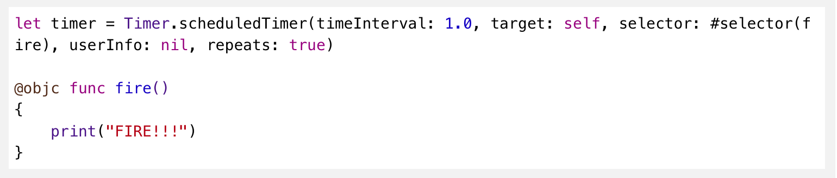

**Optional Part:**

Make it so that the user is able to pause/start/reset the timer when required.