**MAP523/DPS923**

**Lab Three**

In this lab, you are requested to create a class “Bullet” that will be used in class “enemy” that we built during the last lecture.

A bullet has a graphical representation, direction, speed and spawning point. Use the following types for these attributes:

Speed: float

Direction: struct (x, y)

Spawning point: struct(x, y)

Structures in swift are simply defined as follows:

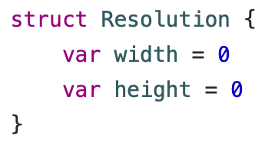

Screen%20Shot%202019-05-21%20at%207.51.02%20AM.png

Finally, you can use vga.width and vga.height to access these properties. If you need more details, you can refer to the following link:

<https://docs.swift.org/swift-book/LanguageGuide/ClassesAndStructures.html>

For this class, you are required to:

* Create appropriate constructors for the bullet class
* Create a method start() that updates the position of the bullet periodically toward the direction of the move.

**Note:** You must incorporate the velocity parameter into this method to affect the motion of the bullet, i.e. bullets with higher speed move faster

* The bullet will start to move beginning from the spawning point
* You may use any other helper methods, if needed
* The bullet must be wiped out from the memory as soon as it is outside of the boundaries of the screen.

Once you have finished the class bullet, test the methods to make sure that they work fine.