**SENECA COLLEGE OF APPLIED ARTS AND TECHNOLOGY**

**SCHOOL OF INFORMATION AND COMMUNICATIONS TECHNOLOGY – SY**

**TEST FIVE**

TERM Summer 2017

Course WEB 222

NAME:

STUDENT NUMBER:

SECTION:

DATE: Wednesday, August 02, 2017

TIME ALLOWED: 50 Minutes

**SPECIAL INSTRUCTIONS:**

1. Manage your time carefully.
2. This is a closed-book exam; therefore, you cannot use any materials.
3. Please use the question pages to write down your answer.
4. For multiple choice questions, draw a circle around the correct answer.

This exam includes a *cover page*, plus 5 pages of *question*.

* Which of the following statements in NOT true about the “Document” object?
  + It the root node of the HTML document
  + When an HTML document is loaded into a web browser, it becomes a document object.
  + Can be accessed by calling document.getElementById()
  + Provides properties and methods to access all node objects, from within JavaScript.

1. Consider the html tag here: <input type=”text” onclick=”someFunction(this)” />. The keyword “this” refers to which of the following?
   1. The “text” attribute of the <input> tag.
   2. The <input> tag.
   3. It has no meaning here and the syntax of this <input> tag is wrong here
   4. None of above
2. Consider the following html code:

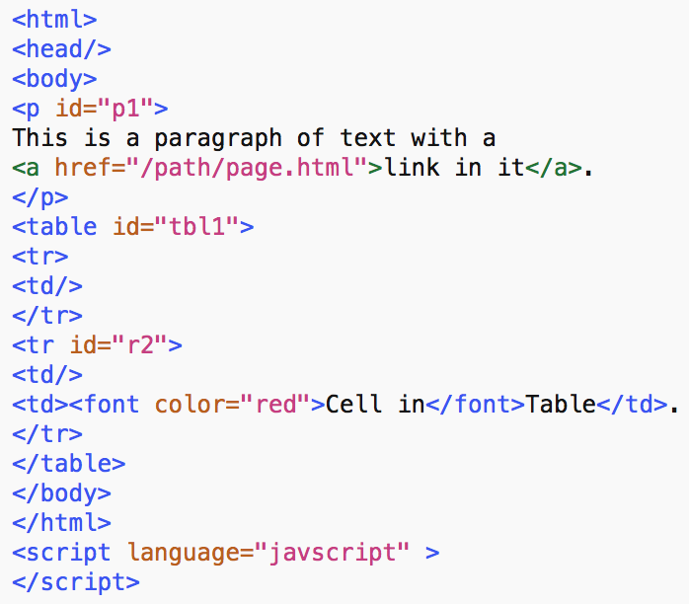

Assuming that the <html> tag is the root of the document (document.documentElement returns <html>), answer the following question:

What is the number of children of the <p> tag?

* 1. 1
  2. 2
  3. 3
  4. 4

1. In the DOM, every node has some properties that contain some information about that node. The properties are:
   1. nodeName
   2. nodeValue
   3. nodeType
   4. All of above
2. What two structures is JSON built on?
   1. A collection of name/value pairs, and an ordered list of values, or array.
   2. A collection of object/item pairs, and an ordered list of pairs, or array.
   3. A collection of name/value objects, and an ordered list of objects, or array.
   4. A collection of native-value pairs, and an ordered list of arrays, or values.
3. How are the objects organized in HTML DOM?
   1. Class-wise
   2. Queue
   3. Hierarchy
   4. None of the mentioned
4. What will be the output of the following code fragment?

<html>

<head>

<title>A Simple Page</title>

<script language="JavaScript">

var A = "Compile ",

B = "Error";

C = A + B;

alert(C);

</script>

</head>

<body></body>

</html>

* 1. “Compile Error ” will be printed
  2. Nothing will be printed
  3. None of these

1. Which of the following is NOT the proper way of creating an object in JavaScript?
   1. var person = {firstName:"John", lastName:"Doe", age:50, eyeColor:"blue"};
   2. var person = {firstName:"Alex", getName: function() {return this.firstName}};
   3. var person = new Object();
   4. var person = new Object(“John”, “Doe”, 50, “Blue”);
2. Write down the advantages of JSON over XML as we discussed in class.

|  |
| --- |
| No tags, less overhead  Compatible with mobile devices  Easier when used in JavaScript (parse, string functions in JavaScript support JSON) |

1. In a few sentences, explain the “WSDL” in the context of web-service.

|  |
| --- |
| The description of the service provided by server. Specifically, name of functions, parameters for each function, return type, etc. |

1. In SOAP-based web-services, what is the type or structure of the messages exchanged between the client and the server? (This is a short answer question).

XML

1. In the box below, provide the equivalent JSON code for the following XML:

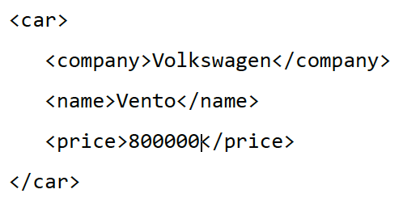

|  |
| --- |
| Car = {company:”Volkswagon”, “name”:Vento, price:”800000”} |

1. Using ONLY JavaScript recreate the following html element with its attributes and text. Assign the created element into a variable called “inpt”.

<button value=”Alex” name=”uname”>Click Me</button>

|  |
| --- |
| Var inpt = Document.createElement(“button”);  b.setAttribute(“value”, “Alex”);  b.setAttribute(“name”, “uname”);  b.innerHTML=”Click Me”; |

1. For each of the following, write down the appropriate selector to select the specified elements.
   1. Select all <button> elements.

button

* 1. Select all <h1> and <h2> elements.

h1, h2

* 1. Select all tables whose class is “students”.

Table.students

1. Create an object in JavaScript that contains a collection of cars in it. For this object, create a function addCar(name) that adds this car to the collection. Next, provide another function displayCars() that prints out the name of all cars in this collection separated by a comma. Example:

addCar(“BMW”);

addCar(“Porsche”);

addCar(“Benz”);

displayCars();

Output: BMW, Porsche, Benz

<script>

function person() {

cars = ["A", "B"];

this.addCar = function(car){

cars[cars.length] = car;

}

this.display = function() {

for (var i = 0; i < cars.length; i++) {

console.log(cars[i]);

}

}

};

var p1 = new person();

p1.addCar("BMW");

p1.display();

</script>