**SENECA COLLEGE OF APPLIED ARTS AND TECHNOLOGY**

**SCHOOL OF INFORMATION AND COMMUNICATIONS TECHNOLOGY – SY**

**TEST FOUR**

TERM Summer 2017

Course WEB 222

NAME:

STUDENT NUMBER:

SECTION:

DATE: Wednesday, July 19, 2017

TIME ALLOWED: 60 Minutes

**SPECIAL INSTRUCTIONS:**

1. Manage your time carefully.
2. This is a closed-book exam; therefore, you cannot use any materials.
3. Please use the question pages to write down your answer.
4. For multiple choice questions, draw a circle around the correct answer.

This exam includes a *cover page*, plus 5 pages of *question*.

1. XML is designed to _________ and store data.
   1. Transport
   2. Design
   3. Verify
   4. Represent
2. What is the correct syntax of the declaration which defines the XML version?
   1. <xml version="A.0" />
   2. <? xml version="A.0" ?>
   3. <? xml version="A.0" />
   4. None of above
3. XML validation is:
   1. To check the syntax of XML and to make sure that tags are in proper order
   2. To check the grammar of XML file
   3. To check for the successful transmission of the XML file
   4. All of above
4. The use of a DTD in XML development is:
   1. required when validating XML documents
   2. no longer necessary after the XML editor has been customized
   3. used to direct conversion using an XSLT processor
   4. a good guide to populating a templates to be filled in when generating an XML document automatically
5. **The attribute used to define a new namespace is**
   1. XMLNS
   2. XMLNamespace
   3. NameSpace
   4. None of above
6. Which of the following changes the style of all elements whose class is equal to “cen”?
   1. #cen
   2. #.cen
   3. .cen
   4. p.cen
7. Which of the following statements returns the <html> element?
   1. Document.getHtmlNode()
   2. Document.documentElement
   3. Element.rootElement()
   4. Element.documentElement
8. If we open a XML file with a browser, the browser will:
   1. Display the file as a plain text file with all tags and elements in it, just as typed in
   2. Display it as an HTML file, e.g. it will trash the tags and will ONLY display the data for each tag
   3. Display a blank page, since browsers ONLY display HTML, but not XML
   4. Will display the tags and data as they have been typed in, further, displays them in a hierarchy view
9. Which of the following is the proper way of assigning a listener to an element?
   1. Document.addEventListener(“click”, void function());
   2. <button onclick=”myFunction(3, 4)”>Click Me</button>
   3. Element.addEventListener(“click”, function() {console.log(“Event Handled”)});
   4. Both (b) and (c) are correct.
10. Which of the following represents the inline CSS for an <h1> tag?
    1. <style "color:blue;margin-left:30px;"> <h1>Hello World!!!</h1> </style>
    2. <h1 style="color:blue;margin-left:30px;"> Hello World!!! </h1>
    3. <style> h1 { color:blue;margin-left:30px; } </style> <h1>Hello World!!!</h1>
    4. Both (b) and (c) are correct
11. Which of the following statements is NOT true about the “Document” object?
12. It is the root of the HTML document
13. When an HTML document is loaded into a web browser, it becomes a document object
14. Can be accesses by calling document.getElementById()
15. Provides properties and methods to access all node objects, from within JavaScript.
16. In the box provided below, explain the advantages of transferring data over a network as “Text” over “Binary”.

|  |
| --- |
| * Platform Independent * Well-Structured for transportation, therefore, understandable by human * Can be opened by any simple editor |

1. In the following code fragment, modify the style of the paragraph text using JavaScript code. Clicking on the button the font size and color of the paragraph text will be changed.

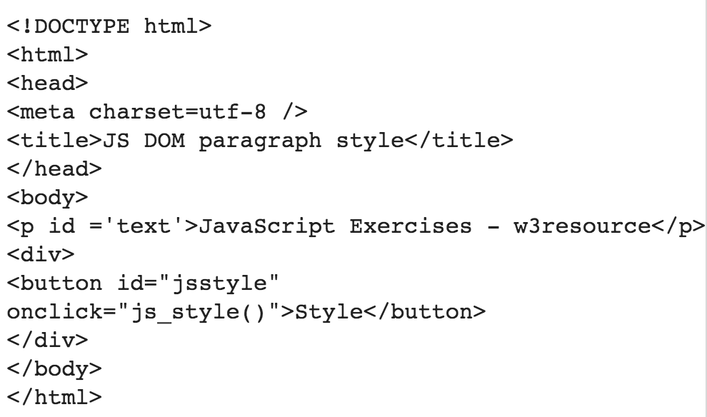

|  |
| --- |
| Document.getElementById(“text”).style.color=”Red”  Document.getElementById(“text”). style.fontsize=12 |

1. Look at the following code fragment. Write a JavaScript program to removes items from a dropdown list one at a time.

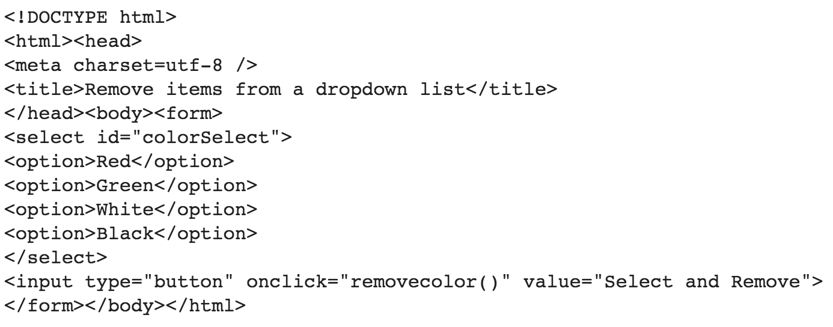

|  |
| --- |
| Var tmp = Document.getElementById(“colorSelect”);  tmp.removeChild(tmp.firstChild) |

1. In the following box, develop a function in JavaScript that accepts an integer as argument and decides if this number is a prime number. A prime number is ONLY divisible by itself and 1.

|  |
| --- |
| For(var I = 2; I < n; i++)  {  if (n%i == 0) return false;  } |

1. Consider “Book” as an object. In the following box, write down XML code to represent it.

|  |
| --- |
| <book ISBN=”123456”>  <author> William </author>  <title>Something</title>  </book> |

1. Consider node “B” whose id=”bbb” with three children and a parent in a DOM tree. Write down JavaScript code in the following box to swap ONLY node “B” with its firshChild. Note: do not apply any change to other parts of the tree.

|  |
| --- |
| For(var I = str.length – 1; I >= 0; i--)  {  Console.log(str.charAt(i));  }  If you store the reversed in an array and return the array, it will also be accepted |

1. In the following box, write down a function that accepts a string and outputs the reverse of that string.

Note: Use str.charAt(idx) to return the character stored at index=idx in a string.

|  |
| --- |
| Function reverse(text)  {  for(var i = text.length-1; I >=0; i--)  {  console.log(text[i]);  }  } |

1. In the following box, write down a JavaScript code that turns the color of all <p> tags to “Red”.

|  |
| --- |
| Var arr = Document.getElementsByTagName(“p”);  For (var I = 0; I < arr.length; i++) arr[i].style.color=”Red”; |

1. Write down a JavaScript function that accepts a string as argument and decides if it is a palindrome. Palindrome is a word, phrase, or sequence that reads the same backward as forward, e.g., *madam.*

Note: Use str.charAt(idx) to return the character stored at index=idx in a string.

|  |
| --- |
| This is the PseudoCode: (Any other algorithm with correct logic will also be accepted)  function isPalindrome (text)  if text is null  return false  left ← 0  right ← text.length - 1  while (left < right)  if text[left] is not text[right]  return false  left ← left + 1  right ← right - 1  return true |