**SENECA COLLEGE OF APPLIED ARTS AND TECHNOLOGY**

**SCHOOL OF INFORMATION AND COMMUNICATIONS TECHNOLOGY – SY**

**TEST THREE**

TERM Summer 2017

Course WEB 222

NAME:

STUDENT NUMBER:

SECTION:

DATE: Wednesday, July 5, 2017

TIME ALLOWED: 60 Minutes

**SPECIAL INSTRUCTIONS:**

1. Manage your time carefully.
2. This is a closed-book exam; therefore, you cannot use any materials.
3. Please use the question pages to write down your answer.
4. For multiple choice questions, draw a circle around the correct answer.

This exam includes a *cover page*, plus 5 pages of *question*.

1. Which of the following is NOT the proper way of creating an object in JavaScript?
   1. var person = {firstName:"John", lastName:"Doe", age:50, eyeColor:"blue"};
   2. var person = {firstName:"Alex", getName: function() {return this.firstName}};
   3. var person = new Object();
   4. var person = new Object(“John”, “Doe”, 50, “Blue”);
2. Consider the html tag here: <input type=”text” onclick=”someFunction(this)” />. The keyword “this” refers to which of the following?
   1. The “text” attribute of the <input> tag.
   2. The <input> tag.
   3. It has no meaning here and the syntax of this <input> tag is wrong here.
   4. None of above
3. The “Cascading Style Sheets” describe the ____________ of a webpage.
   1. contents
   2. representation
   3. scripts
   4. (a) and (c) both are correct
4. In the following code fragment, the character ‘p’ in ‘p {…}’ is referred to as:

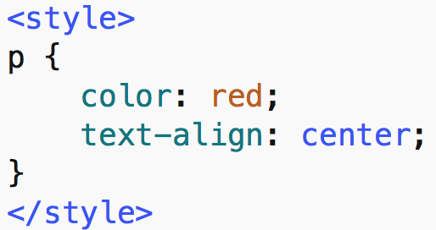

* 1. attribute
  2. value
  3. selector
  4. none of above

1. Within <style> tag, which of the following can be used to specifically refer to an element whose id is equal to “para”?
   1. .para
   2. !para
   3. para
   4. #para
2. Which of the following changes the style of all elements whose class is equal to “cen”?
   1. #cen
   2. #.cen
   3. .cen
   4. p.cen
3. Which of the following statements is NOT true about CSS?
   1. Inline CSS can ONLY affect a single element at a time.
   2. Internal CSS are defined within the <Style> tags.
   3. The inline style sheet has the highest precedence over external CSS.
   4. The <style> tag is a requirement in an external CSS.
4. In the DOM, every node has some properties that contain some information about that node. The properties are:
   1. nodeName
   2. nodeValue
   3. nodeType
   4. All of above
5. Which of the following is **syntactically** correct? (TBD)
   1. Document.createElement(“BUTTON”).className;
   2. Document.createElement(“INPUT”).attributes;
   3. Document.getElementsByClassName(“center”)[0].style;
   4. Document.getNamedItem(“BUTTON”);
6. Which of the following represents the inline CSS for an <h1> tag?
   1. <style "color:blue;margin-left:30px;"> <h1>Hello World!!!</h1> </style>
   2. <h1 style="color:blue;margin-left:30px;"> Hello World!!! </h1>
   3. <style> h1 { color:blue;margin-left:30px; } </style> <h1>Hello World!!!</h1>
   4. Both (b) and (c) are correct
7. Consider the following code fragment:

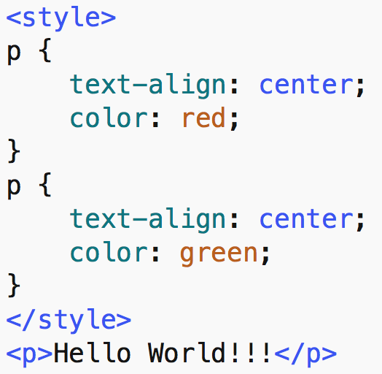

What will be the color of the text “Hello World!!!”?

1. Red
2. Green
3. No style will be applied to the text because both style definitions have the same target <p>.
4. There is a syntax error in this fragment due to a conflict between styles.
5. In the box provided below, fill in the <style> tag to change the color of all paragraphs whose class is equal to “par”.

|  |
| --- |
| <style>  p.par {color:red;}  </style> |

1. In the box below, fill in the <style> tag to change the color of all <h1>, <h2> and <p> elements in a web-page.

|  |
| --- |
| <style>  h1, h2, p {color:red}  </style> |

1. Consider the CSS defined as: <style>#hh {text-align: center;} </style>. In the following box, provide an example of an element that can be affected by this style.

|  |
| --- |
| <p id=”hh”>Hello World!!</P> |

1. Consider the CSS defined as: <style> h1.center {text-align: center;} </style>. In the following box, provide an example of an element that can be affected by this style.

|  |
| --- |
| <h1 class=”center”>Hello World!!</h1> |

1. Consider the following code fragment:

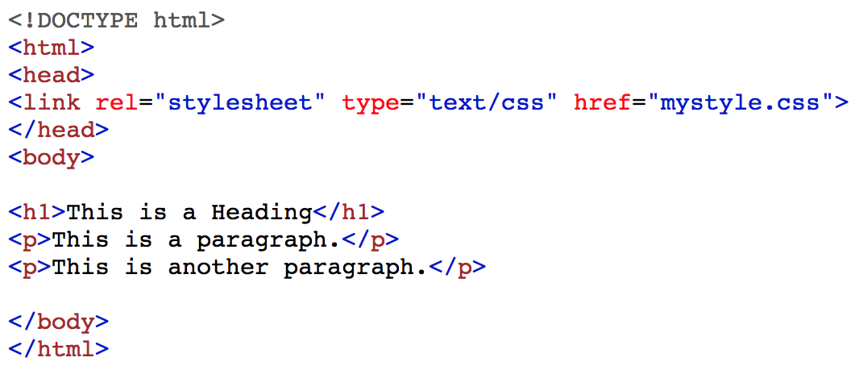

In the following box, write a piece of code in JavaScript to remove all the styles from the web-page.

|  |
| --- |
| <Script language=”JavaScript”>  var tmp = document.getElementsByTagName(“link”)[0];  tmp.parent.removeChild(tmp);  </Script> |

1. In the following box, write down the advantage(s) of using CSS in our web pages.

|  |
| --- |
| Less code redundancy, less bandwidth usage  More flexibility for changes  Easier to maintain a website |

1. In the following box, write down a JavaScript expression to remove all the rows of a <table>. Assume that there is ONLY one table in the page and that the table has at least one row with at least one column (the exact number of columns is unknown to us).

|  |
| --- |
| <Script language=”JavaScript”>  for(vari=0; i< table.children.length; i++)  {  table.removeChild(table.firstChild)  }  </Script> |

1. Consider that there is ONLY one paragraph in a web-page. In the box below, using ONLY JavaScript, add a style to this paragraph to make it center-aligned and change its color to red. Hint: Use element.style and Style Object from the cheat-sheet

|  |
| --- |
| <Script language=”JavaScript”>  paragraph.style.textAlign=”Center”  paragraph.style.color=”Red”  </Script> |

1. Consider that we have ONLY one <h1> tag in our web-page. Using JavaScript, we want to see whether or not any style assigned to this element.

|  |
| --- |
| <Script language=”JavaScript”>  Console.log(h1.style)  </Script> |

1. Develop a JavaScript function that takes a DOM element as argument and reverses the order of its children, i.e. first child becomes last child, second child becomes one before last child, etc. (This question in duplicated from Test Two)

|  |
| --- |
| Since this question is duplicated from test two, you can find its solution from test two. |