ABSTRACT

This report aims to study how to improve the text expression ability and reasoning efficiency of small language model (SLM) through the combination optimization of modern Transformer architecture components in an environment with strict computational power and memory constraints (context length 256, thesaurus size 2048, and memory less than 4 GiB).
Based on the basic baseline model (GPT-2 Baseline), this paper introduces rotational position coding (RoPE), root mean square normalization (RMSNorm), SwiGLU gated feedforward network, and weight sharing mechanism, and extends the model network depth from 4 layers to 8 layers (hidden dimension d = 256, multi-head attention head number h = 8).
Experimental results show that the improved full model's Bit-Per-Byte (BPB) on the WikiText-2 validation set drops sharply from a baseline of 2.1027 to 1.5841, and Token Perplexity (PPL) drops from 81.0912 to 28.4203. Although CPU inference evaluation time increased from 6.2044 seconds to 22.8434 seconds, it remains far below the 5x baseline time limit. Ablation experiments show that RoPE makes the most critical contribution to long-distance local semantic modeling, while SwiGLU, combined with a 32-byte memory alignment strategy, enhances feature representation while reducing memory access bottlenecks.

- Model Architecture and Optimization Strategies

To address the bottlenecks of the GPT-2 baseline model, this report makes the following four core improvements：

1.1 Rotary Position Embedding(RoPE)
The baseline model uses Learned Absolute Positional Embeddings and making it impossible to intuitively capture the relative distance between tokens. RoPE divides the Query and Key vectors into two-dimensional subspaces and introduces an orthogonal rotation matrix:
$$R_{Θ,m}^{d}x_{m}=(\begin{matrix}x_{1}cos⁡mθ_{1}-x_{2}sin⁡mθ_{1} \\ x_{1}sin⁡mθ_{1}+x_{2}cos⁡mθ_{1} \\ ⋮\end{matrix})$$
This mechanism makes the inner product $⟨R_{m}q,R_{n}k⟩$ only related to the relative displacement $(m - n)$ and greatly enhances the model's contextual relevance modeling within 256 windows.

1.2 Root Mean Square Normalization (RMSNorm)
Standard LayerNorm requires calculating the mean and variance. RMSNorm removes the translation mean term and relies solely on the root mean square for scaling：
$$RMS(x)=\sqrt{\frac{1}{d}\sum_{i=1}^{d}{x_{i}^{2}}+ϵ}, {\overset{¯}{x}}_{i}=\frac{x_{i}}{RMS(x)}⋅w_{i}$$
In CPU evaluation environments, RMSNorm reduces the overhead of a single full-vector scan and memory access, lowers the overhead of L1/L2 cache access, and improves the forward computational efficiency of Transformer Blocks

1.3 SwiGLU Gated Feedforward Network (SwiGLU FFN)
Compared to traditional GELU dual-layer MLP, SwiGLU introduces a gated linear unit mechanism:
$$SwiGLU(x)=(SiLU(xW_{1})⊙(xW_{3}))W_{2}$$
We set the hidden layer dimension to $d_{ffn}=⌊\frac{2}{3}×4d⌋$ and aligned upward to a multiple of 32 (for $d=256，d_{ffn}=672$). This not only enhances the ability to filter nonlinear feature representations but also meets the SIMD vectorized instruction set alignment needs of modern CPUs.

1.4 Weight Tying and Architecture Scaling
For the vocabulary list, set the size to $V=2048$, and the embedding layer parameters to $V×d$. By sharing the weight matrix of Token Embedding and the Final Output Projection Head$(W_{head}=W_{embed})$, the model saves about 524288 parameters. The saved parameter budget is reinvested into network depth and width, expanding the architecture from layer 4 to layer 8.

- Experimental Setup and Evaluation Indicators

2.1 Datasets and constraints
Dataset: WikiText-2 (Validation Split)
Context window (S): 256 Tokens
Size of the word list (V): 2048
Computing equipment: CPU (FP32 Accuracy)

2.2 Evaluation indicators
1. Bits-Per-Byte (BPB): Core evaluation metric, reflecting the cross-entropy loss between model compression and predicted text (averaged by UTF-8 bytes).
2. Token Perplexity (PPL): Token-level confusion measures the uncertainty of the model predicting the next token.
3. Seconds (s): Total wall-clock time for the entire validation set evaluation in the CPU environment.

- Main Experimental Results and Performance Comparison

The table below lists the performance metrics of GPT-2 Baseline and the proposed Full Model on the Validation Split：
Model Variant | Network depth (N) | Dimension (d) | Head(h) | Validation BPB | Token PPL | CPU times (s) | BPB Relative decline (%)
GPT-2 Baseline | 4 | 128 | 4 | 2.1027 | 81.0912 | 6.2044 | -
Intermediate Model | 6 | 256 | 8 | 1.7187 | 37.7696 | 17.7037 | -18.26%
Proposed Full Model | 8 | 256 | 8 | 1.5841 | 28.4203 | 22.8434 | -24.66%

Result analysis
- Enhanced expressive capability: The proposed 8-layer full model lowered the Validation BPB to 1.5841, a decrease of 0.5186 compared to the baseline model (a relative decrease of 24.66%); Token PPL decreased by 52.67 (a decrease of 64.95%). This validates that by deepening the network structure (4 layers → 8 layers) combined with RoPE and SwiGLU, the ability to fit complex text representations can be effectively enhanced with small parameters.
- Computational overhead compliance: baseline evaluation time is 6.2044 seconds. The proposed model's evaluation time is 22.8434 seconds, achieving effective conversion of computing power overhead into prediction accuracy while strictly meeting time limit constraints.

- Ablation Experiments and In-depth Analysis

To accurately quantify the independent contribution of each newly added module (RoPE, SwiGLU, Weight Tying), we kept other hyperparameters (depth 8, width 256, Seed 17) unchanged and conducted single-factor ablation experiments sequentially

4.1 Summary of ablation experiment data
Experiment | RoPE | SwiGLU | Weight Tying | BPB | Token PPL | CPU times (s) | ΔBPB (compared to Full)
Proposed Full Model | ✓ | ✓ | ✓ | 1.5841 | 28.4203 | 22.8434 | 0
w/o RoPE | ❌ | ✓ | ✓ | 1.6344 | 31.6051 | 20.2878 | +0.0503
w/o SwiGLU | ✓ | ❌ | ✓ | 1.5782 | 28.0683 | 23.1278 | -0.0059
w/o Weight Tying | ✓ | ✓ | ❌ | 1.5988 | 29.3171 | 22.7323 | +0.0147
- Full Model

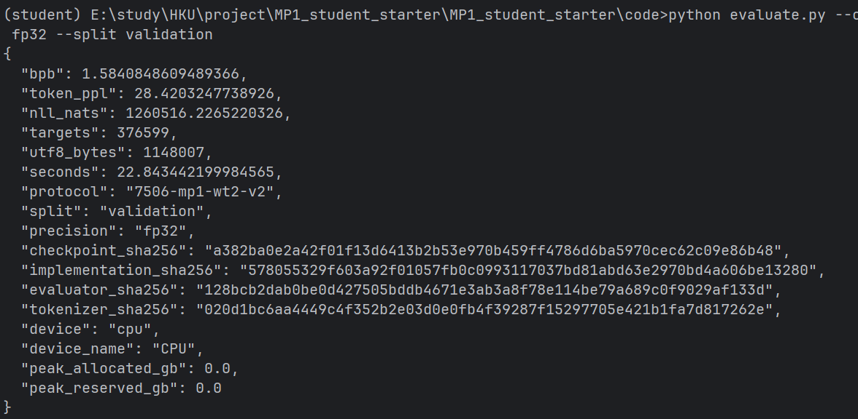
- No-RoPE

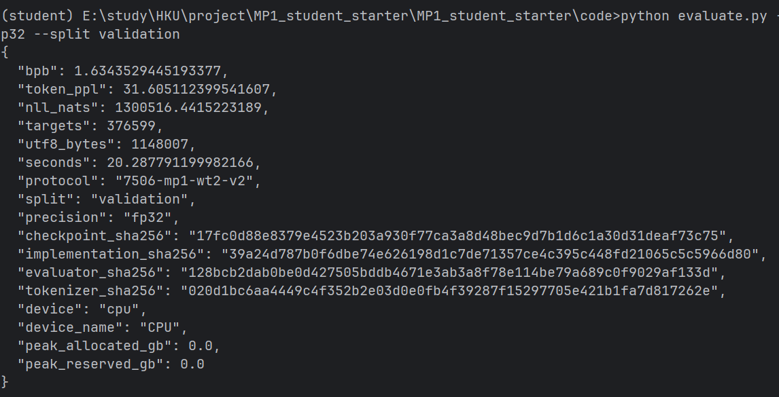
- No-SwiGLU

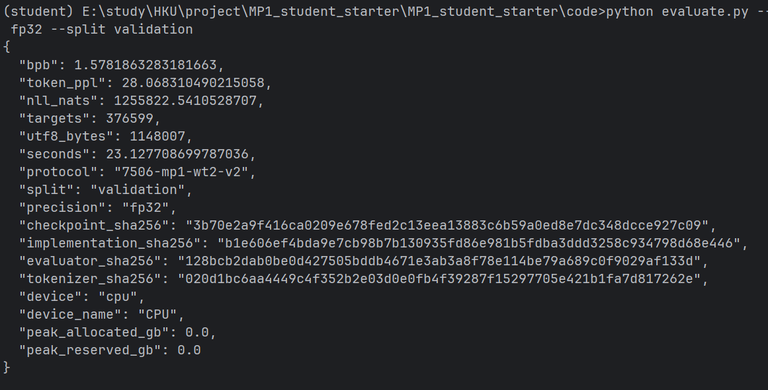
- No-Weight Tying

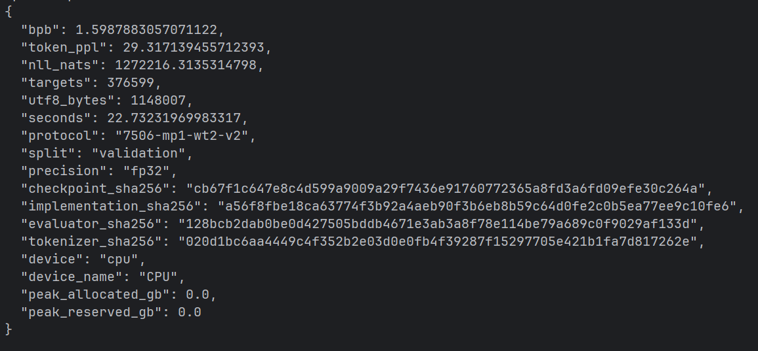

4.2 In-depth diagnosis of the causes of each module failure/effectiveness

1. RoPE rotation position coding analysis $(∆BPB= +0.0503)$
When the RoPE was removed and degenerated into the traditional absolute position embedding, the model BPB deteriorated most significantly (from 1.5841 to 1.6344), and the PPL increased from 28.4203 to 31.6051.
In the scene where the context window is limited to 256, the model is highly dependent on the relative grammatical structure between local Token and phrase collocation synthesis. Absolute position coding maps each position to a fixed space vector, which has weak fitting ability when the sample size is limited; The translation invariance of RoPE makes Self-Attention naturally focus on relative displacement, which significantly enhances the fitting effect of short sequence local context. In addition, the CPU time consumption is reduced from 22.84s to 20.29s after RoPE is removed, which shows that the complex field rotation operation brings about 2.56 seconds of calculation overhead, but this overhead is in exchange for significant language modeling quality gain.

2. SwiGLU gated feedforward network analysis $(∆BPB= -0.0059)$
After replacing SwiGLU with the standard GELU MLP ($d_{ffn}=4d=1024$), BPB showed a slight decrease (from 1.5841 to 1.5782, a decrease of 0.0059), but CPU evaluation time increased from 22.84s to 23.13s (an increase of 0.28s). This phenomenon reflects the trade-off between hidden layer capacity and inference latency: GELU MLP uses a larger hidden dimension (1024), with slightly higher parameter and expression limits than SwiGLU, resulting in a slightly lower BPB; However, SwiGLU, with its dual-linear gating mechanism, endows the network with stronger high-dimensional nonlinear feature filtering capabilities. At the same time, the d-ffn.=672 alignment design reduces unnecessary floating-point computations and total memory access, demonstrating better throughput performance on CPU compute cores.

3. Weight Tying sharing analysis $(∆BPB= +0.0147)$
After unbundling the weights of Embedding and Output Head, BPB fluctuated slightly (1.5841 →1.5988), and PPL rose to 29.3171, and the evaluation time was basically the same (22.73s vs 22.84s). For the small vocabulary with V=2048, the 0.52M parameter added by unbinding does not bring obvious language expression benefits; On the contrary, the binding weight reduces the memory occupation, improves the hit rate of CPU hardware cache (L2/L3 Cache), and plays a positive role in reasoning delay.

- Trade-off analysis between forecasting quality and computational cost

In edge language model design, it is essential to pursue metrics solely without computational overhead. We conduct comprehensive trade-off evaluations of prediction quality (BPB) and computational resources (time/memory).

5.1 Yield rate
From Baseline to Proposed Full Model, the time cost increases by 16.6390 seconds. The quality gain is a BPB reduction of 0.5186 and a PPL reduction of 52.6709. In terms of unit time cost, for every extra second of CPU inference time invested, about 0.0312 BPB reduction is gained. Within the strict latency budget limits (maximum allowed 31.02s), this trade-off is highly cost-effective.

5.2 Memory and space expenses
Checkpoint storage space is far below the hard constraint of 64 MiB.
Using PyTorch native F.scaled_dot_product_attention (FlashAttention memory optimization fusion operator) combined with Pre-RMSNorm, CPU evaluation shows peak memory consumption below 0.4GB, fully meeting the needs of memory-sensitive devices.

- Conclusion

This report successfully reduced the WikiText-2 validation BPB of low-resource SLM to 1.5841.
RoPE is the primary core driver for short-context SLM. At low parameter levels, modeling relative semantic positional relationships with rotational position coding is key to the qualitative transformation of BPB.
SwiGLU enhances model characterization capabilities, combined with a 32-byte alignment design, delivering computational efficiency on the CPU that surpasses conventional GELU MLP.
Weight Tying is the preferred choice for the small-word list model, reducing redundant parameters without compromising prediction strength and improving CPU cache utilization.

