ABSTRACT

This report investigates how to accurately select numerically correct reasoning processes from multiple candidate answers under fixed candidate sets, offline inference, and strict resource constraints. Given four candidate answers per question and a fixed 1024-dimensional text embedding representation, the model does not directly generate new answers but instead focuses on selecting among candidates. The study compares voting baselines, learning-to-rank approaches, projection tree models, and out-of-fold training-based evidence correction methods using 4,755 training questions, 798 validation questions, and 467 test questions provided by the course.
Under unified data splits and official evaluation protocols, the initial approach achieved 373/467 (79.87%) on the test set, while the final model improved to 394/467 (84.37%), increasing correct answers by 21 and accuracy by 4.50 percentage points. On the full validation set, accuracy rose from 729/798 to 748/798, with performance on conflicting questions improving from 286/355 to 305/355. The model's deployment footprint increased slightly from 13.26 KiB to 284.50 KiB, and prediction and scoring time for the full validation set in the same machine environment increased from approximately 0.544 seconds to 1.015 seconds.
Ablation experiments conducted on the final formulation with a learning rate of 0.003 demonstrate that removing the arithmetic-evidence feature reduces the number of correct answers on the validation set from 305 to 301, while removing the ranking loss term reduces it to 304; by contrast, removing the KL-divergence constraint or switching to training with a single fixed seed leaves the model's candidate-selection behavior unchanged. This indicates that local numerical evidence provides a clear performance benefit. Nevertheless, the model still exhibits failure cases when faced with deep semantic ambiguities involving quantitative scope, event timing, and target scope; in this paper, by examining specific failure cases alongside resource costs, we provide an in-depth discussion of the method's benefit boundaries.

1 Model Architecture and Optimization Strategy
1.1 Task Description
Each problem input consists of the question text, four candidate reasoning processes, and their corresponding 1024-dimensional fixed embedding vectors. The candidate selector must output an index within the range [0,3]. The official scorer determines the score based on whether the final numerical value of the selected candidate is equivalent to the standard reference answer. Equivalent values in fractional form are considered identical answers, and multiple candidates may be correct for a single question. Training supervision strictly relies on the correctness of the final answer, without automatically assuming that an entire reasoning process is step-by-step correct.
The provided dataset includes: 4,755 training questions, 798 validation questions, and 467 test questions. Among them, the training and validation sets contain 2,114 and 355 conflicting questions respectively, while all 467 test questions are conflicting. The remaining 443 validation questions have only one valid answer group, and the methods proposed in this study achieved 100% accuracy on these questions. Therefore, when reporting experimental results, both overall accuracy and accuracy on conflicting questions should be reported simultaneously; direct comparison between the full validation set accuracy (93.73%) and test set accuracy (84.37%) is not appropriate due to differences in difficulty.
1.2 Ridge Regression and Voting Fusion
The initial baseline method defined in this study refers to a first-learned model with a test accuracy of approximately 79.87%, rather than a simple majority voting mechanism. This approach estimates the mean, standard deviation, and linear weights of embedding vectors solely from the training set, using binary labels indicating whether each candidate provides the correct final value. A ridge regression model is fitted via closed-form solution with a regularization coefficient of 10. During inference, the model fuses the ridge regression prediction score with 0.25 times the answer vote ratio, discards candidates unable to yield valid numerical outputs, and selects the candidate with the highest combined score.
The answer vote ratio is defined as the frequency of a given numerical answer among the four candidates divided by 4. This method features small model size and extremely fast training speed, making it highly suitable as a cost benchmark. However, simple linear mapping struggles to effectively capture complex nonlinear differences among candidates within a single question, and the majority voting mechanism often fails when multiple candidates jointly miss constraints such as number of people, days, or costs. The goal of improvement is to significantly enhance the ability to distinguish correct answer groups from easily confused incorrect ones, while preserving the advantages of offline execution and compact model size.
2 Final Model and Training Method
2.1 Projection-based Ranking Baseline Model
The final model first standardizes the fixed embeddings and constructs a 64-dimensional, variance-normalized feature projection based on relative differences among candidates. The projection matrix and associated statistics are estimated solely on the data used to fit the teacher model. The model uses linear ranking scores as the base score for residual trees and supplements them with nonlinear decision logic via 20 rounds of residual trees (depth 4), incorporating candidate projections, relative projections, and seven summary features per candidate. Additionally, it integrates four types of answer-type priors estimated from the training set, each weighted by 0.25.
The baseline model's linear layer is trained for 8 epochs using the AdamW optimizer with a learning rate of 0.003, batch size of 128, and weight decay of 0.01. The loss function combines ranking terms for correct and incorrect candidates within each question, along with a binary cross-entropy loss weighted at 0.25. Input feature clipping thresholds are set to [-8, 8], and both the baseline and teacher models use a fixed random seed of 42. It should be noted that this stage only trains the selector component; no new large language models are downloaded or trained.
2.2 Numerical Evidence and Group Correction
Candidates are grouped by their officially parsed numerical answers, so equivalent answers are not treated as negatives. The reference score for a group is its maximum base-model candidate score. A correction head averages candidate increments within each group, adds the result to the reference score and applies softmax. Its 20 inputs comprise seven candidate summaries, five base-score/group statistics and eight conservative arithmetic-evidence features. Each head has 20 linear weights; tanh bounds each candidate increment to [-2, 2]:
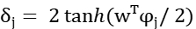
The correction objective combines negative log-likelihood of the correct answer group, mean ranking loss against other valid groups, and KL regularization toward the reference distribution. The ranking margin is 0.2, with ranking and KL weights of 0.75 and 0.01. Seeds 42, 43 and 44 are each trained for 60 epochs; inference averages their group probabilities equally.
2.3 Out-of-Fold Supervision and Fixed Hyperparameters
Training questions are divided into three folds. Each teacher fits two folds and predicts the unseen third fold, giving every training question one set of out-of-fold (OOF) features and scores. Correction heads learn only from the 2,114 training disagreement questions. A separate base model is fitted on the full training split for deployment. OOF supervision reduces dependence on in-sample base scores, although differences in teacher training-set size can still cause a distribution shift.
Component | Final Fixed Settings
Baseline Layer | 8 epochs; learning rate 0.003; batch size 128; weight decay 0.01
Projection and Tree | 64-dimensional; 20 epochs; depth 4; answer prior weight 0.25
Error Correction Head | 60 epochs; learning rate 0.01; batch size 128; weight decay 0.03
Pruning and Seeds | Features6; gradient 1; fold seed 20261025; head seeds 42/43/44
3 Experimental Setup
3.1 Experimental Data
All comparison methods strictly follow the same data split of 4755/798/467, with consistent numerical parsers, underlying data, and independent evaluators. The training code fits only on the input and reference answers from the training set; the validation set is reserved exclusively for development tuning and component comparisons; test set results directly reference saved public evaluation records.
Resource measurements were conducted using an Intel Core i7-12700H, Windows 11, and a quad-core CPU. Total runtime represents the wall-clock time of one new prediction process plus an independent scoring process, measured serially once per method. These results are used for magnitude comparison and do not reflect stable latency distributions.
3.2 From Initial to Final Scheme
Table 1 starts with a ridge regression and voting scheme achieving 79.87%, retaining only one interpretable intermediate stage: the previously frozen projected model. Since the configurations of these stage models are not entirely identical, this table compares overall approaches, while rigorous single-component contributions are analyzed through ablation studies in the final formulation presented in the next section.
Table 1 Accuracy and resource comparison on the same splits
Method | Validation  (all) | Validation  (disagr.) | Public  test | Full valid.  time (s) | Assets  (KiB)
Baseline  Ridge + voting | 729/798  91.35% | 286/355  80.56% | 373/467  79.87% | 0.544 | 13.26
Projected  ranker | 750/798  93.98% | 307/355  86.48% | 381/467  81.58% | 0.687 | 281.49
Evidence  correction | 748/798  93.73% | 305/355  85.92% | 394/467  84.37% | 1.015 | 284.50
Compared with the learned baseline, the final model answers 21 more test questions correctly (+4.4968 percentage points), and 19 more validation questions (+2.3810 points overall and +5.3521 points on disagreements). Improvement is therefore observed on both supplied splits. However, the intermediate ranker scores 750/798 on validation, exceeding the final 748/798; adding correction does not improve every split.
Question-level validation comparison shows 33 baseline errors corrected and 14 previously correct answers lost, for a net gain of 19. The improvement reflects a balance between repairs and regressions, rather than preserving every earlier correct decision.
4 Experimental Results
4.1 Controlled Design
To correspond to the final learning rate of 0.003, we ablate by fixing the full base model and three in-training teacher models. When removing arithmetic evidence, we refit the 12-dimensional summary head using the same out-of-fold samples, 60 training epochs, and three seeds. When removing the ranking or KL term, we simply set the corresponding loss weight to zero and retrain the head. For removing the correction head, we directly use the same base model with a learning rate of 0.003. In single-seed controls, we retain one of the three pre-trained members without selecting the seed with the best validation performance. All control experiments use only training fitting and validation scoring, with final weights kept unchanged.
This ablation study uses a unified experimental setup for measurement, with the full model selection matching the official deployment exactly on a per-question basis. The deployed asset size is 291,329 bytes; identifiers in the experimental configuration contribute only tens of bytes difference. Tables 1 and 2 come from different single measurements, so the full model times of approximately 1.015 seconds and 0.973 seconds should not be interpreted as algorithmic acceleration.
Table 2 Component ablations at base learning rate 0.003
Setting | Correct on  disagreement  questions | Accuracy | Full validation  time (s) | Assets  (KiB)
Without correction head | 302/355 | 85.07% | 0.888 | 282.6
Without arithmetic evidence | 301/355 | 84.79% | 0.786 | 284.4
Without ranking loss | 304/355 | 85.63% | 1.003 | 284.5
Without KL constraint | 305/355 | 85.92% | 0.978 | 284.5
Seed 42 only | 305/355 | 85.92% | 0.974 | 283.7
Seed 43 only | 305/355 | 85.92% | 0.967 | 283.7
Seed 44 only | 305/355 | 85.92% | 0.938 | 283.7
Full three-head model | 305/355 | 85.92% | 0.973 | 284.5
Ablations use a common evaluation entry point; the full model makes exactly the same selections as the deployment entry point. Deployment assets total 291,329 bytes; experimental configuration labels add only a few bytes. Tables 1 and 2 use separate single-run timings, so 1.015 versus 0.973 seconds is measurement variation, not an algorithmic speedup.
4.2 Comparative Analysis
The full model gains three correct disagreement answers over the matched base model: eight repairs and five regressions. Removing arithmetic features reduces the score from 305 to 301, supporting their contribution beyond summary features. Removing ranking reduces it to 304, suggesting a smaller benefit from explicitly comparing incorrect groups. These differences are only a few questions and do not establish consistent gains across splits.
Without KL, selections remain identical on all 798 validation questions. Each single-seed model also scores 305/355 and makes the same selections as the full ensemble. This validation set therefore provides no observed selection benefit from KL or three-head averaging. Additional heads require little storage but still add training and computation; their necessity has not been demonstrated.
A simpler single-head or no-KL variant could be assessed through training-fold comparisons. Here, ablations explain the frozen final model rather than replace it. Removing arithmetic evidence saves approximately 0.187 seconds in this run but loses four correct answers, providing a clearer accuracy-cost trade-off than additional ensemble members with no observed selection gain.
4.3 Final Experimental Results Figure
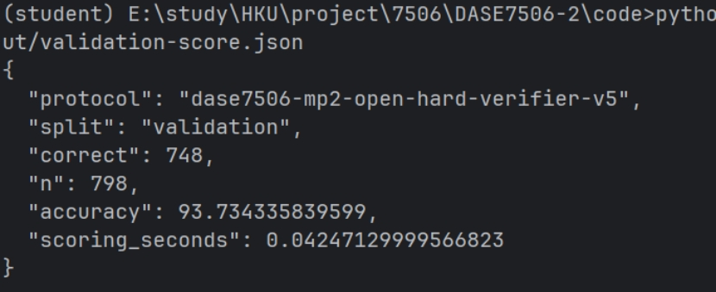
Figure 1 Official validation scoring output

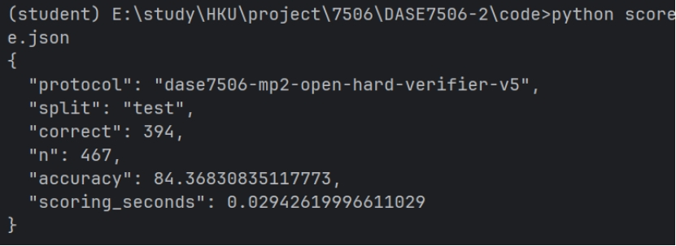
Figure 2 Official test scoring output
5 Error Analysis
5.1 Local Arithmetic and Semantic Scope
Of 48 reviewed errors in the intermediate ranker, 41 mainly involved scope, targets, timing, relations or constraints; only three were arithmetic errors. The final model fixes rows 65, 522 and 739, including an incorrect sum of 36 instead of 35. These repairs establish local consistency, not semantic understanding. The reviewed cases are distinct from the final model's 50 errors.
5.2 Remaining Failures
Failures include selecting revenue 980 instead of profit 308 (row 330), and double-counting time periods (row 726). Correct arithmetic can still use the wrong quantity or target. Unreliable learned corrections may also override correct base rankings; equation checking alone cannot resolve these errors.
6 Computational Cost and Benefit

Assets increase from 13.26 to 284.50 KiB (21.46-fold), but remain 0.278 MiB, or 1.74% of the 16 MiB limit. Complete validation runtime rises by 0.471 seconds (87%), with 19 more validation and 21 more public-test answers correct. This trade-off favours accuracy within the asset budget; ridge regression is preferable for minimal latency.
Against the intermediate ranker, however, the final model is 0.328 seconds slower and two validation answers worse. Matched ablations support arithmetic-based correction, not every additional module.
Table 3 Recorded training costs and dependencies
Stage | Time  (s) | Workload and dependencies
Initial learned model | 2.13 | Ridge regression and answer voting; NumPy
Final full retraining | 20.22 | 4 base models/teachers and 3 heads; PyTorch and XGBoost
Additional ablations | 16.03 | 3 variants, 9 heads; reuse training-fold teachers
Recorded training times exclude full startup; ablation time also excludes shared feature construction and validation. They are not comparable update costs or total project search cost. Local validation timings do not establish reference-Xeon eligibility.
7 Conclusion
The final 0.003 model improves both supplied splits over the learned baseline within the asset limit. Arithmetic evidence and ranking help in this validation comparison; KL and ensembling have no observed selection benefit.
Future training-only work should test scope-aware features, evidence gating and single-head simplification, reporting repairs, regressions, latency and assets together.

