

Software Requirement Specification
<Project Name>

Version  Status  Date | <version>  <status>  <Current date>

Confidentiality Notice
Copyright (c) 2025 eInfochips. - All rights reserved
This document is authored by eInfochips and is eInfochips intellectual property, including the copyrights in all countries in the world. This document is provided under a license to use only with all other rights, including ownership rights, being retained by eInfochips. This file may not be distributed, copied, or reproduced in any manner, electronic or otherwise, without the express written consent of eInfochips.

Template Version 1.8
Contents

1 Document Details 4
1.1 Revision & Approval History 4
1.2 Definition, Acronyms and Abbreviations 5
1.3 References 5
2 introduction 6
2.1 Purpose of the Document 6
2.2 Intended Audience 6
3 software overview 7
3.1 Overview 7
3.2 Scope 8
4 Functional RequiREment 9
4.1 <Logical Block> 9
4.1.1 Requirements 9
4.1.2 Safety Requirements 10
4.1.3 Cyber Security Requirements 11
4.1.4 Business Rules 12
4.1.5 Screen(s)/ Wireframes 12
4.2 Operating environment 12
4.3 Configuration Parameters 13

Document Details

Revision & Approval History
Version | Author |  | Reviewer |  | Approver
 | Name | Date  (DD-MM-YYYY) | Name | Date  (DD-MMM-YYYY) | Name | Date  (DD-MM-YYYY)

Version | Description of Change

Definition, Acronyms and Abbreviations
Definition/Acronym/Abbreviation | Description
RTM | Requirement Traceability Matrix
QTS | Query Tracking Sheet
FMEA | Failure Mode & Effect Analysis
SAFREQ | Safety Requirement
ASIL | Automotive Safety Integrity Level
FTTI | Fault Handling Time Interval
Table 1: Definitions, Acronyms and Abbreviations

References

No. | Document | Version | Remarks
Table 2: References

introduction

Purpose of the Document
<Describe the purpose of this Software Requirements Specification and its usage.>
<Note: This section is mandatory for all projects>

Intended Audience
<Describe the different types of readers that the document is intended for, such as developers, project team members, marketing staff, users, testers, etc.>
<Note: This section is mandatory for all projects>

software overview

Overview
<Provide a description of the environment where the project being specified resides. Briefly explain all the relevant entities and their interactions.

Provide details of existing software, if any, for its problems and need for the proposed software/ product

Provide description of the software/ product being specified and its purpose, its boundaries, its relation with other entities, relevant benefits, objectives, and goals.>
<Note: This section is mandatory for all projects>

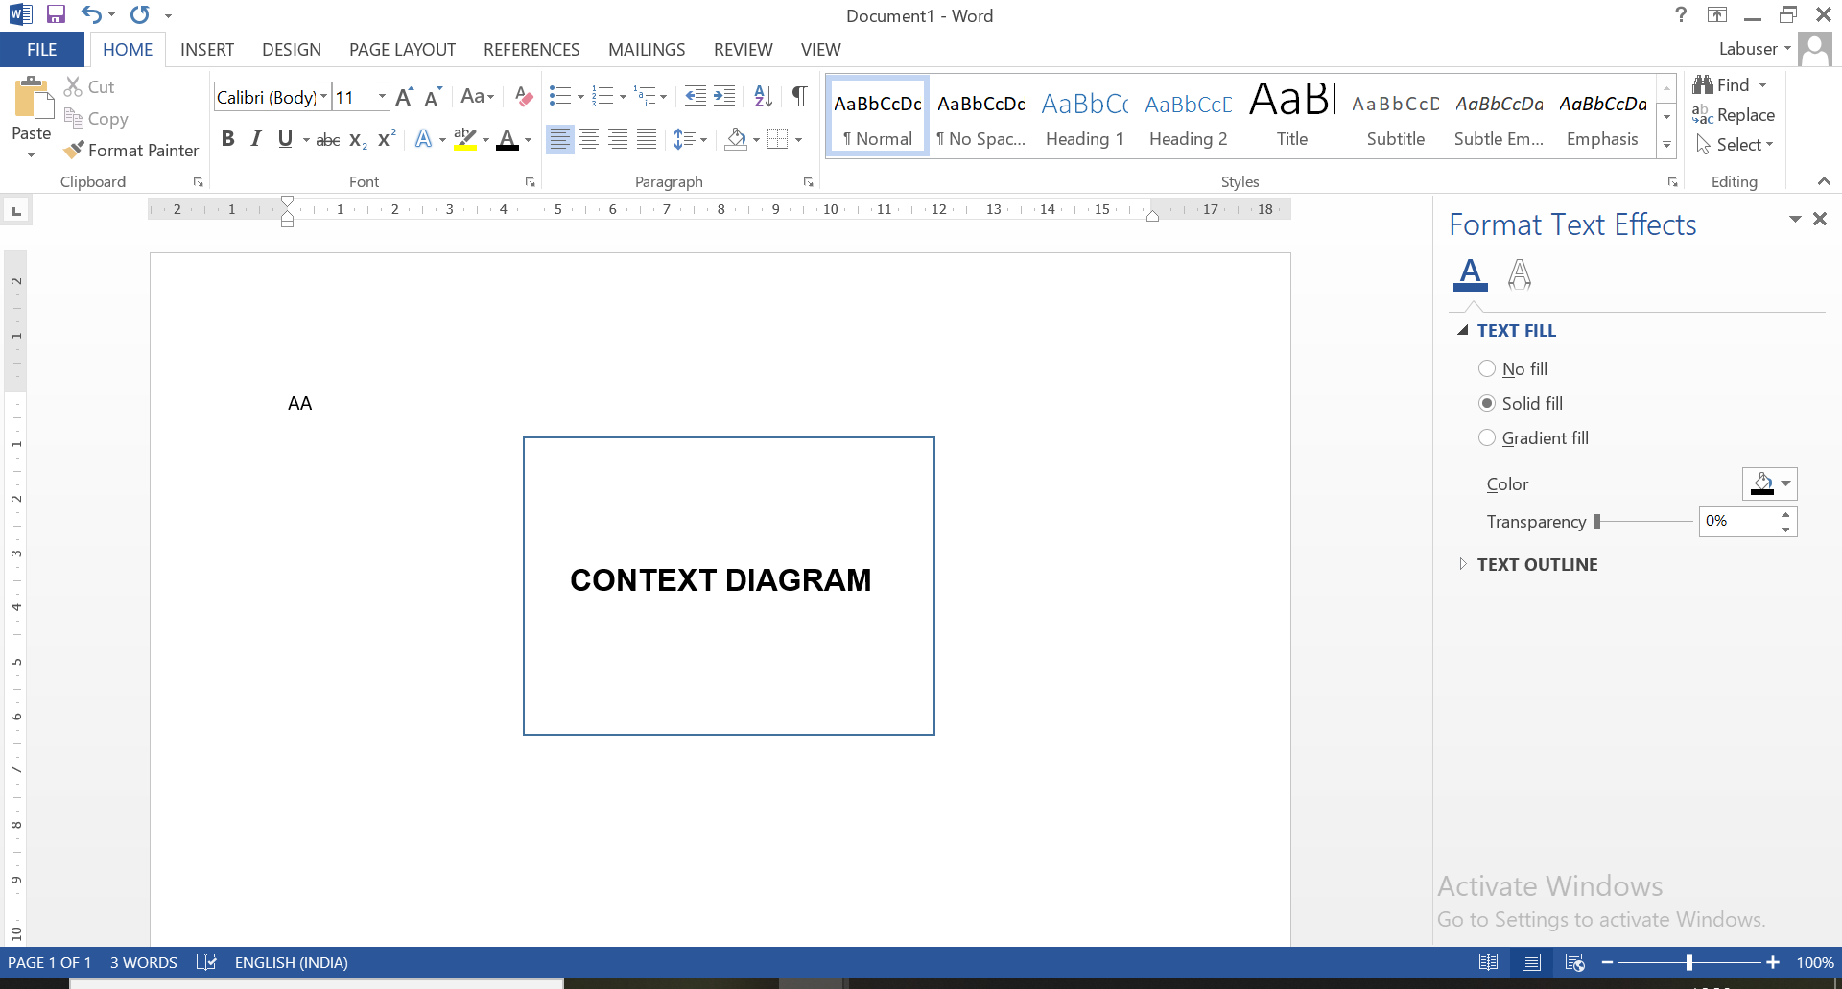
Figure 1: Context Diagram

Scope
<Define scope of the software as addressed by this SRS document in terms of the software block diagram, features to be included and excluded.
The software block diagram is a logical view of the software being specified with a set of logical blocks and each block has a set of requirements. Briefly explain the identified block. Its requirements must be documented in the subsequent section>
<Add security concept architecture for automotive projects>
<Note: This section is mandatory for all projects>

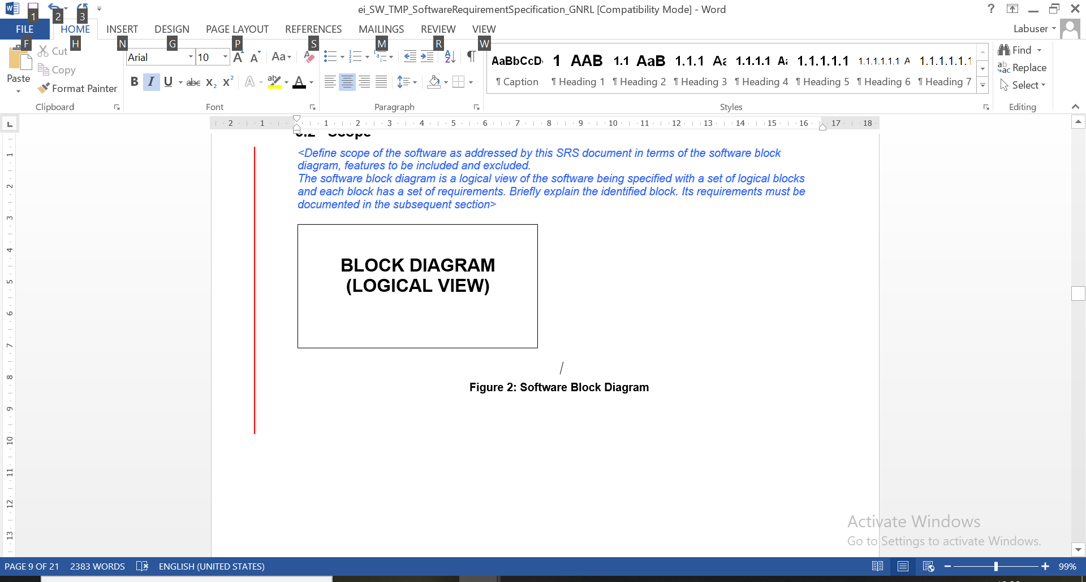
Figure 2: Logical View

Functional RequiREment
<Describe the detailed requirements by breaking down each of the high-level requirements to low-level requirements>

<State the performance (Non-Functional) requirement of each of the features of hardware/software as applicable. If there is no particular performance requirement, do state accordingly.>
<Note: This section is mandatory for all projects>

<Logical Block>
<List all the requirements related to this logical block in a structured way (sub-groups, sequential)>

Requirements
<Note: This section is mandatory for all projects>

<Requirement/Functionality Name>
<For Automotive projects: REQ ID, Purpose, Validation Rules, Testability with respect to test environment, Feasible within project constraints, Critical (technical, customer, competence, cost, schedule..) are mandatory>
<Add project specific fields as appropriate>

Term | Description
REQ ID | RQ01
Purpose¹ | <Purpose of the Functionality>
Derived Requirement | <Map derived requirements, if any (All necessary data points would be covered here)>
Requirement Priority | <Urgent/High/Medium/Low>
Access Restrictions | <Role based>
Input(s)
Output(s)
Process | <Complete transaction process along with field details>
Mandatory Fields | <the fields which are necessary for processing>
Pre-Loaded Values | <the values maintained at the client for ease of the user e.g. list of values etc.>
Default Values | <e.g. if any field contains some value as the page appears like image size=<x> pixels>
Valid range of Values | [X..Y]
Data Latency Period | <the request fulfillment time>
Data Retention Period | <the frequency of the data maintenance>
Data Rate/ <Daily> Number of transaction | <Data Rate requirement – Network bandwidth/ Memory Transfer Rate / Video Frames per Second etc.>  <Or The number of transactions at a time/daily etc.>
External Events | <List of the external events that triggers this functionality, i.e. events triggered by the external entities.>
Temporal Events | <List of temporal events that triggers this functionality. Temporal events are events triggered by time.>
Validation Rules/  Verification criteria² | <List out all validation rules related to feature.  For Automotive projects, document the verification criteria >
Constraints | <List out any constraints related to feature implementation, API handling and the design constraints for the features, if any.>
Effects on other systems/sub system | <if the particular functionality is affecting some other functionality/subsystem etc.>
Testability with respect to test environment  (Yes/No)  Note: Mention in which phase of testing, this requirement will be tested | <Yes/ No> <If ‘No’ explain>
Feasible within project constraints  (Yes/No)  Note: Add the impact of requirement on operating environment defined in section 4.2 | <Yes/No> <If ‘No’ explain>
Critical  (Yes/No) | <Yes/No> <If ‘Yes’ explain>
Acceptance Criteria | < Acceptance criteria are a set of parameters that a feature must meet to be accepted by the customer and other software or system components.  It will also be the reference point for QA to define the validation scenarios  and their pass/fail criteria.>

¹ Describe the requirement description in detailed manner in given field. Software qualification test cases should be derived based on this description.
² Verification criteria can be used for the development of software test cases.

Safety Requirements
<Applicable for Automotive Projects>

<Safety Requirement/Functionality Name>
<List down the Safety Requirement derived based on Safety Goals, System Requirements, Technical Safety Requirement, System Architectural Design Specification and Hardware-Software Interface >

Term | Description
Requirement ID | Map functional requirement ID here, from sec 4.1.1 and sec 7.0, for which these safety requirements are written
Software Safety Requirement ID | Mention safety requirement ID here, start form SW_SAF_REQ_01
Description | Description of Safety Requirement  Software Safety-related functionality of the software can be:  - functions that enable the system to achieve or maintain a safe state or degraded state  - functions related to the detection, indication and mitigation of faults of safety-related hardware elements  - functions that enable the safe execution of a function  - functions related to performance or time-critical operations
Derived From | <Map derived requirements (All necessary data points would be covered here).  Software safety requirements to be derived from Technical Safety Concept, Technical Safety Requirements, System architectural design Specification and Hardware-Software Interface.  In case of decomposed ASIL, provide reference of the source requirement of ASIL decomposition.
Requirement Priority | <Urgent/High/Medium/Low>
Safety Mechanism | <Define Safety Mechanism>  For each safety mechanism to maintain a safe state mention:  - Transition between normal operation state to safe state or to emergency operation state  - Software safety mechanism to meet fault detection time interval (FDTI)  - Software safety mechanism to meet fault handling time interval (FHTI)  - Software safety mechanism to meet fault tolerance time interval (FTTI)  - Software safety mechanism to meet emergency Operation Time Interval
ASIL Level | Mention ASIL level of Safety Requirement. If the requirement is decomposed, the ISO 26262 ASIL decomposition notation shall be used (e.g. “ASIL B(D)”)
Safety Goal | Mention the associated safety goal number
FTTI | Define fault Handling Time Interval
Status | <A status of a safety requirement can be “proposed”, “assumed”, “accepted”, “reviewed”, “delivered” or “verified>
Verification | <Mention Verification Strategy>
Testability with respect to test environment  (Yes/No) | <Yes/ No> <If ‘No’ explain>
Necessity | <Mention the essential capability, Characteristics, Constraint, and Quality Factor, which if Removed, Deleted will lead to Deficiency>
Traceability | <Define How Traceability of Safety Requirement to its upper hierarchical level and next lower hierarchical level will be maintained >
Acceptance Criteria | < Acceptance criteria are a set of parameters that a feature must meet to be accepted by the customer and other software or system components.  It will also be the reference point for QA to define the validation scenarios  and their pass/fail criteria.>

Cyber Security Requirements
<Applicable for Automotive Projects>

<CS Requirement/Functionality Name>
<List down the cybersecurity requirement attributes including ID, source, detailed description, applicable CAL level, rationale, verification methods, and acceptance criteria>

Term | Description
Requirement ID | <CS-REQ-001>
Requirement Source | <From which phase the requirement is identified, e.g.,Risk Assessment, Security goals, etc>
Detailed Requirements/  Specification | <A precise and unambiguous statement of the cybersecurity requirement/specification. Clearly describe what must be done or achieved>
Requirement Priority | <Urgent/High/Medium/Low>
CAL Level Applicable | <Indicates the Cybersecurity Assurance Level(s) to which the requirement applies: CAL1, CAL2, CAL3, CAL4, or All. This helps in tailoring requirements based on risk assessment>
Rationale | <Justifies why the requirement exists. Describes the underlying risk or reason (e.g., "To prevent unauthorized firmware updates")>
Verification Method | <Describes how compliance with the requirement will be verified: Review, Analysis, Test, Audit, or Inspection>
Testability with respect to test environment  (Yes/No) | <Yes/ No> <If ‘No’ explain>
Status | <A status of a security requirement can be “proposed”, “assumed”, “accepted”, “reviewed”, “delivered” or “verified>
Acceptance Criteria | < Acceptance criteria are a set of parameters that a feature must meet to be accepted by the customer and other software or system components.  It will also be the reference point for QA to define the validation scenarios  and their pass/fail criteria >

Business Rules
<List of operating principles and/or business rules pertaining to functionality.>

ID | Rule Definition | Type of Rule  (Fact/ Constraint) | Static or Dynamic | Source/Originator

Screen(s)/ Wireframes

Operating environment
<Analyze if any of the requirements in this block has an impact on the operating environment. This includes 3rd party software, hardware interfaces (e.g. signals, signal quality, voltage, current), environment (temperature, EMC), performance (e.g. response time, processing time) and hardware resources (RAM, ROM, Flash, EEPROM.
Define/draw operating environment that considers other elements interacting with the real time software. (Providing input to or taking output from)
Note: This information should be used during feasibility and variability analysis of each requirement defined in section 4.1.1>
<Note: This section is mandatory for all automotive projects.>

Configuration Parameters
<Configuration Parameters are those that are defining the software behavior of a certain feature or selecting/including certain feature in the build (at the time of compilation) that will be released.
Configuration parameters should include run time parameters that needs to be updated before running the software in real time environment>
<Note: This section is mandatory for all automotive projects.>

External Interface
<The software which will be developed might interact with many other existing automatic and/or non-automatic systems. These external interfaces must be identified to make sure that software will be compatible with the external interface. Also describe how these external interfaces are linked to the software/ product in scope.>

User Interface

<Describe the logical characteristics of each interface between the software product and the users. This may include sample screen images, any GUI standards or product family style guides that are to be followed, screen layout constraints, standard buttons and functions (e.g., help) that will appear on every screen, keyboard shortcuts, error message display standards, and so on. Define the software components for which a user interface is needed. Details of the user interface design should be documented in a separate user interface specification.>

Hardware Interface

<Specify the logical and physical characteristics of each interface between the software and the hardware components of the system. These configuration characteristics, which should cover details on what devices, are to be supported, how they are to be supported and protocol.>

<Note: This section is mandatory for Automotive projects. Projects working on ISO 26262 requirements to give reference of Hardware-Software Interface>

Software Interface

<Describe the connections between this product and other specific software components (name and version), including databases, operating systems, tools, libraries, and integrated commercial components. Identify the data items or messages coming into the system and going out and describe the purpose of each. Describe the services needed and the nature of communications. Refer to documents that describe detailed application programming interface protocols. Identify data that will be shared across software components. If the data sharing mechanism must be implemented in a specific way (for example, use of a global data area in a multitasking operating system), specify this as an implementation constraint.>

<Note: This section is mandatory for Automotive projects>

