Play Store App Insights
Solution guide | 25 questions, with calculations and limits

What stands out
The cleaned sample contains 9,659 app names across 33 categories. Average rating is 4.17 among apps with a score, and 92.19% of listings are free. Games have the largest combined install lower bound, while Events has the highest category rating. Those are different kinds of success and should be assessed separately.
App size and price have weak relationships with ratings. The review text offers a more useful starting point for product work: lower-rated apps have more mentions of updates, reliability, loading and account access. These findings suggest issues to investigate, rather than proving what caused an app’s score.
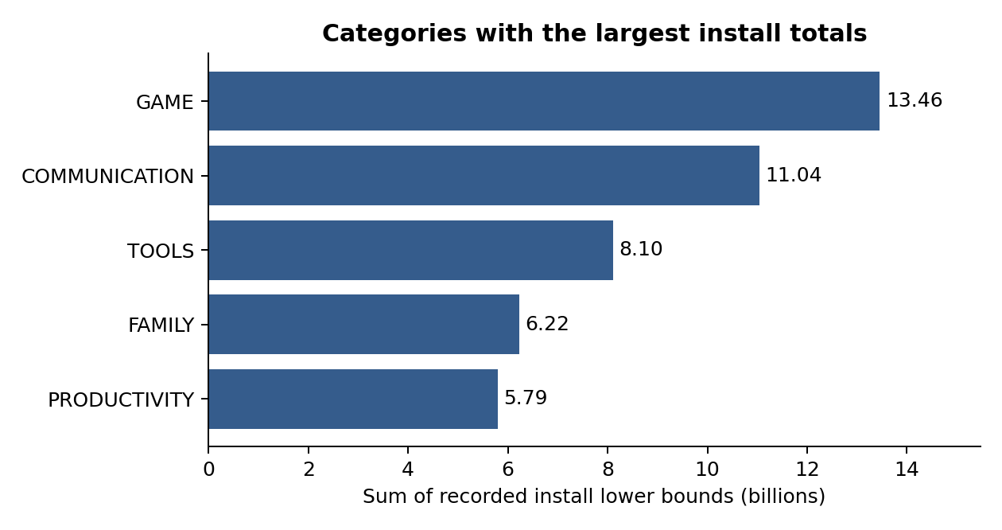
This is a historical dataset with recorded last-update dates through 8 August 2018. It should be used to practise analysis and form hypotheses, not to describe today’s app market. All 25 questions are addressed. Twenty-four can be analysed with the supplied files; M06 requires update histories that are not present.

Data preparation and definitions
Step | Rows
Original app rows | 10,841
Exact duplicates removed | 483
Malformed row excluded | 1
Additional repeated-name records removed | 698
Retained app names | 9,659
Apps with a rating | 8,196
Apps with a known size | 8,431

The malformed “Life Made WI-Fi Touchscreen Photo Frame” row has shifted fields, including a rating of 19. It is excluded and saved separately. For repeated app names, the record with the most reviews is retained; ties use installs, then latest update date, then original row order. This preserves a single whole record. App name is an imperfect identifier because no package ID is supplied.
Ratings are not imputed. “Varies with device” remains unknown for size. Sizes ending in M are treated as MB; sizes ending in k are divided by 1,000. One missing Type is inferred as Free from a zero price. Version fields can remain missing because they are not needed by these questions. Text is trimmed, category labels are standardized and dates are parsed.
Install strings become numeric lower bounds. The source dollar symbol is retained for prices; no currency conversion is performed. Genre combinations such as “Art & Design;Creativity” remain a single label. Averages give equal weight to apps unless stated otherwise. Correlations use complete pairs, with Spearman correlation as a check on skew and ranking.
Reviews are cleaned separately: 64,295 source rows minus 33,616 exact duplicates and 987 remaining rows without usable text or a valid sentiment label leave 29,692 reviews. A name-based join matches 28,250; 1,442 unmatched reviews remain in the cleaned export but are excluded from comparisons by app rating. Repeated text may represent separate users, so deduplication is a practical choice in the absence of review IDs.

Ratings and app sizes

B01 What is the average app rating?
The mean rating is 4.173 out of 5 across 8,196 rated apps. Each app has equal weight. The 1,463 apps without a rating are excluded from this mean, but retained for counts, installs and other relevant calculations.
Method: Mean of non-missing Rating values.

B02 How many unique categories are there?
There are 33 categories after removing the malformed record. FAMILY has the largest number of app names, 1,874; GAME has 946. Category size describes this sample, not the current size of the entire Play Store.
Method: Count distinct Category values.

B03 What is the distribution of app sizes?
Among 8,431 apps with a known size, the median is 12.00 MB and the mean is 20.40 MB. The middle half ranges from 4.60 to 28.00 MB. The distribution has a long upper tail, with values from 0.0085 to 100 MB. Device-dependent sizes are unknown, not zero.
Method: Convert M to MB and k to MB using k / 1,000; plot known sizes.
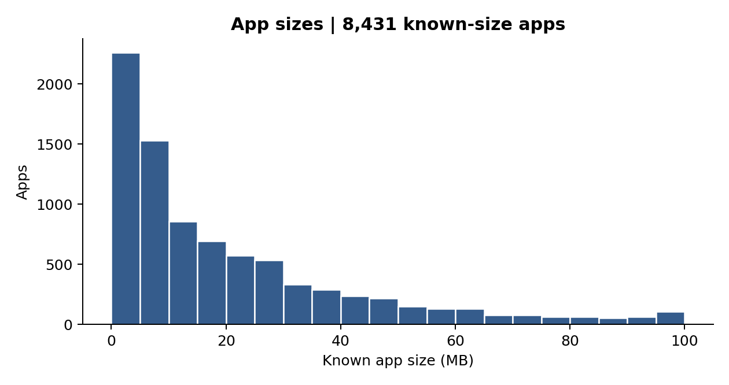

App types, audiences and install leaders

B04 How many apps are free or paid?
There are 8,905 free apps (92.19%) and 754 paid apps (7.81%). One missing Type value is classified as Free because its recorded price is zero. A free listing can still earn money through advertising or purchases inside the app; those revenues are not measured here.
Method: Count Type after the documented zero-price inference.

B05 What is the most common content rating?
Everyone is the most common label: 7,903 apps, or 81.82% of the cleaned sample. The label describes content suitability. It does not tell us the actual ages of users.
Method: Count Content Rating labels and select the largest count.

B06 What are the top five most installed apps?
Facebook, WhatsApp Messenger, Instagram, Messenger and Subway Surfers are five representatives of the highest recorded install band, 1 billion+. Twenty apps share that band. The table uses review count, then app name, to break install ties. These are not five uniquely ranked winners by actual downloads.
Method: Sort install lower bound descending, reviews descending, then app name ascending.
App | Install lower bound | Rating
Facebook | 1,000,000,000 | 4.100
WhatsApp Messenger | 1,000,000,000 | 4.400
Instagram | 1,000,000,000 | 4.500
Messenger – Text and Video Chat for Free | 1,000,000,000 | 4
Subway Surfers | 1,000,000,000 | 4.500

Review counts and category sizes

B07 How many apps have ratings of at least 4.0?
6,287 apps have a rating of 4.0 or higher. That is 76.71% of rated apps and 65.09% of all cleaned app records. Missing ratings are not counted as poor ratings.
Method: Count Rating >= 4.0.

B08 What is the average review count for free and paid apps?
Free apps average 234,420.54 reviews; paid apps average 8,748.01. The medians are much lower: 1,379 and 88.5. A few large apps pull the averages upward. These are counts recorded in the app listing file, not the number of review texts supplied in the second CSV.
Method: Group by Type and calculate mean and median Reviews.
Type | Apps | Mean reviews | Median reviews
Free | 8,905 | 234420.539 | 1,379
Paid | 754 | 8748.011 | 88.500

B09 What is the average size in each category?
GAME has the largest average known size at 41.66 MB, followed by FAMILY at 27.31 MB and TRAVEL_AND_LOCAL at 24.20 MB. TOOLS has the smallest mean at 8.77 MB. The complete 33-category table is in the workbook and category_summary.csv; known-size counts show the denominator used for each mean.
Method: Group by Category; average non-missing SizeMB.
Category | Known sizes | Mean MB
GAME | 862 | 41.657
FAMILY | 1,755 | 27.312
TRAVEL_AND_LOCAL | 173 | 24.204
TOOLS | 733 | 8.771
LIBRARIES_AND_DEMO | 81 | 10.603
PERSONALIZATION | 351 | 11.225

Updates and category ratings

B10 How many apps were last updated in 2018?
6,287 apps have a recorded last-update date in 2018, or 65.09% of the cleaned sample. This counts apps, not individual update releases. The dataset stops at a latest observed date of 8 August 2018.
Method: Parse Last Updated and count records with year = 2018.

M01 How are installs and ratings correlated?
For 8,196 apps with ratings, Pearson r = 0.0402 and Spearman rho = 0.0272. Both are close to zero. Higher recorded installs do not have a strong overall relationship with rating in this sample. The binned analysis in A03 shows why a single correlation does not describe the whole pattern.
Method: Pairwise complete observations; correlate InstallsMin and Rating.

M02 Which categories have the highest average ratings?
EVENTS leads at 4.436, followed by ART_AND_DESIGN at 4.359 and EDUCATION at 4.355. EVENTS has only 45 rated apps. Use the number of rated apps alongside the average, and do not treat a category mean as a forecast for a new product.
Method: Group by Category, average Rating and sort descending.
Category | Rated apps | Mean rating
EVENTS | 45 | 4.436
ART_AND_DESIGN | 59 | 4.359
EDUCATION | 106 | 4.355
BOOKS_AND_REFERENCE | 169 | 4.345
PERSONALIZATION | 298 | 4.332

Price and ratings

M03 How is paid-app price related to rating?
Among 602 rated paid apps, Pearson r = −0.1140 and Spearman rho = −0.0965. This is a weak negative association. Apps priced above $10 average 4.127, compared with 4.301 for prices up to $1. The middle bands do not decline steadily. Twenty paid listings cost more than $100, so the rank correlation is a useful check on extreme prices. Exact-price means are supplied in paid_price_ratings.csv and the workbook.
Method: Filter Type = Paid; group by price, then calculate pairwise Pearson and Spearman correlations.
Price band ($) | Apps | Rated | Mean rating
(0, 1] | 148 | 106 | 4.301
(1, 3] | 290 | 235 | 4.292
(3, 5] | 159 | 148 | 4.238
(5, 10] | 84 | 58 | 4.259
Above 10 | 73 | 55 | 4.127

The full paid-price table keeps every observed price, including unusual expensive listings. Removing extreme prices without saying so would change the question. Paid-app price also has almost no linear relationship with review count (Pearson r = −0.0144; Spearman rho = 0.1239, n = 754). Price alone does not explain engagement.

M04 How do ratings differ across content labels?
The median rating is 4.3 for Everyone, Everyone 10+ and Teen, compared with 4.2 for Mature 17+. Their distributions overlap substantially. Adults only 18+ has only three rated apps and Unrated has one, so those groups do not support broad comparisons.
Method: Use non-missing ratings in each content group; compare quartiles and a boxplot.
Content label | Rated | Q1 | Median | Q3
Adults only 18+ | 3 | 4.150 | 4.500 | 4.550
Everyone | 6,618 | 4 | 4.300 | 4.500
Everyone 10+ | 305 | 4.100 | 4.300 | 4.500
Mature 17+ | 357 | 3.900 | 4.200 | 4.400
Teen | 912 | 4 | 4.300 | 4.500
Unrated | 1 | 4.100 | 4.100 | 4.100

Content-rating distributions
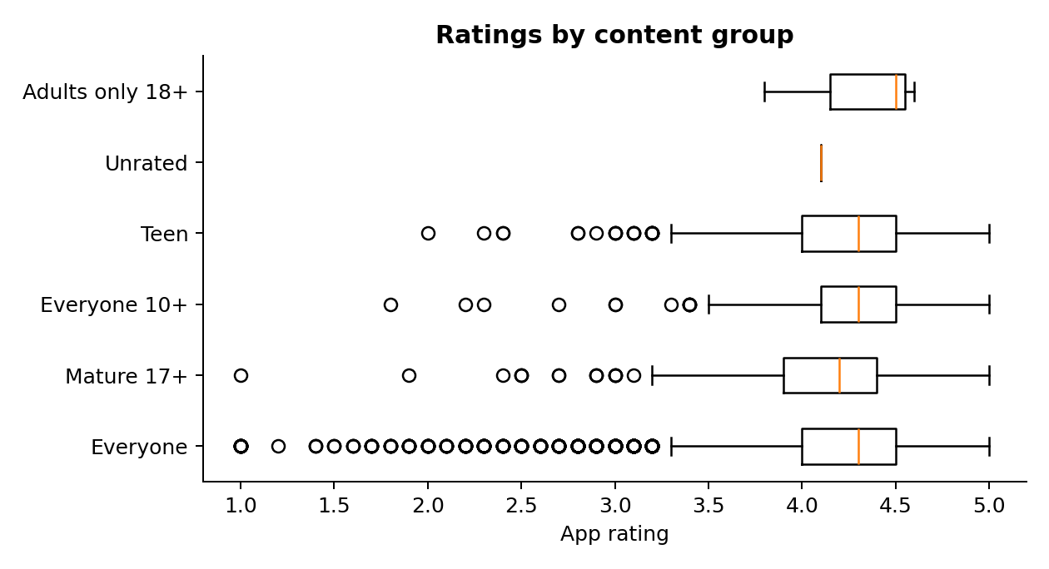
Boxes show the middle half of app ratings, with a median line. Whiskers and points show the spread beyond the box. The tiny adult-only and unrated groups should not drive a product decision.

M05 Which genres have the most apps above one million installs?
Tools leads with 173 apps, followed by Action with 128 and Photography with 124. The filter is strictly greater than 1,000,000 on the recorded lower bound. Apps labelled exactly 1,000,000+ are excluded, even though some may have more than one million actual installs. Combined genre labels are kept intact to avoid counting one app more than once.
Method: Filter InstallsMin > 1,000,000; count apps by the complete Genres string.
Genre | Apps above threshold
Tools | 173
Action | 128
Photography | 124
Communication | 99
Productivity | 91

M06 What is the average time between app updates?
This cannot be calculated reliably from these files. Each selected app record contains one Last Updated value. Repeated listings are not a verified release history, and differences between different apps’ dates are not update intervals. A valid calculation needs an app identifier and a dated sequence of releases for each app. A02 shows the distribution of recorded last-update dates instead.
Method: Not estimable: a longitudinal app release table is required.

Size and popularity

M07 How is app size related to installs?
Among 8,431 known-size apps, Pearson r = 0.1342 and Spearman rho = 0.3102. Larger apps tend to appear in higher install bands, although the relationship is noisy and may reflect categories such as games. It does not show that increasing an app’s size will increase downloads. Apps with device-dependent size are excluded.
Method: Plot SizeMB against InstallsMin + 1 on a log y-axis; correlate the untransformed values.
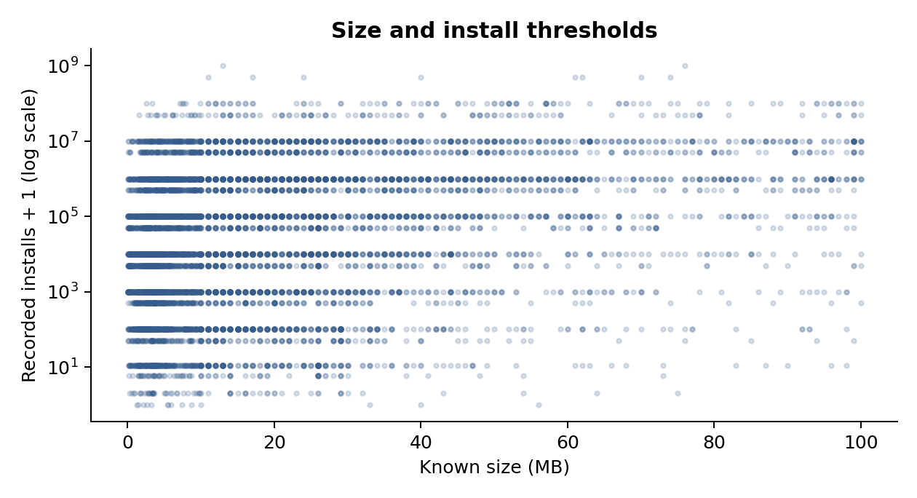
As a separate check against the problem statement, size and rating have Pearson r = 0.0630 and Spearman rho = 0.0502 across 7,026 complete records. Smaller downloads may matter to users, but this dataset does not establish a useful size-to-rating relationship.

Review leaders and audience mix

M08 Which apps have the most reviews, and what are their ratings?
Facebook has the largest recorded review count at 78,158,306, with a rating of 4.1. WhatsApp Messenger follows with 69,119,316 and a rating of 4.4. Instagram has 66,577,446 and a rating of 4.5. High visibility and strong ratings are different measures; the most-reviewed app is not the highest-rated app.
Method: Sort Reviews descending; display the top ten app names and ratings.
App | Reviews | Rating
Facebook | 78,158,306 | 4.100
WhatsApp Messenger | 69,119,316 | 4.400
Instagram | 66,577,446 | 4.500
Messenger – Text and Video Chat for Free | 56,646,578 | 4
Clash of Clans | 44,893,888 | 4.600
Clean Master- Space Cleaner & Antivirus | 42,916,526 | 4.700
Subway Surfers | 27,725,352 | 4.500
YouTube | 25,655,305 | 4.300
Security Master - Antivirus, VPN, AppLock, Booster | 24,900,999 | 4.700
Clash Royale | 23,136,735 | 4.600

M09 How do content labels differ between free and paid apps?
Everyone accounts for 81.41% of free apps and 86.60% of paid apps. Teen accounts for 11.05% of free apps and 6.90% of paid apps. Percentages use the total within each app type, so the unequal group sizes do not distort the comparison.
Method: Crosstab Content Rating by Type; divide each count by its type total.
Content label | Free | Paid | % of free | % of paid
Adults only 18+ | 3 | 0 | 0.03% | 0.00%
Everyone | 7,250 | 653 | 81.41% | 86.60%
Everyone 10+ | 291 | 31 | 3.27% | 4.11%
Mature 17+ | 375 | 18 | 4.21% | 2.39%
Teen | 984 | 52 | 11.05% | 6.90%
Unrated | 2 | 0 | 0.02% | 0.00%

Install totals and perfect scores

M10 Which five categories have the most installs?
GAME, COMMUNICATION, TOOLS, FAMILY and PRODUCTIVITY have the largest sums of recorded install lower bounds. GAME totals about 13.46 billion and COMMUNICATION about 11.04 billion. These totals combine apps and users can install several apps, so they are not unique audience counts or exact download totals.
Method: Group by Category, sum InstallsMin, then take the five largest totals.
Category | Install lower-bound total
GAME | 13,457,924,415
COMMUNICATION | 11,038,276,251
TOOLS | 8,102,771,915
FAMILY | 6,221,541,505
PRODUCTIVITY | 5,793,091,369

A01 Which ten apps have the highest ratings?
There are 271 apps tied at 5.0. The ten below are selected by rating, review count, install threshold and app name. Their review counts range from 43 to 141, and their install lower bounds from 100 to 5,000. A perfect score from a small group is not strong evidence of broad adoption. A separate top_rated_100_reviews.csv table provides a simple sensitivity check; the 100-review cutoff is an analyst choice.
Method: Sort Rating, Reviews and InstallsMin descending, then App ascending.
App | Rating | Reviews | Install floor
Ríos de Fe | 5 | 141 | 1,000
FD Calculator (EMI, SIP, RD & Loan Eligilibility) | 5 | 104 | 1,000
Oración CX | 5 | 103 | 5,000
Barisal University App-BU Face | 5 | 100 | 1,000
Master E.K | 5 | 90 | 1,000
CL REPL | 5 | 47 | 1,000
AJ Cam | 5 | 44 | 100
CS & IT Interview Questions | 5 | 43 | 1,000
Ek Vote | 5 | 43 | 500
AI Today : Artificial Intelligence News & AI 101 | 5 | 43 | 100

What last-update dates show

A02 What patterns appear in app updates over time?
Recorded last-update dates cluster near the end of the dataset. July 2018 has 2,317 apps, the largest monthly count; June has 911 and August has 984. August is only observed through 8 August and cannot be compared as a full month. This is a last-update-date distribution, not a history of release activity. Seasonal update behaviour cannot be established from this snapshot.
Method: Count app records by parsed last-update month and plot in date order.
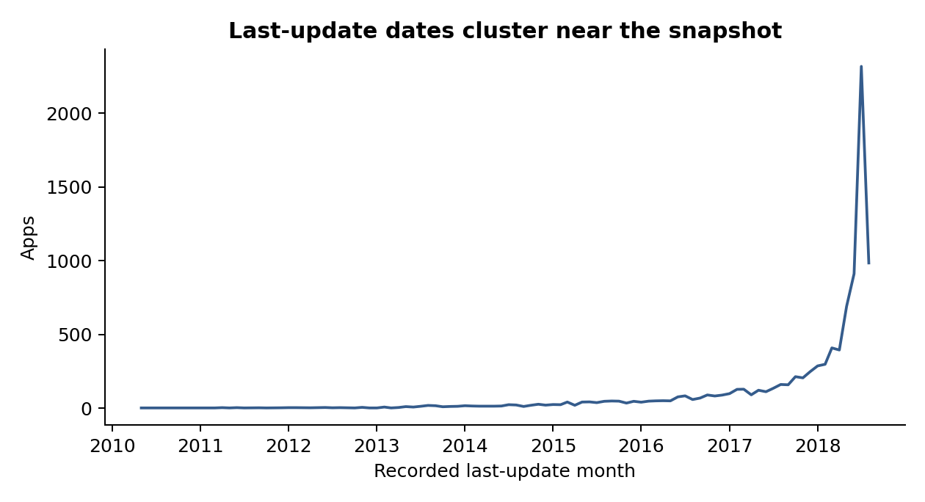
A month close to the snapshot is more likely to be an app’s latest update than a much earlier month. That selection effect can produce an upward-looking curve even when actual release frequency is stable. A release-event dataset is needed before testing seasonal behaviour.

Ratings by install band

A03 How does average rating vary across install bands?
The average is 4.345 below 1,000 recorded installs, drops to 4.038 in the 10,000–<100,000 band, then rises to 4.370 at 100 million+. This is not a simple straight-line pattern. Only 638 of 1,790 apps in the smallest band have ratings, while all 233 in the largest band do. Different rating coverage and small review counts can affect comparisons.
Method: Use fixed, non-overlapping bands of install lower bounds; calculate rated count, mean and median.
Install band | Apps | Rated | Mean | Median
Below 1K | 1,790 | 638 | 4.345 | 4.600
1K–<10K | 1,355 | 1,121 | 4.049 | 4.200
10K–<100K | 1,499 | 1,443 | 4.038 | 4.200
100K–<1M | 1,617 | 1,598 | 4.132 | 4.200
1M–<10M | 2,024 | 2,022 | 4.220 | 4.300
10M–<100M | 1,141 | 1,141 | 4.305 | 4.300
100M+ | 233 | 233 | 4.370 | 4.400

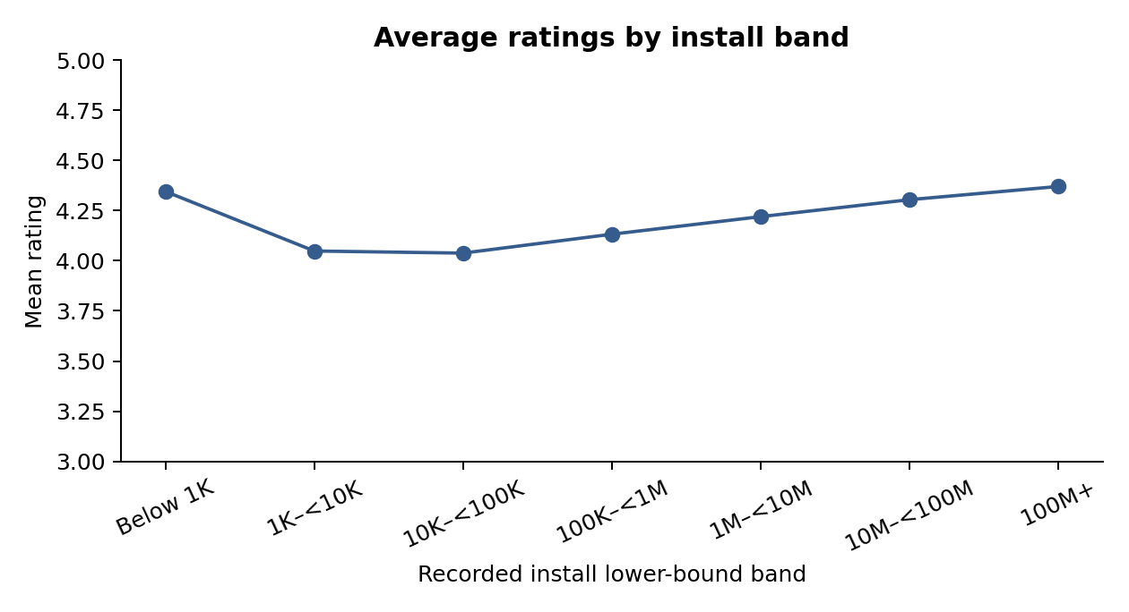

Review sentiment

A04 What do review sentiment and themes tell us?
The usable review set contains 29,692 distinct app/text records with sentiment labels. Of these, 28,250 match 816 cleaned app names. High-rated apps (rating >= 4.0) contribute 24,892 reviews; lower-rated apps contribute 3,358. Positive sentiment accounts for 65.70% in the high group and 53.22% in the low group. Negative sentiment accounts for 20.59% and 27.75%, respectively. The remaining reviews are neutral.
Method: Reuse the dataset’s sentiment labels; join by exact app name; classify app rating bands; count dictionary-based text themes.
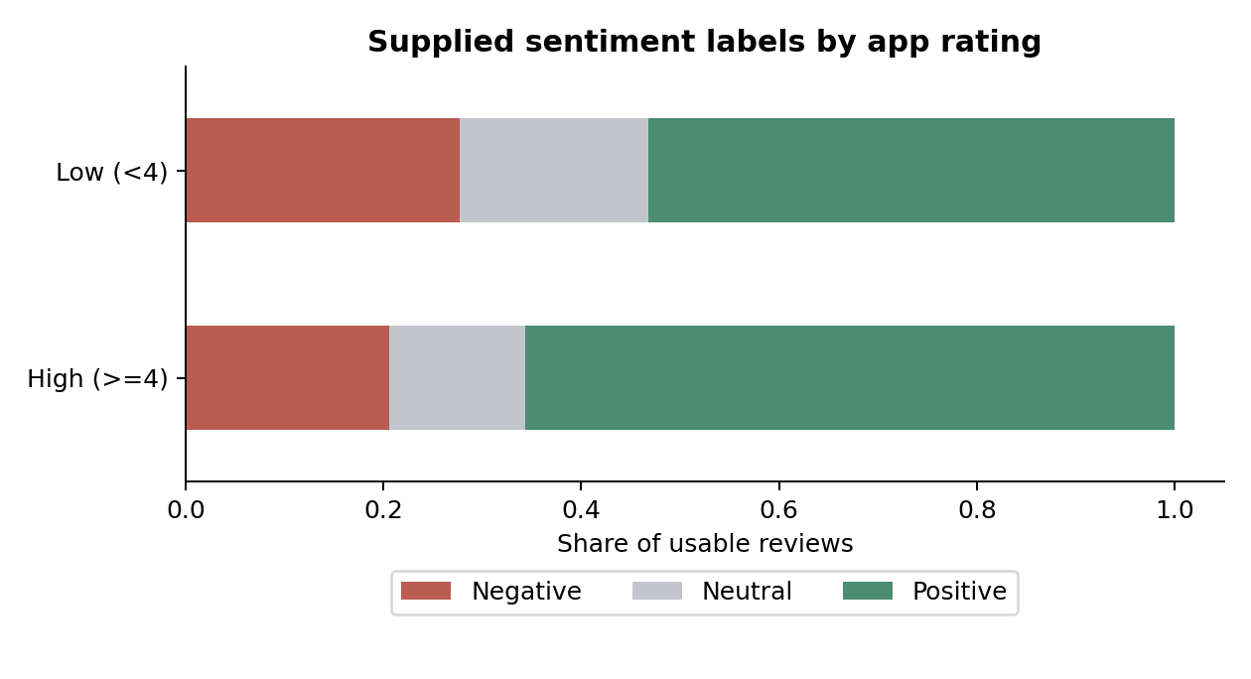
Sentiment labels and polarity scores are already supplied with the review data. This project summarizes those labels; it does not claim to have trained or validated a new sentiment model. Scores describe a review’s text, while the rating band is the app’s overall score. Individual review star ratings are not supplied.

Themes in high- and lower-rated apps
Theme | High-rated apps | Lower-rated apps
Account and access | 3.96% | 7.06%
Ads | 5.74% | 3.75%
Crashes and reliability | 5.17% | 8.40%
Ease of use | 8.40% | 6.61%
Enjoyment | 17.86% | 10.01%
Payments and price | 9.53% | 7.89%
Speed and loading | 5.22% | 7.00%
Updates | 9.15% | 13.73%

Enjoyment and ease-of-use language appears more often in the high-rated group. Update mentions rise from 9.15% in the high group to 13.73% in the low group; reliability mentions rise from 5.17% to 8.40%. Account/access mentions rise from 3.96% to 7.06%. Ads are mentioned more often in the high group, so the data does not support a blanket claim that ad mentions explain low ratings.
Themes use eight explicit keyword dictionaries, saved in theme_rules.json. Each review counts at most once per theme, but it can match several themes. A mention is not necessarily a complaint: “no crashes” still matches reliability. Overall sentiment is not sentiment toward each mentioned feature. Phrase counts use two-word phrases, English stop-word removal and a five-review minimum; review_phrases.csv contains the results.
These are exploratory text summaries, not hand-labelled topic estimates. The sample covers 816 of 9,659 app names, and some apps contribute far more review text than others. Translations, short text and automated labels can introduce errors. Before changing a feature, read a balanced sample of the relevant reviews and confirm whether the same issue appears in current product feedback.

Genre ratings and next steps

A05 Are some genres rated higher or lower?
The unrestricted leaders include Board;Pretend Play and Comics;Creativity at 4.8, each based on one app. Among genres with at least 30 rated apps, Events leads at 4.436, followed by Puzzle at 4.370. Educational is lowest at 3.872, followed by Dating at 3.980. Mean and median differences describe this snapshot; they do not show that a genre is consistently better over time. The 30-app cutoff is a reporting safeguard, not a significance test.
Method: Group by the full Genres label; report count, mean and median, with a 30-rated-app comparison.
Genre | Rated apps | Mean | Median
Events | 45 | 4.436 | 4.500
Puzzle | 100 | 4.370 | 4.400
Art & Design | 55 | 4.358 | 4.400
Educational | 32 | 3.872 | 3.950
Dating | 133 | 3.980 | 4.100
Maps & Navigation | 118 | 4.036 | 4.200

What the product team can do next
Use category install totals to choose products worth studying, then examine competition, acquisition costs and retention with newer data. A large historical install total does not establish a profitable gap in the market.
For an existing app, start with the reliability, loading, account-access and update issues raised in current reviews. Confirm the issue in crash reports or support tickets, release a focused change, and compare crash-free sessions, task completion and retention before and after it.
Test pricing with a product-specific experiment. This file has no paid conversions, advertising income, refunds or retention measures, so it cannot identify a revenue-maximizing price. Keep download size under review, but do not add features merely to match the size of popular apps.

Files, methods and further reading
The workbook contains Summary, Categories, Distributions, Rankings, Review analysis, Updates and Apps. Headline metrics and most category metrics are formulas linked to the cleaned app rows. Other result tables are labelled Python snapshots and can be regenerated with analyze.py. The results folder contains full tables, including all categories, price points and genres.
Run analyze.py to reproduce cleaning, calculations, sentiment summaries and charts. Play_Store_Analysis.ipynb provides an executed walkthrough. Source CSVs, the original brief, the supplied license file, excluded records and the app deduplication trail are included. SourceRow refers to the original CSV line number including the header.

References
Dataset listing supplied with the assignment: https://www.kaggle.com/datasets/lava18/google-play-store-apps
pandas duplicate handling: https://pandas.pydata.org/docs/reference/api/pandas.DataFrame.drop_duplicates.html
pandas correlation methods: https://pandas.pydata.org/docs/reference/api/pandas.Series.corr.html
scikit-learn phrase counting: https://scikit-learn.org/stable/modules/generated/sklearn.feature_extraction.text.CountVectorizer.html
Methods references were checked on 23 September 2026. Data results come from the supplied CSV files. The unrelated healthcare and loan-analysis paragraphs in the brief are outside this project’s app-analysis scope.

