Heart Health Analysis
  - Solution guide for the 25 project questions

Main findings
The source file contains 1,025 rows and 302 distinct records. Mean age is 54.43 years, resting blood pressure 131.61 mm Hg and cholesterol 246.00 mg/dL. Exercise-induced angina is recorded in 33.66% of source rows.
The outcome label needs correction before any clinical interpretation. All 302 distinct rows match original Cleveland records on eight unchanged clinical fields. In every match, target=1 corresponds to original num=0, meaning absence of disease. DiseasePresent is therefore defined as 1 minus target. This gives 499 disease-present source rows and 138 distinct disease-present records.
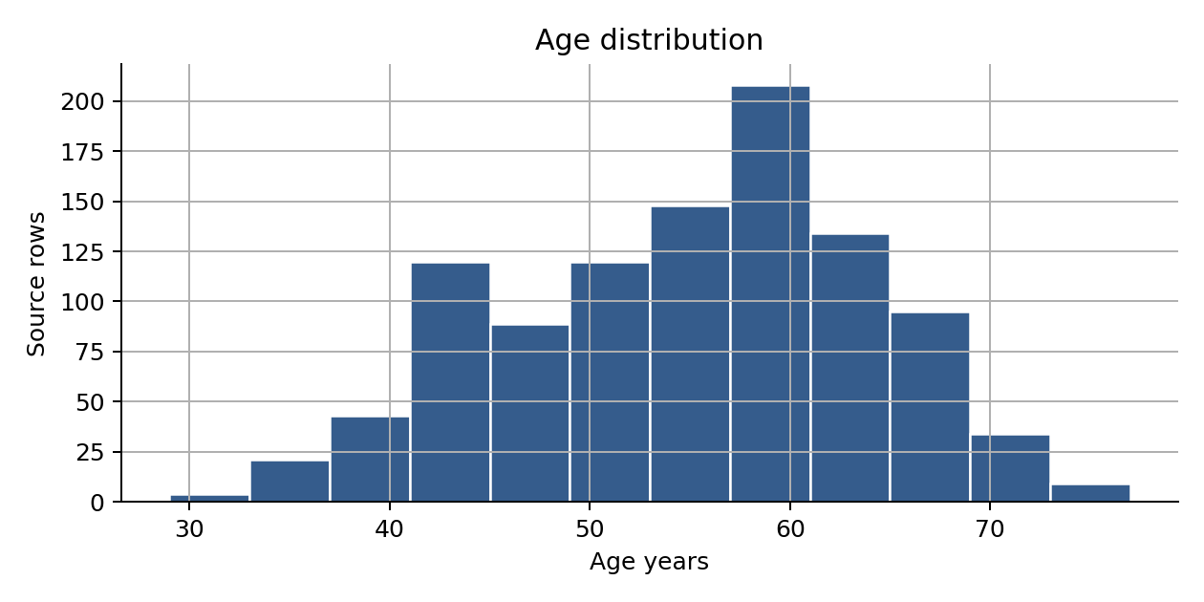
Higher oldpeak and lower maximum exercise heart rate are the strongest continuous associations with corrected disease presence. The full-feature model reaches an AUC of 0.900 on a small held-out set. Its eight missed disease cases show why a single accuracy figure is insufficient for care decisions.

Data preparation and source verification
Item | Records
Source rows | 1,025
Distinct records | 302
Identical later rows | 723
Blank or null cells | 0
Rows with unresolved ca=4 | 18
Rows with unresolved thal=0 | 7
Distinct records matched to Cleveland | 302

Descriptive answers use the full attached file so the basic totals can be reproduced directly. Inference and model evaluation use distinct records. Removing duplicates reduces repeated observations but cannot verify unique patient identity because patient IDs are absent. The original CSV remains unchanged.
The code comparison checks eight fields jointly: age, sex, resting pressure, cholesterol, fasting blood sugar flag, maximum heart rate, exercise-induced angina and oldpeak. These keys are unique in both comparison populations, giving a one-to-one match. The source_comparison.csv table retains both sets of recoded fields and the original diagnostic outcome.
No blank cells appear, but ca=4 and thal=0 match missing original values. They are labeled Unknown in model inputs. Categories remain categorical. Outliers are flagged with 1.5-times-interquartile-range fences and retained because unusually high clinical readings are not automatically errors. Numeric model features are standardized using training data only.
The thal codes describe a thallium stress-test result. A diagnosis of thalassemia, future disease onset, treatment response and survival cannot be inferred from these records. Corrected label meaning is used consistently in disease tables, figures and models.

Basic demographic and clinical results

B01 Average age
The average age across the 1,025 source rows is 54.43 years. Ages range from 29 to 77. After removing identical rows, the mean is 54.42 years. The sample describes people evaluated in a clinical setting and does not measure the age distribution of the general population.
Calculation: Average age.

B02 Recorded sex
The file contains 713 male-coded rows and 312 female-coded rows, representing 69.56% and 30.44%. The source field records sex. It does not provide gender identity, and the counts cannot establish which group has higher population risk.
Calculation: Count sex codes 1 and 0.

B03 Resting blood pressure
Mean resting blood pressure is 131.61 mm Hg across all source rows. The median is 130 mm Hg. A dataset average cannot classify an individual patient or establish a treatment threshold.
Calculation: Average trestbps.

B04 Fasting blood sugar flag
153 rows have fbs=1, meaning fasting blood sugar above 120 mg/dL. This is 14.93% of the file. The field is a threshold flag rather than a recorded glucose concentration or a verified diabetes diagnosis.
Calculation: Sum fbs; divide by the row count.
Sex code | Source rows | Share
0 | 312 | 30.44%
1 | 713 | 69.56%

Symptoms heart rate and cholesterol

B05 Chest pain types
Four chest pain codes appear: 0, 1, 2 and 3. Matching against Cleveland records identifies code 0 as asymptomatic, 1 as atypical angina, 2 as non-anginal pain and 3 as typical angina. Their source-row counts are 497, 167, 284 and 77. These categories should not be ranked as a numeric severity scale.
Calculation: Count cp codes; verify the recoding against original matched records.

B06 Maximum heart rate
The largest recorded maximum heart rate is 202 bpm. The mean is 149.11 bpm. This is an exercise-test measurement, and the observed maximum is not a recommended exercise target or a direct measure of psychological stress.
Calculation: Maximum thalach.

B07 Exercise induced angina
345 of 1,025 rows record exercise-induced angina, or 33.66%. The result counts source records. Without patient identifiers, it should not be described as 345 verified unique patients.
Calculation: Average exang multiplied by 100.

B08 Average cholesterol
Mean serum cholesterol is 246.00 mg/dL, with a median of 240 mg/dL. The maximum is 564 mg/dL. High values remain in descriptive results because the file does not establish that they are recording errors.
Calculation: Average chol.
Chest pain code | Source rows | Share
0 | 497 | 48.49%
1 | 167 | 16.29%
2 | 284 | 27.71%
3 | 77 | 7.51%

ECG and vessel codes

B09 Resting ECG code two
15 rows have restecg=2. The Cleveland comparison maps this recoded level to an ST-T wave abnormality. The original Cleveland code 2 has a different meaning, so using the original codebook without checking recoding would give the wrong interpretation.
Calculation: Count restecg equal to 2.

B10 Vessel count distribution
The ca counts are 578 for code 0, 226 for code 1, 134 for code 2 and 69 for code 3. Another 18 rows carry code 4. Their matched original ca values are missing, so code 4 is kept as an unresolved category rather than interpreted as four vessels. Vessel imaging measurements alone do not determine urgency or a care plan.
Calculation: Count every observed ca value and retain the unresolved code.
Vessel code | Source rows | Share
0 | 578 | 56.39%
1 | 226 | 22.05%
2 | 134 | 13.07%
3 | 69 | 6.73%
4 | 18 | 1.76%

Code interpretation
The recoded file differs from the original Cleveland codebook. Chest pain code 0 is asymptomatic, ECG code 0 corresponds to probable or definite left ventricular hypertrophy, and slope code 0 is downsloping. The case study provides the complete checked dictionary. An unresolved category remains separate from known clinical findings.

Age cholesterol and chest pain

M01 Age and cholesterol
Pearson correlation between age and cholesterol is 0.220 across all rows and 0.207 across distinct records. Spearman correlation is 0.203 and 0.189 respectively. These are weak positive associations. Age alone explains little of the observed cholesterol variation.
Calculation: Calculate Pearson and Spearman correlations in both populations.
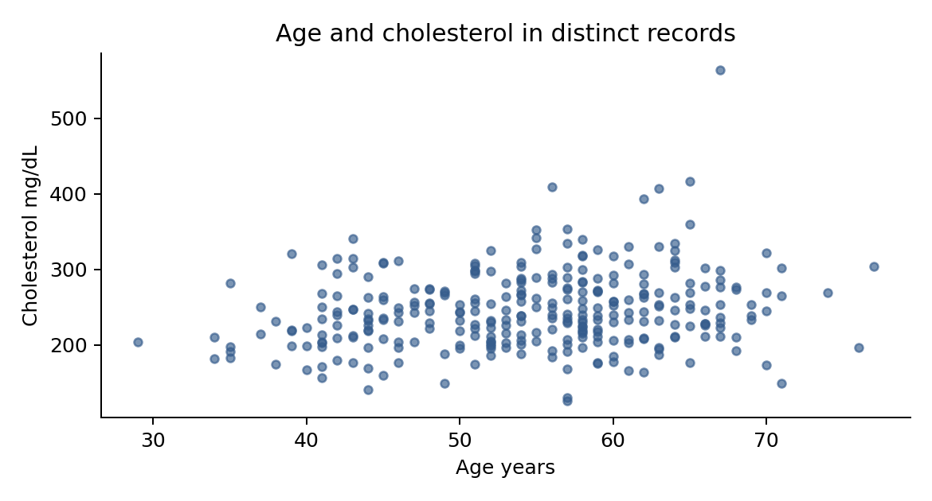

M02 Chest pain across ages
The age-band table counts each chest pain code within Under 40, 40 to 49, 50 to 59, 60 to 69 and 70 or older. Code 0 is the largest category in every band except Under 40, where code 2 leads. The exact-age table is also provided. Compare within-band percentages before interpreting a tall bar as a stronger relationship, because the bands contain different numbers of rows.
Calculation: Cross-tabulate age group and cp; calculate row percentages; retain an exact-age cross-tab.
Age band | cp 0 | cp 1 | cp 2 | cp 3
Under 40 | 15 | 11 | 24 | 7
40 to 49 | 94 | 62 | 72 | 9
50 to 59 | 210 | 72 | 110 | 30
60 to 69 | 163 | 13 | 68 | 31
70 or older | 15 | 9 | 10 | 0

Heart rate and resting pressure

M03 Heart rate and angina
Rows without exercise-induced angina have mean maximum heart rate of 155.34 bpm, compared with 136.84 bpm for rows with angina. The difference is 18.50 bpm. The groups differ in other clinical characteristics, so this comparison does not identify the effect of angina or a safe exercise intensity.
Calculation: Group thalach by exang and compare means.
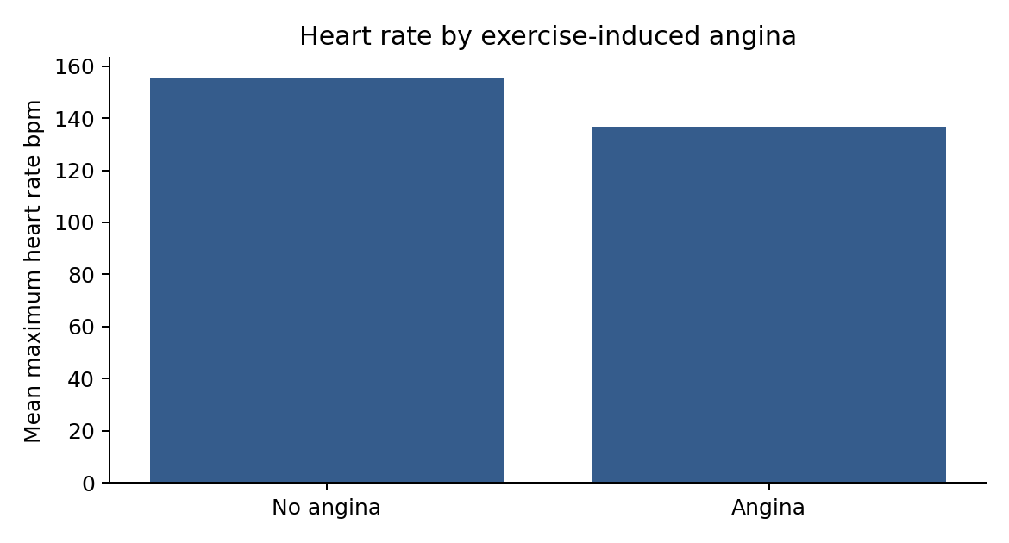

M04 Blood pressure by sex
Among distinct records, mean resting pressure is 130.91 mm Hg for male-coded records and 133.08 mm Hg for female-coded records. The male-minus-female difference is -2.17 mm Hg, with a 95% interval from -6.69 to 2.35. Welch’s two-sided test gives p=0.344. This sample does not provide clear evidence of a mean difference at the 5% level.
Calculation: Use Welch’s t-test on 206 male-coded and 96 female-coded distinct records; calculate the mean-difference interval.

Blood sugar and vessel associations

M05 Blood sugar and disease presence
Corrected disease presence is 53.59% in fbs=1 rows and 47.82% in fbs=0 rows. A Fisher exact test on distinct records gives an odds ratio of 1.163 and p=0.746. The sample offers little evidence of an association between this flag and the corrected outcome. This does not invalidate established clinical evidence about diabetes and cardiovascular health.
Calculation: Cross-tabulate fbs against DiseasePresent; use Fisher’s exact test on distinct records.

M06 Vessel measurements and disease
Corrected disease presence rises from 28.20% for ca=0 to 70.80%, 84.33% and 86.96% for ca=1, 2 and 3. The ca=4 share is 16.67%, but that code represents unresolved source values and is excluded from the clinical sequence. These are contemporaneous diagnostic associations rather than future disease probabilities.
Calculation: Calculate DiseasePresent / rows within each ca code.
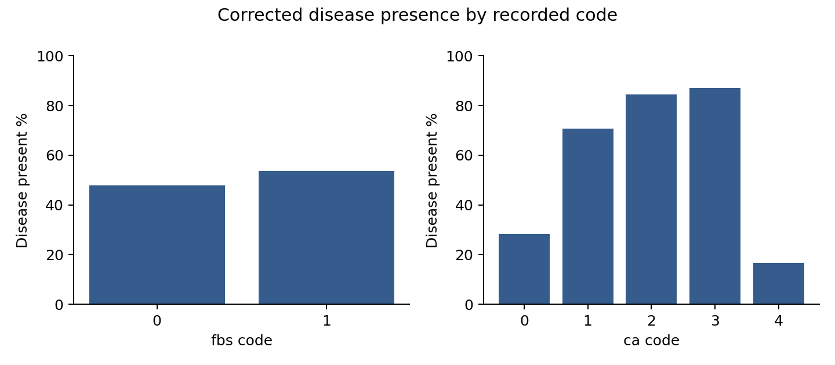
All shares on this page use corrected disease presence, not target=1. The full-file vessel table retains the unresolved code so its 18 rows are visible. Clinical category comparisons should use codes 0 through 3 and treat Unknown separately.

ST depression and stress test results

M07 ST depression by chest pain
Mean oldpeak is 1.439 for cp=0, 0.324 for cp=1, 0.785 for cp=2 and 1.381 for cp=3. Oldpeak records exercise-related ST depression. A group average does not show that the chest pain category caused the ECG finding or supply a standalone severity rating.
Calculation: Group oldpeak by cp and calculate mean and median.
cp | Source rows | Mean oldpeak | Median
0 | 497 | 1.439 | 1.200
1 | 167 | 0.324 | 0
2 | 284 | 0.785 | 0.500
3 | 77 | 1.381 | 1.200

M08 Stress test results among disease records
Among the 499 rows with corrected disease presence, thal=3 accounts for 320 rows or 64.13%, thal=2 for 132 or 26.45%, thal=1 for 43 or 8.62%, and unresolved thal=0 for 4 or 0.80%. The verified meanings are reversible defect, normal result and fixed defect for codes 3, 2 and 1. This field is not a diagnosis of thalassemia.
Calculation: Filter DiseasePresent=1 and count thal. The separate target=1 table preserves the brief’s literal filter, which selects the opposite outcome.
thal code | Disease rows | Share of disease rows
0 | 4 | 0.80%
1 | 43 | 8.62%
2 | 132 | 26.45%
3 | 320 | 64.13%

Common profiles and clinical differences

M09 Common combinations
The most common combination among corrected disease-present rows is cp=0, fbs=0, exang=1 and thal=3, with 140 rows or 28.06% of the disease subset. The next combination changes exang to 0 and has 70 rows. These are common recorded profiles, not a clinical score. Counts alone do not show how strongly a combination distinguishes disease from its absence.
Calculation: Filter DiseasePresent=1; count cp, fbs, exang and thal combinations. A separate table retains the requested target=1 filter.
cp | fbs | exang | thal | Disease rows
0 | 0 | 1 | 3 | 140
0 | 0 | 0 | 3 | 70
0 | 0 | 1 | 2 | 51
0 | 1 | 1 | 3 | 35
2 | 0 | 0 | 3 | 29

M10 Clinical measurements by disease
In distinct records, the disease-present group is older by 4.02 years, has resting pressure higher by 5.15 mm Hg, maximum heart rate lower by 19.28 bpm, and oldpeak higher by 0.999. These differences remain significant after adjusting the five comparison p-values. Cholesterol is higher by 8.45 mg/dL, but its interval includes zero. Means and distributions are provided for both outcome groups.
Calculation: Compare five continuous measurements with Welch tests and 95% intervals; adjust p-values with Benjamini-Hochberg.
Measurement | Mean absent | Mean present | Adjusted p value
age | 52.59 | 56.60 | <0.001
trestbps | 129.25 | 134.40 | 0.015
chol | 242.64 | 251.09 | 0.155
thalach | 158.38 | 139.10 | <0.001
oldpeak | 0.587 | 1.586 | <0.001

The full table includes group sizes and confidence intervals. Each of the five tests is performed on distinct records. The adjustment controls the false-discovery rate within this comparison family. None of the tests identifies a treatment effect.

Age cholesterol and pressure together

A01 Age cholesterol and pressure together
A three-factor logistic model on distinct records estimates an odds ratio of 1.560 per additional 10 years of age, with a 95% interval of 1.171 to 2.078. The adjusted cholesterol odds ratio per 50 mg/dL is 1.067 and pressure per 10 mm Hg is 1.111. Their intervals include 1. This model estimates additive associations on log odds. It does not prove a combined causal effect, test interactions or estimate future incidence.
Calculation: Fit an unpenalized logistic model using age, cholesterol and resting pressure; calculate HC1 sandwich standard errors and nominal p-values.
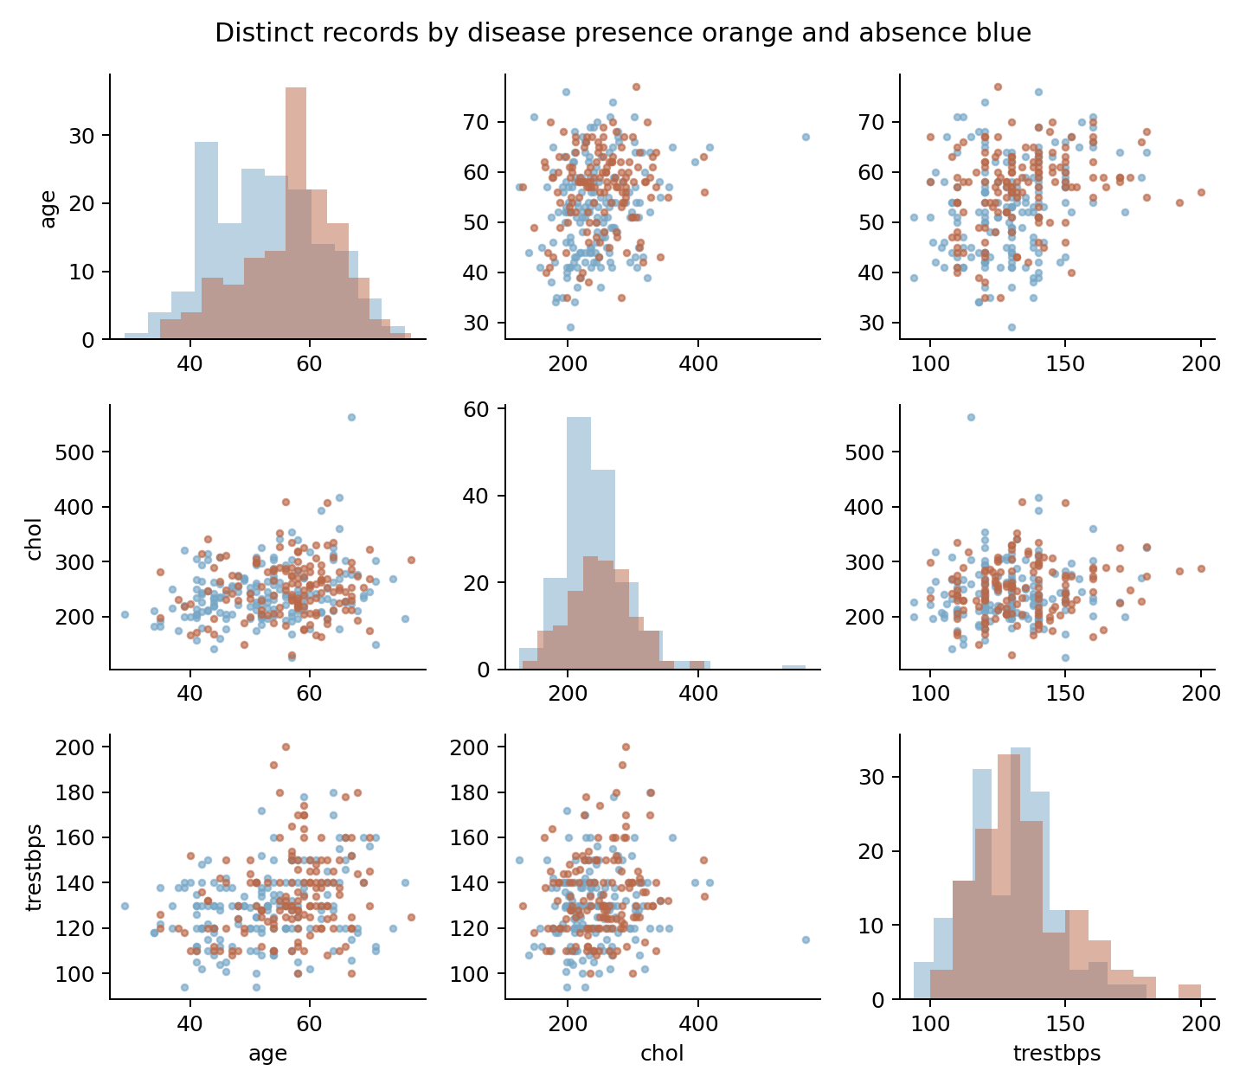

Combined model estimates and correlations
Term | Odds ratio | 95% low | 95% high | p value
Age per 10 years | 1.560 | 1.171 | 2.078 | 0.002
Cholesterol per 50 mg/dL | 1.067 | 0.831 | 1.369 | 0.612
Pressure per 10 mm Hg | 1.111 | 0.968 | 1.275 | 0.133

The three-factor model uses maximum likelihood with an intercept. HC1 sandwich intervals allow variance misspecification under independent-record assumptions. The coefficients converge numerically. The small historical sample, linear log-odds specification and missing confounders still limit inference. An odds ratio is not a percentage-point change in probability.

A02 Strongest continuous correlation
Oldpeak has the largest absolute Pearson correlation with corrected disease presence among the continuous clinical measurements, at 0.438. Maximum heart rate follows at -0.423. Age is also continuous but is a demographic variable. Correlations for every feature are included, while nominal code correlations are kept separate because their numeric ordering can be arbitrary.
Calculation: Rank absolute Pearson correlations among age, trestbps, chol, thalach and oldpeak; also retain all-feature results.
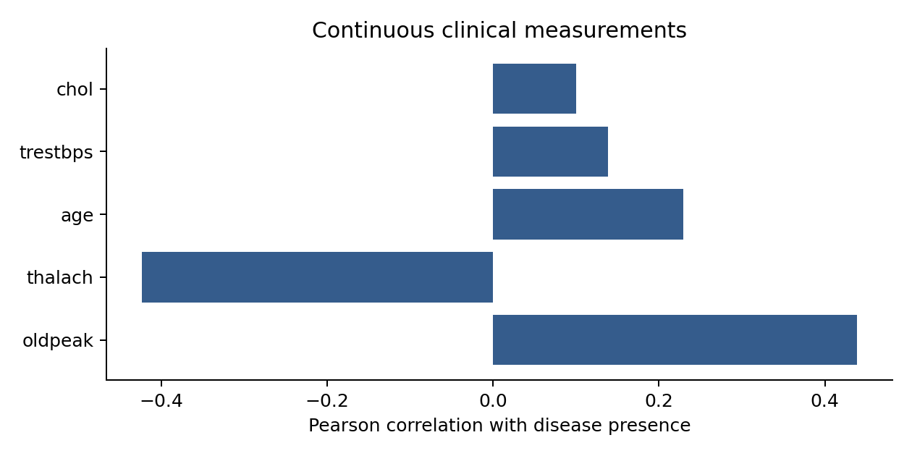

Predicting corrected disease presence

A03 Logistic classification model
The model uses all 13 supplied predictors and the corrected disease outcome. On 76 held-out distinct records, ROC AUC is 0.900, accuracy is 80.26%, precision is 79.41%, and recall is 77.14% at a 0.5 threshold. It identifies 27 disease-present records, misses 8, and gives 7 false positives. The results describe this internal split and do not establish clinical readiness.
Calculation: Stratify distinct records into 226 training and 76 test rows with seed 42. Scale numeric inputs and one-hot encode categories inside a training-only pipeline. Fit L2 logistic regression with C=1.
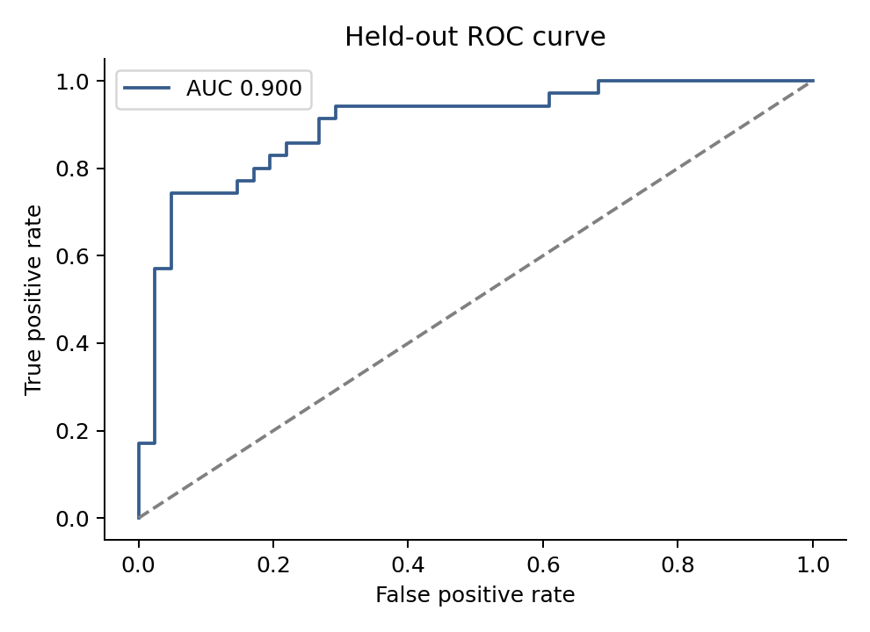
Held-out result | Records
True negatives | 34
False positives | 7
False negatives | 8
True positives | 27

Model evaluation and limits
Five-fold stratified cross-validation runs only within the 226 training records. Mean AUC is 0.913, with a between-fold standard deviation of 0.037. Numeric scaling and category encoding are fitted separately inside each fold. C=1 and the 0.5 classification threshold are fixed before evaluating the held-out set.
The test AUC has a bootstrap 95% interval from 0.822 to 0.961, conditional on the fitted model and test sample. The Brier score is 0.122, compared with 0.248 for a constant training-prevalence prediction. The bootstrap does not measure all uncertainty from choosing a training sample or deploying the model elsewhere.
The classifier uses age, resting pressure, cholesterol, maximum heart rate and oldpeak as standardized numeric features. Sex, chest pain, the blood sugar flag, ECG, angina, slope, vessel code and stress-test code are one-hot encoded. Unknown vessel and stress-test categories are kept explicit. Penalized coefficients are supplied for interpretation, without treating them as significance tests.
A sensitivity analysis removes six distinct records with unresolved ca or thal codes, then repeats the stratified split. Its AUC is 0.921 on 74 test records. Because the split changes, this difference does not prove that removing the records improves the model.
All predictors are contemporaneous diagnostic measurements. The model does not predict future disease, survival or a preventive treatment benefit. Original patient identifiers and dates are absent. External validation, calibration assessment and clinical review would be needed before applying the model to patient care.

ST slope and the survival question

A04 ST slope by chest pain
For cp=0, the most common slope is code 1, with 292 rows. For cp=1 and cp=2, slope code 2 leads with 118 and 159 rows. For cp=3, code 1 leads with 39 rows. Source matching identifies slope 0 as downsloping, 1 as flat and 2 as upsloping. Counts and within-chest-pain percentages show the full comparison.
Calculation: Cross-tabulate cp and slope and calculate row percentages.
cp | Downsloping 0 | Flat 1 | Upsloping 2
0 | 42 | 292 | 163
1 | 8 | 41 | 118
2 | 15 | 110 | 159
3 | 9 | 39 | 29

A05 Survival over time
Survival rates cannot be calculated from this dataset. It has no starting date, follow-up duration, death event or censoring indicator. Age and a stress-test code cannot replace those fields. The thal distribution answers a cross-sectional question about test findings, not survival.
Calculation: Required follow-up fields are an index date, last observation or event date, event status, and verified stress-test category.

A suitable follow-up dataset
Record a stable patient ID, a defined start date, time to death or last contact, event status and the stress-test category measured at the start. Account for people whose follow-up ends before an event. Kaplan-Meier curves could then compare survival by category, with an adjusted survival model if sample size and assumptions support it.

Recommendations and next steps

Fix clinical definitions first
Keep the checked outcome mapping and recoded dictionary with the data. Confirm how unresolved test codes arose and retain a link to the original records. A reversed outcome label would reverse the apparent direction of clinical associations.

Use results to plan further evaluation
Higher oldpeak and lower maximum exercise heart rate distinguish the recorded outcome groups most clearly among continuous measurements. Review these findings with a cardiologist alongside symptoms and other investigations. The file does not support standalone triage thresholds, medication changes or exercise prescriptions.

Keep prevention advice separate from model results
WHO identifies tobacco use, unhealthy diet, physical inactivity and harmful alcohol use as modifiable cardiovascular risk factors. Prevention programs can draw on that guidance and clinician-led assessment. Those behaviors are not measured here, so this analysis cannot quantify the benefits of changing them. The WHO reference is listed in Additional Resources.

Measure outcomes before claiming improvement
Track patient outcomes and compare care pathways prospectively before reporting better diagnosis or fewer disease events. The measured project results are the calculated associations and internal model performance. No improvement in patient outcomes was measured.

