Hotel Booking Analysis
  - Solution guide for the 25 assignment questions

What the records show
The sample contains 119,390 booking records scheduled to arrive from July 2015 through August 2017. Just over 37% carry the canceled flag. City Hotel has more records and a higher cancellation rate than Resort Hotel. Longer advance booking is associated with more cancellations, while repeat-guest bookings cancel less often.
The most useful next step is to study long-lead bookings and channel-specific cancellation patterns. The findings support targeted investigation and a measured pilot. They do not establish that changing a deposit rule, accepting more requests or increasing prices will cause better results.
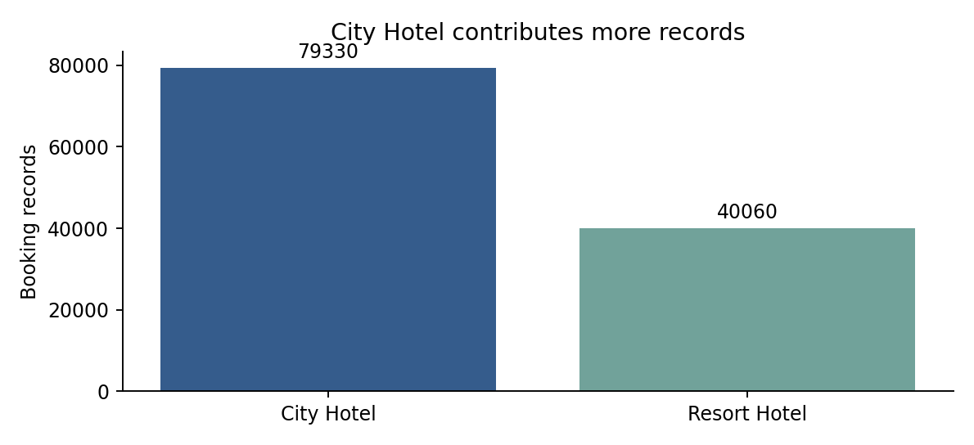
All 25 questions are addressed below. Revenue is reported as an estimated lodging value, and special requests are treated as service demand. Actual occupancy, accounting revenue and guest satisfaction require data that is not included in this file.

Preparing the data
Item | Records
Source booking records | 119,390
Identical later rows retained | 31,994
Rows if exact duplicates were removed | 87,396
Missing children counts | 4
Unknown countries | 488
Records with zero guests | 180
Records with zero nights | 715
Negative ADR records | 1
ADR records above 1000 | 1

Identical rows remain in the primary analysis. The source paper describes one observation per booking, and there is no booking ID to verify which identical rows are redundant. Removing them reduces the cancellation rate from 37.04% to 27.49% and mean lead time from 104.01 to 79.89 days. That is a material change, so the separate sensitivity table is included rather than silently replacing the source population.
Four missing children counts stay unknown. They are excluded only when guest composition is needed. Missing country becomes Unknown. NULL agent and company IDs mean not applicable, following the source documentation, and remain empty identifiers. Dates are parsed, total nights are calculated, and anomalous records are flagged instead of erased from descriptive counts.
The one negative ADR of -6.38 and one ADR of 5,400 remain in the requested descriptive means. The negative value is excluded from the lodging-value proxy and ADR regression. A separate regression caps ADR at its eligible-sample 99th percentile, 252.00, to test sensitivity to high rates.

Booking lead time and service demand

B01 Average booking lead time
The average lead time is 104.01 days, while the median is 69 days. The higher mean shows that some bookings made far in advance pull the average upward. These are days from booking entry to scheduled arrival, including bookings that later canceled.
Calculation: Average lead_time across all 119,390 records.

B02 Bookings by hotel type
City Hotel has 79,330 records, or 66.45% of the sample. Resort Hotel has 40,060, or 33.55%. This compares two properties with different capacity and business mixes. It does not establish that city hotels are more popular across the industry.
Calculation: Count records by hotel.

B03 Canceled bookings
The is_canceled flag identifies 44,224 records, giving a cancellation rate of 37.04%. The final status splits these into 43,017 Canceled and 1,207 No-Show records. The project uses the supplied flag consistently, so no-shows are included in cancellation totals.
Calculation: Sum is_canceled; divide by the record count.

B05 Special requests per booking
Bookings average 0.571 special requests. Most records have none: 70,318 of 119,390, or 58.90%. Requests can help estimate service workload, but their count does not measure whether the guest was satisfied or whether the request was fulfilled.
Calculation: Average total_of_special_requests.
Final status | Records
Check-Out | 75,166
Canceled | 43,017
No-Show | 1,207

Arrival months and guest origin

B04 Most common arrival month
August has the most scheduled arrivals in the pooled sample, with 13,877 bookings. July and August each occur in three years; the other months occur in two. After dividing by the number of observed year-months, May leads with 5,895.5 records per observed May. Use the pooled answer for the assignment, and the coverage-adjusted view for planning.
Calculation: Count arrival_date_month; also divide counts by observed year-months.
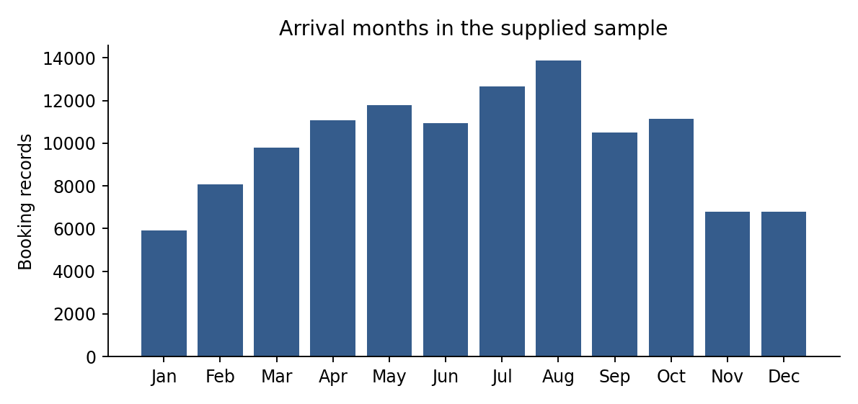

B06 Country with the most bookings
PRT, the code for Portugal, has the most records: 48,590, or 40.70% of all bookings. Country is unknown for 488 records and stays separate from known countries. This is a booking-level count, not a count of unique guests.
Calculation: Count country labels; retain missing country as Unknown.
Country code | Bookings
PRT | 48,590
GBR | 12,129
FRA | 10,415
ESP | 8,568
DEU | 7,287

Rates parking and stay length

B07 ADR by hotel type
City Hotel has mean ADR of 105.30, compared with 94.95 for Resort Hotel. Their medians are 99.90 and 75.00. These booking-weighted means include canceled bookings and the source outliers. ADR is expressed in the source currency units; no exchange-rate conversion is made.
Calculation: Group by hotel and average adr.
Hotel | Bookings | Mean ADR | Median ADR
City Hotel | 79,330 | 105.30 | 99.90
Resort Hotel | 40,060 | 94.95 | 75

B08 Bookings requiring parking
7,416 bookings require at least one parking space, representing 6.21% of all records. This percentage uses bookings as the denominator. It cannot be described as a percentage of individual guests, because one booking can contain several guests.
Calculation: Count required_car_parking_spaces > 0; divide by all records.

B09 Average week and weekend nights
The mean is 2.500 week nights and 0.928 weekend nights per booking, giving 3.428 total nights. The main figures include booked nights for canceled records. They describe stay length, not occupancy rate. Actual occupancy needs occupied room-nights and available room-nights for the same dates.
Calculation: Average stays_in_week_nights and stays_in_weekend_nights; add them for total nights.

B10 Bookings through travel agents
103,050 bookings have a travel-agent ID, or 86.31% of the sample. The other 16,340 have no applicable agent. The source paper explains that a NULL agent means the booking did not come through an agent, so these IDs are not filled with a typical agency number.
Calculation: Count non-missing agent IDs; keep IDs categorical.

Hotel cancellations and segment rates

M01 Cancellation rates by hotel
City Hotel has a cancellation rate of 41.73%: 33,102 out of 79,330 records. Resort Hotel is at 27.76%: 11,122 out of 40,060. The difference is 13.96 percentage points. Channel mix, advance booking and deposit arrangements may contribute to this gap.
Calculation: Calculate sum(is_canceled) / record count within each hotel.
Hotel | Bookings | Canceled | Rate
City Hotel | 79,330 | 33,102 | 41.73%
Resort Hotel | 40,060 | 11,122 | 27.76%

M02 ADR by market segment
Online TA has the highest mean ADR at 117.20, followed by Direct at 115.45. Complementary is lowest at 2.89, which fits a segment containing many free or heavily discounted stays. Undefined has only two records and is not useful for a broad comparison. ADR alone does not measure segment profitability because commissions and costs are absent.
Calculation: Group by market_segment; report count, mean and median ADR.
Segment | Bookings | Mean ADR | Median ADR
Aviation | 237 | 100.14 | 95
Complementary | 743 | 2.886 | 0
Corporate | 5,295 | 69.36 | 65
Direct | 12,606 | 115.45 | 105
Groups | 19,811 | 79.48 | 70
Offline TA/TO | 24,219 | 87.35 | 85.50
Online TA | 56,477 | 117.20 | 109.80
Undefined | 2 | 15 | 15

Cancellations and advance booking

M03 Lead time and cancellation
Longer lead times are associated with more cancellations. The rate rises from 9.63% for bookings made 0 to 7 days ahead to 67.66% for those made at least 366 days ahead. Pearson correlation is 0.293 and Spearman is 0.317. The relationship can also reflect group bookings and deposit practices; it is not a causal effect of waiting longer.
Calculation: Correlate lead_time with is_canceled; compare explicit day bands.
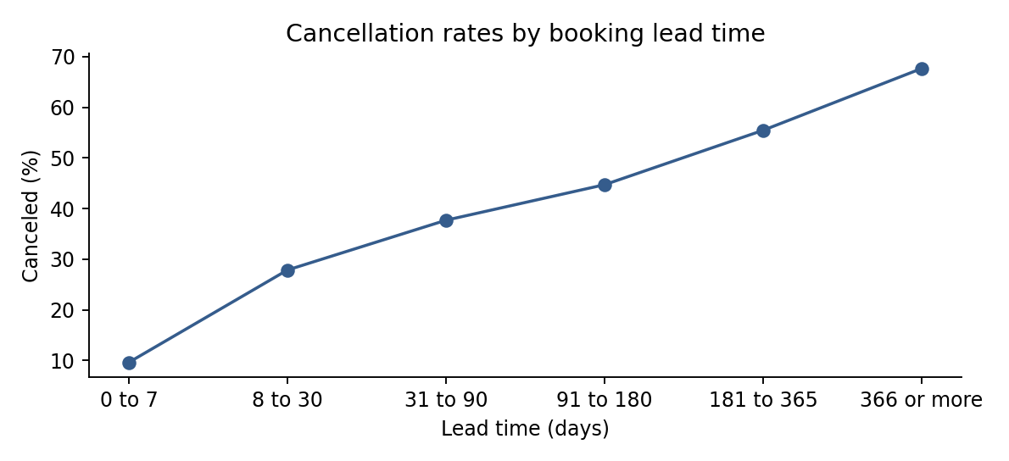
Lead days | Bookings | Canceled | Rate
0 to 7 | 19,746 | 1,902 | 9.63%
8 to 30 | 18,960 | 5,283 | 27.86%
31 to 90 | 29,553 | 11,141 | 37.70%
91 to 180 | 26,439 | 11,821 | 44.71%
181 to 365 | 21,544 | 11,947 | 55.45%
366 or more | 3,148 | 2,130 | 67.66%

The separate lead_scatter.png shows each binary outcome. Because many points overlap at 0 and 1, the band chart is easier to interpret. Each rate uses the booking count in its own lead-time band.

Channels history and annual ADR

M04 Largest distribution channel
TA/TO has 97,870 booking records, or 81.98% of the sample. Direct has 14,645 and Corporate has 6,677. A large channel count does not by itself establish effectiveness, because acquisition cost and net income are not supplied. TA/TO means travel agents and tour operators.
Calculation: Count records by distribution_channel.

M05 Previous cancellations by hotel
Mean previous cancellations are 0.0797 for City Hotel and 0.1017 for Resort Hotel. These are historical counts recorded on each booking, rather than the current booking’s outcome. Multiple bookings can carry the same guest history, and no guest ID is available for a unique-customer average.
Calculation: Average previous_cancellations by hotel.

M06 ADR over the years
Mean ADR rises from 87.18 in 2015 to 98.33 in 2016 and 114.64 in 2017. The years cover different months: July to December 2015, all of 2016, and January to August 2017. Restricting the comparison to July and August gives 102.55, 134.63 and 153.24 respectively. Both views rise, but composition changes prevent interpreting the difference as a pure price increase.
Calculation: Average ADR by arrival year; repeat for July and August, present in all years.
Arrival year | Bookings | Mean ADR
2015 | 21,996 | 87.18
2016 | 56,707 | 98.33
2017 | 40,687 | 114.64

Year July and August only | Bookings | Mean ADR
2015 | 6,665 | 102.55
2016 | 9,635 | 134.63
2017 | 10,238 | 153.24

Estimating lodging value

M07 Month with the largest lodging value
August leads with an estimated completed-stay lodging value of 4,917,159.06 source currency units. Its average per observed August is 1,639,053.02 and also leads after the coverage adjustment. The assignment’s sum-of-ADR calculation gives August 1,944,327.60, but adding daily rates is not a revenue calculation. The full table retains this requested arithmetic alongside the lodging-value estimate.
Calculation: For Check-Out records with positive nights and nonnegative ADR, sum adr × total nights; allocate the whole stay to arrival month.
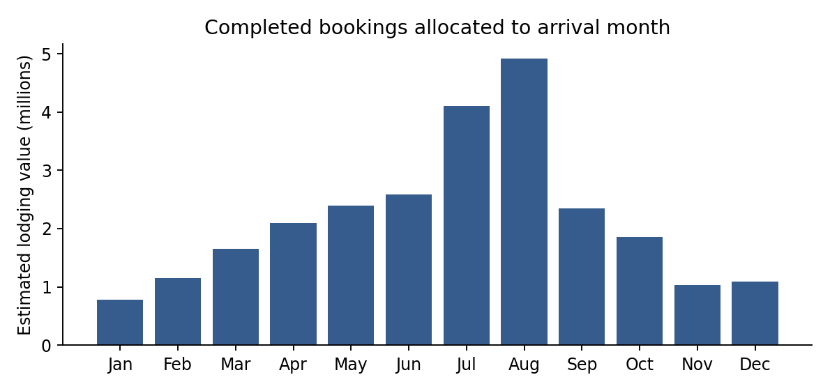
The proxy sums ADR multiplied by total nights only for Check-Out bookings with positive nights and nonnegative ADR. It totals 25,996,324.21 across the sample and 255,030 eligible booking-nights. Dividing those totals gives a night-weighted ADR of 101.93.
The entire stay is assigned to its arrival month, so this is not a calendar-night revenue ledger. It omits cancellation fees, meals, commissions, taxes and refunds. A zero-night booking contributes no stay value. Actual room-night occupancy cannot be established without room inventory and occupied-room records.

Requests repeat guests and room choices

M08 Special requests and ADR
Mean ADR is 94.96 for no requests, 108.46 for one request and 117.03 for two requests. Pearson correlation is 0.172 and Spearman is 0.196, indicating a weak positive association. The five-request group has only 40 records. Guest composition, room type and season can explain part of the difference, so the result does not justify charging for requests.
Calculation: Group by request count; correlate total_of_special_requests with adr.
Requests | Bookings | Mean ADR
0 | 70,318 | 94.96
1 | 33,226 | 108.46
2 | 12,969 | 117.03
3 | 2,497 | 123.85
4 | 340 | 130.57
5 | 40 | 127.75

M09 Stay length for repeat and new guests
Repeat-guest bookings average 1.926 nights, compared with 3.477 for records without the repeat flag. There are 3,810 repeat-guest records and 115,580 others. The flag identifies recorded booking history, not a verified first-ever customer relationship. These means include canceled reservations.
Calculation: Add week and weekend nights; average by is_repeated_guest.
Repeat flag | Bookings | Mean nights
0 | 115,580 | 3.477
1 | 3,810 | 1.926

M10 Most frequently reserved room type
Room type A is most common, with 85,994 bookings, or 72.03% of the sample. Type D follows with 19,201. The analysis uses reserved_room_type as requested, rather than the final assigned room. Codes are anonymized and should not be renamed as standard, deluxe or suite without a mapping.
Calculation: Count records by reserved_room_type.

Cancellation factors

A01 Factors associated with cancellation
A logistic regression on 119,206 eligible records finds higher cancellation odds with longer lead time, any previous cancellation, City Hotel, Online TA and non-refundable deposits, after the specified controls. Repeat-guest records have lower odds. An extra 30 lead-time days has an odds ratio of 1.095, with a 95% interval of 1.089 to 1.101. Odds ratios compare odds, not probability-point changes. The full coefficient table includes robust uncertainty and adjusted p-values.
Calculation: Fit an unpenalized logistic model with HC1 robust standard errors; apply Benjamini-Hochberg adjustment across non-intercept terms.
Factor | Odds ratio | 95% low | 95% high | Adjusted p value
Lead time per 30 days | 1.095 | 1.089 | 1.101 | <0.001
Any previous cancellation | 66.19 | 56.10 | 78.11 | <0.001
Repeat guest | 0.083 | 0.067 | 0.103 | <0.001
City versus Resort | 1.253 | 1.214 | 1.295 | <0.001
Online TA versus Direct | 2.760 | 2.613 | 2.914 | <0.001
Non Refund versus No Deposit | 318.28 | 257.37 | 393.61 | <0.001

The model controls for lead time, nights, adults, children, babies, repeat status, any previous cancellation, hotel, market segment, customer type, deposit type, season and arrival year. References are Resort Hotel, Direct, Transient, No Deposit, Winter and 2016. The model excludes 180 zero-guest records and four records with unknown children counts. The two Undefined-market records are among those four exclusions.
The very large Non Refund association reflects this sample’s booking arrangements. It does not show that non-refundable deposits cause cancellations or that introducing them would reduce risk. Full coefficient results are in cancellation_logistic.csv, including terms that are not significant.

Interpreting and checking the cancellation model
The inference model uses unpenalized maximum likelihood, solved by Newton steps with backtracking. Its score converged near zero after nine iterations. HC1 sandwich standard errors allow unequal residual variance, and 95% intervals use a normal approximation. Adjusted p-values control the false-discovery rate across non-intercept terms. Statistical significance here describes conditional associations under the model assumptions.
The records do not identify guest, group or booking clusters, so dependence within repeated patterns cannot be fully modeled. Robust standard errors do not fix that problem. The duplicate-row sensitivity and observational design should be considered before relying on small p-values. Linear effects on log odds, omitted variables and historical sampling also limit interpretation.

Final booking changes and requests
Retrospective factor | Odds ratio | 95% low | 95% high
booking_changes | 0.661 | 0.637 | 0.686
total_of_special_requests | 0.479 | 0.467 | 0.490

Adding final booking-change and request counts produces odds ratios of 0.661 and 0.479 per additional count. These are descriptive associations. Guests who remain booked have more opportunity to change a reservation or add requests, so the fields are not used as initial-booking predictors. Reservation status, its date and the canceled flag are also excluded from prediction inputs.

Prediction on later arrivals
Measure | Value
Training records with known outcome by 31 December 2016 | 78,195
Test arrivals in January to August 2017 | 40,620
ROC AUC | 0.775
Brier score | 0.177
Constant-rate baseline Brier | 0.238
Recall at probability threshold 0.5 | 0.328

The prediction model is separately fitted with L2 regularization and no year dummy. It uses an arrival-period split and only known training outcomes. It recalls 32.85% of canceled test bookings at a 0.5 threshold, so it misses many cancellations. This is a historical benchmark, not a validated production model; feature values at original booking time are not independently verified.

Guest composition and daily rates

A02 Guest composition and ADR
In the adjusted multiple regression, an additional adult is associated with 5.93 more ADR units, a child with 14.67, and a baby with 5.90. The respective 95% intervals are 3.85 to 8.02, 13.75 to 15.60, and 3.27 to 8.54. The model holds hotel, segment, reserved room, arrival month, year and stay length constant. These are conditional associations, not per-person surcharges.
Calculation: OLS with adults, children and babies plus controls; HC3 standard errors; compare an upper-99th-percentile capped outcome.
Additional guest | ADR difference | 95% low | 95% high
adults | 5.932 | 3.847 | 8.018
children | 14.67 | 13.75 | 15.60
babies | 5.902 | 3.268 | 8.536

The adjusted OLS model uses 119,205 records and explains 47.4% of the observed ADR variation in-sample. It excludes the negative ADR record in addition to the cancellation-model exclusions. It is fitted with an intercept and categorical reference coding, and uses HC3 leverage-adjusted sandwich standard errors. The estimates are not a forecast accuracy test.

Sensitivity to high ADR values
Additional guest with capped ADR | ADR difference | 95% low | 95% high
adults | 5.782 | 3.737 | 7.827
children | 13.98 | 13.12 | 14.83
babies | 6.105 | 3.507 | 8.704

Capping the outcome at 252.00 changes the adult estimate to 5.78, child to 13.98 and baby to 6.11. Their signs stay positive. The uncapped results remain the primary estimates. Unadjusted regression results and a detailed guest-composition table are included so readers can compare simple averages with controlled estimates.

Booking changes and service needs

A03 Booking changes and guest requests
Booking changes and special requests have Pearson correlation of 0.0528 and Spearman correlation of 0.0419. Both are close to zero. The data therefore offers little evidence of a strong overall relationship between these counts. More importantly, no satisfaction score is present. The requested relationship can be measured, but the effect of booking flexibility on guest satisfaction cannot.
Calculation: Correlate booking_changes and total_of_special_requests; inspect counts by change frequency.
Changes | Bookings | Mean requests | Mean ADR
0 | 101,314 | 0.556 | 101.37
1 | 12,701 | 0.625 | 103.20
2 | 3,805 | 0.713 | 107.29
3 | 927 | 0.810 | 109.80
4 | 376 | 0.806 | 107.64
5 | 118 | 0.822 | 103.15
6 | 63 | 0.889 | 100.74
7 | 31 | 0.645 | 88.04

The few records with many changes should not dominate an operational rule. The complete table retains all observed change counts. A useful follow-up would join request fulfillment, complaint records and post-stay survey scores to a stable booking ID. That would make it possible to study whether changes create service problems or help guests get what they need.

Seasonal cancellation patterns

A04 Seasonal cancellation patterns
Across all observed years, summer has the highest cancellation rate at 38.73% and winter the lowest at 33.08%. The complete year 2016 gives a different ranking: autumn is highest at 38.45%, followed by summer at 36.31%, spring at 34.67% and winter at 32.92%. This difference warns against assuming a stable seasonal rule from a partial multi-year sample. Seasonal terms are not significant at the adjusted 5% level in the baseline logistic model.
Calculation: Define Northern Hemisphere seasons; calculate canceled / bookings by season and month, with a separate complete-2016 view.
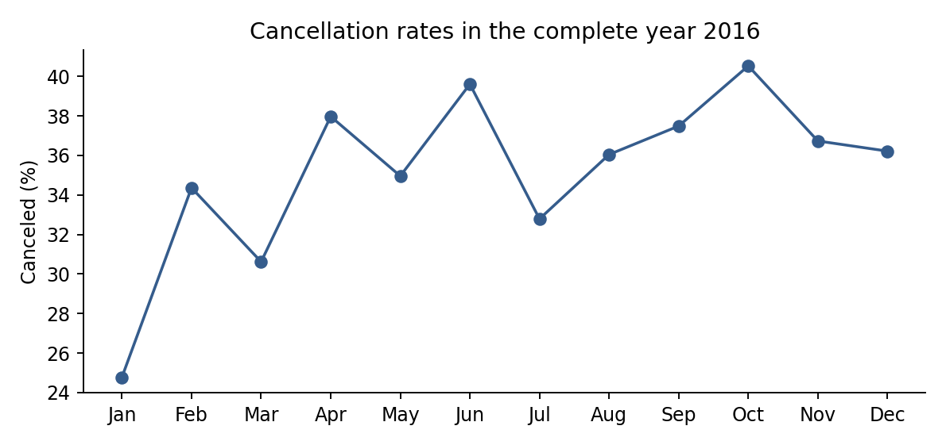
Season in 2016 | Bookings | Canceled | Rate
Autumn | 16,051 | 6,172 | 38.45%
Spring | 15,730 | 5,453 | 34.67%
Summer | 14,927 | 5,420 | 36.31%
Winter | 9,999 | 3,292 | 32.92%

Winter means December to February, spring March to May, summer June to August and autumn September to November. These calendar groupings are analyst definitions. The workbook contains pooled months and seasons as well as the complete-2016 comparison.

Lead time by market segment

A05 Lead time across market segments
Groups book farthest ahead, with a median of 162 days and a middle-half range of 70 to 285 days. Offline TA/TO has a median of 109 days, Online TA 58, Direct 16 and Corporate 7. Aviation and Complementary each have a median of 3 days. Undefined has only two records. These distributions can help choose when to send confirmations and reminders for each segment.
Calculation: Group lead_time by market_segment; calculate median, quartiles and percentiles; draw a boxplot.
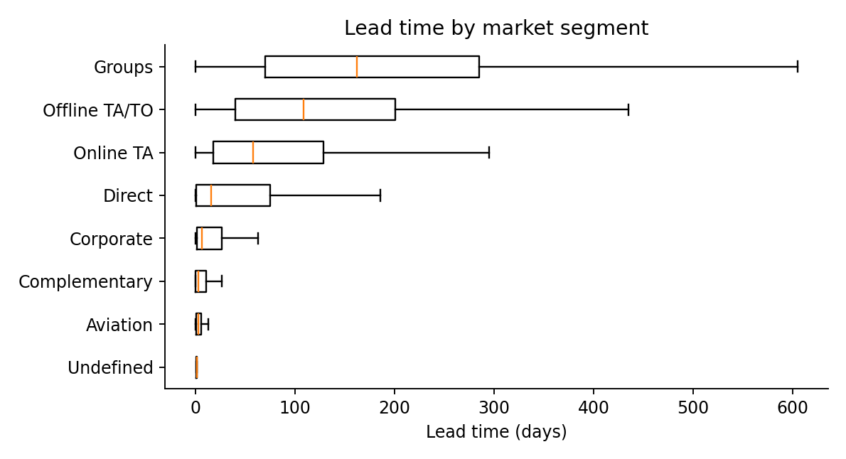
Segment | Bookings | Median days | Q1 days | Q3 days
Aviation | 237 | 3 | 1 | 6
Complementary | 743 | 3 | 0 | 11
Corporate | 5,295 | 7 | 2 | 26.50
Direct | 12,606 | 16 | 1 | 75
Groups | 19,811 | 162 | 70 | 285
Offline TA/TO | 24,219 | 109 | 40 | 201
Online TA | 56,477 | 58 | 18 | 129
Undefined | 2 | 1.500 | 1.250 | 1.750

Boxes show the middle half of lead times, with a median line. Whiskers use 1.5 times the interquartile range. Outlier points are hidden for readability but remain in the calculations and full CSV table.

Recommendations for hotel operations

Review long advance bookings
Start with Groups and Offline TA/TO, whose median lead times are 162 and 109 days. Test a confirmation schedule before the arrival date and measure changes in cancellation timing, net room income and staff workload. Do not use the model to cancel a reservation or change a deposit automatically.

Compare channels using net value
TA/TO contributes 81.98% of records, but its volume does not reveal commission cost or margin. Add commissions, cancellation fees and fulfilled room-nights before deciding whether to shift business toward Direct. Compare similar rooms, months and guest mixes rather than overall averages alone.

Plan service work from recorded needs
Use request counts and parking demand to plan preparation. Confirm what guests requested and whether the hotel fulfilled it. Collect an actual satisfaction measure before evaluating the effect of requests or booking changes on the guest experience.

Build a usable operations record
A stable booking ID would resolve duplicate handling and permit event histories. Daily room inventory would support occupancy. A revenue ledger would support actual revenue and profitability. Original booking-time snapshots would allow prediction testing without relying on final record values.
These conclusions describe two historical properties from July 2015 to August 2017. The Elite Hotels International name belongs to the assignment scenario and is not an identified source operator. The data does not establish current hotel-market conditions.

Resources and reproduction
The workbook contains Summary, Calendar, Segments, Guests, Models and Monthly inputs. Main totals, weighted means and cancellation rates are formulas linked to monthly source aggregates. Regression, correlation, quantile and guest-detail tables are labeled Python snapshots. All booking-level data, audit records and full tables are included in the project ZIP.
Run analyze.py to rebuild data preparation, result tables, regressions and charts. Hotel_Analysis.ipynb provides an executed walkthrough for all 25 questions. README.md explains how to run the project and which presentation outputs require a separate rebuild. SourceRow is the original CSV row number including the header.

Dataset origin and field definitions
Antonio, N., de Almeida, A. and Nunes, L. (2019). Hotel booking demand datasets. Data in Brief, 22, 41–49. DOI 10.1016/j.dib.2018.11.126.
https://pmc.ncbi.nlm.nih.gov/articles/PMC6297060/

Supplied dataset listing
The attached hotel_bookings.csv is the calculation source.
https://www.kaggle.com/datasets/jessemostipak/hotel-booking-demand

Logistic regression and prediction evaluation
Official scikit-learn documentation describes LogisticRegression and classification metrics.
https://scikit-learn.org/stable/modules/model_evaluation.html

Least squares
Official NumPy documentation for the numerical OLS solver.
https://numpy.org/doc/stable/reference/generated/numpy.linalg.lstsq.html

Logistic sigmoid
Official SciPy documentation for expit.
https://docs.scipy.org/doc/scipy/reference/generated/scipy.special.expit.html
References checked on 6 October 2026. The healthcare and loan-analysis boilerplate at the end of the supplied brief is unrelated to the hotel questions. The analysis follows the hotel scope and corrects the revenue and occupancy definitions where required.

