Porter delivery analysis
  - Case study and solution guide
I analyzed 197,428 orders to understand delivery times, order demand and partner availability. The typical order took 44.33 minutes, measured by the median. Only 13.16% of orders with valid delivery timestamps arrived within 30 minutes.
Market 1 deserves further review: even after excluding deliveries over three hours in a sensitivity check, its average was 51.11 minutes, compared with 45.94 minutes in Market 2. The data identifies where to investigate; it does not establish the cause of a delay.

Problem and scope
The case describes a delivery business trying to reduce delays and improve customer satisfaction. The task is to compare markets, restaurant categories, ordering protocols and staffing conditions, then recommend practical next steps. Operations, logistics, customer service and restaurant partners are the intended readers.
This guide answers the ten basic and ten medium-level questions. Nineteen can be calculated. The customer comparison cannot be completed because the dataset has no customer identifier. Customer satisfaction, route distance and promised delivery times are also absent, so those outcomes cannot be measured directly.
Measure | Result
Orders | 197,428
Valid delivery durations | 197,421
Median delivery duration | 44.33 minutes
Mean delivery duration | 48.47 minutes
Mean for durations of at most 180 minutes | 47.53 minutes
Delivered within 30 minutes | 25,976 of 197,421 orders — 13.16%
Markets and stores | 6 known markets and 6,743 stores

Most order timestamps fall between 21 January and 18 February 2015. One record begins on 19 October 2014 and ends almost 99 days later. The source does not specify a timezone or monetary unit. Hourly results use the recorded clock, and price results stay in source units.
Source: uploaded dataset.csv.zip, containing dataset.csv. All reported numbers are calculated from this file.

Data dictionary
Each row represents one order in the case study. The file has no order ID, so source_row records the original CSV line number for tracing individual records. The source contains 14 columns.
Field | Meaning | Use or qualification
market_id | Market code | Keep missing values as Unknown in grouped summaries.
created_at | Order placement timestamp | Use to derive recorded hour, date and weekday.
actual_delivery_time | Delivery completion timestamp | Subtract created_at to obtain elapsed delivery time.
store_id | Restaurant or store identifier | A hashed identifier; it does not identify a customer.
store_primary_category | Restaurant category | 74 known categories; missing values form a separate group.
order_protocol | Order-placement method code | Codes 1 to 7; no mapping to named channels is supplied.
total_items | Total items in the order | A count, separate from subtotal.
subtotal | Order subtotal | Keep original units; currency and scaling are unconfirmed.
num_distinct_items | Distinct items in the order | Count of different items, rather than total quantity.
min_item_price | Lowest item price | Check for negatives and values above max_item_price.
max_item_price | Highest item price | Used with min_item_price to calculate price range.
total_onshift_partners | On-duty partners at order placement | A snapshot, not the number assigned to this order.
total_busy_partners | Busy partners at order placement | A snapshot; do not sum across orders.
total_outstanding_orders | Outstanding orders at placement | A workload snapshot, not this order’s item count.

The screenshots combine “total items subtotal” in one line. The actual file has two separate fields: total_items is a quantity and subtotal is a value. The analysis uses the file’s structure.

Cleaning and calculation rules
I retained all source rows and added quality flags. Missing numeric values were not replaced with zero or an average, because that would change the relationships being measured. Each calculation uses the fields it needs, so an order with missing staffing data still contributes to order volume and delivery summaries.
Issue | Records | Treatment
Missing delivery timestamp | 7 | Exclude from duration calculations only.
Missing market / protocol | 987 / 995 | Show as Unknown.
Missing restaurant category | 4,760 | Show as Unknown; do not infer from store history.
Missing each partner or workload field | 16,262 | Exclude only from calculations requiring that field.
Negative on-shift / busy / outstanding | 21 / 21 / 44 | Set corresponding analytical copy to missing.
Invalid item-price range | 813 | Exclude from price-range correlation.
Busy count exceeds on-shift count | 40,394 | Flag; compare ratios with and without these rows.
Zero on-shift count | 3,615 | Do not divide by zero.
Exact duplicate rows | 0 | No duplicate removal was needed.

Delivery minutes equal the elapsed seconds between placement and completion divided by 60. There are 197,421 positive durations and no zero or negative durations. The main results include every positive duration. A separate sensitivity sample retains durations of at most 180 minutes, excluding 138 records (0.07% of valid durations). This is an analyst-selected cutoff, not proof that longer deliveries are errors.
The IQR outlier rule is reported separately: flag durations below Q1 minus 1.5 times the interquartile range or above Q3 plus 1.5 times that range. These flags do not automatically remove records. The 180-minute check and the IQR rule answer different questions.
Pearson correlation describes linear association. Spearman correlation checks whether the direction is similar when values are ranked. Both use complete pairs of relevant values. Group standard deviations use the sample formula. Repeated store and time observations limit causal and statistical claims.
No timezone conversion or price scaling is applied. The 30-minute metric is an exercise threshold, not a measured contractual on-time rate. Peak hours are defined as the three recorded hours with the most orders.

Basic question 1

Order volumes across markets
Market | Orders | Share of all orders
2 | 55,058 | 27.89%
4 | 47,599 | 24.11%
1 | 38,037 | 19.27%
3 | 23,297 | 11.80%
5 | 18,000 | 9.12%
6 | 14,450 | 7.32%
Unknown | 987 | 0.50%

Market 2 has the most orders, followed by Market 4. Together they account for 52.00% of all orders. Missing market IDs account for 0.50%, and remain in the denominator. Staffing plans should consider the large workload in Markets 2 and 4 alongside delivery performance in each market.
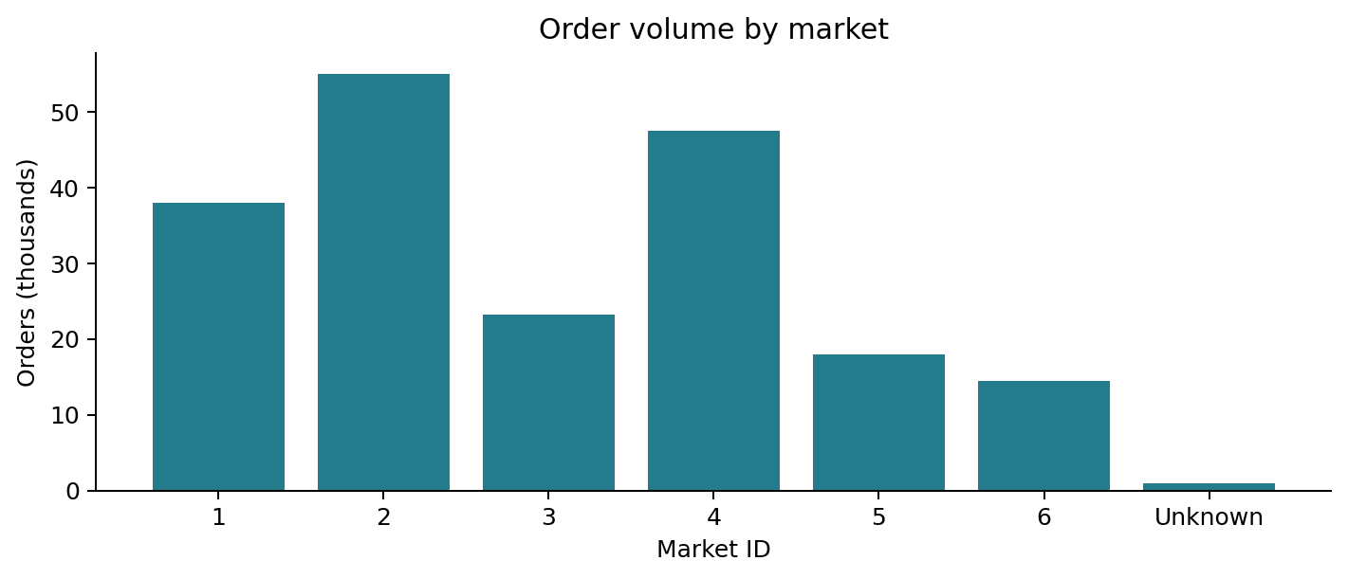
Method: count rows by market_id. Detail: results/B01_market_orders.csv.

Basic questions 2 and 5

B02 Average delivery time by restaurant category
Italian orders have the highest unfiltered category average, 70.20 minutes. That result is affected by the almost 99-day record: the average is 50.09 minutes in the 180-minute sensitivity sample. Among known categories with at least 30 valid orders, Spanish has the highest sensitivity average at 56.18 minutes, followed by Caribbean at 56.10 minutes.
Category | Valid orders | Mean min | Median min | Mean ≤180 min
italian | 7,179 | 70.20 | 47.35 | 50.09
spanish | 37 | 56.18 | 50.93 | 56.18
caribbean | 253 | 56.10 | 52.93 | 56.10
brazilian | 310 | 55.97 | 52.38 | 55.97
american | 19,399 | 47.76 | 44.37 | 47.60
pizza | 17,320 | 50.87 | 47.40 | 50.72
mexican | 17,098 | 44.55 | 41.35 | 44.41
burger | 10,958 | 47.18 | 43.95 | 47.00
sandwich | 10,059 | 44.76 | 41.38 | 44.61
kosher | 51 | 41.58 | 34.68 | 41.58

Kosher has the lowest unfiltered average among categories with at least 30 orders, at 41.58 minutes, but it has only 51 observations. Compare counts and medians before acting on category rankings. Larger groups such as pizza and Mexican offer more evidence for an operational review.
Detail: results/B02_category_delivery.csv includes all 74 known categories and Unknown. The table shows selected categories, not the complete ranking.

B05 Number of items and subtotal
Across 197,428 orders, Pearson r is 0.56 and Spearman r is 0.66. Orders with more items generally have higher subtotals. The relationship is moderate rather than exact because item prices differ.
This does not show that increasing the item count through a promotion will raise revenue by a particular amount. Discounts, item mix and customer selection would need to be measured separately.
Method: complete-pair correlations between total_items and subtotal. Detail: results/B05_items_subtotal_correlation.csv.

Basic questions 3 and 4

B03 Peak hours for order placement
The busiest recorded hour is 02:00–02:59 with 36,976 orders (18.73%). It is followed by 01:00–01:59 with 28,190 orders (14.28%) and 03:00–03:59 with 27,068 orders (13.71%). These three hours contain 46.72% of orders. They must not be interpreted as local overnight demand until the source timezone is confirmed.
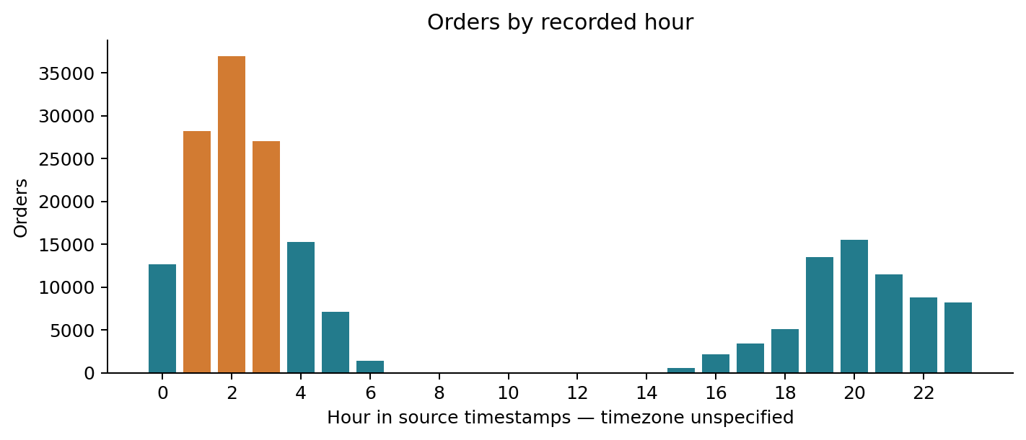

B04 Days with the highest order volume
Day | Orders | Share
Monday | 27,403 | 13.88%
Tuesday | 24,062 | 12.19%
Wednesday | 24,254 | 12.28%
Thursday | 25,673 | 13.00%
Friday | 27,875 | 14.12%
Saturday | 34,541 | 17.50%
Sunday | 33,620 | 17.03%

Saturday has the highest total, followed by Sunday. These are sample totals, not a forecast of an average future week. The date coverage is uneven: Wednesday includes partial boundary days, and Sunday includes the isolated October record. Per-observed-date figures are provided in the CSV, but do not correct partial-day coverage.
Method: extract hour and weekday from created_at and count rows. Detail: results/B03_hourly_orders.csv and B04_weekday_orders.csv.

Basic questions 6 and 7

B06 Delivery distribution and outliers
Delivery time is right-skewed. The middle half of valid deliveries lies between 35.07 and 56.35 minutes; the median is 44.33 minutes. The 90th percentile is 70.58 minutes and the 95th percentile is 81.20 minutes.
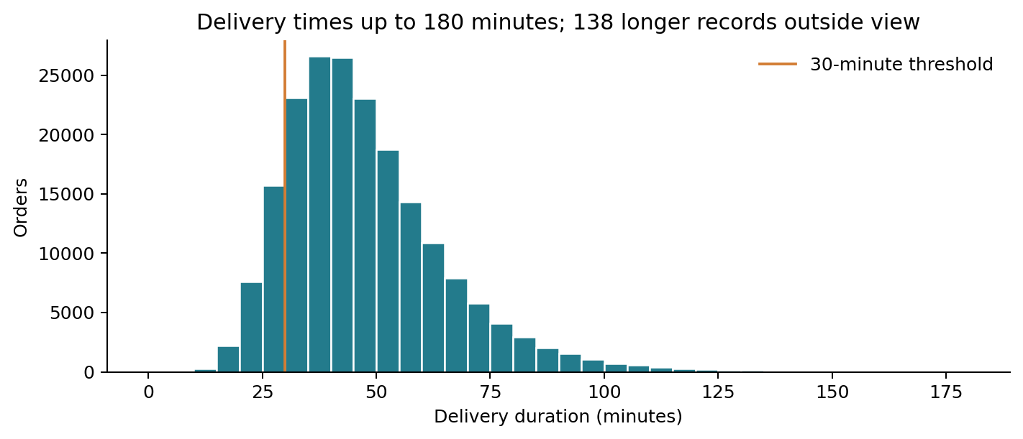
The IQR limits are 3.14 and 88.28 minutes. They flag 6,278 orders (3.18% of valid durations), including unusually short and long deliveries. These are review flags, not confirmed errors.
The longest duration is 141,947.65 minutes, or 98.57 days. It drives the overall standard deviation up to 320.49 minutes. In the 180-minute sensitivity sample, the mean is 47.53 minutes and standard deviation is 18.04 minutes, compared with an unfiltered mean of 48.47 minutes.

B07 Orders delivered within 30 minutes
25,976 of 197,421 valid-duration orders were delivered in 30 minutes or less: 13.16%. The seven orders without completion timestamps are excluded from that denominator. Dividing by all 197,428 orders also rounds to 13.16%, but treats the missing outcomes differently.
The result suggests that a general 30-minute promise would not match most deliveries in this sample. Before changing customer promises, confirm the intended service target and review performance by market, distance and restaurant preparation time.
Detail: results/B06_delivery_quantiles.csv, B06_longest_deliveries.csv and B07_within_30_minutes.csv. The histogram excludes 138 durations above 180 minutes from view only.

Basic questions 8 and 9

B08 Order volume and busy partners
For 2,486 observed market-hour bins with valid busy-partner data, Pearson r is 0.775 and Spearman r is 0.813. Higher order volume is strongly associated with more busy partners. Within-market Pearson correlations range from 0.667 in Market 6 to 0.930 in Market 1.
I counted orders within each market, date and hour, then averaged the nonnegative busy-partner snapshots in that same bin. Adding those snapshots would count the same people repeatedly. Unknown markets are excluded. Empty hours are not assumed to be zero-volume hours because the file does not establish continuous coverage.
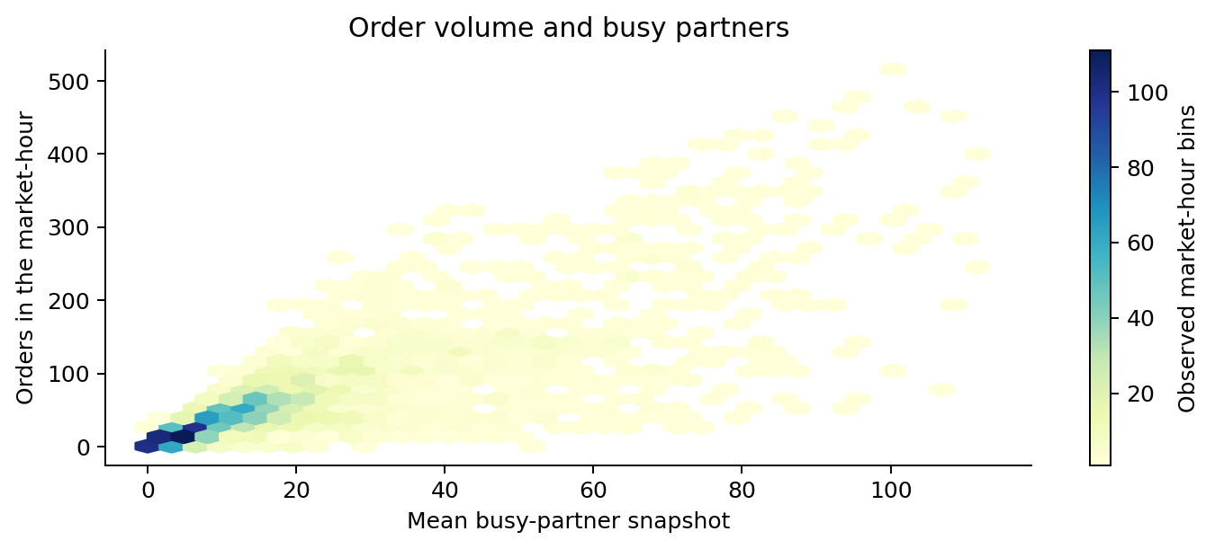

B09 Average delivery time by day of week
Day | Valid orders | Mean min | Mean ≤180 min
Monday | 27,402 | 51.71 | 51.32
Tuesday | 24,061 | 46.33 | 46.21
Wednesday | 24,254 | 44.47 | 44.06
Thursday | 25,673 | 47.10 | 46.80
Friday | 27,875 | 44.75 | 44.66
Saturday | 34,541 | 50.09 | 49.97
Sunday | 33,615 | 52.72 | 48.34

Sunday is slowest in the full data. Monday is slowest in the sensitivity sample, and Wednesday is fastest in both. Day-level averages describe associations; they do not isolate weekday effects from workload, restaurant mix or unusual events.
Detail: results/B08_market_hour_observations.csv, B08_volume_busy_correlation.csv and B09_weekday_delivery.csv.

Basic question 10

Five stores with the longest average delivery times
The table below is the requested ranking using all valid durations. Store identifiers are retained in full so that each result can be checked against the source.
Store ID | Valid orders | Mean min | Median min
675f9820626f5bc0afb47b57890b466e | 17 | 8,407.30 | 55.13
d397c2b2be2178fe6247bd50fc97cff2 | 21 | 325.03 | 55.75
d290dc6cabaffa37f5473eb33611607e | 2 | 259.22 | 259.22
55285adfd78a019a3245917649e29b3c | 1 | 226.92 | 226.92
2e6d9c6052e99fcdfa61d9b9da273ca2 | 1 | 160.50 | 160.50

The first store’s mean is inflated by the almost 99-day record. Three of the five stores have only one or two orders. These results answer the ranking question, but should not be used alone to judge store performance.

A second ranking for operational review
For a more stable review list, I also ranked stores with at least 30 deliveries in the 180-minute sensitivity sample. The minimum count and time cutoff are explicit analytical choices, not requirements from the original question.
Store ID | Eligible orders | Mean min
2d2c8394e31101a261abf1784302bf75 | 43 | 84.05
50abc3e730e36b387ca8e02c26dc0a22 | 52 | 80.14
0a7d7a81e8e3a20e4c34748e98ef45f6 | 99 | 79.92
d0aa518d4d3bfc721aa0b8ab4ef32269 | 46 | 79.09
16db016ed3a5b8d7c596928306161ada | 30 | 78.25

The first store in this review list averages 84.05 minutes across 43 orders. Restaurant preparation, pickup waits and route distance would be useful follow-up measures. None is available in the supplied file, so the analysis cannot say which caused the delay.
Detail: results/B10_top5_stores.csv, B10_top5_stores_le180_min30.csv and B10_all_store_delivery.csv.

Medium questions 1 and 2

M01 Delivery time by order protocol
Protocol | Valid orders | Mean min | Mean ≤180 min
7 | 19 | 41.37 | 41.37
5 | 44,289 | 45.71 | 45.44
Unknown | 995 | 46.84 | 46.84
3 | 53,197 | 46.96 | 46.71
2 | 24,051 | 47.36 | 47.18
4 | 19,353 | 48.43 | 48.21
1 | 54,723 | 52.52 | 49.78
6 | 794 | 61.09 | 59.68

Protocol 7 has the lowest average at 41.37 minutes, but only 19 orders. Protocol 5 averages 45.71 minutes across 44,289 orders and is the fastest of the high-volume protocols. Protocol 6 is slowest at 61.09 minutes; its sensitivity average remains high at 59.68 minutes.
Protocol names are not supplied. The code must not be relabeled as phone, app or pre-booking without a mapping. Differences may reflect restaurant or market mix, so a controlled comparison is needed before attributing delays to the ordering method.

M02 Average order value by market
Market | Orders | Mean subtotal | Median subtotal
1 | 38,037 | 2,744.39 | 2,260.00
2 | 55,058 | 2,632.54 | 2,198.00
3 | 23,297 | 2,575.67 | 2,145.00
4 | 47,599 | 2,896.37 | 2,379.00
5 | 18,000 | 2,411.93 | 2,000.00
6 | 14,450 | 2,512.99 | 2,048.00
Unknown | 987 | 2,674.30 | 2,247.00

Market 4 has the highest average subtotal at 2,896.37 source units. Market 5 has the lowest at 2,411.93. The difference is 484.43 units, or 20.09% relative to Market 5. All orders contribute because subtotal has no missing values.
Detail: results/M01_protocol_delivery.csv and M02_market_order_value.csv. Monetary units are unconfirmed; no currency symbol or division by 100 is applied.

Medium questions 3 and 4

M03 On-shift partners and peak-hour delivery times
During the three busiest recorded hours, the pooled correlation between on-shift partners and delivery duration is very weak: Pearson r = −0.038 across 84,698 complete pairs. The sensitivity result is −0.054 across 84,638 pairs. A larger headcount alone does not explain much of the variation in delivery time.
Market | Eligible peak orders | Pearson r
1 | 17,368 | -0.193
2 | 25,306 | <0.001 in magnitude
3 | 9,843 | -0.075
4 | 23,441 | 0.003
5 | 7,913 | -0.028
6 | 307 | 0.030

Market 1 shows the clearest negative association at −0.193. Most other market correlations are close to zero. Market 6 has just 307 usable peak-hour observations, so coverage is particularly limited there. Staffing and demand can vary together, so these correlations do not measure the effect of adding staff.

M04 Total items and distinct items in a regression
I fitted delivery minutes against total_items and num_distinct_items together, with an intercept. Each coefficient holds the other item measure constant. The model does not control for distance, preparation, market or restaurant.
Sample | Orders | Total item coef | Distinct item coef | R squared
All valid durations | 197,421 | -0.07 | 1.41 | 0.0046%
Durations ≤180 min | 197,283 | -0.03 | 1.80 | 2.5514%
≤180 min and ≤12 items | 195,398 | 0.23 | 1.50 | 2.3007%

In the 180-minute sample, each additional distinct item is associated with about 1.80 more minutes at a fixed total item count. The total-item coefficient is close to zero. When orders above the 99th-percentile item count (12) are excluded, that coefficient becomes +0.23 minutes, showing sensitivity to extreme item counts, including one order with 411 items.
The sensitivity model explains only 2.55% of duration variation. Item complexity alone is not an adequate delivery-time model. The CSV includes HC3 standard errors and approximate intervals; these do not adjust for repeated observations within stores or time periods.
Detail: results/M03_peak_staffing_correlation.csv and M04_item_complexity_regression.csv.

Medium questions 5 and 6

M05 Delivery-time fluctuations through the week
The weekly pattern is uneven. In the 180-minute sensitivity sample, the average rises from 44.66 minutes on Friday to 49.97 on Saturday, drops to 48.34 on Sunday and reaches 51.32 on Monday. Wednesday has the lowest average at 44.06 minutes. The gap between Monday and Wednesday is 7.26 minutes.
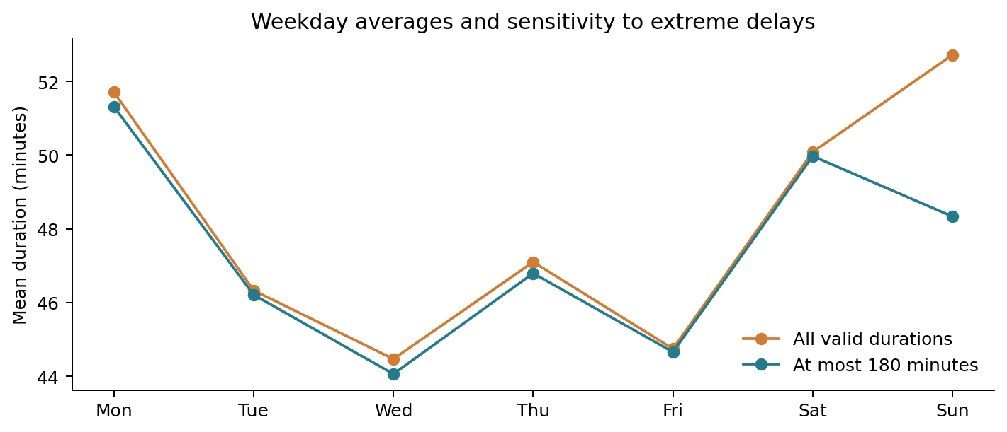
This question overlaps with B09. The same weekday calculation is reused so the two answers remain consistent. Daily results are also included for checking whether a particular date drives a weekly average. The main observation window is short, so this is a sample pattern rather than an established seasonal trend.
An operational follow-up would compare staffing, pickup waits and demand on Mondays and Saturdays. Confirm local time and calendar coverage before changing schedules.

M06 Item price range and order value
The item price range is max_item_price minus min_item_price. After excluding 13 negative minimum prices and 800 rows where the minimum exceeds the maximum, 196,615 orders remain. Pearson r with subtotal is 0.509 and Spearman r is 0.560.
A wider mix of item prices is moderately associated with a higher subtotal. This could partly reflect larger baskets or more expensive products. The correlation does not show that widening a menu’s price range will itself increase spending.
Detail: results/M05_weekday_trends.csv, M05_date_delivery.csv and M06_price_range_correlation.csv.

Medium questions 7 and 8

M07 Categories with above-average order values
The overall mean subtotal is 2,682.33 source units. An above-average order has subtotal strictly greater than this threshold. Within each category, I divided the number of above-average orders by all orders in that category.
Category | Orders | Above-average orders | Share
moroccan | 25 | 20 | 80.00%
cheese | 24 | 17 | 70.83%
burmese | 821 | 555 | 67.60%
lebanese | 9 | 6 | 66.67%
irish | 55 | 36 | 65.45%
italian | 7,179 | 4,572 | 63.69%

Moroccan leads the raw ranking at 80.00%, but the estimate comes from only 25 orders. Among categories with at least 30 orders, Burmese is highest at 67.60% across 821 orders. Italian and steak also have high shares with more than 1,000 orders each. These associations may reflect menu prices and basket mix, rather than a category effect on spending.

M08 Variation within markets and categories
Market | Standard deviation min | SD for ≤180 min
1 | 728.45 | 20.87
2 | 17.95 | 16.43
3 | 19.93 | 18.07
4 | 33.67 | 17.27
5 | 17.88 | 17.13
6 | 19.80 | 18.10

Market 1 has the greatest spread, even in the sensitivity sample. Its unfiltered standard deviation of 728.45 minutes is dominated by extreme records. Among known categories with at least 30 sensitivity observations, tapas has the highest standard deviation at 24.74 minutes, followed by Spanish at 22.32 minutes.
Median-centered Levene tests (Brown–Forsythe) reject equal variances for both markets and categories at p < 0.001 in the 180-minute sample, using known groups with at least 30 observations. These are exploratory results: the large sample and repeated store/time observations limit an independent-observation interpretation. The size of the spread is more useful operationally than the p-value alone.
Detail: results/M07_category_above_average.csv, M08_market_dispersion.csv, M08_category_dispersion.csv and M08_variance_tests.csv.

Medium questions 9 and 10

M09 Partner availability across markets
I calculated busy partners divided by on-shift partners for orders with positive on-shift counts and nonnegative busy counts. The main availability comparison also requires busy counts not to exceed on-shift counts. Records that fail that condition remain in the source and are included in a separate ratio sensitivity calculation.
The table uses the 180-minute duration sample. Each row shows an order-level correlation within a market, rather than a correlation based only on six market averages.
Market | Eligible orders | Mean busy ratio | Pearson r with duration
1 | 25,506 | 89.18% | 0.211
2 | 40,459 | 86.97% | 0.136
3 | 16,686 | 83.26% | 0.223
4 | 37,978 | 85.86% | 0.241
5 | 15,245 | 76.10% | 0.233
6 | 505 | 86.41% | 0.216

Higher busy ratios have modest positive associations with longer delivery times in all six markets. Across the six market averages, Pearson r is 0.540, but six observations are too few for a strong market-level conclusion. Mean ratios and durations in that comparison use the same eligible rows.
Including ratios above 1 changes the results materially: for example, Market 4’s within-market correlation falls from 0.241 to 0.027. The count definitions or timing need investigation before this ratio is treated as a trusted utilization measure. Market 6 has only 505 eligible sensitivity observations, so its result has limited coverage.

M10 First-time and repeat customer orders
This comparison cannot be calculated from the supplied dataset. There is no customer ID, first-order flag or customer order history. store_id identifies a restaurant, so repeated store orders cannot be used as evidence of a repeat customer.
To answer it, obtain a pseudonymous customer ID and purchase history before the observation window. Label an order as first-time only if it is the customer’s first known order in complete history; otherwise use “first observed” and disclose that earlier purchases may be missing. Then compare mean total_items and subtotal across the two groups, with counts and medians.
Detail: results/M09_market_utilization.csv, M09_between_market_correlation.csv and M10_customer_comparison_status.csv.

Recommended actions and project files

Where to act first
Validate the extreme completion timestamps and the partner-count definitions first. These issues materially change store rankings, day comparisons and utilization results. Preserve the original values while checking against order-event logs.
Review Market 1 and the stores in the minimum-30-order sensitivity ranking. Collect preparation time, pickup wait and route distance to distinguish restaurant delays from dispatch or travel delays. Use medians and upper percentiles alongside averages.
Confirm the source timezone before scheduling around the peak recorded hours. Markets 2 and 4 account for just over half of orders, while Market 1 has slower delivery performance. Capacity planning should weigh both workload and service quality.
Track the 30-minute share, median duration and 90th percentile by market and restaurant, with valid-order counts. Evaluate any staffing or protocol changes through a controlled rollout. The correlations in this study do not establish the benefit of a particular intervention.

How to reproduce the analysis
The project ZIP contains the original dataset, orders with quality flags, analysis.py, an executed analysis notebook, six charts and question-level CSV results. The report is included as Porter_Delivery_Analysis.docx. The original dataset’s SHA-256 is recorded in results/summary.json.
Install the versions in requirements.txt, then run the following command from the extracted project folder:
python analysis.py --input data/dataset.csv --output .
The script recreates calculations, charts and validation results. Running python build_report.py then recreates this document from those outputs. The notebook displays the completed outputs and includes the command to rerun the analysis. The scripts do not fetch an external dataset.
validation.txt records reconciliation of market, hour and weekday totals, an independent check of the 30-minute numerator, valid ratio and price-range bounds, and coverage of all 20 questions. CSV files provide complete category and store results that would be too long to print here.

Sources and further reading
Project dataset — Dataset link supplied in the assignment. Calculations use the uploaded CSV.
https://www.kaggle.com/datasets/ranitsarkar01/porter-delivery-time-estimation
pandas datetime conversion — Reference for timestamp parsing.
https://pandas.pydata.org/docs/reference/api/pandas.to_datetime.html
NumPy least squares — Reference for fitting the item-complexity regression.
https://numpy.org/doc/stable/reference/generated/numpy.linalg.lstsq.html
SciPy Levene test — Reference for the median-centered variance comparison.
https://docs.scipy.org/doc/scipy/reference/generated/scipy.stats.levene.html

