MYP Mathematics 2
Student Coursebook · Improved First Edition
SADIKOU MOUKODDIM
This Word file is generated from the same sources as the print edition, so every sentence, worked example, practice set and answer matches the PDF. Figures and photographs are embedded at print resolution. Edit the text freely; the pagination will differ from the PDF, which is expected.

PART I · NUMBER AND PROPORTION
1 Ratios and equivalent ratios
Number and proportion · key concept Form · Equivalence, Representation
A ratio can describe an entire family of situations:
the same relationship at a different size, in different
units, or on a different scale.
Global context: Fairness and development
01 · MYP UNIT PLANNER
The chapter in one view: the concepts, the context and the evidence that will be looked for.
STATEMENT OF INQUIRY Equivalent ratios preserve a multiplicative relationship, so one comparison can organise fair shares and scaled quantities across different totals and units.
Key and related concepts
Key concept · Form. A ratio has a written form — a : b, and a simplest form. Its form shows which quantities are compared, and in what order.
Related · Equivalence. Multiplying or dividing both parts by the same non-zero number gives a different-looking ratio with the same relationship.
Related · Representation. Tape diagrams, ratio tables, double number lines and graphs each expose a different feature of the same comparison.
Global context · Fairness and development
Exploration: fair distribution, shared resources and just comparison. A harvest shared between three families, or a recipe scaled for a hundred people, needs a rule that can be stated, checked and defended. A ratio makes that rule visible, so a decision can be examined rather than merely asserted.
Inquiry questions
- Factual: What is a ratio, and how is an equivalent ratio formed?
- Conceptual: How can different ratios show the same relationship?
- Debatable: When a fixed-ratio share is fair, and when is another comparison needed?
Criterion | Strands | Evidence in this chapter
A · Knowing and understanding | i, ii, iii | Simplify and interpret ratios; share quantities accurately.
B · Investigating patterns | i, ii, iii | Investigate equivalent ratio chains and state the scaling rule.
C · Communicating | i, ii, iii, iv | Use ratio notation and units; move between representations.
D · Applying mathematics | i, ii, iii, iv, v | Garden task: select quantities, justify a share, evaluate fairness.

ATL · Thinking skills
In order for a student to test the claim that adding the same amount to both parts keeps a ratio the same, students must produce a counterexample, explain why it fails and repair the claim.
02 · LEARNING INTENTIONS AND SUCCESS CRITERIA
You are learning to | You have succeeded when you can
Read, write and interpret ratio language in context. | Describe a situation with a part-to-part and a part-to-whole ratio, and say what each term counts.
Form equivalent ratios and write a ratio in simplest form. | Simplify 18 : 24 and generate three ratios equivalent to it.
Use a ratio table and a double number line to scale a relationship. | Solve a scaling problem with a table and check it on a double number line.
Share a quantity in a given ratio. | Divide 120 in the ratio 5 : 3 and check by recombining.
Compare two ratios and justify which is greater. | Decide whether 4 : 5 or 7 : 9 is greater, with a calculation, not an impression.
Explain why a ratio is unchanged by scaling but changed by adding. | Give one example that works and one that fails, and say where the difference lies.

How this chapter runs
Stage | What happens
Engage | A school fair sells lemonade in three sizes at the same taste.
Explore | Strips of paper are folded to compare parts before any rule is named.
Explain | Ratio notation, simplest form, ratio tables, double number lines, sharing.
Worked examples | Seven complete solutions with a check on each.
Practise | Five graded sets: fluency, reasoning, problem solving, extension.
Investigate | The lemonade stand: four recipes, one conjecture.
Reflect | Summary, vocabulary, misconceptions and a self-assessment.

Prerequisite check · 10 minutes, no calculator
- Write 3/4 as a decimal and as a percentage.
- Find 1/5 of 60.
- Simplify 12/18.
- Calculate 7 × 8 and 56 ÷ 8.
- Which is greater, 2/3 or 3/5? Explain in one sentence.
- Share 40 sweets equally between 5 children.
If more than two answers are wrong, revise equivalent fractions and finding a fraction of a quantity before starting section 1.2. Answers are in the back of the book.
SECTION 1.1
1.1 Understanding ratio language
Criterion A · I, II, III · Related concepts: Representation, Ratio as comparison
A ratio is not a pair of numbers that happen to sit beside each other. It is a statement about how quantities are related by multiplication, and the order of the statement is part of its meaning.
03 · ENGAGE
Three jugs, one taste. Which information do you actually need in order to repeat a recipe for a larger crowd?
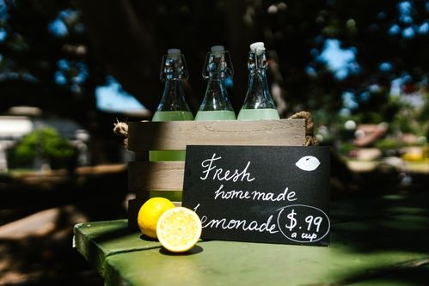
Lemonade at a stall. Three jugs made to the same recipe taste the same because the ratio of juice to water is unchanged, not the amounts.
Photograph: Pexels, free licence (see the image register).
At a school fair the lemonade stall sells three jugs. The small jug mixes 2 cups of lemon juice with 5 cups of water. The medium jug mixes 4 cups with 10. The large jug mixes 6 cups with 15. Customers say all three taste the same, and the stallholder insists she has not changed the recipe.
Before reading on, write down one sentence that explains how all three jugs can be the same recipe when the numbers are different. Then write a second sentence that says what would change the taste.
04 · EXPLORE
Two strips, folded and compared.
Take two strips of paper of equal length. Fold the first into 3 equal parts and shade 1 part. Fold the second into 6 equal parts and shade 2 parts. Hold them side by side.
- What fraction of each strip is shaded?
- Are the two shaded lengths the same? How can you tell without measuring?
- Now shade 1 part of a strip folded into 4. Is that the same comparison as either of the others?
- Fold a third strip into 9 equal parts and shade 3. Which earlier strip does it match?
- Write a conjecture: when do two shaded strips show the same comparison?
- Test the conjecture on a strip folded into 12 parts. How many parts would you shade to match a strip with 1 part in 4 shaded?
05 · EXPLAIN
A ratio compares two or more quantities multiplicatively. For quantities a and b, the ratio is written a : b, read “a to b”. The quantities must be measured in the same unit before the ratio is written or simplified.
There are three common ways to write a two-part ratio: in words, with a colon, or as a fraction. A ratio of 3 parts blue to 5 parts yellow can be written “3 to 5”, 3 : 5, or 3/5 when the fraction is understood as a comparison, not as a share of the whole. The notation you choose should make the meaning clearer, not merely shorter.
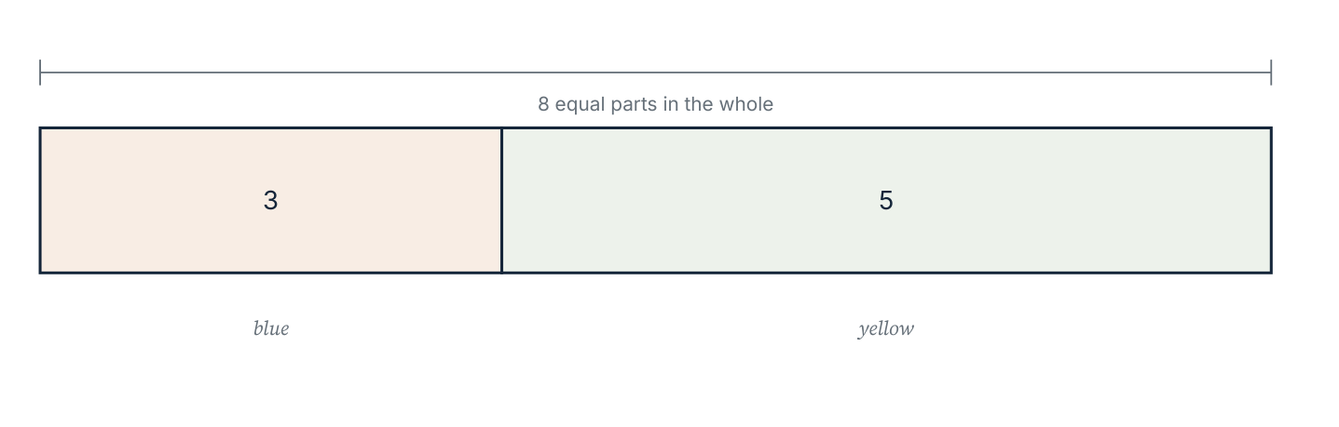
A tape diagram for the ratio 3 : 5. The whole bar has 3 + 5 = 8 equal parts. Blue is 3/8 of the whole, while the ratio of blue to yellow is 3 : 5.
Part to part, and part to whole
A part-to-part ratio compares two parts of a group. A part-to-whole ratio compares one part with the entire group. In the diagram above, the part-to-part ratio of blue to yellow is 3 : 5. The part-to-whole ratio of blue to all counters is 3 : 8. Confusing these two is the most common source of error in the whole chapter, because the second term answers a different question.
Order matters. The ratio of blue to yellow is not the same statement as the ratio of yellow to blue. Reversing the terms describes a different comparison, even though both ratios use the same two numbers.
Worked example 1.1.1 · Reading the terms
A paint mix uses 3 parts blue to 5 parts yellow. State (a) the ratio of blue to yellow, (b) the ratio of blue to the whole mix, (c) the fraction of the mix that is yellow.
1 The order of the words decides the order of the numbers: blue to yellow is 3 : 5.
2 The whole mix has 3 + 5 = 8 parts, so blue to the whole is 3 : 8.
3 Yellow is 5 of those 8 parts, so the fraction is 5/8.
4 State each answer with its unit of meaning: parts, not cups.
ANSWER (a) 3 : 5 (b) 3 : 8 (c) 5/8
Check the two parts add to the whole: 3 + 5 = 8 equal parts, and 3/8 + 5/8 = 1.
Worked example 1.1.2 · Same unit first
A shelf holds 45 cm of books and has 1.2 m of space in total. Write the ratio of the books to the total space in simplest form.
1 The quantities are in different units, so convert first: 1.2 m = 120 cm.
2 The ratio of books to total space is 45 : 120.
3 Divide both terms by 15: 45 ÷ 15 = 3 and 120 ÷ 15 = 8.
4 The ratio in simplest form is 3 : 8.
ANSWER 3 : 8
The books fill 3/8 of the shelf, which is a little under half — plausible for a shelf with space to spare.
Worked example 1.1.3 · Which comparison is being asked for?
In a box of 24 counters, 9 are red and the rest are green. Write (a) red to green, (b) green to red, and (c) red to all counters, each in simplest form.
1 Green counters: 24 − 9 = 15.
2 Red to green is 9 : 15, which divides by 3 to give 3 : 5.
3 Green to red is 15 : 9, which divides by 3 to give 5 : 3.
4 Red to all counters is 9 : 24, which divides by 3 to give 3 : 8.
ANSWER (a) 3 : 5 (b) 5 : 3 (c) 3 : 8
3 + 5 = 8 parts, and 3/8 of 24 is 9 red counters, as stated.
Writing “the ratio of red to green is 3 : 5, so 3/5 of the counters are red”. The ratio 3 : 5 compares red with green only. Red is 3/8 of the whole box, because the whole is 3 + 5 = 8 parts. Always identify what the second term counts before writing a fraction.
Practice 1.1
SUPPORT 1–5 · CORE 6–9 · EXTENSION 10–12
1. A recipe uses 2 parts lemon to 5 parts water. Write the ratio of lemon to water, and of lemon to the whole mixture. [F]
2. In a class of 30 students, 18 walk to school. Write the ratio of walkers to non-walkers in simplest form. [F]
3. Write each ratio in simplest form: (a) 12 : 18 (b) 25 : 40 (c) 36 : 24 (d) 45 : 60. [F]
4. A model car is 24 cm long and the real car is 4.8 m long. Write the ratio of model length to real length in simplest form. [F]
5. A bag contains 15 white and 10 black beads. State the ratio of white to black, and the fraction of the beads that are black. [F]
6. Two quantities are in the ratio 4 : 9. The smaller is 28. Find the larger. [R]
7. Explain why 0.6 m : 45 cm is not written as 0.6 : 45, and give the simplified ratio. [R]
8. A smoothie mixes mango, yoghurt and milk in the ratio 3 : 2 : 5. State the ratio of mango to the whole drink. [P]
9. A photograph is 15 cm wide and 10 cm high. A print is made at 45 cm wide. What should its height be if the shape is unchanged? [P]
10. A student says “the ratio 5 : 2 means the first quantity is 2.5 times the second”. Is the student right? Justify with a calculation. [E]
11. Two ratios are 3 : 4 and 6 : 8. A student claims they are different because the numbers are different. Write a reply in two sentences. [E]
12. Find a ratio equivalent to 2 : 3 whose two terms add to 45. [E]
SECTION 1.2
1.2 Equivalent ratios and simplest form
Criterion A · II · Related concepts: Equivalence, Simplification
Two ratios are equivalent when they describe the same multiplicative relationship. The numbers may change; the comparison does not.
Ratios a : b and c : d are equivalent if there is a non-zero number k such that c = k a and d = k b. A useful test is the cross-product condition a d = b c.
Multiplying or dividing both terms by the same non-zero number produces an equivalent ratio. This is the same operation that produces equivalent fractions, applied to each part of the comparison. A ratio is in simplest form when the terms are whole numbers with no common factor greater than 1.
To test whether a : b = c : d, check whether a d = b c. For example, 6 : 9 and 10 : 15 are equivalent because 6 × 15 = 90 and 9 × 10 = 90.
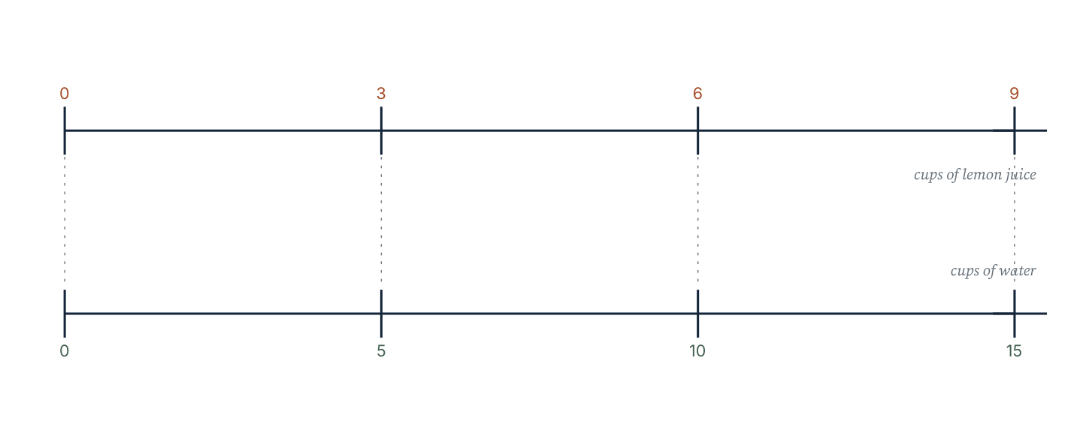
A double number line for 3 : 5. Every mark on the upper line is paired with the mark directly below it. Multiplying both quantities by the same factor moves you to another equivalent pair.
Worked example 1.2.1 · Simplify and justify
Write 42 : 56 in simplest form and justify your answer with a common factor.
1 Both terms are even, so divide by 2: 21 : 28.
2 Both are multiples of 7, so divide by 7: 3 : 4.
3 Equivalently, divide once by the highest common factor, 14: 42 ÷ 14 = 3 and 56 ÷ 14 = 4.
4 Check with the cross-product: 42 × 4 = 168 and 56 × 3 = 168.
ANSWER 3 : 4
3 and 4 share no factor greater than 1, so the ratio is in simplest form.
Worked example 1.2.2 · Find the missing term
The ratios 4 : 7 and 12 : x are equivalent. Find x.
1 The first term has been multiplied by 3, because 4 × 3 = 12.
2 Multiply the second term by the same factor: 7 × 3 = 21.
3 Check with cross-products: 4 × 21 = 84 and 7 × 12 = 84.
ANSWER x = 21
Both cross-products agree, so the ratios are equivalent.
Worked example 1.2.3 · Decide, do not guess
Are 8 : 12 and 14 : 21 equivalent? Are 8 : 12 and 10 : 14 equivalent? Justify each answer.
1 Simplify 8 : 12 by dividing both terms by 4: 2 : 3.
2 Simplify 14 : 21 by dividing both terms by 7: 2 : 3. The ratios are equivalent.
3 Simplify 10 : 14 by dividing both terms by 2: 5 : 7, which is not 2 : 3. Check: 8 × 14 = 112 and 12 × 10 = 120, and these differ.
4 When the simplified forms match, the ratios are equivalent; when they do not, they are not.
ANSWER 8 : 12 = 14 : 21, but 8 : 12 ≠ 10 : 14.
Simplest form is a fingerprint: two equivalent ratios always share it.
“5 : 10 simplifies to 1 : 2 because 5 − 4 = 1 and 10 − 8 = 2.” Subtracting the same amount from both terms changes the ratio, because a ratio is a multiplicative comparison. Only multiplying or dividing both terms by the same non-zero number preserves it.
Practice 1.2
SUPPORT 1–5 · CORE 6–10 · EXTENSION 11–13
1. Write each ratio in simplest form: (a) 8 : 12 (b) 15 : 25 (c) 27 : 36 (d) 48 : 64. [F]
2. Copy and complete: 3 : 4 = 9 : … = … : 20 = 30 : …. [F]
3. Write three ratios equivalent to 5 : 6. [F]
4. Are 9 : 12 and 15 : 20 equivalent? Justify with a common simplified form. [F]
5. Find x: 7 : 8 = x : 40. [F]
6. A recipe uses flour and sugar in the ratio 5 : 2. If 350 g of flour is used, what mass of sugar is needed, and what is the total mass of the two ingredients? [P]
7. Which ratio is equivalent to 6 : 9? A 2 : 3 B 3 : 2 C 6 : 3 D 12 : 15 [R]
8. A student says “adding 3 to both terms of 2 : 5 gives the equivalent ratio 5 : 8”. Find a counterexample to the claim in general, and explain in one sentence why adding fails while multiplying works. [R]
9. The ratio of two angles is 3 : 7 and their sum is 180°. Find both angles. [P]
10. A map uses a scale of 1 : 25 000. A path measures 6 cm on the map. How long is the real path, in kilometres? [P]
11. Two ratios are in the form k : 12 and 15 : 20. Find k if they are equivalent. [E]
12. Find all whole numbers n such that 4 : n is equivalent to a ratio whose terms add to 21. [E]
13. The ratio of boys to girls in a year group is 5 : 4. There are 12 more boys than girls. How many students are there in the year group? [E]
SECTION 1.3
1.3 Ratio tables and double number lines
Criterion A · II · C · II · Related concepts: Representation, Scaling
A ratio table organises equivalent pairs so that the scaling factor becomes visible. A double number line shows the same relationship spatially, and a graph turns the same relationship into a line.
Building a ratio table
Each row of a ratio table contains one pair of equivalent quantities. To move from one entry to the next, multiply or divide both quantities by the same factor. A useful strategy is to scale through a convenient unit, such as one part, because that makes every other entry easier to find.
Concentrate (cups) | 2 | 4 | 6 | 8 | 10
Water (cups) | 5 | 10 | 15 | 20 | 25

A ratio table for lemon concentrate and water. The ratio 2 : 5 holds in every column.
The ratio is 2 : 5 in every column. Multiplying both quantities by 2 gives 4 : 10, by 3 gives 6 : 15, by 4 gives 8 : 20. If a table is built by adding the same amount to each row instead, the entries no longer line up and the table no longer represents equivalent ratios.
Using a unit rate
Dividing both terms so that the first is 1 gives the unit rate: the amount of the second quantity for each one of the first. For the concentrate above, 1 cup of concentrate needs 2.5 cups of water. Once the unit rate is known, any quantity can be found with one multiplication.
Worked example 1.3.1 · Complete the table and scale
A recipe uses 3 cups of rice for every 4 people. Complete a ratio table for 3, 6, 9 and 15 people, and state the unit rate.
1 Write the base pair: 3 cups : 4 people.
2 Scale by 2 for 8 people: 6 cups. Scale by 3 for 12 people: 9 cups.
3 For 15 people, scale by 3.75: 3 × 3.75 = 11.25 cups.
4 The unit rate is 3 ÷ 4 = 0.75 cups per person.
ANSWER 6 cups for 8 people, 9 cups for 12 people, 11.25 cups for 15 people; unit rate 0.75 cups per person.
Check with the unit rate: 15 × 0.75 = 11.25, as in the table.
Worked example 1.3.2 · Read a double number line
On a double number line, kilometres run 0, 15, 30, 45 and miles run 0, 9, 18, 27. How many kilometres are in 21 miles?
1 Each 9 miles matches 15 km, so the scale factor from miles to kilometres is 15 ÷ 9 = 5/3.
2 For 21 miles: 21 × 5/3 = 35 km.
3 Alternatively, use the unit rate: 1 mile is 5/3 km, so 21 miles is 21 × 5/3 = 35 km.
ANSWER 21 miles = 35 km
Sanity check: 21 miles is a little more than twice 9 miles, and 35 km is a little more than twice 15 km.
Worked example 1.3.3 · From table to graph
Paint costs £6 for 2 litres. Complete the pairs (2, 6), (3, 9), (5, 15), (8, 24) and describe the graph of cost against litres.
1 Every pair has the same quotient: 6 ÷ 2 = 9 ÷ 3 = 15 ÷ 5 = 24 ÷ 8 = 3.
2 The points lie on a straight line through the origin.
3 The gradient of that line is the cost per litre, £3.
4 A straight line through the origin is exactly what a constant ratio looks like on a graph.
ANSWER A straight line through the origin with gradient 3.
Check one point off the line: 4 litres should cost £12, and 4 × 3 = 12.
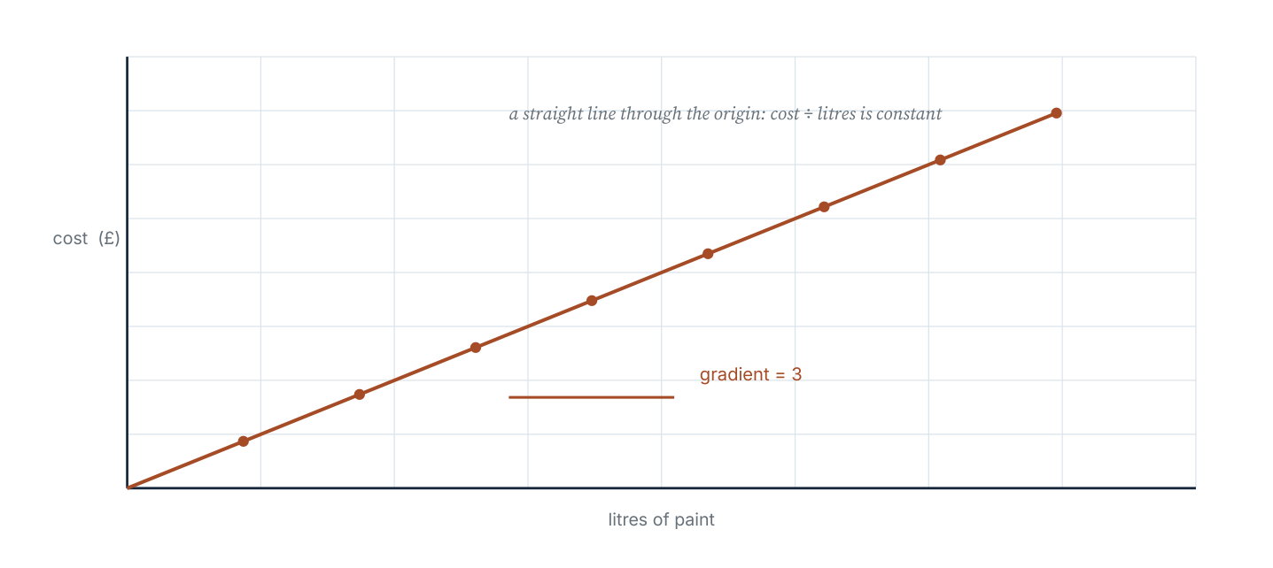
Cost against volume for paint at £3 per litre. The constant quotient becomes the gradient of a straight line through the origin.
Practice 1.3
SUPPORT 1–4 · CORE 5–9 · EXTENSION 10–12
1. Copy and complete the ratio table for 3 : 7: 3 : 7, 6 : …, 9 : …, … : 35. [F]
2. A car travels 48 km on 4 litres of fuel. Complete the table for 6, 8 and 10 litres. [F]
3. On a map, 4 cm represents 10 km. How many kilometres does 14 cm represent? [F]
4. State the unit rate: (a) 5 pens cost £4 (b) 8 kg cost £12 (c) 240 km in 3 hours. [F]
5. Lemonade mixes 250 ml of syrup with 1.5 litres of water. How much syrup is needed for 6 litres of water? [P]
6. A printer produces 45 pages in 3 minutes. How long will 300 pages take? Give your answer in minutes and seconds. [P]
7. The pairs (1, 4), (2, 8), (3, 12) and (5, 22) are plotted. Which pair does not belong, and how does the graph show it? [R]
8. A recipe for 8 people uses 600 g of pasta. Write a ratio table for 8, 12 and 20 people and state the mass per person. [P]
9. Two ratio tables are given. In the first, both rows double each time. In the second, the second row gains 3 each time while the first gains 1. Which is a ratio table, and why? [R]
10. A shop sells rope at £1.20 per metre. Write five equivalent pairs (metres, cost) and explain why they lie on a straight line through the origin. [E]
11. Express 3 : 8 as a unit rate with first term 1, and as a unit rate with second term 1, using fractions. [E]
12. A photograph is enlarged so that 2 cm becomes 7 cm. A detail 6 mm long in the original is how long in the enlargement? Give your answer in centimetres. [E]
SECTION 1.4
1.4 Sharing and comparing with ratios
Criterion A · III · C · III · Related concepts: Quantity, Proportionality
To share a quantity in a given ratio, find the value of one part first: divide the total by the number of parts, then multiply by each term.
Sharing in a ratio
- Add the terms of the ratio to find the total number of parts.
- Divide the quantity by the number of parts to find the value of one part.
- Multiply the value of one part by each term of the ratio.
- Check that the shares add back to the original quantity.
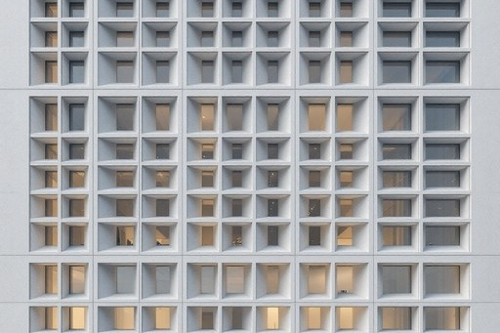
A gridded facade. Every bay repeats the same proportions, so one bay measured gives the whole elevation without counting it.
Photograph: Pexels, free licence (see the image register).
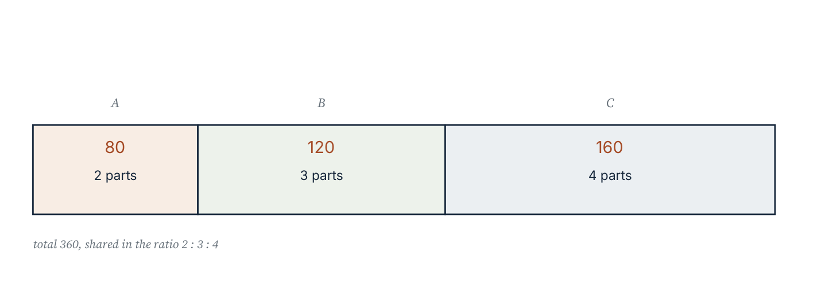
A quantity of 360 shared in the ratio 2 : 3 : 4. The bar is cut into nine equal parts of 40, giving shares of 80, 120 and 160.
Worked example 1.4.1 · Two-part sharing
Share £72 in the ratio 5 : 3.
1 There are 5 + 3 = 8 parts.
2 One part is 72 ÷ 8 = £9.
3 The first share is 5 × 9 = £45; the second is 3 × 9 = £27.
4 Check: 45 + 27 = 72, and 45 : 27 simplifies to 5 : 3.
ANSWER £45 and £27
Recombine the shares and re-simplify the ratio: both checks pass.
Worked example 1.4.2 · Three-part sharing from a difference
Two amounts are in the ratio 3 : 8 and their difference is 45. Find both amounts.
1 The difference of the terms is 8 − 3 = 5 parts.
2 Those 5 parts are worth 45, so one part is 45 ÷ 5 = 9.
3 The amounts are 3 × 9 = 27 and 8 × 9 = 72.
4 Check: 72 − 27 = 45, as required.
ANSWER 27 and 72
The difference check confirms the ratio, not just the arithmetic.
Worked example 1.4.3 · Comparing two ratios
Which is greater, 4 : 5 or 7 : 9? Justify your answer.
1 Write each as a fraction of the first quantity: 4/5 = 0.8 and 7/9 ≈ 0.778.
2 Since 0.8 > 0.778, the ratio 4 : 5 represents a larger first quantity relative to the second.
3 Cross-product check: 4 × 9 = 36 and 5 × 7 = 35. Because 36 > 35, 4 : 5 > 7 : 9.
4 Alternatively write both with a common second term of 45: 4 : 5 = 36 : 45 and 7 : 9 = 35 : 45.
ANSWER 4 : 5 is greater than 7 : 9
Two methods agree, so the comparison is robust.
To share 72 in the ratio 5 : 3, dividing 72 ÷ 2 = 36 treats the ratio as two equal shares. The ratio tells you there are 5 + 3 = 8 parts, not two. Always find the number of parts first.
Practice 1.4
SUPPORT 1–4 · CORE 5–9 · EXTENSION 10–12
1. Share 72 in the ratio 5 : 3. [F]
2. Share 180 in the ratio 2 : 3 : 4. [F]
3. Share 96 in the ratio 3 : 5. [F]
4. Two amounts are in the ratio 4 : 7. The smaller amount is 36. Find the larger amount and the total. [P]
5. Two amounts are in the ratio 3 : 8. Their difference is 45. Find both amounts. [P]
6. Share 120 in the ratio 7 : 3 : 2. [F]
7. A rectangle has perimeter 60 cm. Its length and width are in the ratio 7 : 3. Find the length and width. [P]
8. The angles of a triangle are in the ratio 2 : 3 : 4. Find the three angles. [P]
9. Which is greater, 4 : 5 or 7 : 9? Show your method. [R]
10. Three classes share 360 students in the ratio 5 : 6 : 7. How many students are in each class? [P]
11. A sum of money is shared in the ratio 3 : 5. The larger share is £120 more than the smaller. Find the total sum. [E]
12. A recipe uses flour, sugar and butter in the ratio 6 : 2 : 3. The butter weighs 240 g. Find the total mass of the three ingredients. [E]
06 · INVESTIGATE AND APPLY
The lemonade stand: four recipes, one conjecture, one test.
Which recipe is which? (Investigation)
A community fair is selling lemonade. Four teams use different recipes, each described by the ratio of lemon juice to water. The teams want to know which recipes taste the same and how to scale any recipe to a larger container.
Recipe | Lemon juice | Water | Total
A | 2 | 5 | 7
B | 4 | 10 | 14
C | 6 | 15 | 21
D | 3 | 8 | 11

- Write each recipe as a ratio of lemon juice to water, in simplest form.
- Which recipes have the same simplified ratio? What does that suggest about their taste?
- Complete a table showing the amount of lemon juice needed for 30 cups of water for each recipe.
- Plot the pairs (lemon juice, water) for recipe A for 1, 2, 3 and 4 times the base quantity. Describe the graph.
- Write a conjecture: if two recipes have the same simplified ratio, what is true about the taste? Test it with the pair 3 : 7 and 9 : 21.
- Recipe D uses 3 cups of lemon and 8 cups of water. Is it more or less lemony than recipe A? Justify with a calculation.
- Give one reason why the ratio alone might not guarantee that two lemonades taste identical.
Cooking for 45 (Criterion D)
A community kitchen has a recipe for 12 people: 600 g rice, 450 g lentils and 90 ml oil. The team needs to cook for 45 people, keeping the ingredients in the same ratio.
- Find the scale factor from 12 people to 45 people.
- Calculate the mass of each ingredient needed for 45 people. Give masses to the nearest gram and oil to the nearest millilitre.
- Explain why tripling the recipe and then adding a quarter of the original recipe gives the same result as multiplying by 3.75.
- The kitchen has 2.4 kg of rice. Is that enough? Justify with a comparison, and comment on the accuracy of your answer.
- Suggest one realistic reason why a cook might deliberately use a ratio slightly different from the written one.
07 · REFLECT AND CONSOLIDATE
SECTION 1.6
1.6 Summary, revision and reflection
What this chapter established
- A ratio compares quantities multiplicatively, and the order of the terms carries meaning.
- Part-to-part and part-to-whole ratios answer different questions; the denominator of a fraction comes from the total number of parts.
- Quantities must be in the same unit before a ratio is written.
- Multiplying or dividing both terms by the same non-zero number gives an equivalent ratio; adding does not.
- A ratio table, a double number line and a straight-line graph are three representations of one relationship.
- Sharing in a ratio needs the value of one part, found by dividing the total by the number of parts.
Vocabulary to use precisely
ratio · term · part-to-part · part-to-whole · equivalent ratios · simplest form · ratio table · double number line · unit rate · scale factor · share
Misconceptions to close
The mistake | What is really happening
“3 : 5 means 3/5 of the whole.” | 3 : 5 compares two parts. The whole is 3 + 5 = 8 parts, so the fraction is 3/8.
“Adding the same amount to both terms keeps the ratio.” | It does not. 2 : 3 becomes 5 : 6 when 3 is added, and 5/6 ≠ 2/3. Only multiplying or dividing works.
“The larger numbers mean the larger ratio.” | 10 : 20 is smaller than 3 : 4, because 0.5 < 0.75. Compare the quotients or use cross-products.
“Sharing in a ratio means dividing by the number of terms.” | Divide by the number of parts, which is the sum of the terms.

Revision questions
- Write 18 : 24 in simplest form and state the scale factor from the simplest form to the original.
- Share £154 in the ratio 4 : 7.
- Are 12 : 20 and 15 : 25 equivalent? Justify.
- A map scale is 1 : 50 000. A road measures 7 cm. How long is the real road, in kilometres?
- Two amounts are in the ratio 5 : 9 and add to 210. Find both.
Answers to the revision questions are in the answer section, with the method for each.
Self-assessment
I can … | Not yet | Getting there | Confident
write a ratio from a description and say what each term counts | □ | □ | □
simplify a ratio and form equivalent ratios | □ | □ | □
use a ratio table, a double number line and a graph | □ | □ | □
share a quantity in a two- or three-part ratio and check it | □ | □ | □
compare two ratios with a calculation and justify the comparison | □ | □ | □
explain why scaling preserves a ratio but adding does not | □ | □ | □

Reflect on the criteria
Criterion A: which calculation would you now do without checking?
Criterion B: what pattern did the ratio tables reveal that a single ratio did not?
Criterion C: where did a diagram carry an argument that words alone would have made slower?
Criterion D: which real context changed how you understood a ratio?
ATL · Communication
In order for a student to explain a method to someone who was absent, students must name each step, give the reason for it and check the result by recombining the shares.
Mixed practice · consolidate and extend
Practice 1.M
MIXED 1–12
1. Simplify: (a) 14 : 21 (b) 30 : 45 (c) 64 : 80. [F]
2. Share 252 in the ratio 5 : 4. [F]
3. A 3.5 m length of timber is cut in the ratio 2 : 5. Find both pieces in centimetres. [P]
4. A recipe for 6 people uses 450 g of flour. How much flour is needed for 10 people? [F]
5. Which is greater, 5 : 8 or 7 : 11? Justify. [R]
6. A photograph 12 cm by 8 cm is enlarged so that its width becomes 30 cm. Find its new height. [P]
7. Three friends share a prize in the ratio 2 : 3 : 6. The largest share is £180. Find the total prize. [P]
8. A student simplifies 24 : 36 to 4 : 6 and says it is in simplest form. Identify the error and give the correct answer. [R]
9. A juice blend uses orange, mango and water in the ratio 5 : 2 : 8. State the fraction of the blend that is water. [F]
10. Two quantities are in the ratio 7 : 4 and their difference is 27. Find both quantities. [P]
11. A map has a scale of 1 : 20 000. Two villages are 4.5 km apart. How far apart are they on the map, in centimetres? [E]
12. The ratio of red to blue beads in a jar is 3 : 7. After 20 red beads are added, the ratio becomes 5 : 7. How many blue beads are there? [E]

Answers · chapter 1
PRACTICE 1.1
1. 2 : 5 and 2 : 7.
2. 18 : 12 = 3 : 2.
3. (a) 2 : 3 (b) 5 : 8 (c) 3 : 2 (d) 3 : 4.
4. 24 cm : 480 cm = 1 : 20.
5. 3 : 2; 2/5 are black.
6. 63.
7. The units differ, so convert to centimetres: 60 : 45 = 4 : 3.
8. 3 : 10.
9. 30 cm.
10. Yes: 5 ÷ 2 = 2.5, so the first quantity is 2.5 times the second.
11. They are equivalent: both simplify to 3 : 4, so the same multiplicative comparison is described.
12. 2 : 3 = 18 : 27.
PRACTICE 1.2
1. (a) 2 : 3 (b) 3 : 5 (c) 3 : 4 (d) 3 : 4.
2. 3 : 4 = 9 : 12 = 15 : 20 = 30 : 40.
3. 10 : 12, 15 : 18, 20 : 24 (any three equivalent pairs).
4. Yes: both simplify to 3 : 4.
5. x = 35.
6. Sugar 140 g; total 490 g.
7. A (2 : 3).
8. Counterexample: 2 : 5 = 10 : 25, but 5 : 8 ≠ 2 : 5. Adding changes the difference between the terms, while multiplying scales both by the same factor, which is what preserves a multiplicative comparison.
9. 54° and 126°.
10. 150 km.
11. k = 9.
12. n = 8 (4 : 8 = 7 : 14, terms 21) or n = 3 (4 : 3 = 12 : 9, terms 21).
13. 108 students (6 parts = 12).
PRACTICE 1.3
1. 6 : 14, 9 : 21, 15 : 35.
2. 72 km, 96 km, 120 km.
3. 35 km.
4. (a) £0.80 per pen (b) £1.50 per kg (c) 80 km per hour.
5. 1 L of syrup.
6. 20 minutes.
7. (5, 22): 22 ÷ 5 = 4.4, not 4, so the point is off the line.
8. 1.2 kg for 12 people, 2 kg for 20; 75 g per person.
9. The first: doubling both rows keeps the quotient constant. The second does not, because 4/1 ≠ 7/2.
10. £1.20 covers 1 m, £2.40 covers 2 m, and so on; cost ÷ metres is always 1.2, which is the gradient of a straight line through the origin.
11. 3 : 8 = 1 : 8/3 and 3 : 8 = 3/8 : 1.
12. 2.1 cm.
PRACTICE 1.4
1. £45 and £27.
2. 40, 60 and 80.
3. 36 and 60.
4. Larger 63, total 99.
5. 27 and 72.
6. 70, 30 and 20.
7. Length 21 cm, width 9 cm.
8. 40°, 60° and 80°.
9. 4 : 5 is greater: 4/5 = 0.8 > 7/9 ≈ 0.778; cross-products 36 > 35.
10. 100, 120 and 140.
11. £480 (one part is £60).
12. 880 g: one part is 80 g and there are 11 parts.
PRACTICE 1.M
1. (a) 2 : 3 (b) 2 : 3 (c) 4 : 5.
2. 140 and 112.
3. 100 cm and 250 cm.
4. 750 g.
5. 5 : 8 = 0.625 and 7 : 11 ≈ 0.636, so 7 : 11 is greater (55 < 56 by cross-product).
6. 20 cm.
7. £330 (11 parts, one part £30).
8. 4 : 6 is not in simplest form: divide again by 2 to get 2 : 3.
9. 8/15.
10. 63 and 36.
11. 22.5 cm.
12. 70 blue beads: if red = 3k and blue = 7k, then (3k + 20) : 7k = 5 : 7, so 21k + 140 = 35k and k = 10.

PART I · NUMBER AND PROPORTION
2 Proportional reasoning
Number and proportion · key concept Relationships · Models, Equivalence
Two quantities are proportional when one is always a fixed
multiple of the other. That single number can connect a
recipe to a banquet, a map to a journey and a model to the
building it represents.
Global context: Orientation in space and time
01 · MYP UNIT PLANNER
What makes a relationship proportional, and what does the constant of proportionality let you predict?
STATEMENT OF INQUIRY A single constant of proportionality links a model to the reality it represents, so a measurement in one can be converted into a claim about the other.
Key and related concepts
Key concept · Relationships. In a proportional relationship every pair of values has the same quotient, and the graph is a straight line through the origin.
Related · Models. A scale drawing or a recipe is a model: it keeps one relationship and discards everything else.
Related · Equivalence. Proportion problems are solved by writing an equivalent ratio whose missing term is the answer.
Global context · Orientation in space and time
Exploration: how maps, plans and timelines compress a reality too large to see at once. Every scale is a decision about what to keep and what to leave out, and a good model makes that decision visible.
Inquiry questions
- Factual: How do you test whether two quantities are proportional?
- Conceptual: Why does the graph of a proportional relationship pass through the origin?
- Debatable: When is a scale model more useful than the real thing?
Criterion | Strands | Evidence in this chapter
A · Knowing and understanding | i, ii | Find constants of proportionality; solve proportions.
B · Investigating patterns | i, ii, iii | Compare proportional and non-proportional tables and graphs.
C · Communicating | ii, iii, iv | Use scale notation; explain what a scale factor preserves.
D · Applying mathematics | i, ii, iii, iv, v | Design a nature-reserve map with a justified scale.

ATL · Thinking skills
In order for a student to decide whether a relationship is proportional, students must test the quotient for every pair, not only for the first, and describe the graph that the table would produce.
02 · LEARNING INTENTIONS AND SUCCESS CRITERIA
You are learning to | You have succeeded when you can
Recognise a proportional relationship from a table, a graph or a description. | Say whether a table is proportional and name the test you used.
Find the constant of proportionality. | State the constant as a number and as a sentence with units.
Solve proportion problems with equivalent ratios. | Set up 3 : 5 = x : 40 and solve it two ways.
Use a scale drawing or map to find real lengths. | Convert a drawing length to a real length and back without losing the unit.
Recognise similar figures and use a scale factor. | Find a missing side of a similar figure and justify the factor.
Distinguish proportional from additive change. | Give one table that looks proportional and show with a calculation why it is not.

Prerequisite check · 10 minutes, no calculator
- Simplify 18 : 24.
- Find 3/4 of 60.
- Solve 4 : 7 = 12 : x.
- Convert 2.5 m to centimetres.
- Which is greater, 5 : 8 or 3 : 5?
- Write the next three terms of 3, 6, 9, 12, ….
If three or more answers are wrong, revisit section 1.2 before continuing.
SECTION 2.1
2.1 Recognising proportional relationships
Criterion A · I · B · II · Related concepts: Relationships, Constant of proportionality
A proportional relationship is not simply a relationship that grows. It is a relationship in which every value of the second quantity is the same multiple of the first.
03 · ENGAGE
Two shops, two price lists. Which shop simply charges more per rule, and which one behaves differently?
Shop A sells ribbon at £1.20 per metre: 2 m cost £2.40, 5 m cost £6.00. Shop B charges £2 for the first metre and £1.20 for each metre after that: 2 m cost £3.20, 5 m cost £6.80. Both price lists rise. Only one of them is proportional.
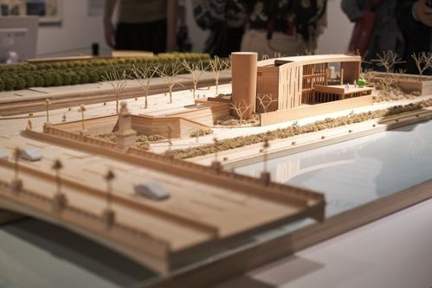
An architectural scale model keeps the proportions of the building and discards its materials, its weight and its plumbing. A model is a set of deliberate decisions about what to keep.
Photograph: Pexels, free licence (see the image register).
Before reading on, work out the cost per metre for both shops at 2 m and at 5 m. Write a sentence that says which shop's price per metre stays constant.
04 · EXPLORE
Do the quotients agree?
Copy the two tables. For each pair, divide the second quantity by the first and record the result to two decimal places.
Shop A length (m) | 2 | 3 | 4 | 5 | 6
Cost (£) | 2.40 | 3.60 | 4.80 | 6.00 | 7.20
Cost ÷ length | 1.20 | 1.20 | 1.20 | 1.20 | 1.20

Shop B length (m) | 1 | 2 | 3 | 4 | 5
Cost (£) | 2.00 | 3.20 | 4.40 | 5.60 | 6.80
Cost ÷ length | 2.00 | 1.60 | 1.47 | 1.40 | 1.36

- Which table has the same quotient in every column?
- Plot both sets of points on one set of axes. What shape does each make?
- Does either line pass through the origin? What does that mean about the cost of 0 metres?
- Write a conjecture: a table is proportional if and only if …
- Test your conjecture on the pairs (1, 4), (2, 7), (3, 10). Does the second quantity grow by a constant amount each time? Is the relationship proportional?
- Invent a table of your own that grows but is not proportional, and one that is. Swap with a partner and test each other's.
05 · EXPLAIN
Two quantities are in direct proportion when one is a constant multiple of the other: y = k x, where k is not zero. The constant k is the constant of proportionality. A relationship is proportional exactly when y ÷ x has the same value for every pair, and its graph is a straight line through the origin.
A proportional relationship graphed: cost against volume at £3 per litre. Equal quotients produce equal gradients, and a zero volume costs zero.
Two tests, used together. Divide: if y ÷ x is constant, the relationship is proportional. Graph: if the points lie on a straight line through the origin, it is proportional. A straight line that misses the origin is called linear, not proportional.
Proportional relationships are everywhere in measurement: cost and quantity at a fixed unit price; distance and time at a steady speed; the circumference and diameter of any circle; the mass and volume of one material. Recognising one means you can predict a value you have not measured.
Worked example 2.1.1 · Find the constant
Four litres of paint cost £34. Find the constant of proportionality and the cost of 7 litres.
1 The constant is the cost per litre: k = 34 ÷ 4 = 8.5.
2 Write the relationship: cost = 8.5 × litres.
3 For 7 litres: 8.5 × 7 = £59.50.
4 State the constant in words, with its unit: £8.50 per litre.
ANSWER k = 8.5; 7 litres cost £59.50
Check by ratio: 34 : 4 = 59.5 : 7, since 34 × 7 = 4 × 59.5 = 238.
Worked example 2.1.2 · Proportional or not?
A taxi charges £4 to start plus £2 per kilometre. Is the cost proportional to the distance? Justify with a table.
1 Build a table: 1 km £6, 2 km £8, 3 km £10, 4 km £12.
2 Divide: 6 ÷ 1 = 6, 8 ÷ 2 = 4, 10 ÷ 3 ≈ 3.33. The quotients are not constant.
3 The graph is a straight line, but it starts at £4, not at £0, so it does not pass through the origin.
4 The cost is linear but not proportional; the fixed charge is what breaks the proportionality.
ANSWER Not proportional — the quotients differ and the line misses the origin.
At 0 km the cost is £4, whereas a proportional relationship must give 0.
Worked example 2.1.3 · Reasoning from the graph
A line passes through (0, 0) and (6, 15). State the constant of proportionality and the value of y when x = 10.
1 Because the line passes through the origin, k = y ÷ x.
2 Using the point (6, 15): k = 15 ÷ 6 = 2.5.
3 Then y = 2.5x, so when x = 10, y = 25.
4 Check the point is on the line: 25 ÷ 10 = 2.5, the same constant.
ANSWER k = 2.5; y = 25
Any two points on a proportional line give the same quotient.
“The table adds 3 each time, so it is proportional.” Constant addition gives a linear pattern, not a proportional one: 2, 5, 8, 11 grows by 3 but 5 ÷ 2 ≠ 8 ÷ 5. Proportionality is about a constant multiplier, so test by dividing.
Practice 2.1
SUPPORT 1–5 · CORE 6–9 · EXTENSION 10–12
1. Find the constant of proportionality: (a) 5 kg cost £12.50 (b) 8 m of cable cost £36 (c) 3 hours produce 195 parts. [F]
2. A car travels 240 km in 3 hours at a steady speed. Write the relationship and find the distance in 7 hours. [F]
3. Which of these tables are proportional? (a) 2, 4, 6 with 7, 14, 21 (b) 1, 2, 3 with 5, 8, 11 (c) 4, 6, 8 with 10, 15, 20. [F]
4. A photocopier produces 84 pages in 3 minutes. How many pages in 11 minutes? [F]
5. A line passes through the origin and (4, 10). State k and find y when x = 14. [F]
6. A plumber charges £40 call-out plus £25 per hour. Make a table for 1 to 4 hours, then explain why the charge is not proportional to the time. [R]
7. Two students disagree. One says “a proportional graph is a straight line”, the other says “a straight-line graph is proportional”. Who is right, and what is the counterexample? [R]
8. A recipe uses 3 eggs for every 8 portions. How many eggs are needed for 28 portions? [P]
9. The cost of 7 identical books is £59.50. Find the cost of 11 books and state the constant of proportionality with its unit. [P]
10. A relationship satisfies y = k x. When x increases from 4 to 12, y increases by 30. Find k. [E]
11. Explain why the circumference of a circle is proportional to its diameter, and state the constant in exact form. [E]
12. A shop's price list is: 1 kg £4.50, 2 kg £8.00, 3 kg £11.50. A customer claims the price is proportional. Test the claim and describe the pricing rule you can infer. [E]
SECTION 2.2
2.2 Solving proportional problems
Criterion A · II · C · II · Related concepts: Equivalence, Proportion
A proportion is an equation saying that two ratios are equal. Solving one means finding the missing term without abandoning the relationship.
A proportion is a statement that two ratios are equal, such as a : b = c : d. The cross-product condition a d = b c follows from multiplying both sides by b d, and it holds for every true proportion.
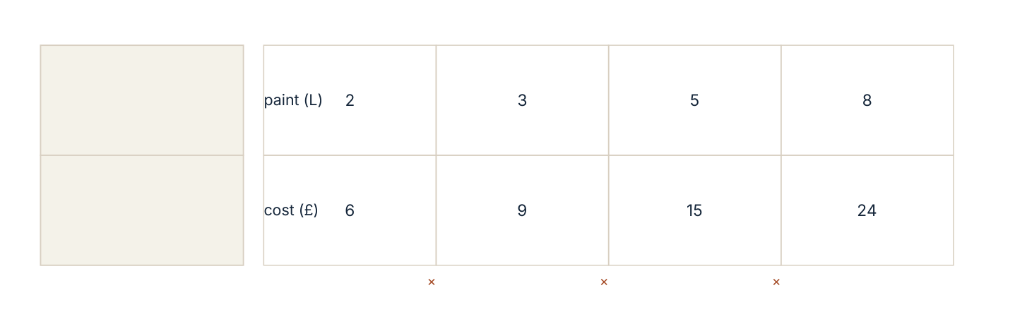
Scaling a proportion through a unit: multiplying the first column by 2.5 gives the fourth, and every pair keeps the quotient 3.
Three reliable methods
- Scale by a factor. If the known pair is multiplied by k, multiply the other term by the same k.
- Find the unit rate. Divide to get the value for one unit, then multiply.
- Cross-multiply. Write a/ b = c/ d and solve a d = b c.
All three give the same answer when the relationship is proportional. Choose the one that keeps the numbers easiest to handle, and say which you used.
Worked example 2.2.1 · Solve by scaling
A recipe for 12 people needs 600 g of rice. How much rice is needed for 45 people?
1 Find the scale factor from 12 to 45: 45 ÷ 12 = 3.75.
2 Multiply the quantity by the same factor: 600 × 3.75 = 2 250 g.
3 State the answer in a sensible unit: 2.25 kg.
4 Check with the unit rate: 600 ÷ 12 = 50 g per person, and 50 × 45 = 2 250 g.
ANSWER 2 250 g, or 2.25 kg
Both methods agree, and 2.25 kg is plausible for 45 servings.
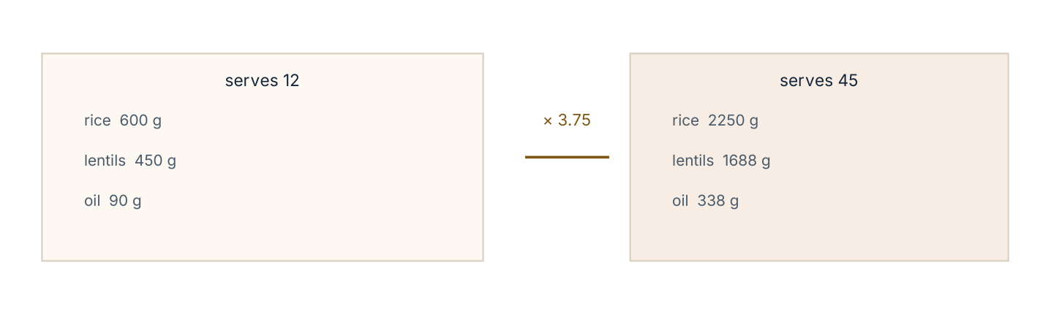
Scaling a recipe by 3.75. Every ingredient is multiplied by the same factor, so the dish tastes the same.
Worked example 2.2.2 · Solve by cross-multiplying
If 5 pens cost £4, how much do 8 pens cost?
1 Write the proportion: 5/ 4 = 8/ x, where x is the cost in pounds.
2 Cross-multiply: 5x = 32.
3 Divide both sides by 5: x = 6.4.
4 State the answer with its unit: £6.40.
ANSWER 8 pens cost £6.40
The unit price is £0.80, and 8 × 0.80 = 6.40.
Worked example 2.2.3 · A proportion with a fractional term
A tap fills 3/4 of a tank in 18 minutes. How long does it take to fill the whole tank?
1 Let t be the time for the whole tank. Then 18/ (3/4) = t/ 1.
2 18 ÷ (3/4) = 18 × 4/3 = 24.
3 So t = 24 minutes.
4 Check: three quarters of 24 minutes is 18 minutes, as stated.
ANSWER 24 minutes
The whole is larger than three quarters, so the time must be larger than 18 minutes.
Setting up the proportion upside down. “5 pens cost £4, so 8 pens cost x” gives 5/ 8 = 4/ x, which solves to £6.40 only by accident here. Keep the same quantity on top of both fractions: pens over pens, money over money.
Practice 2.2
SUPPORT 1–5 · CORE 6–9 · EXTENSION 10–12
1. Solve: (a) 3 : 5 = x : 45 (b) 7 : 4 = 21 : x (c) x : 9 = 8 : 12. [F]
2. If 6 identical notebooks cost £9, what do 10 cost? [F]
3. A car uses 8 litres to travel 96 km. How many litres for 156 km? [F]
4. A recipe for 4 people needs 300 g of pasta. How much for 10 people? [F]
5. A map scale is 1 : 25 000. A road is 8 cm on the map. Find its real length in kilometres. [F]
6. A tap fills 2/5 of a tank in 12 minutes. How long to fill it completely? [P]
7. Two quantities are proportional. When the first is 15 the second is 40. Find the second when the first is 21. [P]
8. A printer prints 45 pages in 3 minutes. How long for 300 pages? Give the answer in minutes and seconds. [P]
9. A recipe uses flour and sugar in the ratio 5 : 2. If 350 g of flour is used, find the mass of sugar and the total mass. [P]
10. A photograph 12 cm by 8 cm is enlarged so that the width is 30 cm. Find the new height, and the factor by which the area increases. [E]
11. A model car is 18 cm long and the real car is 4.5 m long. Find the scale as a ratio in the form 1 : n. [E]
12. Two taps run at constant rates. Tap A fills 5 litres in 3 minutes; tap B fills 8 litres in 5 minutes. Together, how long will they take to fill a 120-litre tank? [E]
SECTION 2.3
2.3 Scale drawings, maps and similar figures
Criterion C · III · D · II · Related concepts: Models, Scale
A scale drawing is a proportional model of something too large or too small to handle at full size. Every length is multiplied by the same scale factor, and every angle is unchanged.
A drawing is to scale when every length in the drawing is the same multiple of the corresponding real length. The multiplier is the scale factor; a map is often written as a ratio, 1 : 50 000, meaning 1 unit on the map represents 50 000 of the same units on the ground.
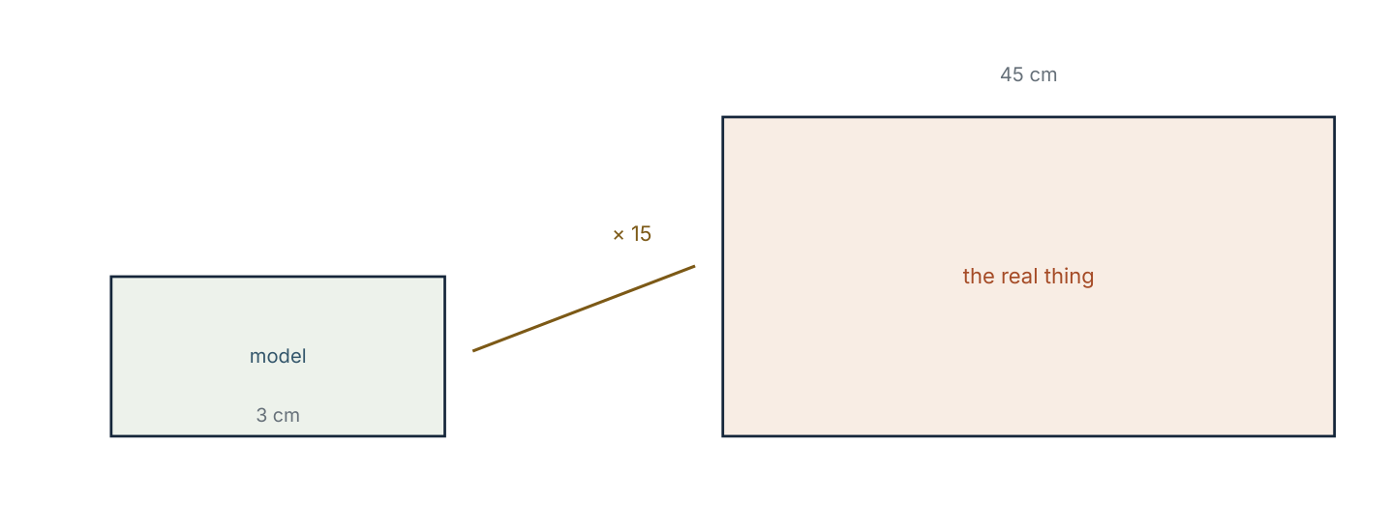
A model at 1 : 15 and the object it represents. Lengths are multiplied by 15; angles are unchanged.
Converting between drawing and reality is a multiplication, so the only real care needed is with units. A scale of 1 : 50 000 used with centimetres gives centimetres on the ground, which must then be converted to metres or kilometres.
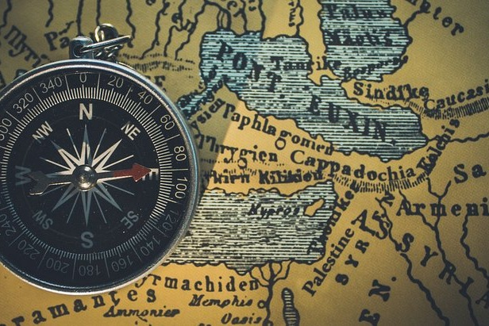
A compass on a printed map. The map keeps direction and relative distance, and discards height, weather and time — a model is defined as much by what it leaves out as by what it keeps.
Photograph: public domain, via Wikimedia Commons (see the image register).
Worked example 2.3.1 · Map to ground
A map has scale 1 : 50 000. Two villages are 7 cm apart on the map. Find the real distance in kilometres.
1 Multiply the map length by the scale: 7 × 50 000 = 350 000 cm.
2 Convert to metres: 350 000 ÷ 100 = 3 500 m.
3 Convert to kilometres: 3 500 ÷ 1 000 = 3.5 km.
4 Write the answer with the unit the question asked for: 3.5 km.
ANSWER 3.5 km
Sanity check: 1 cm represents 0.5 km, so 7 cm represents 3.5 km.
Worked example 2.3.2 · Ground to map
A garden is 24 m long. On a plan it is drawn 16 cm long. Find the scale of the plan in the form 1 : n.
1 Convert to the same unit: 24 m = 2 400 cm.
2 The scale factor is 2 400 ÷ 16 = 150.
3 So 1 cm on the plan represents 150 cm in the garden.
4 The scale is 1 : 150.
ANSWER 1 : 150
Check: 16 × 150 = 2 400 cm = 24 m, as stated.
Worked example 2.3.3 · Similar figures
Two rectangles are similar. The first is 6 cm by 9 cm; the second has a shorter side of 10 cm. Find its longer side.
1 Similar means a single scale factor applies to every side.
2 The factor is 10 ÷ 6 = 5/3.
3 The longer side is 9 × 5/3 = 15 cm.
4 Check that the ratios of corresponding sides agree: 6 : 9 = 10 : 15, since 6 × 15 = 90 = 9 × 10.
ANSWER 15 cm
Cross-products agree, so the sides are in the same ratio.
“The map is 1 : 50 000, so 7 cm becomes 350 000 km.” The scale relates like units to like units: 7 cm becomes 350 000 cm, which is 3.5 km. Convert the unit before you convert the magnitude.
Practice 2.3
SUPPORT 1–4 · CORE 5–9 · EXTENSION 10–12
1. A map has scale 1 : 20 000. Find the real distance, in metres, of 6 cm on the map. [F]
2. A plan uses 1 cm for every 2 m. Find the plan length of a 14 m wall. [F]
3. A model is built at 1 : 40. The real door is 2 m high. How high is the door on the model, in centimetres? [F]
4. Two similar triangles have corresponding sides 8 cm and 20 cm. Find the scale factor. [F]
5. A photograph 15 cm by 10 cm is enlarged to 45 cm wide. Find its new height and describe how the area changes. [P]
6. A map shows a lake as a rectangle 4 cm by 2.5 cm. The scale is 1 : 25 000. Find the real dimensions in metres. [P]
7. A model aircraft is 35 cm long. The real aircraft is 42 m long. Find the scale as 1 : n. [P]
8. Two rectangles are 5 cm × 8 cm and 12.5 cm × 20 cm. Are they similar? Justify with a calculation. [R]
9. A student says “a scale of 1 : 50 means the drawing is 50 times bigger”. Correct the statement and give one example. [R]
10. A garden plan is drawn at 1 : 200. The plan shows a path 3.5 cm long. The path is widened from 1.2 m to 1.5 m. How wide is it on the plan, in millimetres? [E]
11. Two similar rectangles have areas 24 cm² and 96 cm². Find the scale factor between them. [E]
12. A map is photocopied at 80 % of its original size. A distance measured as 5 cm on the copy corresponds to 2 km in reality. Find the original scale. [E]
06 · INVESTIGATE AND APPLY
A plan that fits: the nature-reserve map.
A plan that fits (Investigation)
A nature reserve is a rectangle 2.4 km by 1.5 km. The warden wants a single A4 plan on which the whole reserve is drawn, with a 2 cm margin on every side, and on which the paths can be measured to within 10 m.
- Convert the reserve's dimensions to centimetres.
- An A4 page is 21.0 cm by 29.7 cm. Find the largest possible drawing area once the margins are removed.
- Test three candidate scales: 1 : 10 000, 1 : 12 500 and 1 : 15 000. For each, work out the drawn dimensions and decide whether the whole reserve fits.
- Choose a scale and justify it with the measurements, not with a preference.
- At your chosen scale, what real distance does 1 mm on the plan represent? Is the 10 m measuring requirement met?
- Write a conjecture about what happens to the accuracy of a plan as the scale ratio gets larger.
- A path is 1.2 km long. Draw it to your scale and label its length.
The community orchard (Criterion D)
A community orchard is planned as a rectangle 60 m by 45 m, divided into equal square plots. The committee must decide how many plots to make and how to draw the plan for the noticeboard.
- Find the largest square plot size that divides both dimensions exactly.
- How many plots does that give?
- Draw a scale plan at 1 : 500 and state the drawn size of one plot.
- The fence costs £18.50 per metre. Estimate the cost of fencing the perimeter, then calculate it exactly.
- The committee wants at least 20 plots. What is the largest plot size that allows this, and how does it change the plan?
- Justify your recommendation in three sentences, using the mathematics.
07 · REFLECT AND CONSOLIDATE
SECTION 2.5
2.5 Summary, revision and reflection
What this chapter established
- A relationship is proportional when y ÷ x is the same for every pair; its graph is a straight line through the origin.
- The constant of proportionality k carries units and meaning: cost per litre, kilometres per hour, centimetres per centimetre.
- A linear relationship with a non-zero starting value is not proportional.
- Proportions are solved by scaling, by unit rate, or by cross-multiplying, and all three must give the same answer.
- A scale drawing multiplies every length by the same factor and leaves every angle unchanged.
- Similar figures have equal angles and proportional sides.
Vocabulary to use precisely
proportion · proportional · constant of proportionality · unit rate · scale · scale factor · scale drawing · similar · cross-multiply · linear (not proportional)
Misconceptions to close
The mistake | What is really happening
“It grows by the same amount, so it is proportional.” | Constant addition is linear, not proportional. 2, 5, 8 has a constant difference of 3 but quotients 2.5, 2.5, 2.67 that do not agree.
“Any straight line is proportional.” | Only a line through the origin is. A £4 call-out charge breaks proportionality.
“Scale 1 : 50 000 means the map is 50 000 times smaller in every way.” | It is 50 000 times smaller in length; areas scale by the square of the factor.
“Similar shapes have equal sides.” | Congruent shapes have equal sides; similar shapes have proportional sides.

Revision questions
- Is the table 3, 6, 9 with 12, 24, 33 proportional? Justify.
- A car uses 7 litres for 84 km. Find the constant of proportionality and the fuel for 150 km.
- A map has scale 1 : 40 000. Two points are 6.5 cm apart. Find the real distance in kilometres.
- Two similar rectangles have sides 9 cm and 15 cm corresponding. The smaller has area 54 cm². Find the area of the larger.
- Explain in two sentences why a scale plan cannot preserve both lengths and areas by the same factor.
Self-assessment
I can … | Not yet | Getting there | Confident
test whether a relationship is proportional and say why | □ | □ | □
find and interpret a constant of proportionality | □ | □ | □
solve a proportion by two different methods | □ | □ | □
convert between map and ground distances | □ | □ | □
use a scale factor on similar figures | □ | □ | □

Reflect on the criteria
Criterion A: which proportion did you solve fastest, and why?
Criterion B: what did the two tables reveal that one pair of values could not?
Criterion C: how did you show which quantity was on top of each fraction?
Criterion D: where did a model change a decision you would have made?
ATL · Thinking skills
In order for a student to choose a scale for a plan, students must estimate the drawn dimensions before drawing, compare them with the space available and revise the scale on evidence.
Mixed practice · consolidate and extend
Practice 2.M
MIXED 1–12
1. Find the constant: 12 kg cost £36. [F]
2. Solve 8 : 11 = 24 : x. [F]
3. A recipe for 6 needs 450 g of flour. Find the mass for 15. [F]
4. A map scale is 1 : 30 000. Find 9 cm in kilometres. [F]
5. Are 4, 10, 16 with 6, 15, 24 proportional? Justify. [R]
6. A 3 m length of timber is cut in the ratio 2 : 5. Find both pieces in centimetres. [P]
7. A photograph 10 cm by 15 cm is enlarged to 25 cm wide. Find the new height. [P]
8. A student writes 3/ 5 = x/ 8 for “3 pens to £5, x pens to £8”. Is the set-up correct? Explain. [R]
9. A car travels 150 km in 2 hours at a steady speed. How far in 5 hours? [P]
10. A model is 1 : 25. A real window is 1.5 m wide. How wide on the model, in centimetres? [P]
11. Two similar triangles have areas 36 cm² and 81 cm². Find the ratio of their corresponding sides. [E]
12. A tap fills 3/8 of a tank in 15 minutes. How long for 5/8 of the tank? [E]

Answers · chapter 2
PRACTICE 2.1
1. (a) 2.50 (b) 4.50 (c) 65.
2. d = 80t; 560 km.
3. (a) yes (b) no (c) yes.
4. 308 pages.
5. k = 2.5; y = 35.
6. Table 65, 90, 115, 140; 65 ÷ 1 = 65 but 90 ÷ 2 = 45, so not proportional — the £40 call-out is a fixed charge.
7. The first student is right: a proportional graph is straight and passes through the origin. A taxi graph is straight but starts at the call-out charge.
8. 10.5 eggs, so 11 whole eggs.
9. £93.50; £8.50 per book.
10. k = 3.75.
11. C = πd, with k = π exactly.
12. Not proportional: 4.50 ÷ 1 = 4.50, 8 ÷ 2 = 4.00, 11.50 ÷ 3 ≈ 3.83. The price per kg falls as the quantity rises, as a bulk discount would.
PRACTICE 2.2
1. (a) 27 (b) 12 (c) 6.
2. £15.
3. 13 litres.
4. 750 g.
5. 2 km.
6. 30 minutes.
7. 56.
8. 20 minutes.
9. Sugar 140 g; total 490 g.
10. 20 cm; area × 6.25.
11. 1 : 25.
12. About 20 minutes: together they deliver 5/3 + 8/5 = 49/15 litres each minute, so 120 ÷ 49/15 ≈ 19.8 minutes.
PRACTICE 2.3
1. 1 200 m.
2. 7 cm.
3. 5 cm.
4. 2.5.
5. 30 cm high; the area multiplies by 9.
6. 1 000 m by 625 m.
7. 1 : 120.
8. Yes: 12.5 ÷ 5 = 2.5 and 20 ÷ 8 = 2.5, so the scale factor is 2.5 in both directions.
9. It means the drawing is 50 times smaller: 1 unit on the drawing represents 50 of the same units in reality.
10. 7.5 mm.
11. Scale factor 2 (areas in the ratio 4 : 1).
12. 1 : 32 000. 5 cm on the copy is 6.25 cm on the original, and 6.25 cm represents 2 km = 200 000 cm, so 1 cm represents 32 000 cm.
PRACTICE 2.M
1. 3.
2. 33.
3. 1 125 g.
4. 2.7 km.
5. Yes: 6 ÷ 4 = 1.5, 15 ÷ 10 = 1.5 and 24 ÷ 16 = 1.5, so each pair shares the same ratio.
6. 85.7 cm and 214.3 cm (approximately 86 cm and 214 cm).
7. 37.5 cm.
8. No: the pens are on top in the first fraction and the money in the second. Keep like quantities in the same position.
9. 375 km.
10. 6 cm.
11. 2 : 3.
12. 25 minutes.

PART I · NUMBER AND PROPORTION
3 Rates and unit rates
Number and proportion · key concept Relationships · Change, Quantity
A rate compares quantities measured in different units.
Reduced to a single unit, a rate becomes a tool for
comparison: which is cheaper, which is faster, which is
denser.
Global context: Scientific and technical innovation
01 · MYP UNIT PLANNER
Rates as comparisons across units, and the unit rate as the fair basis for a decision.
STATEMENT OF INQUIRY A rate compares quantities measured in different units, and reducing a rate to a single unit turns a difficult comparison into a direct one.
Key and related concepts
Key concept · Relationships. A rate is a ratio between a quantity and the time, space or amount it occupies.
Related · Change. Speed, flow and density all describe how one quantity changes as another changes.
Related · Quantity. The unit attached to a rate is part of its meaning: 60 km per hour is not 60.
Global context · Scientific and technical innovation
Exploration: how engineers and scientists compare systems. A fuel consumption figure, a pump's delivery and the density of a material are all rates, and each one lets a designer predict behaviour before building anything.
Inquiry questions
- Factual: What is the difference between a ratio and a rate?
- Conceptual: Why does a unit rate make comparison fair?
- Debatable: When is the cheapest unit price not the best choice?
Criterion | Strands | Evidence in this chapter
A · Knowing and understanding | i, ii | Convert rates; compute unit rates; use speed, density and flow formulas.
B · Investigating patterns | i, ii | Investigate how unit price changes with pack size.
C · Communicating | ii, iii | Write rates with correct compound units and interpret them.
D · Applying mathematics | i, ii, iii, iv, v | Decide a contract: the breakfast club, on measured evidence.

ATL · Thinking skills
In order for a student to compare two products fairly, students must convert both to the same unit of comparison, state that unit, and check that the quantities being compared are genuinely equivalent.
02 · LEARNING INTENTIONS AND SUCCESS CRITERIA
You are learning to | You have succeeded when you can
Identify a rate and write it with a compound unit. | Write 250 km in 4 hours as a rate with units, and say what it means.
Convert a rate to a unit rate. | Reduce a price, a speed or a flow to a per-one value correctly.
Use the speed, density and flow relationships. | Rearrange s = d/ t for any of the three quantities.
Compare products using unit price. | Decide which of two pack sizes is better value and show the comparison.
Solve multi-step rate problems. | Find a total time or cost where two rates act together.
Judge whether a rate comparison is fair. | Name one factor a unit-price comparison ignores.

Prerequisite check · 10 minutes, no calculator
- Simplify 45 : 60.
- Find 240 ÷ 4.
- Convert 1.5 kg to grams.
- Convert 2 hours 15 minutes to minutes.
- A 5 kg bag costs £12. Find the cost per kilogram.
- Write 3/4 as a decimal.
If three or more answers are wrong, revisit section 2.2 before continuing.
SECTION 3.1
3.1 What is a rate?
Criterion A · I · Related concepts: Relationships, Quantity
A rate is a ratio whose two quantities are measured in different units. That difference is the whole point: a rate tells you how much of one thing happens for each unit of another.
03 · ENGAGE
Which pump fills the tank first? Two pumps give their output in different ways, and neither number answers the question on its own.
Pump A delivers 240 litres in 4 minutes. Pump B delivers 150 litres in 2.5 minutes. A caretaker says pump A is faster because 240 is bigger than 150. Before reading on, decide whether the caretaker is right, and write the calculation that settles it.
04 · EXPLORE
Reduce both to one unit.
Copy the table and fill in the third column by dividing the litres by the minutes.
Pump | Litres | Minutes | Litres per minute
A | 240 | 4
B | 150 | 2.5
C | 375 | 7.5

- Which pump delivers the most litres per minute?
- Does the pump with the largest total delivery also have the largest rate?
- Pump C is added. Without dividing, predict where it ranks. Then check.
- How long would pump B take to deliver 600 litres?
- How many litres would pump A deliver in an hour?
- Write a conjecture: when two totals differ, what must you compute before comparing them fairly?
- Invent two pumps where the larger total has the smaller rate.
05 · EXPLAIN
A rate compares two quantities measured in different units. A unit rate is that comparison reduced to one unit of the second quantity: litres per minute, kilometres per hour, grams per cubic centimetre, pounds per kilogram. A unit rate is found by dividing.
Because the units are different, they cannot be cancelled away as they are in a ratio: 240 litres in 4 minutes is 60 litres per minute, and the compound unit “litres per minute” is retained in the answer. Writing the unit is not decoration. It is the part of the answer that says what has been measured.
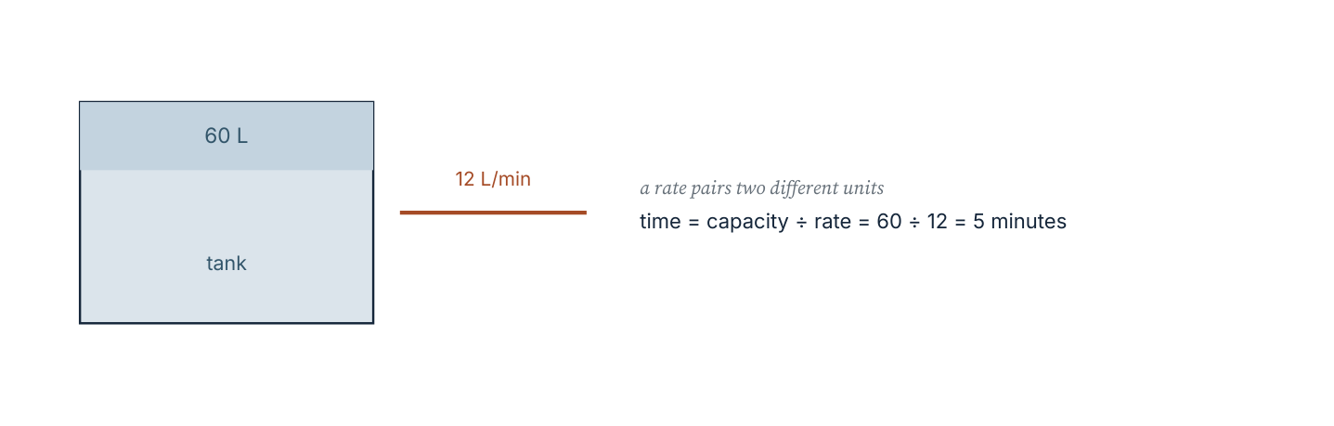
A pump as a rate: capacity divided by rate gives the time to fill. The unit of the answer, minutes, follows from litres ÷ (litres per minute).
Three rates that every other rate problem in this chapter is built on: speed = distance ÷ time; density = mass ÷ volume; unit price = price ÷ quantity. Each can be rearranged, and each keeps its compound unit in the answer.
Worked example 3.1.1 · Find and interpret a unit rate
A printer produces 480 pages in 6 minutes. Find the unit rate and the time needed for 1 200 pages.
1 Divide: 480 ÷ 6 = 80 pages per minute.
2 The unit rate is 80 pages per minute; the unit is part of the answer.
3 For 1 200 pages: 1 200 ÷ 80 = 15 minutes.
4 Check by multiplication: 80 × 15 = 1 200 pages.
ANSWER 80 pages per minute; 15 minutes
Multiply back to the original total, and the units cancel as they should.
Worked example 3.1.2 · Choose the better buy
Rice is sold in 2 kg bags for £3.60 and in 5 kg bags for £8.25. Which is better value per kilogram?
1 Unit price of the small bag: 3.60 ÷ 2 = £1.80 per kg.
2 Unit price of the large bag: 8.25 ÷ 5 = £1.65 per kg.
3 Compare like with like: £1.65 < £1.80, so the 5 kg bag is cheaper per kilogram.
4 State the saving: 15 pence per kilogram.
ANSWER The 5 kg bag, at £1.65 per kg against £1.80 per kg
Check by total: 5 kg at £1.80 would cost £9.00, and the bag costs £8.25.
Worked example 3.1.3 · A rate with a mixed unit
A cyclist covers 27 km in 1 hour 30 minutes. Find the average speed in km/h.
1 Convert the time to hours: 1 hour 30 minutes = 1.5 hours.
2 Speed = distance ÷ time = 27 ÷ 1.5 = 18.
3 The unit is kilometres per hour: 18 km/h.
4 Check: 18 × 1.5 = 27 km, the original distance.
ANSWER 18 km/h
Always convert the time unit before dividing, or the answer will carry the wrong unit.
“480 pages in 6 minutes is 480 ÷ 6 = 80, so 80 pages.” The number is right; the answer is not. A rate without its unit is uninterpretable. Write “80 pages per minute”, or use the compound unit pages/min.
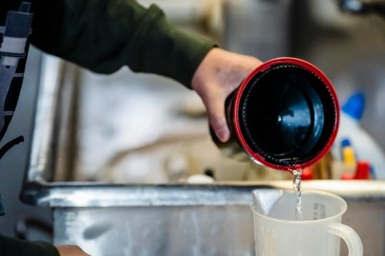
Filling a measuring jug. The rate is visible only in the unit: millilitres per second, not simply “millilitres”.
Photograph: Pexels, free licence (see the image register).
Practice 3.1
SUPPORT 1–5 · CORE 6–9 · EXTENSION 10–12
1. Find the unit rate: (a) 360 km in 4 hours (b) £7.20 for 9 kg (c) 240 words in 3 minutes. [F]
2. Write each as a rate with a compound unit: (a) 15 litres in 5 minutes (b) 84 students in 3 classes (c) 450 g in 6 portions. [F]
3. A car travels 195 km in 2.5 hours. Find its average speed. [F]
4. Which is better value: 3 kg for £5.10 or 5 kg for £8.00? [F]
5. A tap delivers 18 litres in 1.5 minutes. How long for 60 litres? [F]
6. A 750 ml bottle of juice costs £1.80 and a 1.5 litre bottle costs £3.30. Find both unit prices per litre. [P]
7. A train covers 240 km in 2 hours 40 minutes. Find its average speed in km/h. [P]
8. Two printers: one prints 90 pages in 2 minutes, the other 200 pages in 5 minutes. Which is faster, and by how many pages per minute? [P]
9. A recipe serves 4 and uses 0.6 kg of potatoes. Find the mass per serving in grams. [P]
10. A student claims “4 kg for £10 is better than 3 kg for £7.20 because £10 − £7.20 is less than the price of 1 kg”. Test the reasoning with unit prices and explain the error. [E]
11. A car's fuel consumption is 6.5 litres per 100 km. How many kilometres per litre is that, and how much fuel is needed for 340 km? [E]
12. A tap fills a 90-litre tank in 12 minutes. A second tap fills it in 18 minutes. How long do they take together? [E]
SECTION 3.2
3.2 Unit prices and best buys
Criterion A · II · D · II · Related concepts: Quantity, Equivalence
Comparing prices is a rate problem, and the fair comparison is almost never the one the shelf label invites you to make.
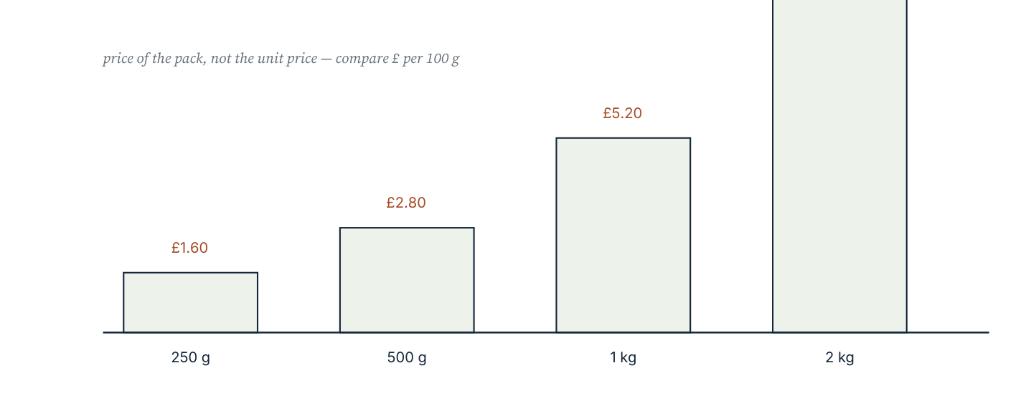
Four pack sizes with their prices. The tallest bar is not the best value: the comparison must be made per unit of quantity, not per pack.
The comparison routine
- Convert every price to the same unit of quantity — usually 100 g or 1 kg, or 100 ml or 1 litre.
- Divide price by quantity for each product.
- Compare the unit prices and state the winner with the units.
- Check the decision makes sense: a bulk pack can be worse value if it will not be used.
Worked example 3.2.1 · Compare three pack sizes
Pasta is sold at £0.95 for 500 g, £1.70 for 1 kg and £2.40 for 1.5 kg. Which is the best value?
1 Convert all to price per 100 g: 0.95 ÷ 5 = £0.19; 1.70 ÷ 10 = £0.17; 2.40 ÷ 15 = £0.16.
2 The 1.5 kg pack has the lowest price per 100 g.
3 The saving against the 500 g pack is 3p per 100 g, or 30p per kilogram.
4 State the answer with the comparison unit: £0.16 per 100 g.
ANSWER The 1.5 kg pack, at £0.16 per 100 g
Cross-check: 1.5 kg at £0.19 per 100 g would cost £2.85, and the pack costs £2.40.
Worked example 3.2.2 · The same rate in different units
A car uses 6.4 litres per 100 km. Express this in kilometres per litre.
1 100 km needs 6.4 litres, so 1 litre covers 100 ÷ 6.4 km.
2 100 ÷ 6.4 = 15.625.
3 The car travels 15.625 km per litre, about 15.6 km/L.
4 Check by multiplication: 15.625 × 6.4 = 100 km.
ANSWER 15.625 km per litre
Reciprocal rates are still rates; the unit changes but the relationship does not.
Worked example 3.2.3 · A rate over a mixed quantity
A 1.5 litre bottle of lemonade costs £2.10 and a 330 ml can costs £0.85. Which is better value per litre?
1 Convert both quantities to litres: 330 ml = 0.33 L.
2 Bottle: 2.10 ÷ 1.5 = £1.40 per litre.
3 Can: 0.85 ÷ 0.33 = £2.575… per litre, about £2.58.
4 The bottle is far better value per litre, though it may not all be drunk.
ANSWER The 1.5 litre bottle, at £1.40 per litre
Check the can: 0.33 × 2.575 ≈ 0.85, as priced.
“The bigger pack is always better value.” Sometimes it is not: shops price small packs as loss leaders, and a bulk pack that is wasted is not cheap. Compare unit prices, then decide with the use in mind.
Practice 3.2
SUPPORT 1–4 · CORE 5–9 · EXTENSION 10–12
1. Find the price per 100 g: (a) £1.80 for 400 g (b) £2.40 for 600 g. [F]
2. Which is better value: 250 ml for £1.20 or 750 ml for £3.30? [F]
3. A 12-pack of pens costs £4.80. Find the price per pen. [F]
4. A car travels 480 km on 40 litres. Find the fuel used per 100 km. [F]
5. Soap powder: 1.5 kg for £4.20, 3 kg for £7.80, 5 kg for £12.50. Which is the best value per kg? [P]
6. Convert 45 miles per gallon to a cost per 100 miles if fuel costs £1.45 per litre (£1 gallon ≈ 4.55 litres). [P]
7. A café sells coffee at £2.40 for 300 ml and £3.20 for 450 ml. Which is better value per 100 ml? [P]
8. Two mobile contracts: £9 for 5 GB and £14 for 8 GB. Find the cost per GB and say which is cheaper, then name one factor the comparison ignores. [R]
9. A shop sells 6 eggs for £1.80 and 10 eggs for £2.80. Find both unit prices and decide which is better value, showing your working. [P]
10. A bulk pack is £12 for 4 kg and a small pack is £2.10 for 700 g. Find both unit prices and the percentage saving per kilogram of the bulk pack. [E]
11. A shop advertises ‘20 % extra free’ on a 500 g pack at the same price. By what percentage does the unit price fall? [E]
12. Fuel consumption rises from 6.0 to 7.5 litres per 100 km. By what percentage does the distance travelled per litre fall? [E]
SECTION 3.3
3.3 Speed, density and flow
Criterion A · II · C · III · Related concepts: Change, Quantity
Speed, density and flow are the three rates that carry most of the science in Year 2. Each is a division, and each can be rearranged to answer the other two questions.
s = d ÷ t d = s t t = d ÷ s
ρ = m ÷ V m = ρV V = m ÷ ρ
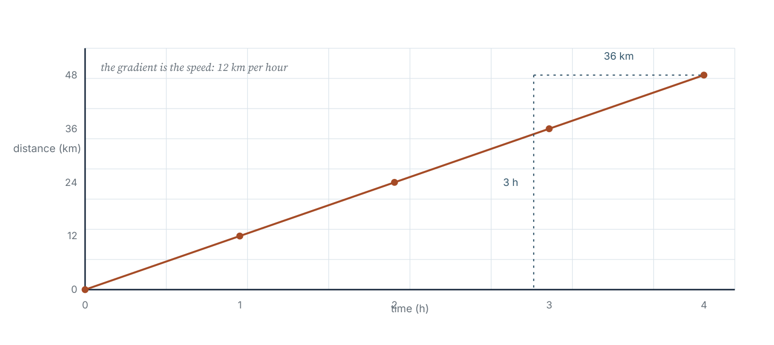
Distance against time at a steady 12 km/h. The gradient of the line is the speed, which is why the unit of a gradient is a rate.
A worked example in this section always states the formula, substitutes the values with their units, and then gives the answer. Writing the substitution is what makes the working checkable — by you, and by a reader.
Worked example 3.3.1 · Find the time
A car travels 210 km at an average speed of 84 km/h. How long does the journey take?
1 Write the formula: t = d ÷ s.
2 Substitute: t = 210 ÷ 84 = 2.5.
3 The unit follows from kilometres ÷ kilometres per hour, which is hours.
4 The journey takes 2.5 hours, or 2 hours 30 minutes.
ANSWER 2.5 hours (2 h 30 min)
Check: 84 × 2.5 = 210 km, as given.
Worked example 3.3.2 · Density
A metal block has mass 540 g and volume 60 cm³. Find its density in g/cm³, and its mass if it were cut to 25 cm³.
1 Density = mass ÷ volume = 540 ÷ 60 = 9.
2 The density is 9 g/cm³.
3 For 25 cm³: m = ρV = 9 × 25 = 225 g.
4 Check: the volume is just over 40 % of the original, and so is the mass.
ANSWER 9 g/cm³; 225 g
Density is a property of the material, so it is unchanged by cutting the block.
Worked example 3.3.3 · Two rates together
Tap A fills a tank in 6 minutes; tap B fills the same tank in 12 minutes. How long do they take together?
1 Convert each to a rate per minute: A fills 1/6 of the tank per minute, B fills 1/12.
2 Together they fill 1/6 + 1/12 = 3/12 = 1/4 of the tank per minute.
3 Time = 1 ÷ (1/4) = 4 minutes.
4 Check: in 4 minutes A fills 4/6 and B fills 4/12, and 4/6 + 4/12 = 1.
ANSWER 4 minutes
Never average the times. Rates add; times do not.
“One tap takes 6 minutes and the other 12, so together they take 9 minutes.” Averaging times assumes the taps take turns. They work at the same time, so the rates add: 1/4 of the tank per minute, giving 4 minutes.
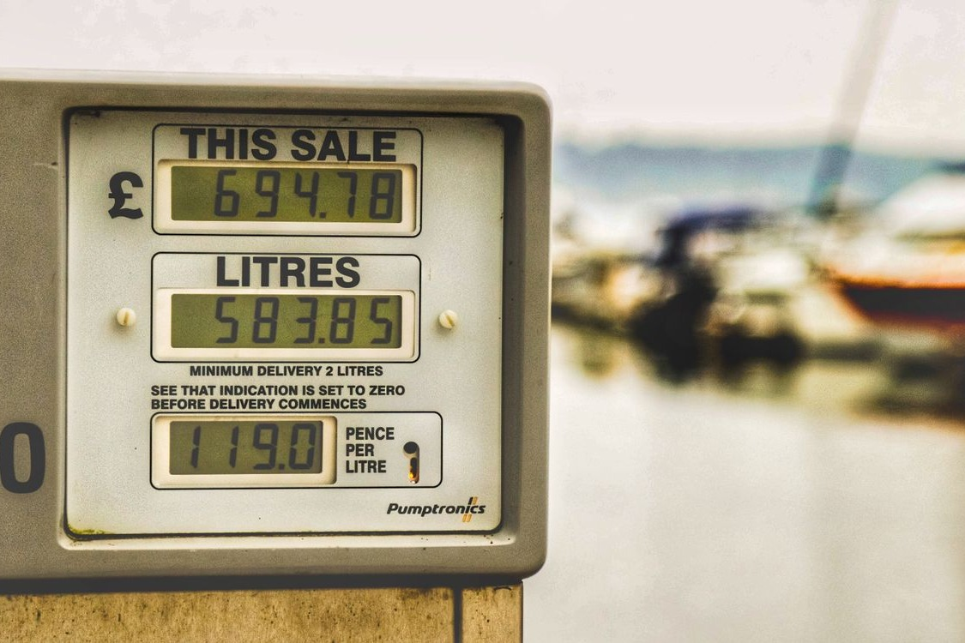
A fuel pump display showing litres delivered and price per litre. The compound units on the display are the rates this section formalises.
Photograph: Pexels, free licence (see the image register).
Practice 3.3
SUPPORT 1–5 · CORE 6–9 · EXTENSION 10–12
1. A car travels 330 km in 3 hours. Find the average speed. [F]
2. A cyclist rides at 18 km/h for 2.5 hours. How far? [F]
3. A train covers 405 km at 90 km/h. Find the journey time. [F]
4. A liquid has mass 246 g and volume 300 cm³. Find its density. [F]
5. A tap delivers 15 litres per minute. How long to fill a 240-litre tank? [F]
6. A walker covers 8 km in 1 hour 20 minutes. Find the speed in km/h. [P]
7. A steel block of density 7.8 g/cm³ has volume 150 cm³. Find its mass. [P]
8. Two pipes fill a tank in 10 and 15 minutes. How long together? [P]
9. A car travels 60 km at 80 km/h and then 90 km at 60 km/h. Find the total time and the average speed for the whole journey. [P]
10. A 1.2 kg block of material has density 2.4 g/cm³. Find its volume in cm³, then the side of the cube with that volume (to the nearest 0.1 cm). [E]
11. A tap fills a tank in 8 minutes and a drain empties it in 20 minutes. Both are open. How long to fill the tank? [E]
12. A runner's pace is 4 minutes 30 seconds per kilometre. Find the speed in km/h, to two decimal places. [E]
06 · INVESTIGATE AND APPLY
The unit price trap: when the cheaper rate is not cheaper.
The unit price trap (Investigation)
A school canteen buys juice in three formats. The manager wants the lowest cost per litre, but the kitchen also wastes what is not used within two days.
Format | Volume | Price | Used within two days
Carton | 200 ml | £0.42 | always
Bottle | 1 L | £1.85 | 90 %
Drum | 5 L | £8.20 | 55 %

- Find the cost per litre of each format.
- Rank the formats by cost per litre.
- Now compute the cost per litre actually used, allowing for waste.
- Does the ranking change? Explain why.
- The canteen serves 240 portions of 200 ml per day. How many litres does it need per day?
- Write a conjecture about when buying in bulk stops being better value.
- Recommend a purchasing rule to the manager, in three sentences, using your numbers.
The breakfast club contract (Criterion D)
A breakfast club serves 120 students. A supplier offers two contracts for milk.
Contract | Delivery | Price
P | 24 one-litre bottles each week | £14.40 per delivery
Q | One 30-litre drum each week | £16.50 per delivery

- Find the cost per litre under each contract.
- The club uses about 22 litres a week. Which contract leaves less waste?
- Calculate the weekly and annual cost of each contract, taking waste into account.
- One litre of milk serves 8 students. Verify that 22 litres is enough for 120 students with a sensible allowance for seconds.
- Write the ratio of milk to students as a unit rate.
- Recommend a contract and justify your choice with the calculations, naming one assumption you have made.
07 · REFLECT AND CONSOLIDATE
SECTION 3.5
3.5 Summary, revision and reflection
What this chapter established
- A rate compares quantities with different units and keeps its compound unit in the answer.
- A unit rate reduces a comparison to one unit, which is what makes comparison fair.
- Unit price is a rate, and the largest pack is not automatically the best value.
- Speed = distance ÷ time; density = mass ÷ volume; each rearranges to give the other quantities.
- Rates add when two agents work together; times do not.
- A unit-price comparison ignores waste, quality and storage, and should be reported as a comparison of one thing only.
Vocabulary to use precisely
rate · unit rate · unit price · speed · density · flow rate · compound unit · per · average speed · best buy
Misconceptions to close
The mistake | What is really happening
“A rate is just a number.” | 60 means nothing until it is 60 km/h. The unit is the meaning.
“The bigger number is the faster rate.” | Totals are not rates. 240 in 4 minutes is 60 per minute, which is slower than 150 in 2.5 minutes (also 60).
“Together, two taps take the average of their times.” | Rates add, not times: 1/6 + 1/12 = 1/4 per minute gives 4 minutes, not 9.
“Comparing prices means comparing prices.” | Compare prices per unit of the same quantity, in the same unit.

Revision questions
- Find the unit rate: 420 km in 3.5 hours.
- A 1.2 kg pack costs £4.32. Find the price per kilogram.
- A tap delivers 2.5 litres per minute. How long to fill 75 litres?
- A block of mass 810 g has volume 300 cm³. Find its density.
- Two printers print 60 pages in 4 minutes and 105 pages in 6 minutes. Which is faster, and by how much per minute?
Self-assessment
I can … | Not yet | Getting there | Confident
write and interpret a rate with a compound unit | □ | □ | □
find a unit rate and use it to solve a problem | □ | □ | □
compare products by unit price and say what the comparison ignores | □ | □ | □
use and rearrange the speed, density and flow relationships | □ | □ | □
solve a problem where two rates act together | □ | □ | □
convert a rate to a different but equivalent unit | □ | □ | □

Reflect on the criteria
Criterion A: which unit rate are you now able to find without thinking?
Criterion B: what pattern appeared when you compared pack sizes?
Criterion C: how did you make the unit of each answer unambiguous?
Criterion D: which real decision did a rate change for you?
ATL · Communication
In order for a student to defend a purchasing decision, students must present the unit prices, name the quantity being compared and state the assumption the comparison makes.
Mixed practice · consolidate and extend
Practice 3.M
MIXED 1–12
1. Find the unit rate: £13.50 for 6 kg. [F]
2. A car travels 276 km in 4 hours. Find its average speed. [F]
3. Convert 90 km/h to metres per second. [F]
4. Which is better value: 400 g for £2.20 or 700 g for £3.50? [F]
5. A tank holds 480 litres and is filled in 16 minutes. Find the flow rate. [F]
6. A liquid of density 1.2 g/cm³ fills a 250 cm³ container. Find the mass. [P]
7. A journey of 180 km takes 2 hours 15 minutes. Find the average speed. [P]
8. A student converts 72 km/h to m/s by dividing by 60. Identify the error and give the correct value. [R]
9. Three packs: 250 g £1.10, 500 g £2.00, 1 kg £3.90. Rank them by value. [P]
10. Two pumps deliver 40 litres in 5 minutes and 65 litres in 8 minutes. Together, how long for 810 litres? [E]
11. A car does 12.5 km per litre. Fuel costs £1.42 per litre. Find the fuel cost of a 400 km journey. [E]
12. A recipe scales from 4 to 10 people and the cooking time is unchanged. Explain, using rates, why the time cannot simply be scaled too. [E]

Answers · chapter 3
PRACTICE 3.1
1. (a) 90 km/h (b) £0.80 per kg (c) 80 words per minute.
2. (a) 3 litres per minute (b) 28 students per class (c) 75 g per portion.
3. 78 km/h.
4. 5 kg for £8.00 (£1.60 per kg against £1.70).
5. 5 minutes.
6. £2.40 per litre and £2.20 per litre; the larger bottle is better value.
7. 90 km/h.
8. The first (45 pages per minute against 40).
9. 150 g.
10. The reasoning is wrong: 4 kg for £10 is £2.50 per kg, and 3 kg for £7.20 is £2.40 per kg, so the smaller pack is better value.
11. 15.38 km per litre; 22.1 litres.
12. 7.2 minutes.
PRACTICE 3.2
1. (a) £0.45 per 100 g (b) £0.40 per 100 g.
2. 750 ml for £3.30 (£0.44 per 100 ml against £0.48).
3. £0.40 per pen.
4. 8.33 litres per 100 km.
5. The 5 kg pack at £2.50 per kg (1.5 kg £2.80; 3 kg £2.60).
6. £14.66 per 100 miles: 100 ÷ 45 = 2.22 gallons, 2.22 × 4.55 = 10.11 litres, 10.11 × £1.45 = £14.66.
7. The 450 ml at £0.71 per 100 ml (300 ml is £0.80).
8. £1.80 and £1.75 per GB; the larger bundle is cheaper per GB, but the comparison ignores coverage and whether 8 GB is needed.
9. £0.30 and £0.28 per egg; the 10-pack is better value.
10. £3.00 per kg and £3.00 per kg — equal (4 kg at £12 is £3.00 per kg; 700 g at £2.10 is £3.00 per kg), so the percentage saving is 0 %.
11. 16.7 %.
12. 20 %.
PRACTICE 3.3
1. 110 km/h.
2. 45 km.
3. 4.5 hours.
4. 0.82 g/cm³.
5. 16 minutes.
6. 6 km/h.
7. 1 170 g.
8. 6 minutes.
9. Total time 2.25 hours; average speed 66.7 km/h.
10. 500 cm³; side 7.9 cm.
11. 13.3 minutes.
12. 13.33 km/h.
PRACTICE 3.M
1. £2.25 per kg.
2. 69 km/h.
3. 25 m/s.
4. 700 g for £3.50 (£0.50 per 100 g against £0.55).
5. 30 litres per minute.
6. 300 g.
7. 80 km/h.
8. Dividing by 60 only converts hours to minutes. 72 km/h is 72 000 m ÷ 3 600 s = 20 m/s.
9. 1 kg at £3.90 (£0.39 per 100 g), then 500 g (£0.40), then 250 g (£0.44).
10. About 50 minutes: the rates are 8 and 8.125 litres per minute, so 810 ÷ 16.125 ≈ 50.2 minutes.
11. £45.44.
12. Browning and oven heat are not proportional to quantity; a larger quantity needs a longer time in the same oven, but the relationship is not a simple multiple.

PART II · ALGEBRA AND PATTERN
4 Integers and operations
Algebra and pattern · key concept Logic · Quantity, Change
Negative numbers extend the number line in both directions.
Their arithmetic is not a set of rules to memorise but a
consequence of one idea: every number has an opposite, and
opposites cancel.
Global context: Scientific and technical innovation
01 · MYP UNIT PLANNER
Signed numbers on the line, and the arithmetic that keeps the line consistent.
STATEMENT OF INQUIRY Extending the number line below zero forces a consistent arithmetic of signs, so that every calculation can be represented as movement along a line.
Key and related concepts
Key concept · Logic. The rules for signed arithmetic are not arbitrary: each follows from requiring that the number line and the laws of arithmetic keep working below zero.
Related · Quantity. A negative number records a quantity in the opposite direction: a debt, a fall, a depth.
Related · Change. Adding a negative number is a move left; subtracting a negative is a move right.
Global context · Scientific and technical innovation
Exploration: temperatures below freezing, depths below sea level and balances below zero. Instruments report signed quantities because the world has directions, not only sizes.
Inquiry questions
- Factual: How do you order and compare negative numbers?
- Conceptual: Why is subtracting a negative the same as adding a positive?
- Debatable: Does a negative number measure anything real, or is it only a bookkeeping device?
Criterion | Strands | Evidence in this chapter
A · Knowing and understanding | i, ii, iii | Order integers; add, subtract, multiply and divide signed numbers.
B · Investigating patterns | i, ii, iii | Investigate the pattern that forces (−) × (−) = +.
C · Communicating | ii, iii, iv | Use the number line and bracket notation to make the working readable.
D · Applying mathematics | i, ii, iv | Model a weather station's readings and justify a decision.

ATL · Thinking skills
In order for a student to explain a rule for signs, students must show the pattern that makes the rule necessary and give the counterexample that would follow if the rule were different.
02 · LEARNING INTENTIONS AND SUCCESS CRITERIA
You are learning to | You have succeeded when you can
Order integers and find absolute values. | Order −7, 4, −2, 0, −5 and state each distance from zero.
Add and subtract integers. | Compute −8 + 3, −5 − 7 and 4 − (−6) with a number line.
Multiply and divide integers. | Predict and check the sign of a product before computing it.
Apply the order of operations to signed expressions. | Evaluate −3² + 4 × (−2) correctly.
Use integers to model real situations. | Write a signed expression for a temperature change or an account balance.
Justify a rule for signs. | Explain, with a pattern, why a negative times a negative is positive.

Prerequisite check · 10 minutes, no calculator
- Calculate 7 + 8 and 15 − 9.
- Which is greater, −3 or −7?
- Calculate 6 × 7 and 42 ÷ 6.
- What is 3²?
- Evaluate 2 + 3 × 4.
- Write the next two terms of 10, 7, 4, …
If three or more answers are wrong, revisit the four operations and the order of operations before section 4.2.
SECTION 4.1
4.1 Integers, order and absolute value
Criterion A · I · Related concepts: Quantity, Number line
An integer is a whole number that may be positive, negative or zero. The number line shows all of them, equally spaced, with zero in the middle.
03 · ENGAGE
Two readings, one morning. Which is colder, and by how much?

A thermometer in snow. The scale continues below zero, which is exactly what the integers were invented to describe.
Photograph: Pexels, free licence (see the image register).
At 06:00 a mountain weather station records −9°C. At 14:00 it records −2°C. A student says the temperature has fallen because −9 is a bigger number than −2. Before reading on, sketch a number line, mark both readings, and write the size of the change with its direction.
04 · EXPLORE
Walking the line.
Copy a number line from −10 to 10 and mark these points: −7, −2, 0, 3, 8.
- Which two marked numbers are furthest apart? How did you find the distance?
- How far is each mark from zero? Record each distance without a sign.
- Start at −3 and move 5 places right. Where do you finish? Write the calculation.
- Start at 2 and move 6 places left. Where do you finish? Write the calculation.
- Compare −5 and −2. Which is less, and which is further from zero?
- Write a conjecture: how can a number line turn every addition into a movement, and every subtraction into a movement in the opposite direction?
05 · EXPLAIN
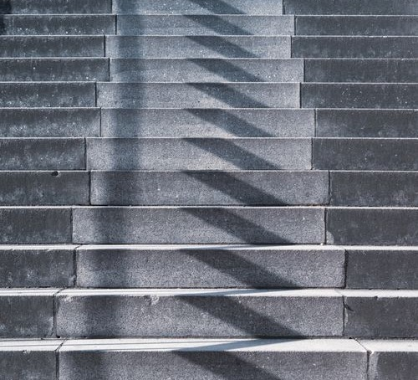
A flight of steps. Each step is the same height, so the treads give a natural number line: up is positive, down is negative.
Photograph: Pexels, free licence (see the image register).
An integer is a whole number that may be positive, negative or zero. The absolute value of an integer is its distance from zero, written with vertical bars: |−5| = 5 and |5| = 5. On the number line, larger means further right, so −2 > −5.
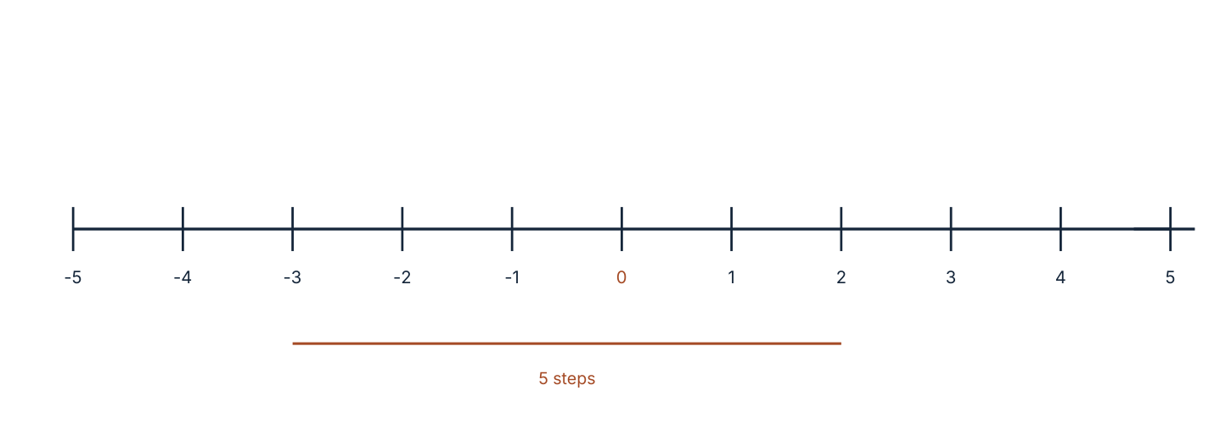
Integers ordered on the number line. The arrow shows the change from −3 to 2: five steps to the right, so the change is +5.
Adding a negative number moves left; subtracting a positive number also moves left. Subtracting a negative number moves right, because removing a debt increases what you have. The number line makes both statements visible, which is why it is worth drawing before computing.
|−a| = |a|: a number and its opposite are the same distance from zero. That is why cancelling one +1 with one −1 leaves nothing: the two distances are equal and opposite.
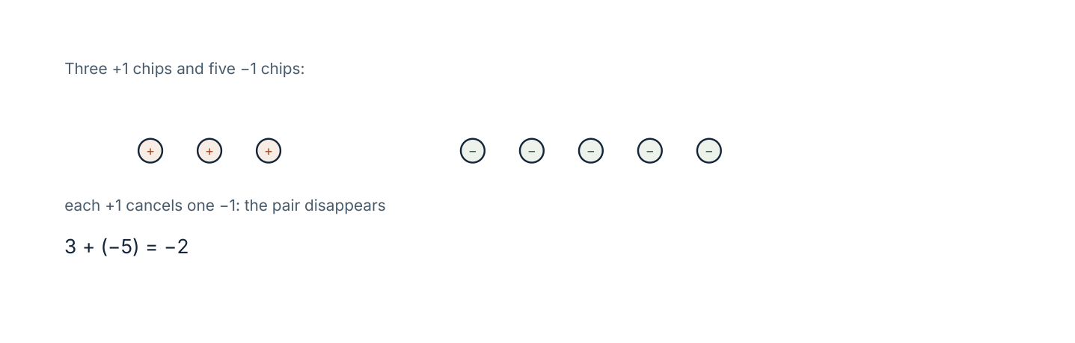
Three +1 chips and five −1 chips. Each opposite pair cancels, leaving two −1 chips: 3 + (−5) = −2.
Worked example 4.1.1 · Order and absolute value
Order −4, 3, −7, 0, −1 from least to greatest, then write the absolute value of each.
1 On the number line, further left is smaller: −7 < −4 < −1 < 0 < 3.
2 Take distances from zero: |−7| = 7, |−4| = 4, |−1| = 1, |0| = 0, |3| = 3.
3 Note that the order of the numbers and the order of their absolute values differ.
4 Report both orders, since the question asks for both.
ANSWER −7 < −4 < −1 < 0 < 3; absolute values 7, 4, 1, 0, 3
The smallest number has the largest absolute value — a useful check.
Worked example 4.1.2 · Two readings, one change
A temperature rises from −9°C to −2°C. What is the change?
1 Change = final − initial = −2 − (−9).
2 Subtracting −9 is the same as adding 9: −2 + 9 = 7.
3 The change is +7 degrees, that is, a rise of 7 degrees.
4 Check on the line: from −9, move right 7 places to −2.
ANSWER A rise of 7 degrees
A negative answer would have meant a fall; the sign carries the direction.
“−9 is bigger than −2, so the temperature rose by 11.” The sign of the answer comes from the calculation −2 − (−9) = +7, not from the sizes of the digits. Compare positions on the line, not digit values.
Practice 4.1
SUPPORT 1–5 · CORE 6–9 · EXTENSION 10–12
1. Write the integer that describes each: (a) a debt of £40 (b) 12 m below sea level (c) a gain of 6 points (d) 3°C below zero. [F]
2. Order from least to greatest: −6, 2, −9, 0, −1, 5. [F]
3. Find each absolute value: |−12|, |7|, |0|, |−3|. [F]
4. Write the integers between −4 and 1 inclusive. [F]
5. Calculate: (a) −5 + 8 (b) −6 − 4 (c) 3 − 9. [F]
6. The temperature falls from 4°C to −7°C. By how much does it fall? [P]
7. A submarine is at −35 m and rises 12 m. What is its new depth? [P]
8. Which is greater, −8 or −11? Which has the greater absolute value? Explain the difference in one sentence. [R]
9. Find two integers whose difference is −6 and whose sum is 4. [P]
10. A student says “−5 is further from zero than −2, so −5 is bigger”. Explain the error, using the number line. [E]
11. The temperature at midnight was −6°C. It rose 3°C by 06:00 and then fell 8°C by noon. Find the noon temperature. [E]
12. Find all integers x such that |x| = 7 and x < 0. [E]
SECTION 4.2
4.2 Adding and subtracting integers
Criterion A · II · Related concepts: Change, Number line
Every addition of a signed number can be read as a movement along the line, and every subtraction as a movement in the reverse direction.
Two equivalent readings
- Movement: −8 + 3 means start at −8 and move 3 right, finishing at −5.
- Cancelling: −8 + 3 combines eight −1 chips with three +1 chips; three pairs cancel, leaving five −1 chips.
Both readings give the same answer, and both are worth knowing. The movement reading is fast for small numbers; the cancelling reading explains why the answer has the sign it does.
Worked example 4.2.1 · Add and subtract
Calculate (a) −5 − 7, (b) 4 − (−6), (c) −3 + (−4) + 9.
1 (a) Subtracting 7 moves 7 left from −5: the result is −12.
2 (b) Subtracting −6 is the same as adding 6, so 4 + 6 = 10.
3 (c) Combine the negatives first: −3 + (−4) = −7, then −7 + 9 = 2.
4 Check (b) on the line: from 4, move 6 right, finishing at 10.
ANSWER (a) −12 (b) 10 (c) 2
For (c), the total leftward movement is 7 and the rightward movement is 9, so the net movement is 2 right.
Worked example 4.2.2 · A real balance
An account balance is −£120. A payment of £50 is made into it, then a bill of £80 is taken out. Find the balance and interpret it.
1 Start at −120.
2 Adding £50: −120 + 50 = −70.
3 Subtracting £80: −70 − 80 = −150.
4 The balance is −£150: the account is overdrawn by £150.
ANSWER −£150, an overdraft of £150
Check the net change: +50 − 80 = −30, and −120 − 30 = −150.
Worked example 4.2.3 · A distance between two points
The temperature at the summit is −8°C and at the base −3°C. How much colder is the summit?
1 Change = summit − base = −8 − (−3).
2 −8 + 3 = −5.
3 A change of −5 degrees means the summit is 5 degrees colder.
4 Check on the line: −8 is five places left of −3.
ANSWER 5 degrees colder
The sign gives the direction; the size gives the amount.
“4 − (−6) = −2, because the two minus signs cancel.” Cancelling does happen, but it produces addition: 4 − (−6) = 4 + 6 = 10. Two signs together are not a multiplication.
Practice 4.2
SUPPORT 1–5 · CORE 6–10 · EXTENSION 11–13
1. Calculate: (a) −6 + 9 (b) −8 − 3 (c) 5 − 12 (d) −4 + (−7). [F]
2. Calculate: (a) 7 − (−5) (b) −3 − (−9) (c) −9 + 9. [F]
3. Fill in the missing number: −7 + … = −2. [F]
4. A lift starts at floor −2, goes up 5 floors, then down 7. Which floor is it on? [F]
5. Calculate: (a) −5 + 3 − 4 (b) 6 − 9 + 2 (c) −2 − 6 − 1. [F]
6. The temperature rises from −11°C by 7°C. What is the new temperature? [P]
7. An account holds £240 and two payments of £165 and £190 are taken out. Find the balance and interpret it. [P]
8. Find the distance between −7 and 4 on the number line. [P]
9. A mountain is 3 200 m above sea level and a trench is 1 450 m below. Find the difference in height. [P]
10. Two numbers have a sum of −7 and a difference of 15. Find both. [R]
11. Explain, using the number line, why subtracting a negative number is the same as adding a positive one. [E]
12. The temperature fell by 5°C each night for four nights, starting at 2°C. Write and evaluate an expression for the final temperature. [E]
13. Find two integers, one positive and one negative, whose product is −36 and whose sum is 5. [E]
SECTION 4.3
4.3 Multiplying and dividing integers
Criterion A · III · B · III · Related concepts: Logic, Change
Multiplication of signs follows from one requirement: the number line and the laws of arithmetic must keep working when negative numbers are included.
Repeated addition
3 × (−4) means three lots of −4: −4 + (−4) + (−4) = −12. When the first factor is negative, the reading is less obvious, and the pattern below settles it.
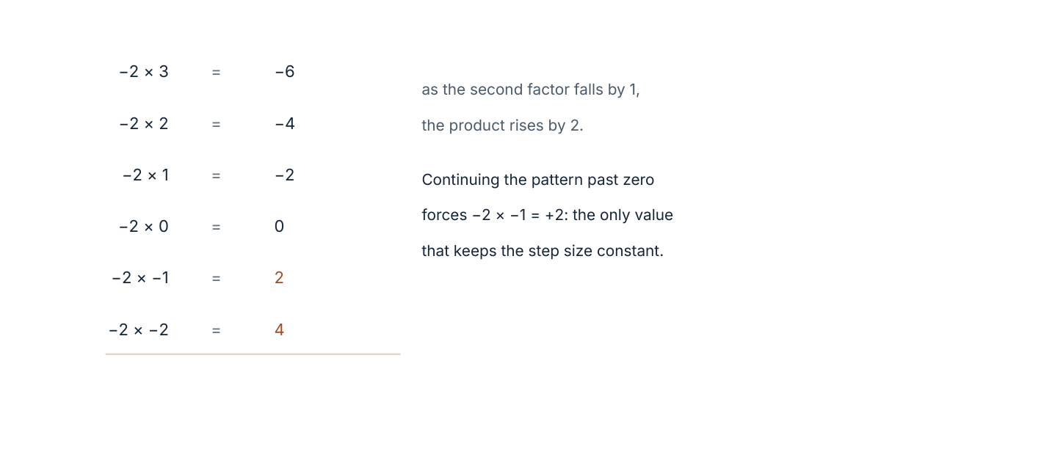
The product −2 × n as n falls by 1. Each step raises the product by 2, and continuing past zero forces −2 × (−1) = +2.
The four cases, in one line: (+) × (+) = +, (+) × (−) = −, (−) × (+) = −, (−) × (−) = +. Exactly two negatives give a positive; one negative gives a negative.
Worked example 4.3.1 · Compute with signs
Calculate (a) −6 × 4, (b) −6 × (−4), (c) −48 ÷ 8, (d) −48 ÷ (−6).
1 (a) One negative factor, so the product is negative: −24.
2 (b) Two negative factors, so the product is positive: 24.
3 (c) One negative term, so the quotient is negative: −6.
4 (d) Two negatives, so the quotient is positive: 8.
ANSWER (a) −24 (b) 24 (c) −6 (d) 8
Check (d) by multiplying back: 8 × (−6) = −48.
Worked example 4.3.2 · Order of operations with signs
Evaluate −3² + 4 × (−2) − (−5).
1 Indices first, and the minus sign is not part of the square: −3² = −9.
2 Multiplication next: 4 × (−2) = −8.
3 Now the expression reads −9 − 8 + 5.
4 Working left to right: −17 + 5 = −12.
ANSWER −12
Note that (−3)² = +9: the brackets matter, and so does the order.
Worked example 4.3.3 · Division as the inverse
Given that −7 × 9 = −63, write two division statements and explain the signs.
1 Divide the product by one factor: −63 ÷ 9 = −7.
2 Divide by the other factor: −63 ÷ (−7) = 9.
3 Each quotient has exactly one negative because each product has exactly one negative factor.
4 The two statements check each other: they reconstruct the original product.
ANSWER −63 ÷ 9 = −7 and −63 ÷ (−7) = 9
Division is multiplication read backwards, so the sign rules must agree.
Writing −3² = 9. Without brackets, the square applies only to 3, so −3² = −(3 × 3) = −9. With brackets, (−3)² = +9. Write the brackets whenever the sign is inside the power.
Practice 4.3
SUPPORT 1–5 · CORE 6–10 · EXTENSION 11–13
1. Calculate: (a) −5 × 6 (b) −5 × (−6) (c) 7 × (−3). [F]
2. Calculate: (a) −36 ÷ 4 (b) −36 ÷ (−4) (c) 36 ÷ (−9). [F]
3. State the sign of each product without computing: (a) −3 × 8 (b) −3 × (−8) (c) −3 × (−8) × (−2). [F]
4. Evaluate: (a) −4² (b) (−4)² (c) −2³. [F]
5. Evaluate: (a) 2 − 3 × (−4) (b) (−6 + 2) × −5. [F]
6. A submarine descends 15 m every minute for 6 minutes. Write and evaluate an expression for its total change in depth. [P]
7. The product of two integers is −48 and one of them is 6. Find the other. [P]
8. Find two integers whose product is −12 and whose sum is −1. [P]
9. Explain why (−2) × (−3) = 6, using the pattern of −2 × 3, −2 × 2, −2 × 1, −2 × 0. [R]
10. A student writes −3² = 9. Identify the error and give the correct value, with and without brackets. [R]
11. Evaluate −2 × (−3 + 7) − 4² ÷ (−2). [E]
12. The product of three integers is negative. What do you know about the signs of the integers? Give two different possibilities. [E]
13. Find all pairs of integers whose product is −36 and whose sum is positive. [E]
A mountain weather station (Criterion D)
A weather station records temperatures every six hours for two days. The records are: −6, −2, 3, −1, −4, −7, 0, 2, all in degrees Celsius.
- Find the highest and lowest readings and the range.
- Find the change between each consecutive pair of readings.
- Which change is the largest fall, and which is the largest rise?
- Find the mean of the eight readings.
- The station's sensor is accurate to ±1°C. State the mean to an appropriate accuracy, and justify your rounding.
- On the third day the temperature falls by 3°C every six hours from a start of 4°C. Write an expression for the reading after four intervals and evaluate it.
- Write two sentences a walker would find useful, based on these figures.
06 · INVESTIGATE AND APPLY
Why is a negative times a negative positive?
Why is negative times negative positive? (Investigation)
The rule (−) × (−) = + is often given as something to memorise. This investigation derives it, and tests what would happen if it were different.
- Complete the table of −3 × n for n = 4, 3, 2, 1, 0, −1, −2. What happens to the product each time n falls by 1?
- Continue the pattern for another three rows. Does the pattern force a particular value at each step?
- Now suppose (−3) × (−1) were −3 instead of +3. Complete the table again with that assumption and describe what happens to the step size.
- Test the same reasoning starting from −5 × n. Does the conclusion depend on the choice of −3 or −5?
- Use a different argument: the distributive law gives (−2) × (3 + (−3)) = 0. Expand and see what value (−2) × (−3) must have.
- Write your generalisation in one sentence, and name the two principles it relies on.
- Find one place in real life where a negative times negative naturally appears, and explain it.
07 · REFLECT AND CONSOLIDATE
SECTION 4.6
4.6 Summary, revision and reflection
What this chapter established
- Integers continue the number line below zero; larger means further right, not further from zero.
- The absolute value is the distance from zero, and it is never negative.
- Adding a negative moves left; subtracting a negative moves right.
- The sign of a product or quotient depends only on the number of negative factors: an even count gives positive, an odd count gives negative.
- The order of operations applies to signed numbers, and brackets around a sign change the meaning of a power.
- Signed numbers model debt, depth, temperature and any quantity with a direction.
Vocabulary to use precisely
integer · negative number · opposite · absolute value · number line · sign · order of operations · index (power) · inverse operation
Misconceptions to close
The mistake | What is really happening
“−9 is larger than −2 because 9 > 2.” | −9 is further left, so it is smaller. The digits describe the distance, the sign describes the direction.
“Two minus signs always cancel by disappearing.” | They combine into a plus: 4 − (−6) = 4 + 6 = 10.
“−3² = 9.” | Without brackets the square applies to 3 only: −3² = −9, while (−3)² = 9.
“A negative answer means the calculation is wrong.” | A negative answer means a direction or a deficit; it can be entirely correct.

Revision questions
- Order from least to greatest: −3, 7, −10, 0, −1.
- Calculate −12 + 5 − (−3).
- Calculate −6 × (−5) ÷ (−2).
- Evaluate −2² + (−3)².
- The temperature is −4°C and falls 7°C. Find the new temperature, and state the absolute value of the change.
Self-assessment
I can … | Not yet | Getting there | Confident
order integers and find absolute values | □ | □ | □
add and subtract integers without a calculator | □ | □ | □
predict the sign of a product or quotient | □ | □ | □
apply the order of operations to signed expressions | □ | □ | □
model a real situation with a signed expression | □ | □ | □
explain why a negative times a negative is positive | □ | □ | □

Reflect on the criteria
Criterion A: which signed calculation are you now able to do mentally?
Criterion B: what pattern convinced you of the sign rules?
Criterion C: where did the number line make your reasoning clearer?
Criterion D: which real quantity would be misreported without a sign?
ATL · Critical thinking
In order for a student to explain a rule that others memorise, students must produce the pattern that makes the rule necessary and describe what would fail without it.
Mixed practice · consolidate and extend
Practice 4.M
MIXED 1–12
1. Calculate: (a) −9 + 4 (b) −9 − 4 (c) 9 − 14. [F]
2. Calculate: (a) −7 × 8 (b) −72 ÷ (−9). [F]
3. Order: −5, 0, 3, −8, 1. [F]
4. Evaluate: −5 + 2 × (−3). [F]
5. The temperature falls from 3°C to −8°C. Find the change. [F]
6. A diver descends in 4 stages of 12 m each. Write and evaluate an expression for the total descent. [P]
7. Find the mean of −4, 2, −7, 5. [P]
8. Explain why the product of two negatives must be positive, using one example and one pattern. [R]
9. Evaluate (−3)² − 4 × (−2) + 1. [F]
10. The sum of two integers is −5 and their product is 6. Find them. [E]
11. A shop's balance is −£240. Three payments of £95 each are received. Find the new balance. [E]
12. Find all integer values of n such that −3 < n ≤ 2, and state the sum of their absolute values. [E]

Answers · chapter 4
PRACTICE 4.1
1. (a) −40 (b) −12 (c) +6 (d) −3.
2. −9 < −6 < −1 < 0 < 2 < 5.
3. 12, 7, 0, 3.
4. −4, −3, −2, −1, 0, 1.
5. (a) 3 (b) −10 (c) −6.
6. 11 degrees.
7. −23 m.
8. −8 is greater; −11 has the greater absolute value. On the line, −8 lies to the right of −11, while −11 is further from zero.
9. −1 and 5.
10. −5 is further from zero but lies to the left of −2, so it is smaller.
11. −11°C.
12. x = −7.
PRACTICE 4.2
1. (a) 3 (b) −11 (c) −7 (d) −11.
2. (a) 12 (b) 6 (c) 0.
3. 5.
4. Floor −4.
5. (a) −6 (b) −1 (c) −9.
6. −4°C.
7. −£115, an overdraft of £115.
8. 11.
9. 4 650 m.
10. −11 and 4.
11. Subtracting a number means moving left by that many places; subtracting a negative number means moving left by a negative amount, which is moving right — the same as adding the positive number.
12. 2 + 4 × (−5) = −18°C.
13. −4 and 9.
PRACTICE 4.3
1. (a) −30 (b) 30 (c) −21.
2. (a) −9 (b) 9 (c) −4.
3. (a) negative (b) positive (c) negative.
4. (a) −16 (b) 16 (c) −8.
5. (a) 14 (b) 20.
6. −15 × 6 = −90 m.
7. −8.
8. −4 and 3.
9. Each time the second factor falls by 1 the product rises by 2, so after 0 the next products must be +2 and +4; any other choice would break the constant step of the pattern.
10. The square applies to the 3 only, so −3² = −9; with brackets, (−3)² = +9.
11. 0.
12. One negative and two positives, or all three negative.
13. (−4, 9), (−3, 12), (−2, 18), (−1, 36) with positive sums: 5, 9, 16, 35.
PRACTICE 4.M
1. (a) −5 (b) −13 (c) −5.
2. (a) −56 (b) 8.
3. −8 < −5 < 0 < 1 < 3.
4. −11.
5. −11 degrees.
6. 4 × (−12) = −48 m.
7. −1.
8. Every time the second factor falls by 1 the product rises by 2, so continuing past zero forces a positive result; without that the distributive law fails, since (−2)×(3+(−3)) = 0 needs (−2)×(−3) = +6.
9. 18.
10. −2 and −3.
11. £45.
12. −2, −1, 0, 1, 2; sum of absolute values 6.

PART II · ALGEBRA AND PATTERN
5 Algebraic expressions and equations
Algebra and pattern · key concept Relationships · Equivalence, Simplification
A letter is a number you have not chosen yet. An expression
describes what would happen to it; an equation is a
question written as a balance, and solving it is a search
for the one number that keeps the balance level.
Global context: Identities and relationships
01 · MYP UNIT PLANNER
Notation, equivalence and the balance method: the grammar of algebra.
STATEMENT OF INQUIRY Algebraic notation compresses a relationship into symbols, and the balance of an equation makes the unknown recoverable by inverse operations.
Key and related concepts
Key concept · Relationships. An expression describes how an output depends on an input; an equation states that two such descriptions are equal.
Related · Equivalence. Two expressions are equivalent when they give the same value for every substitution, which is why simplifying is allowed.
Related · Simplification. Collecting like terms and expanding brackets change the form of an expression without changing its values.
Global context · Identities and relationships
Exploration: how a formula relates quantities that vary independently, and how an unknown quantity can be described precisely before it is found. Every spreadsheet, price list and plan uses this idea.
Inquiry questions
- Factual: What is the difference between a term, an expression and an equation?
- Conceptual: Why can an expression be simplified without changing its value?
- Debatable: Is algebra a language for describing, or a machine for solving?
Criterion | Strands | Evidence in this chapter
A · Knowing and understanding | i, ii, iii | Use notation; substitute; simplify; solve linear equations.
B · Investigating patterns | i, ii, iii | Investigate number tricks and prove why they always give the same result.
C · Communicating | i, ii, iii, iv | Write and read algebraic notation; explain each solving step.
D · Applying mathematics | i, ii, iii, iv, v | Choose between two pricing plans, with an equation as the evidence.

ATL · Thinking skills
In order for a student to justify a solving step, students must name the inverse operation used and show that the same operation was applied to both sides.
02 · LEARNING INTENTIONS AND SUCCESS CRITERIA
You are learning to | You have succeeded when you can
Use algebraic notation correctly. | Write “five more than three times a number” as 3n + 5 and say what each part means.
Substitute values into expressions, including negative values. | Evaluate 4x − 3 when x = −2 without a sign error.
Simplify expressions by collecting like terms and multiplying out brackets. | Simplify 5a + 3 − 2a + 7 and 3(2x − 4).
Solve one- and two-step linear equations. | Solve 4x − 7 = 21 and check the answer by substitution.
Solve equations with brackets and with the unknown on both sides. | Solve 3(x + 2) = 5x − 4 and explain each step.
Form an equation from a real situation and interpret the solution. | Write and solve an equation for two pricing plans, and say what the solution means.

Prerequisite check · 10 minutes, no calculator
- Calculate 7 × 8 − 9.
- Calculate −3 + 11.
- Evaluate 2n + 1 when n = 4.
- Simplify 3 + 3 + 3 + 3.
- Solve x + 7 = 12.
- Simplify 2 × 5a.
If three or more answers are wrong, revisit signed arithmetic in chapter 4 before continuing.
SECTION 5.1
5.1 The language of algebra
Criterion A · I · C · I · Related concepts: Relationships, Notation
Algebra is compressed reasoning. A letter stands for a number, and everything written around it is a statement about what would happen to that number.
03 · ENGAGE
The number trick that always ends in three.
Think of a number. Add 5. Double it. Subtract 4. Halve it. Subtract your original number. Your answer is 3 — every time, for every starting number. Before reading on, try it with three different starting numbers, including a negative one, and write down what you notice.
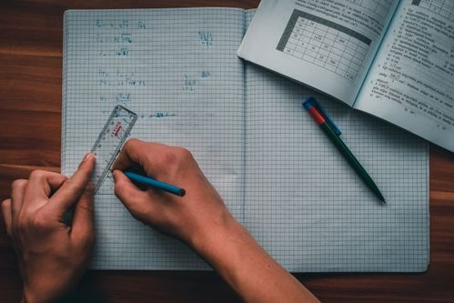
Working with symbols. The point of notation is not brevity for its own sake: it is that every step can be checked without re-reading the words.
Photograph: Pexels, free licence (see the image register).
04 · EXPLORE
Track the same number through the machine.
Let the starting number be n, and record the expression after each step.
Step | Instruction | What you have
1 | Think of a number | n
2 | Add 5 | n + 5
3 | Double it | 2(n + 5) = 2n + 10
4 | Subtract 4 | 2n + 6
5 | Halve it | n + 3
6 | Subtract your number | 3

- Why does the final answer not contain n?
- Try the same trick with the final instruction changed to “subtract twice your number”. What is the result now, and why?
- Test your prediction with n = 4 and n = −3.
- Invent a trick of your own that always ends in 5, and write the expression at each step.
- Write a conjecture: what makes a number trick end in a constant?
- Exchange tricks with a partner and prove each other's.
05 · EXPLAIN
A variable is a letter standing for a number that may change. A term is a single number, letter or product of them; an expression combines terms with operations and has no equals sign; an equation states that two expressions are equal. Like terms have exactly the same letters with the same indices.
Notation is conventional and worth learning exactly: 3n means 3 × n; n/5 means n ÷ 5; n² means n × n. Writing 3n and never 3 × n is not laziness — it keeps the coefficient visually separate from the variable, which makes collecting terms possible.
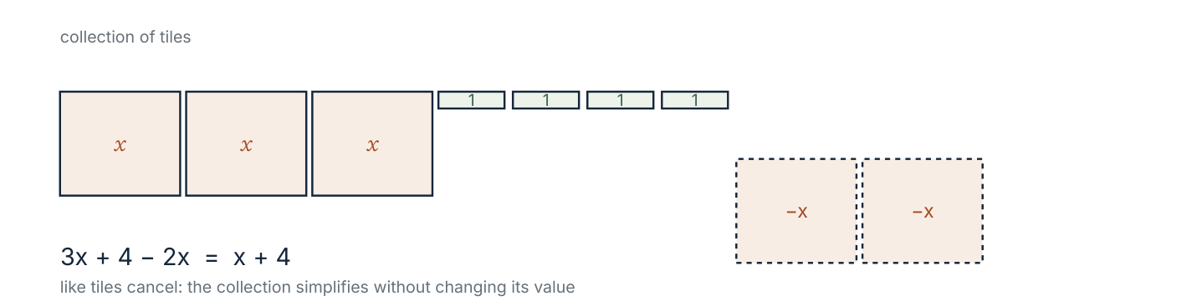
Algebra tiles for 3x + 4 − 2x. Like tiles cancel in pairs, which is what collecting terms does symbolically.
Substitution
Substituting means replacing each letter with a number, in brackets if the number is negative, and then evaluating by the order of operations.
Worked example 5.1.1 · Substitute a negative value
Evaluate 4x − 3 when x = −2, and when x = 1.5.
1 Write the substitution with brackets: 4(−2) − 3.
2 Multiply first: −8 − 3 = −11.
3 For x = 1.5: 4(1.5) − 3 = 6 − 3 = 3.
4 Check the second by another route: 4 × 1.5 = 6, and 6 − 3 = 3.
ANSWER −11 and 3
The brackets are not optional: 4 × −2 − 3 invites a sign error, while 4(−2) − 3 does not.
Worked example 5.1.2 · Write an expression
A taxi charges £4 plus £2 per kilometre. Write an expression for the cost of k kilometres, and find the cost of 7 km.
1 The distance part costs 2k pounds.
2 The fixed charge is added: 2k + 4.
3 For k = 7: 2(7) + 4 = 18.
4 The cost is £18.
ANSWER 2k + 4; £18 for 7 km
Check a simple case: 1 km should cost £2 + £4 = £6, and 2(1) + 4 = 6.
Worked example 5.1.3 · Interpret an expression
An expression for the total cost of a school trip is 12n + 45. Explain what each part means and find the cost when n = 30.
1 12n is a cost per student, so 12 is the cost in pounds for each of n students.
2 45 is a fixed cost that does not depend on the number of students: a minibus hire, for example.
3 For n = 30: 12(30) + 45 = 360 + 45 = 405.
4 The total cost is £405.
ANSWER £12 per student plus a fixed £45; £405 for 30 students
If n = 0 the cost is £45, confirming the fixed part.
“3n means 3 followed by n, that is, 3n = 30 when n = 0.” Juxtaposition means multiplication: 3n = 3 × n, which is 0 when n = 0. The coefficient is a multiplier, never a digit.
Practice 5.1
SUPPORT 1–5 · CORE 6–9 · EXTENSION 10–12
1. Write using algebra: (a) 7 more than a number n (b) three times a number m (c) a number t divided by 4. [F]
2. Evaluate 5x + 2 when (a) x = 3 (b) x = −4 (c) x = 0. [F]
3. Evaluate 3y² when (a) y = 2 (b) y = −3. [F]
4. Identify the terms and the like terms in 4a + 3b − 2a + 5. [F]
5. Simplify: (a) 6m + 2m (b) 5p − 8p (c) 3 + 4x + 5. [F]
6. A phone contract costs £8 plus £0.15 per minute. Write an expression for m minutes and find the cost of 40 minutes. [P]
7. A rectangle has length x + 3 and width x. Write an expression for its perimeter. [P]
8. Explain why 2n + 3 and 3 + 2n are always equal, using one numerical example and one sentence about the operations. [R]
9. The expression 5n + 20 gives the total cost in pounds of n tickets plus a booking fee. Find the cost of 6 tickets and describe the booking fee. [P]
10. A student says “4x means 40 when x = 10, because 4 and the 0 make 40”. Explain the error. [E]
11. Write an expression for the sum of three consecutive integers, the smallest being n. Simplify it. [E]
12. The cost of hiring a hall is £60 plus £5 per person. Write an expression for p people and find the number of people when the cost is £210. [E]
SECTION 5.2
5.2 Equivalent expressions
Criterion A · II · C · II · Related concepts: Equivalence, Simplification
Two expressions are equivalent when they give the same value for every value of the variable. Simplifying is the art of finding a shorter form that keeps every value.
Expressions are equivalent when substituting any number for the variable gives the same result in both. Collecting like terms and expanding brackets both produce equivalent expressions, because they follow from the distributive and commutative laws.
Two operations that preserve value
- Collecting like terms. 5a + 3b − 2a simplifies to 3a + 3b: the a-terms are combined and the b-term is untouched.
- Expanding brackets. 3(2x − 4) becomes 6x − 12: every term inside is multiplied by the factor outside.
Testing equivalence
To show two expressions are equivalent, simplify both and compare, or substitute two different values and check both give the same result. To show they are not, one counterexample is enough — and it is also complete.
Worked example 5.2.1 · Simplify by collecting
Simplify 7x + 4 − 3x + 9 − x.
1 Collect the x-terms: 7x − 3x − x = 3x.
2 Collect the numbers: 4 + 9 = 13.
3 The simplified expression is 3x + 13.
4 Check with x = 2: original 14 + 4 − 6 + 9 − 2 = 19; simplified 3(2) + 13 = 19.
ANSWER 3x + 13
A single substitution catches most collecting errors, which is why it is worth doing.
Worked example 5.2.2 · Expand and simplify
Simplify 4(2x + 3) − 2(x − 5).
1 Expand the first bracket: 4(2x + 3) = 8x + 12.
2 Expand the second, keeping the minus sign with every term: −2(x − 5) = −2x + 10.
3 Collect: 8x − 2x + 12 + 10 = 6x + 22.
4 Check with x = 1: original 4(5) − 2(−4) = 20 + 8 = 28; simplified 6 + 22 = 28.
ANSWER 6x + 22
The common error is writing −2(x − 5) = −2x − 10. Both terms inside change sign.
Worked example 5.2.3 · Are they equivalent?
Are 3(x + 2) and 3x + 2 equivalent? Are 2(x + 3) and 2x + 6?
1 Expand 3(x + 2) = 3x + 6, which differs from 3x + 2.
2 Test x = 1: 3(3) = 9 but 3 + 2 = 5. One counterexample proves they are not equivalent.
3 Expand 2(x + 3) = 2x + 6, which is identical to the second expression.
4 Both are correct statements, but only the second pair is equivalent.
ANSWER 3(x + 2) ≡ 3x + 6, so the first pair is not equivalent; the second pair is.
Expanding is the test; a counterexample settles a negative answer.
“3(x + 2) = 3x + 2, because the 3 only multiplies the first term.” The factor outside a bracket multiplies every term inside: 3(x + 2) = 3x + 6. Substituting x = 1 exposes the error immediately.
Practice 5.2
SUPPORT 1–5 · CORE 6–9 · EXTENSION 10–12
1. Simplify: (a) 8y + 3y (b) 9m − 12m (c) 4 + 6t − 4. [F]
2. Simplify: (a) 3x + 5 + 2x + 7 (b) 6a − 2a + 4 − 9. [F]
3. Expand: (a) 5(x + 2) (b) 3(2y − 4) (c) 6(3 − m). [F]
4. Simplify 2(x + 5) + 3(x − 1). [F]
5. Are 4(x + 1) and 4x + 4 equivalent? Justify. [F]
6. Simplify 5(2a − 3) − 2(a − 4). [P]
7. Write two different expressions equivalent to 6x + 9. [P]
8. A student simplifies 3(x + 4) to 3x + 4. Substitute x = 2 into both to show the error. [R]
9. The perimeter of a rectangle is 2(l + w). Expand it and explain what each part counts. [P]
10. Simplify 4(2x + 1) − 3(x − 2) + x. [E]
11. Show that 2(n + 3) − 2n always equals 6, whatever the value of n. [E]
12. Find a value of x for which 5(x + 2) and 5x + 2 give different results. Can the two expressions ever be equal? Explain. [E]

Solving by hand. Writing each step on its own line is not fussiness: it is what makes an error findable.
Photograph: Pexels, free licence (see the image register).
SECTION 5.3
5.3 Solving linear equations
Criterion A · III · C · III · Related concepts: Equivalence, Balance
An equation is a balance. Whatever you do to one side, you must do to the other, until the unknown stands alone.
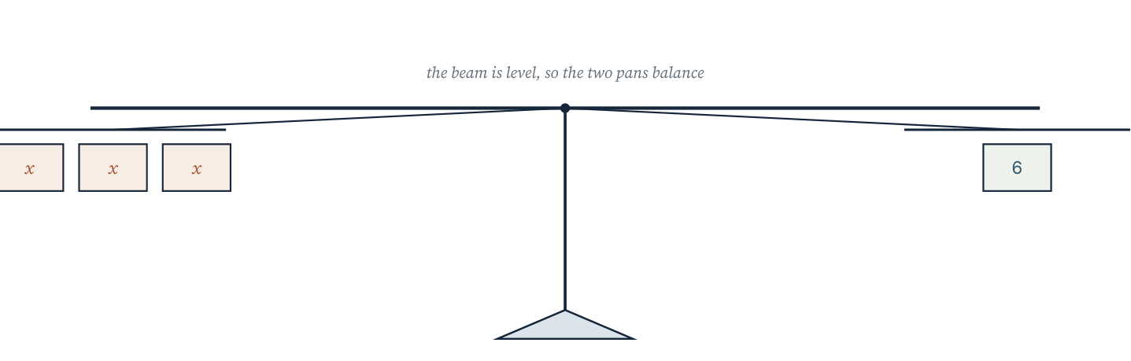
A balance with three x-tiles on one side and six unit tiles on the other. Removing the same quantity from both sides keeps it level.
The balance method
- Simplify each side if necessary, expanding any brackets.
- Undo addition or subtraction first, using the inverse operation on both sides.
- Undo multiplication or division last.
- Check by substituting the solution into the original equation.
The order matters. Undoing the operations in reverse order of their application is exactly what keeps the working readable: if the unknown was multiplied and then added to, we subtract first, then divide.
Worked example 5.3.1 · Two steps
Solve 4x − 7 = 21.
1 Add 7 to both sides: 4x = 28.
2 Divide both sides by 4: x = 7.
3 Check: 4(7) − 7 = 28 − 7 = 21, as required.
4 Report the solution as x = 7.
ANSWER x = 7
Substitution is not optional: it is the only evidence that the solution is right.
Worked example 5.3.2 · Unknown on both sides
Solve 3(x + 2) = 5x − 4.
1 Expand the left side: 3x + 6 = 5x − 4.
2 Collect the unknown on one side: subtract 3x from both sides, giving 6 = 2x − 4.
3 Add 4 to both sides: 10 = 2x, so x = 5.
4 Check in the original: 3(5 + 2) = 21 and 5(5) − 4 = 21. Both agree.
ANSWER x = 5
Collecting the unknown on the side that keeps it positive avoids sign slips.
Worked example 5.3.3 · A fractional solution
Solve x/3 + 4 = 10.
1 Subtract 4 from both sides: x/3 = 6.
2 Multiply both sides by 3: x = 18.
3 Check: 18/3 + 4 = 6 + 4 = 10, as required.
4 The solution is a whole number here, but it need not be in general.
ANSWER x = 18
Multiplying by the denominator is the inverse of dividing by it.
“4x − 7 = 21, so 4x = 21 − 7 = 14, so x = 3.5.” The 7 was subtracted although it was already being subtracted. Undo −7 by adding 7: 4x = 28, so x = 7. Check by substitution to settle any doubt.
Practice 5.3
SUPPORT 1–5 · CORE 6–10 · EXTENSION 11–13
1. Solve: (a) x + 9 = 15 (b) x − 4 = 11 (c) 3x = 27. [F]
2. Solve: (a) 2x + 5 = 17 (b) 5x − 3 = 32 (c) 4x + 9 = 1. [F]
3. Solve: (a) x/2 + 3 = 8 (b) x/5 − 1 = 4. [F]
4. Solve 6x + 4 = 3x + 19. [F]
5. Solve 2(x + 3) = 16. [F]
6. Solve 5(x − 2) = 3x + 4. [P]
7. Solve 4(2x + 1) = 3(x + 8). [P]
8. The perimeter of a rectangle is 46 cm. Its length is 3 cm more than its width. Write an equation and solve it. [P]
9. Two plans: Plan A costs £20 plus £6 per hour; Plan B costs £35 plus £3 per hour. Write an equation for equal cost and solve it. [P]
10. A student solves 3x + 4 = 19 by writing 3x = 19 + 4 = 23. Identify the error and give the correct solution. [R]
11. Solve 3(x − 4) = 2(x + 1) and check your answer. [E]
12. The sum of three consecutive odd numbers is 87. Form an equation and solve it. [E]
13. Solve 5 − 2x = 17 and explain why the answer is negative. [E]
Choosing a repair plan (Criterion D)
A workshop offers two repair plans for a machine. Plan A charges a call-out of £45 and £2 for each kilometre travelled. Plan B charges no call-out but £ per kilometre, given by the expression 6k.
- Write an expression for the cost of Plan A for k kilometres.
- For what distance do the two plans cost the same? Form an equation and solve it.
- For a job 15 km away, which plan is cheaper, and by how much?
- For a job 4 km away, which plan is cheaper?
- Sketch both cost lines on one set of axes and mark the point where they cross.
- Write one sentence of advice to a customer, using the numbers.
- Name one factor this comparison ignores.
06 · INVESTIGATE AND APPLY
The number trick, proved.
The number trick (Investigation)
A trick that always gives 3 is convincing once, but a proof is what makes it certain. This investigation turns the trick into algebra.
- Perform the trick with n = 2, n = 7 and n = −4. Record each intermediate value.
- Now write the expression after each step, starting from n: add 5, double, subtract 4, halve, subtract n.
- Simplify your final expression. Why does n disappear?
- Change one instruction and predict the new result: for example, double before adding 5.
- Test your prediction with two different starting numbers.
- Design a trick that ends in 7, and give its algebraic proof.
- Write a generalisation: what must be true of the instructions for the trick to end in a constant?
- Explain why a trick that ends in n + 3 cannot be used as a guessing trick.
07 · REFLECT AND CONSOLIDATE
SECTION 5.6
5.6 Summary, revision and reflection
What this chapter established
- A variable is a number not yet chosen; an expression describes what would happen to it; an equation states an equality to be solved.
- Like terms have identical letters and indices, and only like terms can be collected.
- A factor outside a bracket multiplies every term inside it.
- Equivalent expressions agree for every substitution; one counterexample proves two expressions are not equivalent.
- Solving is undoing: apply inverse operations to both sides, in reverse order of application.
- Every solution should be checked by substitution.
Vocabulary to use precisely
variable · term · coefficient · expression · equation · like terms · simplify · expand · equivalent · substitute · solve · inverse operation
Misconceptions to close
The mistake | What is really happening
“3(x + 2) = 3x + 2.” | The 3 multiplies both terms: 3x + 6. Substituting x = 1 shows it.
“−2(x − 5) = −2x − 10.” | Both terms change sign: −2x + 10.
“4x − 7 = 21 gives 4x = 14.” | The 7 is subtracted, so it must be added back: 4x = 28.
“2x and 2x² are like terms.” | The indices differ, so they cannot be collected: 2x + 2x² stays as it is.

Revision questions
- Simplify 6a + 5 − 2a + 3.
- Expand and simplify 3(2x − 1) + 2(x + 4).
- Solve 7x − 5 = 30.
- Solve 2(x + 4) = 5x − 1.
- A hire firm charges £25 plus £8 per hour. Write an expression for h hours and find the cost of 6 hours.
Self-assessment
I can … | Not yet | Getting there | Confident
write an expression from a description | □ | □ | □
substitute, including negative values | □ | □ | □
collect like terms and expand brackets | □ | □ | □
solve a two-step equation and check it | □ | □ | □
solve an equation with brackets or an unknown on both sides | □ | □ | □
form an equation from a real situation | □ | □ | □

Reflect on the criteria
Criterion A: which equation type can you now solve without writing every step?
Criterion B: what did the number trick show about why algebra is more than arithmetic?
Criterion C: how did you show that each step kept the balance?
Criterion D: which equation came from a real decision you might face?
ATL · Thinking skills
In order for a student to solve an unfamiliar equation, students must identify which operations were applied to the unknown, and undo them in reverse order.
Mixed practice · consolidate and extend
Practice 5.M
MIXED 1–12
1. Simplify 9x − 4 + 3x − 6. [F]
2. Expand 4(3m − 2). [F]
3. Evaluate 3a + 5 when a = −3. [F]
4. Solve 8x + 3 = 35. [F]
5. Solve 5(x − 2) = 20. [F]
6. Simplify 2(3x + 1) − 4(x − 3). [P]
7. Solve 4x + 7 = 2x + 19. [P]
8. A student writes 5x + 3 = 28, so 5x = 31. Identify the error and solve correctly. [R]
9. Write an expression for the area of a rectangle with length 2x + 5 and width 3. [P]
10. Two brothers' ages add to 27. One is twice the other minus 3. Form an equation and solve it. [E]
11. Show that 3(2n + 1) − 2(3n − 1) always equals 5. [E]
12. Solve 6 − 3x = 21 and explain the sign of the answer. [E]

Answers · chapter 5
PRACTICE 5.1
1. (a) n + 7 (b) 3m (c) t/4.
2. (a) 17 (b) −18 (c) 2.
3. (a) 12 (b) 27.
4. Terms: 4a, 3b, −2a, 5; like terms 4a and −2a.
5. (a) 8m (b) −3p (c) 4x + 8.
6. 0.15m + 8; £14.
7. 4x + 6.
8. Both equal 7 when n = 2; addition is commutative, so the order of the two terms does not change the total.
9. £50; the booking fee is £20.
10. Juxtaposition means multiplication: 4x with x = 10 is 40 only by coincidence, since 4 × 10 = 40. With x = 5 the expression is 20, not 45.
11. n + (n + 1) + (n + 2) = 3n + 3.
12. 5p + 60; 30 people.
PRACTICE 5.2
1. (a) 11y (b) −3m (c) 6t.
2. (a) 5x + 12 (b) 4a − 5.
3. (a) 5x + 10 (b) 6y − 12 (c) 18 − 6m.
4. 5x + 7.
5. Yes: 4x + 4 in both cases.
6. 8a − 7.
7. 3(2x + 3) and 6(x + 1.5).
8. 3(2 + 4) = 18 but 3(2) + 4 = 10, so the expansion is wrong.
9. 2l + 2w: two lengths and two widths.
10. 6x + 10.
11. 2n + 6 − 2n = 6.
12. x = 1 gives 15 against 7, so they differ. They can never be equal: 5(x + 2) = 5x + 10, which is always 8 more than 5x + 2.
PRACTICE 5.3
1. (a) 6 (b) 15 (c) 9.
2. (a) 6 (b) 7 (c) −2.
3. (a) 10 (b) 25.
4. x = 5.
5. x = 5.
6. x = 7.
7. x = 4.
8. 2(w + w + 3) = 46, so w = 10 cm and the length is 13 cm.
9. 20 + 6h = 35 + 3h, so h = 5 hours.
10. The 4 was added rather than subtracted: 3x = 15, x = 5.
11. x = 14.
12. The three numbers are 27, 29 and 31, from n + (n + 2) + (n + 4) = 87, so 3n + 6 = 87 and n = 27.
13. x = −6; the unknown was multiplied by −2 before the 5 was added, so a negative value is needed.
PRACTICE 5.M
1. 12x − 10.
2. 12m − 8.
3. −4.
4. x = 4.
5. x = 6.
6. 2x + 14.
7. x = 6.
8. The 3 should be subtracted: 5x = 25, x = 5.
9. 3(2x + 5) = 6x + 15.
10. a + (2a − 3) = 27, so a = 10 and the ages are 10 and 17.
11. 6n + 3 − 6n + 2 = 5.
12. x = −5; dividing a positive by −3 gives a negative.

PART II · ALGEBRA AND PATTERN
6 Numerical patterns and generalisation
Algebra and pattern · key concept Change · Patterns, Models
A sequence is a list with a rule. The interesting question
is never “what comes next?” but “what is the rule,
and how do you know it holds for every term?”
Global context: Personal and cultural expression
01 · MYP UNIT PLANNER
From a list of numbers to a rule that generates all of them.
STATEMENT OF INQUIRY A pattern becomes mathematics when its rule is written in terms of the term's position, because a rule can predict terms that have never been counted.
Key and related concepts
Key concept · Change. A sequence records how a quantity changes from step to step, and a linear sequence changes by a constant amount.
Related · Patterns. The nth term is the pattern expressed as a formula in n.
Related · Models. A function machine, a table and a graph are three models of the same rule.
Global context · Personal and cultural expression
Exploration: ornament, tilework and building patterns that repeat and grow. A pattern that can be described is one that can be continued, taught and criticised.
Inquiry questions
- Factual: How do you find the next term of a sequence?
- Conceptual: Why does the nth term make the term-to-term rule unnecessary?
- Debatable: Is a pattern established by three terms, or does it need a reason?
Criterion | Strands | Evidence in this chapter
A · Knowing and understanding | i, ii | Find term-to-term rules, nth terms, and use function machines.
B · Investigating patterns | i, ii, iii | Investigate growing patterns, describe and justify the general rule.
C · Communicating | ii, iii, iv | Move between a diagram, a table, a formula and a graph.
D · Applying mathematics | i, ii, iii, iv, v | Model a lantern arch and justify a construction decision.

ATL · Thinking skills
In order for a student to justify a generalisation, students must show that the rule reproduces the terms already checked and explain the structure of the pattern that makes it hold for all terms.
02 · LEARNING INTENTIONS AND SUCCESS CRITERIA
You are learning to | You have succeeded when you can
Continue a sequence and state its term-to-term rule. | Give the rule for 5, 8, 11, 14, … and the next two terms.
Find the nth term of a linear sequence. | Write 4, 7, 10, 13, … as 3n + 1 and check the first three terms.
Use a function machine forwards and backwards. | Find the input that gives a stated output.
Plot the terms of a sequence and describe the graph. | Say why a linear sequence's points lie on a straight line.
Describe a growing shape pattern with a rule. | Count the sticks in a pattern and write the rule for n shapes.
Justify a generalisation. | Explain why the rule must hold for all n, not only the terms tested.

Prerequisite check · 10 minutes, no calculator
- Write the next three terms of 2, 5, 8, 11, …
- Calculate 3 × 10 + 1.
- Calculate 4².
- Complete the table for y = 2x + 3 when x = 1, 2, 3.
- Plot the points (1, 2), (2, 4), (3, 6) and describe them.
- Simplify 5n − 2n.
If three or more answers are wrong, revisit section 5.2 before continuing.
SECTION 6.1
6.1 Sequences and term-to-term rules
Criterion A · I · B · I · Related concepts: Patterns, Change
A sequence is an ordered list of numbers generated by a rule. The term-to-term rule says how to get from one term to the next; it is the simplest description, but not the most powerful.
03 · ENGAGE
The staircase that grows by one square each time.
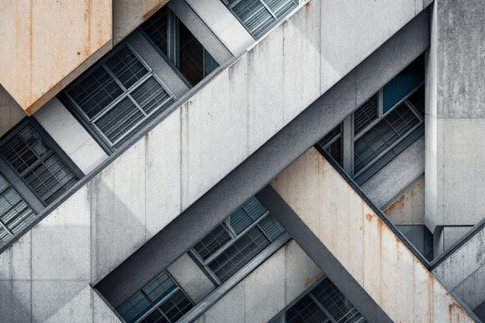
A building facade. Rows, columns and offsets repeat, and a rule that describes the repetition describes the whole elevation.
Photograph: Pexels, free licence (see the image register).
A staircase is built from square tiles. The first has 1 tile, the second 3, the third 6, the fourth 10. Before reading on, work out how many tiles the fifth staircase has, then the tenth, and write down the method you used.
04 · EXPLORE
Count, tabulate, generalise.
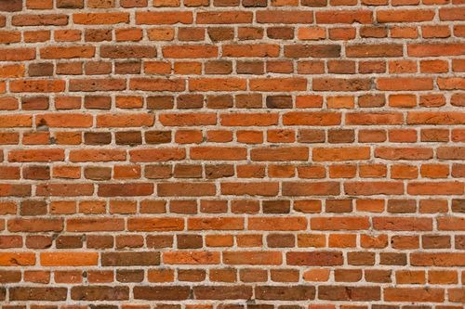
A running bond brick wall. Every course is the last one shifted by half a brick: a translation, applied again and again.
Photograph: Pexels, free licence (see the image register).
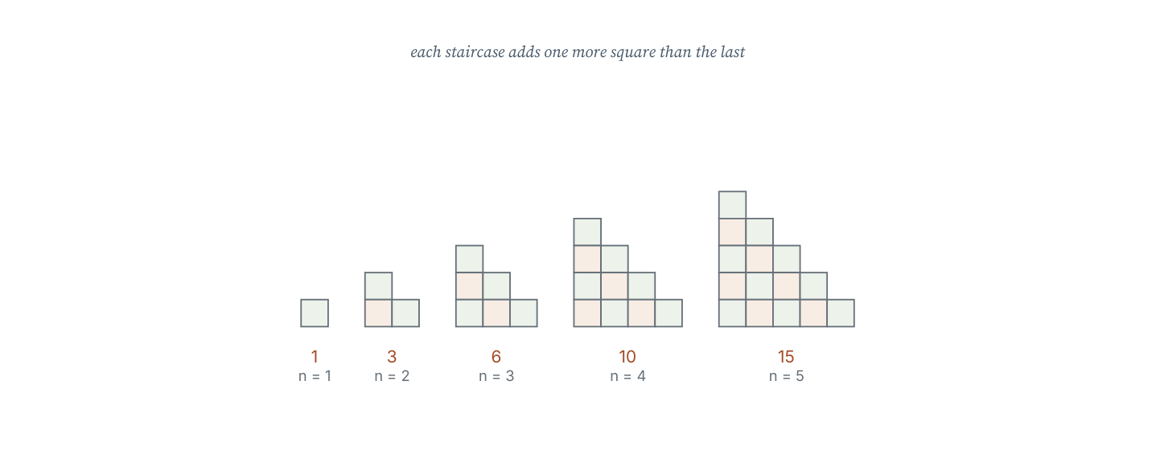
The first five triangular numbers as tile staircases. Each new staircase is the previous one plus a row one tile longer.
Staircase, n | 1 | 2 | 3 | 4 | 5 | 6
Tiles, t | 1 | 3 | 6 | 10 | 15 | 21
Difference |  | 2 | 3 | 4 | 5 | 6

- Describe how the number of tiles changes from one staircase to the next.
- Is the change constant? What does the difference row show you?
- Find a way to compute the tenth staircase without listing all the earlier ones.
- Compare the sequence with the constant-difference sequence 4, 7, 10, 13. What is different about the two patterns of growth?
- Write a conjecture about the sequences whose difference row is constant.
- Find the 100th term of 4, 7, 10, 13, … and explain why your method cannot simply be repeated 100 times by hand.
05 · EXPLAIN
A sequence is an ordered list of numbers, each called a term. A term-to-term rule describes how to get from one term to the next. A sequence whose terms increase or decrease by a constant amount is linear, and that constant amount is the common difference.
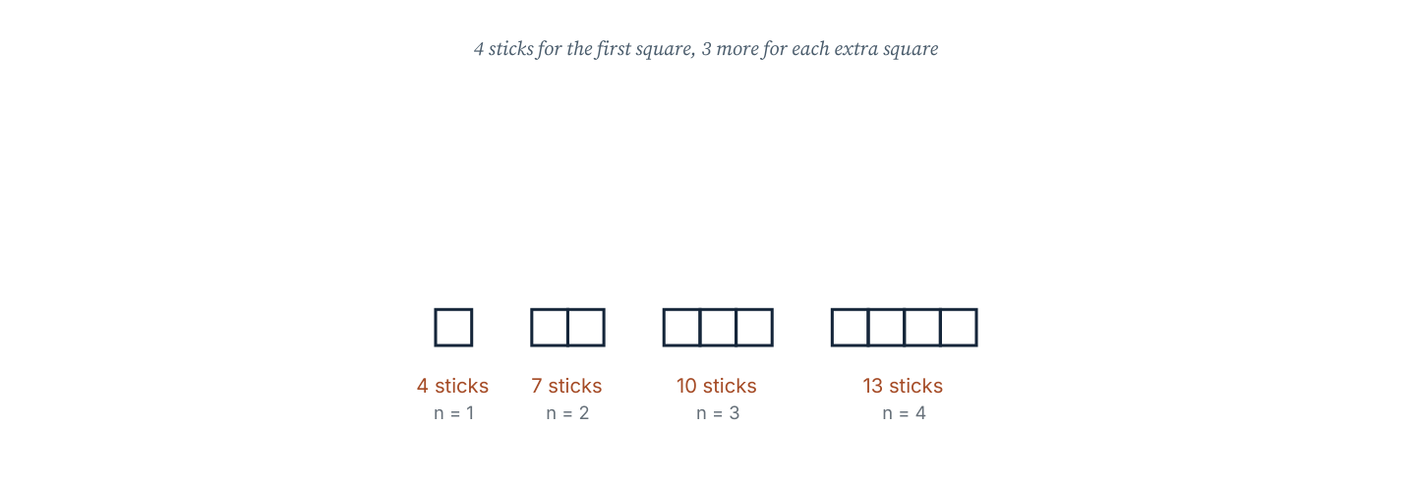
A growing matchstick pattern. Four sticks make the first square and each extra square needs three more, giving 3n + 1 sticks for n squares.
The matchstick pattern is worth studying because the rule can be read from the picture. The first square takes 4 sticks; each extra square shares one side and adds 3 sticks. So n squares take 4 + 3(n − 1) sticks, which simplifies to 3n + 1. A rule found from a picture can be checked against a rule found from a table, and agreement is evidence.
Worked example 6.1.1 · Find the term-to-term rule
Write the term-to-term rule for (a) 7, 12, 17, 22, … and (b) 64, 32, 16, 8, … and give the next two terms.
1 (a) The differences are 5 each time, so the rule is “add 5”.
2 Next terms: 27, 32.
3 (b) Each term is half the one before, so the rule is “double or halve”: multiply by 1/2.
4 Next terms: 4, 2.
ANSWER (a) add 5; 27, 32 (b) multiply by 1/2; 4, 2
Check (b) backwards: doubling 4 gives 8, which is in the list.
Worked example 6.1.2 · A picture to a rule
A pattern of equilateral triangles is made from sticks: 3 sticks for 1 triangle, 5 for 2, 7 for 3. Find the rule and the number of sticks for 20 triangles.
1 The differences are 2 each time, so the rule is “add 2”.
2 Write the rule in terms of n: 2n + 1, since n = 1 gives 3.
3 For n = 20: 2(20) + 1 = 41.
4 Check n = 3: 2(3) + 1 = 7, as counted.
ANSWER 2n + 1; 41 sticks
The first term fixes the constant: 2(1) + c = 3 gives c = 1.
Worked example 6.1.3 · Two rules, one sequence
For 5, 9, 13, 17, … state the term-to-term rule and a rule for the nth term. Which is more useful for finding the 50th term?
1 The common difference is 4, so the term-to-term rule is “add 4”.
2 The nth term is 4n + 1, since 4(1) + 1 = 5.
3 The 50th term is 4(50) + 1 = 201, found in one step.
4 The term-to-term rule would need 49 additions; the nth term needs one calculation.
ANSWER Add 4; nth term 4n + 1; 201
Check the 50th by the equivalent formula 5 + 4(50 − 1) = 201.
“The sequence is 3, 6, 9, … so the next term must be 12; the rule is ‘add 3’ and that is the only possibility.” Any three terms can be continued in many ways — 3, 6, 9 could be followed by 12 or by 18 (doubling) or by 9 (repeating). A rule becomes a generalisation only when there is a reason for it, usually the structure of a diagram or the context.
Practice 6.1
SUPPORT 1–5 · CORE 6–9 · EXTENSION 10–12
1. Write the next three terms and the term-to-term rule: (a) 6, 10, 14, … (b) 40, 36, 32, … (c) 3, 6, 12, … [F]
2. Find the common difference: (a) 9, 14, 19, … (b) 100, 87, 74, … [F]
3. A sequence starts 2, 7, 12, … Find the 10th term by continuing the pattern. [F]
4. A matchstick pattern uses 5 sticks for 1 shape, 8 for 2 and 11 for 3. Find the number of sticks for 12 shapes. [F]
5. Write the first four terms of the sequence with nth term (a) 2n + 3 (b) 5n − 1 (c) n². [F]
6. A sequence is 4, 11, 18, 25, … Write its term-to-term rule and find the 15th term. [P]
7. A tiling pattern uses 6 tiles in the first row, 10 in the second, 14 in the third. How many tiles are in the tenth row? [P]
8. Two students describe 3, 5, 7, 9. One says “add 2”; the other says “odd numbers from 3”. Are both rules valid? Which is more useful, and why? [R]
9. A sequence has nth term 4n − 3. Which term is 41? [P]
10. A savings account starts at £120 and gains £25 each month. Write the balance after n months as an expression, and find when it reaches £320. [E]
11. The first three terms of a sequence are 7, 12, 17. Write the term-to-term rule and the nth term, then explain why three terms are not enough to be certain of the fourth. [E]
12. Find the 100th term of 5, 9, 13, 17, … and explain in one sentence why the nth term is a stronger description than the term-to-term rule. [E]
SECTION 6.2
6.2 The nth term of a linear sequence
Criterion A · II · B · II · Related concepts: Patterns, Generalisation
The nth term is a formula that gives any term directly from its position. It turns a list into a rule.
For a linear sequence with first term a and common difference d, the nth term is a + (n − 1)d, which simplifies to d n + (a − d). The coefficient of n is always the common difference.
A reliable method
- Find the common difference d; it becomes the coefficient of n.
- Write d n and compare it with the sequence to see what must be added or subtracted.
- Fix the constant by testing the first term.
- Check the formula on the second and third terms before trusting it.
Worked example 6.2.1 · Find the nth term
Find the nth term of 6, 10, 14, 18, …
1 The common difference is 4, so the rule begins 4n.
2 For n = 1, 4(1) = 4, but the first term is 6, so add 2.
3 The nth term is 4n + 2.
4 Check: n = 2 gives 10 and n = 3 gives 14, as listed.
ANSWER 4n + 2
Take the difference first, fix the constant second, and always check two terms.
Worked example 6.2.2 · A decreasing sequence
Find the nth term of 30, 26, 22, 18, …
1 The common difference is −4, so the rule begins −4n.
2 For n = 1, −4(1) = −4, but the first term is 30, so add 34.
3 The nth term is 34 − 4n, or −4n + 34.
4 Check: n = 2 gives 26 and n = 4 gives 18.
ANSWER 34 − 4n
A decreasing sequence has a negative coefficient of n; that is expected, not an error.
Worked example 6.2.3 · Which term is it?
The nth term of a sequence is 5n − 2. Is 88 a term of the sequence?
1 Set 5n − 2 = 88 and solve.
2 Add 2: 5n = 90, so n = 18.
3 Since 18 is a whole number, 88 is the 18th term.
4 Check: 5(18) − 2 = 90 − 2 = 88, as required.
ANSWER Yes — 88 is the 18th term
If the solution for n were not a whole number, the value would not be in the sequence.
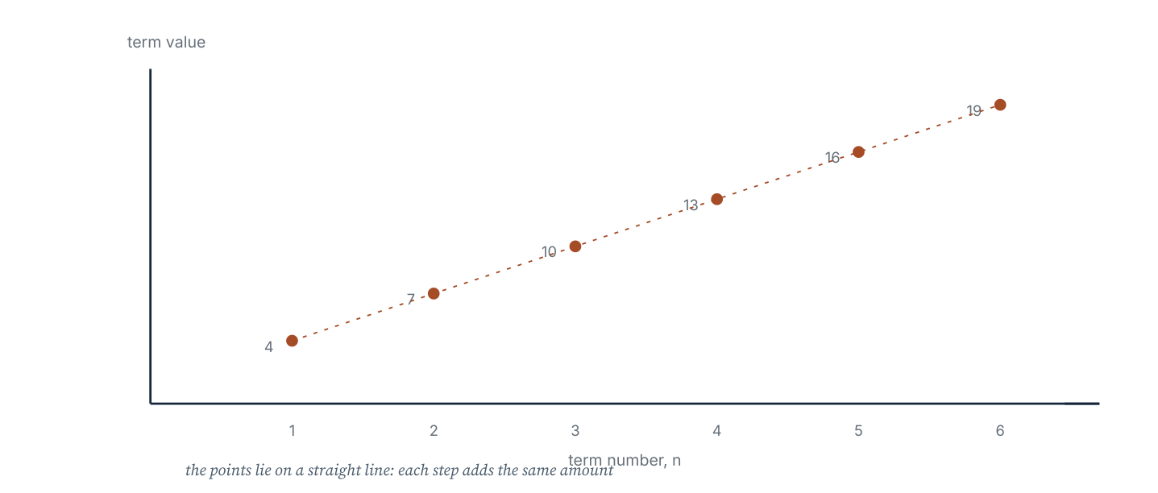
The terms of 4, 7, 10, 13, … plotted against their position. The points lie on a straight line whose gradient is the common difference.
Worked example 6.2.4 · From a graph to a rule
The terms of a sequence plotted against n lie on a straight line through (1, 7) and (3, 15). Find the nth term.
1 The gradient is (15 − 7) ÷ (3 − 1) = 8 ÷ 2 = 4, so the rule begins 4n.
2 At n = 1 the value is 7, so 4(1) + c = 7, giving c = 3.
3 The nth term is 4n + 3.
4 Check: n = 3 gives 15, which is the second point.
ANSWER 4n + 3
The gradient of the term-number graph is the common difference.
“The nth term of 5, 8, 11, … is 3n, because the difference is 3.” The difference gives the coefficient, not the whole rule: 3n gives 3, 6, 9, not 5, 8, 11. The constant must be adjusted by testing the first term, giving 3n + 2.
Practice 6.2
SUPPORT 1–5 · CORE 6–10 · EXTENSION 11–13
1. Find the nth term: (a) 3, 7, 11, … (b) 8, 13, 18, … (c) 2, 9, 16, … [F]
2. Find the nth term: (a) 20, 18, 16, … (b) 50, 44, 38, … [F]
3. The nth term is 4n + 1. Write the first four terms. [F]
4. The nth term is 7n − 4. Find the 12th term. [F]
5. Is 100 a term of the sequence with nth term 6n + 4? Justify. [F]
6. Find the nth term of 11, 15, 19, 23, … and use it to find the 30th term. [P]
7. A sequence has nth term 3n + 5. Which term equals 56? [P]
8. A tiling pattern has nth row containing 5n + 2 tiles. How many tiles are in the 20th row, and in which row are there 97 tiles? [P]
9. A line passes through the points (1, 9) and (4, 21) of a sequence graph. Find the nth term. [P]
10. Two sequences are 6, 10, 14, … and 4, 9, 14, … Will any term appear in both? Find the smallest such value. [R]
11. A sequence has nth term k n + 3. The fifth term is 23. Find k and the tenth term. [E]
12. Explain why the graph of a linear sequence's terms against n is a straight line, and what its gradient represents. [E]
13. The nth term of a sequence is 2n² − 1. Write the first four terms and describe how the differences behave. [E]
SECTION 6.3
6.3 Function machines and linear graphs
Criterion C · II · B · III · Related concepts: Models, Representation
A function machine is a sequence rule written as a process: it takes an input, applies the rule once, and gives an output. Its graph shows every input and output at once.
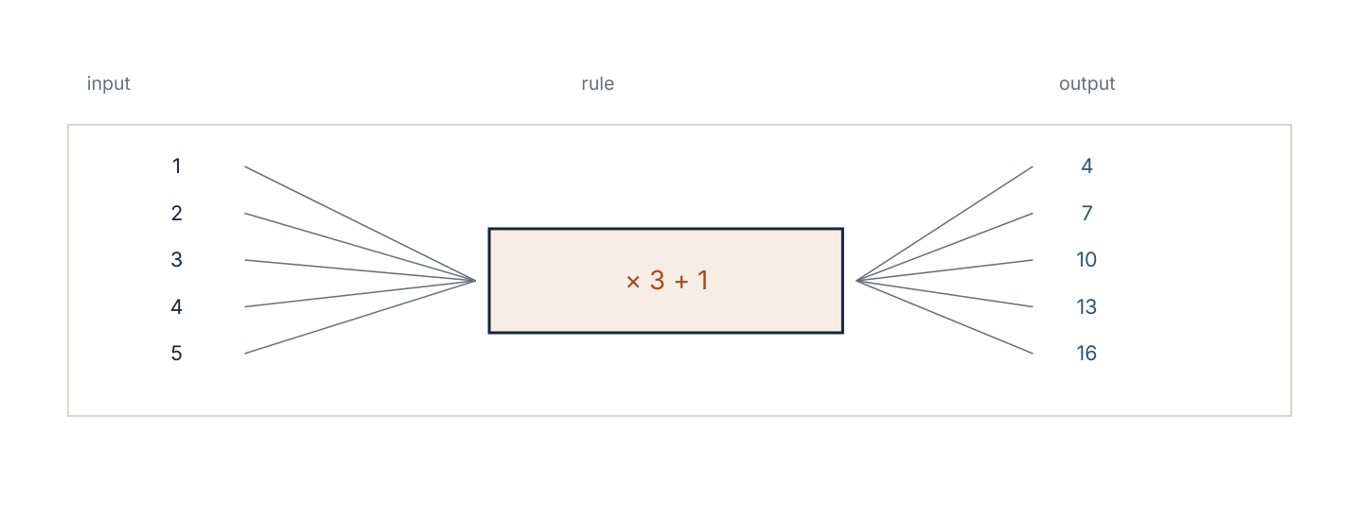
A function machine applying × 3 + 1. Working backwards undoes the operations in reverse order.
A machine can be read in three directions: forwards from input to output; backwards from output to input, undoing each operation in reverse order; and sideways, as the graph of y = 3x + 1, which is a straight line.
Worked example 6.3.1 · Forwards and backwards
A machine applies the rule × 3 + 1. Find the output for input 7, and the input that gives output 25.
1 Forwards: 7 × 3 = 21, then 21 + 1 = 22.
2 Backwards: undo “+ 1” by subtracting 1, giving 24.
3 Undo “× 3” by dividing by 3: 24 ÷ 3 = 8.
4 Check forwards: 8 × 3 + 1 = 25, as required.
ANSWER Output 22; input 8
Undoing in reverse order is essential: subtracting 1 before dividing would give the wrong input.
Worked example 6.3.2 · Plot and describe
Plot the outputs of y = 2x + 1 for x = 0, 1, 2, 3 and describe the graph.
1 Compute the pairs: (0, 1), (1, 3), (2, 5), (3, 7).
2 Plot them on axes with x horizontal and y vertical.
3 The points lie on a straight line; extending it cuts the y-axis at 1.
4 The gradient is 2: each step of 1 across gives a step of 2 up.
ANSWER A straight line through (0, 1) with gradient 2
The constant in the rule is the intercept; the coefficient is the gradient.
Worked example 6.3.3 · Interpret a real graph
A plumber's charge is C = 25h + 40 for h hours. Interpret the numbers and find the charge for 3.5 hours.
1 40 is the charge when h = 0: the call-out fee.
2 25 is the gradient: the charge per hour.
3 For h = 3.5: 25(3.5) + 40 = 87.5 + 40 = 127.5.
4 The charge is £127.50.
ANSWER £40 call-out plus £25 per hour; £127.50
Check h = 1: £65, which is the call-out plus one hour's work.
“The graph of y = 3x + 1 passes through the origin because the rule is linear.” It passes through (0, 1), not (0, 0). Only a proportional rule has no constant term, and only its graph goes through the origin.
Practice 6.3
SUPPORT 1–5 · CORE 6–10 · EXTENSION 11–13
1. A machine applies × 4 − 3. Find the output for inputs 2, 5 and 10. [F]
2. A machine applies + 6 then ÷ 2. Find the output for input 14, and the input for output 10. [F]
3. Complete the table for y = 3x − 2 when x = 0, 1, 2, 3, 4. [F]
4. State the gradient and intercept of (a) y = 5x + 2 (b) y = 8 − x. [F]
5. Does the graph of y = 4x − 1 pass through the origin? Explain. [F]
6. A taxi charge is C = 3.5k + 6. Find the charge for 12 km and the distance travelled for £41. [P]
7. A machine's output is 4x + 7. Find the input that gives 43. [P]
8. Plot y = x + 4 and y = 2x + 1 for x = 0 to 4 on the same axes. At which point do the lines cross? [P]
9. A student says “the graph of y = 2x is a straight line through the origin, so every straight line goes through the origin”. Give a counterexample. [R]
10. A phone plan costs £12 plus £0.08 per text. Write the cost function, find the cost of 250 texts, and the number of texts for a £40 bill. [E]
11. Two machines: A applies × 2 + 3, B applies + 3 then × 2. Do they give the same output for every input? Test with 4 and 1. [E]
12. The graph of a linear rule passes through (0, 5) and (4, 17). Write the rule. [E]
The lantern arch (Criterion D)
A community arch is built from lantern posts set at equal horizontal spacing along a curve. The height of the nth post (from the left, counting from 0) follows the rule h = 0.5n² − 4n + 8 metres for the first section of the arch.
- Complete a table of heights for n = 0 to 6.
- Sketch the points. What shape does the arch take?
- Find the lowest point of this section and the value of n at which it occurs.
- The posts are 0.8 m apart horizontally. How wide is the section modelled?
- The builders need a rule for the rising half of the arch only. Describe the values of n for which the arch is rising.
- Explain why a linear rule would be unsuitable for the arch, using your table as evidence.
06 · INVESTIGATE AND APPLY
The growing staircase and the mosaic border.
The growing staircase (Investigation)
The staircases in section 6.1 use 1, 3, 6, 10, 15 tiles. These are the triangular numbers, and their rule is not linear.
- Extend the table to n = 8 and record the first differences.
- Record the second differences. What do you notice?
- Test the rule t = n(n + 1) ÷ 2 on n = 1 to 6.
- Find a way to see the rule in the picture: what happens if two identical staircases are fitted together?
- Use your method to find the 20th triangular number without listing the earlier ones.
- Write a generalisation about sequences whose second differences are constant.
- Compare the triangular numbers with the square numbers 1, 4, 9, 16 and describe the relationship between them.
The mosaic tile border (Investigation)
A mosaic border is built from square tiles arranged in a rectangle around a central panel. A border one tile wide around a 5 by 5 panel uses 24 tiles; around a 6 by 6 panel it uses 28.
- Draw the two borders described and count the tiles to verify the numbers.
- Make a table of tiles for panels of side 3, 4, 5, 6 and 7.
- Find the first differences and hence the nth term.
- Explain the rule from the picture: why is the number of tiles always a multiple of 4?
- How many tiles are needed for a panel of side 40?
- The mosaic artist has 200 tiles. What is the largest panel side that can be bordered?
- Write one sentence explaining why the rule holds for every panel size, not only the ones counted.
07 · REFLECT AND CONSOLIDATE
SECTION 6.6
6.6 Summary, revision and reflection
What this chapter established
- A sequence is a list generated by a rule; the term-to-term rule describes the step, the nth term describes any term directly.
- A linear sequence has a constant common difference, which becomes the coefficient of n in its formula.
- The constant in the formula is fixed by testing the first term.
- A function machine can be worked forwards and backwards; backwards means undoing in reverse order.
- The graph of a linear rule is a straight line whose gradient is the common difference and whose intercept is the value at n = 0.
- A generalisation needs a reason, not just three matching terms.
Vocabulary to use precisely
sequence · term · term-to-term rule · common difference · linear sequence · nth term · function machine · input · output · gradient · intercept · generalise
Misconceptions to close
The mistake | What is really happening
“The common difference is the nth term.” | The difference gives the coefficient: 3n + 2, not 3n.
“Three terms prove the rule.” | Many rules fit three terms. A generalisation needs a structural reason, usually from the diagram or context.
“A linear graph passes through the origin.” | Only a proportional rule does. y = 3x + 1 meets the y-axis at 1.
“Working backwards means undoing the operations in the same order.” | Undo them in reverse order: subtract before dividing if the machine added before multiplying.

Revision questions
- Find the nth term of 7, 11, 15, 19, …
- A machine applies × 5 − 2. Find the input that gives 43.
- The nth term of a sequence is 6n − 1. Find the 15th term and say whether 80 is a term.
- State the gradient and intercept of y = 9 − 2x.
- A pattern uses 4 sticks for 1 shape and 7 for 2. Find the number of sticks for 15 shapes and the rule for n shapes.
Self-assessment
I can … | Not yet | Getting there | Confident
continue a sequence and state its term-to-term rule | □ | □ | □
find the nth term of a linear sequence | □ | □ | □
work a function machine forwards and backwards | □ | □ | □
plot a linear rule and read its gradient | □ | □ | □
find a rule from a shape pattern | □ | □ | □
justify why a rule holds for all terms | □ | □ | □

Reflect on the criteria
Criterion A: which rule can you now find without a table?
Criterion B: what did the second differences tell you that the first differences could not?
Criterion C: which representation — picture, table, formula, graph — carried your argument best?
Criterion D: where did a rule let you predict something you never counted?
ATL · Critical thinking
In order for a student to defend a generalisation, students must show the rule reproduces the terms already known and explain the structure that guarantees the rest.
Mixed practice · consolidate and extend
Practice 6.M
MIXED 1–12
1. Find the nth term: 9, 14, 19, … [F]
2. Find the nth term: 40, 34, 28, … [F]
3. The nth term is 8n + 3. Find the 9th term. [F]
4. A machine applies × 6 + 1. Find the output for input 4. [F]
5. State the gradient of y = 7x − 4. [F]
6. A sequence has nth term 5n − 3. Which term is 62? [P]
7. A tiling row has 3n + 4 tiles. How many tiles in the 12th row? [P]
8. A student says the nth term of 4, 8, 12, … is 4 because the difference is 4. Correct the reasoning. [R]
9. Plot y = 3x − 1 for x = 0 to 4 and state where the line crosses the y-axis. [F]
10. A savings plan pays £50 in month 1 and increases by £15 each month. Write the amount in month n and find the month in which it first exceeds £200. [E]
11. The first three terms of a sequence are 3, 8, 15. Find a rule in n involving n² and check it on all three terms. [E]
12. Two sequences: A is 5n + 2, B is 3n + 10. Find the smallest n for which A exceeds B, and the value of both at that n. [E]

Answers · chapter 6
PRACTICE 6.1
1. (a) 18, 22, 26; add 4 (b) 28, 24, 20; subtract 4 (c) 24, 48, 96; double.
2. (a) 5 (b) −13.
3. 47.
4. 38.
5. (a) 5, 7, 9, 11 (b) 4, 9, 14, 19 (c) 1, 4, 9, 16.
6. Add 7; 102.
7. 42.
8. Both describe the same list, but “add 2” explains how to continue it, while “odd numbers from 3” is a description.
9. The 11th term.
10. £120 + 25n; after 8 months.
11. Add 5, so the nth term is 5n + 2 and the fourth term is 22. But “add 5, add 5, then add 9” also gives 7, 12, 17 and a different fourth term, 26; three terms fit many rules, so only a reason from the context fixes the sequence.
12. 5 + 4(99) = 401; the nth term needs one calculation for any term, while the term-to-term rule needs every step in between.
PRACTICE 6.2
1. (a) 4n − 1 (b) 5n + 3 (c) 7n − 5.
2. (a) 22 − 2n (b) 56 − 6n.
3. 5, 9, 13, 17.
4. 80.
5. Yes: 6n + 4 = 100 gives n = 16, a whole number.
6. 4n + 7; 127.
7. n = 17.
8. 102 tiles; row 19.
9. 4n + 5.
10. Yes: sequence A is 4n + 2 and sequence B is 5m − 1. The terms are 6, 10, 14, 18, 22, 26, 30, 34 for A and 4, 9, 14, 19, 24, 29, 34 for B, so 14 is the smallest value in both.
11. k = 4; tenth term 43.
12. The gradient is the common difference, because each increase of 1 in n adds the same amount to the term.
13. 1, 7, 17, 31; the differences are 6, 10, 14, so the second differences are constant at 4.
PRACTICE 6.3
1. 5, 17, 37.
2. Output 10; input 14.
3. Table −2, 1, 4, 7, 10.
4. (a) gradient 5, intercept 2 (b) gradient −1, intercept 8.
5. No: at x = 0, y = −1, so it crosses below the origin.
6. £48; 10 km.
7. 9.
8. They cross at (3, 7).
9. y = 2x + 1 is straight but meets the y-axis at 1.
10. C = 0.08m + 12; £32; 350 texts.
11. No: A gives 11 from 4 and 5 from 1; B gives 14 and 8.
12. y = 3x + 5.
PRACTICE 6.M
1. 5n + 4.
2. 46 − 6n.
3. 75.
4. 25.
5. 7.
6. n = 13.
7. 40 tiles.
8. The difference gives the coefficient of n, not the whole rule: 4n gives 4, 8, 12 when n = 1, 2, 3.
9. Crosses the y-axis at −1.
10. 50 + 15(n − 1); month 12, when the payment is £215.
11. n² + 2n: 3, 8, 15.
12. n = 5; A gives 27 and B gives 25, so A first exceeds B at n = 5.

PART III · GEOMETRY AND SPACE
7 2D geometry: angles, perimeter and area
Geometry and space · key concept Relationships · Space, Measurement
Every figure in this chapter obeys a small number of angle
and length facts. Learn to see which fact applies, and the
diagram stops being a puzzle and becomes an argument.
Global context: Orientation in space and time
01 · MYP UNIT PLANNER
From naming shapes to proving what their angles must be.
STATEMENT OF INQUIRY The properties of a two-dimensional figure are consequences of a small set of relationships, so a measurement you cannot make can still be deduced.
Key and related concepts
Key concept · Relationships. Angles, sides and areas are linked: changing one property constrains the others.
Related · Space. Shapes occupy the plane, and their boundaries meet at points, lines and angles.
Related · Measurement. Perimeter, area and angle size are quantities we can calculate from structure rather than by measuring.
Global context · Orientation in space and time
Exploration: how structures and surfaces around us are shaped by geometry — trusses, paving, roofs and screens. Geometry is how a culture fixes a form so that it can be rebuilt.
Inquiry questions
- Factual: What are the angle facts for a straight line, a point and parallel lines?
- Conceptual: Why does the angle sum of a polygon depend only on its number of sides?
- Debatable: Is a formula more reliable than a careful measurement?
Criterion | Strands | Evidence in this chapter
A · Knowing and understanding | i, ii | Recall and apply angle, triangle, polygon and circle facts.
B · Investigating patterns | i, ii, iii | Investigate polygon angle sums and tessellation.
C · Communicating | ii, iii, iv | Give reasons for each step and label diagrams fully.
D · Applying mathematics | i, ii, iii, iv | Cost and plan a paved area with a justified design.

ATL · Thinking skills
In order for a student to justify an angle calculation, students must name the geometric fact used at each step rather than simply stating the answer.
02 · LEARNING INTENTIONS AND SUCCESS CRITERIA
You are learning to | You have succeeded when you can
Use angle facts for a straight line, a point and parallel lines. | Find a missing angle and state which fact you used.
Find angles in triangles and quadrilaterals. | Use the 180° and 360° sums and the exterior angle result.
Find interior and exterior angles of polygons. | Use (n − 2) × 180° and 360° ÷ n correctly.
Calculate circumference and area of circles. | Use C = 2πr and A = πr² with units.
Work with composite shapes. | Split a shape, then find area and perimeter without double counting.
Explain rather than assert. | Write a two-line reason for every angle you find.

Prerequisite check · 10 minutes, no calculator
- Classify 45°, 90° and 130° as acute, right or obtuse.
- Calculate 180 − 63.
- Calculate 3 × 7².
- Find the perimeter of a rectangle 7 cm by 4 cm.
- Find the area of a triangle with base 8 cm and height 5 cm.
- Name a quadrilateral with four equal sides and four right angles.
If three or more answers are wrong, revisit the angle and area work in chapter 1 before continuing.
SECTION 7.1
7.1 Angle relationships and parallel lines
Criterion A · I · C · II · Related concepts: Space, Relationships
An angle is a measure of turn between two lines meeting at a point. A handful of facts about angles then let you find angles you never measured.
03 · ENGAGE
Why a bridge is a lattice of triangles.
Look at the steel truss of a railway bridge. The diagonals divide the span into triangles, not rectangles. Before reading on, write down one reason a designer would choose triangles: think about what happens to a rectangle when you push one corner.
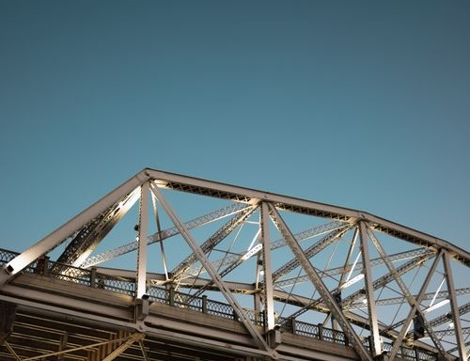
A steel truss bridge. The diagonals lock each bay into triangles, so the span keeps its shape under load.
Photograph: Pexels, free to use under the Pexels licence.
04 · EXPLORE
Measure, then explain.
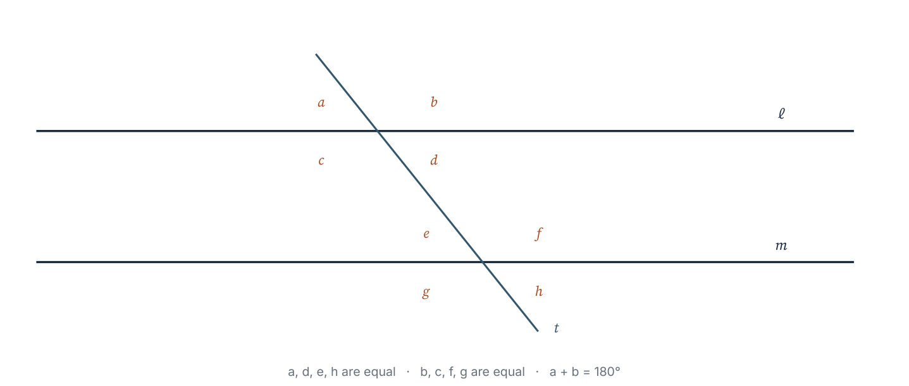
Two parallel lines cut by a transversal. The eight angles formed fall into two equal groups, which is why one measurement determines all of them.
- Measure every angle marked in the diagram with a protractor and record them in two groups of equal size.
- Which pairs are equal because they are vertically opposite?
- Which pairs add to 180°? Describe where they sit.
- Write a conjecture about the angles formed when a transversal cuts two parallel lines.
- Predict the effect on corresponding angles if the two lines were not parallel.
- Explain why a truss of triangles cannot be distorted by pushing on a corner, while a rectangle can.
05 · EXPLAIN
Angles on a straight line add to 180°. Angles at a point add to 360°. Vertically opposite angles are equal. When a transversal cuts two parallel lines, corresponding angles are equal, alternate angles are equal, and co-interior angles add to 180°.
Fact | What it looks like | What you may write
Straight line | two angles side by side on a line | a + b = 180°
At a point | angles all the way round one vertex | a + b + c = 360°
Vertically opposite | an X shape | the two angles are equal
Corresponding (parallel) | same position at each intersection | the two angles are equal
Alternate (parallel) | opposite sides of the transversal, Z shape | the two angles are equal
Co-interior (parallel) | same side of the transversal, C shape | the two angles add to 180°

Worked example 7.1.1 · Two facts, one answer
Two angles lie on a straight line. One is 118°. Find the other.
1 Angles on a straight line add to 180°.
2 So the other angle is 180° − 118° = 62°.
3 Check: 118 + 62 = 180, as required.
ANSWER 62°
Name the fact before you calculate; it is the first mark in an examination.
Worked example 7.1.2 · Parallel lines
A transversal cuts two parallel lines. One of the co-interior angles is 73°. Find the alternate angle to the 73° angle and the co-interior angle.
1 Co-interior angles add to 180°, so the other is 180° − 73° = 107°.
2 The alternate angle equals the 73° angle, so it is 73°.
3 Check: 73 + 107 = 180, and the alternate angle sits in the Z shape with the 73° angle.
ANSWER Alternate 73°; co-interior 107°
Sketch the Z and C shapes; the letters remind you which pair is which.
Worked example 7.1.3 · Angles with algebra
Two angles on a straight line are (3x + 10)° and (x + 30)°. Find x and both angles.
1 Angles on a straight line add to 180°: (3x + 10) + (x + 30) = 180.
2 Collect: 4x + 40 = 180, so 4x = 140 and x = 35.
3 The angles are 3(35) + 10 = 115° and 35 + 30 = 65°.
4 Check: 115 + 65 = 180.
ANSWER x = 35; 115° and 65°
Always substitute back: the check catches an algebra slip in one line.
“The answer is 62° because the two angles look equal.” Angles in a diagram are not drawn to scale, and equal-looking angles may be supplementary. Every angle must be justified by a named fact, not by appearance.
Practice 7.1
SUPPORT 1–5 · CORE 6–9 · EXTENSION 10–12
1. Classify each angle: (a) 38° (b) 90° (c) 141° (d) 205°. [F]
2. Find the complement of 34° and the supplement of 34°. [F]
3. Two angles on a straight line are 118° and x°. Find x. [F]
4. Two lines cross. One angle is 47°. Write the sizes of the other three angles at the crossing. [F]
5. A transversal cuts two parallel lines and one corresponding angle is 72°. Find the alternate angle and the co-interior angle. [F]
6. Angles at a point are 130°, 96° and x°. Find x. [P]
7. Two angles on a straight line are (3x + 10)° and (x + 30)°. Find x and both angles. [P]
8. Two co-interior angles are 3x° and (2x + 20)°. Find x and both angles. [P]
9. A student says two angles of 50° and 130° must be co-interior. Is that reasoning valid? Explain. [R]
10. In a parallelogram, one angle is 68°. Using parallel-line facts, find the other three angles and justify each. [E]
11. Two parallel lines are cut by a transversal. One angle is 5x° and the alternate angle is (2x + 45)°. Find x. [E]
12. Explain, using the straight-line fact, why the three angles of a triangle add to 180°. [E]
SECTION 7.2
7.2 Triangles
Criterion A · II · C · III · Related concepts: Space, Generalisation
A triangle is the simplest rigid polygon: fix its three sides and its shape cannot change. Its angles follow a single rule.
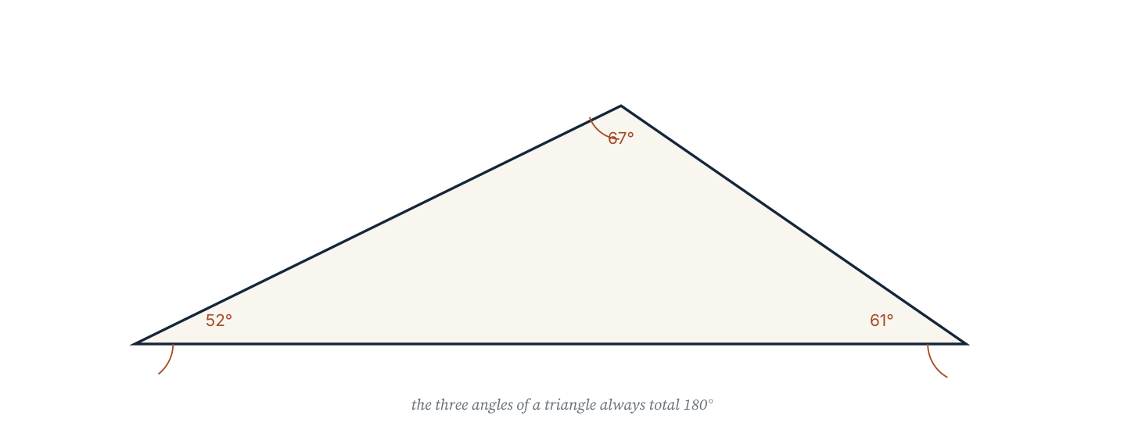
Draw any triangle, tear off its three corners and place them together along a straight line: they fit exactly. That experiment is the reason for the angle sum, and the reason is the straight-line fact from section 7.1.
Two results worth knowing by name
Angle sum of a triangle. The three interior angles of any triangle add to 180°.
Exterior angle. An exterior angle of a triangle equals the sum of the two interior opposite angles.
Types of triangle
Name | Property | Consequence
Equilateral | three equal sides | each angle is 60°
Isosceles | two equal sides | the angles opposite them are equal
Scalene | no equal sides | no equal angles
Right-angled | one angle of 90° | the other two add to 90°

Worked example 7.2.1 · Two angles given
A triangle has angles of 42° and 67°. Find the third angle.
1 The angles of a triangle add to 180°.
2 Third angle = 180° − 42° − 67° = 71°.
3 Check: 42 + 67 + 71 = 180.
ANSWER 71°
Subtract both known angles in one step to avoid rounding twice.
Worked example 7.2.2 · Isosceles triangle
An isosceles triangle has an apex angle of 44°. Find the two base angles.
1 The base angles are equal because the sides opposite them are equal.
2 They share 180° − 44° = 136°.
3 Each base angle is 136° ÷ 2 = 68°.
4 Check: 44 + 68 + 68 = 180.
ANSWER 68° each
Divide after subtracting: the equal pair shares the remainder.
Worked example 7.2.3 · The exterior angle
The exterior angle at one vertex of a triangle is 125°. One interior opposite angle is 48°. Find the other interior opposite angle.
1 The exterior angle equals the sum of the two interior opposite angles.
2 So 125° = 48° + y.
3 y = 125° − 48° = 77°.
4 Check: the third interior angle is 180 − 48 − 77 = 55°, and 125 + 55 = 180 on a straight line.
ANSWER 77°
The exterior angle and the adjacent interior angle always add to 180°.
“The angles of a triangle are 90°, 45° and 55° because the diagram looks right.” Those three add to 190°, so no such triangle exists. Always add your three answers as a check; if the sum is not 180°, one of them is wrong.
Practice 7.2
SUPPORT 1–5 · CORE 6–9 · EXTENSION 10–12
1. Two angles of a triangle are 58° and 71°. Find the third. [F]
2. An isosceles triangle has an apex angle of 44°. Find each base angle. [F]
3. What is each angle of an equilateral triangle? [F]
4. An exterior angle is 125° and one interior opposite angle is 48°. Find the other. [F]
5. A triangle has sides 5 cm, 5 cm and 8 cm. Name its type and state which angles are equal. [F]
6. The angles of a triangle are 2x, 3x and 4x. Find x and the three angles. [P]
7. A right-angled triangle has one acute angle of 37°. Find the other acute angle. [P]
8. An isosceles triangle has a base angle of 74°. Find the apex angle. [P]
9. A student claims a triangle can have angles 100°, 50° and 40°. Show why this is impossible. [R]
10. A triangle has angles x, 2x and 3x. Find the angles and classify the triangle. [E]
11. The exterior angle at the apex of an isosceles triangle is 130°. Find the two base angles. [E]
12. Explain why a triangle with two right angles cannot exist, using the angle sum. [E]
SECTION 7.3
7.3 Quadrilaterals and polygons
Criterion B · I · A · III · Related concepts: Patterns, Generalisation
A polygon's angle sum is fixed by its number of sides. That single relationship replaces a page of separate facts.
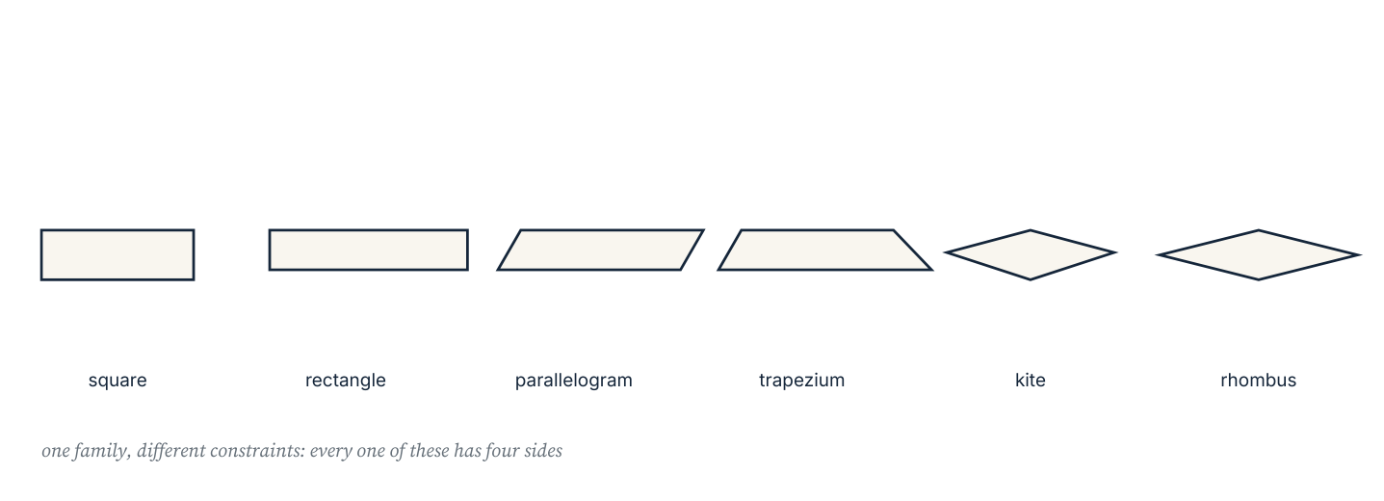
Families of quadrilaterals. Each shape's angle and side properties follow from its definition, not from the way it is drawn.
Quadrilateral | Angle fact | Side fact
Parallelogram | opposite angles equal; all four add to 360° | opposite sides equal and parallel
Rhombus | opposite angles equal | all four sides equal
Rectangle | all four angles 90° | opposite sides equal
Square | all four angles 90° | all four sides equal
Trapezium | angles add to 360° | one pair of parallel sides
Kite | one pair of opposite angles equal | two pairs of adjacent equal sides

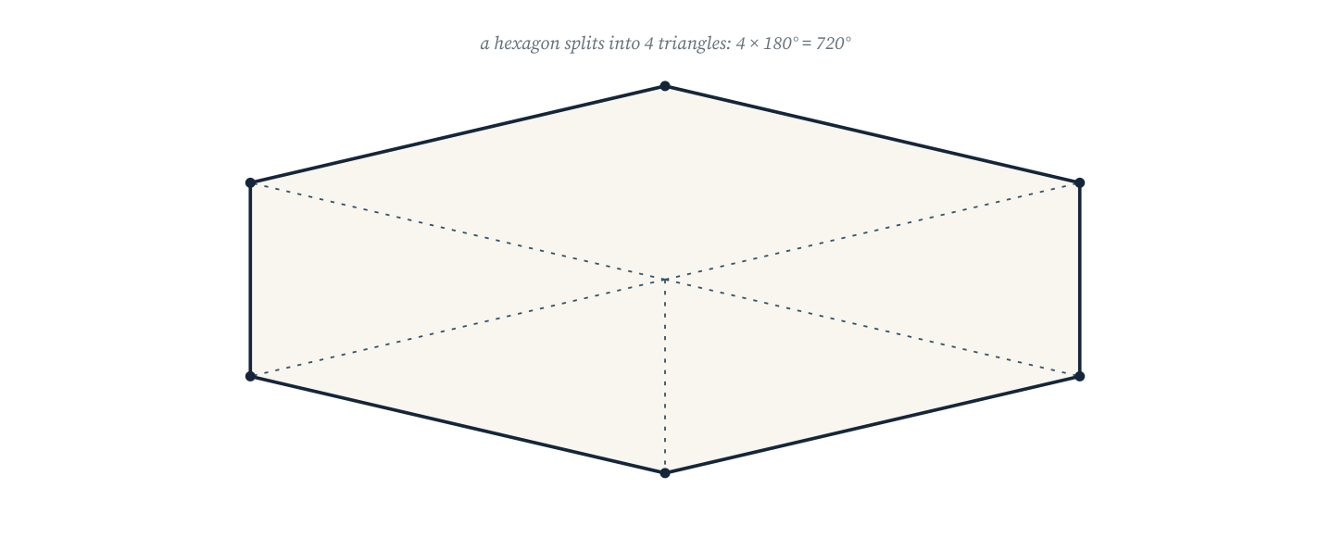
Dissecting a polygon from one vertex gives n − 2 triangles, so its interior angles sum to (n − 2) × 180°.
Interior angle sum of a polygon with n sides: (n − 2) × 180°.
Exterior angles of any convex polygon add to 360°, so each exterior angle of a regular polygon is 360° ÷ n.
Each interior angle of a regular polygon is (n − 2) × 180° ÷ n.
Worked example 7.3.1 · Quadrilateral and pentagon
Find the missing angle of a quadrilateral whose other angles are 85°, 95° and 110°, then find each interior angle of a regular pentagon.
1 A quadrilateral's angles add to 360°, so the missing angle is 360 − 85 − 95 − 110 = 70°.
2 A pentagon has 5 sides, so its sum is (5 − 2) × 180 = 540°.
3 A regular pentagon divides this equally: 540 ÷ 5 = 108°.
4 Check with the exterior angle: 360 ÷ 5 = 72, and 180 − 72 = 108°.
ANSWER 70°; 108°
The exterior-angle check works for every regular polygon.
Worked example 7.3.2 · How many sides?
A regular polygon has an exterior angle of 24°. How many sides does it have, and what is each interior angle?
1 Exterior angles add to 360° and are equal in a regular polygon.
2 Number of sides = 360 ÷ 24 = 15.
3 Each interior angle = 180 − 24 = 156°.
4 Check: 15 × 156 = 2340, and (15 − 2) × 180 = 2340.
ANSWER 15 sides; 156°
Two independent routes — exterior angles and the interior sum — agreeing is a strong check.
Worked example 7.3.3 · Is it possible?
Can a regular polygon have an interior angle of 130°?
1 If the interior angle were 130°, the exterior angle would be 50°.
2 The number of sides would be 360 ÷ 50 = 7.2.
3 A polygon cannot have 7.2 sides, so no such regular polygon exists.
4 The angle must be one that divides 360 exactly when subtracted from 180°.
ANSWER No — it would need 7.2 sides
Test candidates with the exterior angle; a whole-number result is required.
“A regular polygon with 10 sides has each interior angle 180° ÷ 10 = 18°.” That is the exterior angle. Interior and exterior angles add to 180°, so the interior angle is 144°, and 10 × 144 = 1440 = (10 − 2) × 180.
Practice 7.3
SUPPORT 1–5 · CORE 6–10 · EXTENSION 11–13
1. Find the fourth angle of a quadrilateral with angles 85°, 95° and 110°. [F]
2. A parallelogram has one angle of 68°. Find the other three. [F]
3. Find the interior angle sum of (a) a pentagon (b) a hexagon (c) a decagon. [F]
4. Find each interior and exterior angle of a regular hexagon. [F]
5. Find the interior angle sum of an octagon. [F]
6. A regular polygon has an exterior angle of 24°. How many sides does it have? [P]
7. Find each interior angle of a regular octagon. [P]
8. A polygon has an interior angle sum of 1260°. How many sides? [P]
9. A regular polygon has an exterior angle of 45°. Find its number of sides and each interior angle. [P]
10. A student says a regular polygon can have an interior angle of 130°. Test the claim. [R]
11. Each interior angle of a regular polygon is 156°. Find the number of sides. [E]
12. Find the interior angle sum of a 20-sided polygon. [E]
13. Explain why the exterior angles of any convex polygon add to 360°. [E]
SECTION 7.4
7.4 Circles: circumference and area
Criterion A · II · D · II · Related concepts: Measurement, Models
A circle is fixed by one length — its radius. Both its boundary and its interior follow from that single number.
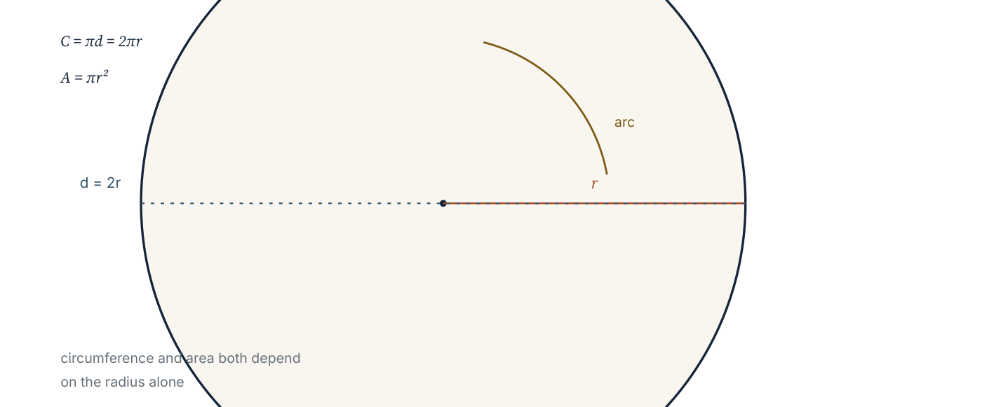
The parts of a circle. The ratio of circumference to diameter is π for every circle, whatever its size.
Circumference: C = πd = 2πr.
Area: A = πr².
Use π = 3.14 unless the question says otherwise, and always state the unit: cm, cm², m².
The constant π is a ratio, not a measurement: for any circle, the distance round the edge is about 3.14 times the distance across the middle. The area formula comes from cutting the circle into thin sectors and rearranging them into a shape close to a parallelogram of base πr and height r.
Worked example 7.4.1 · From diameter to area
A circular table top has diameter 1.4 m. Find its circumference and area, using π = 3.14.
1 The radius is half the diameter: r = 0.7 m.
2 Circumference = 2πr = 2 × 3.14 × 0.7 = 4.396 m.
3 Area = πr² = 3.14 × 0.7² = 3.14 × 0.49 = 1.5386 m².
4 State units: circumference in metres, area in square metres.
ANSWER 4.40 m and 1.54 m² (2 d.p.)
Square the radius before multiplying by π; order matters.
Worked example 7.4.2 · A semicircle
A semicircle has radius 6 cm. Find its perimeter and area.
1 Area of the full circle is π × 6² = 113.04 cm²; half is 56.52 cm².
2 The curved edge of the semicircle is half the circumference: π × 6 = 18.84 cm.
3 The perimeter also includes the straight diameter, 12 cm.
4 Perimeter = 18.84 + 12 = 30.84 cm.
ANSWER Area 56.52 cm²; perimeter 30.84 cm
Perimeter follows the boundary, so the diameter must be included.
Worked example 7.4.3 · Working backwards
A circular flower bed has circumference 31.4 m. Find its radius and area.
1 C = 2πr, so r = C ÷ (2π) = 31.4 ÷ 6.28 = 5 m.
2 Area = πr² = 3.14 × 25 = 78.5 m².
3 Check: 2 × 3.14 × 5 = 31.4, the given circumference.
ANSWER r = 5 m; area 78.5 m²
Rearranging before substituting avoids arithmetic clutter.
“The area of a circle of diameter 10 cm is 3.14 × 10² = 314 cm².” The formula needs the radius, not the diameter: with r = 5 the area is 78.5 cm². A factor of four error is the classic circle mistake.
Practice 7.4
SUPPORT 1–5 · CORE 6–10 · EXTENSION 11–13
1. Find the circumference of circles with (a) r = 5 cm (b) r = 12 m. Use π = 3.14. [F]
2. Find the area of circles with (a) r = 4 cm (b) r = 10 m. [F]
3. A circle has diameter 14 cm. Find its circumference and area. [F]
4. A semicircle has radius 6 cm. Find its perimeter and area. [F]
5. A circle has area 78.5 cm². Find its radius. [F]
6. A bicycle wheel has diameter 0.7 m. How far does the bicycle travel in 100 complete turns of the wheel? [P]
7. A ring has outer radius 10 cm and inner radius 6 cm. Find the area of the ring. [P]
8. A quadrant has radius 8 cm. Find its area and its perimeter. [P]
9. A circle has circumference 62.8 cm. Find its radius and area. [F]
10. Which is larger: the area of one circle of radius 10 cm, or the total area of two circles of radius 5 cm? Show the comparison. [R]
11. A running track consists of a rectangle 60 m by 30 m with a semicircle on each short side. Find the distance round the track. [E]
12. A circular pizza of diameter 30 cm is cut into 8 equal sectors. Find the area of one sector and the length of its curved edge. [E]
13. Explain why doubling the radius multiplies the area by 4 but the circumference by only 2. [E]
SECTION 7.5
7.5 Composite shapes and perimeter
Criterion C · I · D · III · Related concepts: Measurement, Models
Most real surfaces are not one shape. Splitting them into shapes you know is the core skill; deciding how to split them is the judgement.
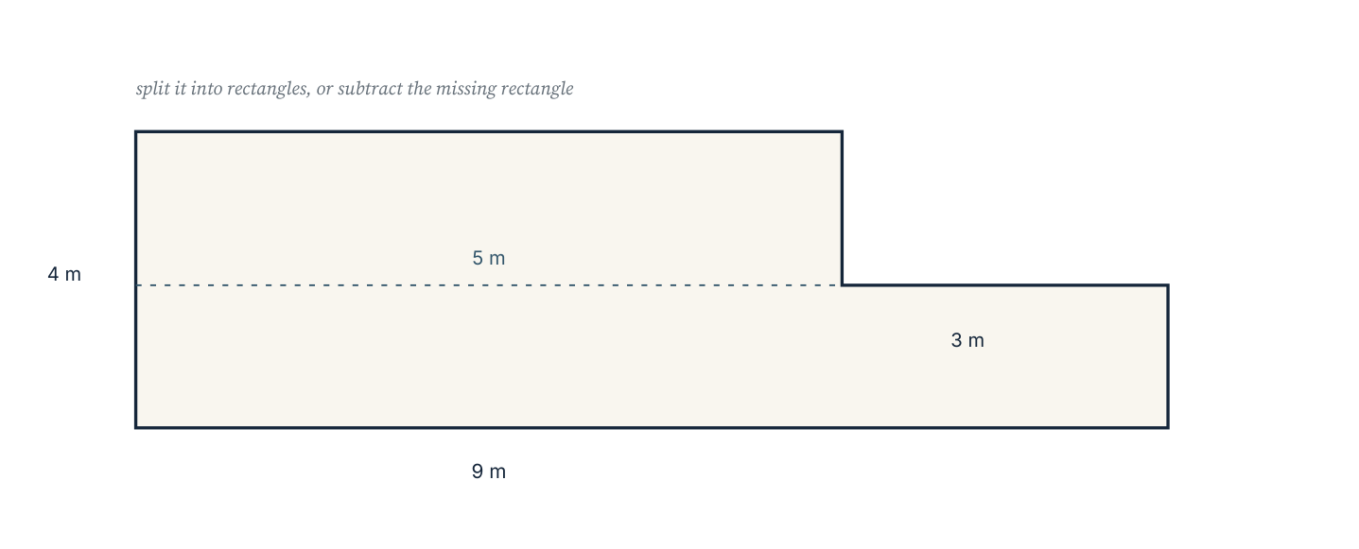
A composite shape split into a rectangle and a semicircle. The dashed line shows one useful split; other splits give the same area.
Areas add: the area of a composite shape is the sum of the areas of its parts, provided the parts do not overlap. Perimeters do not add in the same carefree way, because the boundary of a composite shape excludes the internal dividing line.
Worked example 7.5.1 · Rectangle and semicircle
A window is a rectangle 80 cm wide and 120 cm high with a semicircle on top. Find its total area and its perimeter, using π = 3.14.
1 Rectangle area = 80 × 120 = 9600 cm².
2 Semicircle radius = 40 cm, so its area = π × 40² ÷ 2 = 2512 cm².
3 Total area = 9600 + 2512 = 12 112 cm².
4 Perimeter = 120 + 80 + 120 + (π × 80 ÷ 2) = 320 + 125.6 = 445.6 cm.
ANSWER Area 12 112 cm²; perimeter 445.6 cm
The top edge of the rectangle is inside the shape, so it is not part of the perimeter.
Worked example 7.5.2 · Subtracting a shape
A square lawn of side 10 m has a circular pond of diameter 6 m in the middle. Find the grassed area.
1 Lawn area = 10 × 10 = 100 m².
2 Pond radius = 3 m, so pond area = 3.14 × 9 = 28.26 m².
3 Grassed area = 100 − 28.26 = 71.74 m².
4 Check that the pond fits inside the square: diameter 6 m < 10 m.
ANSWER 71.74 m²
Subtracting is splitting with a negative sign; keep the units consistent.
Worked example 7.5.3 · A shape with a missing corner
An L-shaped room is a 6 m by 5 m rectangle with a 2 m by 3 m rectangle removed from one corner. Find its area and perimeter.
1 Whole rectangle area = 6 × 5 = 30 m².
2 Removed area = 2 × 3 = 6 m², so the room is 24 m².
3 Boundary: 6 + 5 + 4 + 2 + 2 + 3 = 22 m, walking round the L.
4 Check the boundary by adding only outer edges, skipping the internal lines.
ANSWER 24 m²; perimeter 22 m
Walk the boundary once, in order, and add each edge as you pass it.
“The perimeter of the composite shape is the perimeter of the rectangle plus the circumference of the circle.” Parts of the boundary are internal, and some circle edges are only partly exposed. Trace the actual outline of the finished shape before adding anything.
Practice 7.5
SUPPORT 1–4 · CORE 5–9 · EXTENSION 10–12
1. Find the area of a rectangle 8 cm by 5 cm joined to a square of side 4 cm. [F]
2. A shape is a square of side 10 m with a circular hole of diameter 6 m. Find the remaining area. [F]
3. Find the area of a right-angled triangle with base 9 cm and height 6 cm. [F]
4. A rectangle 12 cm by 7 cm has a triangle of base 12 cm and height 4 cm on top. Find the total area. [F]
5. A window is a rectangle 80 cm by 120 cm with a semicircle on top (radius 40 cm). Find its total area. [P]
6. An L-shaped room is a 6 m by 5 m rectangle with a 2 m by 3 m rectangle removed. Find its area and perimeter. [P]
7. A running track is a 60 m by 30 m rectangle with a semicircle on each short side. Find its perimeter. [P]
8. A circular pond of diameter 8 m sits in a square lawn of side 12 m. Find the grassed area. [P]
9. A student adds the perimeters of the two shapes to find the perimeter of a joined shape. Explain the error. [R]
10. A flower bed is a semicircle of diameter 10 m attached to a rectangle 10 m by 4 m. Find its area and perimeter. [E]
11. A logo is a square of side 8 cm with a quarter circle of radius 8 cm removed from one corner. Find the remaining area. [E]
12. A path 1 m wide runs round the outside of a rectangular garden 10 m by 6 m. Find the area of the path. [E]
Paving the courtyard (Criterion D)
A school courtyard 9 m by 6 m is to be paved. The design must include a circular planting bed of diameter 3 m and a semicircular seating area of radius 1.5 m, both inside the courtyard. Paving costs £28 per square metre.
- Calculate the total area of the courtyard.
- Calculate the area taken by the planting bed and the seating area, and the area left to pave.
- Find the cost of the paving, to the nearest pound.
- The paving slabs are 0.6 m squares. How many slabs are needed, allowing 10% extra for cutting?
- Propose one change to the design that reduces the cost by at least 10%, keeping both circular features.
- Justify your change with calculations, and state one assumption you made.
06 · INVESTIGATE AND APPLY
Angle sums and the hexagonal paving.
The polygon angle sum (Investigation)
The angle sum of a polygon can be found by dissecting it into triangles from one vertex.
- Draw a quadrilateral and one diagonal. How many triangles? What is the angle sum?
- Repeat for a pentagon and a hexagon, drawing all diagonals from one vertex.
- Record your results in a table: sides, triangles, angle sum.
- Write the angle sum in terms of n and test it on a decagon.
- Explain why the number of triangles is always n − 2.
- A regular polygon has an interior angle of 150°. Use your rule to find how many sides it has.
- Write one sentence explaining why the rule works for every polygon, not only the ones you drew.
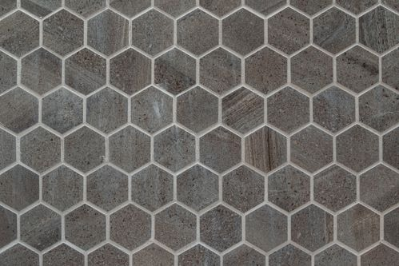
Hexagonal paving. Three 120° angles meet at every vertex and total 360° exactly, which is why no gap or overlap appears.
Photograph: Pexels, free licence (see the image register).
Why hexagons tile (Investigation)
Bees build hexagonal cells and pavements are often laid in hexagons. The reason is arithmetic, not preference.
- Find each interior angle of a regular hexagon.
- Three hexagons meet at each vertex. Show that the angles fit exactly with no gap.
- Test a regular pentagon: show that three cannot meet at a point.
- Test a regular octagon in the same way.
- Which regular polygons tile the plane on their own? Write a conjecture.
- Explain your conjecture using the interior angle formula.
- Find one combination of two different regular polygons that also fits around a point, and show the arithmetic.
07 · REFLECT AND CONSOLIDATE
SECTION 7.6
7.6 Summary, revision and reflection
What this chapter established
- Angles on a straight line add to 180°; angles at a point add to 360°; vertically opposite angles are equal.
- Parallel lines give equal corresponding and alternate angles; co-interior angles add to 180°.
- The angles of a triangle add to 180°, and an exterior angle equals the sum of the two interior opposite angles.
- The interior angles of an n-sided polygon add to (n − 2) × 180°; exterior angles add to 360°.
- C = 2πr and A = πr²; the radius, not the diameter, belongs in both.
- Composite areas add, but perimeters must be traced along the real boundary.
Vocabulary to use precisely
acute · obtuse · reflex · vertically opposite · corresponding · alternate · co-interior · isosceles · exterior angle · regular polygon · circumference · composite shape
Misconceptions to close
The mistake | What is really happening
Judging angles by appearance. | Diagrams are not to scale; only named facts justify an answer.
Using the diameter in the area formula. | Area needs the radius; halving the diameter first changes the answer by a factor of 4.
Adding perimeters of joined shapes. | Internal edges are not part of the boundary and must be removed.
Writing 18° for a decagon's interior angle. | 18° is the exterior angle; the interior angle is 144°.

Revision questions
- Two angles on a straight line are 4x° and 2x°. Find x.
- A triangle has angles 39° and 58°. Find the third.
- Find each interior angle of a regular nonagon (9 sides).
- A circle has radius 9 cm. Find its area and circumference.
- A rectangle 10 m by 4 m has a semicircle of radius 2 m removed from one long side. Find the remaining area.
Self-assessment
I can … | Not yet | Getting there | Confident
use the straight-line and point angle facts | □ | □ | □
identify corresponding, alternate and co-interior angles | □ | □ | □
find angles in triangles, including isosceles cases | □ | □ | □
use the polygon angle formula | □ | □ | □
calculate circumference and area of circles | □ | □ | □
find the area and perimeter of composite shapes | □ | □ | □

Reflect on the criteria
Criterion A: which facts can you now apply without a prompt?
Criterion B: what did the polygon dissection let you predict?
Criterion C: did you name the fact you used at every step?
Criterion D: where did an area calculation decide a real choice?
ATL · Communication skills
In order for a student to communicate a geometric argument, students must label the diagram, name each fact used, and give the reason before the result.
Mixed practice · consolidate and extend
Practice 7.M
MIXED 1–12
1. Find the supplement of 47°. [F]
2. Two angles of a triangle are 63° and 44°. Find the third. [F]
3. Find the interior angle sum of a heptagon (7 sides). [F]
4. Find the circumference of a circle of radius 3.5 cm. [F]
5. Find the area of a circle of diameter 20 cm. [F]
6. A regular polygon has exterior angle 15°. How many sides? [P]
7. An isosceles triangle has apex angle 96°. Find each base angle. [P]
8. A square of side 9 cm has a quarter circle of radius 9 cm removed. Find the remaining area. [P]
9. A student writes “a decagon has interior angle 36°”. Correct the error. [R]
10. A circular mirror of diameter 60 cm is framed with a 5 cm wide wooden rim. Find the area of the rim. [E]
11. A regular polygon has each interior angle 140°. Find the number of sides and the exterior angle. [E]
12. Two parallel lines are cut by a transversal. One angle is 3x + 12 and its co-interior partner is 2x + 8. Find both angles. [E]

Answers · chapter 7
PRACTICE 7.1
1. (a) acute (b) right (c) obtuse (d) reflex.
2. Complement 56°; supplement 146°.
3. 62°.
4. 47°, 133°, 133°.
5. Alternate 72°; co-interior 108°.
6. 134°.
7. x = 35; 115° and 65°.
8. x = 32; 96° and 84°.
9. No — many pairs add to 180° without being co-interior; the reason must be the parallel lines.
10. 112°, 112° and 68°: adjacent angles on the transversal are co-interior, opposite angles are equal.
11. x = 15.
12. Placing the three angles together along a straight line at one vertex gives 180°, because a straight line is 180°.
PRACTICE 7.2
1. 51°.
2. 68° each.
3. 60°.
4. 77°.
5. Isosceles; the angles opposite the two 5 cm sides are equal.
6. x = 20; 40°, 60°, 80°.
7. 53°.
8. 32°.
9. 100 + 50 + 40 = 190 ≠ 180, so no such triangle exists.
10. 30°, 60°, 90°; right-angled.
11. 65° each: the apex interior angle is 50°, so the base angles share 130°.
12. Two right angles already total 180°, leaving 0° for the third angle, which is impossible.
PRACTICE 7.3
1. 70°.
2. 112°, 112°, 68°.
3. (a) 540° (b) 720° (c) 1440°.
4. Interior 120°; exterior 60°.
5. 1080°.
6. 15 sides.
7. 135°.
8. 9 sides.
9. 8 sides; interior 135°.
10. No: the exterior angle would be 50° and 360 ÷ 50 = 7.2, not a whole number.
11. 15 sides.
12. 3240°.
13. Walking round the polygon you turn through the exterior angle at each vertex and return facing the same way, a total turn of 360°.
PRACTICE 7.4
1. (a) 31.4 cm (b) 75.36 m.
2. (a) 50.24 cm² (b) 314 m².
3. C = 43.96 cm; A = 153.86 cm².
4. Area 56.52 cm²; perimeter 30.84 cm.
5. 5 cm.
6. C = 2.198 m, so 100 turns cover 219.8 m.
7. 3.14 × (10² − 6²) = 200.96 cm².
8. Area 50.24 cm²; perimeter 28.56 cm.
9. r = 10 cm; A = 314 cm².
10. One circle: 314 cm² against 2 × 78.5 = 157 cm², so the single large circle is twice the area.
11. Two lengths of 60 m plus a full circle of diameter 30 m: 120 + 94.2 = 214.2 m.
12. Area 88.36 cm²; curved edge 11.78 cm.
13. Area depends on r², so doubling r multiplies area by 2² = 4, while circumference depends on r only.
PRACTICE 7.5
1. 40 + 16 = 56 cm².
2. 71.74 m².
3. 27 cm².
4. 108 cm².
5. 12 112 cm².
6. 24 m²; perimeter 22 m.
7. 120 + 94.2 = 214.2 m.
8. 144 − 50.24 = 93.76 m².
9. Internal edges are not part of the outside boundary, so they are counted twice and must be removed.
10. Area 40 + 39.25 = 79.25 m²; perimeter 4 + 10 + 4 + 15.7 = 33.7 m.
11. 64 − 50.24 = 13.76 cm².
12. Outer 12 m by 8 m is 96 m²; the garden is 60 m²; so the path is 36 m².
PRACTICE 7.M
1. 133°.
2. 73°.
3. 900°.
4. 21.98 cm.
5. 314 cm².
6. 24 sides.
7. 42° each.
8. 17.42 cm².
9. The exterior angle is 36°, so the interior angle is 144°.
10. 3.14 × (35² − 30²) = 1020.5 cm².
11. 9 sides; exterior angle 40°.
12. 5x + 20 = 180 gives x = 32, so the angles are 108° and 72°.

PART III · GEOMETRY AND SPACE
8 3D geometry: solids, surface area and volume
Geometry and space · key concept Form · Space, Measurement
A solid is a surface you could wrap and a space you could fill.
This chapter separates those two questions — how much
material, and how much room — because they are answered
by different formulas.
Global context: Globalisation and sustainability
01 · MYP UNIT PLANNER
From describing a solid to measuring its skin and its interior.
STATEMENT OF INQUIRY The form of a three-dimensional object determines both the material needed to make it and the space it can hold, so design is a negotiation between surface and volume.
Key and related concepts
Key concept · Form. A solid is defined by its faces, edges and vertices, and by the shape that is swept to make it.
Related · Space. Volume measures the room inside; surface area measures the boundary.
Related · Measurement. Both quantities are computed from a few lengths, with units that must be tracked carefully.
Global context · Globalisation and sustainability
Exploration: packaging, storage and water tanks. Material cost follows surface area; transport and storage cost follows volume. Every container is a compromise between the two.
Inquiry questions
- Factual: How do you find the volume of a prism?
- Conceptual: Why can two solids have the same volume but very different surface areas?
- Debatable: Should packaging be designed to minimise material, or to sell the product?
Criterion | Strands | Evidence in this chapter
A · Knowing and understanding | i, ii | Use the surface-area and volume formulas for prisms and cylinders.
B · Investigating patterns | i, ii, iii | Investigate how volume and surface area change with scale.
C · Communicating | ii, iii, iv | Draw and interpret nets, and record units correctly.
D · Applying mathematics | i, ii, iii, iv, v | Design and cost packaging for a stated volume.

ATL · Thinking skills
In order for a student to model a real container, students must decide which measurement the question asks for — material or capacity — and justify the formula chosen.
02 · LEARNING INTENTIONS AND SUCCESS CRITERIA
You are learning to | You have succeeded when you can
Count faces, edges and vertices. | Describe a cuboid, a prism and a pyramid correctly.
Use Euler's relationship. | Check V − E + F = 2 on any solid you meet.
Find the surface area of a prism or cylinder. | Use a net and state the answer in square units.
Find the volume of a prism or cylinder. | Use area of cross-section × length.
Convert between cm³, m³ and litres. | Convert 1570 cm³ to 1.57 litres without error.
Find the volume and surface area of a composite solid. | Split it, calculate the parts, and remove hidden faces.

Prerequisite check · 10 minutes, no calculator
- Calculate 6 × 4 × 3.
- Calculate 2 × (5 × 4 + 5 × 3 + 4 × 3).
- Calculate 3.14 × 5².
- Find the area of a triangle with base 6 cm and height 4 cm.
- How many cm³ are in 1 litre?
- Name a solid with 6 square faces.
If three or more answers are wrong, revisit area work in chapter 7 before continuing.
SECTION 8.1
8.1 Solids, faces and nets
Criterion A · I · C · II · Related concepts: Space, Form
Every solid can be described by its flat faces, its edges and its corners, and by the flat pattern — the net — that folds into it.
03 · ENGAGE
The problem with a stack of boxes.
A stockroom is filled with identical cartons. The manager measures one carton, writes the number on the outside, and claims that the whole stockroom's storage capacity can be found from that one number. Before reading on, decide what that number is, and what else the manager would need to know.

Stacked cartons. One measured volume, repeated, predicts the space a whole stack occupies — but not the material used to make it.
Photograph: Pexels, free to use under the Pexels licence.
04 · EXPLORE
Count, record, conjecture.
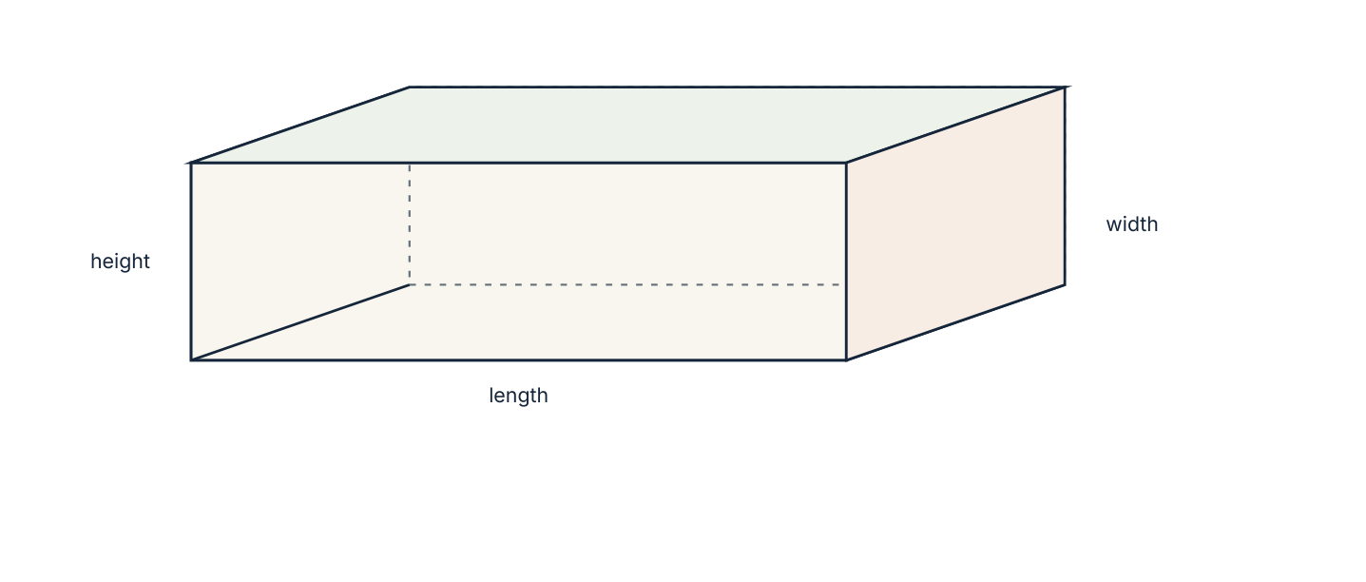
A cuboid with length, width and height marked. Its six faces come in three pairs of equal rectangles.
Solid | Faces F | Edges E | Vertices V | V − E + F
Cube | 6 | 12 | 8 | 2
Triangular prism | 5 | 9 | 6 | 2
Square-based pyramid | 5 | 8 | 5 | 2
Triangular pyramid (tetrahedron) | 4 | 6 | 4 | 2

- Copy and complete the table for two more solids of your own choosing.
- What do you notice about the last column?
- Write the relationship as an equation.
- Test it on the box in the photograph: count faces, edges and vertices.
- Which solids have all faces the same shape?
- Sketch a net for a cuboid and count the rectangles. How many different rectangles are there?
05 · EXPLAIN
A face is a flat surface, an edge is where two faces meet, and a vertex is a corner where edges meet. A net is a flat pattern that folds to make the solid. For any convex polyhedron, V − E + F = 2 (Euler's relationship).
Naming solids
Solid | Defining property | Examples
Prism | uniform cross-section, flat ends | cuboid, triangular prism
Cylinder | uniform circular cross-section | tin, pipe, tank
Pyramid | flat base, triangular faces meeting at an apex | Egyptian pyramid
Cone | circular base, curved surface to an apex | ice-cream cone
Sphere | every point the same distance from the centre | ball, globe

Worked example 8.1.1 · Using Euler's relationship
A solid has 12 faces and 30 edges. How many vertices does it have?
1 Euler's relationship is V − E + F = 2.
2 Substitute: V − 30 + 12 = 2.
3 So V − 18 = 2 and V = 20.
4 Check: 20 − 30 + 12 = 2, as required.
ANSWER 20 vertices
Substitute before rearranging; the arithmetic is less error-prone.
Worked example 8.1.2 · Counting a prism
A prism has a hexagonal cross-section. Find its number of faces, edges and vertices, and check Euler's relationship.
1 A hexagon has 6 sides, so the ends are 2 faces and the sides are 6 rectangles: F = 8.
2 Count the edges in three groups: 6 round the top, 6 round the bottom and 6 vertical, so E = 18.
3 Each end has 6 vertices: V = 12.
4 Check: 12 − 18 + 8 = 2, as Euler requires.
ANSWER F = 8, E = 18, V = 12
Counting in a system — all top edges, then all bottom, then all vertical — prevents double counting.
“A cylinder has 2 faces, 0 edges and 0 vertices, so Euler's relationship fails.” Euler's relationship applies to polyhedra, solids with flat faces only. A cylinder's curved surface is not a face in this sense, so the relationship is simply not being claimed here.
Practice 8.1
SUPPORT 1–5 · CORE 6–9 · EXTENSION 10–12
1. State the number of faces, edges and vertices of (a) a cuboid (b) a triangular prism (c) a square-based pyramid. [F]
2. Check Euler's relationship for a cube. [F]
3. A solid has 12 faces and 30 edges. Find its number of vertices. [F]
4. How many squares are in the net of a cube? [F]
5. Name a solid with a uniform triangular cross-section. [F]
6. A hexagonal prism is cut along an edge and opened flat. How many rectangles and how many hexagons does the net contain? [P]
7. A tetrahedron has 4 faces. Find its edges and vertices and check Euler's relationship. [P]
8. Sketch a net for a cuboid 4 cm by 3 cm by 2 cm and label each rectangle with its dimensions. [P]
9. Two different solids both have 6 faces. Name them. [R]
10. A prism has an n-sided cross-section. Write expressions for its faces, edges and vertices, and show that Euler's relationship holds for every n. [E]
11. A solid has 5 faces and 8 edges. Identify it and find its vertices. [E]
12. Explain why a sphere cannot be unfolded into a net of flat faces. [E]
SECTION 8.2
8.2 Surface area
Criterion A · II · D · II · Related concepts: Measurement, Models
Surface area is the total area of the outside of a solid: the material you would need to make it. A net makes the calculation visible.
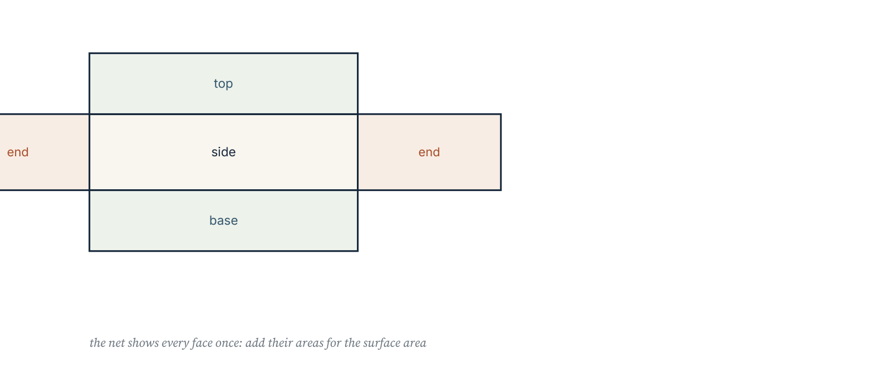
The net of a triangular prism. Each face appears exactly once, so the surface area is the sum of five flat areas.
Prism or cuboid: surface area = sum of the areas of all faces.
Cylinder (closed): S = 2πr² + 2πrh — two circles plus the curved rectangle.
Cylinder (open top): omit one circle, S = πr² + 2πrh.
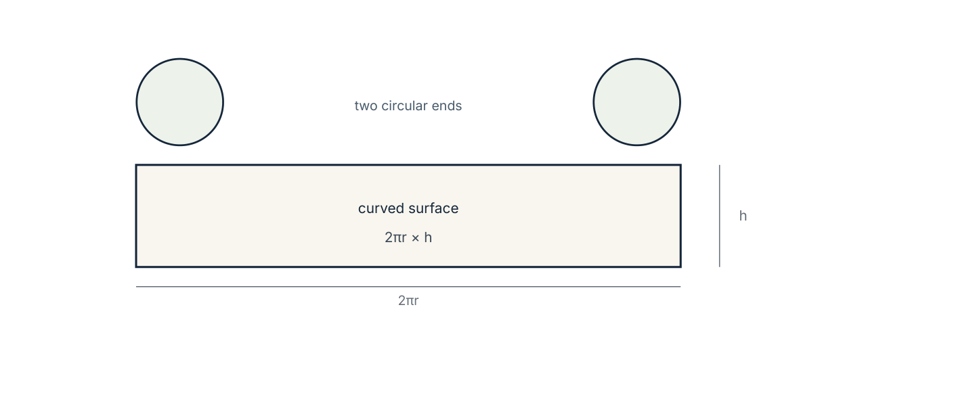
The curved surface of a cylinder unrolls into a rectangle of width 2πr and height h, which is why the curved area is 2πrh.
Worked example 8.2.1 · A cuboid
Find the surface area of a cuboid measuring 8 cm by 5 cm by 3 cm.
1 The three pairs of faces have areas 8×5 = 40, 8×3 = 24 and 5×3 = 15 cm².
2 Each area occurs twice: 2(40 + 24 + 15).
3 = 2 × 79 = 158 cm².
4 Check by imagining the net: six rectangles, three sizes, each repeated.
ANSWER 158 cm²
Adding the three different face areas first, then doubling, is faster than six separate calculations.
Worked example 8.2.2 · A closed cylinder
Find the surface area of a closed cylinder of radius 5 cm and height 12 cm, using π = 3.14.
1 Two circular ends: 2 × 3.14 × 5² = 157 cm².
2 Curved surface: 2πrh = 2 × 3.14 × 5 × 12 = 376.8 cm².
3 Total = 157 + 376.8 = 533.8 cm².
4 Check the curved area as a rectangle 31.4 cm by 12 cm: 376.8 cm².
ANSWER 533.8 cm²
If the cylinder has no lid, subtract one circle — that is 78.5 cm² less.
Worked example 8.2.3 · A triangular prism
A triangular prism has a right-angled triangular cross-section with legs 3 cm and 4 cm, and length 10 cm. Find its surface area.
1 Cross-section area = ½ × 3 × 4 = 6 cm²; two ends give 12 cm².
2 The hypotenuse is 5 cm (3-4-5 triangle), so the perimeter of the end is 3 + 4 + 5 = 12 cm.
3 The three rectangular sides have total area 12 × 10 = 120 cm².
4 Surface area = 12 + 120 = 132 cm².
ANSWER 132 cm²
The perimeter of the cross-section × length gives all the rectangular faces at once.
“The surface area of a cylinder is 2πrh, because that is the only curved part.” The two circular ends are also surface: omitting them loses 2πr², which for r = 5 cm is 157 cm² — nearly a third of the total.
Practice 8.2
SUPPORT 1–5 · CORE 6–9 · EXTENSION 10–12
1. Find the surface area of a cuboid 8 cm by 5 cm by 3 cm. [F]
2. Find the surface area of a cube of edge 7 cm. [F]
3. Find the surface area of a closed cylinder with r = 5 cm and h = 12 cm. [F]
4. Find the surface area of a closed cylinder with r = 7 cm and h = 10 cm. [F]
5. An open cylinder (no lid) has r = 4 cm and h = 9 cm. Find its surface area. [F]
6. A triangular prism has a right-angled end with legs 3 cm and 4 cm, and length 10 cm. Find its surface area. [P]
7. Find the surface area of a cuboid 12 cm by 7 cm by 4 cm. [P]
8. A water tank is an open cylinder of radius 0.5 m and height 2 m. Find the area of metal used. [P]
9. A cube has surface area 150 cm². Find its edge length and its volume. [P]
10. Two cylinders have the same height. One has twice the radius of the other. How many times greater is its curved surface area? Justify your answer. [R]
11. A cylinder is twice as tall as its radius. Write its surface area in terms of r only. [E]
12. A box with no lid is made from a single sheet of card 20 cm square by cutting 4 cm squares from each corner and folding up the sides. Find its surface area. [E]
SECTION 8.3
8.3 Volume of prisms and cylinders
Criterion A · III · D · III · Related concepts: Measurement, Form
Volume measures the space inside a solid. For any prism, one multiplication of the cross-section by the length settles it.
Prism: V = area of cross-section × length.
Cuboid: V = l×w×h. Cylinder: V = πr²h.
Cone: V = ⅓πr²h. Sphere: V = ⅔πr³.
Capacity: 1 litre = 1000 cm³ = 0.001 m³.
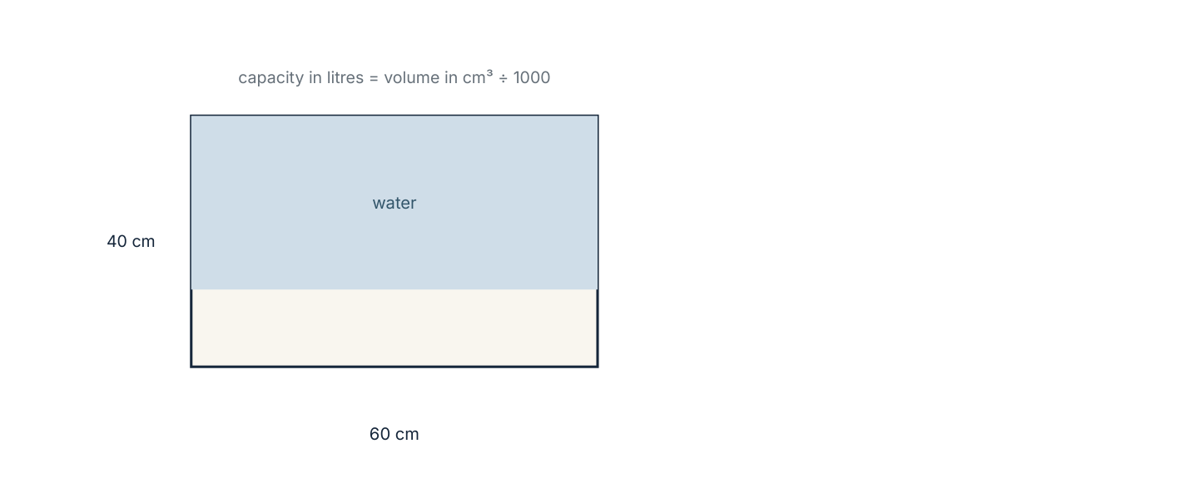
A rectangular tank partly filled. The capacity in litres is the volume in cubic centimetres divided by 1000.
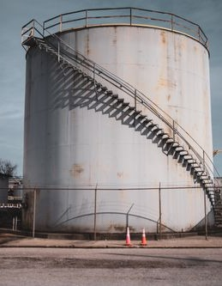
A cylindrical storage tank. Its capacity is πr²h; its material cost is the surface area of the same cylinder.
Photograph: Pexels, free to use under the Pexels licence.
Worked example 8.3.1 · Cuboid and prism
Find the volume of (a) a cuboid 6 cm by 4 cm by 2 cm and (b) a prism whose cross-section has area 12 cm² and whose length is 7 cm.
1 (a) Volume = 6 × 4 × 2 = 48 cm³.
2 (b) Volume = cross-section × length = 12 × 7 = 84 cm³.
3 Both answers are in cubic centimetres: three lengths were multiplied.
4 Check (b) by imagining seven slices each 12 cm² thick.
ANSWER (a) 48 cm³ (b) 84 cm³
Slice-and-stack is the meaning of volume; the formula is just the shortcut.
Worked example 8.3.2 · A cylinder, and a capacity
A cylindrical tank has diameter 1 m and height 2 m. Find its volume in cubic metres and its capacity in litres, using π = 3.14.
1 Radius = 0.5 m.
2 Volume = πr²h = 3.14 × 0.25 × 2 = 1.57 m³.
3 1 m³ = 1000 litres, so the capacity is 1570 litres.
4 Check: 0.5 m radius gives a cross-section of 0.785 m², and two metres of depth doubles it.
ANSWER 1.57 m³ = 1570 litres
Convert after computing; converting first multiplies the chance of error.
Worked example 8.3.3 · Working backwards
A cylinder of radius 5 cm has volume 314 cm³. Find its height.
1 V = πr²h, so 314 = 3.14 × 25 × h.
2 3.14 × 25 = 78.5, so h = 314 ÷ 78.5 = 4.
3 The height is 4 cm.
4 Check: 78.5 × 4 = 314, as given.
ANSWER 4 cm
Divide by the area of the base: height = volume ÷ base area.
“A tank 1 m by 1 m by 1 m holds 100 litres.” It holds 1000 litres: 1 m³ = 100 × 100 × 100 cm³ = 1 000 000 cm³, and each litre is 1000 cm³. Volume units convert by cubes of the length conversion, not by the conversion itself.
Practice 8.3
SUPPORT 1–5 · CORE 6–10 · EXTENSION 11–13
1. Find the volume of a cuboid 6 cm by 4 cm by 2 cm. [F]
2. Find the volume of a cube of edge 5 cm. [F]
3. Find the volume of a prism with cross-section area 12 cm² and length 7 cm. [F]
4. Find the volume of a cylinder with r = 3 cm and h = 10 cm. [F]
5. Find the volume of a cylinder with diameter 14 cm and height 20 cm. [F]
6. A cylinder of radius 5 cm has volume 314 cm³. Find its height. [P]
7. A tank is a cylinder of radius 0.5 m and height 2 m. Find its capacity in litres. [P]
8. A prism has a trapezium cross-section with parallel sides 6 cm and 4 cm and height 3 cm. Its length is 8 cm. Find its volume. [P]
9. A cuboid has volume 240 cm³, length 8 cm and width 5 cm. Find its height. [P]
10. A cube has the same numerical value for its volume and its surface area. Find its edge length. [R]
11. Find the volume of a cone with r = 3 cm and h = 7 cm. [E]
12. Find the volume of a sphere of radius 6 cm. [E]
13. A tap fills a 3-litre container every minute. How long does it take to fill a cylinder of radius 20 cm and height 50 cm? Give your answer in minutes and seconds. [E]
SECTION 8.4
8.4 Composite solids
Criterion C · III · D · IV · Related concepts: Form, Models
Most manufactured objects are combinations of simple solids. Splitting them correctly decides whether the answer is right.
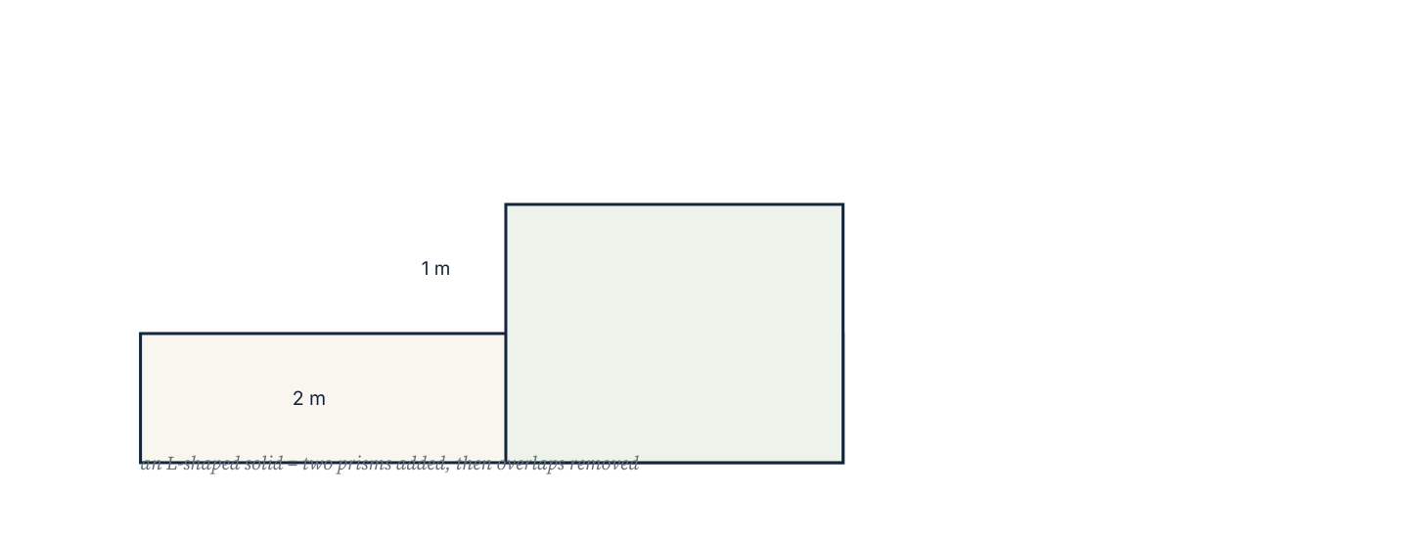
An L-shaped solid treated as two prisms. Adding the parts works for volume; for surface area the shared faces must be removed.
Volumes add without complication, because the parts do not overlap. Surface areas do not: where two solids are joined, the faces that touch disappear from the surface, and both must be subtracted.
Worked example 8.4.1 · Two cuboids
A solid is made by stacking a cuboid 8 cm by 5 cm by 3 cm on a cuboid 8 cm by 5 cm by 2 cm. Find its volume and its surface area.
1 Volumes add: 8×5×3 = 120 and 8×5×2 = 80, total 200 cm³.
2 Surface areas separately: 2(40 + 24 + 15) = 158 and 2(40 + 16 + 10) = 132, total 290 cm².
3 The joined faces are two 8 × 5 rectangles, 40 cm² each, and both disappear: subtract 80.
4 Surface area = 290 − 80 = 210 cm².
ANSWER 200 cm³; 210 cm²
Only the contact faces vanish, not the whole of each solid's base.
Worked example 8.4.2 · A hole through a solid
A cuboid 20 cm by 10 cm by 6 cm has a cylindrical hole of radius 2 cm drilled right through it. Find the volume of material remaining.
1 Cuboid volume = 20 × 10 × 6 = 1200 cm³.
2 Cylinder volume = π × 2² × 6 = 3.14 × 4 × 6 = 75.36 cm³.
3 Remaining = 1200 − 75.36 = 1124.64 cm³.
4 The hole is 6 cm long because it goes through the 6 cm thickness.
ANSWER 1124.64 cm³
The length of the hole equals the dimension it passes through, not the largest dimension.
Worked example 8.4.3 · A swimming pool
A pool is 25 m long, 10 m wide and 2 m deep, filled to 10 cm below the top. Find the volume of water in litres.
1 Water depth = 2 − 0.1 = 1.9 m.
2 Volume = 25 × 10 × 1.9 = 475 m³.
3 1 m³ = 1000 litres, so the water is 475 000 litres.
4 Check the full capacity: 500 m³ = 500 000 litres, and 475 000 is plausibly less.
ANSWER 475 000 litres
Read the depth given, not the depth of the pool: the question says how full it is.
“The surface area of the stacked solid is the sum of the two surface areas, because stacking does not change either one.” Stacking hides two rectangles — one from each solid — so the total falls. Only volume is unaffected by joining.
Practice 8.4
SUPPORT 1–4 · CORE 5–9 · EXTENSION 10–12
1. Two cuboids measure 8×5×3 cm and 8×5×2 cm and are stacked. Find the total volume. [F]
2. A cuboid 20×10×6 cm has a cylindrical hole of radius 2 cm through its 6 cm thickness. Find the remaining volume. [F]
3. Two cubes of edge 4 cm are glued face to face. Find the total surface area. [F]
4. A pool is 25 m by 10 m by 2 m. Find its volume in litres. [F]
5. A solid is a cuboid 12 cm by 6 cm by 4 cm with a 6 cm by 3 cm by 4 cm notch removed. Find its volume. [P]
6. A cylindrical tank of radius 30 cm and height 100 cm is half full. Find the volume of water in litres. [P]
7. A room is 5 m by 4 m by 2.5 m. Find the area of its four walls, excluding floor and ceiling. [P]
8. Paint covers 10 m² per litre. How many litres are needed for two coats on the four walls of the room in question 7? [P]
9. A student says doubling every dimension of a cuboid doubles its volume. Test the claim with a 2×3×4 cm cuboid. [R]
10. A capsule is a cylinder of radius 2 cm and length 6 cm with a hemisphere added at each end. Find its total volume. [E]
11. A garden water butt is a cylinder of diameter 80 cm and height 1.1 m. How many litres does it hold when full? [E]
12. A concrete step is 1.2 m wide, 30 cm deep and 15 cm high. A path needs 12 identical steps. Find the total volume of concrete, in m³. [E]
The packaging brief (Criterion D)
A small business sells tea in 250 g packs. Each pack must hold 250 cm³, and the box must be a cuboid with a square base of side x cm and height h cm. Card costs £0.004 per cm².
- Write h in terms of x, given that the volume is 250 cm³.
- Write the surface area of the closed box in terms of x.
- Complete a table of surface area for x = 4, 5, 6, 7 and 8 cm.
- Which of these sizes uses least card? What is the cost per box?
- Explain why the surface area does not keep falling as x increases.
- Recommend a size, and state one practical reason for choosing a size that is not the mathematical minimum.
06 · INVESTIGATE AND APPLY
Scaling, and the shape that saves material.
Doubling everything (Investigation)
A model is built at twice the size of the original. Only some of its measurements double.
- Take a cube of edge 1 cm and record its surface area and volume.
- Repeat for edges 2, 3 and 4 cm.
- Record the ratios of surface area and volume to the original.
- Write each measurement as a formula in the edge length s.
- Explain why volume grows eightfold when the edge doubles.
- A 30 cm pizza is sold for £9 and a 40 cm pizza for £14. Which is better value per cm² of pizza?
- Write one sentence on why large animals need thicker legs relative to their size.
The cheapest can (Investigation)
A drinks can must hold 330 cm³. Its radius and height can vary, but the volume is fixed.
- Write h in terms of r for a fixed volume of 330 cm³.
- Write the surface area of the closed can in terms of r.
- Complete a table of surface area for r = 2.5, 3, 3.5, 4 and 4.5 cm.
- Identify the radius that gives the least surface area.
- Measure a real 330 cm³ can and compare its dimensions with your answer.
- Explain one reason manufacturers might not use the material-minimising shape.
- Describe what your table shows about the shape of the graph of surface area against radius.
07 · REFLECT AND CONSOLIDATE
SECTION 8.6
8.6 Summary, revision and reflection
What this chapter established
- Solids are described by faces, edges and vertices; V − E + F = 2 for polyhedra.
- A net shows every face once, so it turns surface area into a sum of flat areas.
- Surface area of a closed cylinder is 2πr² + 2πrh; an open one loses a circle.
- Volume of any prism is cross-section × length; a cylinder is the same rule with a circular cross-section.
- 1 litre = 1000 cm³ and 1 m³ = 1000 litres.
- Volumes of joined solids add; surface areas do not, because contact faces are hidden.
Vocabulary to use precisely
face · edge · vertex · net · prism · cross-section · surface area · volume · capacity · composite solid · Euler's relationship
Misconceptions to close
The mistake | What is really happening
Forgetting the two circular ends of a cylinder. | They are surface too; only an open top removes one circle.
Using the diameter in πr². | Halve it first; otherwise the answer is four times too large.
Adding surface areas of joined solids. | Contact faces are no longer on the surface and must be subtracted twice.
Converting m³ to litres by multiplying by 100. | 1 m³ = 1000 litres; volume conversions use cubes of the length conversion.

Revision questions
- Find the surface area of a cube of edge 9 cm.
- Find the volume of a cylinder with r = 4 cm and h = 15 cm.
- A cuboid has volume 180 cm³, length 9 cm and width 5 cm. Find its height.
- A tank holds 2.4 m³. How many litres is that?
- Two cubes of edge 5 cm are joined face to face. Find the surface area of the result.
Self-assessment
I can … | Not yet | Getting there | Confident
count faces, edges and vertices and use Euler's relationship | □ | □ | □
find the surface area of a prism from its net | □ | □ | □
find the surface area of a closed or open cylinder | □ | □ | □
find the volume of a prism, cylinder, cone or sphere | □ | □ | □
convert between cm³, m³ and litres | □ | □ | □
handle a composite solid's volume and surface area | □ | □ | □

Reflect on the criteria
Criterion A: which formula can you now choose without prompting?
Criterion B: what did the scaling investigation show you about powers?
Criterion C: did your units and diagrams communicate the method?
Criterion D: how did a calculation change a design decision?
ATL · Transfer skills
In order for a student to model a container, students must decide whether the question asks for material or capacity, then justify the formula and the units.
Mixed practice · consolidate and extend
Practice 8.M
MIXED 1–12
1. State the number of edges of a triangular prism. [F]
2. Find the volume of a cuboid 9 cm by 6 cm by 5 cm. [F]
3. Find the surface area of a cube of edge 7 cm. [F]
4. Find the volume of a cylinder with r = 5 cm and h = 8 cm. [F]
5. How many litres are in 2.5 m³? [F]
6. A cylinder has volume 942 cm³ and height 12 cm. Find its radius. [P]
7. A cuboid 15 cm by 8 cm by 5 cm is painted on all faces. Find the painted area. [P]
8. A cylinder with no lid has r = 10 cm and h = 14 cm. Find its surface area. [P]
9. A student says a cube of edge 2 cm has twice the volume of a cube of edge 1 cm. Correct the statement. [R]
10. A fish tank is 60 cm long, 30 cm wide and 40 cm deep, filled to 5 cm below the top. How many litres of water does it hold? [E]
11. A cone and a cylinder have the same radius and height. How many cones fill the cylinder? Justify with the formulas. [E]
12. A cylindrical pipe has outer diameter 10 cm and inner diameter 8 cm, and is 1 m long. Find the volume of metal in the pipe. [E]

Answers · chapter 8
PRACTICE 8.1
1. (a) 6, 12, 8 (b) 5, 9, 6 (c) 5, 8, 5.
2. 8 − 12 + 6 = 2, so it holds.
3. 20.
4. Six.
5. A triangular prism.
6. Six rectangles and two hexagons: eight faces in the net.
7. E = 6, V = 4, and 4 − 6 + 4 = 2.
8. A cross of six rectangles; the two 4×3 faces, two 4×2 and two 3×2.
9. A cuboid and a square-based pyramid (both have 6 faces).
10. F = n + 2, E = 3n, V = 2n, and 2n − 3n + n + 2 = 2.
11. A square-based pyramid; V = 5.
12. A sphere has no flat faces and no edges, so it cannot be unfolded into a net of polygons.
PRACTICE 8.2
1. 158 cm².
2. 294 cm².
3. 533.8 cm².
4. 747.32 cm².
5. 276.32 cm².
6. 132 cm².
7. 320 cm².
8. 7.065 m².
9. Edge 5 cm; volume 125 cm³.
10. Twice: the curved area is 2πrh, which is proportional to r.
11. S = 2πr² + 4πr² = 6πr².
12. The base is 12 cm by 12 cm and the four sides are 12 cm by 4 cm: 144 + 192 = 336 cm².
PRACTICE 8.3
1. 48 cm³.
2. 125 cm³.
3. 84 cm³.
4. 282.6 cm³.
5. 3077.2 cm³.
6. 4 cm.
7. 1570 litres.
8. 120 cm³.
9. 6 cm.
10. 6 cm, since 6³ = 216 and 6 × 6² = 216.
11. 65.94 cm³.
12. 904.32 cm³.
13. Volume = 62 800 cm³ ≈ 62.8 litres, so 20.9 minutes, about 20 minutes 56 seconds.
PRACTICE 8.4
1. 200 cm³.
2. 1124.64 cm³.
3. 160 cm².
4. 500 000 litres.
5. 216 cm³.
6. 141.3 litres.
7. 45 m².
8. 9 litres.
9. Volume becomes 8 times: 192 cm³ against 24 cm³.
10. Cylinder 3.14 × 4 × 6 = 75.36 cm³; the two hemispheres make one sphere, ⅔ × 3.14 × 8 = 33.49 cm³; total 108.85 cm³.
11. π × 40² × 110 = 552 640 cm³ ≈ 553 litres.
12. 0.054 m³ per step, so 0.648 m³ for twelve steps.
PRACTICE 8.M
1. 9.
2. 270 cm³.
3. 294 cm².
4. 628 cm³.
5. 2500 litres.
6. r = 5 cm.
7. 470 cm².
8. 1193.2 cm².
9. It has 8 times the volume, because 2³ = 8.
10. 60 × 30 × 35 = 63 000 cm³ = 63 litres.
11. Three: the cone is ⅓πr²h and the cylinder πr²h.
12. 3.14 × (25 − 16) × 100 = 2826 cm³.

PART III · GEOMETRY AND SPACE
9 Transformations and symmetry
Geometry and space · key concept Relationships · Patterns, Movement
A transformation moves a shape without arguing about it:
every point obeys the same rule. Symmetry is what you get
when the rule leaves the shape looking unchanged.
Global context: Personal and cultural expression
01 · MYP UNIT PLANNER
Four moves, one coordinate grid, and the patterns they generate.
STATEMENT OF INQUIRY A small set of transformations generates every repeating pattern, so the symmetry of a design can be described as precisely as its geometry.
Key and related concepts
Key concept · Relationships. Each transformation is a rule linking every point to exactly one image point.
Related · Patterns. Repetition is the visible result of a transformation applied again and again.
Related · Movement. Translation, reflection, rotation and enlargement are the four ways a figure can be moved.
Global context · Personal and cultural expression
Exploration: symmetry in textile design, mosaic and architecture. A pattern is a cultural statement made with mathematical operations.
Inquiry questions
- Factual: What are the four types of transformation?
- Conceptual: Why does reflection change orientation while rotation does not?
- Debatable: Can a design be both original and fully symmetrical?
Criterion | Strands | Evidence in this chapter
A · Knowing and understanding | i, ii | Perform and describe the four transformations on a grid.
B · Investigating patterns | i, ii, iii | Investigate symmetry orders and which shapes tile.
C · Communicating | ii, iii, iv | Describe a transformation fully, with centre, angle or vector.
D · Applying mathematics | i, ii, iii, iv | Design a repeat pattern and justify the transformations used.

ATL · Thinking skills
In order for a student to describe a transformation completely, students must state its type and every detail it requires — vector, mirror line, centre and angle, or centre and scale factor.
02 · LEARNING INTENTIONS AND SUCCESS CRITERIA
You are learning to | You have succeeded when you can
Translate a shape using a column vector. | Move a point by (−3, 4) and give the new coordinates.
Reflect a shape in a given line. | Reflect in the x-axis, the y-axis, y = x and y = −x.
Rotate a shape about a point. | Rotate 90° or 180° and state the direction.
Enlarge a shape from a centre. | Apply scale factors greater or less than 1, including negative ones.
Identify lines and orders of symmetry. | Count them for regular polygons and for a design.
Describe a transformation fully. | Say “reflection in the line y = x”, not just “reflection”.

Prerequisite check · 10 minutes, no calculator
- Plot the points (2, 3) and (−1, 4).
- Write the coordinates of the point 4 units right and 2 down from (1, 5).
- Calculate 3 × 4².
- Name a shape with 4 lines of symmetry.
- How many degrees in a quarter turn?
- Calculate ½ × 8.
If three or more answers are wrong, revisit coordinates and ratio before continuing.
SECTION 9.1
9.1 Translation
Criterion A · I · C · II · Related concepts: Movement, Patterns
A translation slides a shape without turning it. Every point moves by the same amount in the same direction, so the shape's size and orientation are unchanged.
03 · ENGAGE
One tile, repeated.
A wall of identical tiles is built by placing each tile beside the last. Before reading on, describe in words, as precisely as you can, the movement from one tile to the next — and explain why a builder only needs to be told the first tile and that movement.
04 · EXPLORE
Move, record, compare.
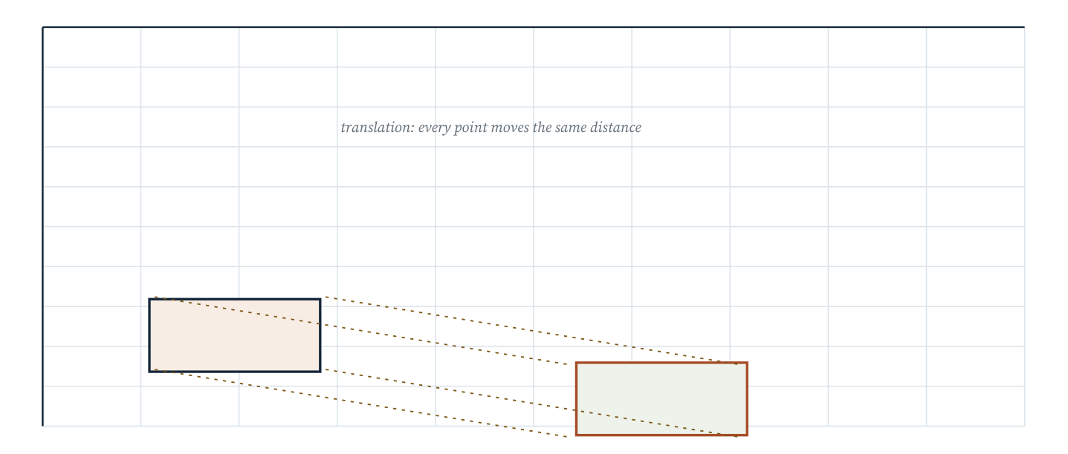
The same shape translated by the vector (5, −2). Every vertex moves 5 units right and 2 down; the image is congruent to the object.
- Copy the diagram onto squared paper and record the coordinates of both shapes.
- Subtract the object's coordinates from the image's. What do you notice?
- Write the movement as a column vector.
- Translate the image again by the same vector and record the new coordinates.
- Describe the single translation equivalent to the two moves together.
- What happens if you apply the opposite vector to the image?
05 · EXPLAIN
A translation moves every point of a shape the same distance in the same direction. It is described by a column vector ( a over b ): a units right and b units up, with negative values meaning left and down. A translation produces a congruent image.
Worked example 9.1.1 · Translate a point
Translate the point A(2, 3) by the vector (3, −1). State the image.
1 A move of 3 right adds 3 to the x-coordinate: 2 + 3 = 5.
2 A move of 1 down subtracts 1 from the y-coordinate: 3 − 1 = 2.
3 The image is A′(5, 2).
4 Check the direction: the new point is right and below the original.
ANSWER A′(5, 2)
Add the vector to the coordinates; do not multiply.
Worked example 9.1.2 · Translate a triangle
A triangle has vertices (1, 1), (4, 1) and (1, 3). Translate it by the vector (2, 3).
1 Apply the same vector to each vertex.
2 (1, 1) → (3, 4); (4, 1) → (6, 4); (1, 3) → (3, 6).
3 The image triangle has vertices (3, 4), (6, 4) and (3, 6).
4 Check: each image vertex is 2 right and 3 above its object vertex.
ANSWER (3, 4), (6, 4), (3, 6)
A translation keeps side lengths and angles, so the image is congruent.
Worked example 9.1.3 · Find the vector
A translation maps (2, 5) to (2, 1). Find the vector and the image of (7, 3).
1 The x-coordinate does not change: the horizontal component is 0.
2 The y-coordinate falls from 5 to 1: the vertical component is −4.
3 The vector is (0, −4).
4 Applying it to (7, 3) gives (7, −1).
ANSWER (0, −4); image (7, −1)
Subtract the object coordinates from the image coordinates to find the vector.
“A translation changes the size of the shape if the vector is long.” A translation only moves a shape; it never stretches it. The vector describes distance and direction, not scale.
Practice 9.1
SUPPORT 1–5 · CORE 6–9 · EXTENSION 10–12
1. Translate A(2, 3) by the vector (3, −1). State the image. [F]
2. Translate B(−1, 4) by the vector (2, 2). [F]
3. Describe the translation that maps (1, 1) to (4, 5). [F]
4. A triangle has vertices (1, 1), (4, 1), (1, 3). Translate it by (2, 3). [F]
5. A translation maps (2, 5) to (2, 1). Find the vector. [F]
6. A translation maps (2, 5) to (2, 1). Find the image of (7, 3). [P]
7. Apply the translation (2, 1) and then (−3, 4) to the point (0, 0). Describe the single equivalent translation. [P]
8. Translate the square with vertices (0, 0), (2, 0), (2, 2), (0, 2) by (−3, 1) and give all four image vertices. [P]
9. A student says “the image of a translation is similar but not congruent”. Correct the statement. [R]
10. A translation maps A(−2, 3) to B(4, −1). Find the vector, and the point that maps to (0, 0). [E]
11. A translation maps (x, y) to (x + 3, y − 2). Find the point whose image is (1, 1). [E]
12. Explain why applying a translation twice is the same as applying one vector, and write the resulting vector for (2, 1) followed by (2, 1). [E]
SECTION 9.2
9.2 Reflection and line symmetry
Criterion A · II · B · I · Related concepts: Patterns, Form
A reflection flips a shape across a mirror line. Distances from the line are preserved, but the shape's orientation is reversed.
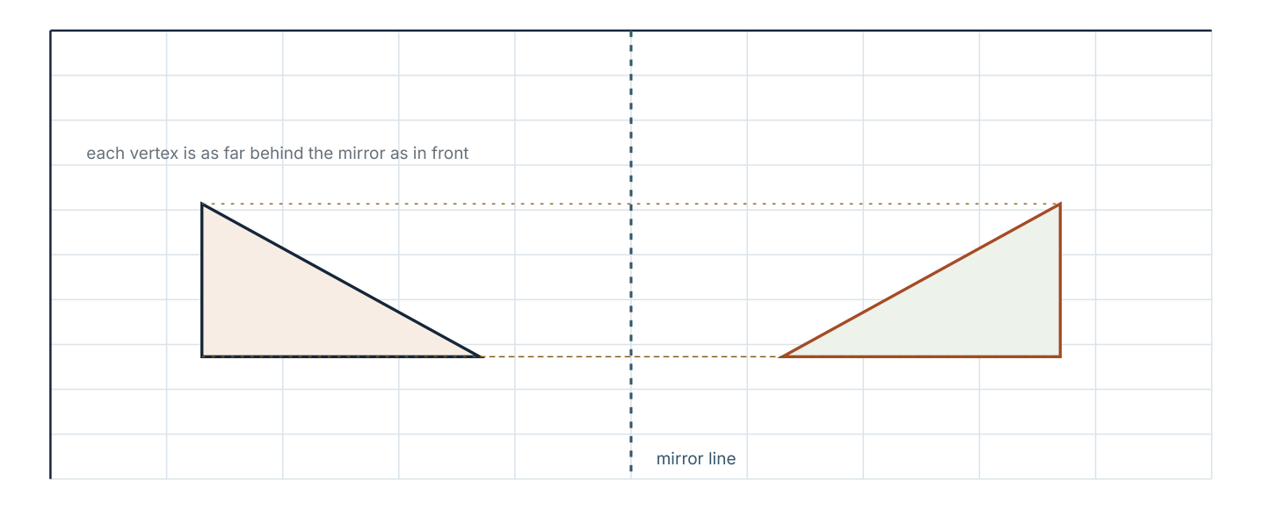
A reflection in the line y = x. Each point and its image are the same distance from the mirror line, measured perpendicular to it.
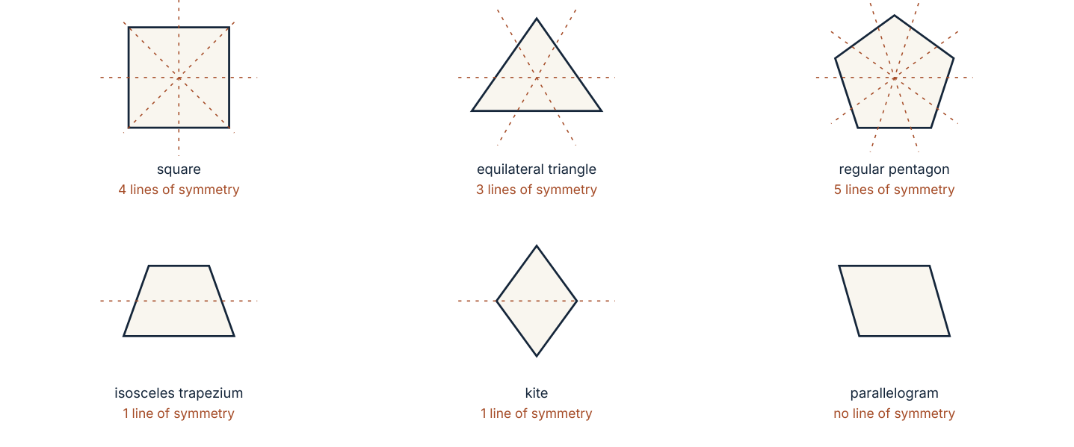
Lines and orders of symmetry for regular polygons. A regular n-gon has n lines of symmetry and rotational symmetry of order n.
Mirror line | Rule for the image of (x, y)
the x-axis | (x, −y)
the y-axis | (−x, y)
the line y = x | (y, x)
the line y = −x | (−y, −x)

A line of symmetry divides a shape into two halves that are mirror images. A shape's order of rotational symmetry is the number of positions in a full turn in which it looks unchanged. A circle has infinitely many lines of symmetry.
Worked example 9.2.1 · Reflect a point
Reflect (3, 2) in (a) the x-axis, (b) the y-axis and (c) the line y = x.
1 (a) The x-axis flips vertically: (3, −2).
2 (b) The y-axis flips horizontally: (−3, 2).
3 (c) In y = x the coordinates swap: (2, 3).
4 Check (c): the line y = x is the diagonal through (0, 0) and (1, 1).
ANSWER (3, −2), (−3, 2) and (2, 3)
Sketch the point and the mirror line before applying the rule.
Worked example 9.2.2 · Reflect a triangle
A triangle has vertices (1, 1), (3, 1) and (2, 4). Reflect it in the x-axis.
1 Reflecting in the x-axis sends (x, y) to (x, −y).
2 (1, 1) → (1, −1); (3, 1) → (3, −1); (2, 4) → (2, −4).
3 The image triangle is below the axis, with the same side lengths.
4 The image is congruent but has been flipped: clockwise has become anticlockwise.
ANSWER (1, −1), (3, −1), (2, −4)
All three vertices must move; a reflection is determined by its mirror line.
Worked example 9.2.3 · Symmetry of a shape
How many lines of symmetry and what order of rotational symmetry does (a) a square and (b) a regular hexagon have?
1 (a) A square has 4 lines of symmetry: one vertical, one horizontal and two diagonals.
2 Its rotational symmetry is of order 4, because a quarter turn returns it to itself.
3 (b) A regular hexagon has 6 lines of symmetry and rotational symmetry of order 6.
4 For a regular polygon both numbers equal the number of sides.
ANSWER (a) 4 lines, order 4 (b) 6 lines, order 6
For a regular polygon, lines of symmetry = order of rotational symmetry = number of sides.
“Every quadrilateral has four lines of symmetry.” Only a square does. A rectangle has two, a rhombus two, a parallelogram none — and a kite has one. Symmetry depends on the shape's actual proportions, not its name.
Practice 9.2
SUPPORT 1–5 · CORE 6–9 · EXTENSION 10–12
1. Reflect (3, 2) in the x-axis, then in the y-axis. [F]
2. Reflect (−4, 5) in the x-axis. [F]
3. Reflect (5, −2) in the y-axis. [F]
4. Reflect (2, 6) in the line y = x. [F]
5. How many lines of symmetry has (a) a square (b) a rectangle (c) an equilateral triangle (d) a circle? [F]
6. Reflect the triangle (1, 1), (3, 1), (2, 4) in the x-axis. [P]
7. Reflect (3, 1) in the line y = −x. [P]
8. A shape has rotational symmetry of order 6 but no line of symmetry. Describe what such a shape might look like. [R]
9. Do the letters A, H, N and S have line symmetry? State how many lines each has. [P]
10. Reflect (5, 3) in the line y = 2. Describe a rule that works for any point reflected in a horizontal line. [E]
11. Explain why reflecting a shape twice in the same line returns it to its original position. [E]
12. Reflect (4, 1) in y = x and then in the y-axis. Describe the single transformation equivalent to the two reflections. [E]
SECTION 9.3
9.3 Rotation and rotational symmetry
Criterion A · III · C · III · Related concepts: Movement, Space
A rotation turns a shape about a fixed point. The centre, the angle and the direction together determine the image completely.
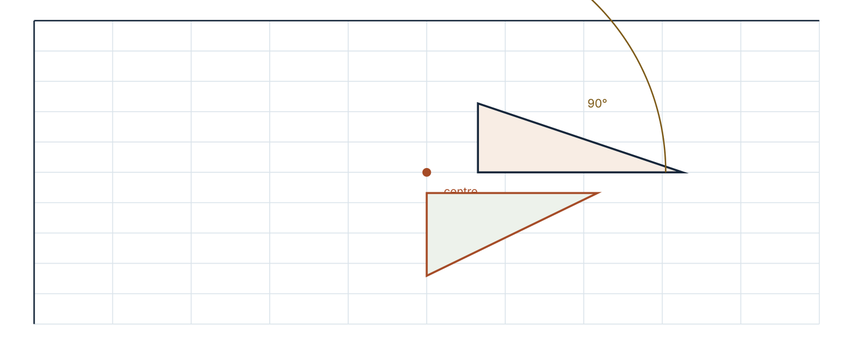
A rotation of 90° anticlockwise about the origin. Distances from the centre are preserved; only direction changes.
Rotation about the origin | Rule for (x, y)
90° clockwise | (y, −x)
90° anticlockwise | (−y, x)
180° (either direction) | (−x, −y)

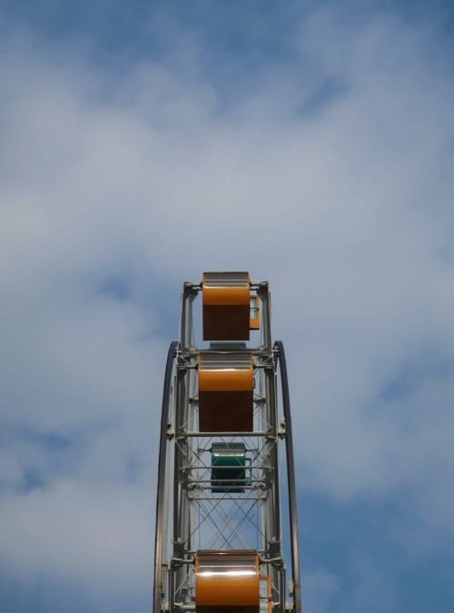
A Ferris wheel. Each cabin is carried through the same rotation about the hub, so the wheel's rotational symmetry is of high order.
Photograph: Pexels, free to use under the Pexels licence.
A rotation turns a shape about a centre through a given angle, either clockwise or anticlockwise. Rotations preserve lengths and angles but change the direction a shape faces.
Worked example 9.3.1 · Rotate a point
Rotate the point (3, 0) about the origin by (a) 90° clockwise and (b) 180°.
1 (a) 90° clockwise sends (x, y) to (y, −x): (0, −3).
2 (b) 180° sends (x, y) to (−x, −y): (−3, 0).
3 Check: the distance from the origin is 3 in every case.
4 The point has moved round the origin, not towards or away from it.
ANSWER (0, −3) and (−3, 0)
The distance to the centre never changes under rotation, which is a quick check.
Worked example 9.3.2 · Find the rotation
A rotation about the origin maps (5, 0) to (0, 5). Describe it.
1 The image is on the y-axis, so the turn is a quarter turn.
2 Moving from the positive x-axis to the positive y-axis is anticlockwise.
3 The rotation is 90° anticlockwise about the origin.
4 Check with the rule: (−y, x) sends (5, 0) to (0, 5).
ANSWER 90° anticlockwise about the origin
A quarter turn clockwise would send (5, 0) to (0, −5).
Worked example 9.3.3 · Order of rotational symmetry
What is the order of rotational symmetry of a regular pentagon, and of the letter S?
1 A regular pentagon looks unchanged after each 360° ÷ 5 = 72° turn.
2 It returns to itself five times in a full turn, so the order is 5.
3 The letter S is unchanged after a half turn, so its order is 2.
4 A shape with no rotational symmetry other than 360° has order 1.
ANSWER Pentagon 5; letter S 2
Order counts the positions in a full turn where the shape looks the same, including the start.
“A rotation changes the size of a shape, because the far corners travel further.” Points further from the centre do move further, but every distance within the shape is unchanged, so the image is congruent. Only an enlargement changes size.
Practice 9.3
SUPPORT 1–5 · CORE 6–9 · EXTENSION 10–12
1. Rotate (3, 0) about the origin by 90° clockwise. [F]
2. Rotate (3, 0) about the origin by 180°. [F]
3. Rotate (2, 1) about the origin by 90° anticlockwise. [F]
4. State the order of rotational symmetry of (a) a square (b) a regular pentagon (c) a rectangle. [F]
5. What is the angle of rotation for a shape with rotational symmetry of order 8? [F]
6. Rotate the triangle (1, 0), (0, 1), (1, 1) by 90° anticlockwise about the origin. [P]
7. A rotation maps (5, 0) to (0, 5). Describe it fully. [P]
8. Rotate (4, 2) by 90° clockwise about the origin, then by 90° clockwise again. What single transformation is equivalent? [P]
9. Two students rotate a shape 90° clockwise and 270° anticlockwise. Do they get the same image? Explain. [R]
10. Rotate (2, 3) by 90° clockwise about the centre (1, 1). [E]
11. Explain why the order of rotational symmetry of a regular n-gon is n. [E]
12. A square is rotated 45° about its centre. Explain why the image is not the same square, and say what the order of symmetry tells you. [E]
SECTION 9.4
9.4 Enlargement
Criterion A · IV · D · III · Related concepts: Movement, Measurement
An enlargement changes size by a scale factor from a fixed centre. It is the only one of the four transformations that changes lengths.
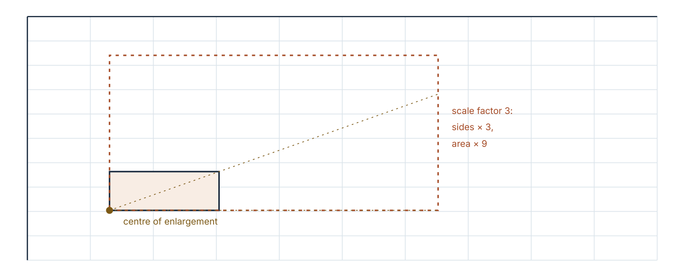
An enlargement with scale factor 3 from a centre at one corner. Every distance from the centre triples, so lengths multiply by 3 and areas by 9.
An enlargement with centre C and scale factor k sends each point to a point k times as far from C, on the same line. Lengths multiply by k, areas by k², volumes by k³. A negative k places the image on the opposite side of the centre.
Worked example 9.4.1 · Enlarge from the origin
Enlarge the triangle with vertices (1, 1), (2, 1) and (1, 2) by scale factor 3 from the origin.
1 Multiply each coordinate by 3.
2 (1, 1) → (3, 3); (2, 1) → (6, 3); (1, 2) → (3, 6).
3 The image triangle is three times as far from the origin in both directions.
4 Check a side length: 1 unit becomes 3 units, as the scale factor requires.
ANSWER (3, 3), (6, 3), (3, 6)
For a centre at the origin, an enlargement is multiplication of both coordinates.
Worked example 9.4.2 · Centre not at the origin
Enlarge the point (2, 3) by scale factor 2 from the centre (1, 1).
1 Find the vector from the centre to the point: (2 − 1, 3 − 1) = (1, 2).
2 Multiply it by the scale factor: 2 × (1, 2) = (2, 4).
3 Add it back to the centre: (1 + 2, 1 + 4) = (3, 5).
4 Check: the image is twice as far from (1, 1) as the original.
ANSWER (3, 5)
Subtract the centre first, multiply, then add the centre back.
Worked example 9.4.3 · Area and scale factor
A photograph 6 cm by 4 cm is enlarged so that its longer side becomes 15 cm. Find the scale factor and the area of the enlargement.
1 Scale factor = 15 ÷ 6 = 2.5.
2 The shorter side becomes 4 × 2.5 = 10 cm.
3 Area of the original is 24 cm²; the enlargement is 15 × 10 = 150 cm².
4 Check with the area scale factor: 24 × 2.5² = 24 × 6.25 = 150 cm².
ANSWER k = 2.5; area 150 cm²
Areas follow k², so an area check is a strong test of a scale factor.
“A shape enlarged by scale factor 2 has twice the area.” Both lengths double, so the area multiplies by 2 × 2 = 4. A 3 cm square becomes 6 cm and its area grows from 9 to 36 cm².
Practice 9.4
SUPPORT 1–5 · CORE 6–10 · EXTENSION 11–13
1. Enlarge (2, 1) by scale factor 3 from the origin. [F]
2. Enlarge (4, 6) by scale factor 0.5 from the origin. [F]
3. Enlarge the triangle (1, 1), (2, 1), (1, 2) by scale factor 2 from the origin. [F]
4. What is the area scale factor for an enlargement of scale factor 3? [F]
5. Enlarge (1, 2) by scale factor −2 from the origin. [F]
6. Enlarge (2, 3) by scale factor 2 from the centre (1, 1). [P]
7. An enlargement maps a 5 cm length to 15 cm. Find the scale factor and the area scale factor. [P]
8. A shape of area 12 cm² is enlarged by scale factor 2. Find the new area. [P]
9. A map uses a scale of 1 : 25 000. What real distance does 4 cm represent? [P]
10. A student says an enlargement with scale factor −1 is a reflection. Is the statement accurate? Explain what the transformation actually is. [R]
11. A cube of edge 2 cm is enlarged by scale factor 3. Find its new volume and compare with the original. [E]
12. An enlargement maps triangle A with area 18 cm² to triangle B with area 162 cm². Find the scale factor and the ratio of a pair of corresponding sides. [E]
13. Explain why the area scale factor is k² rather than k, using a rectangle as an example. [E]
SECTION 9.5
9.5 Tessellation and symmetry in design
Criterion B · II · D · IV · Related concepts: Patterns, Relationships
A tessellation covers the plane with no gaps and no overlaps. Which shapes can do it is decided by the angles at a point, and the design is decided by the transformations used.
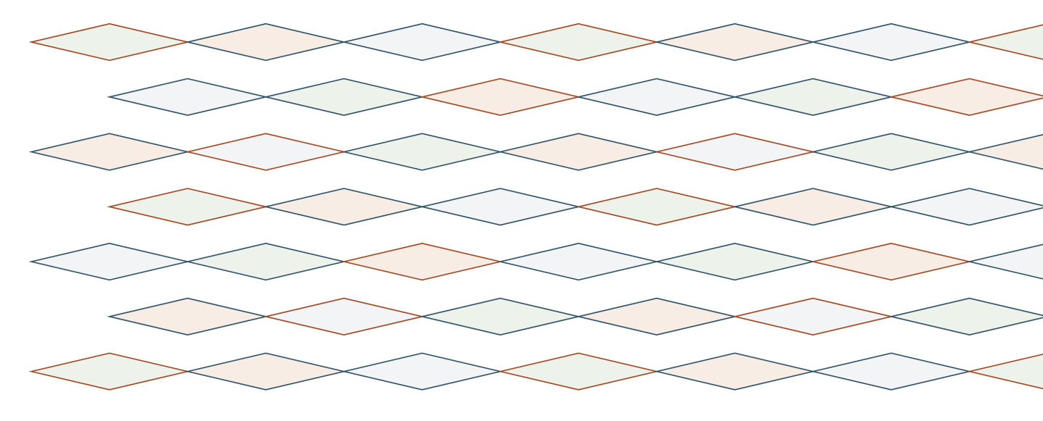
A tessellation built by translation and rotation. Each copy is congruent to the original tile.
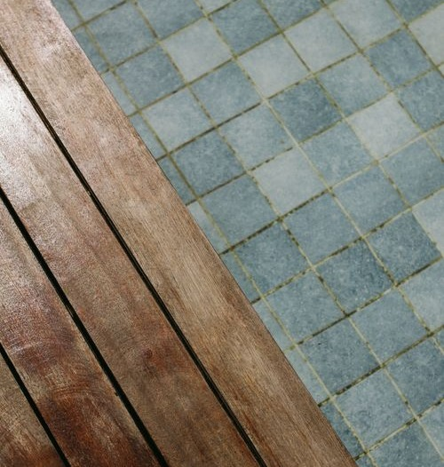
Mosaic tiles laid on a diagonal grid. The pattern is generated by translations along two directions, with reflections across the seams.
Photograph: Pexels, free to use under the Pexels licence.
Three regular hexagons meet at a vertex because 3 × 120° = 360°. Four squares meet because 4 × 90° = 360°. A regular pentagon cannot tile on its own because 108° does not divide 360° exactly — three pentagons leave a gap of 36°.
Worked example 9.5.1 · Why a shape tiles
Explain why a regular octagon does not tessellate on its own.
1 Each interior angle of a regular octagon is (8 − 2) × 180 ÷ 8 = 135°.
2 At a point the angles must total 360°: 360 ÷ 135 = 2.67.
3 Two octagons give 270°, leaving a 90° gap; three give 405°, which overlaps.
4 So octagons need another shape — a square fits the 90° gap, which is why octagons and squares tile together.
ANSWER 135° does not divide 360°
The test is always: does the interior angle divide 360 exactly?
Worked example 9.5.2 · Describing a pattern
A border design repeats a single motif every 6 cm along a strip, with each motif also reflected in the centre line. Name the transformations used.
1 Repeating along the strip is a translation by 6 cm each time.
2 The reflection across the centre line creates the mirror version.
3 The two operations together give a pattern with translation symmetry and a line of symmetry.
4 No rotation or enlargement is needed to describe the design.
ANSWER Translation and reflection
A complete description names the vector and the mirror line, not only the types.
Worked example 9.5.3 · Symmetry of a logo
A logo is a regular hexagon divided into six identical triangles, three shaded and three white, alternating. State its symmetry.
1 The hexagon returns to itself after every 60° turn, so the order of rotational symmetry is 6.
2 Alternating shading also returns after each 60°, because shading is unchanged by another sixth of a turn.
3 The three lines joining opposite vertices are lines of symmetry.
4 The three lines joining midpoints of opposite sides are not, because they swap shaded with white.
ANSWER Order 6; three lines of symmetry
Check symmetry on the colouring, not only on the outline.
“Any shape that fits around a point tiles the plane.” Meeting at one point is not enough: the arrangement must continue across the whole plane. Pentagons of the right kind can tile, but regular pentagons cannot.
Practice 9.5
SUPPORT 1–4 · CORE 5–9 · EXTENSION 10–12
1. How many squares meet at a point in a square tessellation? [F]
2. Find each interior angle of a regular octagon. [F]
3. Explain why regular hexagons tessellate. [F]
4. Name the transformation that slides a shape without turning it. [F]
5. Explain why a regular pentagon does not tessellate on its own. [P]
6. Show that regular octagons and squares can tile together. [P]
7. A pattern repeats a motif every 4 cm along a strip. Name the transformation and state its vector. [P]
8. A design has rotational symmetry of order 4 and 4 lines of symmetry. Name a shape it could be based on. [P]
9. A student says a circle has rotational symmetry of order 1. Correct the statement. [R]
10. Design a border 12 cm long using one motif, translations and reflections. Describe every transformation you used. [E]
11. Two squares and three equilateral triangles meet at a point. Show that the angles fit and describe the resulting tiling. [E]
12. Explain how a designer could produce a pattern with translation symmetry but no reflection symmetry. [E]
The textile commission (Criterion D)
A workshop is commissioned to print a repeat pattern on a 2 m length of cloth. The printer charges £18 per square metre, and a repeat motif costs £0.40 to prepare for each transformation applied to it.
- Design a motif and describe it on a grid with coordinates.
- Apply a translation to repeat it four times and state the vector.
- Apply a reflection and state the mirror line.
- Calculate the area of cloth printed and the cost of printing.
- Cost the transformations used, and compare with a design that uses one fewer transformation.
- Recommend a final design, justifying both the symmetry and the cost.
06 · INVESTIGATE AND APPLY
Which shapes tile, and which designs are symmetric.
The tiling test (Investigation)
Whether a shape tiles the plane depends on the angles that meet at a point.
- Find the interior angle of a regular triangle, square, pentagon, hexagon and octagon.
- For each, test whether 360· is a whole-number multiple of the interior angle.
- Record your results in a table and identify which shapes tile.
- Test combinations: square and triangle, hexagon and triangle, octagon and square.
- Write a rule for a pair of shapes that will tile together.
- Design a tiling of your own using two shapes and verify the angles at every vertex.
- Explain why the rule must hold at every vertex, not only the ones you drew.
Symmetry audit of a design (Investigation)
Choose a design you can see in the room or in the photograph: a tile layout, a window grille or a fabric.
- Sketch the design and mark any lines of symmetry.
- State the order of rotational symmetry.
- Describe the translations that generate the repeat.
- Identify any reflections or rotations used in the design.
- Decide whether the design's symmetry was likely deliberate or accidental, and give a reason.
- Redesign the pattern to increase its symmetry, and describe what you changed.
- Write a paragraph on what the symmetry contributes to the design's effect.
07 · REFLECT AND CONSOLIDATE
SECTION 9.6
9.6 Summary, revision and reflection
What this chapter established
- A translation slides by a column vector and leaves size and orientation unchanged.
- A reflection flips across a mirror line; distances from the line are preserved but orientation is reversed.
- A rotation turns about a centre through an angle in a stated direction.
- An enlargement multiplies lengths by k, areas by k² and volumes by k³.
- Regular polygons have as many lines of symmetry as sides, and rotational symmetry of the same order.
- A shape tiles the plane when its angles fit exactly round a point and the arrangement continues without gaps.
Vocabulary to use precisely
translation · column vector · reflection · mirror line · rotation · centre of rotation · enlargement · scale factor · congruent · similar · tessellation · order of symmetry
Misconceptions to close
The mistake | What is really happening
Giving a transformation's type but no details. | Every transformation needs its vector, line, centre and angle, or centre and scale factor.
Thinking an enlargement of scale factor 2 doubles the area. | Area scales by k², so it quadruples.
Assuming a parallelogram has lines of symmetry. | It has none: a half turn maps it to itself, but no mirror does.
Believing a long translation vector stretches the shape. | A translation never changes size; only enlargement does.

Revision questions
- Translate (3, −2) by the vector (−1, 5).
- Reflect (−2, 7) in the x-axis.
- Rotate (0, 4) 90° clockwise about the origin.
- Enlarge (3, 2) by scale factor −2 from the origin.
- A regular nonagon: state its order of rotational symmetry and its number of lines of symmetry.
Self-assessment
I can … | Not yet | Getting there | Confident
translate a shape using a column vector | □ | □ | □
reflect a shape in a named line | □ | □ | □
rotate a shape about a centre | □ | □ | □
enlarge a shape, including from a centre not at the origin | □ | □ | □
count lines and orders of symmetry | □ | □ | □
explain why a shape does or does not tile | □ | □ | □

Reflect on the criteria
Criterion A: which transformation can you now perform without a rule sheet?
Criterion B: what did the tiling test let you predict?
Criterion C: did your description of each transformation include every detail?
Criterion D: how did cost and symmetry compete in your design?
ATL · Critical thinking
In order for a student to justify a design, students must name the transformation, state its parameters, and show that the pattern's symmetry follows from them.
Mixed practice · consolidate and extend
Practice 9.M
MIXED 1–12
1. Translate (5, 1) by (−2, −3). [F]
2. Reflect (6, −3) in the y-axis. [F]
3. Rotate (2, 0) 180° about the origin. [F]
4. Enlarge (2, 5) by scale factor 2 from the origin. [F]
5. How many lines of symmetry has a regular pentagon? [F]
6. Describe fully the translation mapping (4, 2) to (−1, 6). [P]
7. Reflect (4, 1) in the line y = x. [P]
8. Enlarge (3, 4) by scale factor 0.5 from the centre (1, 0). [P]
9. A student enlarges a rectangle 3 cm by 5 cm by scale factor 4 and says the area is 4 times as large. Correct the error. [R]
10. A regular polygon has 12 lines of symmetry. Name it and give its order of rotational symmetry. [E]
11. A map scale is 1 : 50 000. Find the real length represented by 6 cm, in kilometres. [E]
12. A design has one line of symmetry and rotational symmetry of order 1. Describe a motif that would produce it and one change that would raise its order of symmetry to 2. [E]

Answers · chapter 9
PRACTICE 9.1
1. (5, 2).
2. (1, 6).
3. A translation by (3, 4).
4. (3, 4), (6, 4), (3, 6).
5. (0, −4).
6. (7, −1).
7. (−1, 5).
8. (−3, 1), (−1, 1), (−1, 3), (−3, 3).
9. The image is congruent, not merely similar: lengths and angles are unchanged.
10. Vector (6, −4); working backwards from (0, 0) gives the pre-image (−6, 4).
11. (−2, 3).
12. Two translations add: (2, 1) + (2, 1) = (4, 2), a single translation by (4, 2).
PRACTICE 9.2
1. (3, −2) then (−3, −2).
2. (−4, −5).
3. (−5, −2).
4. (6, 2).
5. (a) 4 (b) 2 (c) 3 (d) infinitely many.
6. (1, −1), (3, −1), (2, −4).
7. (−1, −3).
8. For example, a pinwheel of six identical arms; a half turn leaves it unchanged but no mirror does.
9. A: 1, H: 2, N: 0, S: 0.
10. (5, 1); reflecting in y = c sends (x, y) to (x, 2c − y).
11. The first reflection produces the mirror image, and reflecting that image in the same line returns every point to where it started.
12. (−1, 4); the two reflections together are equivalent to a 90° anticlockwise rotation about the origin.
PRACTICE 9.3
1. (0, −3).
2. (−3, 0).
3. (−1, 2).
4. (a) 4 (b) 5 (c) 2.
5. 45°.
6. (0, 1), (−1, 0), (−1, 1).
7. 90° anticlockwise about the origin.
8. (2, −4) then (−4, −2); equivalent to a 180° rotation about the origin.
9. Yes: 270° anticlockwise is the same as 90° clockwise.
10. Relative vector (1, 2) rotates clockwise to (2, −1), so the image is (3, 0).
11. A rotation of 360° ÷ n maps the polygon onto itself, and there are n such positions before returning to the start.
12. A 45° turn puts vertices where edges were, so the image occupies a different region; the order 4 tells you only 90° turns map it to itself.
PRACTICE 9.4
1. (6, 3).
2. (2, 3).
3. (2, 2), (4, 2), (2, 4).
4. 9.
5. (−2, −4).
6. (3, 5).
7. k = 3; area factor 9.
8. 48 cm².
9. 1 km.
10. Not accurate: a scale factor of −1 is a half turn about the centre (a rotation of 180°), which looks like a reflection only for symmetric shapes.
11. Old volume 8 cm³, new volume 216 cm³, which is 27 times larger since 3³ = 27.
12. k = 3; corresponding sides are in the ratio 3 : 1.
13. A rectangle l × w becomes kl × kw, so its area multiplies by k × k = k².
PRACTICE 9.5
1. Four.
2. 135°.
3. Each interior angle is 120° and 3 × 120° = 360°, so three hexagons meet at every vertex.
4. A translation.
5. Each interior angle is 108° and 360 ÷ 108 is not a whole number: three leave a 36° gap.
6. 135 + 135 + 90 = 360, so two octagons and a square meet at each vertex.
7. A translation with vector 4 cm along the strip.
8. A square, or any design with fourfold symmetry.
9. A circle has infinitely many rotational positions in which it looks unchanged, so its order is not 1.
10. Answers vary; the description must name the vector and the mirror line.
11. 60 + 60 + 60 + 90 + 90 = 360, so the angles fit; the tiling alternates squares and triangles.
12. Use only translations of an asymmetric motif, so that no mirror line exists.
PRACTICE 9.M
1. (3, −2).
2. (−6, −3).
3. (−2, 0).
4. (4, 10).
5. Five.
6. A translation by (−5, 4).
7. (1, 4).
8. (2, 2).
9. The area is 16 times as large, since 4² = 16.
10. A regular dodecagon; order 12.
11. 3 km.
12. Answers vary; a motif with a single mirror line has order 1, and adding a copy rotated by 180° raises the order to 2.

PART IV · PROBABILITY AND DATA
10 Probability and simulation
Probability and data · key concept Logic · Chance, Models
Probability does not tell you what will happen. It measures
how strongly the evidence favours each possibility —
and it lets you build a model, then test it.
Global context: Fairness and development
01 · MYP UNIT PLANNER
From counting outcomes to testing whether a game is fair.
STATEMENT OF INQUIRY Probability assigns a number to uncertainty, and that number can be checked by experiment, so claims about chance can be tested rather than believed.
Key and related concepts
Key concept · Logic. A probability follows from the set of possible outcomes and the assumption that they are equally likely — or from the long-run behaviour of an experiment.
Related · Chance. Outcomes may be impossible, unlikely, even chance, likely or certain.
Related · Models. A tree diagram or sample-space grid is a model of the situation, and a simulation tests it.
Global context · Fairness and development
Exploration: gambling, insurance, weather forecasting and games of chance. Who bears the risk, and who profits from it, depends on probabilities being understood.
Inquiry questions
- Factual: How do you calculate the probability of a single event?
- Conceptual: Why does experimental probability approach theoretical probability as the number of trials increases?
- Debatable: Is a game fair if the expected gain is zero but the odds feel unfair?
Criterion | Strands | Evidence in this chapter
A · Knowing and understanding | i, ii | Calculate simple and combined probabilities.
B · Investigating patterns | i, ii, iii | Simulate an experiment and describe the pattern in the results.
C · Communicating | ii, iii, iv | Use notation P(A), fractions, decimals and tree diagrams correctly.
D · Applying mathematics | i, ii, iii, iv, v | Design a fair game and justify its fairness with expected values.

ATL · Thinking skills
In order for a student to test a claim about chance, students must design a simulation that models the situation, collect enough trials, and compare the experimental result with the theoretical prediction.
02 · LEARNING INTENTIONS AND SUCCESS CRITERIA
You are learning to | You have succeeded when you can
Use the probability scale. | Place events from 0 to 1 and use the words correctly.
Calculate a simple probability. | Write P(event) as a fraction, decimal and percentage.
List a sample space. | Show every outcome for two coins or two dice without missing any.
Use tree diagrams for combined events. | Multiply along branches and add between branches.
Calculate experimental probability. | Compare a relative frequency with a theoretical value.
Design and run a simulation. | Explain what a random device models and how many trials are needed.

Prerequisite check · 10 minutes, no calculator
- Simplify 6/36.
- Write 0.25 as a fraction and as a percentage.
- Calculate 0.3 × 0.3.
- How many outcomes when two coins are tossed?
- Calculate 20% of 150.
- Write 3/8 as a decimal.
If three or more answers are wrong, revisit fractions and decimals in part I before continuing.
SECTION 10.1
10.1 Probability and its scale
Criterion A · I · C · II · Related concepts: Chance, Models
Probability measures how likely an event is, on a scale from 0 (impossible) to 1 (certain). Every other probability sits between them.
03 · ENGAGE
The game with a hidden rule.
A stall offers a prize if you roll a six with one die, but the die looks slightly worn. Before reading on, write down (a) the probability of a six if the die is fair, and (b) one experiment you could run to test whether it is fair.
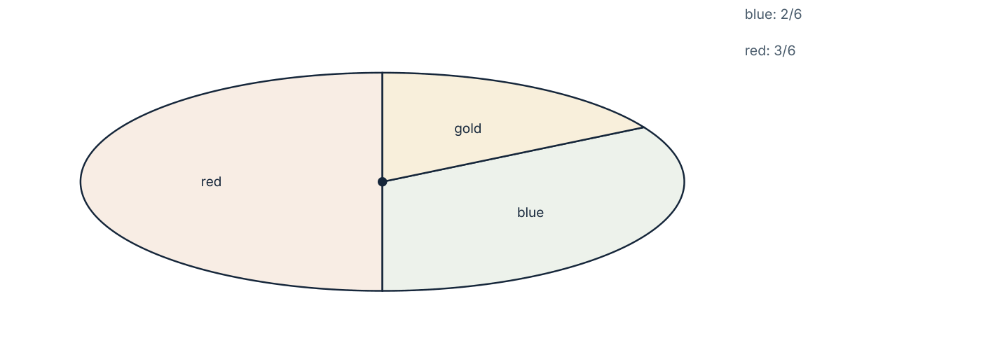
A spinner divided into six equal sectors. Each colour's probability is the number of its sectors divided by six.
04 · EXPLORE
Count the outcomes, then reason.
- Spin the spinner 20 times and record the results in a tally table.
- Calculate the relative frequency of each colour.
- Compare your results with the probabilities suggested by the sector sizes.
- Combine your class results. What happens to the relative frequencies?
- Explain what would happen with 5000 spins.
- Describe a spinner that would give a probability of 1 for blue and 0 for red.
05 · EXPLAIN
The probability of an event A is written P(A). If all outcomes are equally likely, P(A) = (number of favourable outcomes) ÷ (total number of outcomes). For any event, 0 ≤ P(A) ≤ 1, and P(not A) = 1 − P(A).
Probability | 0 | 0.25 | 0.5 | 0.75 | 1
Words | impossible | unlikely | even chance | likely | certain
Fraction | 0 | 1/4 | 1/2 | 3/4 | 1
Percentage | 0% | 25% | 50% | 75% | 100%

Worked example 10.1.1 · A single event
A bag contains 3 red and 5 blue counters. One is taken at random. Find the probability that it is (a) red, (b) blue, (c) not red.
1 There are 8 counters in total.
2 (a) P(red) = 3/8.
3 (b) P(blue) = 5/8.
4 (c) P(not red) = 1 − 3/8 = 5/8, the same as P(blue) because every counter is either red or blue.
5 Check: 3/8 + 5/8 = 1.
ANSWER (a) 3/8 (b) 5/8 (c) 5/8
Probabilities of all possible outcomes always total 1.
Worked example 10.1.2 · Three forms
A spinner has 4 equal sectors, one of which is gold. Write the probability of gold as a fraction, a decimal and a percentage.
1 Favourable outcomes 1, total 4, so P(gold) = 1/4.
2 1 ÷ 4 = 0.25.
3 0.25 = 25%.
4 The complement, P(not gold), is 0.75 or 75%.
ANSWER 1/4 = 0.25 = 25%
All three forms describe the same number; choose the form the question asks for.
Worked example 10.1.3 · Working from a probability
A box contains 20 counters, some red. The probability of drawing red is 0.3. How many red counters are there?
1 P(red) = (number red) ÷ (total) = 0.3.
2 Number red = 0.3 × 20 = 6.
3 Check: 6/20 = 0.3, as required.
4 The other 14 counters are not red.
ANSWER 6 red counters
Multiply the probability by the total to recover a count.
“The probability of winning is 1.2, because there are more chances of winning than losing.” A probability can never exceed 1: 1.2 would mean more favourable outcomes than outcomes. Ratios of chances are not probabilities.
Practice 10.1
SUPPORT 1–5 · CORE 6–9 · EXTENSION 10–12
1. Find the probability of rolling a 4 on a fair six-sided die. [F]
2. Write the probability of each event: (a) impossible (b) certain (c) an even chance. [F]
3. A bag has 3 red and 5 blue counters. Find P(red) and P(blue). [F]
4. A spinner has 4 equal sectors numbered 1 to 4. Find P(1). [F]
5. The probability of rain is 0.35. Find the probability that it does not rain. [F]
6. A bag has 5 red, 4 green and 1 yellow counter. Find P(not green). [P]
7. Write P = 1/4 as a decimal and as a percentage. [F]
8. A box of 20 counters has probability 0.3 of drawing red. How many red counters are there? [P]
9. A student writes P(win) = 1.2 and P(lose) = 0.3. Explain what is wrong with both numbers. [R]
10. A bag contains red and blue counters only. P(red) = 0.45. There are 22 blue counters. How many counters are there in total? [E]
11. A die is rolled once. Write the probability of (a) a prime number (b) a number greater than 2 (c) a multiple of 7. [E]
12. Explain why the probabilities of all the possible outcomes of an event must add to 1. [E]
SECTION 10.2
10.2 Sample spaces
Criterion A · II · C · III · Related concepts: Chance, Logic
A sample space is a complete list of what could happen. Listing it systematically turns a probability question into a counting question.

A pair of dice. Six faces each give thirty-six ordered pairs, and the pairs are not all equally likely to give the same total.
Photograph: Pexels, free licence (see the image register).
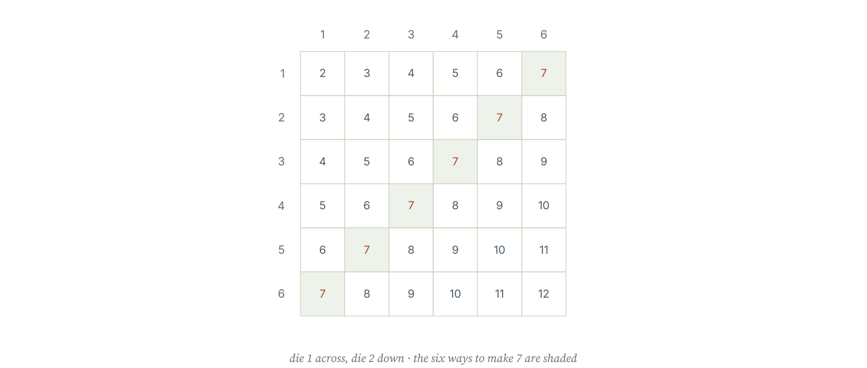
A sample-space grid for rolling two dice. Thirty-six equally likely cells allow every sum to be counted rather than guessed.
A sample space is the set of all possible outcomes of an experiment. Two events are mutually exclusive if they cannot happen at the same time; their probabilities then add.
Worked example 10.2.1 · Two coins
Two fair coins are tossed. List the sample space and find the probability of (a) two heads, (b) exactly one head.
1 The sample space is HH, HT, TH, TT — four outcomes, all equally likely.
2 (a) HH occurs once, so P(two heads) = 1/4.
3 (b) HT and TH give exactly one head, so P = 2/4 = 1/2.
4 Check: 1/4 + 1/2 + 1/4 = 1, counting also TT.
ANSWER (a) 1/4 (b) 1/2
HT and TH are different outcomes; treating them as one gives the classic wrong answer of 1/3.
Worked example 10.2.2 · Two dice
Two fair dice are rolled. Find the probability that the total is (a) 7 and (b) less than 4.
1 There are 6 × 6 = 36 equally likely outcomes.
2 (a) The total is 7 for (1,6), (2,5), (3,4), (4,3), (5,2), (6,1): six outcomes, so P = 6/36 = 1/6.
3 (b) Totals below 4 are 2 and 3: (1,1) gives 2; (1,2) and (2,1) give 3, so three outcomes.
4 P(less than 4) = 3/36 = 1/12.
ANSWER (a) 1/6 (b) 1/12
Counting from the grid prevents the common error of assuming totals are equally likely.
Worked example 10.2.3 · A coin and a die
A coin is tossed and a die is rolled. How many outcomes are in the sample space, and what is the probability of a head and an even number?
1 The coin has 2 outcomes and the die has 6, so there are 2 × 6 = 12 outcomes.
2 Even numbers on the die are 2, 4 and 6, three outcomes.
3 Together with a head this gives 3 favourable outcomes.
4 P(head and even) = 3/12 = 1/4.
ANSWER 12 outcomes; P = 1/4
Multiply the numbers of outcomes, then count the favourable ones.
“With two dice, a total of 7 and a total of 8 are equally likely because each can be made in several ways.” A 7 can be made in six ways and an 8 in five, so 7 is more likely. Only the sample-space grid shows this.
Practice 10.2
SUPPORT 1–4 · CORE 5–9 · EXTENSION 10–12
1. Two coins are tossed. List the sample space and find P(two heads). [F]
2. A die is rolled. Find P(even). [F]
3. Two dice are rolled. Find P(total 12). [F]
4. A coin is tossed and a die rolled. How many outcomes are there? [F]
5. Two dice are rolled. Find P(total 7). [P]
6. Two dice are rolled. Find P(total less than 4). [P]
7. Two dice are rolled. Find P(total is prime). [P]
8. Two coins are tossed. Find the probability of at least one head. [P]
9. A student says P(two heads) with two coins is 1/3 because there are three possibilities: two heads, two tails, or one of each. Explain the error. [R]
10. Three coins are tossed. List the sample space and find P(exactly two heads). [E]
11. Two dice are rolled. Find the probability that the two numbers are the same. [E]
12. Two dice are rolled 200 times. Predict how often the total will be 7, and explain your reasoning. [E]
SECTION 10.3
10.3 Tree diagrams and combined events
Criterion A · III · C · IV · Related concepts: Models, Logic
A tree diagram shows a sequence of events branch by branch. Multiply along a branch for “and”; add between branches for “or”.
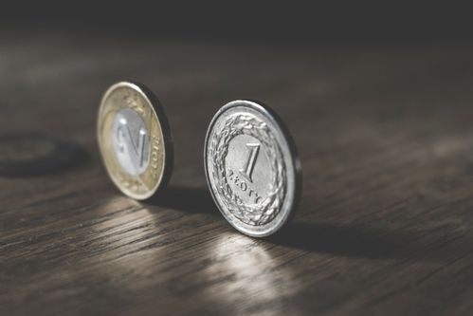
Two coins. HT and TH are different outcomes, which is why counting the sample space carefully matters.
Photograph: Pexels, free licence (see the image register).
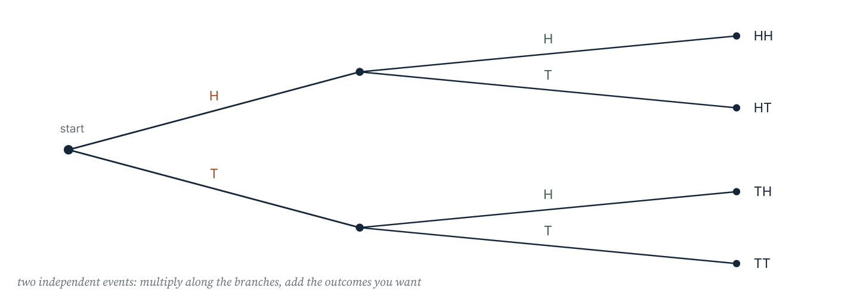
A tree diagram for two tosses of a coin. Multiplying along a branch gives the probability of both outcomes occurring.
Multiplication rule: for independent events, P(A and B) = P(A) × P(B).
Addition rule: for mutually exclusive events, P(A or B) = P(A) + P(B).
Without replacement, the second probability changes because the first item has been removed.
Worked example 10.3.1 · Two independent events
A bag has 4 red and 6 blue counters. One is taken, replaced, then another is taken. Find P(both red) and P(one of each colour).
1 The total stays 10 because the counter is replaced.
2 P(red) = 4/10 = 0.4 on each draw.
3 P(both red) = 0.4 × 0.4 = 0.16.
4 P(one of each) = P(RB) + P(BR) = 0.4×0.6 + 0.6×0.4 = 0.24 + 0.24 = 0.48.
ANSWER P(RR) = 0.16; P(one of each) = 0.48
There are two orders for “one of each”, so both branches must be included.
Worked example 10.3.2 · Without replacement
A bag has 4 red and 6 blue counters. Two are taken without replacement. Find P(both red) and P(one of each colour).
1 First draw: P(red) = 4/10. After removing one red, 3 red remain out of 9.
2 P(RR) = 4/10 × 3/9 = 12/90 = 2/15.
3 P(RB) = 4/10 × 6/9 = 24/90 and P(BR) = 6/10 × 4/9 = 24/90.
4 P(one of each) = 48/90 = 8/15.
ANSWER P(RR) = 2/15; P(one of each) = 8/15
Both the numerator and the denominator change on the second draw.
Worked example 10.3.3 · At least one
The probability of rain on any day is 0.3, independently. Find the probability of rain on at least one of two days.
1 Easier to find the complement: no rain on a day has probability 0.7.
2 P(no rain on either day) = 0.7 × 0.7 = 0.49.
3 P(at least one rainy day) = 1 − 0.49 = 0.51.
4 Check that this is more than 0.3 and less than 0.6, as it must be.
ANSWER 0.51
“At least one” is almost always quicker through the complement.
“Two events each with probability 0.5 have probability 1 of happening between them.” Adding probabilities works only for mutually exclusive events. If both can happen, adding double counts the overlap, and the total can even exceed 1.
Practice 10.3
SUPPORT 1–4 · CORE 5–9 · EXTENSION 10–12
1. Two coins are tossed. Use a tree diagram to find P(two tails). [F]
2. A bag has 4 red and 6 blue counters. One is taken and replaced, then another is taken. Find P(both red). [F]
3. The probability of rain on a day is 0.3. Find the probability of rain on two independent days. [F]
4. A fair coin is tossed twice. Find P(exactly one head). [F]
5. A bag has 4 red and 6 blue counters. Two are taken without replacement. Find P(both red). [P]
6. For the same bag, find P(one of each colour) without replacement. [P]
7. The probability of rain on any day is 0.3. Find the probability of rain on at least one of two independent days. [P]
8. A family has two children. Assuming each is equally likely to be a boy or a girl, find P(one boy and one girl). [P]
9. A student adds P(head) + P(even) for a coin and a die. Explain why the answer is meaningless. [R]
10. A bag has 5 red and 3 green counters. Two are taken without replacement. Find P(both green). [E]
11. Two dice are rolled. Find P(at least one six). [E]
12. A machine produces a faulty item with probability 0.05. Find the probability that in three independent items none is faulty, and hence the probability that at least one is faulty. [E]
SECTION 10.4
10.4 Experimental probability and simulation
Criterion B · I · D · III · Related concepts: Chance, Models
Experimental probability comes from data. As the number of trials grows, the relative frequency settles towards the theoretical probability — which is why a simulation can test a model.
Experimental probability (relative frequency) = number of times the event occurred ÷ number of trials. Expected frequency = probability × number of trials. A simulation replaces a real experiment with a random device that models it.
Worked example 10.4.1 · From a table of results
A spinner is spun 200 times; red appears 84 times. Find the experimental probability of red and comment on whether the spinner looks fair if red has one third of the sectors.
1 Experimental probability = 84 ÷ 200 = 0.42.
2 The theoretical probability for a fair spinner with one third red is about 0.333.
3 The experimental value is higher, but 200 trials still allow noticeable variation.
4 A conclusion needs more trials: the difference is suggestive, not conclusive.
ANSWER 0.42; inconclusive but worth more trials
Small samples vary; state how many trials would settle the question.
Worked example 10.4.2 · Expected frequency
A die is rolled 150 times. How many sixes would you expect, and how many would you expect for an even number?
1 P(six) = 1/6, so expected sixes = 1/6 × 150 = 25.
2 P(even) = 1/2, so expected even numbers = 1/2 × 150 = 75.
3 Expected values are averages over many repetitions, not predictions of a single run.
4 Check: 25 × 6 = 150, which is consistent.
ANSWER 25 sixes; 75 even numbers
Expectation multiplies the probability by the number of trials.
Worked example 10.4.3 · Designing a simulation
Design a simulation to estimate the probability that, in a group of 30 people, at least two share a birthday. State the model, the trials and the comparison.
1 Model: each person's birthday is a random whole number from 1 to 365, chosen independently.
2 Use a random-number generator to produce 30 numbers in that range; check whether any repeat.
3 Repeat for many trials — 100 or more — and count the trials with a repeat.
4 The estimate is (trials with a repeat) ÷ (total trials); compare with the theoretical value of about 0.71.
ANSWER Random numbers 1–365, 30 per trial, many trials
A simulation must state what is random, how it is generated, and how many trials.
“The experimental probability is 0.42, so the true probability is 0.42.” An experimental value estimates the true probability and varies from sample to sample. It becomes more reliable as the number of trials increases, but it never becomes exact.
Practice 10.4
SUPPORT 1–4 · CORE 5–9 · EXTENSION 10–12
1. A spinner lands on red 84 times in 200 spins. Find the experimental probability of red. [F]
2. A die is rolled 150 times. How many sixes would you expect? [F]
3. A coin is tossed 50 times and lands heads 22 times. Find the experimental probability of heads. [F]
4. P(win) = 0.2. In 80 games, how many wins would you expect? [F]
5. A die is rolled 300 times. How many even numbers would you expect, and how many ones? [P]
6. A bag has 3 red and 7 blue counters. In 200 draws with replacement, how many reds would you expect? [P]
7. A coin lands heads 30 times in 40 tosses. Is the coin likely to be biased? Explain carefully. [R]
8. Describe a simulation to estimate the probability of getting at least one six in four rolls of a die. [P]
9. Why does an experimental probability from 20 trials differ more from the theoretical value than one from 2000 trials? [R]
10. A spinner is spun 500 times; blue appears 260 times. If blue has one quarter of the sectors, comment on whether the spinner is fair. [E]
11. A machine produces faulty items with probability 0.05. In a day's production of 400 items, how many faults are expected, and what would 12 faults suggest? [E]
12. Design a simulation to decide whether a coin is fair, stating the number of trials and the decision rule. [E]
The school fair game (Criterion D)
A stall charges £1 to roll two dice. A player wins £3 if the total is 7, £2 if the total is 11, and nothing otherwise. The organiser wants to know whether the stall will raise money.
- List the sample space for two dice and count the outcomes giving 7 and 11.
- Calculate P(7) and P(11).
- Calculate the expected payout per game.
- Find the expected profit per game for the stall.
- Estimate the profit from 300 games.
- Suggest one change to the prizes that would increase the expected profit, and justify it with calculations.
06 · INVESTIGATE AND APPLY
Simulation and the fair game.
Simulating a queue (Investigation)
A small shop has one till. Customers arrive at random, and the manager wants to know how long queues become.
- Decide which quantities are random and give each a range.
- Use random numbers to generate a short sequence of arrivals and service times.
- Simulate ten customers and record the queue length after each.
- Repeat the simulation and compare the two runs.
- Estimate the average queue length over your runs.
- Decide how many runs would be needed before the estimate could be trusted.
- Explain one assumption in your model that might be unrealistic.
Is the game fair? (Investigation)
Two players each roll a die. Player A scores the difference between the two numbers; player B scores the smaller number.
- Build a 6 by 6 grid of the difference and a second grid of the smaller number.
- Find the probability of each possible score for A and for B.
- Calculate the expected score for each player.
- Decide whether the game is fair.
- Change one rule so that the game becomes fair, and verify with expected scores.
- Explain why a game can look fair and still favour one player.
07 · REFLECT AND CONSOLIDATE
SECTION 10.6
10.6 Summary, revision and reflection
What this chapter established
- Probability lies between 0 and 1, and P(not A) = 1 − P(A).
- For equally likely outcomes, P(A) = favourable ÷ total.
- A sample space lists every outcome; a grid makes two-stage experiments countable.
- Multiply along branches of a tree for “and”, add between branches for “or”.
- Without replacement, the second probability changes.
- Experimental probability estimates theoretical probability and improves with more trials.
Vocabulary to use precisely
probability · outcome · event · sample space · equally likely · mutually exclusive · independent · complement · relative frequency · expected frequency · simulation
Misconceptions to close
The mistake | What is really happening
Two coins give three outcomes, so P(two heads) = 1/3. | HT and TH are different, giving four equally likely outcomes and P = 1/4.
Adding probabilities of events that can happen together. | Addition is for mutually exclusive events; otherwise the overlap is counted twice.
Assuming a total of 7 and a total of 8 are equally likely. | There are six ways to score 7 and five ways to score 8.
Thinking an experimental probability is the exact probability. | It is an estimate that varies; more trials narrow the variation.

Revision questions
- A bag has 7 red and 3 blue counters. Find P(blue).
- Two dice are rolled. Find P(total 5).
- A coin is tossed three times. Find P(three heads).
- P(rain) = 0.4 each day. Find P(no rain on two independent days).
- A die is rolled 240 times. How many threes would you expect?
Self-assessment
I can … | Not yet | Getting there | Confident
calculate a simple probability and its complement | □ | □ | □
list a sample space systematically | □ | □ | □
use a tree diagram for two-stage events | □ | □ | □
handle “without replacement” correctly | □ | □ | □
calculate expected frequencies | □ | □ | □
design and interpret a simulation | □ | □ | □

Reflect on the criteria
Criterion A: which probability rule can you now apply without a prompt?
Criterion B: what did the simulation show that a single calculation could not?
Criterion C: were your fractions, decimals and tree diagrams clear enough to follow?
Criterion D: how did expected values settle a question about fairness?
ATL · Research skills
In order for a student to evaluate a probability claim, students must compare a theoretical prediction with experimental evidence and judge whether the difference is larger than chance would explain.
Mixed practice · consolidate and extend
Practice 10.M
MIXED 1–12
1. Find P(rolling an odd number) on a fair die. [F]
2. A bag has 2 red, 3 green and 5 blue counters. Find P(green). [F]
3. Write 0.6 as a fraction and a percentage. [F]
4. Two coins are tossed. Find P(no heads). [F]
5. A die is rolled 60 times. How many fives would you expect? [F]
6. Two dice are rolled. Find P(total 9). [P]
7. A bag has 5 red and 3 green counters. One is taken without replacement, then another. Find P(both green). [P]
8. A spinner lands on red 96 times in 300 spins. Find the experimental probability. [P]
9. A student says P(at least one head in two tosses) = 1/2 + 1/2 = 1. Explain the error. [R]
10. A game costs £2 and pays £5 with probability 0.25. Find the expected profit per game. [E]
11. Three fair coins are tossed. Find P(at least two heads). [E]
12. Two dice are rolled. Find P(both numbers even or a total of 7), and explain why the addition rule applies here. [E]

Answers · chapter 10
PRACTICE 10.1
1. 1/6.
2. (a) 0 (b) 1 (c) 0.5.
3. 3/8 and 5/8.
4. 1/4.
5. 0.65.
6. 6/10 = 3/5.
7. 0.25 and 25%.
8. 6.
9. A probability cannot exceed 1, and the two probabilities cannot add to more than 1 while describing only two outcomes.
10. P(blue) = 0.55, so total = 22 ÷ 0.55 = 40 counters.
11. (a) 3/6 = 1/2 (b) 4/6 = 2/3 (c) 0.
12. The outcomes are mutually exclusive and together cover every possibility, so their probabilities account for the whole of certainty, which is 1.
PRACTICE 10.2
1. HH, HT, TH, TT; 1/4.
2. 1/2.
3. 1/36.
4. 12 outcomes.
5. 1/6.
6. 1/12.
7. 15/36 = 5/12.
8. 3/4.
9. “One of each” can happen in two orders, HT and TH, so the four outcomes are not equally split into three groups.
10. HHH, HHT, HTH, HTT, THH, THT, TTH, TTT; P(exactly two heads) = 3/8.
11. 6/36 = 1/6.
12. About 33 times, since P(7) = 1/6 and 1/6 × 200 ≈ 33.
PRACTICE 10.3
1. 1/4.
2. 0.16.
3. 0.09.
4. 1/2.
5. 2/15.
6. 8/15.
7. 0.51.
8. 1/2.
9. The events are not mutually exclusive and belong to different experiments, so they cannot be added.
10. 3/8 × 2/7 = 6/56 = 3/28.
11. 1 − (5/6)² = 11/36.
12. 0.95³ = 0.857; at least one faulty = 0.143.
PRACTICE 10.4
1. 0.42.
2. 25.
3. 0.44.
4. 16.
5. 150 even and 50 ones.
6. 60 reds.
7. 30/40 = 0.75 is high, but 40 tosses is a small sample; a larger number of tosses is needed before calling the coin biased.
8. Roll a die four times and record whether any six appears; repeat for many trials.
9. Smaller samples vary more about the theoretical value; larger samples average out the variation.
10. 260/500 = 0.52 against 0.25, which is far too high for chance, so the spinner looks biased.
11. 20 faults expected; 12 is below expectation and would not by itself suggest a problem.
12. Toss the coin 200 times; if heads lies outside a reasonable range around 100, judge it biased.
PRACTICE 10.M
1. 1/2.
2. 3/10.
3. 3/5 and 60%.
4. 1/4.
5. 10.
6. 4/36 = 1/9.
7. 3/28.
8. 0.32.
9. The events overlap: heads on the first toss and heads on the second can both happen, so the probabilities cannot simply be added.
10. Expected payout 0.25 × 5 = £1.25 against a £2 cost, so the expected profit is −£0.75 per game.
11. 4/8 = 1/2.
12. 9/36 + 6/36 = 15/36 = 5/12; a total of 7 is odd, so it cannot have both numbers even and the events are mutually exclusive.

PART IV · PROBABILITY AND DATA
11 Univariate data
Probability and data · key concept Representation · Measurement, Patterns
One variable, many values. A single average hides almost
everything, so this chapter is about choosing the right
summary and the right display — and about saying what
the data does not show.
Global context: Scientific and technical innovation
01 · MYP UNIT PLANNER
Collecting one variable well, summarising it honestly, and comparing groups.
STATEMENT OF INQUIRY A single variable can be represented by a table, a display and a small set of summary numbers, and each representation reveals something the others hide.
Key and related concepts
Key concept · Representation. Data becomes evidence only when it is organised into a form that can be read and compared.
Related · Measurement. Every value carries the error of the instrument that produced it.
Related · Patterns. Spread and shape are patterns in data, not noise to be averaged away.
Global context · Scientific and technical innovation
Exploration: measurement, sensor data and the displays that turn readings into decisions. A graph is an argument, and it can mislead.
Inquiry questions
- Factual: How do you calculate the mean, median, mode and range?
- Conceptual: Why can two data sets with the same mean look completely different?
- Debatable: Should a summary always report the average, or the median?
Criterion | Strands | Evidence in this chapter
A · Knowing and understanding | i, ii | Calculate and interpret the averages, range, quartiles and IQR.
B · Investigating patterns | i, ii, iii | Investigate how an outlier changes each summary.
C · Communicating | ii, iii, iv | Choose and construct an appropriate display.
D · Applying mathematics | i, ii, iii, iv, v | Analyse school data and justify a recommendation.

ATL · Thinking skills
In order for a student to interpret a data display, students must state what the display shows, what it leaves out, and how the choice of summary changes the conclusion.
02 · LEARNING INTENTIONS AND SUCCESS CRITERIA
You are learning to | You have succeeded when you can
Classify data as numerical or categorical. | Say whether a variable is discrete, continuous or categorical.
Calculate the mean, median, mode and range. | Choose the summary that suits the data and say why.
Find the mean from a frequency table. | Use Σfx ÷ Σf correctly.
Construct and read displays. | Draw a bar chart, dot plot or frequency diagram with sensible scales.
Find quartiles and the interquartile range. | Read them from an ordered list and from a box plot.
Compare two data sets. | Compare an average and a measure of spread, not just the averages.

Prerequisite check · 10 minutes, no calculator
- Add 4 + 7 + 7 + 9 + 13.
- Find the middle value of 3, 5, 8, 10, 12.
- Divide 40 by 5.
- How many values are in 2, 4, 4, 6, 7, 8?
- Write 0.25 as a percentage.
- Find the difference between 45 and 20.
If three or more answers are wrong, revisit arithmetic with decimals before continuing.
SECTION 11.1
11.1 Data and how to collect it
Criterion A · I · C · II · Related concepts: Measurement, Representation
Before any calculation, the important decisions are what to measure, how to measure it, and whose values to include.
03 · ENGAGE
The average that hid the problem.
A class reports that the average journey to school is 12 minutes. One student travels 55 minutes. Before reading on, decide what the reporter should do about that value, and whether removing it would improve the report or damage it.
04 · EXPLORE
Measure, tabulate, interrogate.

A dashboard of charts. Each chart answers a question; none of them answers every question.
Photograph: Pexels, free to use under the Pexels licence.
Variable | Type | Possible values
Number of people in a household | numerical, discrete | 1, 2, 3, …
Height in centimetres | numerical, continuous | any value in a range
Favourite subject | categorical | named categories
Time to walk to school | numerical, continuous | any value in minutes
Number of pets | numerical, discrete | 0, 1, 2, …

- Decide which of the variables above you could collect in your class in five minutes.
- For one variable, write the exact question you would ask, so that two people would answer it the same way.
- Collect ten values and check whether any are impossible or misread.
- Decide whether your data is discrete, continuous or categorical.
- Identify one way your sample could be biased.
- Suggest how to collect a fairer sample.
05 · EXPLAIN
Numerical data are numbers; they are discrete if the values are counted and continuous if they are measured. Categorical data are names or labels. A population is the whole group of interest and a sample is the part measured; a sample is biased if it does not represent the population.
Four rules that prevent most errors
Good data collection
• Ask one unambiguous question.
• Use a consistent unit and record it.
• Include every value, including zeros and unusually large ones.
• State the size of the sample and how it was chosen.
Worked example 11.1.1 · Classifying variables
Classify each variable: (a) shoe size, (b) time to run 100 m, (c) favourite colour, (d) number of siblings.
1 (a) Shoe size is numerical and discrete: sizes are counted in fixed steps.
2 (b) Time is numerical and continuous: it can take any value, limited only by the stopwatch.
3 (c) Favourite colour is categorical: the values are names.
4 (d) Number of siblings is numerical and discrete.
ANSWER (a) discrete (b) continuous (c) categorical (d) discrete
Ask whether the values are names, counts or measurements.
Worked example 11.1.2 · Recognising a biased sample
A survey asks students in the football club how often they exercise. Explain why the results will be biased.
1 The sample contains only students who already choose to play football.
2 They are likely to exercise more than the school population as a whole.
3 The mean from this sample will overestimate the school's exercise frequency.
4 A better sample would be chosen at random across all year groups.
ANSWER The sample is not representative
Bias comes from how the sample was chosen, not from the size of the numbers.
“More data is always better data.” A large biased sample is still biased — a million responses from a football club tell you about the football club. Size reduces random variation; it does nothing for bias.
Practice 11.1
SUPPORT 1–5 · CORE 6–9 · EXTENSION 10–12
1. Classify each variable as numerical or categorical: (a) shoe size (b) favourite colour (c) number of siblings. [F]
2. State whether each is discrete or continuous: (a) mass in grams (b) number of cars in a car park. [F]
3. Write one question that would collect data about how students travel to school. [F]
4. Explain why “How tall are you?” can produce unusable data. [F]
5. Why should zeros be included when recording the number of pets a student owns? [F]
6. A survey asks shoppers in a sports shop how often they exercise. Explain the bias. [P]
7. Give one reason a sample of 30 students from one class might not represent a school of 900. [P]
8. A student records heights to the nearest metre: 1 m, 2 m, 2 m. Explain what has gone wrong and how to fix it. [R]
9. Describe how to choose a sample of 40 students from a school of 900 so that it is representative. [P]
10. A website asks visitors to rate a product. Explain two reasons the results may be unreliable. [E]
11. Design a short data-collection plan for measuring the time students spend on homework, including the question, the unit and the sample. [E]
12. Explain the difference between a population and a sample, using an example of each. [E]
SECTION 11.2
11.2 Averages and range
Criterion A · II · C · III · Related concepts: Patterns, Measurement
An average is a single number standing in for a set. There are three of them, and they disagree in useful ways.

A spreadsheet of readings and its summary charts. The summary is a choice, and a different choice gives a different story.
Photograph: Pexels, free licence (see the image register).
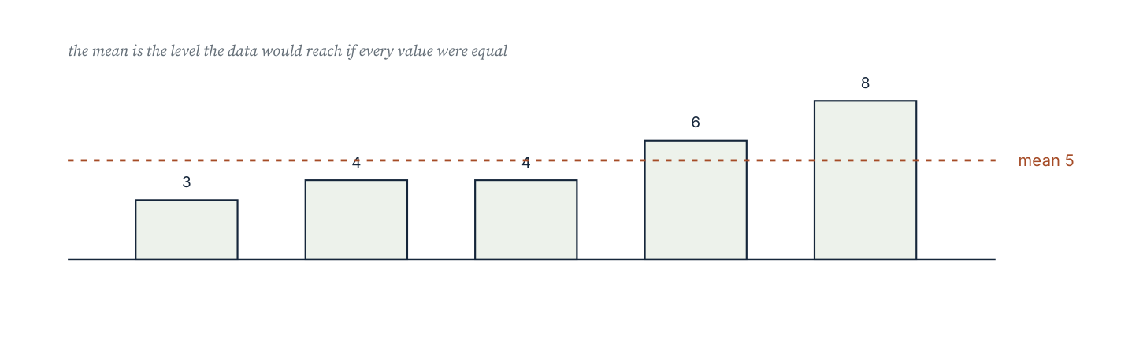
The mean as a balance point: the distances of the values above it counter the distances below.
Mean = sum of values ÷ number of values.
Median = the middle value of an ordered list; with an even count, the mean of the two middle values.
Mode = the most frequent value (there may be none or several).
Range = largest − smallest.
Worked example 11.2.1 · All four summaries
Find the mean, median, mode and range of 4, 7, 7, 9, 13.
1 Sum = 40 and there are 5 values, so the mean is 40 ÷ 5 = 8.
2 The ordered list has middle value 7, so the median is 7.
3 7 occurs twice, more than any other, so the mode is 7.
4 Range = 13 − 4 = 9.
5 Check the mean by balance: 4 and 13 are 4 and 5 away from 8; 7, 7, 9 are 1 each side; the total below equals the total above.
ANSWER mean 8, median 7, mode 7, range 9
Order the list before finding the median, and count the values carefully.
Worked example 11.2.2 · An even number of values
Find the median of 3, 5, 8, 10, 12, 15.
1 There are six values, so there is no single middle value.
2 The two middle values are the 3rd and 4th: 8 and 10.
3 The median is their mean: (8 + 10) ÷ 2 = 9.
4 Check that three values lie below 9 and three above.
ANSWER 9
With an even count the median may not be a value in the list at all.
Worked example 11.2.3 · Mean from a frequency table
Find the mean of the data in the table.
1 Multiply each value by its frequency: 1×4 = 4, 2×6 = 12, 3×9 = 27, 4×5 = 20, 5×1 = 5.
2 Σfx = 68 and Σf = 25.
3 Mean = 68 ÷ 25 = 2.72.
4 Check the median instead: the 13th value lies in the group with value 3, so the median is 3.
ANSWER 2.72
Divide by the total frequency, not by the number of rows.
“The mean of 2, 3, 3, 4 and 48 is about 4, so the typist's speed is about 4.” The mean is 12, dragged up by the value 48. The median, 3, describes the typical value far better. An extreme value is an outlier, and it affects the mean much more than the median.
Practice 11.2
SUPPORT 1–5 · CORE 6–10 · EXTENSION 11–13
1. Find the mean, median, mode and range of 4, 7, 7, 9, 13. [F]
2. Find the mean, median, mode and range of 12, 15, 11, 14, 13. [F]
3. Find the median of 3, 5, 8, 10, 12, 15. [F]
4. Find the range of 20, 31, 45, 27. [F]
5. Find the mean of 2, 3, 3, 4 and 48, and the median. Which is more typical? [F]
6. Find the mean from the frequency table: value 1 (frequency 4), 2 (6), 3 (9), 4 (5), 5 (1). [P]
7. Five numbers have mean 7. Four of them are 6, 8, 5 and 9. Find the fifth. [P]
8. Find the median and mode of 5, 8, 5, 9, 12, 5, 7. [P]
9. A data set is 3, 4, 4, 5, 6. Add the value 40 and recalculate the mean and median. Describe what changed. [R]
10. Class A has 20 students with mean score 60; class B has 30 students with mean score 70. Find the mean score of all 50 students. [E]
11. A cyclist's times for five laps are 42, 45, 44, 46 and 48 seconds. Find the mean, and the time needed on a sixth lap for the mean to be 45 seconds. [E]
12. Explain why the median is often preferred to the mean for house prices. [E]
SECTION 11.3
11.3 Displaying data
Criterion C · II · A · II · Related concepts: Patterns, Representation
A display is chosen to make a pattern visible. The wrong display can hide the pattern the data actually contains.
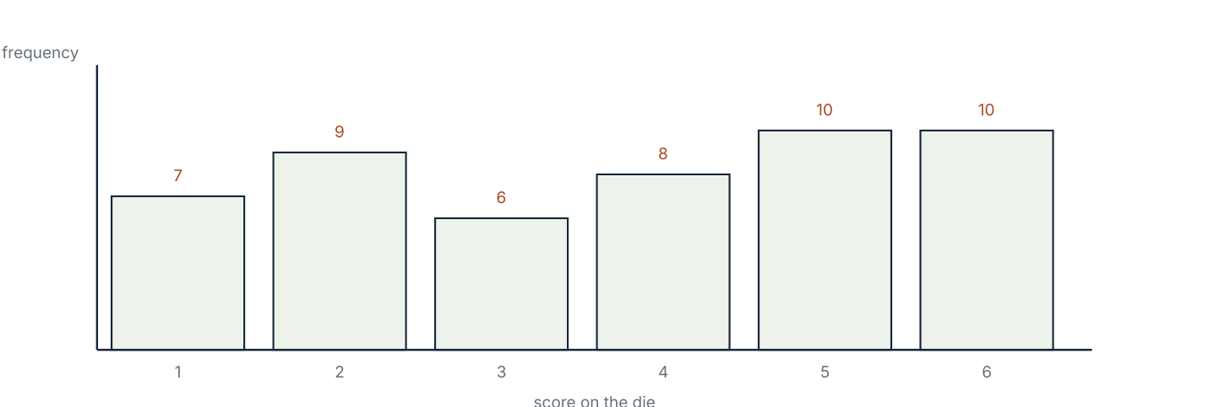
A bar chart for the scores on a die. The bars are separated because the scores are discrete categories.
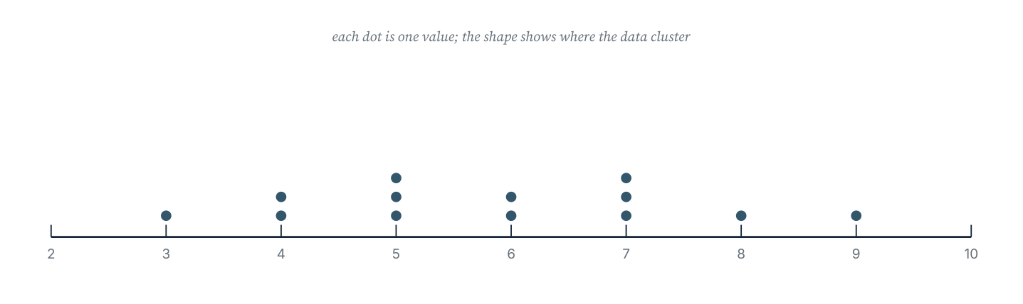
A dot plot of a small data set. Each dot is one value, so both the centre and the spread can be read at once.
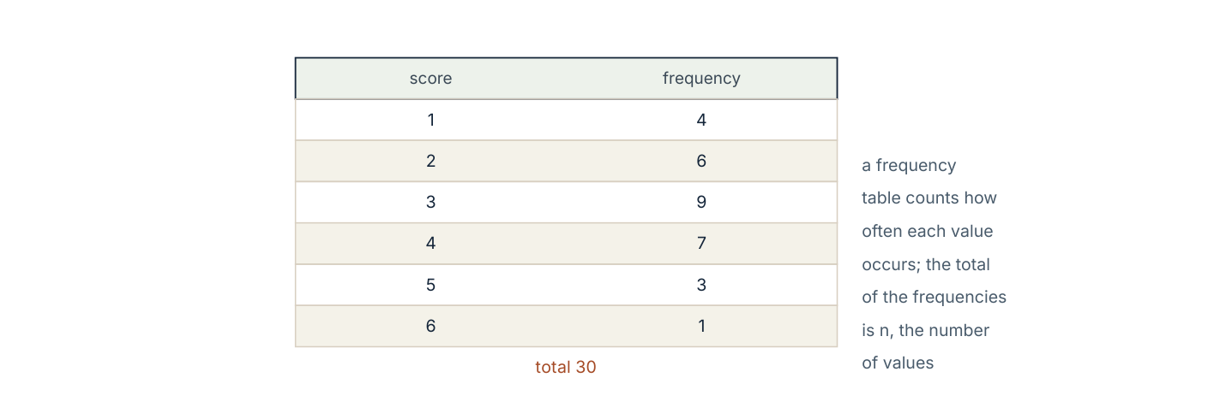
A frequency table. It is the first step towards every display: the counts must be correct before anything is drawn.
Display | Best for | Watch out for
Bar chart | comparing counts in categories | bars must have equal width and be separated
Dot plot | small numerical sets; spotting clusters | each dot must represent exactly one value
Histogram | continuous data in classes | bars touch, because the classes are continuous
Box plot | comparing median and spread of two sets | it hides the shape of the data

Worked example 11.3.1 · From table to bar chart
The table gives the number of students choosing each subject. Describe the chart you would draw and the scale you would use.
1 The variable is categorical, so a bar chart with separated bars is appropriate.
2 The frequencies run from 6 to 18, so a vertical scale of 0 to 20 in steps of 2 fits comfortably.
3 Bars should be of equal width, with the subject names on the horizontal axis.
4 The axis must start at zero, otherwise the comparison of lengths is misleading.
ANSWER A bar chart, 0–20 in steps of 2
Starting a bar axis above zero exaggerates differences.
Worked example 11.3.2 · Reading a dot plot
A dot plot shows 3, 4, 4, 5, 5, 5, 6, 6, 7, 7, 7, 8, 9. Find the median and describe the shape.
1 There are 13 values, so the median is the 7th value.
2 Counting the dots: 3, then two 4s (3rd), three 5s (6th), so the 7th is the first 6.
3 The median is 6.
4 The dots are clustered around 5–7 with single values at 3 and 9, so the distribution is roughly symmetric with a small spread.
ANSWER median 6; clustered around 5–7
Count the dots cumulatively; do not average the distinct values.
Worked example 11.3.3 · Choosing a display
A student wants to show how the mass of 60 apples is distributed. Which display should be used, and why?
1 Mass is continuous, so the values should be grouped into equal class intervals.
2 A histogram is appropriate: the bars touch because neighbouring classes are continuous.
3 A bar chart with gaps would wrongly suggest the classes are separate categories.
4 The vertical axis shows frequency, so 0 must be included.
ANSWER A histogram with equal class intervals
Ask whether the variable is continuous before drawing bars.
“I have used two different colours on a bar chart, so the bars need not have equal width.” Unequal bar widths distort the comparison: readers compare area, not height. Keep bars equal in width and the gaps equal too.
Practice 11.3
SUPPORT 1–4 · CORE 5–9 · EXTENSION 10–12
1. Name a display suitable for comparing the number of students in four year groups. [F]
2. How many values are shown by a dot plot with dots 3, 4, 4, 5, 5, 5, 6? [F]
3. Why must the vertical axis of a bar chart start at zero? [F]
4. Which display is suitable for continuous data grouped into classes? [F]
5. A dot plot shows 3, 4, 4, 5, 5, 5, 6, 6, 7, 7, 7, 8, 9. Find the median. [P]
6. Draw a frequency table for the values 2, 3, 3, 4, 4, 4, 5, 5, 6 and state the mode. [P]
7. A bar chart shows frequencies 6, 18, 9 and 12 for four subjects. Describe a suitable scale. [P]
8. Explain why a histogram's bars touch but a bar chart's do not. [R]
9. A student draws a bar chart with bars of different widths. Explain the problem. [R]
10. Thirty students record the number of hours of sleep. Choose a display and justify your choice in two sentences. [E]
11. What information does a box plot show that a bar chart of the same data cannot? [E]
12. Describe how a misleading graph could be produced from truthful data, and how a reader could detect it. [E]
SECTION 11.4
11.4 Quartiles, spread and comparing groups
Criterion A · III · D · IV · Related concepts: Patterns, Measurement
Two groups can share a mean and differ completely. Comparing spread as well as centre is what makes a comparison honest.
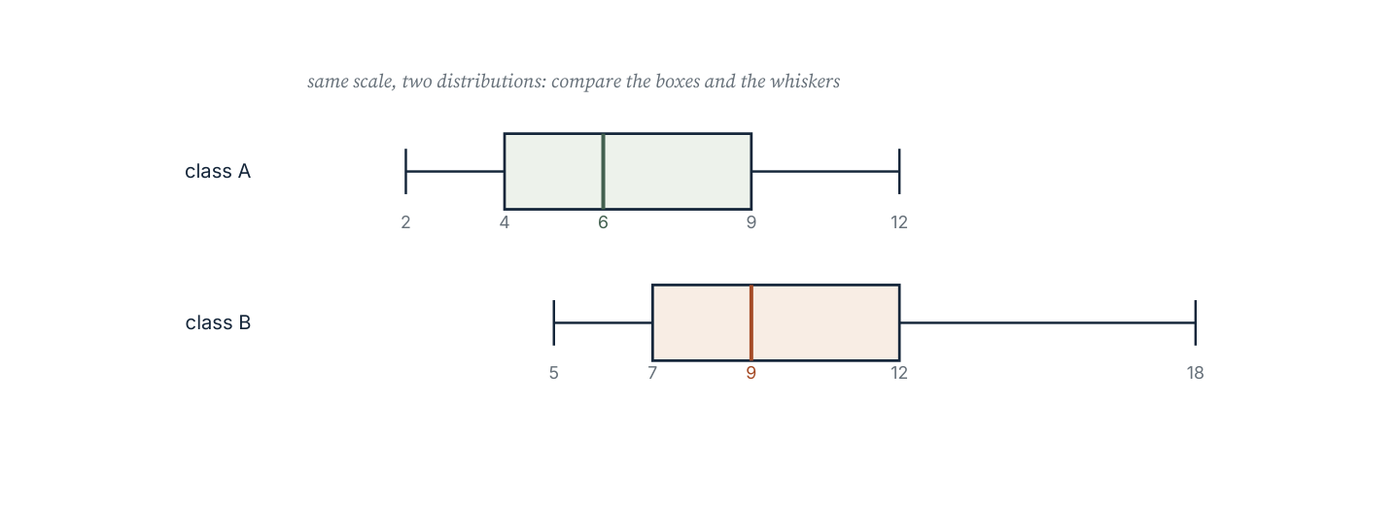
Two box plots compared. The median marks the centre; the box holds the middle half of the data and the whiskers reach the extremes.
The lower quartile (LQ) is the median of the lower half of the data and the upper quartile (UQ) the median of the upper half. The interquartile range (IQR) = UQ − LQ and measures the spread of the middle half. A box plot shows the smallest value, LQ, median, UQ and largest value.
Worked example 11.4.1 · Quartiles and IQR
Find the median, lower quartile, upper quartile and interquartile range of 3, 5, 6, 8, 9, 11, 12, 14, 15.
1 There are 9 values, so the median is the 5th value: 9.
2 The lower half is 3, 5, 6, 8, whose median is (5 + 6) ÷ 2 = 5.5.
3 The upper half is 11, 12, 14, 15, whose median is (12 + 14) ÷ 2 = 13.
4 IQR = 13 − 5.5 = 7.5.
ANSWER median 9, LQ 5.5, UQ 13, IQR 7.5
Do not include the median value itself in either half when the count is odd.
Worked example 11.4.2 · Comparing two classes
Class A has median 62 and IQR 8; class B has median 66 and IQR 22. Compare the two classes.
1 Class B's median is higher, so its typical score is better.
2 Class A's IQR is much smaller, so its scores are tightly grouped.
3 Class B's scores are far more spread out: some are well above and some well below its median.
4 A fair statement: B is better on average, but less consistent.
ANSWER B higher median; A far more consistent
Compare a measure of centre and a measure of spread; one alone is never enough.
Worked example 11.4.3 · Outliers and the IQR
The data are 12, 14, 15, 16, 18, 19, 21, 45. Find the IQR and state whether 45 is an outlier by the 1.5 × IQR rule.
1 Median = (16 + 18) ÷ 2 = 17.
2 Lower half 12, 14, 15, 16 has LQ = 14.5; upper half 18, 19, 21, 45 has UQ = 20.
3 IQR = 20 − 14.5 = 5.5, so 1.5 × IQR = 8.25.
4 The upper boundary is 20 + 8.25 = 28.25, and 45 is above it, so 45 is an outlier.
ANSWER IQR 5.5; 45 is an outlier
An outlier should be investigated, not deleted: it may be a mistake or the most important value.
“Both groups have the same mean, so they are the same.” 10, 10, 10, 10 and 0, 5, 15, 20 both have mean 10, but one has no spread at all. Always report a measure of spread alongside the average.
Practice 11.4
SUPPORT 1–4 · CORE 5–9 · EXTENSION 10–12
1. Find the median of 3, 5, 6, 8, 9, 11, 12, 14, 15. [F]
2. Find the range of 4, 9, 12, 15, 21. [F]
3. State what the box in a box plot represents. [F]
4. Find the IQR of 2, 4, 6, 8, 10, 12, 14. [F]
5. Find the LQ, UQ and IQR of 3, 5, 6, 8, 9, 11, 12, 14, 15. [P]
6. Class A has median 62 and IQR 8; class B has median 66 and IQR 22. Compare them. [P]
7. Find the IQR of 12, 14, 15, 16, 18, 19, 21, 45 and decide whether 45 is an outlier. [P]
8. Two data sets both have mean 10. One is 10, 10, 10, 10; the other is 0, 5, 15, 20. Compare their spreads. [R]
9. A student removes a value of 45 from a data set because it is an outlier. Give one reason this might be wrong. [R]
10. Thirty students' test scores have median 70, LQ 60 and UQ 84. Describe the middle half of the scores and the spread. [E]
11. Compare two runners' times: runner A 60, 61, 60, 62, 61; runner B 55, 68, 58, 66, 63. Which would you select for a single race, and why? [E]
12. Explain why the IQR is less affected by outliers than the range. [E]
The school survey (Criterion D)
A school surveys 80 students about the time spent on homework each week. The results have median 4.5 hours, LQ 3 hours, UQ 6.5 hours, smallest 1 hour and largest 12 hours.
- Draw a box plot of the results and describe the spread.
- Calculate the IQR and interpret it in context.
- Identify whether 12 hours is an outlier using the 1.5 × IQR rule.
- The school proposes a policy limiting homework to 5 hours. Use the data to predict how many of the 80 students would be affected.
- Write one further question you would need answered before supporting the policy.
- Present a recommendation in three sentences, quoting at least two summary values.
06 · INVESTIGATE AND APPLY
Outliers and honest comparison.
How one value changes every summary (Investigation)
A data set of nine values is 4, 5, 5, 6, 7, 8, 8, 9, 10. A tenth value is then added.
- Calculate the mean, median, mode and range of the original nine values.
- Add the value 40 and recalculate all four summaries.
- Record the change in each summary.
- Repeat with the value 11 instead of 40, and compare.
- Which summary changed least? Which changed most?
- Explain, using the way each summary is calculated, why the change happened.
- State one situation where removing an outlier would be honest and one where it would be dishonest.
Reading a display critically (Investigation)
Every graph is a choice. This investigation looks at what a graph decides for the reader.
- Find a graph in a news report, advertisement or textbook.
- State the variable, the population and the sample size if given.
- Describe the scale on each axis, including whether it starts at zero.
- Identify the average used, and whether any spread is shown.
- Decide whether the graph overstates or understates its case, and explain how.
- Redraw the graph so that it is not misleading, keeping the data unchanged.
- Write two sentences on what a careful reader should check first.
07 · REFLECT AND CONSOLIDATE
SECTION 11.6
11.6 Summary, revision and reflection
What this chapter established
- Data are numerical (discrete or continuous) or categorical, and the choice determines the display.
- Mean, median and mode each describe a different sense of ‘typical’; the range and IQR describe spread.
- An outlier moves the mean much more than the median, so the median is safer for skewed data.
- The mean from a frequency table is Σfx ÷ Σf.
- Bar charts compare categories and histograms show continuous classes; axes must start at zero.
- Comparing two groups needs a measure of centre and a measure of spread.
Vocabulary to use precisely
population · sample · bias · discrete · continuous · categorical · mean · median · mode · range · quartile · interquartile range · outlier · box plot
Misconceptions to close
The mistake | What is really happening
Using the mean for any data set. | One extreme value can distort it; the median is better for skewed data.
Drawing a bar chart for continuous data. | Continuous classes need a histogram, whose bars touch.
Starting a bar chart axis at the smallest value. | It exaggerates differences; the axis must start at zero.
Comparing two groups by their means only. | Two sets can share a mean and have completely different spreads.

Revision questions
- Find the mean and range of 8, 11, 14, 17, 20.
- Find the median of 2, 5, 7, 7, 9, 12.
- Find the mean of the frequency table: value 1 (3), 2 (5), 3 (4), 4 (2).
- Find the IQR of 5, 7, 8, 10, 12, 14, 15.
- Two classes have medians 55 and 58 and IQRs 4 and 15. Write one sentence comparing them.
Self-assessment
I can … | Not yet | Getting there | Confident
classify data and spot a biased sample | □ | □ | □
calculate the mean, median, mode and range | □ | □ | □
find a mean from a frequency table | □ | □ | □
choose and construct a suitable display | □ | □ | □
find quartiles and the IQR | □ | □ | □
compare two data sets fairly | □ | □ | □

Reflect on the criteria
Criterion A: which summary can you now calculate and interpret without help?
Criterion B: what did the outlier investigation show you about averages?
Criterion C: was your display readable and correctly scaled?
Criterion D: how did the data support or weaken your recommendation?
ATL · Information literacy
In order for a student to report data honestly, students must state the sample, the summary chosen and the spread, and must not suppress values that weaken the case.
Mixed practice · consolidate and extend
Practice 11.M
MIXED 1–12
1. Classify the variable ‘number of goals scored’. [F]
2. Find the mean of 6, 9, 12, 15, 18. [F]
3. Find the median of 4, 8, 8, 10, 13, 17. [F]
4. Find the mode of 3, 5, 5, 6, 8, 8, 8. [F]
5. Find the range of 14, 22, 9, 31, 18. [F]
6. Find the mean of the frequency table: value 2 (5), 4 (7), 6 (3). [P]
7. Find the IQR of 3, 6, 7, 9, 11, 14, 18. [P]
8. A data set has mean 9 and range 4, and contains six values. Suggest one possible data set. [P]
9. A graph shows exam results with the vertical axis starting at 40. Explain why the graph may mislead. [R]
10. A class of 24 students has mean height 152 cm; a class of 16 has mean height 160 cm. Find the mean height of all 40 students. [E]
11. Two shops record daily sales for a week: A 40, 42, 41, 43, 40, 41, 42; B 20, 60, 35, 70, 25, 50, 38. Compare them using an average and a measure of spread. [E]
12. Explain, using the formulas, why adding one very large value raises the mean but may leave the mode unchanged. [E]

Answers · chapter 11
PRACTICE 11.1
1. (a) numerical (b) categorical (c) numerical.
2. (a) continuous (b) discrete.
3. For example: “How do you usually travel to school: walk, cycle, bus, car or other?”
4. Answers may be given in different units (feet, inches, metres), so the values cannot be compared until converted.
5. A student with no pets would otherwise be left out, which makes the mean too high.
6. Shoppers in a sports shop are more likely to exercise than the general population, so the results overestimate.
7. One class may differ in age, ability or background from the school as a whole.
8. Heights were rounded to the nearest metre, which is far too coarse; record to the nearest centimetre.
9. Number every student and use a random number generator to select 40, keeping the year groups in proportion.
10. Only people who visit the site respond, and they may be those with the strongest opinions; the sample is self-selected.
11. Answers vary; must state the question, the unit, the sample size and how the sample is chosen.
12. The population is the whole group of interest, such as all 900 students; a sample is the part measured, such as 40 of them.
PRACTICE 11.2
1. mean 8, median 7, mode 7, range 9.
2. mean 13, median 13, no mode, range 4.
3. 9.
4. 25.
5. Mean 12, median 3; the median is far more typical because 48 is an outlier.
6. 2.72.
7. 7.
8. Median 7, mode 5.
9. The mean rises from 4.4 to 10.33 while the median rises only from 4 to 4.5; the mean is pulled towards the outlier.
10. 66.
11. Mean 45 s; a sixth lap of 45 s keeps the mean at 45 s.
12. A few very expensive houses pull the mean well above the price most houses actually sell for, while the median stays typical.
PRACTICE 11.3
1. A bar chart.
2. Seven.
3. Otherwise the lengths of the bars do not represent the values, so differences are exaggerated.
4. A histogram.
5. 6.
6. 2 (1), 3 (2), 4 (3), 5 (2), 6 (1); mode 4.
7. 0 to 20 with steps of 2.
8. A histogram's classes are continuous and adjacent, so bars touch; bar chart categories are separate, so bars are separated.
9. Readers compare the area of the bars, so unequal widths distort the comparison.
10. A histogram, because sleep time is continuous and can be grouped into equal class intervals.
11. A box plot shows the median, the quartiles, the spread and possible outliers.
12. For example, by starting the vertical axis above zero or by using unequal bar widths; a reader should check the scale and the axis start.
PRACTICE 11.4
1. 9.
2. 17.
3. The middle half of the data, from LQ to UQ.
4. 8.
5. LQ 5.5, UQ 13, IQR 7.5.
6. B has the higher median but a much larger IQR, so A is more consistent.
7. IQR 5.5; upper boundary 28.25, so 45 is an outlier.
8. The first has no spread; the second has a range of 20, so the same mean hides very different data.
9. The value may be genuine and important; removing it changes the evidence to suit a conclusion.
10. The middle half of scores lies between 60 and 84, a spread of 24 marks.
11. Runner B has the better best time but a far larger spread; for a single race A is the safer choice.
12. The IQR ignores the extreme quarters of the data, while the range is determined entirely by the two extreme values.
PRACTICE 11.M
1. Numerical, discrete.
2. 12.
3. 9.
4. 8.
5. 22.
6. 3.73.
7. LQ 6, UQ 14, IQR 8.
8. For example 7, 8, 9, 9, 10, 11.
9. Starting at 40 exaggerates differences: a small rise looks like a doubling.
10. 155.2 cm.
11. A has mean about 41.3 and range 3; B has mean about 42.6 and range 50. A is consistent, B is erratic.
12. The mean divides the total by the count, so one large value adds a lot to the total; the mode counts frequency, which a single new value may not change.

Image credits
Photographs are used under the Pexels licence; each file's original listing is recorded in image_references/IMAGE_REGISTER.md. All diagrams are original vector artwork drawn for this edition.

