# Ideation Phase

# Brainstorm & Idea Prioritization Template

|  |  |
| --- | --- |
| Date | 27 JUNE 2025 |
| Team ID | LTVIP2025TMID36444 |
| Project Name | **Transfer Learning-Based Classification of Poultry Diseases for Enhanced Health Management** |
| Maximum Marks | 2 Marks |

## Brainstorming Overview:

Brainstorming provides a free and open environment that encourages everyone within a team to participate in the creative thinking process that leads to problem solving. Prioritizing volume over value, out-of-the-box ideas are welcome and built upon, and all participants are encouraged to collaborate, helping each other develop a rich amount of creative solutions.  
  
We followed a structured approach to brainstorming and idea prioritization using a 4-step process.

## Step-1: Team Gathering, Collaboration, and Problem Statement Selection

Our team collaborated virtually to define the goal and chose the following problem statement:  
"How might we enable poultry farmers to detect diseases early using technology and reduce losses due to undiagnosed infections?"  
  
Tools used: Google Meet, Miro, Canva, WhatsApp.

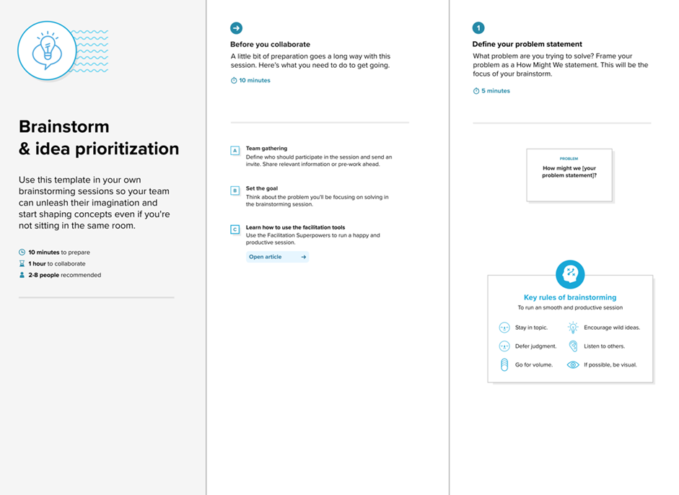

## Step-2: Brainstorming, Idea Listing, and Grouping

Each team member contributed their ideas using sticky notes on a shared board. Ideas were grouped into clusters such as Disease Detection, Farmer Support, and Technical Features.

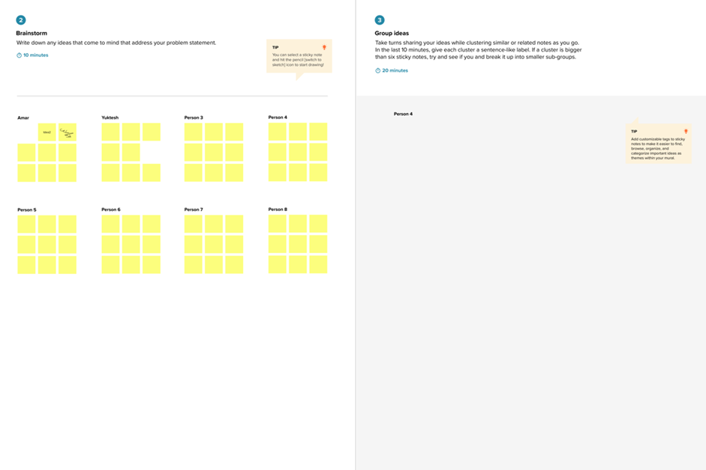

## Step-3: Idea Prioritization

Using a prioritization matrix, we evaluated the ideas based on feasibility and impact. The final idea selected was an image-based disease detection system using transfer learning.

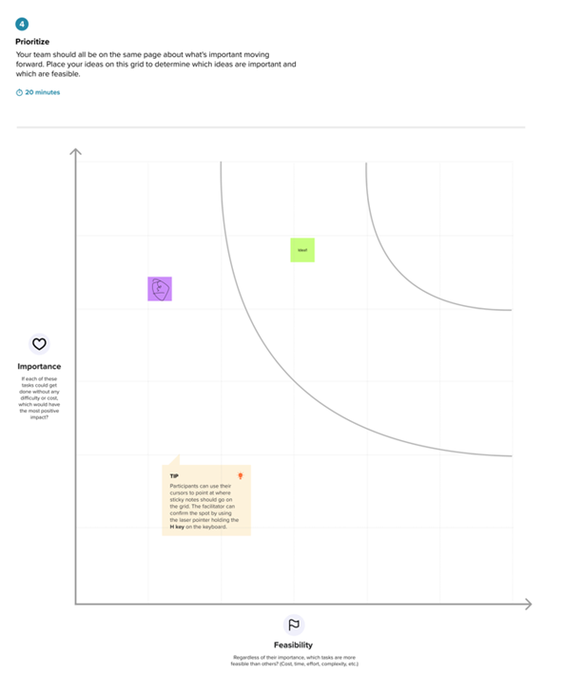

Reference: https://www.mural.co/templates/brainstorm-and-idea-prioritization