# Ideation Phase - Define the Problem Statements

Date: 31 January 2025

Team ID: LTVIP2025TMID36444

Project Name: Transfer Learning-Based Classification of Poultry Diseases for Enhanced Health Management

Maximum Marks: 2 Marks

## Customer Problem Statement Template:

Create a problem statement to understand your customer's point of view. The Customer Problem Statement template helps you focus on what matters to create experiences people will love.  
  
A well-articulated customer problem statement allows you and your team to find the ideal solution for the challenges your customers face. Throughout the process, you’ll also be able to empathize with your customers, which helps you better understand how they perceive your product or service.

Reference: https://miro.com/templates/customer-problem-statement/

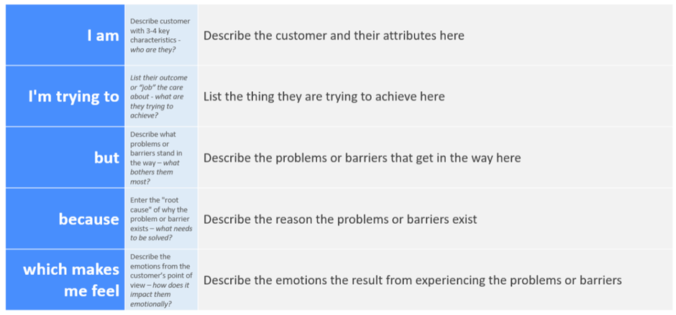

## Example:

|  |  |  |  |  |  |
| --- | --- | --- | --- | --- | --- |
| Problem Statement (PS) | I am | I’m trying to | But | Because | Which makes me feel |
| PS-1 | A poultry farmer in a rural area | Keep chickens healthy and avoid losses | I don’t know what disease they have | I don’t have vet access or knowledge | Worried, frustrated, and financially strained |
| PS-2 | A low-income poultry owner with basic phone access | Detect illness in chickens as early as possible | I don’t recognize symptoms clearly | No training or simple tools for identification | Anxious, helpless, and discouraged |