Roboteers QR codes
Each code opens the Roboteers page, where a person can ask to rent the robots or join the waiting list. Each one is tagged with where it was scanned, so every request tells you which code brought the person: the van, the park, a card, or a particular robot.
Print each code at least 1.5 inches (4 cm) square, black on white, with a clear border of white around it. Do not stretch it. Test every printed code with your phone before you put it on the van or anywhere permanent.

The van
On the back doors and both sides of the van wrap.
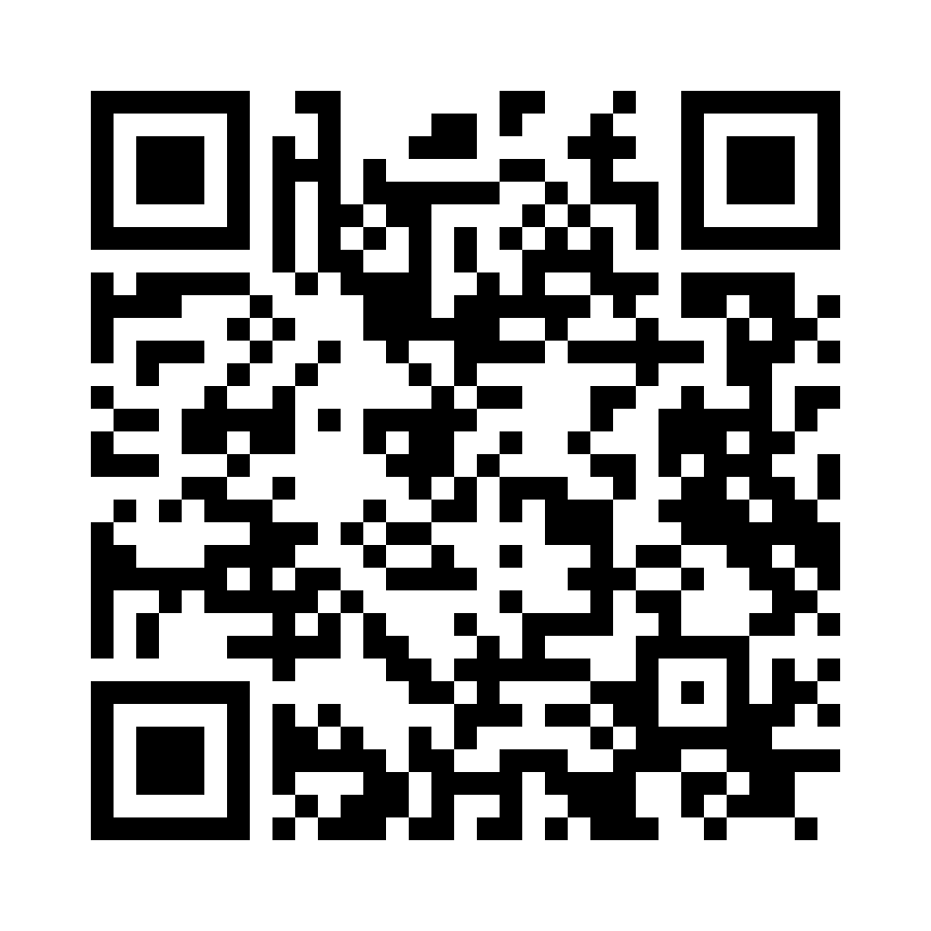
https://emerging-tech-lab.com/roboteers.html?s=van

Park and outdoor events
On a sign or a stand next to the robots when you are out in public.
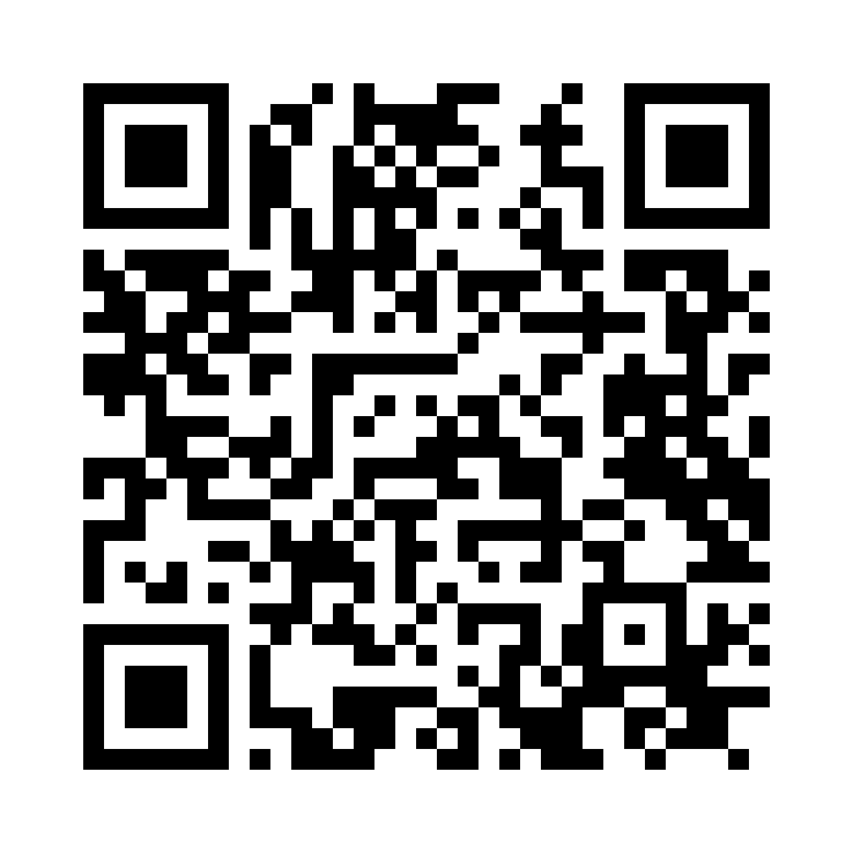
https://emerging-tech-lab.com/roboteers.html?s=park

Business cards
On the back of your business cards.
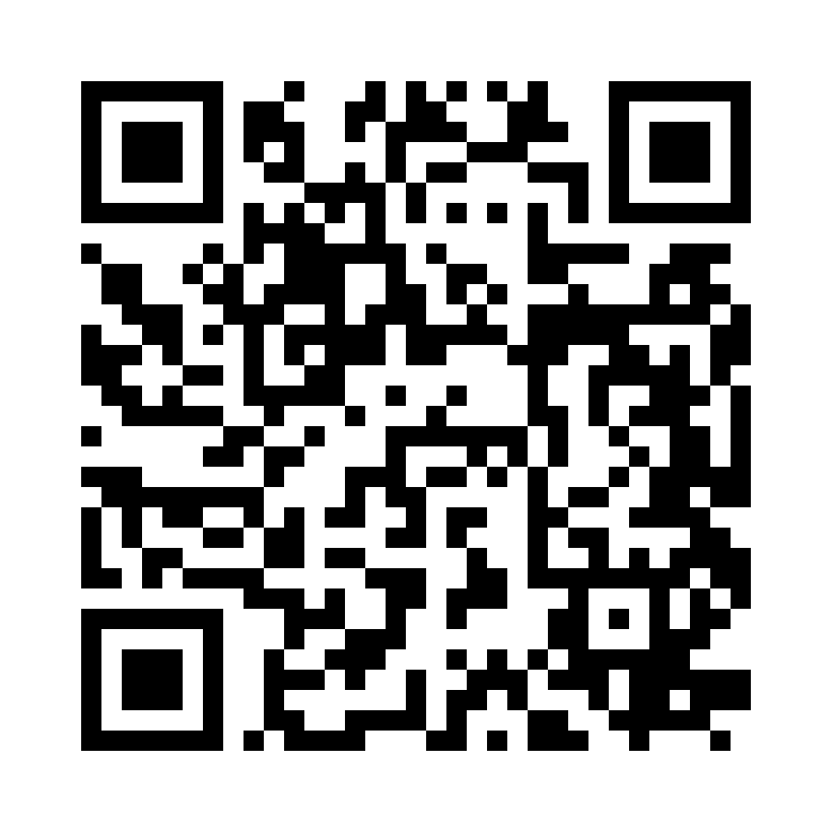
https://emerging-tech-lab.com/roboteers.html?s=card

Flyers
On flyers and anywhere you leave a printed page.
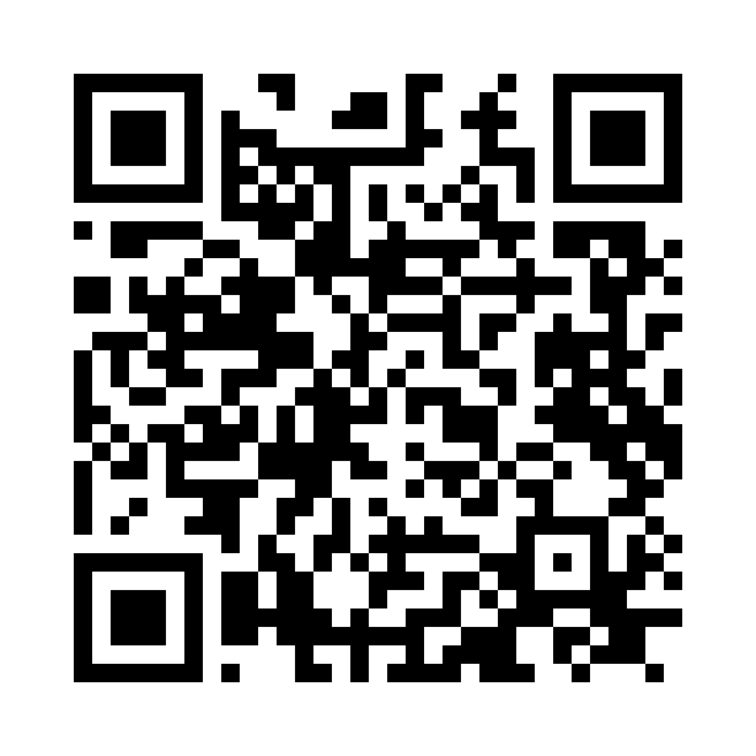
https://emerging-tech-lab.com/roboteers.html?s=flyer

Teddy (Astro)
On Teddy's chest or his stand, so a stranger who meets him can ask for him.
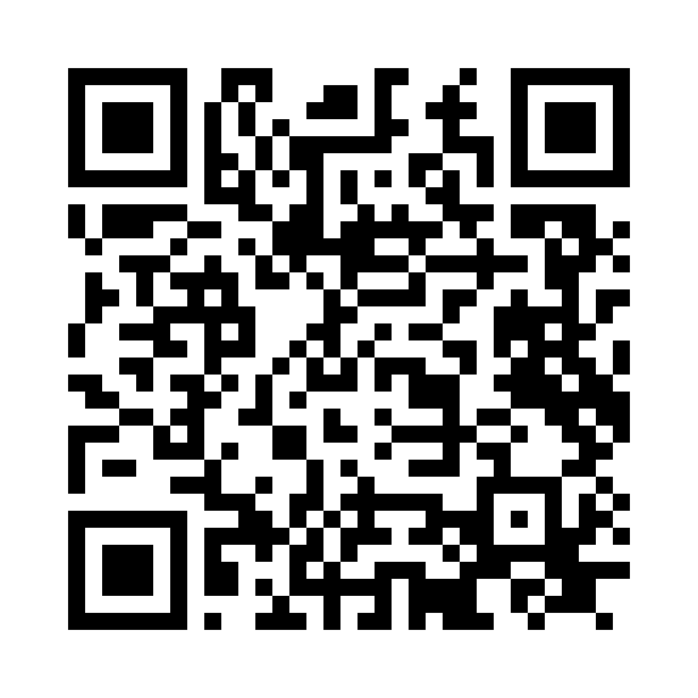
https://emerging-tech-lab.com/roboteers.html?s=teddy

ALICE
On ALICE's chair or stand.
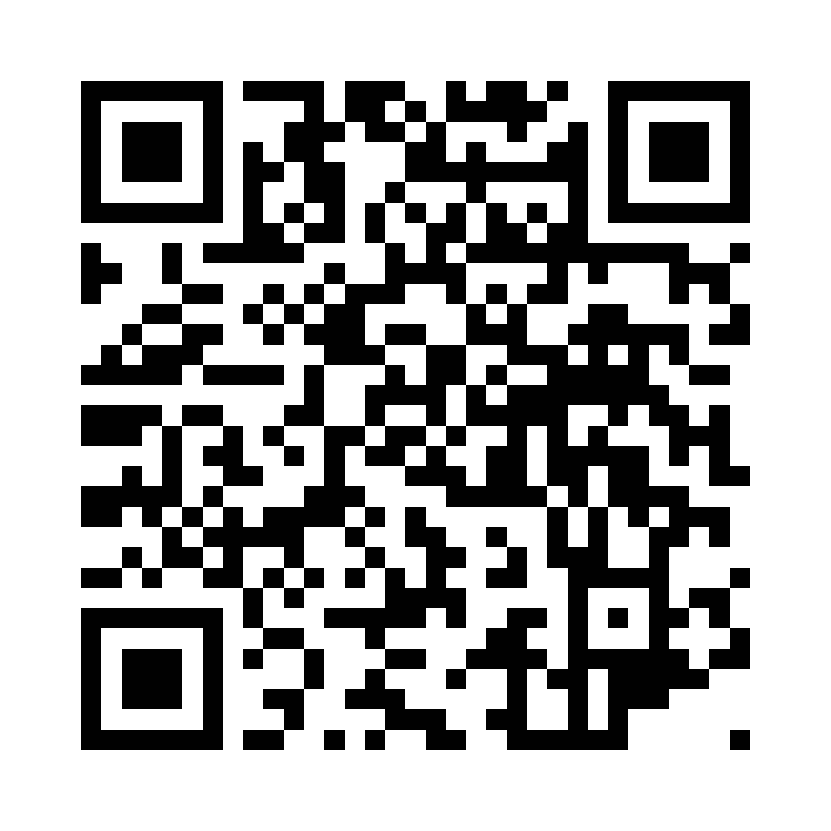
https://emerging-tech-lab.com/roboteers.html?s=alice

Astra
On Astra's stand.
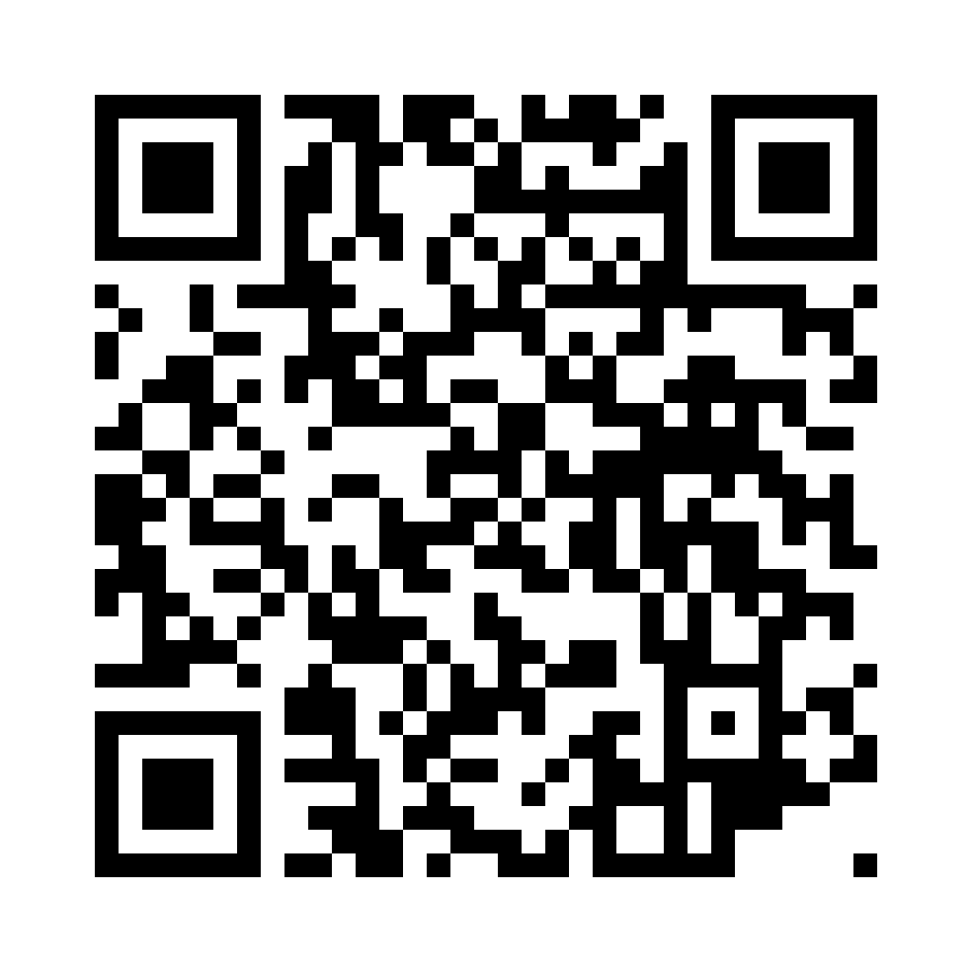
https://emerging-tech-lab.com/roboteers.html?s=astra

Astrad
On Astrad's stand.
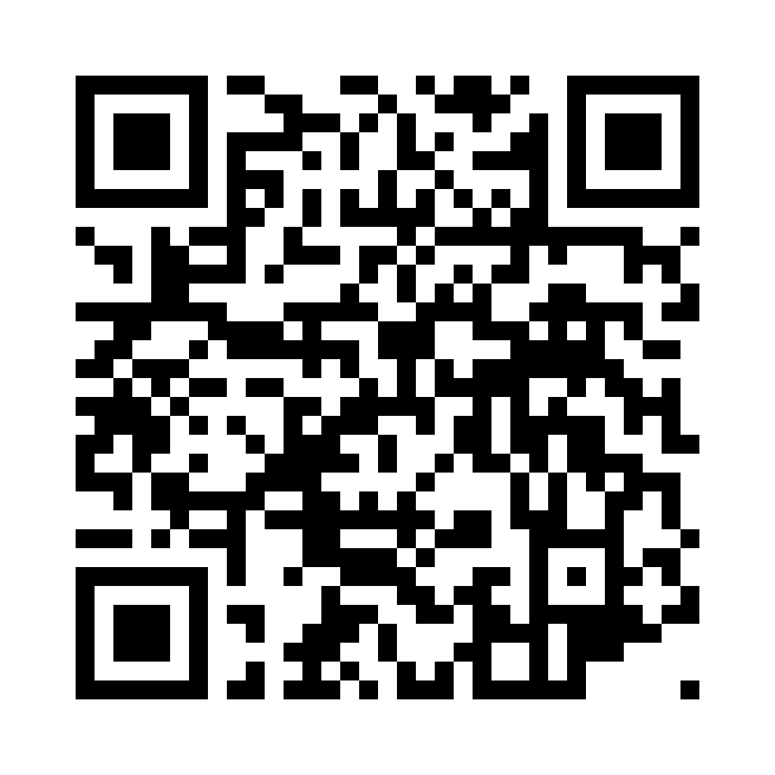
https://emerging-tech-lab.com/roboteers.html?s=astrad

Elle
On Elle's stand.
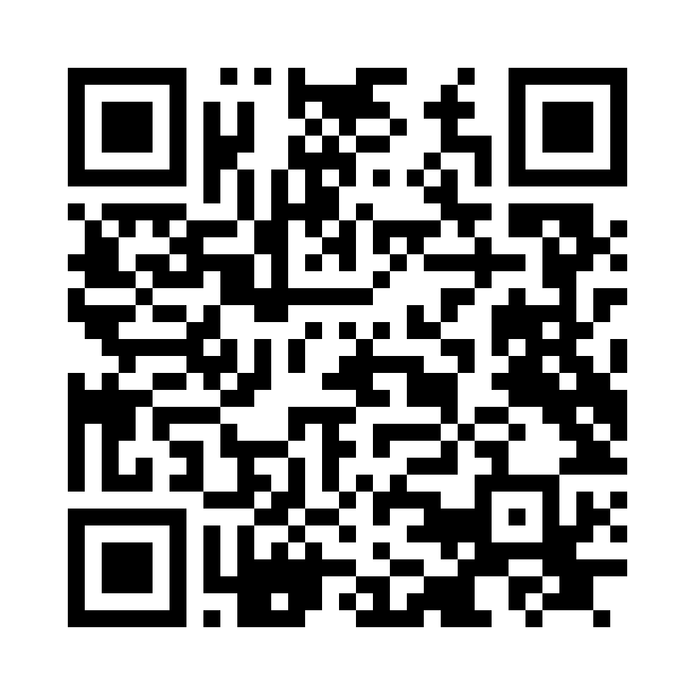
https://emerging-tech-lab.com/roboteers.html?s=elle

